Supporting information for

Identification and quantification of dicarboxylic fatty acids in head tissue of farmed Nile tilapia (Oreochromis niloticus)

Katja Lehnert¹, Mamun M. Rashid², Benoy Kumar Barman², Walter Vetter^{1,}*

¹ University of Hohenheim, Institute of Food Chemistry (170b), D-70593 Stuttgart, Germany
² WorldFish Bangladesh and South Asia, House 2B, Road No. 4, Block B, Banani, Dhaka 1213, Bangladesh

* Corresponding author
Email: walter.vetter@uni-hohenheim.de
ORCID: 0000-0002-5592-4265

Table S1. Fatty acid methyl esters detected in the lipids of transesterified Nile tilapia (Oreochromis niloticus) fillet and head tissue with GC retention times on the Rtx-2330 column (and * DB-5 column) and their way of verification
No. | GC t_{R} [min] | FA | verified by
1 | 17.9 | 12:0 | standard
2 | 19.4 | 13:0 | standard
3 | 20.9 | 14:0 | standard
4 | 21.8 | i15:0 | mass spectrum
5 | 22.0 | a15:0 | mass spectrum
6 | 22.5 | 15:0 | standard
7 | 23.3 | i16:0 | mass spectrum
8 | 24.0 | 16:0 | standard
9 | 24.8 | i17:0 | mass spectrum
10 | 25.1 | a17:0 | mass spectrum
11 | 25.5 | 17:0 | standard
12 | 25.7 | phytanic acid | standard
13 | 26.4 | i18:0 | mass spectrum
14 | 27.1 | 18:0 | standard
15 | 28.4 | 19:0 | mass spectrum
16 | 29.7 | 20:0 | standard
17 | 32.1 | 22:0 | standard
18 | 34.1 | 24:0 | standard
19 | 21.9 | 14:1 isomer | standard
20 | 24.6 | 16:1 isomer | mass spectrum
21 | 24.8 | 16:1n-7 | standard
22 | 26.2 | 17:1 isomer | standard
23 | 27.7 | 18:1n-9 c | standard
24 | 27.8 | 18:1 isomer | mass spectrum
25 | 30.3 | 20:1n-9 | standard
26 | 32.5 | 22:1n-9 | standard
27 | 25.8 | 16:2 isomer | mass spectrum
28 | 26.2 | 16:2 isomer | mass spectrum
29 | 28.4 | 18:2 isomer | mass spectrum
30 | 28.7 | 18:2n-6 | standard
31 | 29.1 | 18:2 isomer | mass spectrum
32 | 29.4 | 18:3n-6 | standard
33 | 29.5 | 18:3 isomer | mass spectrum
34 | 29.8 | 18:3n-3 | standard
35 | 30.5 | PUFAn-3 | mass spectrum
36 | 30.7 | Di-/PUFAn-? | mass spectrum
37 | 30.9 | 20:2n-3 | standard
38 | 31.1 | 20:2 isomer | standard
39 | 31.7 | 20:3n-6 | standard
40 | 32.1 | 20:4n-6 | standard
41 | 32.6 | PUFAn-3 | mass spectrum
42 | 32.7 | PUFAn-3 | mass spectrum
43 | 33.1 | 20:5n-3 | standard
44 | 34.2 | PUFAn-3 | mass spectrum
45 | 34.5 | PUFAn-? | mass spectrum
46 | 35.1 | 22:5n-3 | standard
47 | 35.4 | 22:6n-3 | standard
48 | 13.5* | Di 7:0 | standard
49 | 15.4* | Di 8:0 | standard
50 | 17.1* | Di 9:0 | standard
51 | 18.8* | Di 10:0 | standard
52 | 20.4* | Di 11:0 | standard

Table S2. Amount of erucic acid (mg/200 g fresh weight)ª in Nile tilapia (Oreochromis niloticus) fillet and head tissue in dependence of four feed compositions (FC1 - FC4, see Table 1)
 |  | Mean | Median | Range
Fillet | FC1 | 17 | 11 | 3 - 52
 | FC2 | 55 | 11 | 4 - 230
 | FC3 | 17 | 16 | 9 - 29
 | FC4 | 10 | 9 | 5 - 18
Head | FC1 | 130 | 134 | 110 - 150
 | FC2 | 95 | 96 | 0 – 170
 | FC3 | 140 | 143 | 98 – 170
 | FC4 | 210 | 207 | 110 - 290

ª values transferred from dry weight basis by taken into account 20% proteins and the fat content of the corresponding sample

Table S3. Contribution of individual DiFAs [%] to the fatty acids in Nile tilapia (Oreochromis niloticus) head tissue in dependence of four feed compositions (FC1 - FC4, see Table 1)

Feed comp.* | Di7:0 | Di8:0 | Di9:0 | Di10:0 | Di11:0
FC 1 | 0.005 | 0.06 | 0.4 | 0.02 | 0.03
FC 2 | 0.03 | 0.10 | 0.7 | 0.05 | 0.07
FC 3 | 0.04 | 0.14 | 1.0 | 0.05 | 0.11
FC 4 | 0.06 | 0.19 | 1.4 | 0.08 | 0.15
* see Table 1 for details
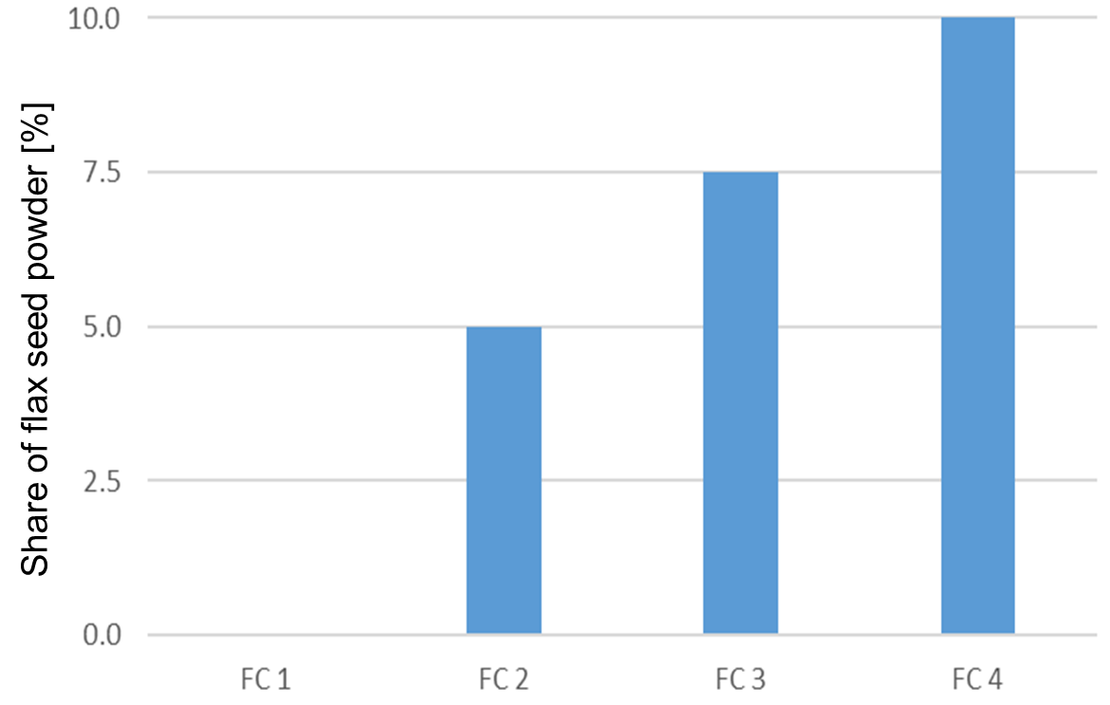

Fig. S1. Share of flax seed powder [%] in different feed compositions (FC 1-4)

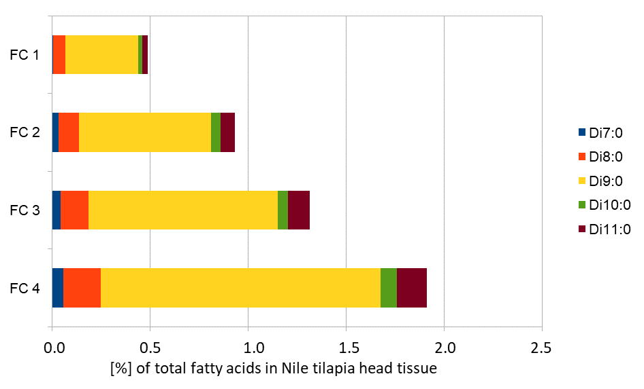

Fig. S2. Concentrations of dicarboxylic fatty acids (DiFAs) in Nile tilapia (Oreochromis niloticus) head tissue [% of total fatty acids] in dependence of four feed compositions as shown in Table 1 (treatments FC1 - FC4)

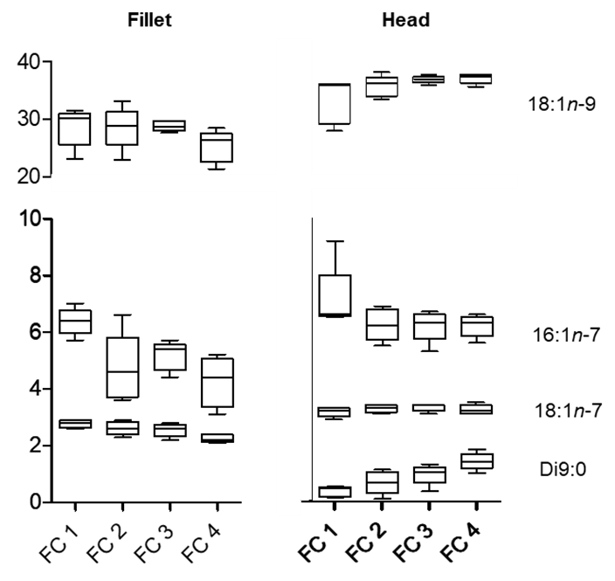

Fig. S3. Contributions (%) of selected fatty acids to the total fatty acids in dependence of four different feed compositions (treatments FC 1 - FC4, see Table 1) in head tissue and fillet of Nile tilapia (Oreochromis niloticus)

