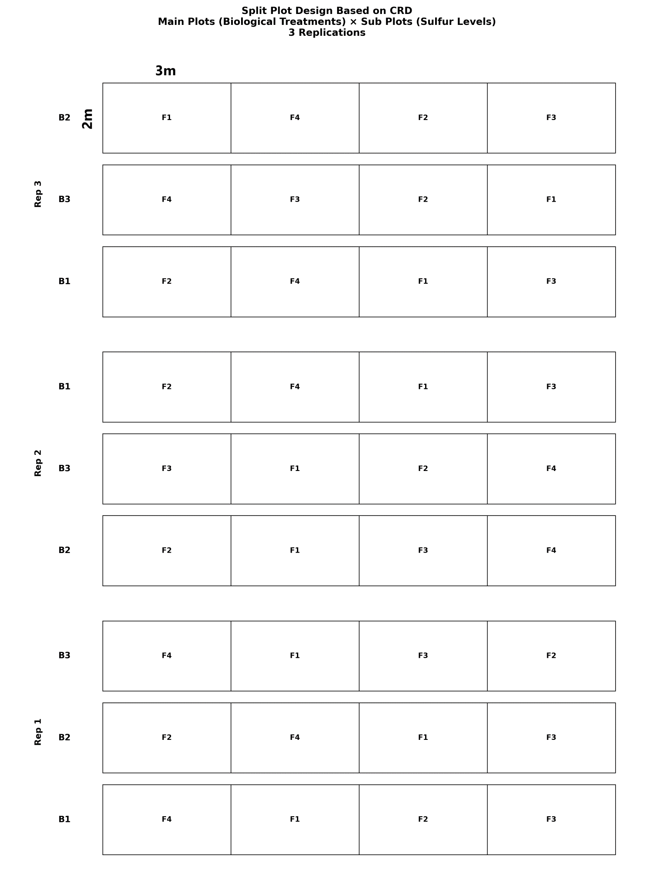
Figure S1 The study map includes the treatments utilized in both the main plots and sub-plots. Biological treatments were categorized into three levels: control (without SOB) (B₁), a microbial consortium featuring Thiobacillus sp., Bacillus subtilis, Paraburkholderia fungorum, and Paenibacillus sp. (B₂), and another microbial consortium comprising Enterobacter sp. and Pseudomonas sp. (B₃) in the main plots. Sulfur was applied at four different levels, organized as sub-plots: control (no sulfur application) (F₁), 175 kg ha⁻¹ of sulfur (F₂), 225 kg ha⁻¹ of sulfur (F₃), and 250 kg ha⁻¹ of sulfur (F₄).

