Crop cultivation in the Talayotic settlement of Son Fornés (Mallorca, Spain): Agricultural practices on the western Mediterranean islands in the first millennium BCE by H.-P. Stika et al., Veget Hist Archaeobot 33, 2024

Electronic Supplementary Material

Archaeological background
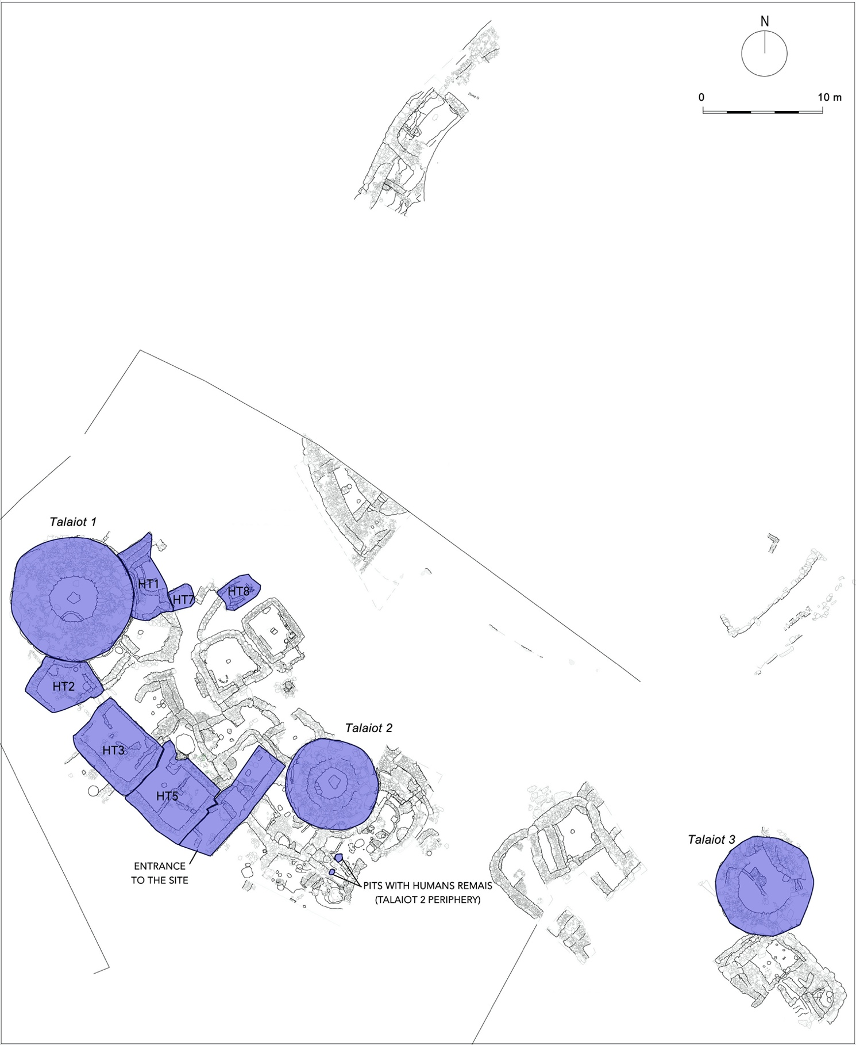
Fig. S1: Plan of the settlement of Son Fornés. Talayotic structures are marked in blue. (ASOME-UAB)
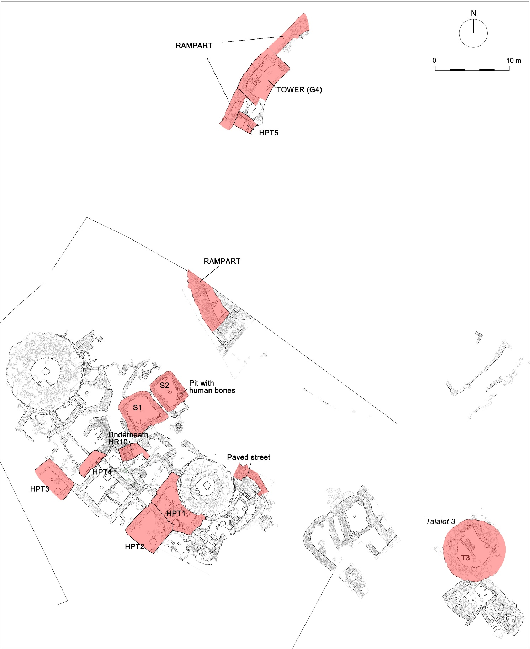
Fig. S2: Plan of the settlement of Son Fornés. Post-Talayotic structures are marked in red (ASOME-UAB).

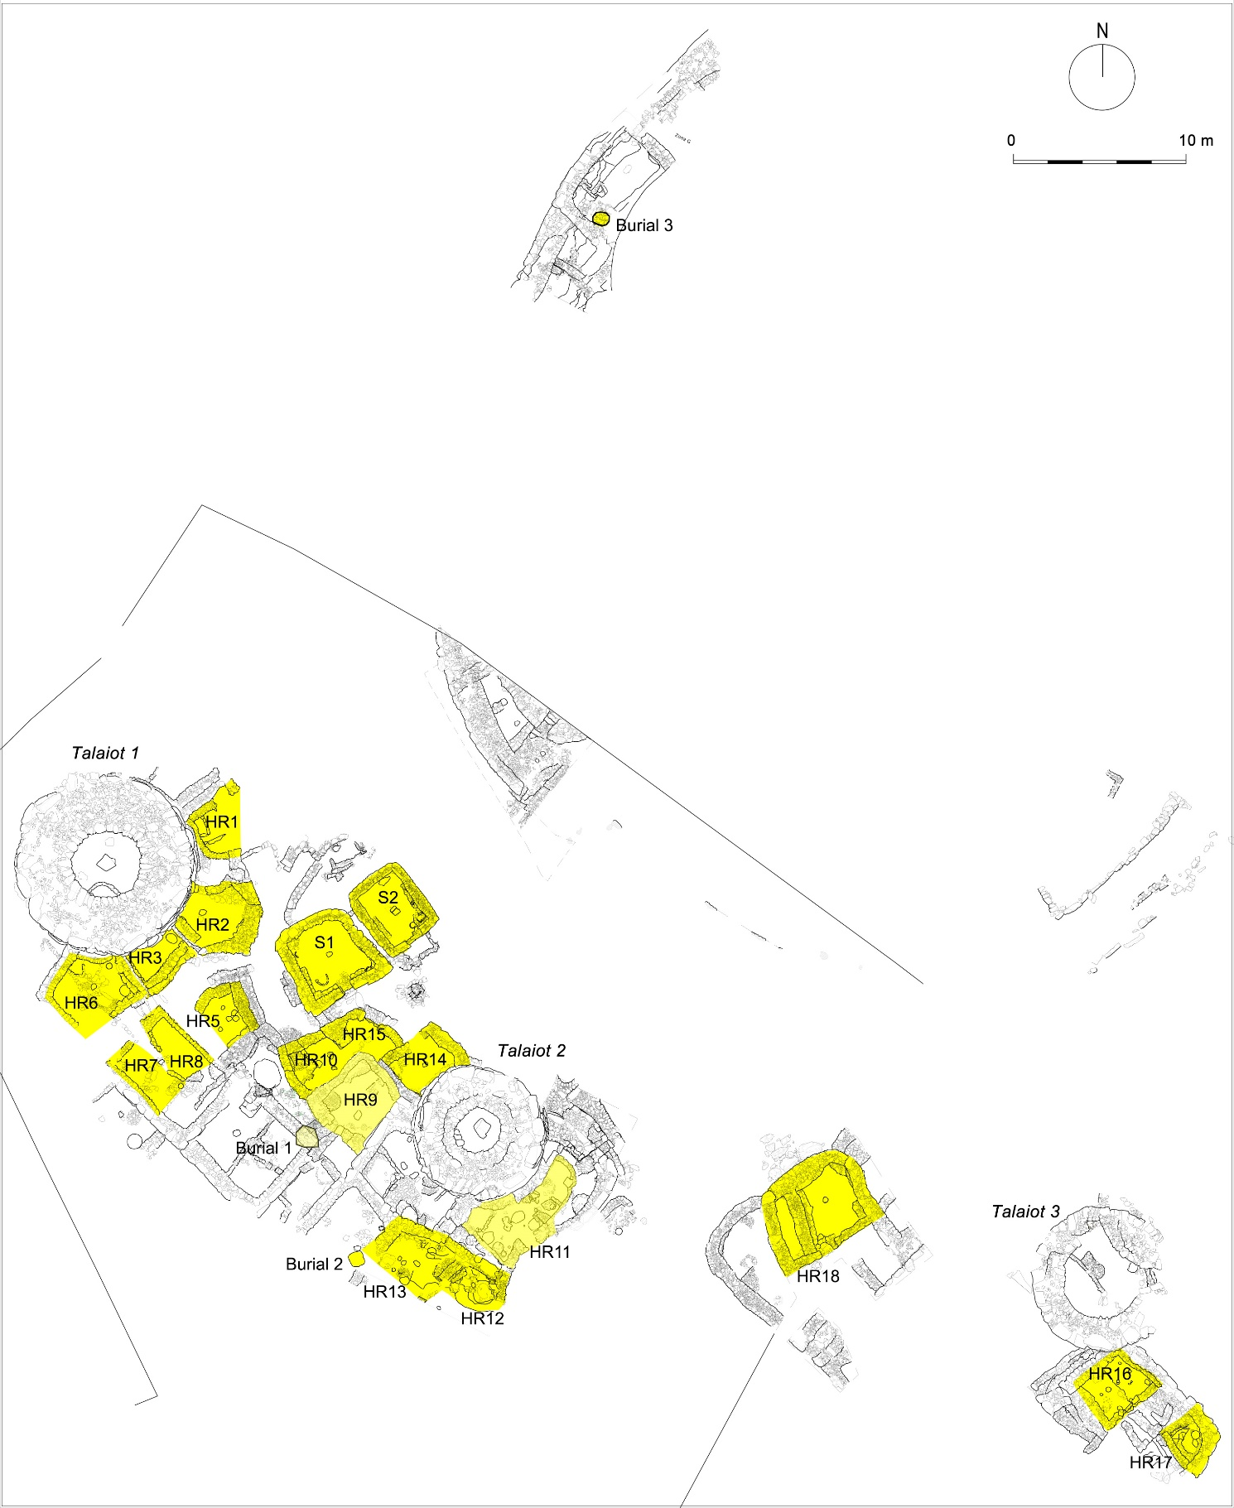
Fig. S3: Plan of the settlement of Son Fornés. Classic structures are marked in yellow (ASOME-UAB).

Material
The identification of botanic samples by period is as follows:
- TALAYOTIC: The samples of the Talayotic settlement come from one of the three talayots (T3), three Talayotic domestic buildings (HT5, HT6 and HT8), the open-air corridor used as the main entrance to the village (Entrance) and two underground pits with human remains in secondary position that had been dug on the outskirts of a talayot (T2).
- POST-TALAYOTIC: The samples of the early Post-Talayotic period come from the tower built in the northern excavated section of the rampart (G4) and the foundation pit of the northern sanctuary (S2 pit), were a set of human remains were found in secondary position. The rest of the samples are dated in the later Post-Talayotic period and include two domestic buildings (HPT1 and HPT5) and part of another one underneath a later Classic occupation (under HR10), the use level of a paved street close to a talayot (T2), the Post-Talayotic remodelling of Talayot 3 (T3) and the first occupation of Sanctuary 2 (S2).
- CLASSIC: The samples of the early Classic period include the first occupation of two buildings (HR10 and HR18 earlier occupation), whereas the later Roman Republican phase is recorded in three more buildings (HR11, HR15 and HR18 later occupation).

Charred grains of hulled barley (Hordeum vulgare var. vulgare) and free-threshing wheat (Triticum aestivum/durum/turgidum) of Talayotic, post-Talayotic and Classic contexts were used for stable isotopes analysis, which included carbon and nitrogen isotope compositions (ẟ¹³C and ẟ¹⁵N respectively). The number of ancient samples analysed per context ranged from 4 (Triticum – post-Talayotic) to 20 (Hordeum – Post-Talayotic), depending on availability (total amount of charred grains = 87; Tab. 7 ESM). In addition, 30 modern samples of T. aestivum and H. vulgare var. vulgare were analysed for their isotopic signatures. These samples were gathered in neighbouring agricultural fields to Son Fornés for two growing seasons (2007 and 2014), and were considered representative of present-day agriculture for the area.

Methods
For easier processing, the dried light fractions from flotation procedures were sieved with mesh sizes of 4.0 mm, 2.5 mm, 1.0 mm and 0.5 mm. Since some samples had a very large volume, the finest fraction (0.5 mm) was divided up with the aid of a sample divider, only parts of the samples were analysed and then extrapolated. "Digitale Zadenatlas van Nederland" (Cappers et al. 2012) and "Determination of grain finds from archaeological excavations" (Jacomet et al. 2006) were used for determination of the archaeobotanical remains as well as a recent comparative collection of seeds and fruits of Central European and Mediterranean flora and a collection of charred cereal residues at the AG Archaeobotany of Dept. Molecular Botany at University of Hohenheim. The ubiquity of plant remains in find complexes and the individual samples are given in the tables and were calculated using the following formula: Ubiquity = sum of samples in which a species occurs / sum of all samples) x 100 (Kreuz 1988).
For conditioning of charred seeds prior to isotope analysis, carbonate crusts were removed by soaking each grain separately in 6M HCl for 24 h at room temperature and then rinsing the grain repeatedly with distilled water (Ferrio et al. 2020). All samples (modern and archaeological) were oven-dried at 60 °C for 24 h before milling to a fine powder for isotope analyses. The stable isotope composition of carbon (δ¹³C, referred to the VPDB standard) and nitrogen (δ¹⁵N, referred to N₂ in air) were determined by isotope ratio mass spectrometry (EA/IRMS). The overall analytical precision was about 0.12‰ for δ¹³C and 0.20‰ for δ¹⁵N. For comparison purposes across periods, carbon isotope discrimination (Δ¹³C) of archaeobotanical and modern samples was calculated from sample δ¹³C and from the δ¹³C of atmospheric CO₂ (δ¹³C_{air}) following Farquhar et al. (1989). The δ¹³C_{air} was inferred by interpolating a range of data from Antarctic ice-core records together with modern data from two Antarctic stations (Halley Bay and Palmer Station) of the CU-INSTAAR/NOAA-CMDL network for atmospheric CO₂, as reported elsewhere (e.g. Araus et al. 2014).

References
Araus JL, Ferrio JP, Voltas J, Aguilera M, Buxó R (2014) Agronomic conditions and crop evolution in ancient Near East agriculture. Nat Commun 5:3953. https://doi.org/10.1038/ncomms4953
Cappers RTJ, Bekker RM, Jans JEA (2012) Digitale zadenatlas van Nederland (Digital seed atlas of the Netherlands), 2nd edn. Groningen Archaeological Studies 4. Barkhuis Publishing, Eelde
Farquhar GD, Ehleringer JR, Hubick KT (1989) Carbon Isotope Discrimination and Photosynthesis. Annu Rev Plant Physiol Plant Mol Biol 40:503–537. https://doi.org/10.1146/annurev.pp.40.060189.002443
Ferrio JP, Aguilera M, Voltas J, Araus JL (2020) Chapter Three - Stable carbon isotopes in archaeological plant remains. In: Montenari M (ed) Stratigraphy & Timescales, Vol 5: Carbon Isotope Stratigraphy. Academic Press, pp 107–145
Jacomet S (2006) Identification of cereal remains from archaeological sites, 2nd edn. IPAS, Basel University, Basel
Kreuz A (1988) Holzkohle-Funde der ältestbandkeramischen Siedlung Friedberg-Bruchenbrücken: Anzeiger für Brennholz-Auswahl und lebende Hecken? In: Küster H (ed) Der prähistorische Mensch und seine Umwelt. Theiss, Stuttgart, pp 139–153

Results
Table S1: Sum of archaeobotanical finds from the Talayotic period in Son Fornés
Campaign |  |  | 2002 | 1981 | 2006 | 2006 | 2006 | 2006 | 2006 | 2003 | 2003 | 2003 | 2003 | 2003 | 2006 | 2006 | 2006 | 2003 | 2011 | 2011 | 1981 | 2003 |  | 2003
Archaeological structure |  |  | Talayot 3 | HT 5 | HT 6 | HT 6 | HT 6 | HT 6 | HT 6 | HT 6 | HT 6 | HT 6 | HT 6 | HT 6 | HT 6 | HT 6 | HT 6 | HT 6 | HT 8 | HT 8 | Entrance | Pit 1 |  | Pit 2
Excavation context |  |  | 1 | 2 | 3 | 4 | 6 | 7 | 8 | 9 | 10 | 11 | 12 | 13 | 14 | 15 | 16 | 17 | 18 | 19 | 20 |  | 22 |  | 23 |  | 23 |  | Sum of features
Vol. (l) |  |  | 670 | 1 | 264 | 408 | 71 | 3 | 2 | 304 | 312 | 7 | 19 | 118 | 101 | 55 | 8 | 29 | 98,5 | 8 | 2 |  | 14 |  | 7 |  | 2501,5 |  | Total volume (l)
Number of samples |  |  | 3 | 1 | 12 | 18 | 8 | 1 | 1 | 1 | 1 | 1 | 4 | 3 | 5 | 4 | 1 | 1 | 6 | 1 | 1 | 2 |  | 1 |  | 76 |  | Sum of samples
 |  |  |  |  |  |  |  |  |  |  |  |  |  |  |  |  |  |  |  |  |  |  |  |  |  | Sum |  | Steadiness
Cereals |  |  |  |  |  |  |  |  |  |  |  |  |  |  |  |  |  |  |  |  |  |  |  |  |  |  |  | features |  | samples
Avena sp. | grain | carb. | 3 |  | 499 | 1184 | 427 | 6 | 68 | 276 | 204 | 5 | 49 | 95 | 6 | 4 | 3 | 29 |  |  |  |  |  |  |  |  | 2858 |  | 65% |  | 63%
Avena sp. | glume | carb. |  |  | 177 | 83 | 65 |  | 12 | 18 | 12 | 7 | 4 |  |  |  |  | 3 |  |  |  |  |  |  |  |  | 381 |  | 39% |  | 27%
Hordeum vulgare | grain | carb. |  |  |  |  |  |  |  |  |  |  | 12 |  |  | 7 |  |  |  |  |  |  |  |  |  |  | 19 |  | 9% |  | 3%
Hordeum vulgare | rachis frag. | carb. |  |  |  |  |  |  |  |  |  |  |  | 8 |  |  |  |  |  |  |  |  |  |  |  |  | 8 |  | 4% |  | 1%
Hordeum vulgare var. vulgare | grain | carb. | 49 |  | 3983 | 14928 | 2242 | 71 | 293 | 10368 | 5198 | 359 | 629 | 1690 | 63 | 884 | 27 | 540 |  |  |  |  | 3 |  |  |  | 41327 |  | 70% |  | 76%
Hordeum vulgare var. vulgare | glume | carb. |  |  |  | 98 |  |  |  |  |  |  |  |  |  |  |  |  |  |  |  |  |  |  |  |  | 98 |  | 4% |  | 3%
Hordeum vulgare var. nudum | grain | carb. |  |  | 23 | 51 | 3 |  | 1 | 45 | 258 |  | 1526 | 7 | 3 | 1 |  | 1 |  |  |  |  |  |  |  |  | 1919 |  | 48% |  | 43%
Triticum cf. dicoccum | grain | carb. |  |  |  | 17 | 16 |  |  | 25 | 7 | 6 | 37 | 12 | 2 |  |  | 1 |  |  |  |  |  |  |  |  | 123 |  | 39% |  | 27%
Triticum aestivum/ durum/ turgidum | grain | carb. | 37 |  | 125 | 798 | 207 | 1 |  | 1378 | 1282 | 155 | 20632 | 1692 | 26 | 33 | 4 | 129 |  |  |  |  |  |  |  |  | 26499 |  | 61% |  | 65%
Triticum sp. | grain | carb. | 3 |  | 13 |  | 3 |  |  |  |  | 24 |  |  | 10 | 21 |  |  |  |  |  |  |  |  |  |  | 74 |  | 26% |  | 14%
Cerealia Indet. | grain | carb. | 6 |  | 279 | 592 | 20 |  | 7 | 404 | 120 | 14 | 213 | 44 | 30 | 31 | 2 | 11 | 4 |  |  |  |  |  |  |  | 1777 |  | 65% |  | 52%
Cerealia indet. | glume | carb. |  |  | 8 | 6 |  |  |  |  | 2 |  |  |  |  | 1 |  |  | 1 |  |  |  |  |  |  |  | 18 |  | 22% |  | 9%
Cerealia Avena sp. / Hordeum sp. | glume | carb. |  |  |  | 104 |  |  |  |  |  |  |  |  |  |  |  |  |  |  |  |  |  |  |  |  | 104 |  | 4% |  | 4%
Cerealia | straw frag. | carb. |  |  |  | 2 |  |  |  |  |  |  |  |  |  |  |  |  |  |  |  |  |  |  |  |  | 2 |  | 4% |  | 1%
Other crops
Ficus carica | pip | carb. | 10 |  | 20 | 49 | 19 | 2 |  | 16 | 11 |  | 16 | 7 | 1 | 1 |  | 4 | 3 |  |  |  | 1 |  |  |  | 160 |  | 61% |  | 43%
Olea europaea | kernel | carb. | 2 |  |  |  |  |  |  |  |  |  |  |  |  |  |  |  |  |  |  |  |  |  |  |  | 2 |  | 4% |  | 1%
cf. Pisum sativum | seed | carb. |  |  |  | 1 |  |  |  |  |  |  |  |  |  |  |  |  |  |  |  |  |  |  |  |  | 1 |  | 4% |  | 1%
Vicia faba | seed | carb. | 3 |  | 2 | 7 | 1 |  |  | 103 |  | 6 | 28 | 1 | 2 | 2 |  | 69 | 25 |  |  |  |  |  |  |  | 249 |  | 52% |  | 20%
Fabaceae, cult. | seed | carb. |  |  | 2 | 1 | 10 |  |  |  |  |  |  |  |  |  |  |  |  |  |  |  |  |  |  |  | 13 |  | 13% |  | 5%
Wild plants
Ajuga sp./ Teucrium sp. | seed | carb. |  |  |  |  |  |  |  |  | 1 |  |  |  |  |  |  |  |  |  |  |  |  |  |  |  | 1 |  | 4% |  | 1%
Anagallis sp. | seed | carb. |  |  |  | 2 |  |  |  |  |  |  |  |  |  |  |  |  |  |  |  |  |  |  |  |  | 2 |  | 4% |  | 1%
Asphodelus sp. | seed | carb. |  |  |  | 1 |  |  |  |  |  |  |  |  |  |  |  |  |  |  |  |  |  |  |  |  | 1 |  | 4% |  | 1%
* Beta sp. | fruit | carb. |  |  | 9 | 25 | 8 |  |  | 40 |  |  |  | 1 | 1 |  |  |  |  |  |  |  |  |  |  |  | 84 |  | 26% |  | 22%
Brassicaceae | pod | carb. |  |  |  | 1 |  |  |  |  |  |  |  |  |  |  |  |  |  |  |  |  |  |  |  |  | 1 |  | 4% |  | 1%
Bromus sp. | seed | carb. | 1 |  | 4 | 2 |  |  |  | 6 |  |  |  |  |  |  |  |  |  |  |  |  |  |  |  |  | 13 |  | 22% |  | 5%
Calendula sp. | seed | carb. |  |  |  | 1 |  |  |  |  |  |  |  |  |  |  |  |  |  |  |  |  |  |  |  |  | 1 |  | 4% |  | 1%
*Capparis spinosa | seed | carb. |  |  |  |  |  |  |  | 1 |  |  |  |  |  |  |  |  |  |  |  |  |  |  |  |  | 1 |  | 4% |  | 1%
Carex sp., bicarpellat | seed | carb. |  |  |  | 1 |  |  |  |  |  |  |  |  | 2 |  |  |  |  |  |  |  |  |  |  |  | 3 |  | 9% |  | 1%
Chenopodium sp. | seed | carb. |  |  |  | 24 | 1 |  |  |  |  |  |  | 1 |  |  |  |  |  |  |  |  |  |  |  |  | 26 |  | 13% |  | 11%
Chenopodium murale | seed | carb. |  |  |  |  |  |  |  |  | 1 |  |  | 1 |  |  |  |  |  |  |  |  |  |  |  |  | 2 |  | 9% |  | 3%
Cistus sp. | seed | carb. |  |  |  |  | 1 |  |  |  |  |  |  |  |  |  |  |  |  |  |  |  |  |  |  |  | 1 |  | 4% |  | 1%
cf. Convolvulus arvensis | seed | carb. |  |  | 8 |  |  |  |  |  | 1 |  | 1 |  |  |  |  |  |  |  |  |  |  |  |  |  | 10 |  | 13% |  | 4%
Cleome sp. | seed | carb. |  |  |  |  |  |  |  | 4 |  |  |  |  |  |  |  |  | 7 |  |  |  |  |  |  |  | 11 |  | 9% |  | 5%
Euphorbia sp. | seed | carb. |  |  |  |  |  |  |  |  | 1 |  |  |  |  |  |  |  |  |  |  |  |  |  |  |  | 1 |  | 4% |  | 1%
Euphorbia helioscopia | seed | carb. |  |  |  |  |  |  |  |  |  |  |  |  |  | 1 |  |  |  |  |  |  |  |  |  |  | 1 |  | 4% |  | 1%
Fabaceae Indet. | seed | carb. |  |  |  | 1 | 3 |  |  |  |  |  |  |  |  |  |  |  |  |  |  |  |  |  |  |  | 4 |  | 9% |  | 3%
Fallopia convolvulus | seed | carb. | 10 |  | 4 | 14 | 5 |  |  | 28 | 9 |  | 34 |  | 3 |  | 1 |  |  |  |  |  |  |  |  |  | 108 |  | 39% |  | 15%
Festuca sp./ Lolium sp. | seed | carb. | 62 |  | 113 | 447 | 30 |  | 1 | 181 | 20 |  | 20 | 12 | 4 | 1 | 6 | 17 | 2 |  |  |  | 3 |  | 1 |  | 919 |  | 70% |  | 63%
Fumaria sp. | seed | carb. |  |  |  |  |  |  |  |  |  | 1 |  |  |  |  |  |  |  |  |  |  |  |  |  |  | 1 |  | 4% |  | 1%
Galium sp. | seed | carb. |  |  |  |  |  |  |  |  |  |  |  |  | 1 |  |  |  | 1 |  |  |  |  |  |  |  | 2 |  | 9% |  | 3%
Galium cf. aparine | seed | carb. | 1 |  |  | 8 | 4 |  |  | 4 |  |  | 1 |  |  |  |  |  |  |  |  |  |  |  |  |  | 17 |  | 22% |  | 9%
Heliotropium europaeum | seed | carb. |  |  |  |  |  |  |  | 4 |  |  |  |  |  |  |  |  | 3 |  | 1 |  |  |  |  |  | 8 |  | 13% |  | 6%
Hordeum sp. | grain | carb. | 1 |  | 8 | 53 | 9 |  | 3 |  | 16 |  | 1 |  |  |  |  |  |  |  |  |  |  |  |  |  | 1 |  | 30% |  | 1%
Hypericum sp. | seed | carb. |  |  | 3 | 3 | 1 |  |  | 4 | 2 |  |  | 2 |  |  |  |  |  |  |  |  |  |  |  |  | 15 |  | 26% |  | 9%
Liliaceae | seed | carb. |  |  |  | 12 |  |  |  |  |  |  |  |  |  |  |  |  |  |  |  |  |  |  |  |  | 12 |  | 4% |  | 1%
Lithospermum cf. arvense | seed | carb. |  |  |  |  |  |  |  |  |  |  |  |  |  |  |  |  | 1 |  |  |  |  |  |  |  | 1 |  | 4% |  | 1%
Lithospermum arvense | seed | carb. |  |  |  |  |  |  |  |  |  |  |  |  | 1 |  |  |  |  |  |  |  |  |  |  |  | 1 |  | 4% |  | 1%
* Malva sp. | pod | carb. |  |  |  | 2 |  |  |  |  |  |  |  |  |  |  |  |  |  |  |  |  |  |  |  |  | 2 |  | 4% |  | 1%
* Malva sp. | seed | carb. | 11 |  | 14 | 36 | 4 |  | 1 | 6 | 14 |  |  | 2 |  |  | 1 |  | 3 |  |  |  |  |  |  |  | 92 |  | 43% |  | 33%
Medicago sp. | seed | carb. | 17 |  | 4 | 14 | 9 |  |  | 14 | 5 | 1 | 2 |  |  |  |  | 1 |  |  |  |  |  |  |  |  | 67 |  | 39% |  | 18%
Melilotus sp./ Anthyllis sp., one-seeded | pod | carb. |  |  | 6 | 3 | 2 |  |  |  | 1 |  |  |  |  |  |  |  |  |  |  |  |  |  |  |  | 12 |  | 17% |  | 9%
Phalaris sp. | grain | carb. | 5 |  | 4 | 3 |  |  | 1 |  | 1 |  |  |  |  |  |  |  |  |  |  |  |  |  |  |  | 14 |  | 22% |  | 8%
* Pinus sp. | veg. frag. | carb. | 1 |  | 1 | 1 |  |  |  | 4 |  |  |  |  | 2 |  |  |  |  |  |  |  |  |  |  |  | 9 |  | 22% |  | 6%
* Pistacia lentiscus | seed | carb. |  |  | 4 |  |  |  |  |  |  |  |  |  |  |  |  |  |  |  |  |  |  |  |  |  | 4 |  | 4% |  | 1%
Plantago sp. | seed | carb. |  |  |  | 11 | 2 |  |  |  | 1 |  | 16 |  |  |  |  |  |  |  |  |  |  |  |  |  | 30 |  | 17% |  | 8%
Poa sp. | grain | carb. | 1 |  |  | 1 |  | 1 |  |  | 1 |  | 1 |  |  |  |  |  |  |  |  |  |  |  |  |  | 5 |  | 22% |  | 6%
Poaceae | grain | carb. | 44 |  | 56 | 91 | 19 |  |  | 138 | 19 |  | 20 | 11 |  | 2 |  |  | 11 |  |  |  |  |  |  |  | 411 |  | 48% |  | 18%
Poaceae | rachis frag. | carb. |  |  | 23 | 56 | 6 |  |  |  |  | 1 | 112 |  |  |  |  |  |  |  |  |  |  |  |  |  | 197 |  | 17% |  | 11%
Polygonum aviculare | seed | carb. |  |  |  | 3 |  |  |  | 8 |  |  |  |  |  |  |  | 2 |  |  |  |  |  |  |  |  | 13 |  | 13% |  | 4%
Raphanus raphanistrum | seed | carb. |  |  | 1 | 2 |  |  |  |  |  |  |  | 1 |  |  |  | 1 |  |  |  |  |  |  |  |  | 5 |  | 17% |  | 5%
Ranunculus sp. | seed | carb. |  | 1 | 4 |  |  |  |  |  | 12 |  |  |  |  |  |  |  |  |  |  |  |  |  |  |  | 17 |  | 13% |  | 4%
Ranunculus arvensis | seed | carb. |  |  |  | 2 |  |  |  |  |  |  |  |  |  |  |  |  |  |  |  |  |  |  |  |  | 2 |  | 4% |  | 1%
Rumex sp. | seed | carb. | 7 | 1 | 6 | 68 | 2 |  |  | 52 |  |  | 1 | 2 |  |  |  | 1 | 5 |  |  |  |  |  |  |  | 145 |  | 43% |  | 30%
* Rosmarinus officinalis | seed | carb. |  |  |  |  | 1 |  |  |  | 2 |  |  |  |  |  |  |  |  |  |  |  |  |  |  |  | 3 |  | 9% |  | 3%
Schoenus nigricans | fruit | carb. | 1 |  |  |  |  |  |  |  |  |  |  |  |  |  |  |  |  |  |  |  |  |  |  |  | 1 |  | 4% |  | 1%
Schoenus nigricans | fruit | min. | 1 |  |  | 1 | 1 |  |  | 4 | 1 |  | 16 |  |  |  |  |  |  |  |  |  |  |  |  |  | 24 |  | 26% |  | 8%
Sherardia arvensis | seed | carb. |  |  | 6 | 2 |  |  |  | 1 |  |  |  |  |  |  |  |  |  |  |  |  |  |  |  |  | 9 |  | 13% |  | 5%
Silene sp. | seed | carb. |  |  |  |  |  |  |  |  |  |  |  | 1 |  |  |  |  |  |  |  |  |  |  |  |  | 1 |  | 4% |  | 1%
Stellaria media | seed | carb. |  |  |  |  |  |  |  |  |  |  |  |  |  |  |  |  |  | 1 |  |  |  |  |  |  | 1 |  | 4% |  | 1%
Trifolium sp. | seed | carb. |  |  | 4 |  |  |  |  |  |  |  |  |  |  |  |  |  |  |  |  |  |  |  |  |  | 4 |  | 4% |  | 1%
* Valerianella sp. | seed | carb. | 9 |  |  | 4 |  |  |  |  | 1 |  |  |  |  |  |  |  |  |  |  |  |  |  |  |  | 14 |  | 13% |  | 8%
Vicia hirsuta | seed | carb. |  |  | 2 |  |  |  |  |  |  |  |  |  | 1 |  |  |  |  |  |  |  |  |  |  |  | 3 |  | 9% |  | 3%
Vicia sp. | seed | carb. |  |  |  | 1 |  |  |  | 12 |  |  |  |  |  |  |  |  |  |  |  |  |  |  |  |  | 13 |  | 9% |  | 3%
amorph charred objects | frag. | carb. | 174 | 4 | 17 | 65 | 13 |  | 4 | 124 | 30 | 3 | 57 | 10 |  |  |  | 24 | 1 | 34 |  |  | 2 |  |  |  | 562 |  | 65% |  | 33%
Twig | frag. | carb. |  |  |  | 60 | 10 |  |  |  |  | 3 |  |  |  |  |  |  |  |  |  |  |  |  |  |  | 73 |  | 13% |  | 6%
Sclerophyll | frag. | carb. |  |  |  | 2 |  |  |  |  |  |  |  |  |  |  |  |  |  |  |  |  |  |  |  |  | 2 |  | 4% |  | 1%
Indet. | seed | carb. |  | 3 |  |  | 2 |  |  |  |  |  | 1 |  | 1 |  |  |  |  |  |  |  |  |  |  |  | 7 |  | 17% |  | 6%
Sum |  |  | 463 | 9 | 5436 | 18944 | 3146 | 81 | 391 | 13268 | 7233 | 591 | 23429 | 3600 | 159 | 989 | 44 | 833 | 67 | 35 | 1 |  | 9 |  | 1 |  | 78729 |  | Sum
Sum of cereals |  |  | 98 |  | 5292 | 18068 | 3048 | 78 | 381 | 12532 | 7097 | 577 | 23106 | 3548 | 140 | 983 | 36 | 717 | 6 |  |  |  | 3 |  |  |  | 75206 |  | Sum of cereals
thereof grains |  |  | 98 |  | 4922 | 17570 | 2918 | 78 | 369 | 12496 | 7069 | 563 | 23098 | 3540 | 140 | 981 | 36 | 711 | 4 |  |  |  | 3 |  |  |  | 74596 |  | thereof grains
thereof chaff |  |  |  |  | 185 | 293 | 65 |  | 12 | 18 | 14 | 7 | 4 | 8 |  | 1 |  | 3 | 1 |  |  |  |  |  |  |  | 611 |  | thereof chaff
Sum of other crops |  |  | 15 |  | 24 | 57 | 30 | 2 |  | 119 | 11 | 6 | 44 | 8 | 3 | 3 |  | 73 | 28 |  |  |  | 1 |  |  |  | 424 |  | Sum of other crops
Sum of wild plants |  |  | 350 | 9 | 305 | 1024 | 133 | 1 | 10 | 635 | 139 | 15 | 283 | 44 | 16 | 4 | 8 | 46 | 34 | 35 | 1 |  | 5 |  | 1 |  | 3098 |  | Sum of wild plants
Find density |  |  | 0,7 | 9,0 | 20,6 | 46,4 | 44,3 | 27,0 | 195,5 | 43,6 | 23,2 | 84,4 | 1233,1 | 30,5 | 1,6 | 18,0 | 5,5 | 28,7 | 0,7 | 4,4 | 0,5 |  | 0,6 |  | 0,1 |  | 31,47 |  | Find density
* wild plants possibly used as food

Table S2: Sum of archaeobotanical finds from the post-Talayotic period in Son Fornés
Campaign |  |  | 2002 | 2002 | 2002 | 2002 | 2002 | 2003 | 2011 | 2002 | 2002 | 2002 | 2002 | 1985 | 2002 | 1990 | 2006 | 2011 | 2011 | 2011
post-Talayotic phase |  |  | 1 | 1 | 1 | 1 | 1 | 1 | 1 | 2 | 2 | 2 | 2 | 2 | 2 | 2 | 2 | 1 | 1 | 1 |  | 1 (550-450 v. Chr.)
Archaeological structure |  |  | Tower G4 | Tower G4 | Tower G4 | Tower G4 | Tower G4 | Tower G4 | pit | Talayot 3 | Talaiot 3 | Talayot 3 | Talayot 3 | HPT1 | HPT 5 | under HR 10 | street | S2 | S2 | S2 |  | 2 (450-250 v. Chr.)
Excavation context |  |  | 24 | 25 | 26 | 27 | 28 | 29 | 30 | 31 | 32 | 33 | 34 | 35 | 36 | 37 | 38 | 47 | 48 | 49 | 18 | Sum of features
Vol. (l) |  |  | 31 | 78 | 69 | 30 | 1 | 57 | 20 | 81 | 31 | 58 | 17 | 3 | 9 | 25 | 60 | 253 | 65 | 47 | 935 | Total volume
Number of samples |  |  | 1 | 1 | 1 | 2 | 3 | 3 | 2 | 3 | 1 | 2 | 2 | 2 | 1 | 4 | 1 | 2 | 5 | 1 | 37 | Sum of samples
 |  |  |  |  |  |  |  |  |  |  |  |  |  |  |  |  |  |  |  |  | sum | steadieness
Cereals
Avena sp. | grain | carb. | 4 | 7 | 2 | 1 |  | 2 |  | 3 |  | 2 |  | 3 | 1 |  |  | 4 | 2 | 31 | 62 | 67%
Avena sp. | glume | carb. |  |  |  |  |  | 1 |  |  |  |  |  | 1 |  |  |  |  |  |  | 2 | 11%
Hordeum vulgare | grain | carb. |  | 1 | 2 |  |  | 1 |  |  |  |  |  | 16 |  |  |  | 3 |  | 1 | 24 | 33%
Hordeum vulgare | rachis | carb. |  |  |  |  |  |  |  |  |  |  |  | 1 |  |  |  |  |  |  | 1 | 6%
Hordeum vulgare var. vulgare | grain | carb. | 11 | 11 | 1 | 1 |  |  |  | 8 | 2 | 1 |  | 12 | 1 |  | 2 | 51 | 1 |  | 102 | 67%
Triticum cf. dicoccum | grain | carb. |  |  |  |  |  |  |  |  |  | 1 |  | 1 |  |  |  |  |  |  | 2 | 11%
Triticum aestivum/durum/turgidum | grain | carb. |  | 2 |  |  |  |  |  | 4 | 1 |  |  | 1 | 1 |  |  |  |  |  | 9 | 28%
Triticum aestivum/durum/ turgidum | rachis | carb. |  |  |  |  |  |  |  |  |  |  |  |  |  |  |  | 45 |  |  | 45 | 6%
Triticum sp. | grain | carb. | 1 | 2 |  |  |  |  |  |  |  |  |  | 4 |  |  |  | 10 | 2 |  | 19 | 28%
Triticum sp. | grain | carb. |  |  |  |  |  |  |  |  |  |  |  |  |  |  |  | 1 |  |  | 1 | 6%
Cerealia Indet. | grain | carb. | 4 | 1 |  |  | 2 | 1 |  | 7 |  | 3 | 3 | 12 | 4 |  |  | 40 | 5 |  | 82 | 61%
Other crops
Ficus carica | pip | carb. |  |  | 1 | 5 |  | 2 |  |  |  |  |  | 1 |  | 2 |  | 1 |  |  | 12 | 33%
Ficus carica | fruit | carb. |  |  |  |  |  |  |  |  |  |  |  |  |  |  |  | 1 |  |  | 1 | 6%
Linum usitatissimum | seed | carb. | 1 |  |  |  |  |  |  |  |  |  |  |  |  |  |  |  |  |  | 1 | 6%
Vitis vinifera | fruit | carb. |  |  |  |  |  |  |  |  |  |  |  |  |  |  |  | 2 |  |  | 2 | 6%
Vitis vinifera | pip | carb. |  |  |  |  |  |  |  |  |  |  |  |  |  |  |  | 1 |  |  | 1 | 6%
Vicia faba | seed | carb. |  |  | 1 |  |  |  |  |  | 2 |  |  |  |  |  |  | 1 |  |  | 4 | 17%
Fabaceae, cult. | seed | carb. |  |  |  |  |  |  |  |  |  |  |  |  |  |  |  | 4 |  |  | 4 | 6%
Wild plants
Agrostemma githago | seed | carb. |  |  |  |  |  |  |  |  |  |  |  |  |  |  |  | 3 |  |  | 3 | 6%
* Amaranthus sp. | seed | carb. |  |  |  |  |  | 6 |  |  |  |  |  |  |  |  |  |  |  |  | 6 | 6%
Brassicaceae | seed | carb. |  |  |  |  |  |  |  |  |  |  |  |  |  |  |  |  | 1 |  | 1 | 6%
Bromus sp. | grain | carb. |  |  |  |  |  |  |  |  |  |  |  | 1 |  |  |  |  | 1 |  | 2 | 11%
Carex sp. | fruit | carb. |  |  |  |  |  |  |  |  |  |  |  |  |  |  |  | 1 |  |  | 1 | 6%
Chenopodium murale | seed | carb. |  |  |  |  |  | 2 |  |  |  |  |  | 3 |  |  |  |  |  |  | 5 | 11%
Fabaceae Indet. | seed | carb. |  |  |  | 1 |  | 1 |  |  | 2 |  | 1 |  |  | 1 |  |  |  |  | 6 | 28%
Fallopia convolvulus | seed | carb. |  |  |  |  |  |  |  |  |  |  |  |  |  |  |  |  |  | 1 | 1 | 6%
Festuca sp./ Lolium sp. | seed | carb. | 1 | 2 | 3 |  |  |  |  |  | 2 | 1 |  |  |  |  |  | 3 | 5 |  | 17 | 39%
Galium cf. aparine | seed | carb. |  |  |  |  |  |  |  |  |  |  |  |  | 1 |  |  |  |  |  | 1 | 6%
Hyoscyamus sp. | seed | carb. |  |  |  |  |  |  |  |  |  |  |  |  |  | 1 |  |  |  |  | 1 | 6%
Lithospermum arvense | seed | carb. |  |  |  |  |  |  |  | 1 |  |  |  |  |  |  |  | 1 |  |  | 2 | 11%
Lolium sp. | seed | carb. |  |  |  |  |  | 1 |  |  |  |  |  |  |  |  |  |  |  |  | 1 | 6%
* Malva sp. | pod | carb. |  | 2 |  |  |  |  |  |  |  |  |  |  |  |  |  |  |  |  | 2 | 6%
* Malva sp. | seed | carb. | 3 |  |  |  |  | 1 |  |  |  |  |  | 3 |  |  |  |  |  | 1 | 8 | 22%
Medicago sp. | seed | carb. | 1 |  |  |  |  |  |  |  |  |  |  |  |  |  |  |  | 3 |  | 4 | 11%
Medicago sp. | pod | carb. |  |  |  |  |  |  |  |  |  |  |  |  |  |  |  |  | 1 |  | 1 | 6%
Melilotus sp./ Anthyllis sp., oneseeded | pod | carb. |  |  |  |  |  |  |  |  |  |  |  |  |  |  |  |  | 1 |  | 1 | 6%
Phalaris sp. | grain | carb. |  |  |  |  |  |  |  |  |  |  |  |  |  |  |  | 54 | 9 |  | 63 | 11%
* Pinus sp. | veg.frag. | carb. |  |  |  |  |  |  |  |  |  |  |  |  |  |  |  |  | 1 | 3 | 4 | 11%
* Pistacia lentiscus | seed | carb. |  |  |  |  |  |  |  |  |  |  |  |  |  |  |  | 1 |  |  | 1 | 6%
Plantago sp. | seed | carb. |  |  |  |  |  |  |  |  |  |  |  |  |  |  |  |  | 2 |  | 2 | 6%
Poaceae | grain | carb. | 1 | 1 |  |  |  |  |  | 5 |  | 4 | 2 |  |  |  |  | 41 | 2 |  | 56 | 39%
* Pinus sp. | veg.frag. | carb. |  |  |  | 1 |  |  |  | 3 |  |  |  |  | 1 |  |  |  |  |  | 5 | 17%
* Pistacia lentiscus | seed | carb. |  | 1 | 1 |  |  | 1 |  |  |  |  |  |  |  |  |  |  |  |  | 3 | 17%
Ranunculus sardous | seed | carb. |  |  |  |  |  |  |  |  |  |  |  |  |  |  |  |  | 6 |  | 6 | 6%
* Rumex sp. | seed | carb. |  | 1 |  |  |  |  | 1 | 3 |  |  |  |  |  |  |  |  | 18 |  | 23 | 22%
* Rosmarinus officinalis | leaf frag. | carb. |  |  |  |  |  |  |  |  |  |  |  |  |  |  |  |  | 1 |  | 1 | 6%
Schoenus nigricans | seed | min. |  |  |  |  |  |  |  |  |  |  |  |  |  |  |  |  | 2 |  | 2 | 6%
Sherardia arvensis | seed | carb. |  | 1 |  |  |  |  |  |  |  | 1 |  |  |  |  |  | 1 |  |  | 3 | 17%
Silene sp. | seed | carb. |  |  |  |  |  |  |  |  |  |  |  |  |  |  |  | 1 | 2 |  | 3 | 11%
Solanum nigrum | seed | carb. |  |  |  |  |  |  |  |  |  |  |  |  |  |  |  |  | 1 |  | 1 | 6%
Solanum luteum | seed | carb. |  |  |  |  |  |  |  |  |  |  |  |  |  |  |  |  | 1 |  | 1 | 6%
Thalictrum Typ | seed | carb. |  |  |  |  |  |  |  |  |  |  |  |  |  |  |  | 1 | 1 |  | 2 | 11%
Trifolium sp. | seed | carb. |  |  |  |  |  | 1 |  | 1 | 1 |  |  |  |  |  |  |  |  |  | 3 | 17%
amorph charred objects | frag. | carb. |  | 69 | 33 |  | 22 | 5 |  | 10 |  | 9 | 1 |  |  |  |  | 3 | 5 |  | 157 | 50%
Twig fragment | frag. | carb. |  |  |  |  |  |  |  |  |  |  |  |  |  |  |  | 8 | 1 |  | 9 | 11%
Sum |  |  | 27 | 101 | 44 | 9 | 24 | 28 | 1 | 45 | 10 | 22 | 7 | 61 | 9 | 8 | 2 | 282 | 76 | 6 | 762 | Sum
Sum of cereals |  |  | 20 | 24 | 5 | 2 | 2 | 5 |  | 22 | 3 | 7 | 3 | 51 | 7 |  | 2 | 154 | 10 | 32 | 349 | Sum of cereals
thereof grains |  |  | 20 | 24 | 5 | 2 | 2 | 4 |  | 22 | 3 | 7 | 3 | 49 | 7 |  | 2 | 109 | 10 | 32 | 301 | thereof grains
thereof chaff |  |  |  |  |  |  |  | 1 |  |  |  |  |  | 2 |  |  |  | 45 |  |  | 48 | thereof chaff
Sum of other crops |  |  | 1 |  | 2 | 5 |  | 2 |  |  | 2 |  |  | 1 |  | 2 |  | 10 |  |  | 25 | Sum of other crops
Sum of wild plants |  |  | 6 | 77 | 37 | 2 | 22 | 18 | 1 | 23 | 5 | 15 | 4 | 7 | 2 | 2 |  | 118 | 64 | 5 | 408 | Sum of wild plants
Find density |  |  | 0,9 | 1,3 | 0,6 | 0,3 | 24,0 | 0,5 | 0,1 | 0,6 | 0,3 | 0,4 | 0,4 | 20,3 | 1,0 | 0,3 | 0,03 | 1,1 | 1,2 | 0,1 | 0,70 | Find density
* wild plants possibly used as food

Table S3: Sum of archaeological finds from the Classic period (Classic I and Classic II) in Son Fornés

Campaign |  |  | 1990 | 1990 | 1990 | 1990 | 2017 | 2017 | 2017 | 2017 | 2002 | 2002 | 2002 | 2002 | 2003 | 2002 | 2002 | 2002 | 2002 | 2002 | 2002 | 2002 | 2017 | 2017 | 2017 | 2017 | 2017 | 2017
Classic Phase |  |  | 1 | 1 | 1 | 1 | 1 | 1 | 1 | 1 | 2 | 2 | 2 | 2 | 2 | 2 | 2 | 2 | 2 | 2 | 2 | 2 | 2 | 2 | 2 | 2 | 2 | 2 |  | 1 early rebublican
Archaeological structure |  |  | HR 10 | HR 10 | HR 10 | HR 10 | HR 18 | HR 18 | HR 18 | HR 18 | HR 11 | HR 11 | HR 11 | HR 11 | HR 11 | HR 11 | HR 11 | HR 11 | HR 11 | HR 15 | HR 15 | HR 15 | HR 18 | HR 18 | HR 18 | HR 18 | HR 18 | HR 18 |  | (250-125 v. Chr.)
Excavation context |  |  | 39 | 40 | 41 | 42 | 43 | 44 | 45 | 46 | 51 | 52 | 53 | 54 | 55 | 56 | 57 | 58 | 59 | 60 | 61 | 62 | 63 | 64 | 65 | 66 | 67 | 68 | 26 | Sum of features
Vol. (l) |  |  | 3 | 7 | 34 | 22 | 5 | 7 | 7 | 5 | 293 | 193 | 15 | 121 | 10 | 3 | 14 | 118 | 130 | 28 | 70 | 13 | 7 | 6 | 5 | 10 | 6 | 10 | 1142 | Total volume
Number of samples |  |  | 1 | 1 | 5 | 5 | 1 | 1 | 1 | 1 | 10 | 11 | 2 | 2 | 1 | 3 | 4 | 4 | 2 | 5 | 1 | 1 | 1 | 1 | 1 | 1 | 1 | 1 | 68 | Sum of samples
 |  |  |  |  |  |  |  |  |  |  |  |  |  |  |  |  |  |  |  |  |  |  |  |  |  |  |  |  | sum | steadieness
Cereals
Avena sp. | grain | carb. |  |  |  | 1 |  |  |  |  | 4 | 4 |  | 1 |  |  |  | 1 |  |  |  | 1 |  | 2 |  | 3 |  | 1 | 18 | 35%
Hordeum vulgare | grain | carb. |  |  | 1 | 3 |  |  |  |  | 9 | 13 | 6 |  |  |  |  |  |  |  |  | 4 |  |  |  |  |  |  | 36 | 23%
Hordeum vulgare | rachis | carb. |  |  |  | 1 |  |  |  |  |  |  |  |  |  |  |  |  |  |  |  |  |  |  |  |  |  |  | 1 | 4%
Hordeum vulgare var. vulgare | grain | carb. |  |  |  |  |  | 12 | 748 |  | 46 | 109 | 42 | 6 | 2 | 1 | 1 | 3 | 38 | 1 | 2 | 2 | 4 | 1 | 4 | 6 | 3 | 3 | 1034 | 77%
Hordeum vulgare var. vulgare | rachis | carb. |  |  |  | 2 |  |  |  |  |  |  |  |  |  |  |  |  |  |  |  |  |  |  |  |  |  |  | 2 | 4%
Hordeum vulgare var. nudum | grain | carb. |  |  |  |  |  |  | 6 |  |  |  |  |  |  |  |  |  | 4 |  |  |  |  |  |  |  |  | 1 | 11 | 12%
Triticum aestivum/durum/ turgidum | rachis | carb. |  |  |  | 1 |  |  |  |  |  |  |  |  |  |  |  |  |  |  |  |  |  |  |  |  |  |  | 1 | 4%
Triticum aestivum/durum/ turgidum | grain | carb. |  |  |  |  |  |  |  |  | 10 | 3 |  | 2 |  |  |  | 1 | 25 |  | 1 |  | 1 |  | 1 | 1 | 3 | 1 | 49 | 42%
Triticum sp. | grain | carb. |  |  |  |  |  |  |  |  | 4 | 1 |  |  |  |  |  |  |  |  |  | 1 |  |  |  |  |  |  | 6 | 12%
Triticum cf. monococcum | grain | carb. |  |  |  |  |  |  |  |  |  |  |  |  |  |  |  |  |  |  |  | 1 |  |  |  |  |  |  | 1 | 4%
Cerealia Indet. | grain | carb. | 1 |  |  | 3 |  | 5 | 12 |  | 16 | 18 | 5 |  |  |  |  | 5 | 29 | 11 |  | 4 |  |  |  | 2 | 4 |  | 115 | 50%
Other crops |  |  |  |  |  |  |  |  |  |  |  |  |  |  |  |  |  |  |  |  |  |  |  |  |  |  |  |  |  | 0%
Ficus carica | pip | carb. |  |  |  | 7 |  |  |  |  |  |  |  | 5 |  |  |  | 2 |  |  |  |  | 1 |  | 1 |  | 1 | 1 | 18 | 27%
Olea europaea | kernel | carb. |  |  |  |  |  |  |  |  | 1 |  |  |  |  |  |  |  |  |  |  |  |  |  |  |  |  |  | 1 | 4%
Vicia faba | seed | carb. |  |  |  |  |  |  | 4 |  |  |  |  |  |  |  |  |  | 4 |  |  |  |  |  |  |  |  |  | 8 | 8%
Wild plants |  |  |  |  |  |  |  |  |  |  |  |  |  |  |  |  |  |  |  |  |  |  |  |  |  |  |  |  |  | 0%
Ajuga sp./ Teucrium sp. | seed | carb. |  |  |  |  |  |  |  |  |  |  |  |  |  |  |  |  |  |  |  |  |  |  |  |  | 1 |  | 1 | 4%
* Beta sp. | fruit | carb. |  |  |  |  |  |  |  |  |  |  | 1 |  |  |  |  |  |  |  |  |  |  |  |  |  |  |  | 1 | 4%
Bromus sp. | seed | carb. |  |  |  |  |  |  |  |  |  |  |  |  |  |  | 2 |  |  |  |  |  |  |  |  |  |  |  | 2 | 4%
Carex sp. | fruit | carb. |  |  |  |  |  |  |  |  |  | 1 |  |  |  |  |  |  |  |  |  |  |  |  |  |  |  |  | 1 | 4%
Centaurea sp. | seed | carb. |  |  |  |  |  |  |  |  |  |  |  | 1 |  |  |  |  | 20 |  |  |  |  |  |  |  |  |  | 21 | 8%
Fabaceae Indet. | seed | carb. |  |  |  | 2 |  |  |  |  |  |  |  |  |  |  |  |  |  |  |  |  |  |  |  | 1 | 2 |  | 5 | 12%
Fallopia convolvulus | seed | carb. |  |  |  |  |  | 1 |  |  |  |  |  |  |  |  |  |  |  |  |  |  |  |  |  |  |  |  | 1 | 4%
Festuca sp./ Lolium sp. | grain | carb. |  |  |  |  |  | 1 |  |  | 1 |  |  |  |  |  |  |  |  |  |  | 1 |  | 1 |  |  | 2 | 1 | 7 | 23%
Galium cf. aparine | seed | carb. |  |  |  |  |  |  |  |  |  | 1 |  |  |  |  |  |  |  |  |  |  |  |  |  |  |  |  | 1 | 4%
Hyoscyamus sp. | seed | carb. |  |  |  |  |  |  |  |  |  |  |  |  |  |  |  |  |  |  |  |  |  |  |  | 1 |  |  | 1 | 4%
Lamiaceae Indet. | seed | carb. |  |  |  | 1 |  |  |  |  |  |  |  |  |  |  |  |  |  |  |  |  |  |  |  |  |  |  | 1 | 4%
Buglossoides cf. tenuiflorum | seed | carb. |  |  |  |  |  |  |  |  |  |  |  |  |  |  |  |  |  |  |  |  |  |  |  | 2 |  |  | 2 | 4%
Lolium sp. | seed | carb. |  |  |  | 17 |  |  |  |  |  |  |  |  |  |  |  |  |  |  |  |  | 1 |  |  |  |  |  | 18 | 8%
* Malva sp. | seed | carb. |  |  |  | 1 | 1 |  |  |  |  |  |  | 1 |  |  |  |  |  |  |  |  |  |  |  |  |  |  | 3 | 12%
Medicago sp. | seed | carb. |  |  |  |  |  |  | 16 |  |  | 1 |  | 1 |  |  |  |  | 1 |  |  |  |  |  |  |  | 1 |  | 20 | 19%
Medicago sp. | pod | carb. |  |  |  |  |  |  |  |  |  |  |  | 1 |  |  |  |  |  |  |  |  |  |  |  |  |  |  | 1 | 4%
Melilotus sp./ Anthyllis sp., oneseeded | seed | carb. |  |  |  |  |  |  | 4 |  |  |  |  |  |  |  |  |  |  |  |  |  |  |  |  |  |  |  | 4 | 4%
Phalaris sp. | grain | carb. |  |  |  |  |  |  |  |  |  |  |  |  |  |  |  |  |  |  |  | 2 |  |  |  | 1 |  |  | 3 | 8%
Phillyrea sp. | seed | carb. |  |  |  |  |  |  |  |  |  | 1 |  |  |  |  |  |  | 1 |  | 1 |  |  |  |  |  |  |  | 3 | 12%
* Pinus sp. | vegfr | carb. |  |  |  | 12 | 1 |  |  |  | 11 | 2 |  |  | 1 |  | 1 |  | 2 |  | 1 |  |  |  |  | 4 |  |  | 35 | 35%
* Pistacia lentiscus | seed | carb. |  |  |  |  |  |  |  |  |  |  |  |  |  |  |  | 1 |  |  |  |  |  |  |  |  |  |  | 1 | 4%
Plantago sp. | seed | carb. |  |  |  |  |  |  |  |  | 1 |  |  |  |  |  |  |  |  |  |  |  | 1 |  |  | 1 |  | 1 | 4 | 15%
Poa sp. | grain | carb. |  |  |  |  |  |  |  |  |  |  |  |  |  |  |  |  |  |  |  |  |  |  |  | 1 |  |  | 1 | 4%
Poaceae | grain | carb. |  |  |  |  |  |  |  |  | 2 | 7 |  | 3 |  | 1 |  | 4 | 3 |  |  |  | 2 |  |  | 13 | 4 | 1 | 40 | 38%
Quercus sp. | cot | carb. |  |  |  |  |  |  |  | 4 |  |  |  |  |  |  |  |  |  |  |  |  |  |  |  |  |  |  | 4 | 4%
Ranunculus sardous | seed | carb. |  |  |  |  |  |  |  |  |  |  |  |  |  |  |  |  |  |  |  |  | 1 |  |  |  |  |  | 1 | 4%
Reseda cf. lutea | seed | carb. |  |  |  | 1 |  |  |  |  |  |  |  |  |  |  |  |  |  |  |  |  |  |  |  |  |  |  | 1 | 4%
Rumex sp. | seed | carb. |  |  | 1 | 2 |  |  |  |  |  |  |  |  |  |  |  | 1 |  |  |  |  | 1 |  | 1 | 2 |  |  | 8 | 23%
Schoenus nigricans | seed | min. |  |  |  |  |  |  |  |  |  |  |  |  |  |  |  | 1 |  |  |  |  |  |  |  |  |  |  | 1 | 4%
* Setaria sp. | fruit | carb. |  |  | 1 |  |  |  |  |  |  |  |  |  |  |  |  |  |  |  |  |  |  |  |  |  |  |  | 1 | 4%
Sherardia arvensis | seed | carb. |  |  |  |  |  |  | 8 |  |  |  |  |  |  |  |  |  |  |  |  |  |  | 1 |  |  |  |  | 9 | 8%
Thalictrum sp. | seed | carb. |  |  |  | 5 |  |  |  |  |  |  |  |  |  |  |  |  |  |  |  |  |  |  |  |  |  |  | 5 | 4%
Thalictrum Typ | seed | carb. |  |  |  |  |  |  |  |  |  |  |  |  |  |  |  |  |  |  |  |  |  |  |  |  | 1 |  | 1 | 4%
Trifolium sp. | seed | carb. |  |  |  | 2 |  |  |  |  |  |  |  |  |  |  |  |  |  |  |  |  |  |  |  |  |  |  | 2 | 4%
* Valerianella sp. | seed | carb. |  |  |  |  |  | 1 |  |  |  |  |  |  |  |  |  |  |  |  |  |  |  |  |  |  |  |  | 1 | 4%
Vicia hirsuta | seed | carb. |  |  |  |  |  |  | 32 |  |  |  |  |  |  |  |  |  |  |  |  |  |  |  |  |  |  |  | 32 | 4%
Vicia sp. | seed | carb. | 1 |  |  | 1 |  |  |  |  |  |  |  | 1 |  |  |  |  |  |  |  |  |  |  |  |  |  |  | 3 | 12%
amorph charred objects | frag. | carb. |  | 1 |  |  | 3 |  | 12 | 20 | 10 | 20 |  | 11 | 3 |  | 1 | 12 | 14 | 10 | 2 |  |  |  |  |  |  |  | 119 | 50%
Sum |  |  | 2 | 1 | 4 | 66 | 5 | 21 | 842 | 24 | 105 | 182 | 54 | 33 | 6 | 2 | 6 | 31 | 144 | 24 | 7 | 16 | 12 | 5 | 7 | 38 | 22 | 10 | 1669 | Sum
Sum of cereals |  |  | 1 |  | 1 | 11 |  | 17 | 766 |  | 89 | 148 | 53 | 9 | 2 | 1 | 1 | 10 | 96 | 12 | 3 | 13 | 5 | 3 | 5 | 12 | 10 | 6 | 1274 | Sum of cereals
thereof grains |  |  | 1 |  |  | 4 |  | 17 | 766 |  | 80 | 135 | 47 | 9 | 2 | 1 | 1 | 10 | 96 | 12 | 3 | 9 | 5 | 3 | 5 | 12 | 10 | 6 | 1234 | thereof grains
thereof chaff |  |  |  |  |  | 4 |  |  |  |  |  |  |  |  |  |  |  |  |  |  |  |  |  |  |  |  |  |  | 4 | thereof chaff
Sum of other crops |  |  |  |  |  | 7 |  |  | 4 |  | 1 |  |  | 5 |  |  |  | 2 | 4 |  |  |  | 1 |  | 1 |  | 1 | 1 | 27 | Sum of other crops
Sum of wild plants |  |  | 1 | 1 | 2 | 46 | 5 | 3 | 72 | 24 | 25 | 33 | 1 | 19 | 4 | 1 | 4 | 19 | 41 | 10 | 4 | 3 | 6 | 2 | 1 | 26 | 11 | 3 | 367 | Sum of wild plants
Find density |  |  | 0,7 | 0,1 | 0,1 | 3,0 | 1,0 | 3,0 | 120,3 | 4,8 | 0,4 | 0,9 | 3,6 | 0,3 | 0,6 | 0,7 | 0,4 | 0,3 | 1,1 | 0,9 | 0,1 | 1,2 | 1,7 | 0,8 | 1,4 | 3,8 | 3,7 | 1,0 | 1,35 | Find density
* wild plants possibly used as food

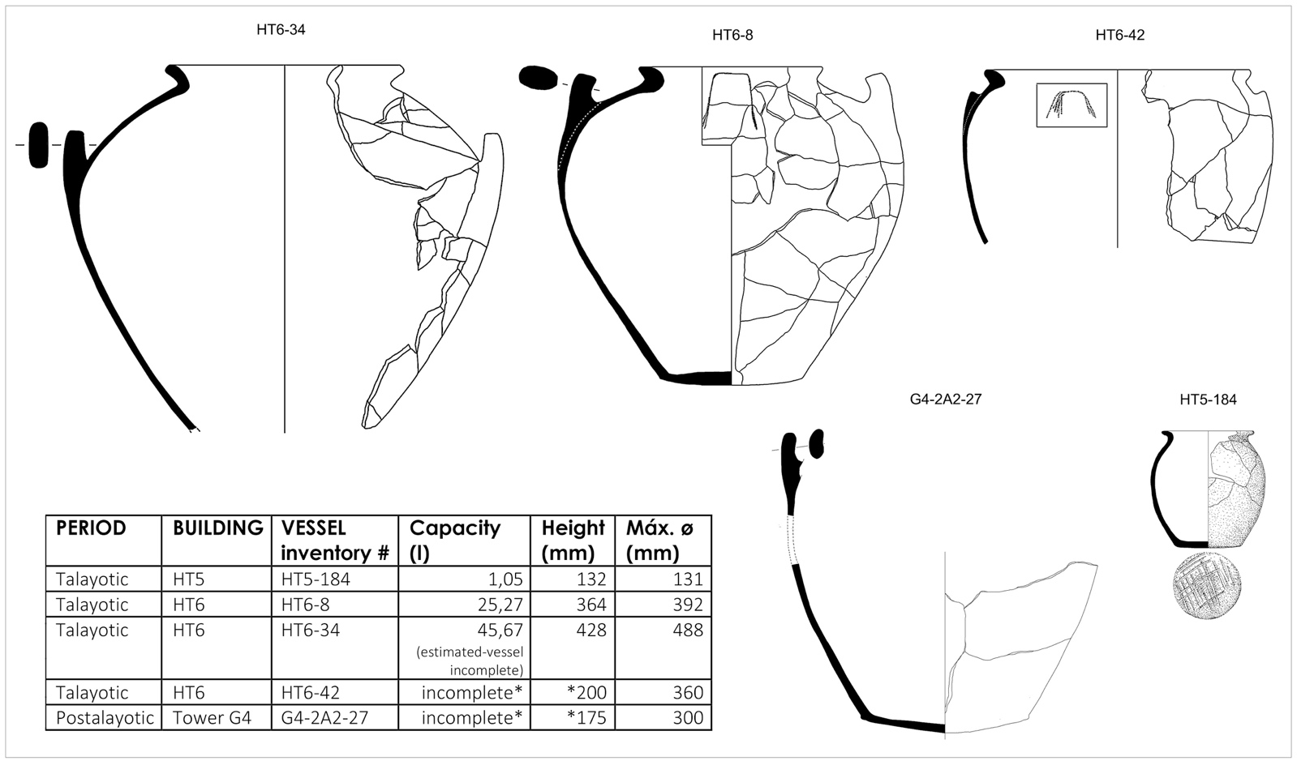
Fig. S4: Reconstruction of ceramic vessels containing in situ storage finds.
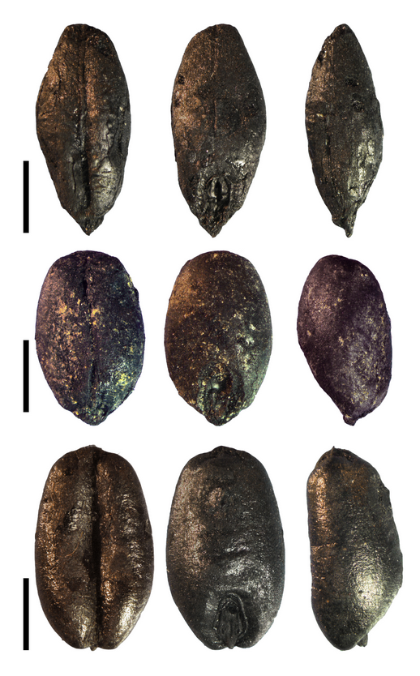
Fig. S5: Photos of the main cereals from Talayotic excavation unit 12 (wooden box), each row one charred grain and each one in three different views.
Top down: Hulled barley (Hordeum vulgare var. vulgare), naked barley (H. v. var. nudum), free-threshing wheat (Triticum aestivum/ durum/ turgidum). Scale 2 mm

Table S4: Son Fornés: Talayotic in situ storage finds of cereals with their accompanying plant remains. Numbers marked with* are extrapolated (x 16)
Campaign |  |  | 2006 | 2006 | 2003 | 2003 | 2003
Period |  |  | T | T | T | T | T
Domestic building |  |  | HT 6 | HT 6 | HT 6 | HT 6 | HT 6
Stratigraphic unit |  |  | IV | IV | VI | II | II
Subunit |  |  | A3 | A3 | B1 interior | B1 interior | A3 (interior)
Zone |  |  | Umbral | Umbral | E1/ Mur B | E2/ Mur B | E2/ Mur B
Excavation context |  |  | 7 | 8 | 12 | 12 | 13
Vol. (l) |  |  | 3 | 2 | 5 | 1 | 16
Vessel |  |  | HT6-42 | HT6-34 | Wooden box | Wooden box | HT6-8
 |  |  |  |  | sub-sample 1 | sub-sample 2
Cereals
Avena sp. | grain | carb. | 6 | 68 | 1 | 32* | 4
Avena sp. | rachis | carb. |  | 3
Avena sp. | awn | carb. |  | 8
Hordeum vulgare | grain | carb. |  |  | 12
Hordeum vulgare var. vulgare | grain | carb. | 71 | 293 | 192 | 365 | 248
Hordeum vulgare var. nudum | grain | carb. |  | 1 | 5 | 1,274 | 2
Triticum cf. dicoccum | grain | carb. |  |  | 25 | 8 | 1
Triticum aestivum/ durum/ turgidum | grain | carb. | 1 |  | 3,213 | 17,034 | 9
Cerealia Indet. | grain | carb. |  | 7 | 193 |  | 8
Other crops
Ficus carica | pip | carb. | 2 |  |  | 16* | 2
Vicia faba | seed | carb. |  |  |  | 3
Wild plants
Fallopia convolvulus | seed | carb. |  |  |  | 32*
Fallopia convolvulus | seed | carb. |  |  | 2
Festuca / Lolium | grain | carb. |  | 1 |  | 16* | 2
Hordeum sp. | grain | carb. |  | 3
Malva sp. | seed | carb. |  | 1
Phalaris sp. | grain | carb. |  | 1
Plantago sp. | seed | carb. |  |  |  | 16*
Poa sp. | seed | carb. | 1
Poaceae | grain | carb. |  |  | 1 | 16* | 1
Poaceae | awnfrag | carb. |  |  |  | 112*
Rumex sp. | seed | carb. |  |  |  |  | 1
Schoenus nigricans | fruit | min. |  |  |  | 16*
Silene sp. | seed | carb. |  |  |  |  | 1
Sum of cereals |  |  | 78 | 380 | 5,441 | 18,713 | 273
Sum of other crops |  |  | 2 |  |  | 19 | 2
Sum of wild plants |  |  |  | 6 | 3 | 208 | 5

Table S5: Carbon isotope discrimination (Δ¹³C) and nitrogen isotope composition (δ¹⁵N) values of charred seed remains from Son Fornès. Results of samples from different periods of occupation are provided along with present-time material (mean ± standard error, SE).

 |  |  |  | Δ¹³C (‰) |  |  | δ¹⁵N (‰)
Period | Species | n |  | Mean | SE |  | Mean | SE
Talayotic | Triticum | 10 |  | 15.19 | 0.26 |  | 7.91 | 0.59
post-Talayotic 1 | " | 4 |  | 15.27 | 0.42 |  | 10.95 | 0.76
post-Talayotic 2 | " | 6 |  | 15.89 | 0.34 |  | 7.79 | 0.93
Classic | " | 17 |  | 15.92 | 0.20 |  | 8.66 | 0.45
Modern | " | 15 |  | 16.15 | 0.22 |  | 1.31 | 0.48
Talayotic | Hordeum | 10 |  | 16.07 | 0.26 |  | 7.68 | 0.59
post-Talayotic 1 | " | 20 |  | 17.44 | 0.19 |  | 9.81 | 0.59
post-Talayotic 2 | " | 10 |  | 16.12 | 0.26 |  | 10.02 | 0.42
Classic | " | 10 |  | 17.40 | 0.26 |  | 8.52 | 0.59
Modern | " | 15 |  | 18.30 | 0.22 |  | 2.56 | 0.48

