Supplementary Information to:
Digestate composition affecting N fertiliser value and C mineralisation
Franziska Häfner ^{1,2}, Jens Hartung³, Kurt Möller^{1,4}

¹ Institute of Crop Science, Department of Fertilization and Soil Matter Dynamics, University of Hohenheim, Fruwirthstraße 20, 70593, Stuttgart, Germany (Corresponding author: Franziska Häfner, email: haefner.franziska@gmail.com)
² Programme Area Next-Generation Horticultural Systems, Leibniz-Institute of Vegetable and Ornamental Sciences (IGZ), Theodor-Echtermeyer-Weg 1, 14979 Großbeeren, Germany
³ Institute of Crop Science, Department of Biostatistics, University of Hohenheim, Fruwirthstraße 23, 70593, Stuttgart, Germany
⁴ Center for Agricultural Technology Augustenberg, Institute of Applied Crop Science, Kutschenweg 20, 76287 Rheinstetten-Forchheim, Germany

Figures S1-S4:

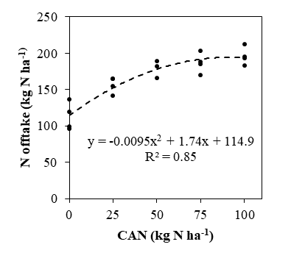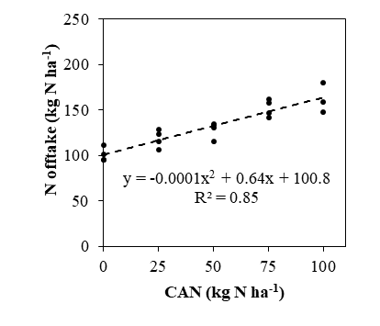
b
a
Supplemental Fig. S1 Nitrogen offtake of spring wheat at 0, 25, 50, 75, and 100 kg N ha⁻¹ calcium ammonium nitrate (CAN) in the 1st (a) and 2nd year (b). Function fitting and equation to the data points (n = 4)
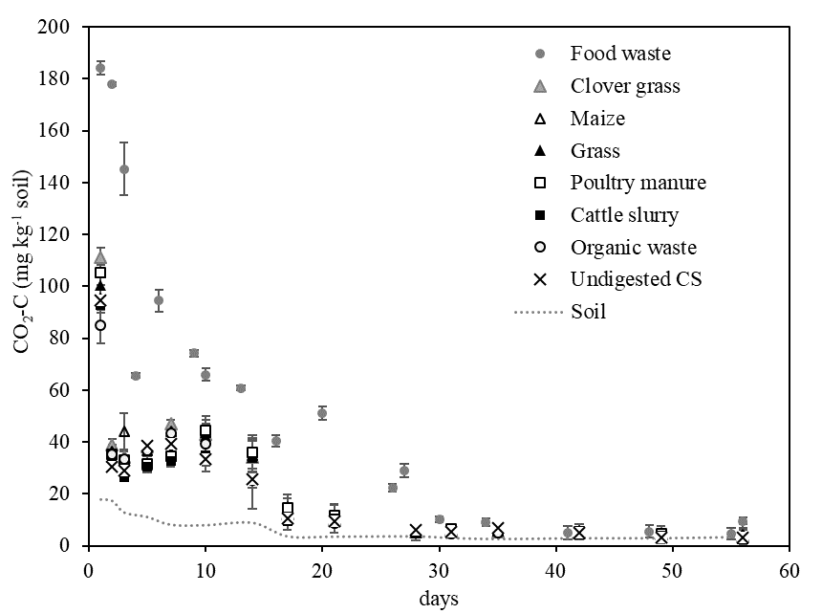
Supplemental Fig. S2 Mean daily CO₂-C emissions of seven digestates, one undigested cattle slurry (CS) and unfertilised soil (n =4). Error bars indicate standard errors of the means. Starting point for measurements, 12 hours after application

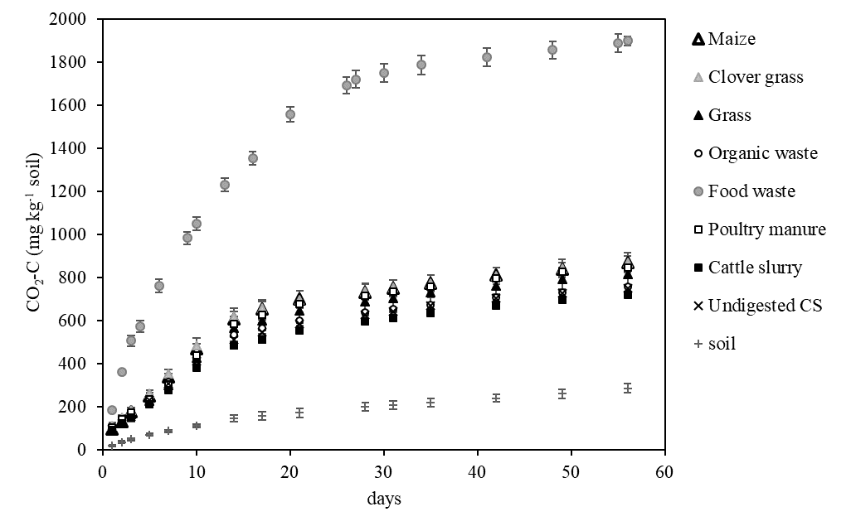 Supplemental Fig. S3 Cumulative soil CO₂-C emissions from seven digestates, one undigested cattle slurry (CS) and unfertilised soil over 56 days of aerobic incubation. Error bars represent the standard error (n = 4); error bars are partially covered by the symbols
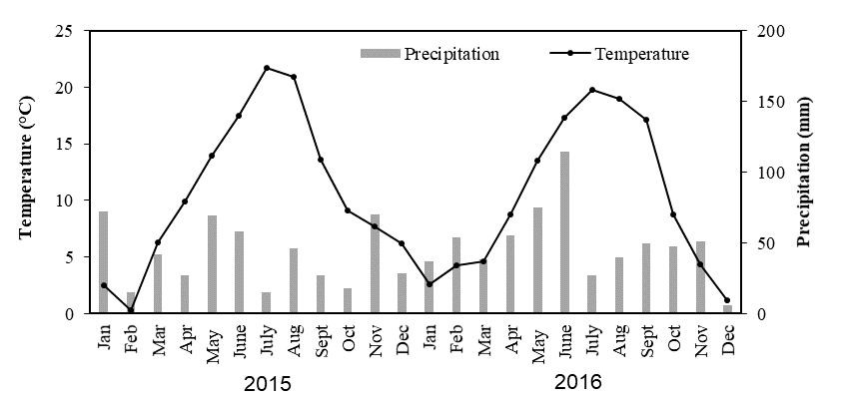
Supplemental Fig. S4 Mean monthly temperature and precipitation data from the experimental field station “Heidfeldhof” 2015 (1st year) and 216 (2nd year)

Tables S1-S4:
Supplemental Table S1 Mean daily CO₂-C emissions of seven digestates, one undigested cattle slurry (CS) and unfertilised soil (control). Means (n = 4) followed by at least one identical letter are not significantly different at α = 0.05, ns = no significant treatment difference
Treatments | Maize | Clover | Grass | Organic waste | Food waste | Poultry manure | Cattle slurry | Undigested  CS | control
 | mg CO₂-C kg⁻¹ soil day⁻¹
Day 1 | 91.7 d | 111 b | 101bd | 87.6 d | 184 a | 105 bc | 92.8 cd | 94.5 cd | 17.9 e
Day 2 | 35.9 bc | 39.0 b | 32.8 bc | 35.7 bc | 178 a | 35.3 bc | 31.4 c | 30.3 c | 17.3 d
Day 3 | 40.9 bc | 34.3 bc | 32.8 bc | 35.0 bc | 145 a | 33.2 bc | 26.3 cd | 28.9 bc | 12.9 d
Day 5 | 36.5 b | 38.2 b | 31.3 c | 37.2 b | 80.0 a | 31.4 c | 30.3 c | 38.5 bd | 11.2 d
Day 7 | 43.6 c | 47.0 b | 36.5 de | 44.4 bc | 87.7 a | 34.6 ef | 32.6 f | 39.3 d | 8.18 g
Day 10 | 41.0 b | 42.9 b | 42.3 b | 42.6 b | 65.9 a | 44.6 b | 34.9 c | 33.6 c | 8.05 c
Day 14 | 33.0 b | 34.0 b | 34.3 b | 25.6 c | 54.0 a | 36.2 b | 25.8 c | 25.8 c | 8.95 d
Day 17 | 14.0 bc | 12.3 bcd | 11.8 ce | 10.7 de | 43.1 a | 14.8 b | 9.44 e | 10.8 de | 3.71 f
Day 21 | 10.5 bc | 10.2 bc | 10.9 bc | 8.86 c | 46.4 a | 11.7 b | 10.5 bc | 9.37 c | 3.64 d
Day 28 | 5.10 bc | 5.30 bc | 6.12 b | 5.47 bc | 22.8 a | 5.72 b | 6.07 b | 6.06 b | 3.70 c
Day 31 | 5.46 b | 5.97 b | 5.98 b | 4.77 b | 9.88 a | 6.35 b | 4.96 b | 5.34 b | 4.63 b
Day 35 | 5.59 b | 5.34 b | 6.09 b | 4.91 bc | 8.51 a | 5.89 b | 5.40 b | 6.88 ab | 2.74 c
Day 42 | 5.52 a | 4.92 a | 4.80 a | 4.57 a | 4.97 a | 5.32 a | 5.18 a | 5.07 a | 3.02 b
Day 49 | 3.78 ns | 4.81 ns | 4.01 ns | 3.90 ns | 4.87 ns | 4.54 ns | 3.88 ns | 3.24 ns | 3.03 ns
Day 56 | 3.76 b | 3.86 b | 3.26 b | 3.86 b | 9.65 a | 2.94 b | 3.25 b | 3.32 b | 3.52 b

Supplemental Table S2 of Growth performance and harvest parameters of spring wheat. Yearly means (n = 40) of all eight organic fertiliser treatments, N0 and N100
 | Grain yield  (Mg ha⁻¹) | N offtake ear emergence  (kg ha⁻¹) | N offtake harvest  (kg ha⁻¹) | Number of ears  m⁻² | Number of grains ear⁻¹ | Number of grains m⁻²  (x 10³) | 1000- grain mass(g) | Grain protein  (%)
Year
1st year | 7.02 | 105 | 157 | 591 | 27.8 | 16.5 | 42.7 | 10.6
2nd year | 4.90 | 128 | 132 | 427 | 23.9 | 10.2 | 44.5 | 12.2

Supplemental Table S3 Mean yearly growth performance and harvest parameters of spring wheat. Differences between incorporation levels with or without, where significant interactions between treatment and incorporation were found (see Table 4). Means with different letters within a row indicate they are significantly different from each other (α = 0.05, Tukey-Test)
 | N offtake  (kg N ha⁻¹) |  | Number of grains ear⁻¹ |  | Number of grains m⁻²  (x 10³) |  | Grain protein  (%)
 | 1st year |  | 2nd year |  | 2nd year |  | 2nd year
 | with | without | with | without | with | without | with | without
Maize | 157 B | 171 A | 28.9 A | 28.3 A | 12.5 A | 10.9 B | 11.6 B | 12.3 A
Clover and Grass | 140 B | 169 A | 24.4 A | 22.9 A | 11.4 A | 10.4 B | 11.4 B | 13.1 A
Grass | 162 A | 161 A | 34.2 A | 25.0 B | 13.3 A | 11.0 B | 11.9 A | 12.5 A
Organic waste | 143 B | 168 A | 36.2 A | 26.8 B | 12.8 A | 10.3 B | 11.2 B | 12.8 A
Food waste | 167 B | 184 A | 25.4 A | 24.8 A | 11.3 A | 11.0 A | 11.6 B | 13.2 A
Poultry manure | 165 A | 177 A | 23.5 A | 25.1 A | 10.6 A | 10.8 A | 11.1 B | 13.4 A
Cattle slurry | 163 A | 145 B | 30.6 A | 27.7 A | 12.2 A | 10.7 B | 11.2 B | 12.2 A
Undigested cattle slurry | 156 A | 149 A | 25.3 A | 25.8 A | 10.7 A | 11.4 A | 11.6 B | 13.4 A

Supplemental Table S4 Spring wheat harvest parameters for the 1st and 2nd year. N100 = calcium ammonium nitrate fertiliser (CAN) and unfertilised soil = control, 7 different digestates and undigested cattle slurry with or without incorporation. Means (n = 4) within one column followed by at least one identical letter are not significantly different at α = 0.05, ns= no significant treatment difference
 | Number of ears  m⁻² |  | 1000-grain mass  (g) |  | Number of grains  ear⁻¹ |  | Grain protein  (%)
year | 1st | 2nd | 1st | 2nd | 1st | 2nd | 1st | 2nd
control | 510 e | 398 ac | 43.0 ab | 44.6 ac | 27.1 ns | 22.0 f | 9.28 c | 11.9 df
N100 (CAN) | 648 bd | 461 a | 42.2 ab | 45.3 a | 28.4 ns | 22.5 ef | 12.1 a | 12.4 cde
With incorporation
Maize | 618 be | 439 ab | 43.2 ab | 44.6 ac | 27.9 ns | 28.9 bcd | 10.1 bc | 11.6 fg
Clover | 537 de | 461 a | 42.6 ab | 44.0 ad | 30.4 ns | 24.4 df | 9.88 bc | 11.4 ab
Grass | 596 be | 396 ac | 43.4 ab | 44.5 ac | 29.1 ns | 34.2 ab | 10.3 b | 11.9 ef
Organic waste | 589 be | 355 c | 42.4 ab | 44.9 ab | 29.2 ns | 36.2 a | 9.89 bc | 11.2 g
Food waste | 707 b | 458 a | 42.4 ab | 43.7 ad | 24.9 ns | 25.4 cf | 10.5 b | 11.6 fg
Poultry manure | 679 ab | 453 a | 43.0 ab | 44.4 ad | 25.9 ns | 23.5 df | 10.2 bc | 11.1 g
Cattle slurry | 618 be | 402 ac | 43.1 ab | 43.5 ad | 28.2 ns | 30.6 ac | 10.2 bc | 11.2 fg
Undigested cattle slurry | 581 be | 421 ac | 43.7 a | 43.0 bcd | 29.1 ns | 25.3 cf | 10.2 b | 11.6 fg
Without incorporation
Maize | 670 abc | 399 ac | 42.1 ab | 43.3 ad | 26.9 ns | 28.3 cde | 10.7 b | 12.3 cde
Clover | 663 abc | 461 a | 42.7 ab | 43.5 ad | 26.7 ns | 22.9 ef | 10.6 b | 13.1 fg
Grass | 542 cde | 445 ab | 42.6 ab | 43.4 ad | 30.4 ns | 25.0 cf | 10.4 b | 12.5 bd
Organic waste | 659 abc | 383 bc | 42.8 ab | 44.1 ad | 26.3 ns | 26.8 cf | 9.66 b | 12.8 abc
Food waste | 685 ab | 446 ab | 43.6 a | 43.3 ad | 26.1 ns | 24.8 df | 12.1 a | 13.2 a
Poultry manure | 607 be | 431 ab | 43.2 ab | 43.6 ad | 30.7 ns | 25.1 cf | 10.8 b | 13.4 a
Cattle slurry | 586 ade | 383 bc | 41.7 b | 42.6 cd | 28.1 ns | 27.7 cde | 10.1 bc | 12.2 cde
Undigested cattle slurry | 589 ade | 453 a | 43.3 ab | 42.2 d | 27.7 ns | 25.8 cf | 10.2 bc | 13.4 a

Supplemental Table S5 Assessment of the NH₃-N losses within 72 hours after application in the 1st and 2nd year based on the ALFAM2 model (Hafner et al. 2019)
 | NH₃-N losses kg ha⁻¹
 | 1st year |  |  | 2nd year
 | with | without |  | with | without
Maize | 7.7 | 0.1 |  | 0.1 | 0.1
Clover and Grass | 8.4 | 0.1 |  | 0.1 | 0.1
Grass | 7.6 | 0.1 |  | 0.1 | 0.1
Organic waste | 4.2 | 0.1 |  | 0.1 | 0.1
Food waste | 7.5 | 0.1 |  | 0.1 | 0.1
Poultry manure | 7.5 | 0.1 |  | 0.1 | 0.1
Cattle slurry | 7.1 | 0.1 |  | 0.1 | 0.1
Undigested Cattle slurry | 5.2 | 0.1 |  | 0.1 | 0.1

