Sustainable growth of organic farming in the EU requires a rethink of nutrient supply – Supplementary material
Marie Reimer^{1,2*,**}, Myles Oelofse^{3**}, Dorette Müller-Stöver³, Kurt Möller^{1,5}, Else K. Bünemann⁴, Silvia Bianchi⁴, Airi Vetemaa⁶, Dóra Drexler⁷, Bence Trugly⁷, Ben Raskin⁸, Hugh Blogg⁸, Anton Rasmussen⁹, Vincenzo Verrastro¹⁰, Jakob Magid³

¹ Institute of Crop Science, Fertilization and Soil Matter Dynamics, University of Hohenheim, Fruwirthstr. 20, 77593 Stuttgart, Germany
²Department of Agroecology, Soil Fertility, Aarhus University, Blichers Allé 20, 8830 Tjele, Denmark
³ Department of Plant and Environmental Sciences, Faculty of Science, University of Copenhagen, Thorvaldsensvej 40, 1871, Frederiksberg, Denmark
⁴ Department of Soil Sciences, Research Institute of Organic Agriculture FiBL, Ackerstrasse 113, Box 219, 5070 Frick, Switzerland
⁵ Center for Agricultural Technology Augustenberg, Institute of Applied Crop Science, Kutschenweg 20, 76287 Rheinstetten-Forchheim, Germany
⁶ Estonian Organic Farming Foundation (EOFF), Kungla 1a, Tartu 50403, Estonia
⁷ Hungarian Research Institute of Organic Agriculture, Miklós tér 1, 1033 Budapest, Hungary
⁸ Soil Association, Spear House, 51 Victoria Street, Bristol, BS1 6AD United Kingdom
⁹ Organic Denmark, Silkeborgvej 260, 8230 Åbyhøj, Denmark
¹⁰ Mediterranean Agronomic Institute of Bari, Valenzano (IAM-B), Italy
* Corresponding author: Marie Reimer, mreimer@agro.au.dk
**shared first authorship
ORCID:
Myles Oelofse: 0000-0001-5497-7747
Marie Reimer: 0000-0002-3998-2756
Dorette Müller-Stöver: 0000-0001-7921-4471
Kurt Möller: 0000-0002-3735-4051
Else K. Bünemann: 0000-0003-4605-6125
Airi Vetemaa: 0000-0002-3785-9076
Dóra Drexle: 0000-0002-8102-8747
Hugh Blogg: 0000-0001-8403-5662
Vincenzo Verrastro: 0000-0001-9715-0918
Jakob Magid: 0000-0001-5867-0910

C: Questionnaire used in the semi-structured interviews.

Questionnaire

Welcome to the Data Collection Tool for the RELACS EU project.

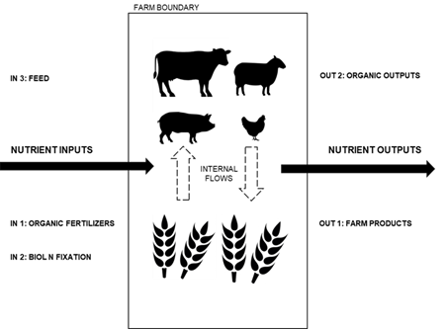
The aim of the project is to understand the use of nutrients on organic farms across Europe.

We are collecting information to understand and assess the nutrient inputs and outputs on your farm. This information will contribute to our understanding of how nutrients are used on organic farms. We will also be able to provide you with an analysis of how balanced your nutrient inputs and outputs are.

Note to enumerator: Please pre-fill all data that may be available prior to interviewing the farmer. The farmer will not have all required data at hand.

A.1 Basic Information
Name of facilitator |  |  | Date
Name of interviewee
Farm address (incl COUNTRY)
Phone No.
E-mail address (if applicable)
Date farm converted to organic farming
Note to enumerator: Data period is for THREE years. We want to collect INPUT and OUTPUT data for harvest years: 2017, 2016 and 2015. For example, any inputs for the 2017 harvest year are noted as 2017. Focus nutrients are NPK. Focus IN and OUT flows depicted in below figure.

A.2 Cropping history (incl legumes and catch crops) and livestock held for the farm.
Please record information for each year

Cropping season | Crop | Total Area for crop (ha) | Livestock (please note type and number for each year
eg.2017 | eg. Winter Wheat | eg. 25 ha | e.g. Cows (50), Pigs (75) etc

A.4 Pleased specify all input types used on your farm and sources over the past three cropping seasons (2015, 2016 and 2017). Note, only inputs sourced from outside the farm boundary. Please provide as much detail as possible about where the input was received from (source) and note if organic or not-organic farm source (if sourced from a farm). The amount refers to the total input for the given year for the WHOLE FARM.
# | Year | Type | Amount (kg) | Source: | Distance (km) | Method of application
x | 2017 | e.g. dairy manure |  | e.g. Purchased from conventional, neighboring dairy farm | 3 km from source to farm | Soil injection
1
2
3
4
5
6
7
8
9
10
11
12
13
14
15
16
17
18
19
20
21
22
23
24
25
26
The next question requires information about outputs, ie what was sold/removed from the farm for each of the past THREE reporting years ie 2015, 2016 and 2017. Please add amounts in the relevant columns. NB: Please record HARVESTED amount.
A.5a Farm Outputs grains and grain legumes |  |  |  |  |  | Please note UNIT (e.g. t/ha or kg/ha):
 | Wheat | Barley | Rye | Oats | Corn | Triticale | Spelt | Other: ______________ |  | Other:___________
2018
2017
2016
A.5.b Farm Outputs root crops, vegetables and others
 | Potatoes | Sugar Beet | Red Beet | Carrots | Other: __________ |  | Other:_________ |  | Other:________ |  | Other:________
2018
2017
2016
A.5.c Farm Outputs animal products and feed (Interviewer: Please not the most appropriate unit here)
 | Dairy | Meat_________ | Eggs (#) | Manure/slurry |  | Silage__________ |  | Other:____________ |  | Other:_______________
2018
2017
2016
Specify “Others” (if not done above) or note anything relevant to the above.

B.1 Why did you choose organic farming? Please score the following potential advantages of farming organically, from 1-5, where 1 is not important, 2 is slightly important, 3 is moderately important, 4 is important and 5 is very important

Higher price for output [ __ ] Reduces input costs [ __ ]
Higher yield [ __ ] Improves soil fertility [ __ ]
Better market [___] Environmental benefits [ __ ]
Health benefits [ __ ] Better Quality [ __ ]
Other, please specify_______________________________________________________________

B. 2 Please score the following possible problems encountered when farming organically, from 1-5, where 1 is not important, 2 is slightly important, 3 is moderately important, 4 is important and 5 is very important

Not enough manure [ __ ] Weed control [ __ ]
Pest control [ __ ] Lack of labour [ __ ]
Low yield [ __ ] Problem with price [ __ ]
Lower quality [ __ ] Disease control [ __ ]
Other, please specify ________________________________________________________________

B. 3 Have there been any unusual problems (drought, lack of market, diseases, pests…) with in the cropping seasons of 2015-2017? (Please state kind of problem and cropping season.)
2015: ____________________________________________________________________________
2016: ____________________________________________________________________________
2017: ____________________________________________________________________________

B. 4 In what ways has you overall farm nutrient management changed since you converted to organic farming in regard to nutrient management? Please describe how ______________________________________________________________________________________________________________________________________________________________________________________________________________________________________________________

B.5 a Do you think that you apply sufficient amount of fertilizer to your crops? Please explain [Note: please get the farmer to elaborate on why they answered as they did] ______________________________________________________________________________________________________________________________________________________________________________________________________________________________________________________

B. 5 b Does your farms rely on external inputs to fulfil the nutritional need?
Yes [ __ ] No [ __ ]

B. 5 c Do you think you can estimate your nutrient farm gate balance is for the following nutrients? (please answer in kg per ha and year)
N: kg ha⁻¹ year⁻¹ K: kg ha⁻¹ year⁻¹
P: kg ha⁻¹ year⁻¹

B. 6 What is the main reason for the use of external inputs?

Fulfilling nutrient needs of:
N [ __ ] P [ __ ]
K [ __ ] S [ __ ]
Humus [ __ ] Others (specify):

B.7. Looking to the future, what do you think the main sources of nutrient inputs to your farm will be? Please explain:
______________________________________________________________________________________________________________________________________________________________________________________________________________________________________________________

B.8. Where do you get advice from about how to manage nutrients on your organic farm? [Note: Please elicit as detailed information from the farmer as possible, including names of advisors (if the farmer is willing to share)]:
______________________________________________________________________________________________________________________________________________________________________________________________________________________________________________________

C.1 View on recycling nutrients from organic waste streams: Please try to answer without regarding the current legislation on the use of recycled fertilizers!

a) In general, would you consider using recycled fertilizer on your farm?
Yes [ __ ] No [ __ ]

C.2 Please fill in the table below about which recycled fertilizer you would consider using and which not. Also, please select a reason behind your decision.

Type of fertilizer | Municipal waste |  |  | Champost | Sewage sludge | Sewage sludge products  (struvite, ashes…) | Bone/meat meal and similar others
Type of fertilizer | Compost |  | Digestables (Biogas)
Type of fertilizer | household sourced | garden and park waste
Would use? | Yes [ _ ]  No [ _ ] | Yes [ _ ]  No [ _ ] | Yes [ _ ]  No [ _ ] | Yes [ _ ]  No [ _ ] | Yes [ _ ]  No [ _ ] | Yes [ _ ]  No [ _ ] | Yes [ _ ]  No [ _ ]
Reason:
Please note that main rationale for yes/no response

General, please acquire any input and output documentation available (take a photo)

Supplementary Tables
Supplementary Table 1. Standard values and assumptions used to quantify Nitrogen inputs from biological nitrogen fixation.
Crop | N value (kg ha⁻¹)/Method used | Source
Common bean (Phaseolus vulgaris) | 50 | (Giller 2001)
Fenugreek (Trigonella foenum-graecum) | 90 | (Büchi et al. 2015)
Hop Clover (Trifolium campestre L.) | 50 | (Büchi et al. 2015)
Sweet Clover (Melilotus spp.) | 52 | (Büchi et al. 2015)
Faba Bean (Vicia faba) | 165 | (Anglade et al. 2015)
Field Pea (Pisum sativum) | 111 | (Anglade et al. 2015)
Lentil (Lens culinaris) | 52 | (Anglade et al. 2015)
Lucerne (Medicago Sativa L.) | 350 | (Moghaddam et al. 2015)
Lupine (Lupinus albus L.) | 189 | (Sulas et al. 2016)
Vetch (Vicia sativa) | 110 | (Büchi et al. 2015)
Red and white clover (Trifolium pratense and Trifolium repens) | When yield recorded: Nitrogen derived fixed from the atmosphere (N_{dfa}) = N content of aboveground biomass*0,58  When yield was not recorded: Red and white clover are treated the same. A pure stand estimate of 150 kg N ha⁻¹ was used, corrected using the percentage of clover in the grass/clover mix. Intercropped, a value of 50 kg N ha⁻¹ was used, and the area was corrected to 50% based on an assumption that there is a 50/50 split the in area between grain and legume. | (Giller 2001; Moawad, Badr El-Din, and Abdel-Aziz 1998; de Resende et al. 2003);
Soybean (Glycine max) | Nitrogen derived fixed from the atmosphere (N_{dfa}) = N content of aboveground biomass*0,52 | (Salvagiotti et al. 2009)

Supplementary Table 2: Change in nitrogen (N) balance due to +/- 10% and 30% biological nitrogen fixation (BNF) inputs to account for uncertainties in the calculation of BNF. Given is the mean and the standard deviation.
 |  | N budget |  |  |  |  | BNF
 |  | -30% | -10% | ±0% | 10% | 30% | -30% | -10% | ±0% | 10% | 30%
All |  | 14.8 ± 37.2 | 22.8 ± 39.9 | 26.8 ± 41.5 | 30.8 ± 43.2 | 38.8 ± 46.9 | 28.1 ± 19.4 | 36.1 ± 24.9 | 40.1 ± 27.7 | 44.1 ± 30.4 | 52.1 ± 35.9
Study regions | DK | 27.7 ± 36.7 | 33.5 ± 39.3 | 36.4 ± 40.6 | 39.2 ± 42 | 45 ± 44.7 | 20.1 ± 11.3 | 25.9 ± 14.6 | 28.7 ± 16.2 | 31.6 ± 17.8 | 37.4 ± 21
Study regions | EST | 12.6 ± 10 | 20.6 ± 12 | 24.6 ± 13.2 | 28.6 ± 14.4 | 36.7 ± 17 | 28.1 ± 10.4 | 36.2 ± 13.4 | 40.2 ± 14.9 | 44.2 ± 16.4 | 52.2 ± 19.4
Study regions | GER N | 19.4 ± 41.2 | 26.9 ± 44 | 30.7 ± 45.5 | 34.4 ± 47.1 | 42 ± 50.5 | 26.3 ± 16.8 | 33.8 ± 21.6 | 37.6 ± 24 | 41.3 ± 26.4 | 48.8 ± 31.2
Study regions | GER S | -3.7 ± 19.9 | 3.4 ± 19.9 | 6.9 ± 20.1 | 10.4 ± 20.4 | 17.5 ± 21.1 | 24.7 ± 9.4 | 31.8 ± 12.1 | 35.3 ± 13.5 | 38.9 ± 14.8 | 46 ± 17.5
Study regions | HUN | 3.2 ± 45.2 | 11.8 ± 50 | 16.2 ± 52.9 | 20.5 ± 55.9 | 29.1 ± 62.5 | 30.2 ± 31 | 38.9 ± 39.8 | 43.2 ± 44.2 | 47.5 ± 48.7 | 56.2 ± 57.5
Study regions | ITA | 13 ± 55.3 | 15.1 ± 53 | 16.1 ± 51.9 | 17.1 ± 50.8 | 19.2 ± 48.8 | 7.2 ± 11 | 9.2 ± 14.1 | 10.3 ± 15.6 | 11.3 ± 17.2 | 13.4 ± 20.3
Study regions | SUI | 39.3 ± 22.2 | 51.5 ± 24.2 | 57.6 ± 25.4 | 63.7 ± 26.7 | 75.9 ± 29.7 | 42.7 ± 15.5 | 54.9 ± 19.9 | 61 ± 22.1 | 67.1 ± 24.3 | 79.3 ± 28.8
Study regions | UK | 8.6 ± 55.1 | 18.1 ± 61 | 22.9 ± 64.1 | 27.6 ± 67.2 | 37.1 ± 73.5 | 33.3 ± 25.5 | 42.9 ± 32.8 | 47.6 ± 36.5 | 52.4 ± 40.1 | 61.9 ± 47.4
Farm type | high stocked (>1.0) | 19.9 ± 53.5 | 31.9 ± 57.6 | 37.9 ± 59.8 | 43.9 ± 62.1 | 56 ± 67 | 42 ± 23.2 | 54 ± 29.8 | 60 ± 33.1 | 66.1 ± 36.4 | 78.1 ± 43
Farm type | low stocked (0.1<x<1.0) | 16.3 ± 29.3 | 23.5 ± 31.7 | 27.1 ± 32.9 | 30.7 ± 34.2 | 37.8 ± 37 | 25 ± 13 | 32.2 ± 16.7 | 35.8 ± 18.6 | 39.3 ± 20.4 | 46.5 ± 24.1
Farm type | stockless (<0.1) | 12.3 ± 35.8 | 19.5 ± 38.1 | 23.1 ± 39.4 | 26.7 ± 40.9 | 34 ± 44.3 | 25.3 ± 19.5 | 32.6 ± 25.1 | 36.2 ± 27.9 | 39.8 ± 30.7 | 47 ± 36.3

Supplementary Table 3: Biological nitrogen fixation (BNF) in kg N ha⁻¹ depending on the area where legumes are grown, either in mixtures or solely. Given for each farm is the study region, total farm area, area with legumes (in total and aggregated over 4 categories, the percentage of the area cropped with legumes, Nutrient input by BNF for the whole farm, and the BNF per area cropped with legumes. (DK=Denmark, EST=Estonia, HU=Hungary, UK=United Kingdom, ITA=Italy, SUI=Switzerland, GER N=Northern Germany, GER S=Southern Germany
Country | Farm | Total area | Legume area | Percentage of legumes | Fodder legumes or legume-grass mix | Grain legumes | Legume-cereal mix | Pasture | BNF | BNF per ha legumes
 |  | ha | ha | % | ha | ha | ha | ha | kg N | kg N ha⁻¹
DK | 1 | 48 | 11 | 23 | 0 | 10 | 0 | 1 | 2306 | 209
DK | 2 | 24 | 4 | 16 | 4 | 0 | 0 | 0 | 923 | 246
DK | 3 | 303 | 25 | 8 | 4 | 19 | 0 | 2 | 42 | 2
DK | 4 | 14 | 4 | 27 | 3 | 0 | 0 | 0 | 242 | 64
DK | 5 | 25 | 16 | 63 | 1 | 0 | 0 | 15 | 1000 | 63
DK | 6 | 322 | 103 | 32 | 12 | 26 | 25 | 40 | 7633 | 74
DK | 7 | 86 | 30 | 35 | 1 | 0 | 17 | 11 | 2956 | 99
EST | 1 | 401 | 352 | 88 | 228 | 0 | 98 | 26 | 19560 | 56
EST | 2 | 444 | 267 | 60 | 112 | 21 | 76 | 58 | 18943 | 71
EST | 3 | 338 | 119 | 35 | 0 | 12 | 83 | 24 | 8939 | 75
EST | 4 | 589 | 321 | 55 | 154 | 53 | 20 | 95 | 20555 | 64
EST | 5 | 164 | 75 | 46 | 41 | 0 | 20 | 15 | 7048 | 93
EST | 6 | 515 | 278 | 54 | 29 | 90 | 159 | 0 | 26948 | 97
EST | 7 | 392 | 375 | 96 | 92 | 1 | 65 | 217 | 14777 | 39
EST | 8 | 410 | 271 | 66 | 40 | 0 | 20 | 211 | 5300 | 20
EST | 9 | 293 | 250 | 85 | 25 | 18 | 32 | 176 | 7048 | 28
EST | 10 | 269 | 229 | 85 | 67 | 41 | 52 | 70 | 16469 | 72
EST | 11 | 615 | 393 | 64 | 14 | 138 | 175 | 66 | 35515 | 90
GER N | 1 | 323 | 113 | 35 | 36 | 11 | 0 | 65 | 3970 | 35
GER N | 2 | 200 | 57 | 28 | 6 | 0 | 24 | 27 | 12402 | 219
GER N | 3 | 43 | 19 | 43 | 7 | 6 | 0 | 6 | 2046 | 109
GER N | 4 | 51 | 14 | 28 | 0 | 14 | 0 | 0 | 1670 | 119
GER N | 5 | 176 | 36 | 21 | 19 | 5 | 11 | 1 | 9717 | 269
GER N | 6 | 378 | 84 | 22 | 39 | 18 | 15 | 13 | 10041 | 119
GER N | 7 | 36 | 5 | 13 | 2 | 1 | 0 | 1 | 317 | 69
GER N | 8 | 56 | 20 | 36 | 11 | 6 | 0 | 3 | 1155 | 57
GER N | 9 | 423 | 157 | 37 | 88 | 20 | 16 | 32 | 11006 | 70
GER N | 10 | 39 | 22 | 55 | 12 | 3 | 0 | 6 | 3310 | 154
GER S | 1 | 87 | 47 | 54 | 2 | 0 | 0 | 45 | 3474 | 73
GER S | 2 | 30 | 17 | 58 | 4 | 5 | 0 | 8 | 942 | 54
GER S | 3 | 48 | 20 | 41 | 10 | 5 | 0 | 4 | 2486 | 127
GER S | 4 | 55 | 25 | 45 | 7 | 8 | 0 | 10 | 2222 | 89
GER S | 5 | 15 | 8 | 56 | 2 | 0 | 2 | 5 | 398 | 49
GER S | 6 | 125 | 62 | 50 | 13 | 3 | 5 | 41 | 5482 | 88
GER S | 7 | 105 | 44 | 42 | 20 | 24 | 0 | 0 | 2707 | 62
GER S | 8 | 69 | 31 | 45 | 13 | 11 | 0 | 7 | 523 | 17
GER S | 9 | 96 | 60 | 63 | 7 | 11 | 1 | 40 | 3116 | 52
GER S | 10 | 116 | 44 | 38 | 14 | 21 | 0 | 9 | 6110 | 138
HUN | 1 | 7 | 4 | 51 | 1 | 2 | 0 | 0 | 831 | 224
HUN | 2 | 99 | 34 | 34 | 33 | 0 | 0 | 1 | 11681 | 346
HUN | 3 | 212 | 61 | 29 | 49 | 12 | 0 | 0 | 12439 | 204
HUN | 4 | 217 | 19 | 9 | 7 | 11 | 0 | 0 | 2301 | 124
HUN | 5 | 38 | 0 | 0 | 0 | 0 | 0 | 0 | 0
HUN | 6 | 208 | 82 | 39 | 11 | 2 | 43 | 26 | 5972 | 73
HUN | 7 | 12 | 0 | 0 | 0 | 0 | 0 | 0 | 0
HUN | 8 | 79 | 34 | 43 | 34 | 0 | 0 | 0 | 4895 | 143
HUN | 9 | 23 | 1 | 5 | 0 | 0 | 1 | 0 | 249 | 226
HUN | 10 | 55 | 8 | 14 | 4 | 2 | 2 | 0 | 1551 | 196
ITA | 8 | 30 | 0 | 0 | 0 | 0 | 0 | 0 | 0
ITA | 9 | 41 | 0 | 0 | 0 | 0 | 0 | 0 | 0
ITA | 12 | 28 | 4 | 16 | 0 | 0 | 0 | 0 | 0
ITA | 13 | 7 | 0 | 0 | 0 | 0 | 0 | 0 | 106 | *
ITA | 15 | 29 | 12 | 40 | 0 | 9 | 0 | 2 | 1026 | 89
SUI | 1 | 44 | 35 | 79 | 0 | 1 | 0 | 34 | 3429 | 98
SUI | 2 | 20 | 9 | 46 | 0 | 5 | 0 | 5 | 1656 | 176
SUI | 4 | 25 | 13 | 51 | 0 | 1 | 0 | 11 | 1455 | 114
SUI | 5 | 24 | 15 | 61 | 0 | 0 | 0 | 14 | 1088 | 75
SUI | 6 | 31 | 16 | 52 | 5 | 9 | 0 | 3 | 3318 | 205
SUI | 7 | 13 | 5 | 38 | 0 | 1 | 0 | 4 | 578 | 114
SUI | 8 | 41 | 28 | 69 | 0 | 0 | 0 | 28 | 1362 | 49
SUI | 9 | 21 | 20 | 92 | 0 | 0 | 0 | 20 | 1298 | 65
SUI | 10 | 48 | 39 | 81 | 0 | 0 | 0 | 39 | 2193 | 56
SUI | 11 | 8 | 7 | 86 | 0 | 0 | 0 | 7 | 470 | 68
UK | 1 | 21 | 21 | 100 | 21 | 0 | 0 | 0 | 2352 | 112
UK | 2 | 378 | 241 | 64 | 222 | 19 | 0 | 0 | 20964 | 87
UK | 3 | 1163 | 240 | 21 | 240 | 0 | 0 | 0 | 21020 | 88
UK | 4 | 160 | 5 | 3 | 0 | 5 | 0 | 0 | 720 | 135
UK | 5 | 73 | 54 | 74 | 54 | 0 | 0 | 0 | 6397 | 118
UK | 6 | 53 | 30 | 56 | 0 | 1 | 0 | 29 | 2139 | 72
UK | 7 | 168 | 130 | 77 | 0 | 22 | 0 | 107 | 6961 | 54
UK | 8 | 106 | 59 | 56 | 0 | 14 | 0 | 45 | 2298 | 39
*BNF from undersown green manures in orchards

Supplementary Table 4: Type and source of external inputs utilized on organic farms for each farm in each study region. (DK=Denmark, EST=Estonia, HU=Hungary, UK=United Kingdom, ITA=Italy, SUI=Switzerland, GER N=Northern Germany, GER S=Southern Germany)
Region_Farm | Type | Source | Distance (km)
EST_1 | Mineral animal feed supplements | Purchased | n.d.
EST_1 | Rape seed cake feed | Purchased | n.d.
EST_2 | Processed chicken manure Limestone | Purchased, Est supplier | >100km
EST_2 | Sea salt | Purchased, Est supplier
EST_2 | Cattle manure | Purchased, Est supplier
EST_2 | Patent kali | Conv. Dairy neighbour | 3 km
EST_2 | Magnesia kaolinit | Purchased, Est supplier
EST_3 | Wood ash
EST_3 | Patent Kali (potash) | Purchased, Est supplier
EST_3 | Magnesium kainite (potash salt) | Purchased, Est supplier
EST_3 | Biostimulants | Purchased, Est supplier
EST_4 | Processed chicken manure | Purchased, Holland
EST_4 | Vinasse | Purchase, Est supploer
EST_4 | Wood ash
EST_5 | No external inputs
EST_6 | No external inputs
EST_7 | Rape seed cake | Purchased, Est supplier
EST_8 | No external inputs
EST_9 | Mineral animal feed supplements | Purchased, Est supplier
EST_10 | No external inputs
EST_11 | No external inputs
HUN_1 | Processed cattle manure | Purchased | 400 km
HUN_2 | Cattle manure | Purchased: Neighbour | 5km
HUN_3 | Beef cattle manure | Purchased: Neighbour cattle farm | 15 km
HUN_3 | Granulated chicken manure | Purchased: Italian producer | 1000 km
HUN_3 | Vinasse | Purchased: Yeast industry | 30 km
HUN_4 | Bacterial fertilizer (phylazonit) | Purchased | 200 km
HUN_4 | Bacterial fertilizer (EM) | Purchased | 15 km
HUN_4 | Foliar micronutrient (various) | Purchased | 350 km
HUN_4 | Granulated chicken manure | Purchased: Input producer | 220 km
HUN_5 | Granulated chicken manure | Purchased | 70 km
HUN_6 | Cattle slurry | Purchased: organic neighbour | 1-6km
HUN_6 | Cattle manure | Purchased: organic neighbour
HUN_7 | Granulated algal fertilizer with lime | Purchased | 150 km
HUN_7 | Bacterial fertilizer | Purchased | 170 km
HUN_7 | Foliar fertilizer | Purchased
HUN_8 | Granulated cattle manure | Purchased | 100 km
HUN_8 | Compost | Purchased | 100 km
HUN_9 | Bacterial fertilizer | Purchased | 250 km
HUN_9 | Foliar fertilizer | Purchased | 100 km
HUN_9 | Biofertilizer (EM) | Purchased | 150 km
HUN_10 | Cattle manure | Purchased: neighbour farm | 3 km
DK_1 | Cattle deep bedding | Organic dairy farm | 13 km
DK_1 | Dairy slurry | Organic dairy farm | 13 km
DK_1 | Park and garden waste | Municipality | 22 km
DK_2 | Pig slurry | Conventional pig farm | 3 km
DK_2 | Binadan (comm. org fert) | Commercial product (ORG) | -
DK_2 | Chicken manure | Organic farm | 68 km
DK_2 | ØGro (comm org fert) | Commercial product (ORG) | -
DK_2 | Deep litter cattle | Conventional dairy farm | 6km
DK_3 | Pig slurry | Conventional farm | 4 km
DK_3 | Biogas digestate slurry | Biogas plant | 6 km
DK_3 | Cattle slurry | Conventional farm | 20 km
DK_4 | Horse manure | Horse farm | 4 km
DK_4 | Deep litter cattle | Organic dairy farm | 4 km
DK_5 | Pig feed | Purchased: organic
DK_6 | Pig slurry | Conventional farm | 12 km+50 km
DK_6 | Mink slurry | Conventional farm | 12 km
DK_6 | Chicken manure | Conventional farm | 50 km
DK_6 | Deep bedding | Organic farm | 15 km 60 km
DK_6 | Biogrow meat/bone pellets | Purchased (Organic product)
DK_6 | Cattle slurry | Sourced organic and conventional | 15 km- 60 km
DK_7 | Pig feed (2015 only) | Organic source
UK_1 | Poultry feed | Purchased: Mill
UK_1 | Straw | Conventional farm | 6 km
UK_2 | No external inputs | - | -
UK_3 | Straw | Purchased: cereal farm | 25 km
UK_3 | Vegetable inputs: range of NPK, granular certified organic fertilizers. | Purchased: www.lawfertilisers.co.uk
UK_4 | Mushroom compost | Exchanged for straw | 15 km
UK_4 | Horse manure | Nearby racing stables | 2 km
UK_5 | No external NPK inputs | - | -
UK_6 | No external NPK inputs | - | -
UK_7 | Compost from MSW | Produced by business | 12 km
UK_7 | Limex (lime product with P) | British Sugar | 160 km
UK_8 | No external inputs
GER N_1 | Plant based biogas digestate | Conventional neighbour exchanged for silage | 8 km
GER N_1 | Potato fruit water concentrate | Purchased: recycling company | 300 km
GER N_1 | Chicken manure | Organic cooperation partner | 250 km
GER N_1 | Compost (park cuttings) | Purchased: Land fill site | 10 km
GER N_1 | Carbolime | Purchased: sugar company | 5 km
GER N_1 | Cattle manure | Conventional neighbour exchanged for silage | 8 km
GER N_1 | Kieserite, granulated | Purchased
GER N_1 | Compost HH waste | Purchased: land fill site | 10 km
GER N_2 | Liquid digestate | Purchased: affiliated biogas plant | 0 km
GER N_2 | Poultry fodder | Purchased
GER N_3 | Champost (spent substrate) | Purchased: substrate companies (some organic) | 100-250 km
GER N_3 | Liquid digestate | Purchased: organic neighbour | 15 km
GER N_3 | Hair meal | Purchased
GER N_3 | Chicken manure | Cooperation: organic partner | 250 km
GER N_3 | Kieserite, granulated | Purchased
GER N_3 | Carbolime | Purchased
GER N_4 | Hair meal | Purchased
GER N_4 | Potato fruit water concentrate | Purchased: recycling company | 260 km
GER N_4 | Potato slop | Purchased: recycling company | 150 km
GER N_4 | Chicken manure | Purchased: organic farm | 220 km
GER N_4 | Kieserite, granulated | Purchased:
GER N_4 | Poultry fodder | Purchased:
GER N_4 | Carbolime | Purchased:
GER N_5 | Chicken manure | Purchased: organic farm | 15 km
GER N_5 | Digestates (liquid) | Cooperation: organic farm | 15 km
GER N_5 | Hair meal | Purchased
GER N_5 | Horse manure | Purchased: organic farm | 15 km
GER N_5 | Cattle manure | Cooperation: organic dairy | 15 km
GER N_5 | Compost (park cuttings) | Purchased: landfill | 10 km
GER N_5 | CarboLime | Purchased: sugar company | 75 km
GER N_5 | Potassium (patent rock) | Purchased
GER N_5 | Champost (spent substrate) | Purchased: substrate company
GER N_6 | Carbolime | Purchased
GER N_6 | Compost (park cuttings) | Purchased: landfill | 10-20 km
GER N_6 | Hair meal | Purchased
GER N_6 | Chicken manure | Purchased: organic farm | 150-200 km
GER N_6 | Potassium (patent rock) | Purchased
GER N_6 | Cattle manure | Purchased: neighbouring farm | 8 km
GER N_6 | Champost (spent substrate) | Purchased: substrate company | 100-200 km
GER N_6 | Carbonated lime | Purchased
GER N_7 | Compost (park cuttings) | Purchased: landfill | 10-20 km
GER N_7 | Poultry fodder | Purchased: organic
GER N_8 | No external inputs
GER N_9 | Digestates (liquid) | Purchased: biogas plant-based facility | 22 km
GER N_9 | Champost (spent substrate) | Purchased substrate company | 150-200 km
GER N_9 | Kieserite, granulated | Purchased
GER N_9 | Carbonated lime | Purchased
GER N_9 | Potato fruit water concentrate | Purchased: recycling company | 250 km
GER N_9 | Hair meal | Purchased
GER N_10 | Carbonated lime | Purchased
GER N_10 | Silage (clover grass organic) | Purchased: organic farm | 15 km
GER N_10 | Mineral fodder cows | Purchased
GER S_1 | No external inputs
GER S_2 | No external inputs
GER S_3 | Cattle manure | Purchased: neighbor conventional farm
GER S_3 | Compost (park cuttings) | Purchased
GER S_3 | Elemental sulphur elemental | Purchased
GER S_4 | Horse manure (25% straw) | Purchased: neighbor conventional farm | 9 km
GER S_4 | Compost (park cuttings) | Purchased: compost company | 10 km
GER S_4 | Elemental sulphur 90% | Purchased
GER S_4 | Stone meal | Purchased
GER S_5 | Kieserite, granulated | Purchased
GER S_5 | Poultry fodder | Purchased (organic)
GER S_6 | Compost (park cuttings) | Purchased: compost company
GER S_6 | Straw | Purchased: organic
GER S_6 | Poultry fodder | Purchased: organic
GER S_7 | Compost (park cuttings) | Purchased: compost company | 10 km
GER S_7 | Chicken manure | Purchased: organic farm | 300 km
GER S_7 | Sheep manure | Purchased: organic farm | 10 km
GER S_7 | Carbonated lime | Purchased
GER S_7 | Kieserite, granulated | Purchased
GER S_8 | Horse manure | Purchased: neighbor farms (2) | 1 km
GER S_8 | Cattle manure | Purchased: neighbor farms (3) (1 org, 2 conv) | 3 km
GER S_8 | Metaflor | Purchased
GER S_8 | Lime from algae | Purchased
GER S_8 | Kieserite, granulated | Purchased
GER S_8 | Digestates (liquid) | Purchased: organic farm | 10 km
GER S_9 | No external inputs
GER S_10 | Cattle manure | Purchased: conv. Neighbour
GER S_10 | horse manure | Purchased: conv. Neighbour
GER S_10 | Champost (spent substrate) | Cooperation: mushroom farm | 20 km
GER S_10 | Compost (park cuttings) | Purchased: compost company | 10-20 km
ITA_1 | Commercial fertilizer | purchased
ITA_1 | potassium sulfate | purchased
ITA_1 | manure pellets | purchased
ITA_1 | biostimulants | purchased
ITA_1 | potassium bicarbonate | purchased
ITA_1 | blood derived fertilizer | purchased
ITA_2 | Commercial fertilizer | purchased
ITA_3 | Commercial fertilizer | purchased
ITA_3 | manure pellets | purchased
ITA_3 | animal manure | purchased: conventional
ITA_4 | commercial fertilizers | purchased
ITA_5 | blood derived fertilizer | purchased
SUI_1 | Animal slurry | purchased:
SUI_1 | Digestates | purchased:
SUI_1 | Commercial fertilizers | purchased
SUI_1 | Hey | purchased: organic
SUI_1 | Grass silage | purchased: organic
SUI_1 | Silage maize | purchased: organic
SUI_1 | Dehydrated alfaalfa | purchased: organic
SUI_2 | Cattle slurry | purchased:
SUI_2 | Digestates | purchased: recycling plant
SUI_2 | Compost | purchased: recycling plant
SUI_3 | Pig slurry | purchased: conventional farm
SUI_3 | Poutry manure | purchased: organic farm
SUI_3 | Cattle slurry | purchased: organic farm
SUI_3 | Commercial fertilizers | purchased:
SUI_3 | Hey | purchased: organic
SUI_3 | Mineral cattle fodder | purchased: organic
SUI_3 | Puoltry fodder | purchased: organic
SUI_4 | Compost | purchased: recycling plant
SUI_4 | Commercial fertilizers | purchased:
SUI_4 | Silage maize | purchased: organic
SUI_4 | Poultry fodder | purchased: organic
SUI_4 | Mineral cattle fodder | purchased:
SUI_4 | Fodder cereals for cattle | purchased: organic
SUI_5 | Cattle manure | purchased:
SUI_5 | Digestates from waste materials | purchased: recycling plant
SUI_5 | Compost | purchased: recycling plant
SUI_5 | Commercial fertilizers | purchased:
SUI_6 | Compost | purchased: recycling plant
SUI_6 | Digestates | purchased: neighboring farm
SUI_6 | patent kali | purchased:
SUI_6 | Commercial fertilizers | purchased:
SUI_6 | Liquid digestates | purchased: recycling plant
SUI_7 | Compost | purchased: recycling plant
SUI_7 | Poultry fodder | purchased: organic
SUI_7 | Cattle fodder | purchased: organic
SUI_7 | Pid fodder | purchased: organic
SUI_7 | Mineral fodder | purchased:
SUI_7 | Left over bread (50kg per week)
SUI_8 | Poultry fodder | purchased: organic
SUI_9 | Commercial fertilizers | purchased:
SUI_9 | Mineral fodder | purchased: organic
SUI_9 | Silage maize | purchased: organic
SUI_9 | Cereals as fodder | purchased: organic
SUI_10 | Poultry fodder | purchased: organic
SUI_10 | Straw | purchased:
SUI_10 | Mineral fodder | purchased: organic
SUI_10 | Cereals as fodder | purchased: organic

Supplementary Table 5. Scores table for the PCA of the farm data including nutrient budgets, nutrient inputs and outputs, percentage of nutrients derived from nutrient sources for N, P, and K, livestock density, reliance on BNF, years under organic management, percentage of area under certain crop species groups, and cultivated area. Shown are PC 1 to 6 and the 10 most influencing variables and their loading scores sorted by absolute value.
PC | Measurements | Loading score | PC | Measurements | Loading score
1 | N output | -0.37 | 4 | N output | -0.37
1 | K output | -0.37 | 4 | K output | -0.37
1 | P input | -0.36 | 4 | P input | -0.36
1 | P output | -0.35 | 4 | K input | -0.34
1 | K input | -0.34 | 4 | % BNF | 0.33
1 | % BNF | 0.33 | 4 | Cultivated area (ha) | 0.17
1 | N input | -0.33 | 4 | Inputs from organic manure | -0.17
1 | Cultivated area (ha) | 0.17 | 4 | Stocking Density (LU/ha) | 0.05
1 | Inputs from organic manure | -0.17 | 4 | Inputs from mineral sources | -0.01
1 | Fodder legumes or legume-grass mix | 0.16 | 4 | Years of organic management | -0.01
2 | N input | -0.33 | 5 | % BNF | 0.33
2 | Cultivated area (ha) | 0.17 | 5 | N input | -0.33
2 | Inputs from recycled sources | -0.12 | 5 | Fodder legumes or legume-grass mix | 0.16
2 | Grain legumes | -0.08 | 5 | Orchards | -0.11
2 | Inputs from conventional manure | -0.08 | 5 | Grain legumes | -0.08
2 | Stocking Density (LU/ha) | 0.05 | 5 | Inputs from conventional manure | -0.08
2 | Pasture | 0.05 | 5 | Pasture | 0.05
2 | Inputs from feed | 0.04 | 5 | Inputs from mineral sources | -0.01
2 | cereals | -0.01 | 5 | cereals | -0.01
2 | Years of organic management | -0.01 | 5 | Years of organic management | -0.01
3 | N output | -0.37 | 6 | Cultivated area (ha) | 0.17
3 | P output | -0.35 | 6 | Inputs from organic manure | -0.17
3 | % BNF | 0.33 | 6 | Fodder legumes or legume-grass mix | 0.16
3 | Inputs from organic manure | -0.17 | 6 | Inputs from recycled sources | -0.12
3 | Orchards | -0.11 | 6 | Grain legumes | -0.08
3 | Grain legumes | -0.08 | 6 | Inputs from conventional manure | -0.08
3 | Grapes | -0.04 | 6 | Stocking Density (LU/ha) | 0.05
3 | Inputs from mineral sources | -0.01 | 6 | Pasture | 0.05
3 | cereals | -0.01 | 6 | Inputs from mineral sources | -0.01
3 | Years of organic management | -0.01 | 6 | Cereals | -0.01

Supplementary Figures
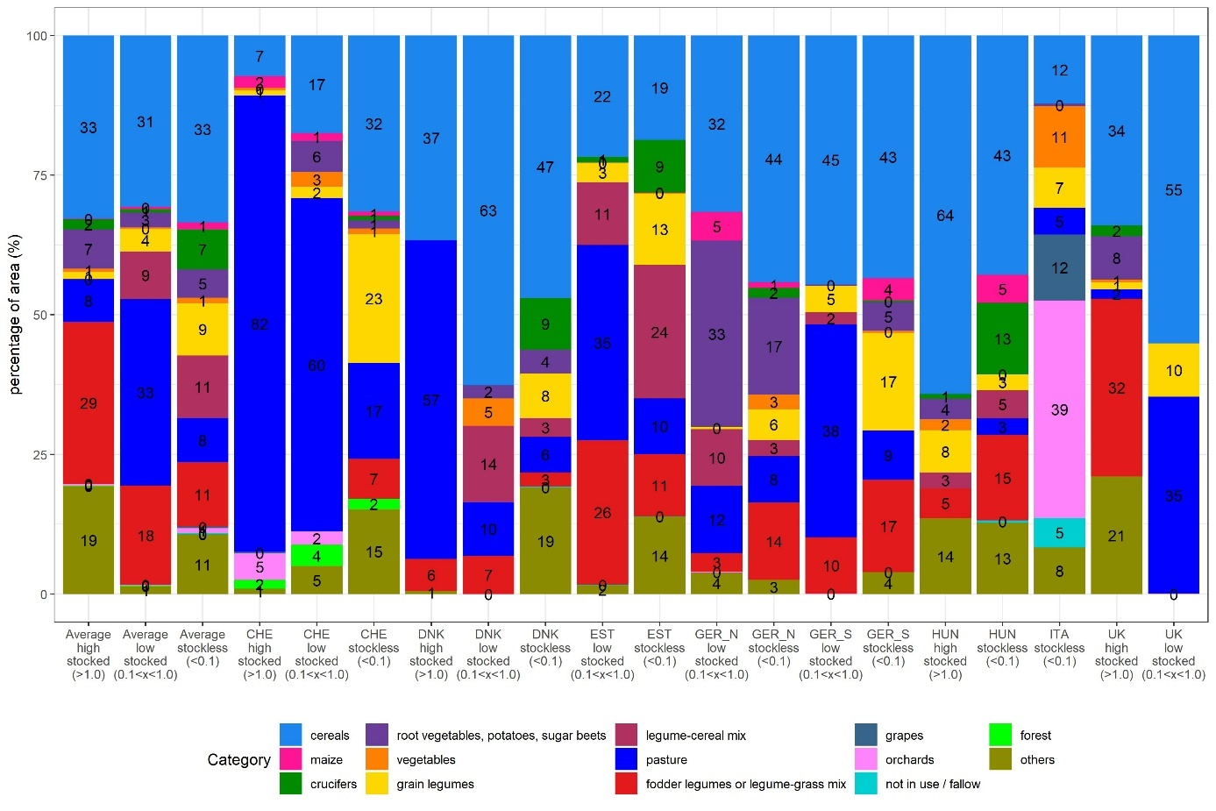Supplementary Figure 1: Percentage of area under a certain crop group for each country and farm type.

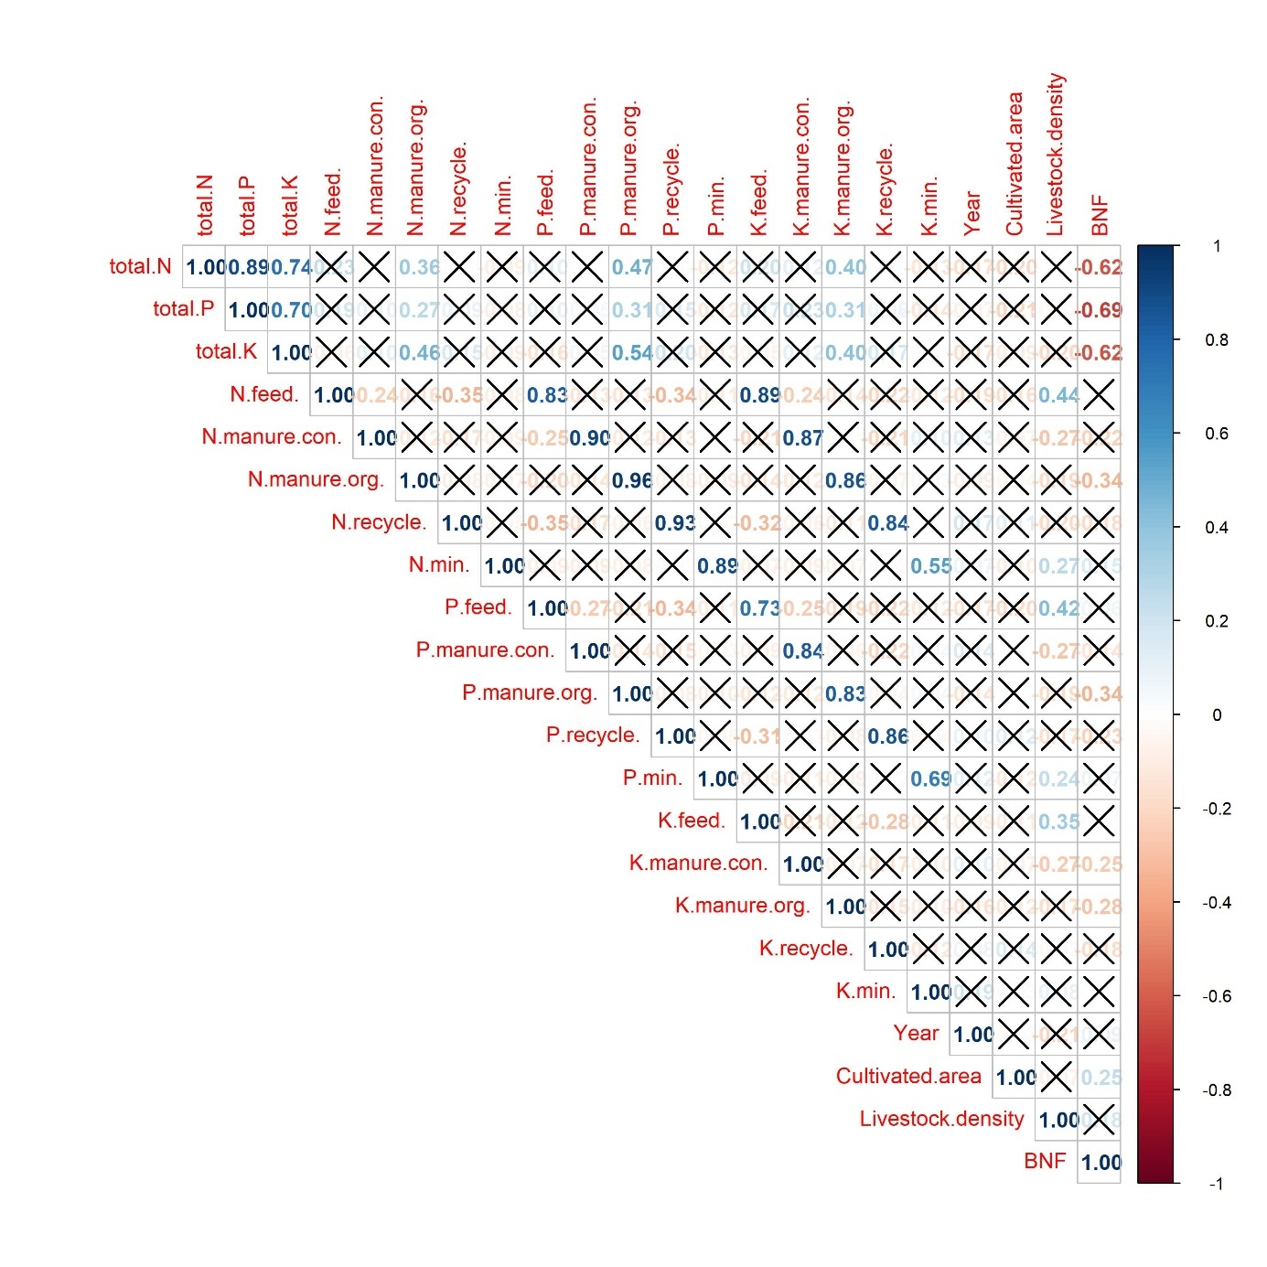Supplementary Figure 2: Correlation plot over all regions among the different sources of inputs (as percentage of total nutrient input), total nutrient input, stocking density, cultivated farm area, years under organic management, and reliance on BNF. Non-significant correlations are marked with an “X” (p<0.05). Numbers reflect the correlation coefficient based on Pearson`s product moment correlation.

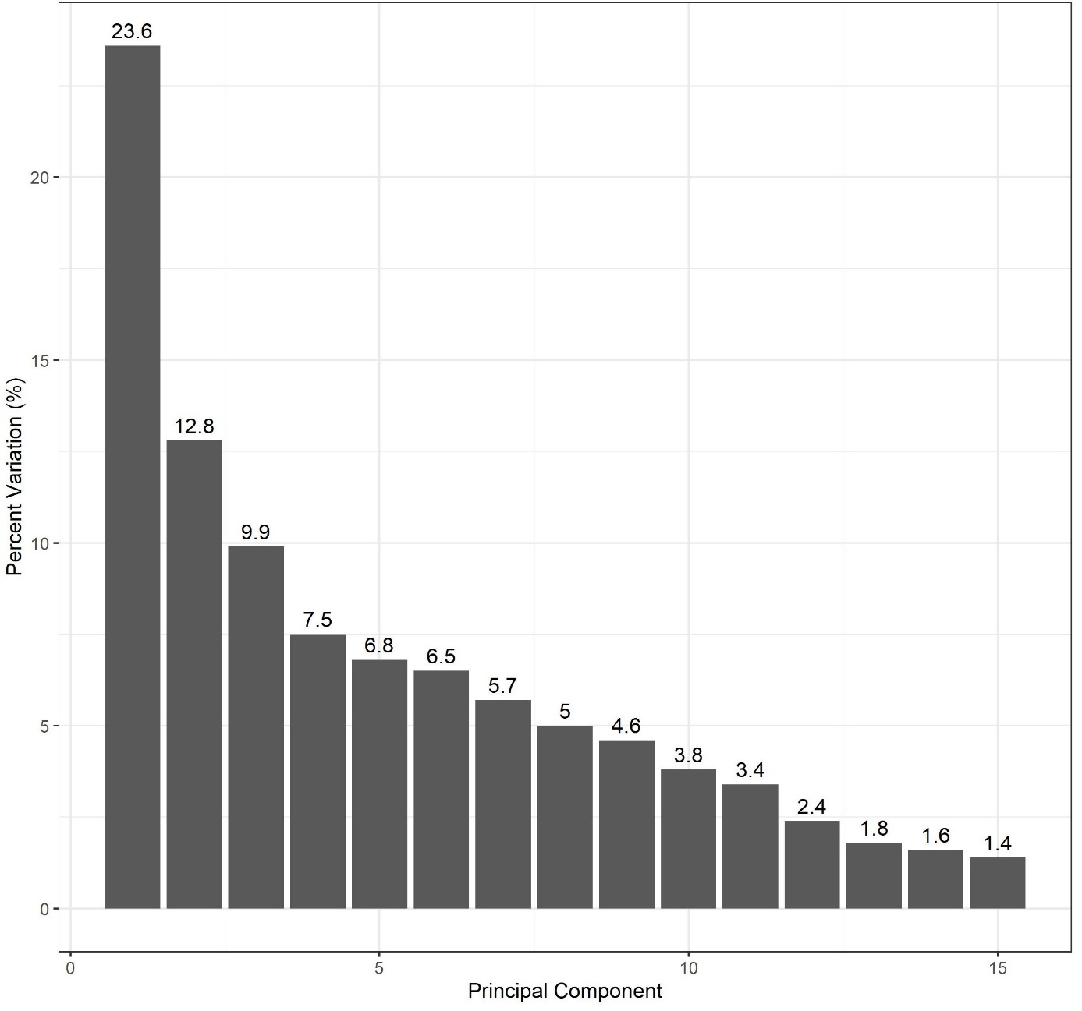Supplementary Figure 3: Screen plot of the PCA of the farm data including nutrient inputs, and outputs, percentage of nutrients derived from nutrient sources averaged over N, P, and K, livestock density, reliance on BNF, years under organic management, share of crops in crop rotation, and cultivated area. The bars show how much percentage of the variation among farms explained by the first 15 principal components.

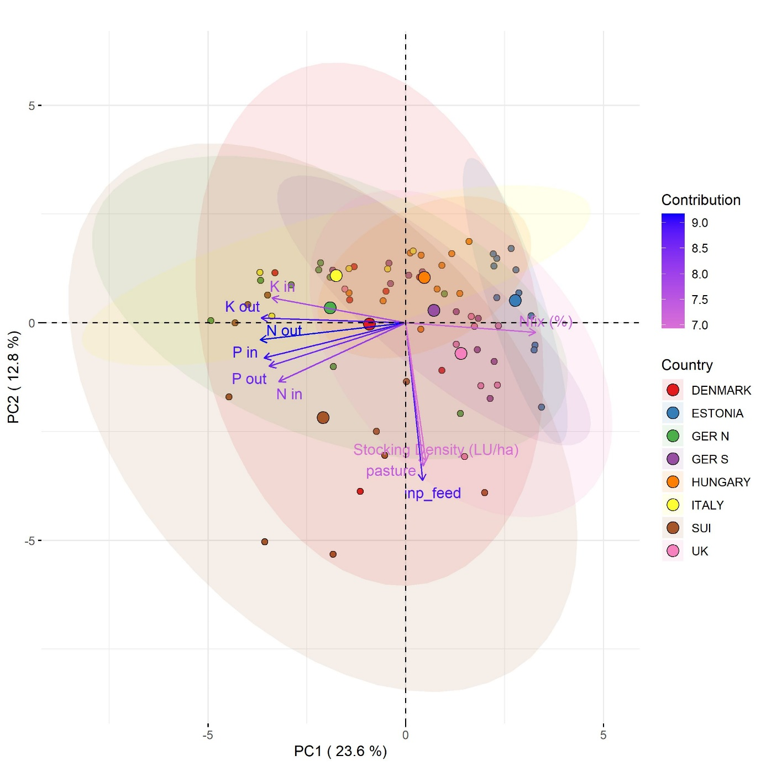
Supplementary Figure 4. PCA biplot of the farm data including nutrient budgets, nutrient inputs and outputs, percentage of nutrients derived from nutrient sources for N,P, and K, livestock density, reliance on BNF, years under organic management, and cultivated area. The biplot shows the relationship between the first two principal components (PC1 and PC2) and the amount of variation explained by each PC is given as well in parentheses on the axes. The dots represent each farm and the colour and corresponding coloured eclipse, and larger estimated mean point show study region. The blue arrows represent the 10 variables with the highest scores. The colour scale of each arrow indicates the strength of the variable's contribution to the principal component, and the angle between the arrows represents the correlation between the variables.

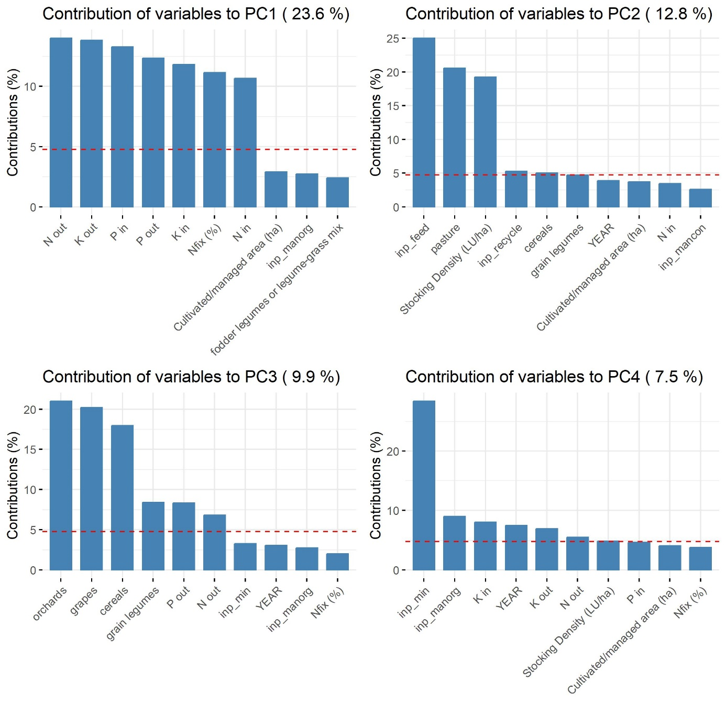
Supplementary Figure 5:

Supplementary Figure 5: Acceptance of recycled fertilizer (in order: products derived from animals (e.g., horn meal), digestates from anaerobic digestion of urban waste, green waste compost, household waste compost, sewage sludge, products derived from sewage sludge (e.g., struvite), and spent mushroom substrate). Bars represent the percentage and numbers the actual count of organic farmers in each study region and over all, that would use this product on their farm. (DK=Denmark, EST=Estonia, HU=Hungary, UK=United Kingdom, ITA=Italy, SUI=Switzerland, GER N=Northern Germany, GER S=Southern Germany)

References of the Supplementary
Anglade J, Billen G, Garnier J (2015) Relationships for estimating N 2 fixation in legumes: incidence for N balance of legume-based cropping systems in Europe. Ecosphere 6:1–24
Büchi L, Gebhard C-A, Liebisch F, et al (2015) Accumulation of biologically fixed nitrogen by legumes cultivated as cover crops in Switzerland. Plant Soil 393:163–175. https://doi.org/10.1007/s11104-015-2476-7
de Resende AS, Xavier RP, Quesada DM, et al (2003) Use of green manures in increasing inputs of biologically fixed nitrogen to sugar cane. Biology and Fertility of Soils 37:215–220
Giller KE (2001) Nitrogen fixation in tropical cropping systems, 2nd ed. CABI Pub, Wallingford, Oxon, UK ; New York, NY, USA
Moghaddam A, Raza A, Vollmann J, et al (2015) Biological nitrogen fixation and biomass production stability in alfalfa (Medicago sativa L.) genotypes under organic management conditions. Biological Agriculture & Horticulture 31:177–192
Moawad H, Badr El-Din SMS, Abdel-Aziz RA (1998) Improvement of biological nitrogen fixation in Egyptian winter legumes through better management of Rhizobium. Plant and soil 204:95–106
Salvagiotti F, Specht JE, Cassman KG, et al (2009) Growth and nitrogen fixation in high-yielding soybean: Impact of nitrogen fertilization. Agronomy Journal 101:958–970
Sulas L, Canu S, Ledda L, et al (2016) Yield and nitrogen fixation potential from white lupine grown in rainfed Mediterranean environments. Scientia Agricola 73:338–346

