Stability of anthocyanin extracts from chokeberry, grape, hibiscus, and purple sweet potato in ω-3-fatty acid rich oil-in-water emulsions

Evelyn Klingerª, Hanna Salminenª, Karola Bause^{b}, Jochen Weiss^{a*}

ªDepartment of Food Material Science, Institute of Food Science and Biotechnology, University of Hohenheim, Garbenstrasse 21/25, 70599 Stuttgart, Germany
^{b}GNT Europa GmbH, 52072 Aachen, Kackertstrasse 22, Germany
⁎Corresponding author

Supplementary Material
Table S1 Composition of coloring plant extracts.
Figure S1. HPLC separation of anthocyanins from chokeberry (A), grape (B), hibiscus (C) and purple sweet potato (D) using HPLC-DAD. Peak assignment is shown in Table 1.
Table S2 Hydrodynamic diameter (d_{h}), volume-based diameter (d_{4,3}), polydispersity index (PDI) and ζ-potential of flaxseed oil-in-water emulsions (1% w/w oil, 0.1% w/w SDS in 10 mM citrate buffer, pH 2) with or without added extract from chokeberry, grape, hibiscus, or purple sweet potato during a ten-day storage at 35°C in the dark.
Figure S2 Relative absorbance of chokeberry, gape, hibiscus, or purple sweet potato extracts with or without 0.1% SDS in 10 mM citrate buffer, pH 2 at room temperature.
Table S3 Sigmoidal data fits and coefficient of determination (R²) of primary and secondary oxidation products formed in flaxseed oil-in-water emulsions (1% w/w oil, 0.1% w/w SDS in 10 mM citrate buffer, pH 2) without or with extracts from chokeberry, grape, hibiscus and purple sweet potato during storage at 35 °C in the dark.
Table S4 Exponential data fits and coefficient of determination (R²) of anthocyanin degradation in oil-in-water emulsions (1% w/w flaxseed oil, 0.1% w/w SDS in 10 mM citrate buffer, pH 2) and in aqueous SDS (0.1 % w/w) solutions with added extracts from chokeberry, grape, hibiscus and purple sweet potato during storage at 35°C in the dark or under light.

Table S1 Composition of coloring plant extracts.
Composition (%) | Chokeberry | Grape | Hibiscus | Purple sweet potato
Dry matter | 55.6 ± 1.6 | 58.3 ± 0.8 | 53.9 ± 3.0 | 48.7 ± 3.3
Waterª | 44.4 | 41.7 | 46.1 | 51.3
Total sugars | 60.6 ± 3.9 | 31.4 ± 1.8 | 6.5 ± 0.4 | 20.9 ± 0.7
Protein | 0.33 ± 0.12 | 0.4 ± 0.12 | 1.64 ± 0.01 | 2.44 ± 0.12
Ash | 0.5 ± 0.02 | 1.2 ± 0.02 | 1.9 ± 0.03 | 4.4 ± 0.01
Fat | n.d. | n.d. | n.d. | n.d.
Total phenolics^{b} | 6.1 ± 0.19 | 4.7 ± 0.18 | 5.0 ± 0.37 | 7.1 ± 0.07
Minerals per wet matter (‰)
Al | 0.01 ± 0.0001 | 0.01 ± 0.0001 | 0.11 ± 0.001 | 0.01 ± 0.0003
Ca | 1.4 ± 0.009 | 0.9 ± 0.02 | 5.3 ± 0.09 | 0.3 ± 0.0003
Fe | 0.01 ± 0.0007 | 0.02 ± 0.0004 | 0.06 ± 0.0003 | 0.02 ± 0.001
K | 3.2 ± 0.01 | 0.08 ± 0.003 | 0.2 ± 0.004 | 9.5 ± 0.03
Mg | 0.5 ± 0.004 | 0.7 ± 0.01 | 2.3 ± 0.03 | 2.9 ± 0.03
Mn | 0.01 ± 0.0001 | 0.004 ± 0.0001 | 0.3 ± 0.003 | 0.1 ± 0.0002
Na | 0.06 ± 0.007 | 0.2 ± 0.007 | 0.2 ± 0.002 | 1.1 ± 0.001
P | 0.5 ± 0.005 | 0.4 ± 0.01 | 0.7 ± 0.006 | 2.1 ± 0.02
S | 0.1 ± 0.003 | 0.2 ± 0.004 | 0.5 ± 0.009 | 0.8 ± 0.007
Zn | 0.003 ± 0 | 0.002 ± 0 | 0.03 ± 0.0006 | 0.03 ± 0.0001
ª The water content was calculated by 100% minus % dry matter
^{b} Total phenolic content was measured as gallic acid equivalents
^{n.d.} The fat content was below the detection limit.

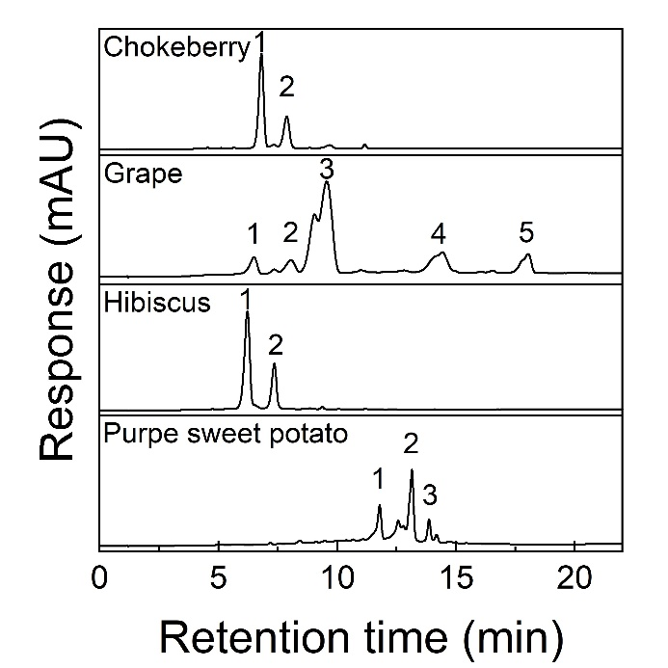
Figure S1. HPLC separation of anthocyanins from chokeberry (A), grape (B), hibiscus (C) and purple sweet potato (D) using HPLC-DAD. Peak assignment is shown in Table 1.

Table S2 Hydrodynamic diameter (d_{h}), volume-based diameter (d_{4,3}), polydispersity index (PDI) and ζ-potential of flaxseed oil-in-water emulsions (1% w/w oil, 0.1% w/w SDS in 10 mM citrate buffer, pH 2) with or without added extract from chokeberry, grape, hibiscus, or purple sweet potato during a ten-day storage at 35°C in the dark.
Sample | d_{h} (nm) |  | d_{4,3} (nm) |  | PDI (-) |  | ζ (mV)
 | Day 0 | Day 10 | Day 0 | Day 10 | Day 0 | Day 10 | Day 0 | Day 10
Control | 145 ± 7 | 155 ± 3 | 145 ± 0.1 | 161 ± 4.9 | 0.21 ± 0.05 | 0.18 ± 0.01 | -78 ± 1 | -72 ± 3
Chokeberry | 145 ± 2 | 153 ± 2 | 149 ± 0.4 | 171 ± 0.3 | 0.21 ± 0.01 | 0.17 ± 0.01 | -67 ± 3 | -68 ± 2
Grape | 143 ± 2 | 152 ± 3 | 144 ± 0.7 | 162 ± 0.6 | 0.20 ± 0.01 | 0.17 ± 0.01 | -60 ± 2 | -53 ± 7
Hibiscus | 134 ± 2 | 137 ± 2 | 146 ± 0.7 | 138 ± 0.2 | 0.19 ± 0.01 | 0.18 ± 0.01 | -74 ± 3 | -59 ± 8
Purple sweet potato | 143 ± 3 | 151 ± 2 | 148 ± 0.2 | 162 ± 0.9 | 0.21 ± 0.01 | 0.17 ± 0.01 | -68 ± 1 | -65 ± 1

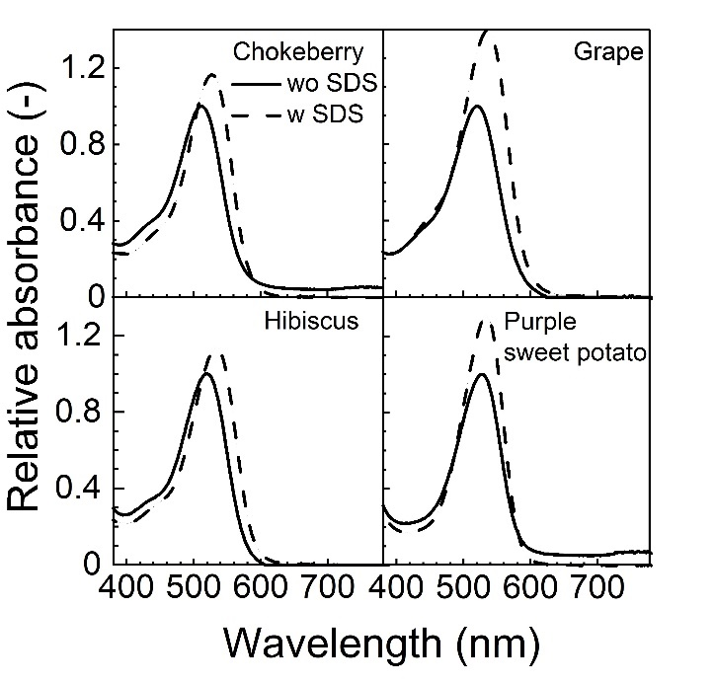
Figure S2 Relative absorbance of chokeberry, gape, hibiscus, or purple sweet potato extracts with or without 0.1% SDS in 10 mM citrate buffer, pH 2 at room temperature.

Table S3 Sigmoidal data fits and coefficient of determination (R²) of primary and secondary oxidation products formed in flaxseed oil-in-water emulsions (1% w/w oil, 0.1% w/w SDS in 10 mM citrate buffer, pH 2) without or with extracts from chokeberry, grape, hibiscus and purple sweet potato during storage at 35 °C in the dark.
$$c=\frac{k_{c}}{exp\left[k_{c}\left(C-t\right)\right]+k_{d}}$$ | Lipid hydroperoxides |  | Propanal |  | Hexanal
 | Cª (mM⁻¹) | R² | Cª (mM⁻¹) | R² | Cª (mM⁻¹) | R²
Reference | 3.6 ± 0.1 | 0.59 ± 0.06 | 0 ± 0 | 0.92 ± 0.02 | 0 ± 0 | 0.91 ± 0.06
Chokeberry | 15.1 ± 6.3 | 0.89 ± 0.07 | 0 ± 0 | 0.93 ± 0.01 | 0 ± 0 | 0.90 ± 0.07
Grape | 21.2 ± 0.8 | 0.70 ± 0.07 | 0 ± 0 | 0.89 ± 0.02 | 0 ± 0 | 0.97 ± 0.03
Hibiscus | 3.8 ± 0.2 | 0.50 ± 0.09 | 0 ± 0 | 0.94 ± 0.01 | 0 ± 0 | 0.88 ± 0.05
Purple sweet potato | 20.3 ± 2.2 | 0.46 ± 0.3 | 0 ± 0 | 0.86 ± 0.03 | 0 ± 0 | 0.87 ± 0.01
ª Integration constant C was calculated according to Eq. 2

Table S4 Exponential data fits and coefficient of determination (R²) of anthocyanin degradation in oil-in-water emulsions (1% w/w flaxseed oil, 0.1% w/w SDS in 10 mM citrate buffer, pH 2) and in aqueous SDS (0.1 % w/w) solutions with added extracts from chokeberry, grape, hibiscus and purple sweet potato during storage at 35°C in the dark or under light.
Sample ${ C}_{t}=C_{0}∙ e^{-kt}$ | SDS |  | o/w
Sample ${ C}_{t}=C_{0}∙ e^{-kt}$ | C₀ (µM) | R² | C₀ (µM) | R²
Chokeberry | 35.9 ± 0.3 | 0.78 ± 0.2 | 35.2 ± 1.5 | 0.95 ± 0.01
Grape | 36.2 ± 0.16 | 0.99 ± 0.01 | 39.0 ± 1.8 | 0.89 ± 0.01
Hibiscus | 34.6 ± 0.3 | 0.96 ± 0.01 | 33.1 ± 0.7 | 0.88 ± 0.05
Purple sweet potato | 38.5 ± 0.05 | 0.47 ± 0.01 | 38.1 ± 2.8 | 0.96 ± 0.02

