Supplementary Material

Supplementary Materials and Methods

Suppl. Table 1: Sequences of the transEDIT CRISPR gRNA target gene set for rat Vps13a.
Gene | Clone ID | Sequence
Vps13a | TEVR-1141939 (KD) | GTAATAATATCTTCATTCGT
Vps13a | TEVR-1209081 (KD2) | GTGACAAGTAAACGTCGATC
Vps13a | TEVR-1074797 (KD3) | GAATGATTATGACGACGCAT
TELA1011 | Non-targeting control (NT) | GGAGCGCACCATCTTCTTCA
KD, knockdown; Vps13a, vacuolar protein sorting 13 homolog A.

Statistics
Data are given as arithmetic means ± standard error of the mean (SEM) and n represents the number of independent cell culture experiments. Shapiro-Wilk test was used to test for normal distribution. Groups were subjected to one-way analysis of variance (ANOVA) followed by Dunnett's multiple comparisons test or Kruskal-Wallis test followed by Dunn's multiple comparisons test. Differences were considered significant if P < 0.05 (with *p<0.05, **p<0.01, and ***p<0.001). GraphPad Prism (version 6.01, https://www.graphpad.com/; GraphPad Software, Boston, MA, USA) or IBM SPSS Statistics (version 27.0, https://www.ibm.com/; IBM, Armonk, NY, USA).

Supplementary Results

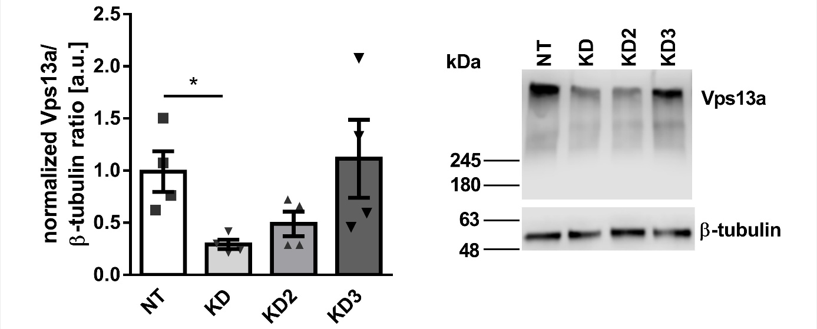
Suppl. Figure 1: Evaluation of the efficiency of the three tested gRNAs in terms of down-regulation of Vps13a protein in osteoblast-like UMR-106 cells.
Representative Western Blot and densitometric analysis (n = 4) of Vps13a protein (⁓360 kDa) and loading control β-tubulin in UMR-106 cells after CRISPR/Cas9-mediated transfection with non-targeting (NT) sequence or three gRNAs (KD, KD2, and KD3) to induce Vps13a knockdown. Data are shown as arithmetic means ± SEM. Note that this Western Blot is identical to that shown in Fig. 1B in the main text. (Kruskal-Wallis test followed by Dunn's multiple comparisons test)

Suppl. Figure 2: Effect of the tested gRNAs for knockdown of Vps13a on FGF23 production in osteoblast-like UMR-106 cells.
Arithmetic means ± SEM of Fgf23 mRNA expression (A, n = 7) normalized to Tbp in UMR-106 cells after CRISPR/Cas9-mediated transfection with non-targeting (NT) sequence or three different gRNAs (KD, KD2, and KD3) to induce Vps13a knockdown, and FGF23 (C-terminal) protein concentration (B, n = 8) in the cell culture supernatant of UMR-106 cells transduced with NT, KD, and KD2 sequence. Note that the data of suppl. Fig. 2B are identical to that in Fig. 2B of the main text. (A: one-way ANOVA followed by Dunnett's multiple comparisons test; B: Kruskal-Wallis test followed by Dunn's multiple comparisons test) FGF23, fibroblast growth factor 23; Tbp, TATA box binding protein.

