Supplementary material for:
On-farm use of recycled liquid ammonium sulphate in southwest Germany using a participatory approach
Benedikt Müller¹*, Jens Hartung², Moritz von Cossel¹, Iris Lewandowski¹, Torsten Müller^{3,} and Andrea Bauerle¹
¹ University of Hohenheim; Institute of Crop Science; Biobased Resources in the Bioeconomy;
² University of Hohenheim; Institute of Crop Science; Biostatistics;
³ University of Hohenheim; Institute of Crop Science; Fertilization and Soil Matter Dynamics;
* Correspondence: Benedikt.Mueller@uni-hohenheim.de; +49711 459-22379
ORCID:
B.M. 0009-0003-3877-7034; J.H. 0000-0001-7054-9232; M.C. 0000-0002-1132-3281; I.L. 0000-0002-0388-4521;
T.M. 0000-0002-0175-9436; A.E. 0000-0003-2777-4092
Keywords: On-farm; Participatory research; Ammonium sulphate solution; Recycled fertilizer; Nitrogen fertilizer replacement value.

Statements and Declarations
Competing Interests: The authors declare no conflict of interest. The funders had no role in the design of the study, in the collection, analyses, or interpretation of data; in the writing of the manuscript; or in the decision to publish the results.
Author Contributions: Conceptualization, B.M. and A.B.; methodology, B.M. and A.B.; formal analysis, B.M.; investigation, B.M.; data curation, B.M.; writing—original draft preparation, B.M.; writing—review and editing, B.M., J.H., I.L., T.M., M.C. and A.B.; visualization, B.M.; supervision, I.L. and A.B.; project administration, A.B, B.M.; funding acquisition, A.B. All authors have read and agreed to the published version of the manuscript.
Funding: This work was carried out within the EIP-AGRI project “Agriplus Hohenlohe” which received funding from the European Union and the Ministry of Food, Rural Affairs and Consumer Protection (MLR) Baden Württemberg under grant no. 212018.
Data Availability Statement: The datasets generated and analyzed in this study are available from the corresponding author on reasonable request.
Acknowledgments: The authors are grateful to the farmers and Bernhard Claus for carrying out the majority of the fieldwork. We would also like to thank the farmers’ families and friends for their direct or indirect help during the harvests. Particular thanks go to Robin Treter for his help taking soil samples, Dagmar Metzger for her work in the laboratory, and Nicole Gaudet for proofreading the manuscript. Thanks also go to Prof. Lars Stoumann Jensen and our colleagues for their ideas and suggestions for improvement. Further, we would like to thank Bodengesundheitsdienst GmbH for additional soil analysis at the start of our project.

Figures:
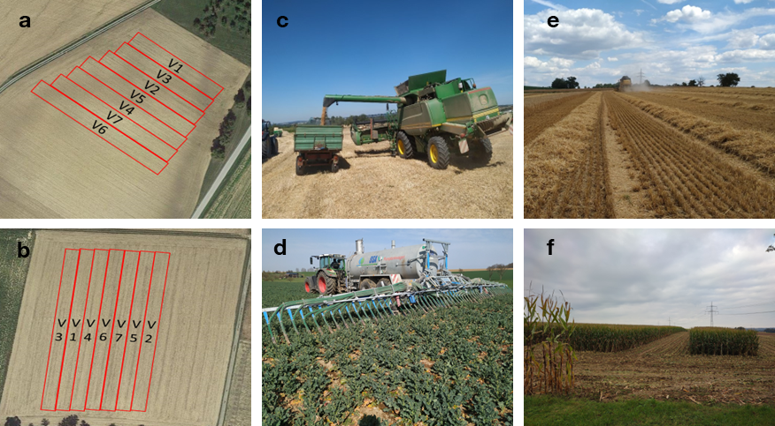
Figure S1 [a, b]: Fields with different plot sizes and randomization of treatments (V1-7). [c]: Unloading of grains from one plot for further measurement of plot yield on a truck scale. [d] ASL fertilization of rapeseed with slurry tanker-trailing hose in 2021. [e] Straw swath of crops in 2020 after harvest. [f] Leftover borders to neighboring plots after harvest of maize in 2021.

Tables:
Table S1 Long-term average precipitation (1981-2010) and precipitation in the experimental years 2020 and 2021 for February till August in the Hohenlohe region (Agrarmeteorologie Baden-Württemberg 2022)
Month | Precipitation (mm) per year
 | 1981 - 2010 | 2020 | 2021
February | 57 | 150 | 36.0
March | 73 | 51.1 | 35.2
April | 57 | 6.9 | 16.5
May | 83 | 26.5 | 74.2
June | 75 | 73.9 | 88.9
July | 82 | 23.7 | 89.1
August | 68 | 63.6 | 86.2
September | 63 | 44.5 | 20.6

Table S2 Comparison of SPAD means of winter wheat and winter barley in 2020 using Fisher´s LSD test. Within a crop and trait, mean values of fertilizer with at least one identical letter are not significantly different from each other (p < 0.005).
Date: | 22.04.2020 | LSD | 22.05.2020 | LSD | 05.06.2020 | LSD | 19.06.2020 | LSD | 26.06.2020 | LSD
Winter Barley
Control | 34.21 | a | 39.65 | a | 38.60 | a | - | - | - | -
LAS | 33.71 | a | 44.24 | b | 46.78 | b | - | - | - | -
CAN | 37.67 | b | 49.71 | d | 49.76 | c | - | - | - | -
Digestate | 37.67 | b | 47.68 | c | 50.16 | c | - | - | - | -
Manure | 37.50 | b | 49.71 | d | 49.22 | c | - | - | - | -
Winter Wheat
Control | 35.20 | a | 40.39 | a | 40.10 | a | 40.69 | a | 39.13 | a
LAS | 35.27 | a | 48.23 | b | 48.04 | b | 51.62 | b | 53.57 | b
CAN | 40.35 | bc | 51.26 | c | 54.24 | d | 55.66 | c | 55.59 | b
Digestate | 39.60 | b | 51.44 | c | 54.27 | d | 55.45 | c | 55.23 | b
Manure | 42.02 | c | 51.06 | c | 51.01 | c | 54.80 | c | 55.43 | b

Table S3 Bivariate covariance parameter estimates for yield, weight of tillers, number of tillers, straw yield, stem weight in 2020
Covariance Parameter | Estimate
Grain yield * Weight of tillers
Grain yield (X) | 3.2152
Weight of tillers (Z) | 1.9248
Estimate correlation (Z,Y) | 1
Number of tillers * Grain yield
Number of tillers (X) | 1788.89
Grain yield (Z) | 1.5443
Estimate correlation (Z,Y) | 1
Straw yield * Stem weight
Straw yield (X) | 1.3629
Stem weight (Z) | 0.1743
Estimate correlation (Z,Y) | 1

Table S4 Agronomic Efficiency (AE) and Nitrogen Fertilizer Replacement Value (NFRV) with Standard Errors (SE) of winter barley and winter wheat in 2020, and maize and rapeseed in 2021. AE in MG / kg N
Year 2020 | Winter Barley |  |  |  | Winter Wheat
 | AE | SE | NFRV (%) | SE (%) | AE | SE | NFRV (%) | SE (%)
LAS | 0.0089 | 0.0049 | 37.87 | 20.85 | 0.0060 | 0.0031 | 40.54 | 20.49
CAN | 0.0235 | 0.0049 | 100.0 | 20.85 | 0.0148 | 0.0031 | 100.0 | 20.49
Digestate | 0.0176 | 0.0054 | 74.89 | 19.14 | 0.0153 | 0.0036 | 103.3 | 24.32
Manure | 0.0218 | 0.0054 | 92.76 | 22.97 | 0.0148 | 0.0036 | 99.86 | 24.32
Year 2021 | Maize |  |  |  | Rapeseed
 | AE | SE | NFRV (%) | SE (%) | AE | SE | NFRV (%) | SE (%)
LAS | 0.0721 | 0.0205 | 94.24 | 26.79 | 0.0053 | 0.0008 | 74.64 | 11.26
CAN | 0.0765 | 0.0205 | 100.0 | 26.79 | 0.0071 | 0.0008 | 100.0 | 11.26
Digestate | 0.1211 | 0.0273 | 158.3 | 35.68 | 0.0074 | 0.0010 | 104.2 | 14.08
Manure | 0.1005 | 0.0279 | 131.3 | 36.47 | 0.0084 | 0.0010 | 118.3 | 14.08

