A review of the knowledge base for the development of natural ingredients value chains in Colombia
Ricardo Vargas-Carpintero*, Felipe Romero-Perdomo, Juan. F. Martínez, Iris Lewandowski
* Corresponding author: ricardo.vargas@uni-hohenheim.de

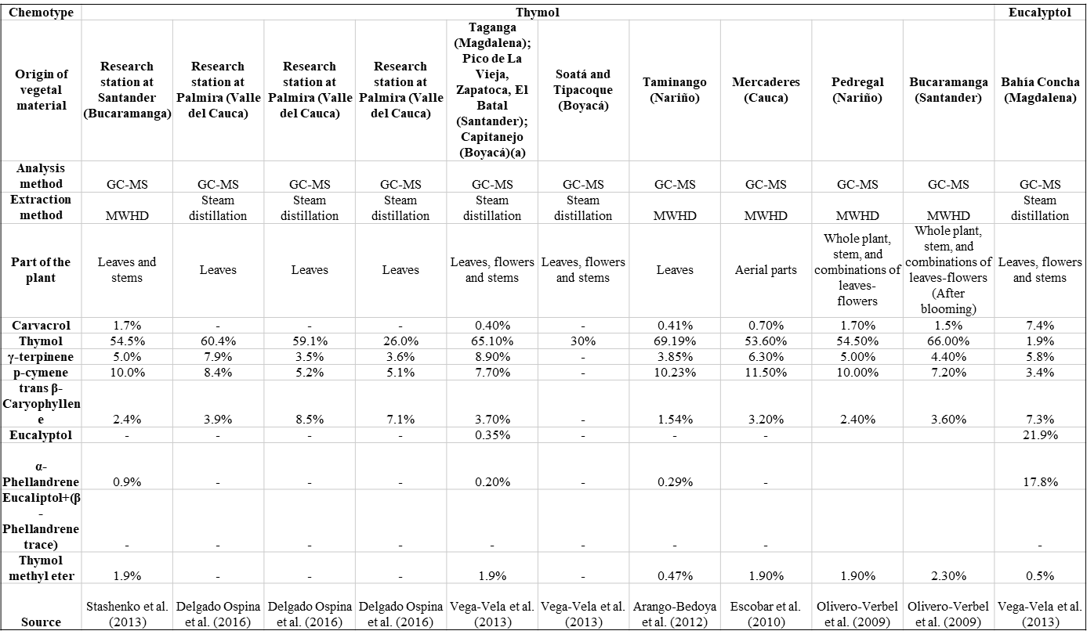
Table S1. Profile of essential oils from L. origanoides in Colombia (continues in page 2)

A review of the knowledge base for the development of natural ingredients value chains in Colombia
Ricardo Vargas-Carpintero*, Felipe Romero-Perdomo, Juan. F. Martínez, Iris Lewandowski
* Corresponding author: ricardo.vargas@uni-hohenheim.de

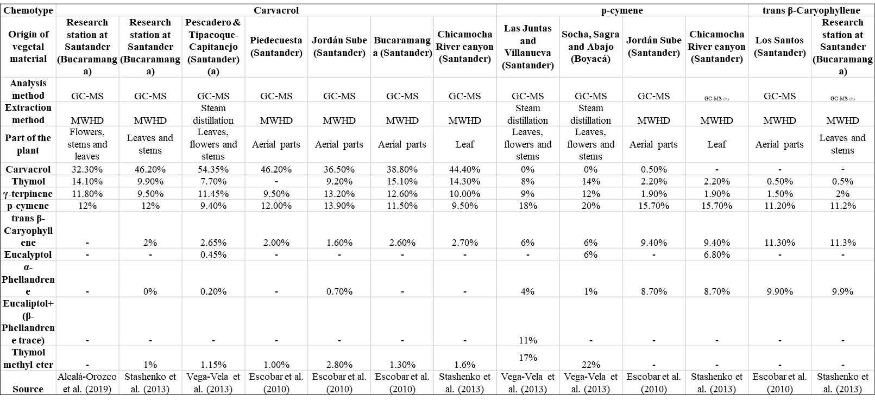
Table S1. Profile of essential oils from L. origanoides in Colombia (continuation)

