Supplementary
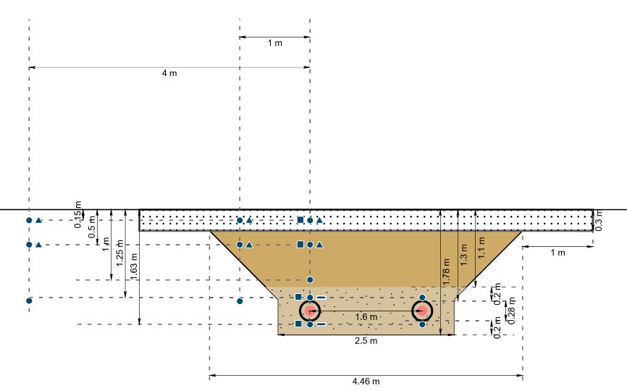
Supplementary Figure 1 Cross-section of a heated trench at the study site Boxberg. The horizontal solid black line represents the land surface; the heating pipes are shown as red circles. The trench is separated into removed topsoil (Ap-layer white dotted area), the subsoil area (Bw-Big1 layer brown area), and the bedding zone (Big2 beige dotted area). Blue symbols referring to the soil sensors installed in the soil: Circle: Pt1000, rectangle: TEROS11, square: TEROS21, line: HFP01.
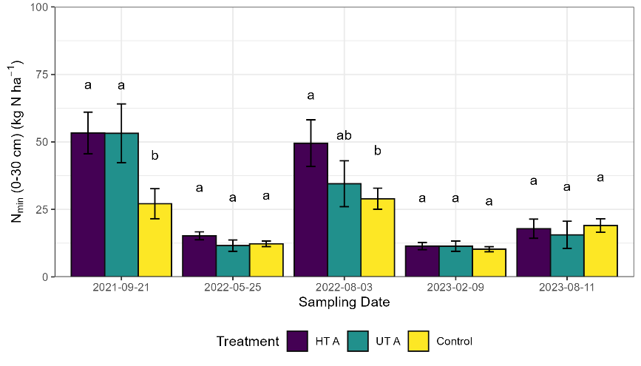
Supplementary Figure 2 Mean N_{min} (0-30 cm) (kg ha⁻¹) (±standard error) for the treatments HT A, UT A, and Control for five sampling dates for 2021-2023. Means with at least one identical lowercase letter did not differ significantly at α = 0.05.

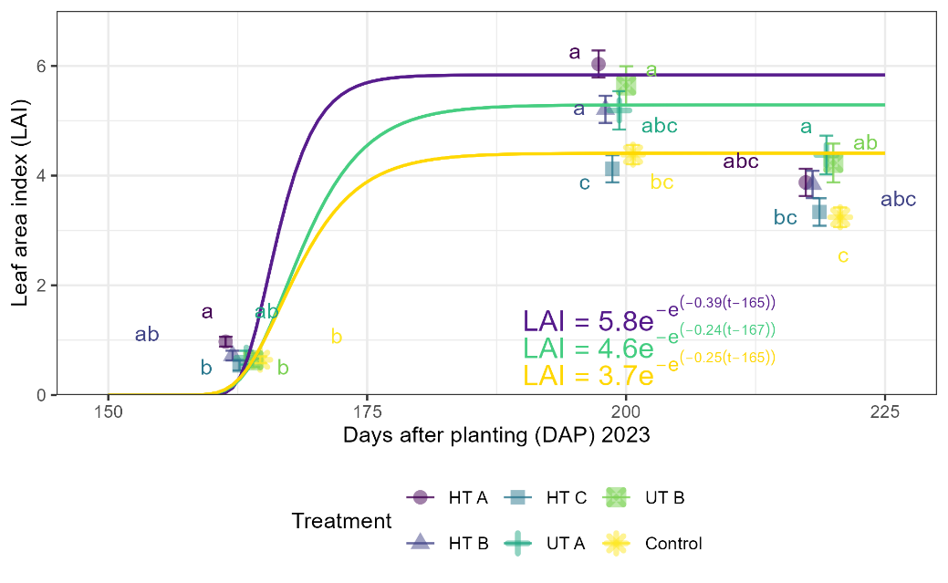
Supplementary Figure 3 Mean LAI (± standard error) for the treatments HT A, HT B, HT C, UT A, UT B, and Control for 2023 from 163-219 days after planting (DAP). Means with at least one identical lowercase letter did not differ significantly at α = 0.05

Supplementary Table 1 Type 3 Tests of fixed effects Sand(S)/Position(Pos)/Soil compaction method(SC)/Trench(T) on total above ground biomass, ear weight, grain weight, and protein content for 2022.
2022 |  |  | Total above-ground biomass |  |  | Stem weight |  |  | Leaf weight |  |  | LAI |  |  | Ear weight
Date | Effect | Num DF | Den DF | F value | Pr > F | Den DF | F value | Pr > F | Den DF | F value | Pr > F | Den DF | F value | Pr > F | Den DF | F value | Pr > F
06/07 | Control | 1 | 55 | 11.78 | 0.0011 | 55 | 7.78 | 0.0072* | 4.894 | 14.65 | 0.0128* | 3.355 | 7.49 | 0.0632 | 55 | 12.17 | 0.001*
06/07 | Control*Pos | 2 | 55 | 6.73 | 0.0024 | 55 | 6.33 | 0.0034* | 52.29 | 8.15 | 0.0008* | 49.75 | 14.64 | <.0001* | 55 | 3.33 | 0.0431*
06/07 | S*(Control*T) | 1 | 55 | 0.01 | 0.9281 | 55 | 0 | 0.9552 | 52.29 | 0.06 | 0.8035 | 49.75 | 0.14 | 0.7067 | 55 | 0 | 0.9562
06/07/ | S*Pos(Control*T) | 2 | 55 | 2.31 | 0.109 | 55 | 2.23 | 0.1173 | 52.29 | 1.3 | 0.2806 | 49.75 | 2.08 | 0.136 | 55 | 1.82 | 0.171
06/07 | S*Sc(Control*T) | 1 | 55 | 0.46 | 0.4982 | 55 | 0.19 | 0.6622 | 54.44 | 1.63 | 0.2076 | 51.53 | 0.86 | 0.3571 | 55 | 0.3 | 0.584
06/07 | S*Sc*Pos(Control*T) | 2 | 55 | 0.72 | 0.4905 | 55 | 0.73 | 0.4877 | 52.29 | 0.67 | 0.5146 | 49.75 | 1.87 | 0.165 | 55 | 1.59 | 0.213
06/07 | Sc*(Control) | 1 | 55 | 0.07 | 0.7957 | 55 | 0 | 0.9932 | 52.29 | 2.52 | 0.1181 | 49.74 | 0.1 | 0.7573 | 55 | 0.02 | 0.8992
06/07 | Sc*Pos(Control) | 2 | 55 | 0.29 | 0.7493 | 55 | 0.25 | 0.7781 | 52.29 | 3.12 | 0.0522 | 49.75 | 0.37 | 0.6903 | 55 | 0.16 | 0.8565
06/07 | T*(Control) | 1 | 55 | 1.29 | 0.2619 | 55 | 0.92 | 0.3404 | 3.377 | 0.1 | 0.771 | 2.925 | 0.23 | 0.665 | 55 | 3.65 | 0.0614
06/07 | T*Pos*(Control) | 1 | 55 | 0.12 | 0.7353 | 55 | 0.71 | 0.4015 | 52.29 | 2.3 | 0.135 | 49.73 | 0.28 | 0.601 | 55 | 0.1 | 0.7517
06/07 | T*Sc*(Control) | 1 | 55 | 1.94 | 0.1691 | 55 | 1.81 | 0.184 | 52.29 | 2.85 | 0.0971 | 49.73 | 0.78 | 0.3823 | 55 | 0.49 | 0.4858
06/07 | T*Sc*Pos*(Control) | 1 | 55 | 0.29 | 0.5903 | 55 | 0.12 | 0.7252 | 52.29 | 0.8 | 0.3755 | 49.73 | 0.01 | 0.9186 | 55 | 0.58 | 0.4513
2023 |  |  | Total above-ground biomass |  |  | Stem weight |  |  | Leaf weight |  |  | LAI |  |  | Ear weight
Date | Effect | Num DF | Den DF | F value | Pr > F | Den DF | F value | Pr > F | Den DF | F value | Pr > F | Den DF | F value | Pr > F | Den DF | F value | Pr > F
06/19 | Control | 1 | 55 | 13.74 | 0.0005* | 55 | 9.62 | 0.003* | 55 | 29.54 | <.0001* | 3.811 | 7.94 | 0.0506 | 55 | 9.68 | 0.0029
06/19 | Control*Pos | 2 | 55 | 0.43 | 0.6503 | 55 | 0.31 | 0.7328 | 55 | 1.63 | 0.2049 | 51.5 | 2.01 | 0.1448 | 55 | 0.69 | 0.5073
06/19 | S*(Control*T) | 1 | 55 | 0.18 | 0.6706 | 55 | 0.42 | 0.5194 | 55 | 0 | 0.9485 | 51.5 | 2.79 | 0.1012 | 55 | 0.04 | 0.8352
06/19 | S*Sc(Control*T) | 1 | 55 | 0.63 | 0.4299 | 55 | 0.91 | 0.3439 | 55 | 1.33 | 0.2545 | 54.63 | 1.12 | 0.2956 | 55 | 0.02 | 0.8814
06/19 | S*Sc*Pos(Control*T) | 2 | 55 | 0.76 | 0.4709 | 55 | 0.58 | 0.5649 | 55 | 0.87 | 0.4267 | 51.5 | 3.18 | 0.0499* | 55 | 0.69 | 0.5066
06/19 | S*Sc*Pos(Control*T) | 2 | 55 | 0.7 | 0.5007 | 55 | 0.48 | 0.6233 | 55 | 3.4 | 0.0406* | 51.5 | 1.11 | 0.3385 | 55 | 0.63 | 0.5343
06/19 | Sc*(Control) | 1 | 55 | 0.01 | 0.9332 | 55 | 0.03 | 0.8719 | 55 | 4.27 | 0.0435* | 51.5 | 0.6 | 0.4406 | 55 | 0.03 | 0.8691
06/19 | Sc*Pos(Control) | 2 | 55 | 0.94 | 0.3965 | 55 | 0.8 | 0.4549 | 55 | 1.17 | 0.3168 | 51.5 | 0.02 | 0.9803 | 55 | 1.35 | 0.2669
06/19 | T*(Control) | 1 | 55 | 0 | 0.9872 | 55 | 0.12 | 0.7287 | 55 | 4.25 | 0.044* | 2.665 | 1.7 | 0.2932 | 55 | 3.55 | 0.0649
06/19 | T*Pos*(Control) | 1 | 55 | 3.01 | 0.0886 | 55 | 2.82 | 0.0985 | 55 | 0.83 | 0.3672 | 51.5 | 0.04 | 0.8418 | 55 | 2.42 | 0.1255
06/19 | T*Sc*(Control) | 1 | 55 | 0.28 | 0.598 | 55 | 0.44 | 0.5094 | 55 | 0 | 0.9949 | 51.5 | 0.57 | 0.4545 | 55 | 0.03 | 0.8575
06/19 | T*Sc*Pos*(Control) | 1 | 55 | 0.71 | 0.4047 | 55 | 0.25 | 0.6213 | 55 | 4.81 | 0.0325 | 51.5 | 0.72 | 0.4001 | 55 | 0.72 | 0.4011
Supplementary Table 2 Type 3 Tests of fixed effects Sand(S)/Position(Pos)/Soil compaction method(SC)/Trench(T) on total above ground biomass, ear weight, grain weight, and protein content for 2023.
2022 |  |  | Total above-ground biomass |  |  | Ear |  |  | Grain |  |  | Protein
Date | Effect | Num DF | Den DF | F value | Pr > F | Den DF | F value | Pr > F | Den DF | F value | Pr > F | Den DF | F value | Pr > F
07/18 | Control | 1 | 3.198 | 0.81 | 0.4314 | 3.557 | 0.05 | 0.8369 | 3.627 | 0.07 | 0.8055 | 54 | 7.86 | 0.007
07/18 | Control*Pos | 2 | 49.72 | 11.23 | <.0001* | 50.04 | 5.99 | 0.0047* | 50.11 | 6.19 | 0.004* | 54 | 4.81 | 0.0119*
07/18 | S*(Control*T) | 1 | 49.72 | 0.04 | 0.8427 | 50.04 | 0.07 | 0.7973 | 50.11 | 0.41 | 0.5227 | 54 | 0.8 | 0.3764
07/18 | S*Pos(Control*T) | 2 | 49.72 | 1.14 | 0.3275 | 50.04 | 0.56 | 0.5752 | 50.11 | 0.66 | 0.5188 | 54 | 0.63 | 0.5352
07/18 | S*Sc(Control*T) | 1 | 52.61 | 1.25 | 0.2687 | 52 | 1.53 | 0.2212 | 52 | 2.49 | 0.1208 | 54 | 1.17 | 0.2843
07/18 | S*Sc*Pos(Control*T) | 2 | 49.72 | 3.62 | 0.0342* | 50.04 | 4.3 | 0.019* | 50.11 | 2.95 | 0.0617 | 54 | 0.65 | 0.5238
07/18 | Sc*(Control) | 1 | 49.71 | 1.44 | 0.2359 | 50.03 | 1.2 | 0.2779 | 50.1 | 1.48 | 0.2292 | 54 | 0.14 | 0.7132
07/18 | Sc*Pos(Control) | 2 | 49.72 | 3.48 | 0.0385* | 50.04 | 2.22 | 0.1191 | 50.11 | 2.37 | 0.1043 | 54 | 0.43 | 0.6516
07/18 | T*(Control) | 1 | 2.587 | 0.57 | 0.5142 | 3.036 | 0.1 | 0.7695 | 3.106 | 0.11 | 0.7597 | 54 | 0.45 | 0.506
07/18 | T*Pos*(Control) | 1 | 49.68 | 2.36 | 0.1307 | 50.02 | 2.62 | 0.1118 | 50.09 | 2.62 | 0.1121 | 54 | 0.5 | 0.4814
07/18 | T*Sc*(Control) | 1 | 49.68 | 0.12 | 0.7347 | 50.02 | 0.25 | 0.6164 | 50.09 | 0.28 | 0.601 | 54 | 0 | 0.9841
07/18 | T*Sc*Pos*(Control) | 1 | 49.68 | 0.07 | 0.796 | 50.02 | 0.19 | 0.6647 | 50.09 | 0.21 | 0.6514 | 54 | 1.08 | 0.3027
2023 |  |  | Total above-ground biomass |  |  | Ear |  |  | Grain weight |  |  | Protein
Date | Effect | Num DF | Den DF | F value | Pr > F | Den DF | F value | Pr > F | Den DF | F value | Pr > F | Den DF | F value | Pr > F
07/24 | Control | 1 | 55 | 10.5 | 0.002* | 55 | 3.83 | 0.0555 | 54 | 3.36 | 0.0725 | 4.313 | 3 | 0.153
07/24 | Control*Pos | 2 | 55 | 1.22 | 0.3037 | 55 | 0.73 | 0.4883 | 54 | 0.83 | 0.4401 | 51.79 | 1.99 | 0.1471
07/24 | S*(Control*T) | 1 | 55 | 0.06 | 0.8058 | 55 | 0.05 | 0.8327 | 54 | 0.03 | 0.8642 | 51.79 | 4.3 | 0.0431*
07/24 | S*Pos(Control*T) | 2 | 55 | 0.43 | 0.6525 | 55 | 0.53 | 0.5906 | 54 | 0.61 | 0.5464 | 51.79 | 1.83 | 0.1701
07/24 | S*Sc(Control*T) | 1 | 55 | 0.31 | 0.5797 | 55 | 0.05 | 0.8221 | 54 | 0 | 0.9706 | 46.1 | 0.01 | 0.9315
07/24 | S*Sc*Pos(Control*T) | 2 | 55 | 5.16 | 0.0088* | 55 | 5.73 | 0.0055* | 54 | 4.89 | 0.0112* | 51.79 | 0.3 | 0.7412
07/24 | Sc*(Control) | 1 | 55 | 2.03 | 0.1601 | 55 | 1.76 | 0.1898 | 54 | 2.01 | 0.1622 | 51.79 | 2 | 0.1636
07/24 | Sc*Pos(Control) | 2 | 55 | 0.18 | 0.8378 | 55 | 0.16 | 0.8522 | 54 | 0.13 | 0.8748 | 51.79 | 0.07 | 0.932
07/24 | T*(Control) | 1 | 55 | 0.06 | 0.8049 | 55 | 0.22 | 0.6418 | 54 | 0.29 | 0.591 | 2.55 | 0.47 | 0.5493
07/24 | T*Pos*(Control) | 1 | 55 | 0.1 | 0.7516 | 55 | 0.15 | 0.6987 | 54 | 0.18 | 0.6717 | 51.79 | 0.83 | 0.3663
07/24 | T*Sc*(Control) | 1 | 55 | 0.07 | 0.7965 | 55 | 0.27 | 0.6052 | 54 | 0.29 | 0.5954 | 51.79 | 0.27 | 0.6071
07/24 | T*Sc*Pos*(Control) | 1 | 55 | 0.37 | 0.5472 | 55 | 0.29 | 0.5913 | 54 | 0.29 | 0.5909 | 51.79 | 0.03 | 0.8743

