Supplementary Material

Chlorinated paraffin screening in chocolate products and infant formula by planar solid phase extraction

Sandra Geyer¹, Patrick Kaffenberger¹, Panagiotis Steliopoulos², and Claudia Oellig^{1,3*}

¹Institute of Food Chemistry, Department of Food Chemistry and Analytical Chemistry,
University of Hohenheim, Garbenstraße 28, 70599 Stuttgart, Germany
²Chemisches und Veterinäruntersuchungsamt (CVUA) Karlsruhe, Weißenburger Straße 3, 76187 Karlsruhe, Germany
³Institute of Food Chemistry and Food Biotechnology, Justus Liebig University Giessen, Heinrich-Buff-Ring 17-19, 35392 Gießen, Germany

*Corresponding author. Tel.: +49-641-99-34960
E-mail address: claudia.oellig@uni-giessen.de

No. | Legend | Page
Fig. S1: | Plate image of a chocolate spread sample (2.5 g) after pSPE and derivatization with tetramethylbenzidine under white light illumination applying different sample preparation approaches (according to Section Results – Sample Preparation). Tracks refer to (1) treatment with semi-concentrated sulfuric acid, (2) extraction with n-hexane before sulfuric acid treatment, (3) saponification, and (4) n-hexane extraction and sulfuric acid treatment in one step. pSPE is done according to Section Planar solid phase extraction with visual light detection. | 5
Fig. S2: | Densitograms of a spiked chocolate spread sample (1.25 g sample with 125 ng CP_{ref} and 300 ng DDT per zone) after pSPE and derivatization with tetramethylbenzidine recorded at 645 nm applying the sample preparation according to Section Results – Sample Preparation, without (dashed line) and with (solid line) dSPE clean-up with GCB showing a reduction of matrix load in the CP target zone (hR_{F} = 50–53). The second development was performed with a mixture of DCM:n-hexane 75:25, V/V. The peak at hR_{F} = 55–60 refers to DDT. pSPE is done according to Section Planar solid phase extraction with visual light detection 4. CP_{ref}: technical reference chlorinated paraffin mixture C₁₄–C₁₇ 52% Cl, DDT: 4,4'-dichlorodiphenyltrichloroethane. | 6
Fig. S3: | Plate images of a chocolate spread sample with different sample weights and amounts per zone after pSPE, (left) under UV 366 nm illumination before derivatization and (right) under white light illumination after derivatization with tetramethylbenzidine. Tracks refer to (1) 3.0 g sample weight (1.5 g per zone), (2) 3.5 g sample weight (1.75 g per zone), (3) 4.0 g sample weight (2.0 g per zone), and (4) 4.5 g sample weight (2.25 g per zone). Sample preparation and pSPE are done according to Sections Sample preparation and Planar solid phase extraction with visual light detection. CP and DDT zones are marked with arrows. CP: chlorinated paraffins, DDT: 4,4'-dichlorodiphenyltrichloroethane. | 7
Fig. S4: | Plate image of spiked infant formula samples (1.0 g sample with 125 ng CP_{ref} and 300 ng DDT per zone) after pSPE under UV 366 nm illumination (without derivatization). Fat extraction of samples was done with different volumes of extraction solvent containing a mixture of DCM:methanol:water (10:5:1 V/V) followed by further sample preparation with sulfuric acid treatment, washing with 1 M sodium hydroxide solution and dSPE clean-up with GCB according to Section Results – Sample Preparation. Tracks refer to (1) 10 mL extraction solvent, (2) 20 mL extraction solvent, (3) 30 mL extraction solvent, and (4) blank (sample preparation without matrix and 10 mL extraction solvent). pSPE and sample preparation are done according to Sections Sample preparation and Planar solid phase extraction with visual light detection. | 8
Fig. S5: | Plate image of spiked infant formula samples (1.0 g sample with 125 ng CP_{ref} and 300 ng DDT per zone) after pSPE and derivatization with o-tolidine (98%, abcr GmbH, Karlsruhe, Germany, 4% tolidine in acetone) under white light illumination. Samples were treated by hydrochloric acid digestion (6 M hydrochloric acid, 30 min at 80°C) and extraction with (1) n-hexane/2-propanol (3:1, V/V), or (3) tBME, and (2) only CP_{ref} and DDT in pure solvent, including further preparation with sulfuric acid treatment, liquid-liquid extraction with 1 M sodium hydroxide solution and dSPE clean-up with GCB according to Section Results – Sample Preparation. pSPE is done according to Section Planar solid phase extraction with visual light detection. Target zones of CP, DDT, and the matrix area are marked with arrows. CP_{ref}: technical reference chlorinated paraffin mixture C₁₄–C₁₇ 52% Cl, DDT: 4,4'-dichlorodiphenyltrichloroethane. | 9
Fig. S6 | Densitograms of a spiked chocolate spread sample (1.25 g sample with 125 ng CP_{ref} and 300 ng DDT per zone) after pSPE and derivatization with tetramethylbenzidine recorded at 645 nm applying the sample preparation according to Section Results – Sample Preparation. The second development was performed with DCM:n-hexane 90:10, V/V (dashed line) or 75:25, V/V (solid line), showing a separation of the coeluting matrix from the CP target zone (hR_{F} = 50–53). The peak at hR_{F} = 55–60 refers to DDT. pSPE is done according to Section Planar solid phase extraction with visual light detection. CP_{ref}: technical reference chlorinated paraffin mixture C₁₄–C₁₇ 52% Cl, DDT: 4,4'-dichlorodiphenyltrichloroethane. | 10
Fig. S7 | Standard deviation of repeatability and standard deviation of reproducibility as a function of the spiked concentration. | 11
Fig. S8 | Straight line between the expectation of the measured concentration and the known concentration, obtained by weighted linear regression, with 0.95 prediction bands. | 12
Fig. S9: | Recovery for samples spiked with CP (0–200 ng g⁻¹ sample). Determination is based on weighted linear regression. | 13
Fig. S10: | Uncertainty in determining CP contents between 0 and 200 ng g⁻¹ sample. Determination is based on weighted linear regression. | 14
Table S1: | Sample number, description, and contained oils of the investigated chocolate products. | 15
Table S2: | Sample number, description, definition according to Regulation (EU) No 609/2013, suitable age (according to packaging), and contained oils of the investigated infant formula samples. | 16
Description 1: | Validation | 17

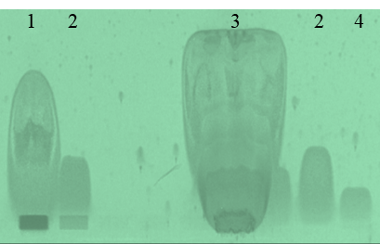

Fig. S1: Plate image of a chocolate spread sample (2.5 g) after pSPE and derivatization with tetramethylbenzidine under white light illumination applying different sample preparation approaches (according to Section Results – Sample Preparation). Tracks refer to (1) treatment with semi-concentrated sulfuric acid, (2) extraction with n-hexane before sulfuric acid treatment, (3) saponification, and (4) n-hexane extraction and sulfuric acid treatment in one step. pSPE is done according to Section Planar solid phase extraction with visual light detection.

Fig. S2: Densitograms of a spiked chocolate spread sample (1.25 g sample with 125 ng CP_{ref} and 300 ng DDT per zone) after pSPE and derivatization with tetramethylbenzidine recorded at 645 nm applying the sample preparation according to Section Results – Sample Preparation, without (dashed line) and with (solid line) dSPE clean-up with GCB showing a reduction of matrix load in the CP target zone (hR_{F} = 50–53). The second development was performed with a mixture of DCM:n-hexane 75:25, V/V. The peak at hR_{F} = 55–60 refers to DDT. pSPE is done according to Section Planar solid phase extraction with visual light detection 4. CP_{ref}: technical reference chlorinated paraffin mixture C₁₄–C₁₇ 52% Cl, DDT: 4,4'-dichlorodiphenyltrichloroethane.

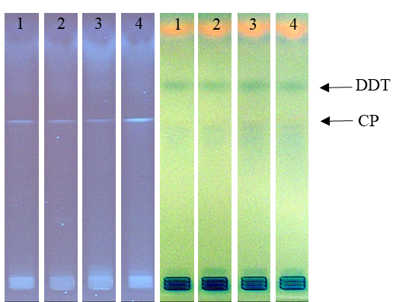

Fig. S3: Plate images of a chocolate spread sample with different sample weights and amounts per zone after pSPE, (left) under UV 366 nm illumination before derivatization and (right) under white light illumination after derivatization with tetramethylbenzidine. Tracks refer to (1) 3.0 g sample weight (1.5 g per zone), (2) 3.5 g sample weight (1.75 g per zone), (3) 4.0 g sample weight (2.0 g per zone), and (4) 4.5 g sample weight (2.25 g per zone). Sample preparation and pSPE are done according to Sections Sample preparation and Planar solid phase extraction with visual light detection. CP and DDT zones are marked with arrows. CP: chlorinated paraffins, DDT: 4,4'-dichlorodiphenyltrichloroethane.

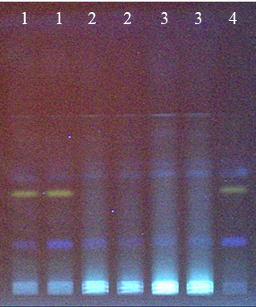
Fig. S4: Plate image of spiked infant formula samples (1.0 g sample with 125 ng CP_{ref} and 300 ng DDT per zone) after pSPE under UV 366 nm illumination (without derivatization). Fat extraction of samples was done with different volumes of extraction solvent containing a mixture of DCM:methanol:water (10:5:1 V/V) followed by further sample preparation with sulfuric acid treatment, washing with 1 M sodium hydroxide solution and dSPE clean-up with GCB according to Section Results – Sample Preparation. Tracks refer to (1) 10 mL extraction solvent, (2) 20 mL extraction solvent, (3) 30 mL extraction solvent, and (4) blank (sample preparation without matrix and 10 mL extraction solvent). pSPE and sample preparation are done according to Sections Sample preparation and Planar solid phase extraction with visual light detection.

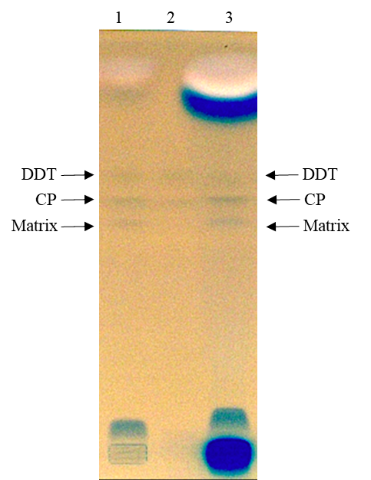
Fig. S5: Plate image of spiked infant formula samples (1.0 g sample with 125 ng CP_{ref} and 300 ng DDT per zone) after pSPE and derivatization with o-tolidine (98%, abcr GmbH, Karlsruhe, Germany, 4% tolidine in acetone) under white light illumination. Samples were treated by hydrochloric acid digestion (6 M hydrochloric acid, 30 min at 80°C) and extraction with (1) n-hexane/2-propanol (3:1, V/V), or (3) tBME, and (2) only CP_{ref} and DDT in pure solvent, including further preparation with sulfuric acid treatment, liquid-liquid extraction with 1 M sodium hydroxide solution and dSPE clean-up with GCB according to Section Results – Sample Preparation. pSPE is done according to Section Planar solid phase extraction with visual light detection. Target zones of CP, DDT, and the matrix area are marked with arrows. CP_{ref}: technical reference chlorinated paraffin mixture C₁₄–C₁₇ 52% Cl, DDT: 4,4'-dichlorodiphenyltrichloroethane.
Fig. S6: Densitograms of a spiked chocolate spread sample (1.25 g sample with 125 ng CP_{ref} and 300 ng DDT per zone) after pSPE and derivatization with tetramethylbenzidine recorded at 645 nm applying the sample preparation according to Section Results – Sample Preparation. The second development was performed with DCM:n-hexane 90:10, V/V (dashed line) or 75:25, V/V (solid line), showing a separation of the coeluting matrix from the CP target zone (hR_{F} = 50–53). The peak at hR_{F} = 55–60 refers to DDT. pSPE is done according to Section Planar solid phase extraction with visual light detection. CP_{ref}: technical reference chlorinated paraffin mixture C₁₄–C₁₇ 52% Cl, DDT: 4,4'-dichlorodiphenyltrichloroethane.

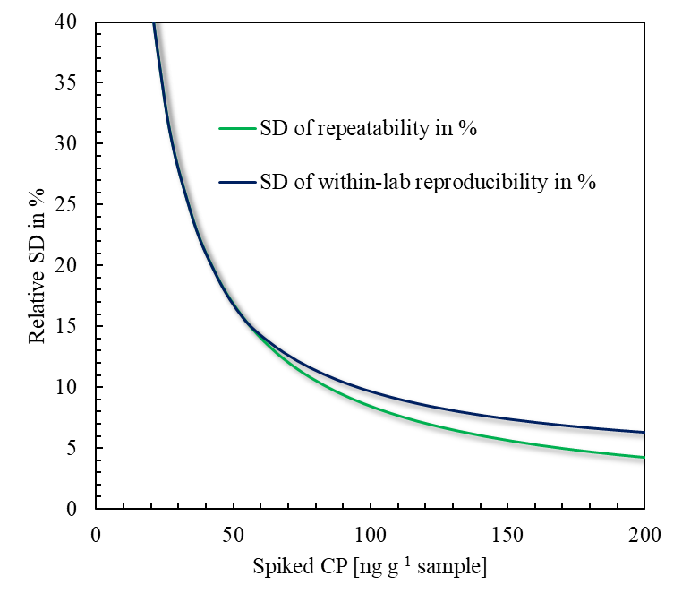
Fig. S7: Standard deviation of repeatability and standard deviation of reproducibility as a function of the spiked concentration.

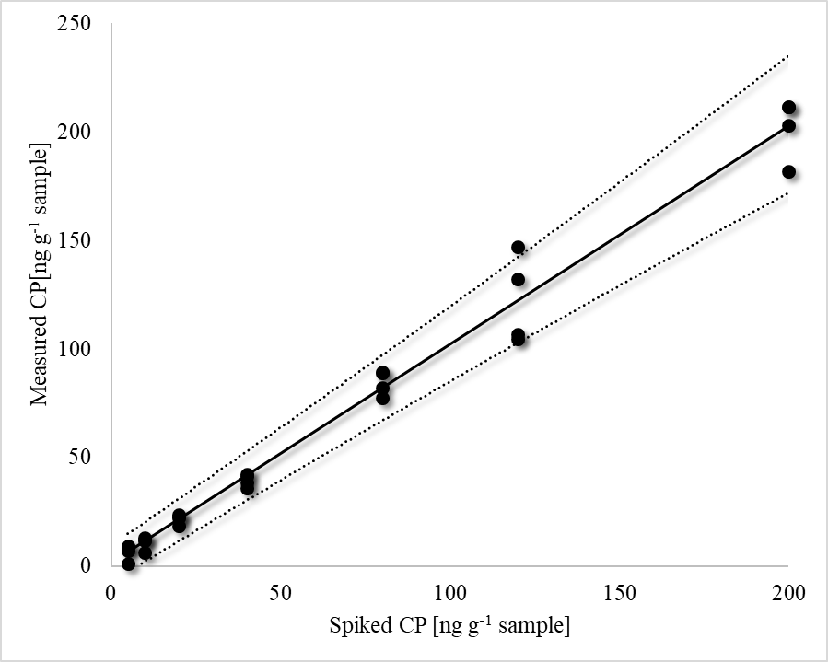
Fig. S8: Straight line between the expectation of the measured concentration and the known concentration, obtained by weighted linear regression, with 0.95 prediction bands.
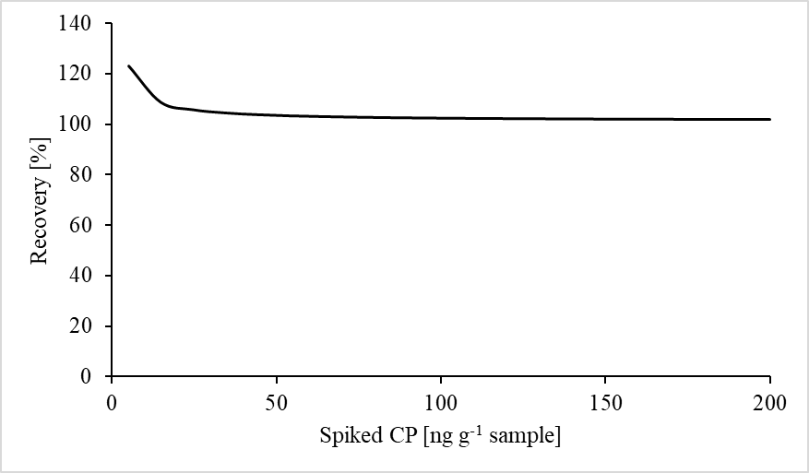
Fig. S9: Recovery for samples spiked with CP (0–200 ng g⁻¹ sample). Determination is based on weighted linear regression.

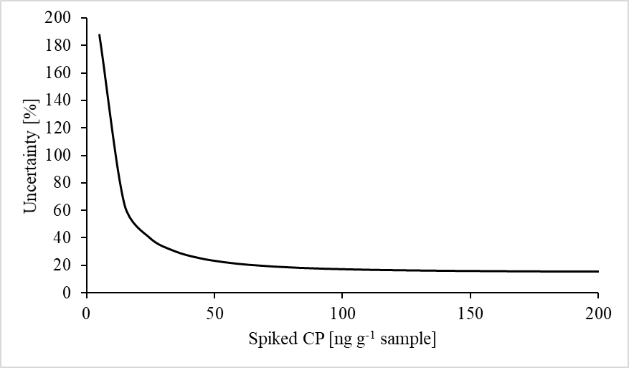
Fig. S10: Uncertainty in determining CP contents between 0 and 200 ng g⁻¹ sample. Determination is based on weighted linear regression.

Table S1: Sample number, description, and contained oils of the investigated chocolate products.
Sample no | Description | Contained oils
1 | Hazelnut spread | r, p, s, h
2 | Hazelnut spread | r, p, h
3 | Hazelnut spread | p, h
4 | Hazelnut spread | s, h, cb
5 | Hazelnut spread | s, h, cb
6 | chocolate glaze | p
7 | Hazelnut spread | s, h, p
8 | Bourbon vanilla cake glaze | p, c
9 | Milk chocolate glaze | p
10 | Chocolate glaze | p
11 | Hazelnut spread | s, h, cb
12 | Cake glaze cocoa | p, c, sb
13 | Cake glaze cocoa | p
14 | Hazelnut spread | r, h, p
15 | Hazelnut spread | s, h, p
16 | Hazelnut spread | s, h, cb
17 | Hazelnut spread | r, p, s
18 | Hazelnut spread | h, s, p
19 | Hazelnut spread | s, h, p
20 | Hazelnut spread | p, s, h
21 | Hazelnut spread | s, p, h
22 | Hazelnut spread | p, h
23 | Hazelnut spread | s, h, p
24 | Hazelnut spread | h, s
25 | Hazelnut spread | h, s, p
p: palm oil/fat, s: sunflower oil, r: rapeseed oil, h: hazelnut oil, cb: cocoa butter, c: coconut oil/fat, sb: shea butter.

Table S2: Sample number, description, definition according to Regulation (EU) No 609/2013, suitable age (according to packaging), and contained oils of the investigated infant formula samples.
Sample no | Description | Definition according to Regulation (EU) No 609/2013 | Suitable for | Contained oils
1 | Toddler milk | Follow-on formula | 1+ year | p, s, r, f
2 | Toddler milk | Follow-on formula | 2+ years | p, s, r, f
3 | Bio-growing-up milk | Follow-on formula | 6th month | p, s, r
4 | Toddler milk | Follow-on formula | 1+ year | p, s, r
5 | Infant formula PRE | Infant formula | From birth | p, s, r
6 | Bio-infant formula | Infant formula | From birth | p, s, r
7 | Bio-infant formula 1 | Infant formula | From birth | p, s, r
8 | Toddler milk | Follow-on formula | 1+ year | p, s, r, f
9 | Bio-infant formula 1 | Infant formula | From birth | p, s, r
10 | Infant formula PRE | Infant formula | From birth | p, s, r
11 | Bio-infant formula 1 | Infant formula | From birth | p, s, r
12 | Bio-infant formula 1 goat milk based | Follow-on formula | 6th month | p, s, r
13 | Growing-up milk 3 | Follow-on formula | 10th month | p, s, r
14 | Infant formula 1 | Infant formula | From birth | p, s, r
15 | Toddler milk | Follow-on formula | 1+ year | p, s, r, f
16 | Toddler milk 2+ | Follow-on formula | 2+ years | p, s, r
17 | Toddler milk 1 | Follow-on formula | 12th month | p, s, r
18 | Toddler milk 2+ | Follow-on formula | 2+ years | p, s, r
19 | Hypoallergenic infant formula | Infant formula | From birth | p, s, r
20 | Toddler milk 1 | Follow-on formula | 12th month | p, s, r
21 | Bio-infant formula 1 goat milk based | Infant formula | From birth | p, s, r
22 | Growing-up milk 2 | Follow-on formula | 6th month | p, s, r
23 | Growing-up milk 3 | Follow-on formula | 10th month | p, s, r
24 | Bio-growing-up milk 3 | Follow-on formula | 12th month | p, s, r
25 | Toddler milk | Follow-on formula | 2+ years | p, s, r, f
26 | Bio-growing-up milk 2 | Follow-on formula | 6th month | p, s, r
27 | Growing-up milk | Follow-on formula | 6th month | p, s, r
28 | Infant formula 1 | Infant formula | From birth | p, s, r
29 | Infant formula 1 | Infant formula | From birth | p, s, r, f, m
30 | Growing-up milk 2 | Follow-on formula | 6th month | p, s, r
31 | Toddler milk | Follow-on formula | 1+ year | p, s, r, f
32 | Infant formula PRE | Infant formula | From birth | s, sb, c, f, m
33 | Toddler milk | Follow-on formula | 12th month | p, c, r, s
34 | Toddler milk 2 | Follow-on formula | 6th month | p, c, r, s, f, m
35 | Toddler milk 3 | Follow-on formula | 10th month | p, c, r, s
36 | Infant formula PRE | Infant formula | From birth | p, r, c, s, f, m
37 | Pre infant formula | Infant formula | From birth | p, r, c, s, f, m
38 | Pre infant formula | Infant formula | From birth | p, r, s, f, m
p: palm oil/fat, s: sunflower oil, r: rapeseed oil,f: fish oil, m: oil from oil from Mortierella alpina, sb: soybean oil, c: coconut oil/fat.
Description 1: Validation
In a first step, the measured concentrations were regressed on the known concentrations by fitting a variance components model to the data. A variance components model incorporates two types of error. One error term reflects measurement dispersion within an arbitrarily selected series, while the other expresses run-related variability that leads to fluctuations among different measurement series. Applying this type of linear regression model enables the estimation of the standard deviation of repeatability and within-lab reproducibility as a function of the spiked concentration [1–3]. The results are shown in Fig. S7. However, although the two curves differ slightly, an f-test showed that there is no significant run-induced variability, i.e., there is no significant difference between the standard deviation of repeatability and that of within-lab reproducibility within the working range. Therefore, we opted to use a weighted linear regression model with one error term for the data analysis. The weighted regression line and the 0.95 prediction bands are displayed in Fig. S8. The parameter estimates and the corresponding 0.95 confidence intervals are as follows: slope b = 1.012 ± 0.056, intercept a = 1.1 ± 2.8. Figs. S9 and S10 show the recovery rate and the uncertainty as a function of the spiked concentration, respectively. Weighted least-squares fitting and the calculation of performance characteristics were carried out as described by Steliopoulos & Stickel [4]. Uncertainty was obtained by dividing the half-width of the 0.95 prediction interval for a single (or mean) future measured concentration, given a spiked true concentration, by the slope of the regression line. In other words, uncertainty was calculated as the half-width of an approximate 0.95 confidence interval around a result that has been corrected for recovery.
References:
[1] Jülicher, B., Gowik, P., and Uhlig, S. (1999). A top-down in-house validation based approach for the investigation of the measurement uncertainty using fractional factorial experiments. Analyst 124, 537–545. DOI=10.1039/.
[2] Steliopoulos, P., Stickel, E., Haas, H., and Kranz, S., 2006, Method validation approach on the basis of a quadratic regression model. Anal. Chim. Acta 572, 121–124. DOI=10.1016/j.aca.2006.04.090.
[3] Brüggemann, L., Morgenstern, P., and Wennrich, R., 2010, Comparison of international standards concerning the capability of detection for analytical methods. Accred. Qual. Assur. 15, 99–104. DOI=10.1007/s00769-009-0589-5.
[4] Steliopoulos, P., & Stickel, E. (2007). Estimation of performance characteristics of a confirmation method for thyreostats in plasma by means of a weighted least-squares approach. Anal. Chim. Acta 592, 181–186. DOI=10.1016/j.aca.2007.04.026.

