Supplementary figure
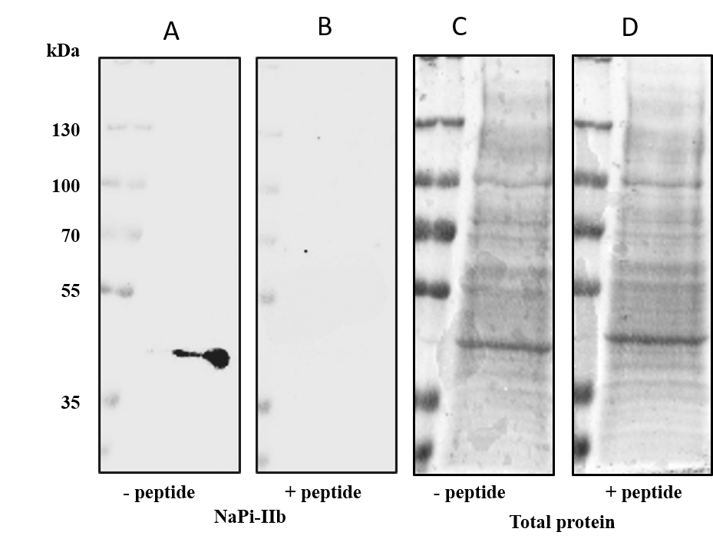

Figure S1: Validation of NaPi-IIb antibody specificity by blocking-peptide control.
Representative Western blots demonstrating specificity of the NaPi-IIb immunoreactive band (~45 kDa) in duodenal BBM preparations. (A) Immunoreactive ~45 kDa band detected when the primary antibody was used without blocking peptide (– peptide). (B) Complete loss of the ~45 kDa band after pre-incubation of the primary antibody with its antigenic blocking peptide (+ peptide), confirming specificity. (C, D) Indian ink total protein staining corresponding to panels A (C) and B (D), serving as loading controls.

