Assessing impacts of crop area expansion and crop-livestock integration on ecosystem functions in African savannas using the coupled LUCIA and LIVSIM models

Modeling Earth Systems and Environment

Appendices
Appendix 1
Regression equations, that translate grass AGB quality parameters into nutritional characteristics of the feed (see Section 2.1.2).
Vegetation dry matter content was estimated as:

$\text{DMcontent}\text{ = -3.12 * CP + 693.10}$ ; (R² = 0.62) Equation A 1

with:
$\text{DMcontent}$ (g/kg fresh matter) dry matter content $CP$ (g/kg dry matter) crude protein content

Crude protein content of pasture vegetation was estimated according to Charrondiere et al. (2004), by multiplying nitrogen (g/100g) in the feed by 6.25 (i.e., assuming that protein contains about 16 % of N).
Furthermore, the neutral detergent fibre (NDF) concentration was estimated as:
$\text{NDF = -1.99 * CP + 869.48}$ ; (R² = 0.82) Equation A 2

with:
$\text{NDF}$ (g/kg dry matter) neutral detergent fiber content
$CP$ (g/kg dry matter) crude protein content

Metabolizable energy (ME) was estimated according to Maff (1984) as:
$\text{ME = 0.016 * }\text{dOMD}$ Equation A 3

where dOMD is the digestibility of organic matter in the pasture sample. dOMD was in turn estimated using an own fitted regression equation:

$\text{dOMD}\text{ = 931.13 - 0.69 * CP - 1.69 * ADL - 0.48 * NDF}$ ; (R² = 0.64) Equation A 4

with:
$\text{ME}$ (g/kg dry matter) metabolizable energy content
$\text{dOMD}$ (g/kg dry matter) digestibility of organic matter in dry matter
$CP$ (g/kg dry matter) crude protein content
$\text{NDF}$ (g/kg dry matter) neutral detergent fiber content
$ADL$ (g/kg dry matter) acid detergent lignin content

Digestibility of dry matter (DMD) in the feed from grasslands was estimated based on our own feed databases, described earlier in the text, as:
$\text{DMD = 1.4827 * CP + 406.59}$ ; (R² = 0.88) Equation A 5

with:
$\text{DMD}$ (g/kg dry matter) digestibility of dry matter
$CP$ (g/kg dry matter) crude protein content

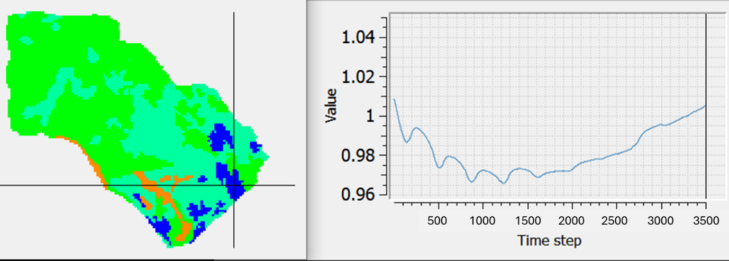
Appendix 2: Plausibility check of topsoil SOC stock under maize cropping in the baseline scenario Trad_Grz. Average over all maize pixels within the study watershed (blue pixels in the left-side map). Values are normalized over initial stocks to account for different initial soil conditions (right-side graph: x-axis = day of simulation, y-axis = normalized SOC)

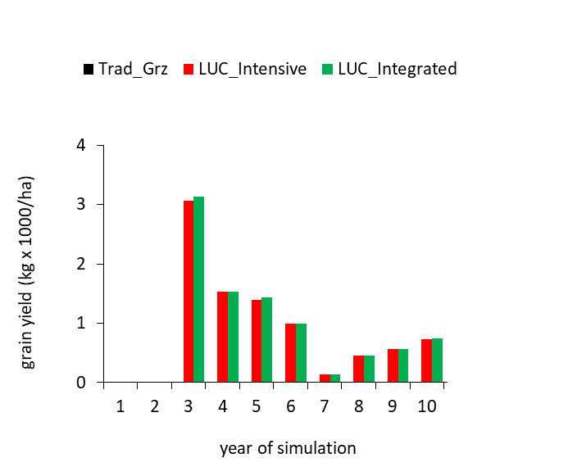
Appendix 3: Maize grain yield per ha, average over cultivated pixels within the grazing area. Grassland conversion and maize cultivation within the grazing area starting in year 3 of the simulation run following an initialization period.

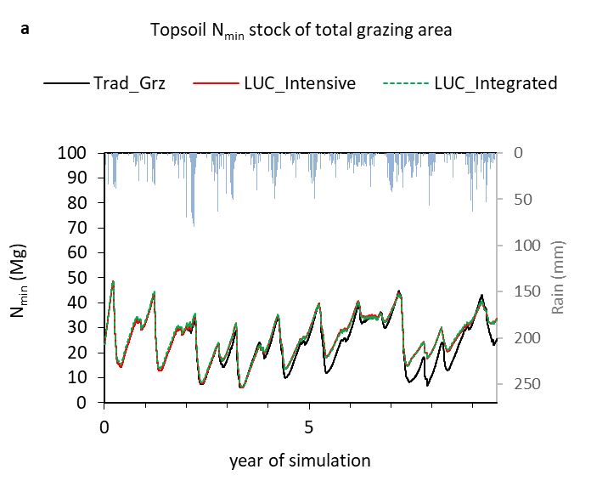 | 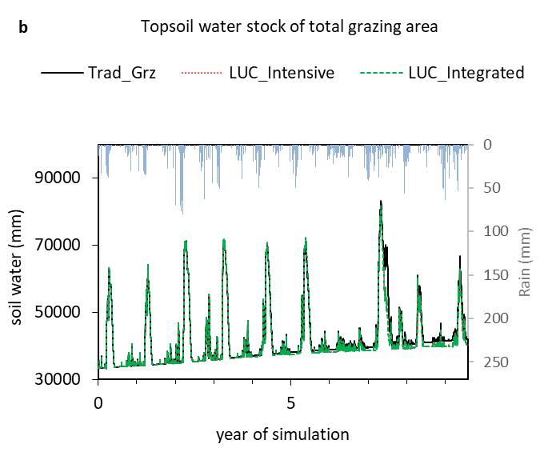
Appendix 4: (a) Topsoil N_{min} stock and (b) topsoil water stock of the total grazing area for the baseline Trad_Grz and two LUC scenarios. Daily rainfall from top (right y-axis).

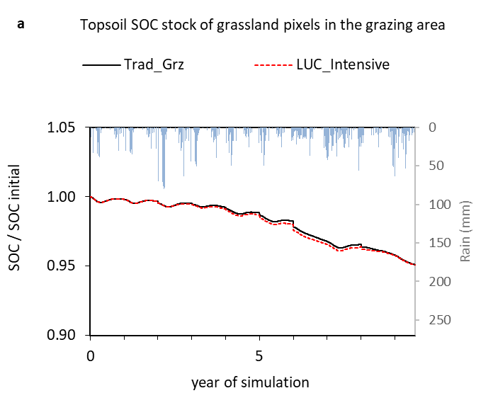 | 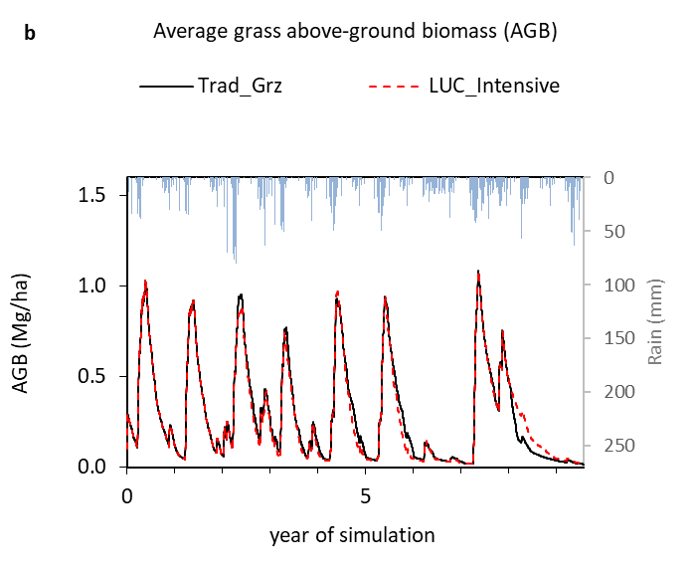
Appendix 5: (a) Topsoil SOC stock relative to initial topsoil SOC stock (accounting for different SOC levels of the different soil types) and (b) grass live above-ground biomass. Average of the remaining grassland pixels within the grazing area that are not converted to maize and on which soil deposition occurs under LUC_Intensive, compared to the same pixels under the baseline Trad_Grz. Daily rainfall from top (right y-axis).

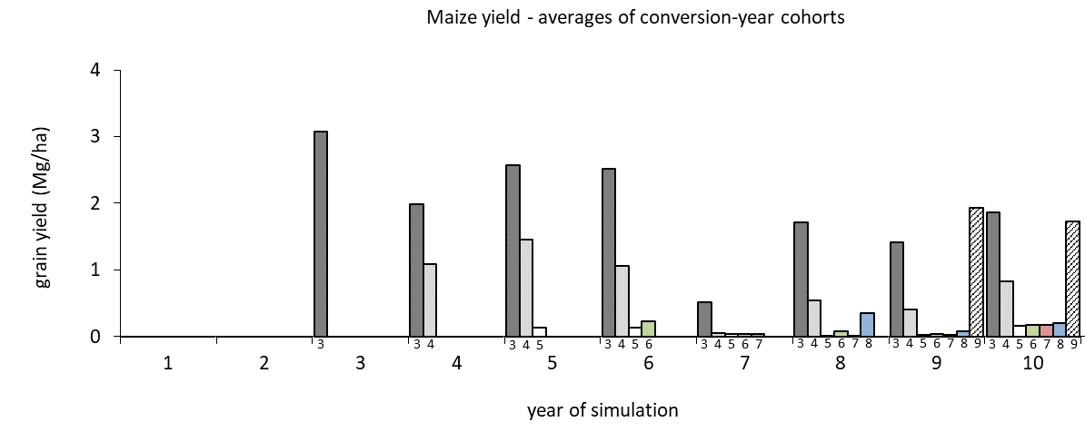
Appendix 6: Maize grain yield per ha, averages over five-pixel-cohorts that were converted to maize fields in the same year, indicated by the numbered bars (conversion-years 3 to 9). Pixel cohorts of years 3, 4 and 9 include 5, 2 and 3 former shrub grassland pixels, respectively (10 shrub grassland pixels were converted in total within 10 years).

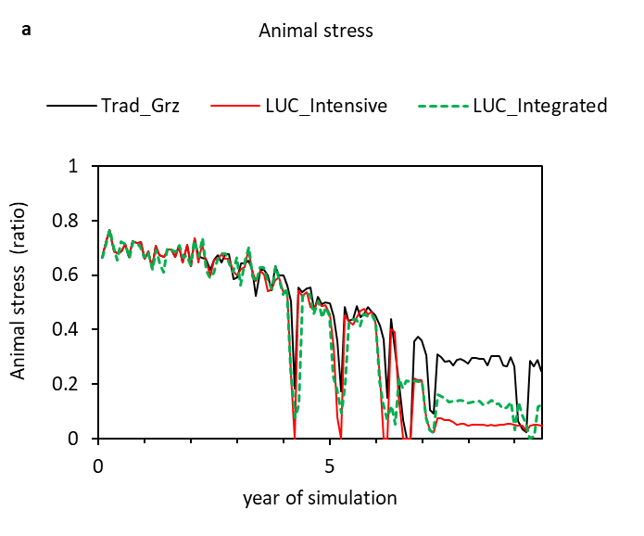 | 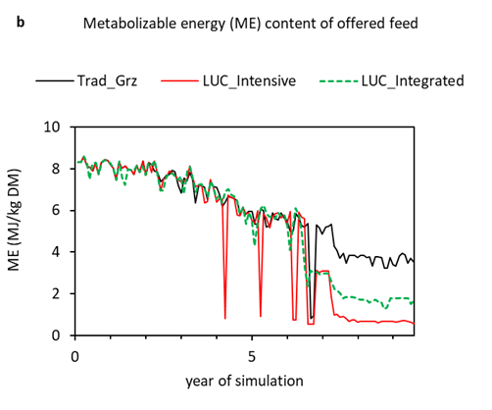
Appendix 7: (a) Animal stress expressed as metabolizable energy (ME) intake (MJ/d) in relation to required ME of the total herd (MJ/d), and (b) metabolizable energy content of the offered feed mixture for the baseline Trad_Grz and two LUC scenarios.

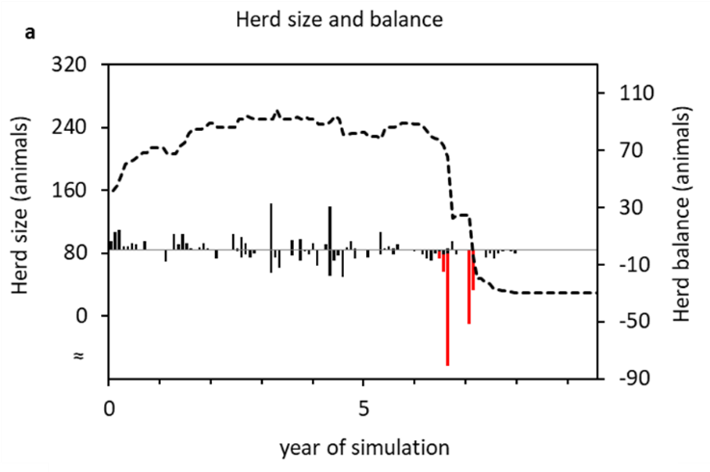 | 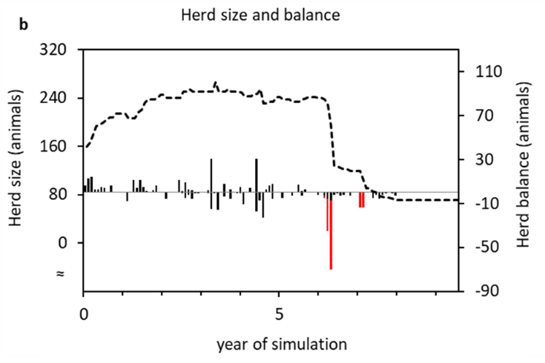
Appendix 8: Herd size (dashed line, left y-axis), combined with herd balance (right y-axis, positive bars = animals born, negative black bars = animals removed or sold, and negative red bars = animals died) for scenarios (a) LUC_Intensive and (b) LUC_Integrated.

