The Tale of Two Ions Na⁺ and Cl⁻: Unraveling Onion Plant Responses to Varying Salt Treatments
M. L. Romo-Pérez¹, C. H. Weinert², B. Egert², S. E. Kulling², C. Zörb¹
¹ University of Hohenheim, Institute of Crop Science, Quality of Plant Products 340e, Schloss Westflügel, 70599 Stuttgart, Germany. ² Max Rubner-Institut, Department of Safety and Quality of Fruit and Vegetables, Haid-und-Neu-Straße 9, 76131 Karlsruhe, Germany

Corresponding authors
M.L. Romo-Pérez: m.romoperez@uni-hohenheim.de
C. Zörb: Christian.zoerb@uni-hohenheim.de

Keywords: Salinity, Allium Cepa L., Sodium (Na⁺), Chloride (Cl⁻), Organic Acids, Tricarboxylic Acid Cycle (TCA), Metabolomics

Table S1 Basic properties of soil mixture at the transplanting time before general fertilization. EC, electrical conductivity
pH-value | NH4-N  mg/kg: | NO3-N  mg/kg: | S_{min}  mg/kg: | K  mg/kg: | P  mg/kg | EC  mS cm⁻¹
7.02 | 4.0 | 4.1 | 13.1 | 5.9 | 7.4 | 0.23

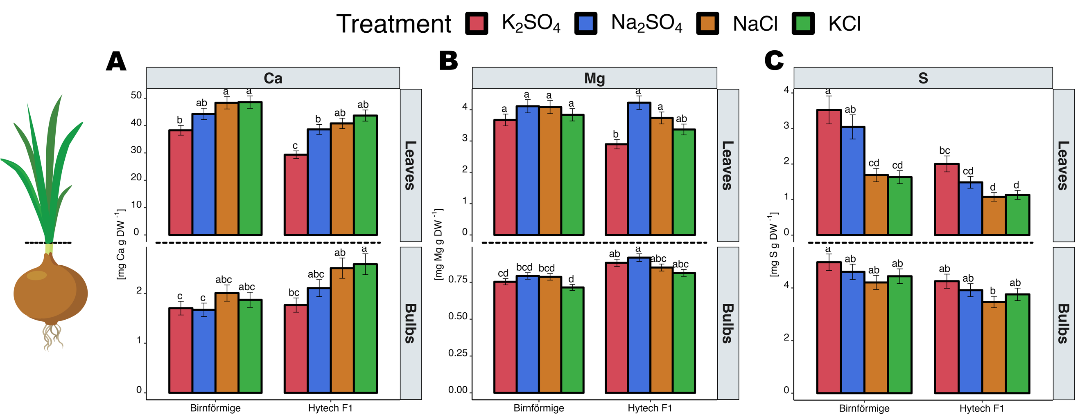
Figure S1 Concentration of Ca²⁺, M ²⁺ and total sulfur in onion bulbs and leaves

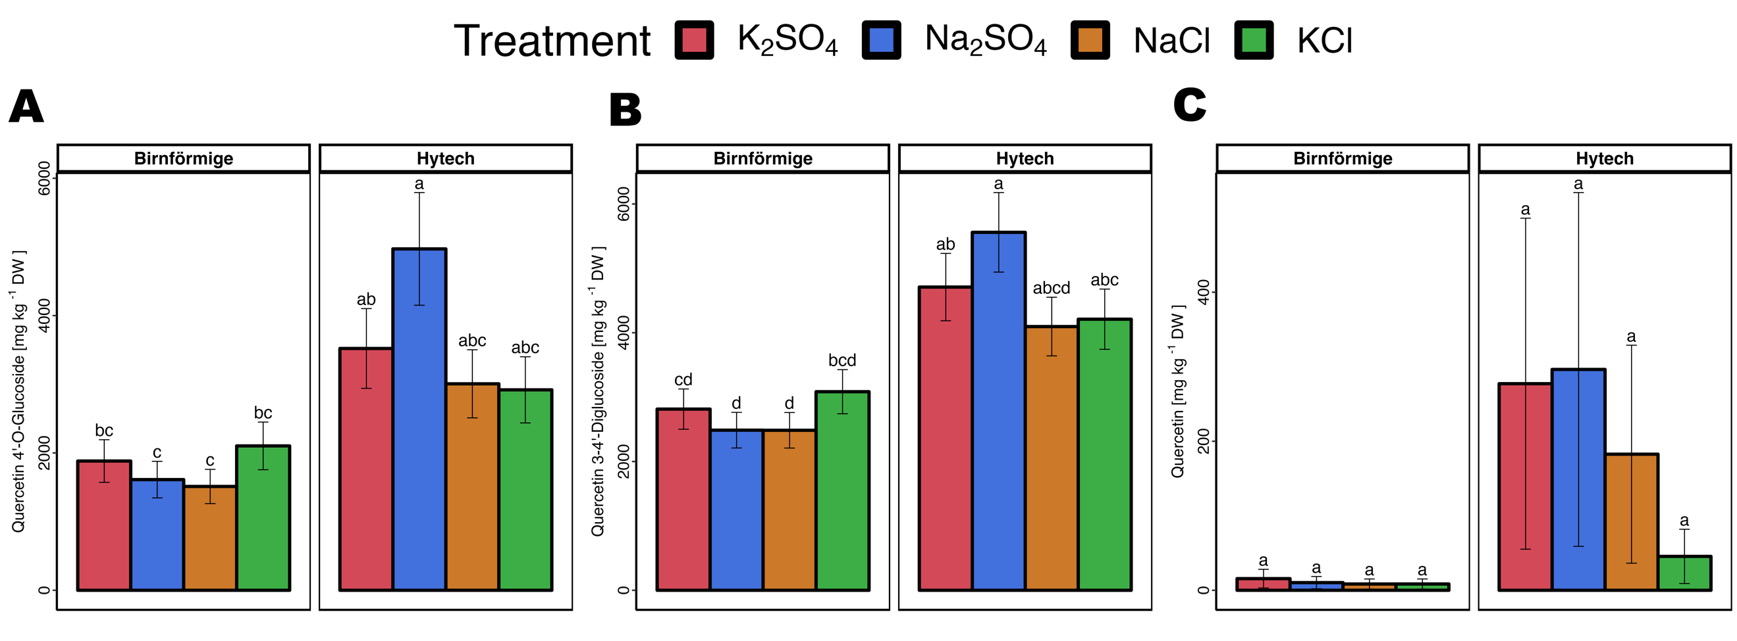
Figure S2 Quercetin concentration in onion bulbs. A: Quercetin-4’-O-Glucoside, B: Quercetine 3-4-Diglucoside, and C: Quercetin.

