Additional file

Table A1 Descriptive statistics for adults aged 18-65: SOEP 2002-2018
Variables | Obs. | Mean | S.D.
Life satisfaction (0-10) | 100,369 | 7.261 | 1.595
Body mass index (kg/m²) | 100,369 | 25.961 | 4.514
Obesityª | 100,369 | 0.162 | 0.369
Overweightª | 100,369 | 0.363 | 0.481
Normal weightª | 100,369 | 0.475 | 0.499
Net annual income | 100,369 | 23177.280 | 20533.620
Age | 100,369 | 43.171 | 11.356
Femaleª | 100,369 | 0.485 | 0.500
Marriedª | 100,369 | 0.621 | 0.485
Years of education | 100,369 | 12.689 | 2.752
Number of children in household | 100,369 | 0.741 | 1.013
Homeownerª | 100,369 | 0.526 | 0.499
ª Dummy variables
Notes: BMI = body mass index, defined as height (in m) divided by weight (in kg) squared. Obesity = BMI≥30; overweight = 25≤BMI<30; normal weight = 18.5≤BMI<25. Net annual income is in euros.

Table A2 Descriptive statistics of BMI: SOEP 2002-2018
Survey years | Weighted obs. | Mean | SD | Min. | Max.
Panel A: 18.5≤BMI≤60
2002 | 30,225,965 | 25.402 | 4.021 | 18.508 | 56.495
2004 | 30,354,902 | 25.557 | 4.127 | 18.508 | 57.099
2006 | 30,500,125 | 25.744 | 4.326 | 18.508 | 59.515
2008 | 32,661,480 | 25.983 | 4.452 | 18.513 | 59.028
2010 | 28,832,815 | 26.220 | 4.639 | 18.508 | 56.811
2012 | 27,528,187 | 26.217 | 4.645 | 18.508 | 58.280
2014 | 33,369,471 | 26.250 | 4.756 | 18.508 | 58.228
2016 | 33,595,886 | 26.435 | 4.813 | 18.508 | 58.770
2018 | 27,174,173 | 26.627 | 5.021 | 18.508 | 58.770
Panel B: 25≤BMI≤60
2002 | 14,459,108 | 28.624 | 3.278 | 25 | 56.495
2004 | 15,071,400 | 28.714 | 3.407 | 25 | 57.099
2006 | 15,644,538 | 28.902 | 3.641 | 25 | 59.515
2008 | 17,321,454 | 29.097 | 3.775 | 25 | 59.028
2010 | 15,732,495 | 29.337 | 3.965 | 25 | 56.811
2012 | 15,099,007 | 29.322 | 3.962 | 25 | 58.280
2014 | 18,066,621 | 29.464 | 4.112 | 25 | 58.228
2016 | 18,771,482 | 29.568 | 4.127 | 25 | 58.770
2018 | 15,338,314 | 29.788 | 4.424 | 25 | 58.770
Note: BMI = body mass index, defined as height (in m) divided by weight (in kg) squared. These results have sampling weights applied.

Table A3 OLS/ordered logit estimates of bodyweight on life satisfaction: SOEP 2018
 | BMI≥18.5 |  |  | BMI≥25
 | (1) | (2) |  | (3) | (4) | (5) | (6)
 | OLS | Ordered logit |  | OLS | OLS | Ordered logit | Ordered logit
Overweightª | -0.127** | -0.206***
 | (0.054) | (0.066)
Obesityª | -0.378*** | -0.510*** |  |  | -0.257*** |  | -0.320***
 | (0.067) | (0.080) |  |  | (0.067) |  | (0.081)
BMI (kg/m²) |  |  |  | -0.028*** |  | -0.034***
 |  |  |  | (0.008) |  | (0.009)
Ln(income) | 0.207*** | 0.259*** |  | 0.268*** | 0.269*** | 0.313*** | 0.314***
 | (0.041) | (0.047) |  | (0.058) | (0.058) | (0.066) | (0.066)
Age | -0.040** | -0.062*** |  | -0.041* | -0.043* | -0.056** | -0.059**
 | (0.016) | (0.020) |  | (0.023) | (0.023) | (0.028) | (0.028)
Age squared | 0.000* | 0.001** |  | 0.000 | 0.000 | 0.001* | 0.001*
 | (0.000) | (0.000) |  | (0.000) | (0.000) | (0.000) | (0.000)
Femaleª | 0.156*** | 0.207*** |  | 0.121 | 0.113 | 0.138 | 0.129
 | (0.054) | (0.063) |  | (0.076) | (0.075) | (0.089) | (0.088)
Years of education | 0.013 | 0.012 |  | -0.008 | -0.007 | -0.009 | -0.008
 | (0.009) | (0.011) |  | (0.013) | (0.013) | (0.015) | (0.015)
Marriedª | 0.480*** | 0.562*** |  | 0.564*** | 0.563*** | 0.676*** | 0.672***
 | (0.055) | (0.067) |  | (0.073) | (0.073) | (0.089) | (0.089)
Number of children | 0.047* | 0.083** |  | 0.033 | 0.039 | 0.072 | 0.080*
 | (0.026) | (0.034) |  | (0.034) | (0.034) | (0.047) | (0.047)
Homeownerª | 0.118** | 0.133** |  | 0.060 | 0.053 | 0.037 | 0.025
 | (0.050) | (0.059) |  | (0.066) | (0.066) | (0.079) | (0.079)
Constant | 5.992*** |  |  | 6.324*** | 5.587***
 | (0.414) |  |  | (0.590) | (0.564)
Observations | 11407 | 11407 |  | 6347 | 6347 | 6347 | 6347
ª Dummy variables
Notes: Dependent variable = life satisfaction. BMI = body mass index, defined as height (in m) divided by weight (in kg) squared. Obesity = BMI≥30; overweight = 25≤BMI<30; normal weight = 18.5≤BMI<25. Standard errors are in parentheses. *p < 0.1, **p < 0.05, ***p < 0.01.

Table A4 OLS estimates of BMI on life satisfaction: SOEP 2002-2018
 | (1) | (2) | (3) | (4) | (5) | (6) | (7) | (8) | (9)
 | SWB | SWB | SWB | SWB | SWB | SWB | SWB | SWB | SWB
BMI (kg/m²) | -0.024** | -0.018* | -0.031*** | -0.041*** | -0.025** | -0.015* | -0.029*** | -0.024*** | -0.028***
 | (0.010) | (0.011) | (0.010) | (0.014) | (0.012) | (0.009) | (0.007) | (0.007) | (0.008)
Ln(income) | 0.314*** | 0.377*** | 0.382*** | 0.349*** | 0.284*** | 0.312*** | 0.263*** | 0.389*** | 0.268***
 | (0.069) | (0.065) | (0.052) | (0.067) | (0.059) | (0.053) | (0.051) | (0.051) | (0.058)
Age | -0.129*** | -0.198*** | -0.169*** | -0.135*** | -0.161*** | -0.119*** | -0.099*** | -0.074*** | -0.041*
 | (0.026) | (0.027) | (0.025) | (0.029) | (0.027) | (0.022) | (0.020) | (0.022) | (0.023)
Age squared | 0.001*** | 0.002*** | 0.002*** | 0.001*** | 0.002*** | 0.001*** | 0.001*** | 0.001** | 0.000
 | (0.000) | (0.000) | (0.000) | (0.000) | (0.000) | (0.000) | (0.000) | (0.000) | (0.000)
Femaleª | 0.248*** | 0.213** | 0.195** | 0.063 | 0.248*** | 0.167** | 0.128** | 0.303*** | 0.121
 | (0.083) | (0.093) | (0.084) | (0.094) | (0.087) | (0.076) | (0.065) | (0.069) | (0.076)
Years of education | 0.016 | 0.020 | 0.032** | -0.001 | 0.020 | 0.013 | -0.000 | -0.018 | -0.008
 | (0.014) | (0.014) | (0.013) | (0.015) | (0.014) | (0.013) | (0.011) | (0.012) | (0.013)
Marriedª | 0.413*** | 0.438*** | 0.430*** | 0.448*** | 0.484*** | 0.341*** | 0.319*** | 0.383*** | 0.564***
 | (0.084) | (0.091) | (0.086) | (0.087) | (0.092) | (0.078) | (0.067) | (0.071) | (0.073)
Number of children | -0.084** | -0.047 | 0.053 | 0.022 | 0.129*** | 0.046 | 0.069** | 0.054* | 0.033
 | (0.036) | (0.041) | (0.042) | (0.049) | (0.050) | (0.049) | (0.029) | (0.032) | (0.034)
Homeownerª | 0.252*** | 0.220*** | 0.232*** | 0.102 | 0.127* | 0.220*** | 0.169*** | 0.161** | 0.060
 | (0.066) | (0.072) | (0.069) | (0.077) | (0.075) | (0.068) | (0.059) | (0.064) | (0.066)
Constant | 6.834*** | 7.044*** | 6.980*** | 7.482*** | 7.997*** | 6.916*** | 7.560*** | 6.163*** | 6.324***
 | (0.845) | (0.751) | (0.675) | (0.833) | (0.756) | (0.673) | (0.556) | (0.584) | (0.590)
Observations | 5727 | 5305 | 5432 | 5137 | 4837 | 5143 | 7782 | 7032 | 6347
ª Dummy variables
Notes: Dependent variable = life satisfaction. BMI = body mass index, defined as height (in m) divided by weight (in kg) squared. Columns (1) through (9) use data from SOEP 2002, 2004, 2006, 2008, 2010, 2012, 2014, 2016 and 2018, respectively. Standard errors are in parentheses. *p < 0.1, **p < 0.05, ***p < 0.01.

Table A5 OLS estimates of overweight and obesity on life satisfaction: SOEP 2002-2018
 | (1) | (2) | (3) | (4) | (5) | (6) | (7) | (8) | (9)
 | SWB | SWB | SWB | SWB | SWB | SWB | SWB | SWB | SWB
Overweightª | 0.002 | -0.153*** | -0.041 | -0.011 | -0.080 | -0.091* | -0.049 | -0.061 | -0.127**
 | (0.049) | (0.057) | (0.055) | (0.062) | (0.063) | (0.054) | (0.047) | (0.051) | (0.054)
Obesityª | -0.136* | -0.228*** | -0.222*** | -0.275*** | -0.313*** | -0.254*** | -0.181*** | -0.222*** | -0.378***
 | (0.074) | (0.078) | (0.078) | (0.086) | (0.084) | (0.070) | (0.061) | (0.062) | (0.067)
Ln(income) | 0.316*** | 0.302*** | 0.335*** | 0.284*** | 0.249*** | 0.241*** | 0.222*** | 0.270*** | 0.207***
 | (0.041) | (0.044) | (0.038) | (0.046) | (0.044) | (0.036) | (0.035) | (0.036) | (0.041)
Age | -0.137*** | -0.153*** | -0.143*** | -0.119*** | -0.123*** | -0.101*** | -0.088*** | -0.075*** | -0.040**
 | (0.015) | (0.018) | (0.016) | (0.019) | (0.019) | (0.015) | (0.014) | (0.015) | (0.016)
Age squared | 0.001*** | 0.002*** | 0.002*** | 0.001*** | 0.001*** | 0.001*** | 0.001*** | 0.001*** | 0.000*
 | (0.000) | (0.000) | (0.000) | (0.000) | (0.000) | (0.000) | (0.000) | (0.000) | (0.000)
Femaleª | 0.271*** | 0.186*** | 0.171*** | 0.155** | 0.233*** | 0.147*** | 0.113** | 0.223*** | 0.156***
 | (0.052) | (0.062) | (0.057) | (0.063) | (0.064) | (0.051) | (0.048) | (0.048) | (0.054)
Years of education | 0.039*** | 0.032*** | 0.036*** | 0.027*** | 0.040*** | 0.027*** | 0.020** | 0.007 | 0.013
 | (0.009) | (0.011) | (0.009) | (0.010) | (0.011) | (0.009) | (0.008) | (0.009) | (0.009)
Marriedª | 0.342*** | 0.367*** | 0.338*** | 0.348*** | 0.398*** | 0.312*** | 0.307*** | 0.328*** | 0.480***
 | (0.057) | (0.065) | (0.063) | (0.065) | (0.067) | (0.056) | (0.049) | (0.053) | (0.055)
Number of children | -0.012 | -0.025 | 0.066** | 0.039 | 0.065* | 0.054 | 0.068*** | 0.089*** | 0.047*
 | (0.026) | (0.029) | (0.032) | (0.035) | (0.037) | (0.034) | (0.022) | (0.023) | (0.026)
Homeownerª | 0.296*** | 0.259*** | 0.273*** | 0.169*** | 0.114** | 0.228*** | 0.160*** | 0.193*** | 0.118**
 | (0.045) | (0.051) | (0.050) | (0.055) | (0.058) | (0.048) | (0.043) | (0.046) | (0.050)
Constant | 6.019*** | 6.426*** | 5.982*** | 6.271*** | 6.689*** | 6.771*** | 6.698*** | 6.438*** | 5.992***
 | (0.414) | (0.424) | (0.395) | (0.454) | (0.479) | (0.380) | (0.344) | (0.369) | (0.414)
Observations | 11985 | 10793 | 10657 | 9725 | 9044 | 9391 | 14523 | 12844 | 11407
ª Dummy variables
Notes: Dependent variable = life satisfaction. BMI = body mass index, defined as height (in m) divided by weight (in kg) squared. Obesity= BMI≥30; overweight = 25≤BMI<30; normal weight = 18.5≤BMI<25. Columns (1) through (9) use data from SOEP 2002, 2004, 2006, 2008, 2010, 2012, 2014, 2016, and 2018, respectively. Standard errors are in parentheses. *p < 0.1, **p < 0.05, ***p < 0.01.

Figure A1 Trends in the components of the intangible cost of overweight
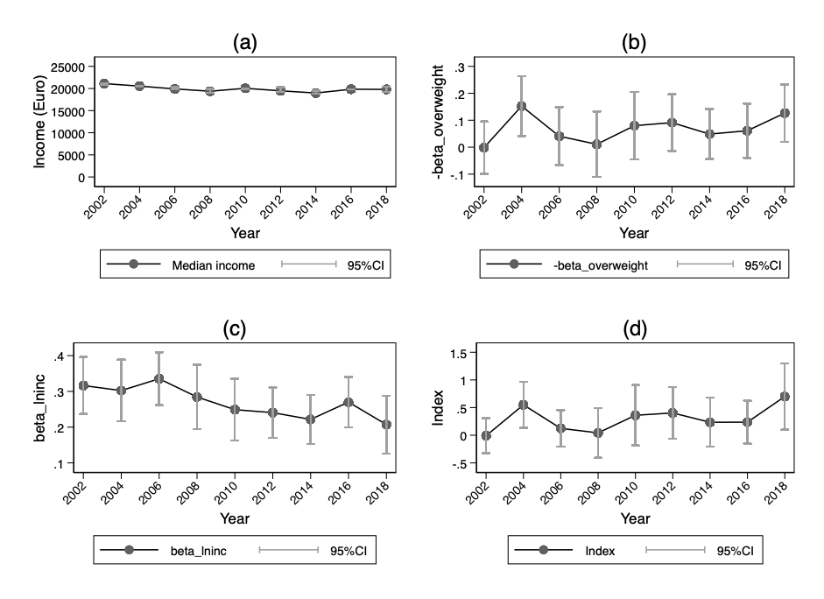
(a) median annual net income in 2018 euros. (b) and (c) the coefficients of overweight and income, respectively, based on equation 10. (d) the trend in the index, which denotes the negative division of the coefficient of overweight and income. The confidence interval is calculated using Fieller’s theorem (see Appendix Table A5 for regression results).

Figure A2 Trends in the components of the intangible cost of obesity
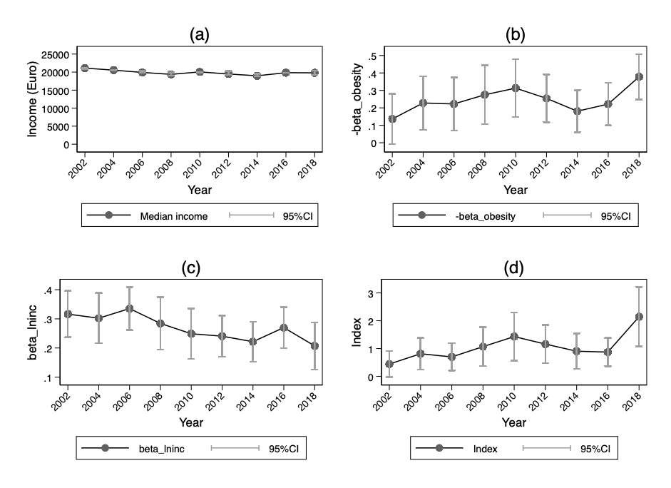
(a) median annual net income in 2018 euros. (b) and (c) the coefficients of obesity and income, respectively, based on equation 10. (d) the trend in the index, which denotes the negative division of the coefficient of obesity and income. The confidence interval is calculated using Fieller’s theorem (see Appendix Table A5 for regression results).

Table A6 OLS/ordered logit estimates of BMI on life satisfaction by different income levels: SOEP 2002-2018
 | OLS |  |  |  | Ordered logit
 | (1) | (2) | (3) |  | (5) | (6) | (7)
 | Low | Middle | High |  | Low | Middle | High
BMI (kg/m²) | -0.025*** | -0.021*** | -0.033*** |  | -0.026*** | -0.023*** | -0.042***
 | (0.006) | (0.006) | (0.005) |  | (0.005) | (0.006) | (0.006)
Ln(income) | 0.186*** | 0.617*** | 0.556*** |  | 0.161*** | 0.663*** | 0.758***
 | (0.041) | (0.129) | (0.050) |  | (0.041) | (0.137) | (0.070)
Age | -0.137*** | -0.124*** | -0.123*** |  | -0.138*** | -0.132*** | -0.160***
 | (0.014) | (0.014) | (0.017) |  | (0.015) | (0.016) | (0.022)
Age squared | 0.001*** | 0.001*** | 0.001*** |  | 0.001*** | 0.001*** | 0.002***
 | (0.000) | (0.000) | (0.000) |  | (0.000) | (0.000) | (0.000)
Femaleª | 0.278*** | 0.188*** | 0.080* |  | 0.288*** | 0.238*** | 0.124**
 | (0.054) | (0.043) | (0.048) |  | (0.054) | (0.047) | (0.061)
Years of education | -0.023** | -0.001 | 0.002 |  | -0.022** | -0.002 | -0.001
 | (0.011) | (0.009) | (0.006) |  | (0.011) | (0.010) | (0.008)
Marriedª | 0.594*** | 0.351*** | 0.282*** |  | 0.574*** | 0.373*** | 0.361***
 | (0.058) | (0.044) | (0.042) |  | (0.057) | (0.048) | (0.053)
Number of children | 0.024 | 0.019 | -0.010 |  | 0.023 | 0.029 | 0.010
 | (0.029) | (0.024) | (0.019) |  | (0.029) | (0.028) | (0.025)
Homeownerª | 0.213*** | 0.144*** | 0.118*** |  | 0.232*** | 0.144*** | 0.127***
 | (0.045) | (0.039) | (0.036) |  | (0.047) | (0.044) | (0.046)
Constant | 8.557*** | 4.013*** | 5.107***
 | (0.455) | (1.268) | (0.625)
Observations | 15274 | 17609 | 19859 |  | 15274 | 17609 | 19859
ª Dummy variables
Notes: BMI = body mass index, defined as height (in m) divided by weight (in kg) squared. Columns (1)-(3) report the OLS estimates for the low-, middle-, and high-income quartiles, respectively; columns (4)-(6) report the same estimates from the ordered logit model. *p < 0.1, **p < 0.05, ***p < 0.01.

