Supplementary Material 1
Fig. S1
Species accumulation curve of parasitoid from various sampling methods
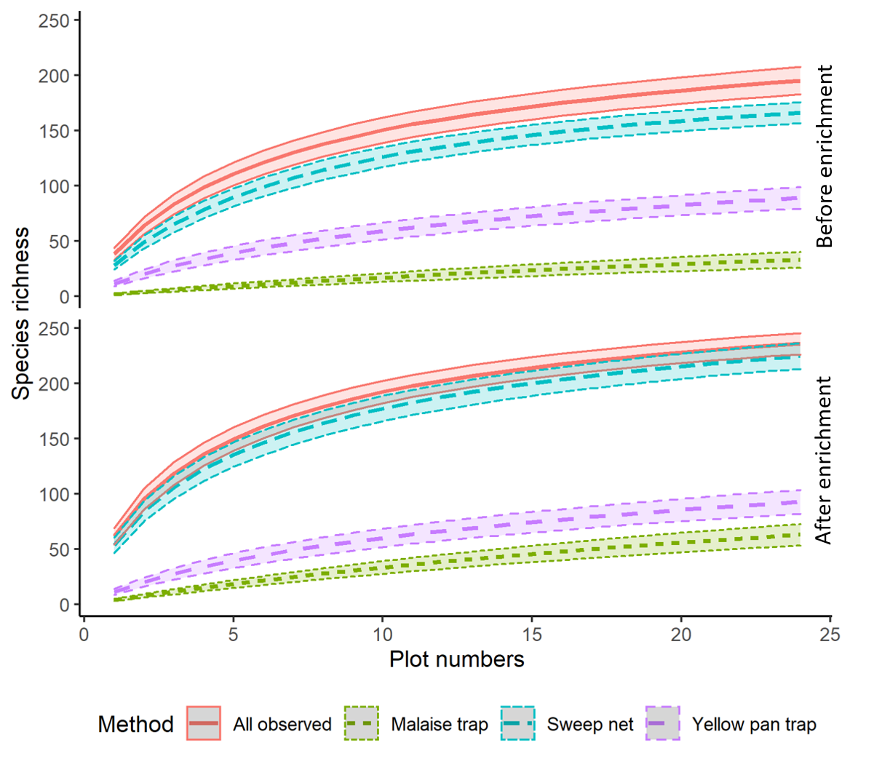
Supplementary Material 2
Observed and estimated species richness (based on ACE value) in different land use type.
Landuse type | Before flower enrichment |  |  |  | After flower enrichment
Landuse type | S | ACE | Obs (%) |  | S | ACE | Obs (%)
Forest | 138 | 172 | 80.23 |  | 189 | 226 | 83.63
Oil palm | 133 | 180 | 73.89 |  | 133 | 165 | 80.60
Rubber | 111 | 172 | 64.53 |  | 156 | 187 | 83.42
S= observed species richness; ACE= estimate species richness based on ACE value; Obs(%)= percentage of species observed

Supplementary Material 3
Dissimilarity of parasitoid species (Bray-Curtis index) between different land use types and treatment
 | Before forest | Before oil palm | Before rubber | After forest | After oil palm | After rubber
Before forest | 0
Before oil palm | 0,5081 | 0
Before rubber | 0,6208 | 0,5110 | 0
After forest | 0,5362 | 0,6461 | 0,8009 | 0
After oil palm | 0,5733 | 0,4020 | 0,6145 | 0,6361 | 0
After rubber | 0,5761 | 0,4986 | 0,7235 | 0,5124 | 0,4556 | 0

