Supplement
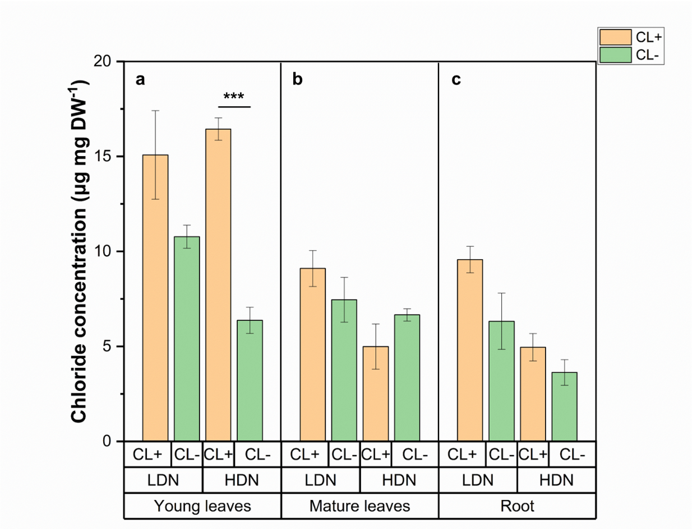
S1. Chloride concentration of young and mature leaves and root in Scoop. a) Cl⁻ concentration in young leaves; b) Cl⁻ concentration in mature leaves; c) Cl⁻ concentration in roots. LDN, low depletion NO₃⁻ level with NO₃⁻ concentration of 93 μg mg FW⁻¹ in mature leaves; HDN, high depletion NO₃⁻ level with NO₃⁻ concentration of 49.6 μg mg FW⁻¹ in mature leaves; yellow bars: CL+, leaf brushing with 60 mM CaCl₂; green bars: CL-, non-brushing; The values represent means ± SE of four independent pots.*** p< 0.001. To simplify, we use CL+ for Cl- brushing treatment and CL- for non-brushing.
S2. Nitrate concentration of young and mature leaves and root in Scoop. a) NO₃⁻ concentration in young leaves; b) NO₃⁻ concentration in mature leaves; c) NO₃⁻ concentration in roots. LDN, low depletion NO₃⁻ level with NO₃⁻ concentration of 93 μg mg FW⁻¹ in mature leaves; HDN, high depletion NO₃⁻ level with NO₃⁻ concentration of 49.6 μg mg FW⁻¹ in mature leaves; yellow bars: CL+, leaf brushing with 60 mM CaCl₂; green bars: CL-, non-brushing; The values represent means ± SE of four independent pots.* p< 0.05, ** p< 0.01. To simplify, we use CL+ for Cl- brushing treatment and CL- for non-brushing.
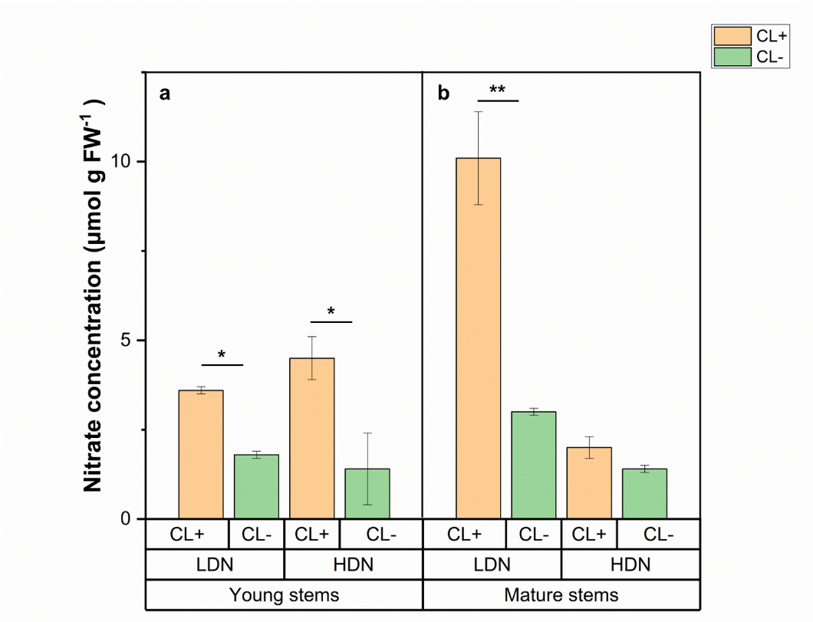
S3. Nitrate concentration of young and mature stems in Feugo. a) NO₃⁻ concentration in young stems; b) NO₃⁻ concentration in mature stems. LDN, low depletion NO₃⁻ level with NO₃⁻ concentration of 93 μg mg FW⁻¹ in mature leaves; HDN, high depletion NO₃⁻ level with NO₃⁻ concentration of 49.6 μg mg FW⁻¹ in mature leaves; yellow bars: CL+, leaf brushing with 60 mM CaCl₂; green bars: CL-, non-brushing; The values represent means ± SE of four independent pots.* p< 0.05, ** p< 0.01. To simplify, we use CL+ for Cl- brushing treatment and CL- for non-brushing.

