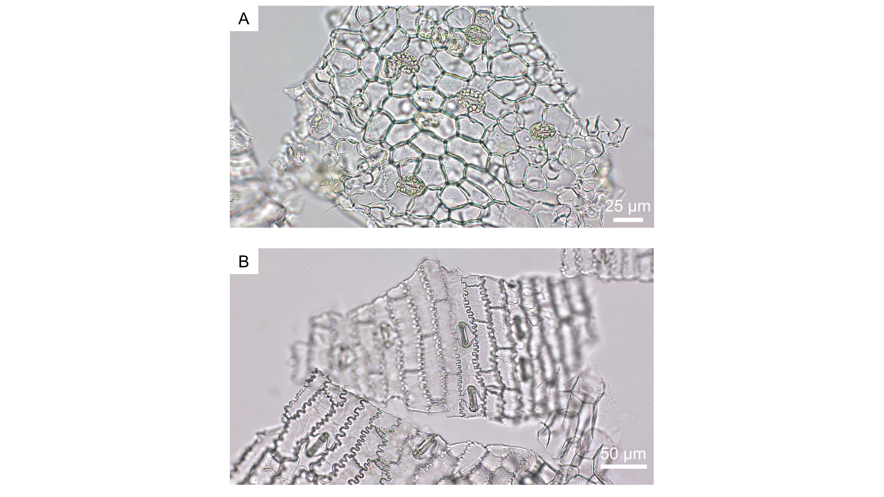
Supplementary figure 1: Microscopic images (Axiolab 5, Zeiss, Oberkochen, Germany) of guard cells in bright field of grapevine (A) and maize (B).

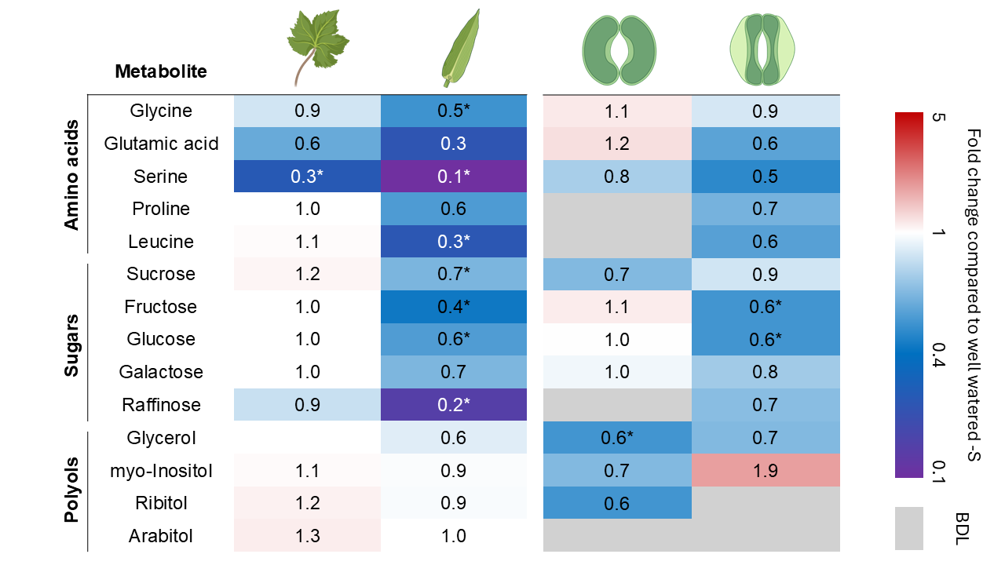
Supplementary figure 2: Analysis of changes of amino acids, sugars, and polyols in leaf material of V. vinifera (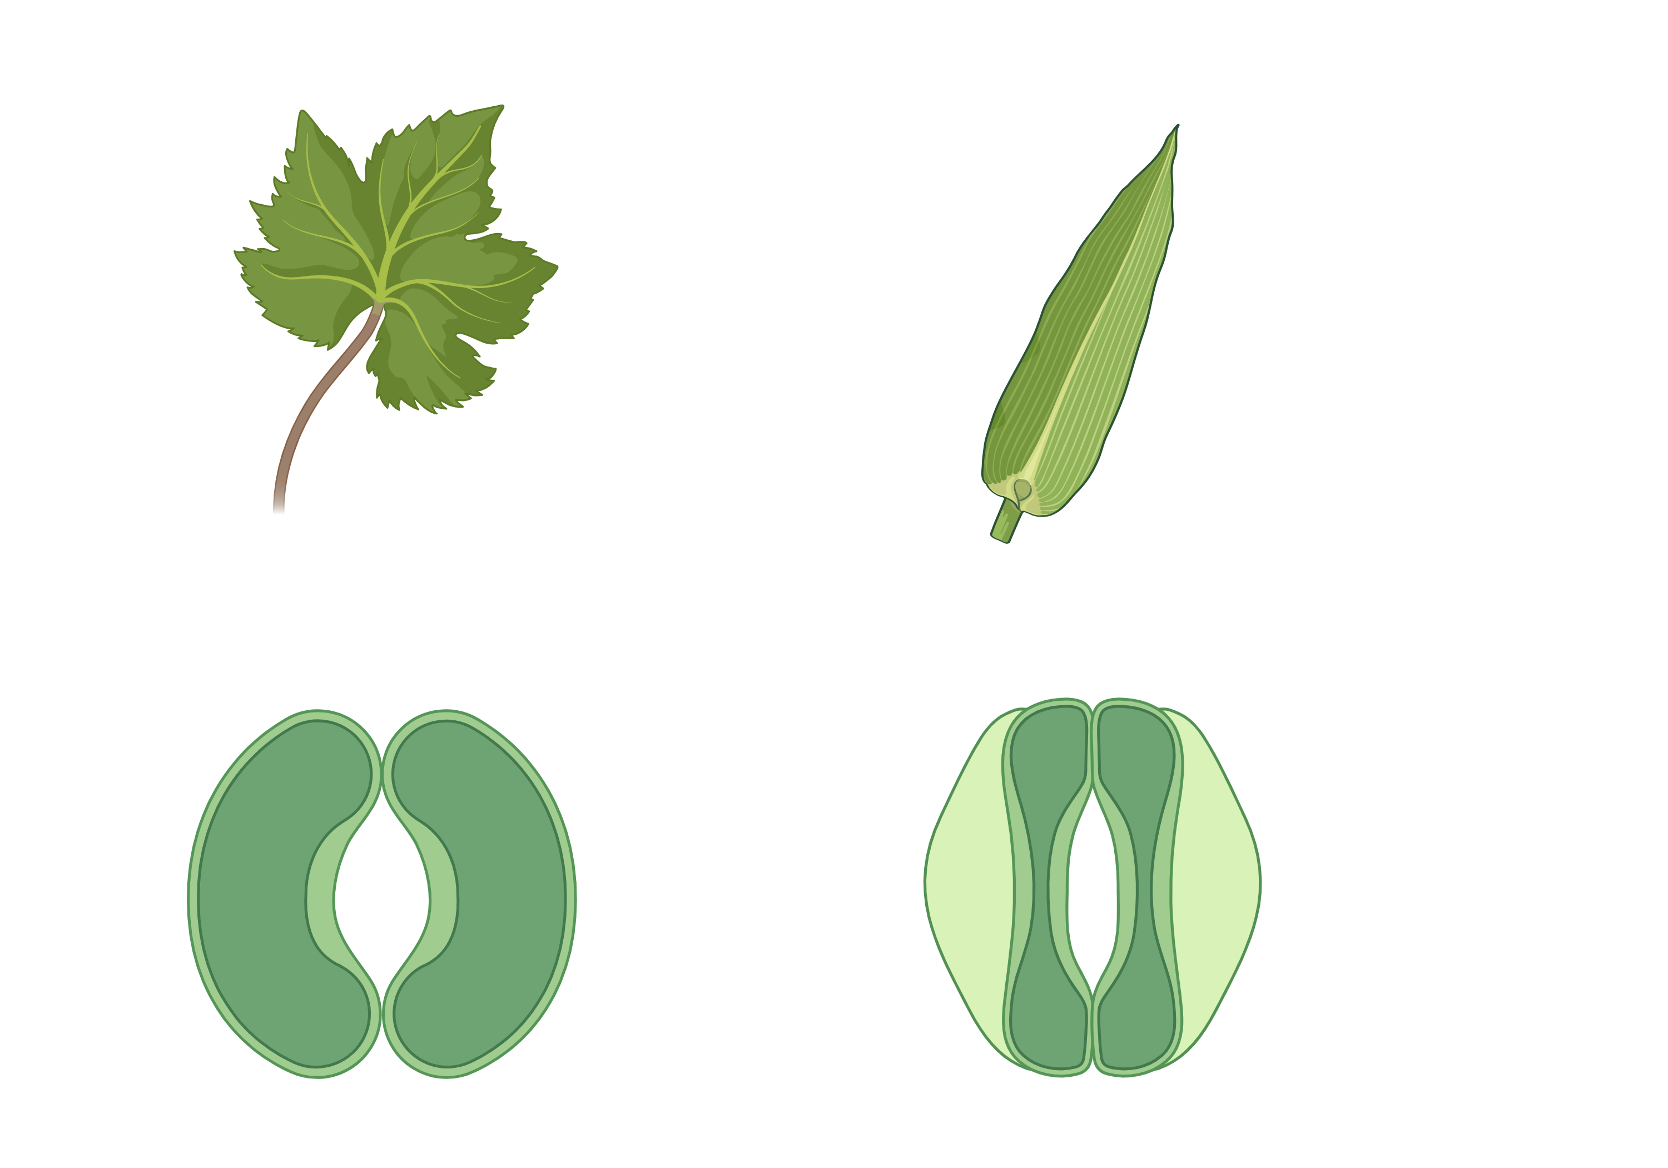) and Z. mays () and guard cells of V. vinifera () and Z. mays () in response to additional sulfate application. The alterations in metabolite concentrations of well-watered plants with additional sulfate application (WW+S) are given relative to well-watered plants without additional sulfate application (WW-S), given as fold change; mean values n=3-5, ± standard error (BDL: below detection limit; Wilcoxon, Mann-Whitney Test with pairwise comparison of WW+S and WW-S: * p ≤ 0.05). (Raw metabolite data of WW+S treatment according to Lehr et al., 2024)

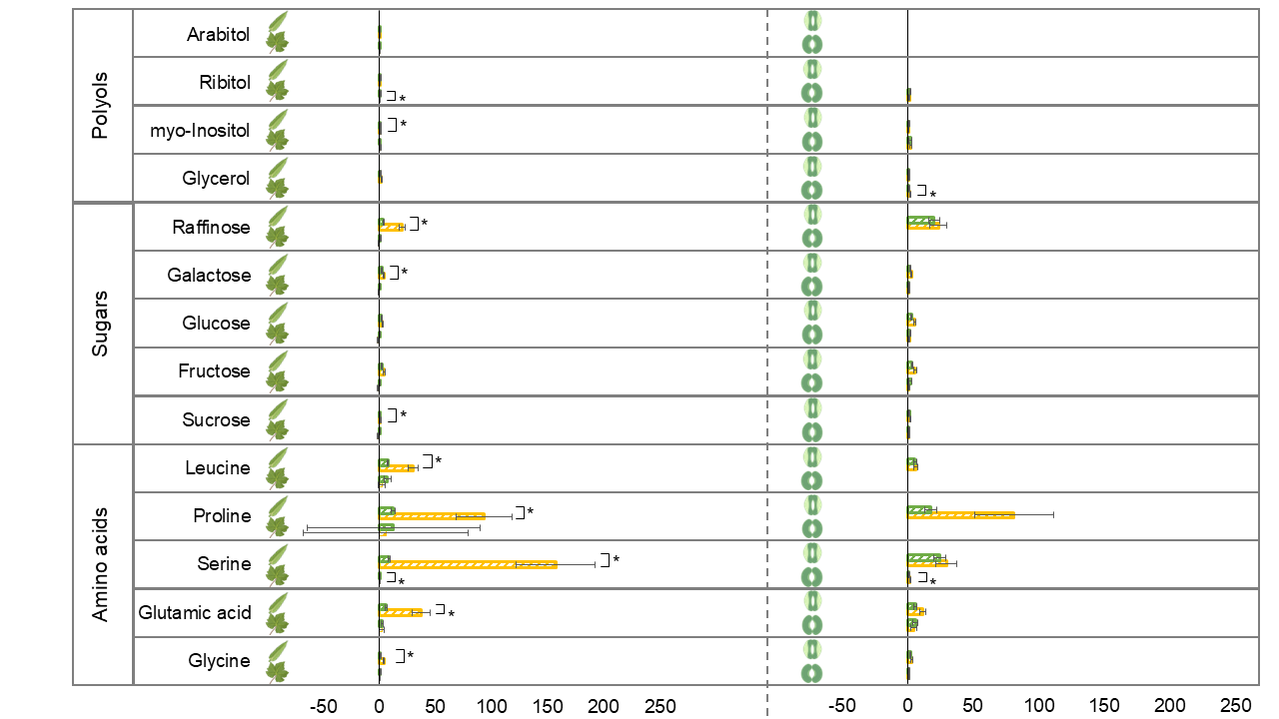
Fold changes compared to well-watered +S and well-watered -S
Drought stress +S (DS+S) Drought stress -S (DS-S)

Supplementary figure 3: Analysis of changes of amino acids, sugars, and polyols in leaf material of V. vinifera ( ) and Z. mays () and guard cells of V. vinifera () and Z. mays () in response to sulfate application and drought stress. The alterations in metabolite concentrations of drought stressed plants with additional sulfate application (DS+S) are given relative to well-watered plants with additional sulfate application. The alterations in metabolite concentrations of drought stressed plants without additional sulfate application (DS-S) are given in comparison to well-watered plants without additional sulfate application, given as fold change; mean values n=3-5, ± standard error (Wilcoxon, Mann-Whitney Test with pairwise comparison of WW+S and WW-S: * p≤0.05). (Raw metabolite data of DS+S treatment according to Lehr et al., 2024.)

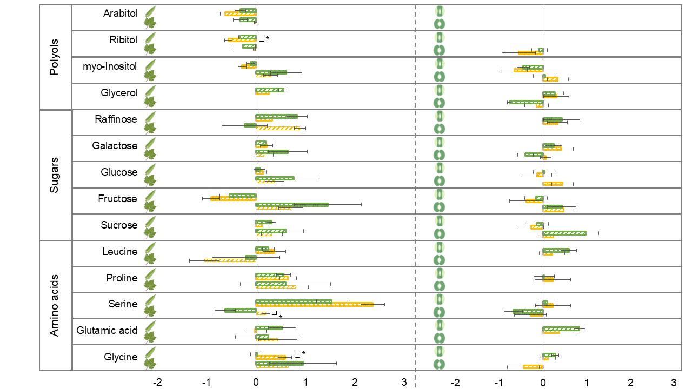
Log₂ fold changes after rewatering compared to well-watered +S and well-watered -S
Drought stress +S (DS+S) Drought stress -S (DS-S)

Supplementary figure 4: Analysis of changes of amino acids, sugars, and polyols in leaf material of V. vinifera ( ) and Z. mays () and guard cells of V. vinifera () and Z. mays () in response to sulfate application and drought stress. The alterations in metabolite concentrations of rewatered plants with additional sulfate application (DS+S) are given relative to well-watered plants with additional sulfate application. The alterations in metabolite concentrations of rewatered plants without additional sulfate application (DS-S) are given in comparison to well-watered plants without additional sulfate application, given as log₂ fold change; mean values n=3-5, ± standard error (Wilcoxon, Mann-Whitney Test with pairwise comparison of WW+S and WW-S: * p≤0.05). (Raw metabolite data of DS+S treatment according to Lehr et al., 2024.)

