Supplementary Material
Bioaccessibility and anti-inflammatory activity in Caco-2 cells of phytochemicals from industrial by-products of coffee (Coffea arabica L.)

Milena Jiménez-Gutiérrez^{a,d}, Christian Zielinski^{b}, María Viñasª, Patricia Esquivel^{c}, Jan Frank^{b}, Andrea Irías-Mataª, Felipe Jiménez-Aspee^{b,*}
ª Centro para Investigaciones en Granos y Semillas (CIGRAS), Universidad de Costa Rica, 2060, San Pedro, Costa Rica.
^{b} Department of Food Biofunctionality (140b), Institute of Nutritional Sciences, University of Hohenheim, D-70599 Stuttgart, Germany.
^{c} Escuela de Tecnología de Alimentos, Universidad de Costa Rica, 2060, San Pedro, Costa Rica.
^{d} Escuela de Química, Universidad de Costa Rica, 2060, San Pedro, Costa Rica.

*Corresponding author: Felipe Jiménez-Aspee
E-mail address: felipe.jimenez@nutres.de

Table S1. Analytical parameters for the quantification of (poly)phenols by HPLC-DAD.

Standard | Linear range  (µmol/L) | Linear response  (r²) | Equation | Detection limit  (µmol/L) | Quantification limit (µmol/L)
Gallic acid | 0.78-200 | 0.9989 | Y=14422.76X+ 6905.9 | 2.34 | 7.82
3-caffeoylquinic acid | 1.56-400 | 0.9984 | Y=22144.28X + 4460.8 | 4.15 | 13.86
Quercetin-3-rutinoside | 0.16-20 | 0.9973 | Y=22285.71X + 822.31 | 0.22 | 0.75
Quercetin-3-glycoside | 0.08-20 | 0.9964 | Y=27638.16X + 1636.7 | 0.28 | 0.95
Mangiferin | 0.19-50 | 0.9992 | Y=20557.16X+ 840.38 | 0.42 | 1.40
p-Coumaric acid | 0.39-100 | 0.9991 | Y=30491.85X+ 1575.6 | 0.86 | 2.86
Ferulic acid | 0.39-100 | 0.9992 | Y=25183.84X + 3999.1 | 0.84 | 2.82
Cyanidin-3-glycoside | 0.10-100 | 0.9991 | Y=34687.43X + 9004.7 | 0.80 | 2.68
Cyanidin-3-rutinoside | 0.10-100 | 0.9975 | Y=23829.98X + 9029.76 | 0.92 | 3.08
Caffeine | 0.98-500 | 0.9975 | Y=11698.6.16X -4843.38 | 5.73 | 19.1

Table S2. Correlation between compound bioaccessibility and cytokine reduction in digested coffee husk and mucilage.

Compound | Cytokine reduction | Spearman rho value | p value
3-caffeoylquinic acid | %IL-8 reduction | -0.533796228 | 0.000799937
 | %IL-6 reduction | -0.347040861 | 0.038107088
 | %TNF-α reduction | -0.309706655 | 0.066040642
5-caffeoylquinic acid | %IL-8 reduction | -0.560748933 | 0.000374723
 | %IL-6 reduction | -0.433469047 | 0.008266523
 | %TNF-α reduction | -0.431400483 | 0.008614559
Caffeic acid | %IL-8 reduction | -0.217041243 | 0.203547295
 | %IL-6 reduction | -0.218317155 | 0.200837153
 | %TNF-α reduction | -0.501612201 | 0.001828566
Caffeine | %IL-8 reduction | -0.567446985 | 0.000307212
 | %IL-6 reduction | -0.35764862 | 0.032228769
 | %TNF-α reduction | -0.568961753 | 0.000293543
Coumaric acid | %IL-8 reduction | -0.352323666 | 0.035079311
 | %IL-6 reduction | -0.431149936 | 0.00865755
 | %TNF-α reduction | -0.240845997 | 0.157067114
Dicaffeoylquinic acid | %IL-8 reduction | -0.312214959 | 0.063764425
 | %IL-6 reduction | -0.393346772 | 0.017627495
 | %TNF-α reduction | -0.088576659 | 0.607450931
Ferulic acid | %IL-8 reduction | 0.097856045 | 0.570183836
 | %IL-6 reduction | -0.145858523 | 0.395982328
 | %TNF-α reduction | 0.174972731 | 0.30740277
Mangiferin | %IL-8 reduction | -0.129901768 | 0.450181788
 | %IL-6 reduction | -0.346993726 | 0.038135028
 | %TNF-α reduction | 0.164925965 | 0.336433163
Quercetin-3-glycoside | %IL-8 reduction | -0.736859245 | 2.98656E⁻⁰⁷
 | %IL-6 reduction | -0.533931375 | 0.000797025
 | %TNF-α reduction | -0.517826447 | 0.001217911
Rutin | %IL-8 reduction | -0.767684527 | 4.66638E⁻⁰⁸
 | %IL-6 reduction | -0.496352317 | 0.002077478
 | %TNF-α reduction | -0.578520336 | 0.000219126

Husk
Mucilage
273 nm
320 nm
360 nm
520 nm
0
5
10
15
20
25
30
35
40
45
50
55
min
0
5
10
15
20
25
30
35
40
45
50
55
min
0
20
40
80
100
60
0
20
40
80
100
60
0
20
40
80
100
60
0
20
40
80
100
60
0
20
40
80
100
60
0
20
40
80
100
60
0
20
40
80
100
60
0
20
40
80
100
60
19
19
29
31
29
31
mAu
mAu
20
20
9
9
34
37
38
22 27 28
39
34
22 27 28
39
37
38

Fig. S1. Chromatographic profile of free (poly)phenols and alkaloids present in coffee husk and mucilage. Number labels refer to Table 1 of the main manuscript.

Husk
Mucilage
273 nm
320 nm
20
20
34
0
20
40
80
100
60
0
20
40
80
100
60
0
20
40
80
100
60
0
20
40
80
100
60
mAu
mAu
2
28
39
0
5
10
15
20
25
30
35
40
45
50
55
min
0
5
10
15
20
25
30
35
40
45
50
55
min
19
2
20
3
20
34
28
39

Fig. S2. Chromatographic profile of bound (poly)phenols and alkaloids present in coffee husk and mucilage. Number labels refer to Table 1 of the main manuscript.
a)
b)
1
8
19
19
1
8
0
0.5
1.0
1.5
2.0
2.5
3.0
3.5
4.0
4.5
5.0
5.5
min
6.0
6.5
7.0
7.5
10.0
10.5
8.0
8.5
9.0
9.5
3.0
3.5
4.0
4.5
5.0
5.5
6.0
6.5
7.0
0
0.5
1.0
1.5
2.0
2.5
3.0
3.5
4.0
4.5
5.0
5.5
min
6.0
6.5
7.0
7.5
10.0
10.5
8.0
8.5
9.0
9.5
0
20
40
60
80
100
0
20
40
60
80
100
mAu
mAu

Fig. S3. Chromatographic profile of alkaloids present in coffee husk and mucilage. Number labels refer to Table 1 of the main manuscript.

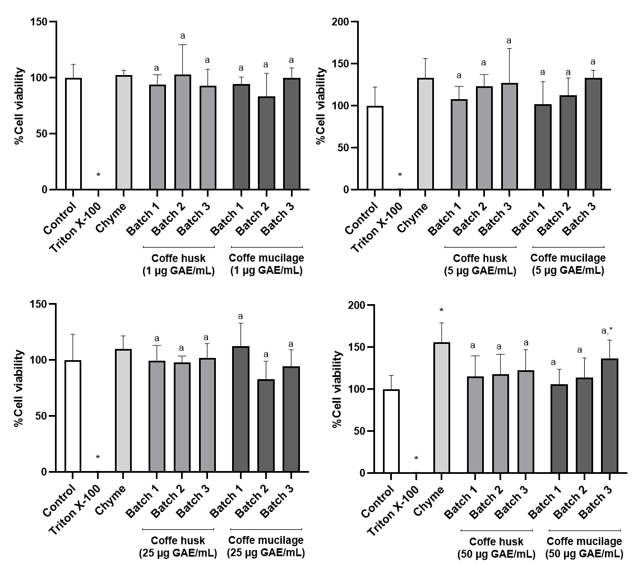

Fig. S4. Evaluation of the cytotoxicity of the bioaccessible fraction of coffee husk and mucilage on differentiated Caco-2 cells. Bars labelled with different lower-case letters indicate significant differences with the chyme at p < 0.05 according to Tukey´s test. * Indicates significant difference with the 100% viability control (ANOVA. p < 0.05)

