Supporting Information

Hypotheses Testing
Table S1. This table provides information on which model(s) and statistical analysis were used to answer the five different hypotheses.
Hypothesis | Models |  |  | Statistical Analysis
Hypothesis | Full model | Alternative model |  | Statistical Analysis
H1: Interactions affect fecundity components during post-disturbance recovery | $$y \sim cone age+pfa$$  $$+NI.dens$$  $$+ NI.dens:pfa$$  $$+\sum_{m=1}^{M}{\begin{aligned}(NI.dens:{ANTV}_{m} \\ +NI.dens:{ANTV}_{m}:pfa\end{aligned}})$$  $$+\left(1\right|species+site$$  $$+focal plant)$$  $$+ (pfa| species+site)$$ |  | $$y \sim cone age+pfa$$  $$+\left(1\right|species+site$$  $$+focal plant)$$  $$+ \left(pfa\right|species$$  $$+site)$$ | Comparison of models with a likelihood ratio test
H2: The spatial scale on which interactions take place differs between fecundity components |  |  | No other model used | Comparison of the estimated spatial scales α of the neighbourhood effects on the three fecundity components and their 95% confidence intervals
H3: functional traits shape interactions and are related to the underlying mechanism |  |  | $$y \sim cone age+pfa$$  $$+NI.dens$$  $$+NI.dens:pfa$$  $$+\left(1\right|species+site$$  $$+focal plant)$$  $$+\left(pfa\right|species$$  $$+site)$$ | Comparison of models with a likelihood ratio test
H4: there is a negative neighbourhood effect on cone production and seed survival and a facilitative effect on seed set and the strength of these effects increases with stand age |  |  | No other model used | Predictions made with the models for each fecundity component
H5: net neighbourhood effects on cumulative reproductive output vary in strength during post-disturbance recovery |  |  | No other model used | Predictions of the cumulative reproductive output made with the three models for each fecundity component

Likelihood profiles
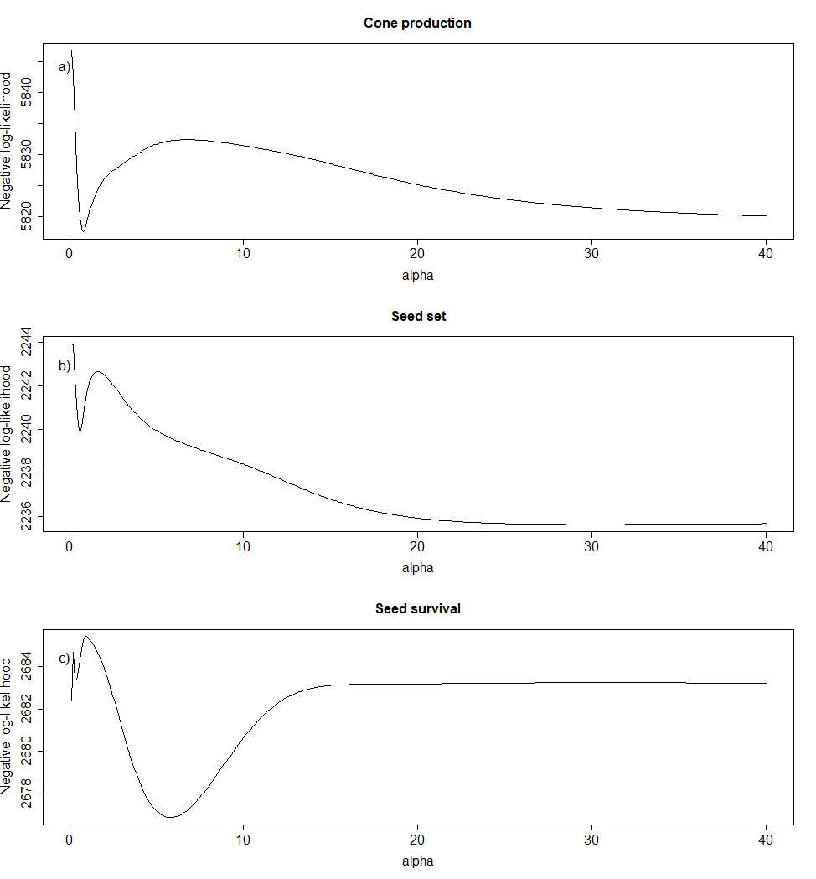
Figure S1. Likelihood profiles of the scaling parameter α in the spatial kernel. The α parameter describes the distance (in meters) at which 50% of the effect of a neighbour plant is left.

Model Estimates
Table S2. Regression coefficients, their standard errors and p-values for neighbourhood models on the three fecundity components (cone production, seed set and seed survival)
 | Cone Production |  |  | Seed Set |  |  | Seed Survival
Predictors | Estimates | std. Error | p | Estimates | std. Error | p | Estimates | std. Error | p
(Intercept) | 1.62 | 0.19 | <0.001 | -4.83 | 0.16 | <0.001 | 2.16 | 0.25 | <0.001
pfa | 0.90 | 0.11 | <0.001 | -0.28 | 0.17 | 0.090 | 0.06 | 0.12 | 0.633
NI.dens | -0.38 | 0.10 | <0.001 | -0.78 | 0.27 | 0.003 | -0.35 | 0.39 | 0.362
cone age | -0.15 | 0.02 | <0.001 | -0.27 | 0.06 | <0.001 | -0.29 | 0.07 | <0.001
NI.dens * SLA | 0.27 | 0.10 | 0.007 | -0.41 | 0.30 | 0.174 | -0.49 | 0.38 | 0.194
NI.dens * leaf N | 0.13 | 0.11 | 0.209 | 0.50 | 0.36 | 0.160 | 0.33 | 0.38 | 0.382
NI.dens * wood  density | 0.02 | 0.15 | 0.899 | 0.11 | 0.30 | 0.723 | 0.34 | 0.49 | 0.492
NI.dens * cone dry mass | 0.09 | 0.10 | 0.382 | -0.26 | 0.22 | 0.229 | 0.91 | 0.39 | 0.020
NI.dens * seed dry mass | 0.07 | 0.11 | 0.500 | 0.44 | 0.22 | 0.050 | 0.04 | 0.26 | 0.869
NI.dens * pollen per infl | -0.18 | 0.12 | 0.133 | -0.24 | 0.17 | 0.168 | -1.33 | 0.38 | 0.001
NI.dens * conspecificity | -0.02 | 0.12 | 0.871 | 0.77 | 0.33 | 0.020 | 0.14 | 0.40 | 0.728
NI.dens * resprouting ability | 0.18 | 0.56 | 0.744 | 9.68 | 3.91 | 0.014 | -2.88 | 3.52 | 0.413
pfa * NI.dens | -0.21 | 0.06 | <0.001 | -0.59 | 0.32 | 0.062 | -0.34 | 0.40 | 0.384
pfa * NI.dens  * SLA | 0.20 | 0.05 | <0.001 | 0.73 | 0.42 | 0.081 | 0.14 | 0.35 | 0.682
pfa * NI.dens  * leaf N | 0.01 | 0.06 | 0.805 | -0.37 | 0.38 | 0.331 | -0.14 | 0.36 | 0.694
pfa * NI.dens  * wood density | -0.07 | 0.08 | 0.411 | 0.07 | 0.29 | 0.808 | 0.11 | 0.45 | 0.808
pfa * NI.dens  * cone dry mass | 0.02 | 0.05 | 0.752 | 0.01 | 0.20 | 0.961 | 0.51 | 0.31 | 0.108
pfa * NI.dens  * seed dry mass | 0.01 | 0.06 | 0.875 | 0.34 | 0.19 | 0.076 | -0.15 | 0.25 | 0.556
pfa * NI.dens  * pollen per infl | -0.06 | 0.06 | 0.335 | 0.16 | 0.19 | 0.397 | -0.16 | 0.37 | 0.668
pfa * NI.dens  * conspecificity | -0.01 | 0.06 | 0.894 | 0.15 | 0.33 | 0.636 | 0.40 | 0.32 | 0.207
pfa * NI.dens  * resprouting ability | -0.10 | 0.32 | 0.745 | 5.39 | 4.52 | 0.233 | 2.79 | 3.34 | 0.404
Random Effects
σ² | 0.35 |  |  | 2.28 |  |  | 3.02
τ₀₀ | 0.08 _{focal_id} |  |  | 0.47 _{focal_id} |  |  | 0.43 _{focal_id}
 | 0.27 _{species_id} |  |  | 0.02 _{site_id} |  |  | 0.07 _{site_id}
 | 0.35 _{site_id} |  |  | 0.17 _{species_id} |  |  | 0.88 _{species_id}
τ₁₁ | 0.09 _{species_id.age.sc.cent} |  |  | 0.00 _{site_id.age.sc.cent} |  |  | 0.01 _{site_id.age.sc.cent}
 | 0.11 _{site_id.age.sc.cent} |  |  | 0.17 _{species_id.age.sc.cent} |  |  | 0.06 _{species_id.age.sc.cent}
ρ₀₁ | 0.99 _{species_id} |  |  | 1.00 _{site_id} |  |  | -1.00 _{site_id}
 | 1.00 _{site_id} |  |  | 1.00 _{species_id} |  |  | -1.00 _{species_id}
N | 497 _{focal_id} |  |  | 349 _{focal_id} |  |  | 377 _{focal_id}
 | 19 _{site_id} |  |  | 19 _{site_id} |  |  | 19 _{site_id}
 | 20 _{species_id} |  |  | 19 _{species_id} |  |  | 19 _{species_id}
Observations | 6107 |  |  | 1167 |  |  | 1309

Neighbour trait effects over time
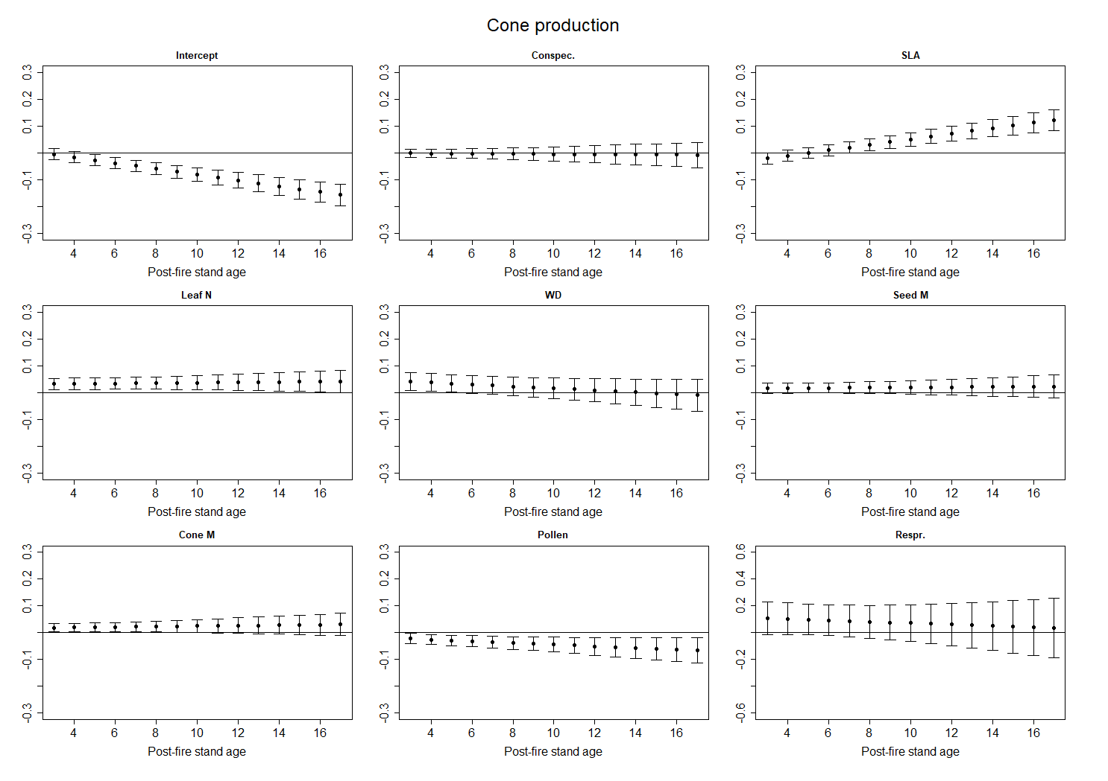
Figure S2 a. Changes in standardised neighbour trait effects on cone production over time. Intercept is the effect of a heterospecific nonsprouter with average neighbour trait values.
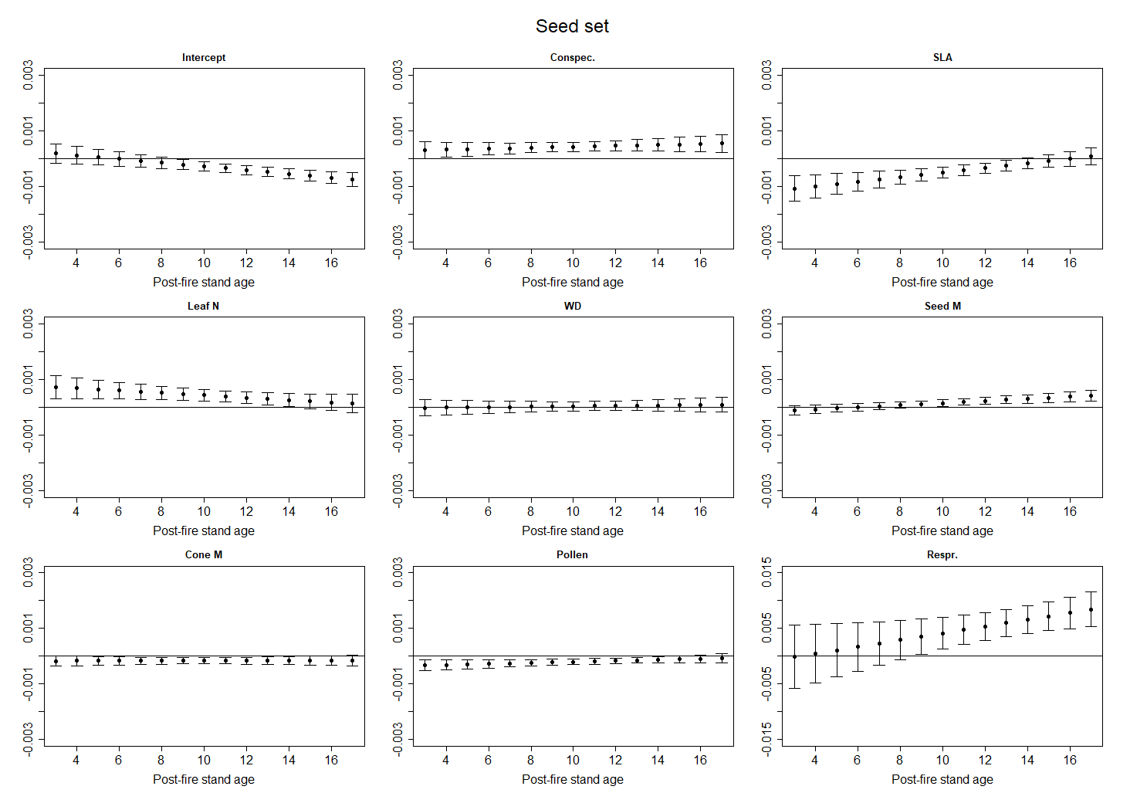
Figure S2 b. Changes in standardised neighbour trait effects on seed set over time. Intercept is the effect of a heterospecific nonsprouter with average neighbour trait values.
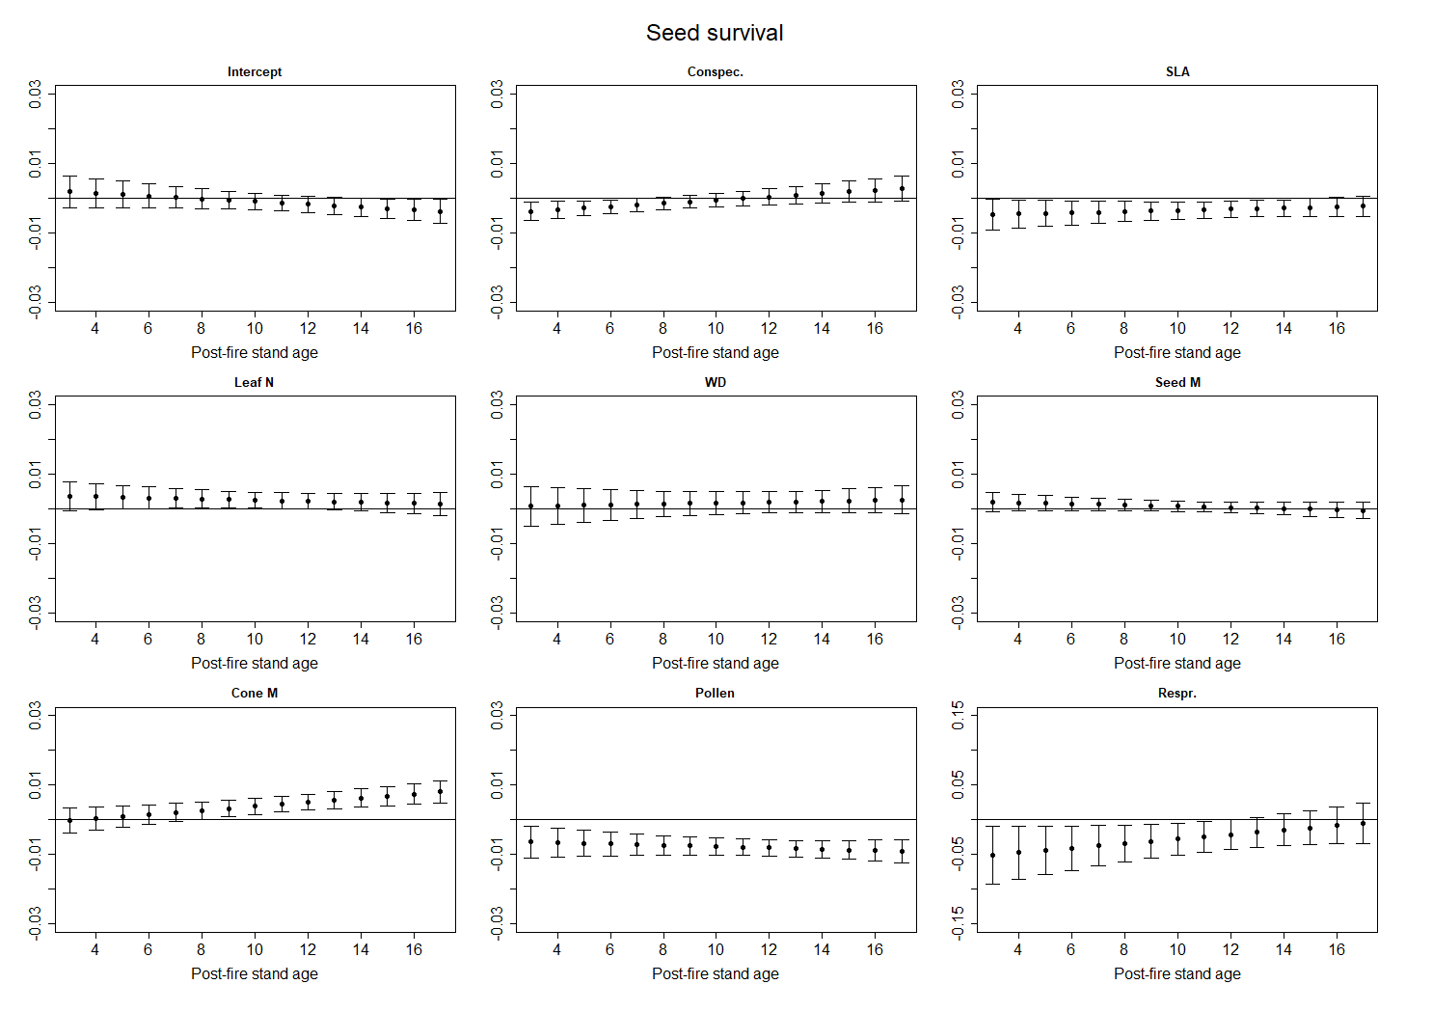
Figure S2 c. Changes in standardised neighbour trait effects on seed survival over time. Intercept is the effect of a heterospecific nonsprouter with average neighbour trait values.

Correlations between log-transformed trait values
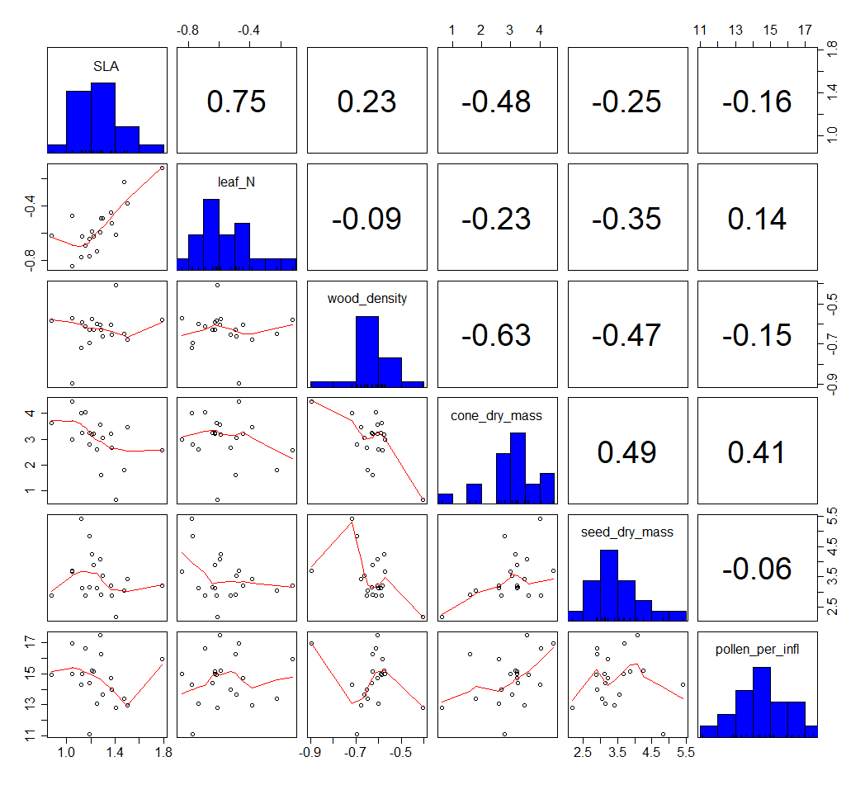
Figure S3. Pearson correlations between the log-transformed species-level median functional trait values of the 20 study species included in the study.

Site information table
Table S3. Post-fire stand ages, number of individuals and number of species for each of the 19 sites
Site | Post-fire stand age | No. of individuals | No. of species
cere_1 | 5 | 10813 | 5
cool_1 | 27 | 3406 | 3
cool_2 | 27 | 1583 | 3
fern_1 | 17 | 37253 | 3
fern_2 | 16 | 782 | 5
flow_1 | 12 | 7400 | 8
groo_1 | 10.5 | 1670 | 3
groo_4 | 10.5 | 686 | 5
held_1 | 2.5 | 15977 | 7
heun_1 | 16 | 5668 | 3
jona_1 | 17 | 948 | 3
jona_2 | 15 | 6611 | 3
jona_3 | 24 | 2647 | 7
jona_4 | 17 | 2026 | 4
lowy_1 | 15 | 8073 | 4
palm_1 | 18 | 989 | 6
roch_1 | 17 | 83 | 3
roch_2 | 17 | 269 | 5
roch_3 | 17 | 313 | 4

Species-Site matrix
Table S4. Species-site matrix. Giving the number of individuals and focals of each species on each site (‘Individuals’/’Focals’).
 | cere_1 | cool_1 | cool_2 | fern_1 | fern_2 | flow_1 | groo_1
prburc | 0/0 | 0/0 | 0/0 | 0/0 | 0/0 | 0/0 | 0/0
prcoro | 0/0 | 0/0 | 0/0 | 0/0 | 0/0 | 0/0 | 0/0
prcpct | 0/0 | 0/0 | 0/0 | 2098/9 | 0/0 | 26/6 | 32/11
prcyna | 60/0 | 0/0 | 0/0 | 0/0 | 12/0 | 104/6 | 0/0
prexim | 0/0 | 0/0 | 0/0 | 0/0 | 0/0 | 40/1 | 0/0
prgran | 0/0 | 0/0 | 0/0 | 0/0 | 0/0 | 0/0 | 0/0
prlaur | 0/0 | 0/0 | 0/0 | 0/0 | 0/0 | 0/0 | 0/0
prlepi | 0/0 | 0/0 | 0/0 | 0/0 | 393/10 | 0/0 | 0/0
prlong | 0/0 | 0/0 | 0/0 | 9564/4 | 0/0 | 2016/4 | 1003/11
prlori | 0/0 | 0/0 | 0/0 | 0/0 | 0/0 | 0/0 | 0/0
prmagn | 0/0 | 0/0 | 0/0 | 0/0 | 0/0 | 0/0 | 0/0
prmund | 0/0 | 0/0 | 0/0 | 0/0 | 0/0 | 0/0 | 0/0
prnana | 984/54 | 0/0 | 0/0 | 0/0 | 0/0 | 0/0 | 0/0
prneri | 9755/24 | 572/5 | 589/4 | 0/0 | 104/3 | 1616/5 | 0/0
prniti | 3/0 | 76/7 | 13/0 | 0/0 | 217/0 | 0/0 | 0/0
probtu | 0/0 | 0/0 | 0/0 | 0/0 | 0/0 | 258/6 | 635/12
prpunc | 0/0 | 0/0 | 0/0 | 0/0 | 0/0 | 0/0 | 0/0
prrepe | 11/0 | 2758/5 | 981/6 | 25591/3 | 56/0 | 239/5 | 0/0
prspec | 0/0 | 0/0 | 0/0 | 0/0 | 0/0 | 0/0 | 0/0
prsusa | 0/0 | 0/0 | 0/0 | 0/0 | 0/0 | 3101/9 | 0/0

 | groo_4 | held_1 | heun_1 | jona_1 | jona_2 | jona_3 | jona_4
prburc | 0/0 | 1340/3 | 0/0 | 0/0 | 0/0 | 1/0 | 0/0
prcoro | 0/0 | 1492/11 | 0/0 | 0/0 | 0/0 | 0/0 | 0/0
prcpct | 0/0 | 0/0 | 89/17 | 0/0 | 0/0 | 0/0 | 0/0
prcyna | 176/15 | 0/0 | 88/8 | 0/0 | 0/0 | 14/2 | 0/0
prexim | 0/0 | 3928/16 | 0/0 | 0/0 | 0/0 | 0/0 | 0/0
prgran | 0/0 | 0/0 | 0/0 | 0/0 | 0/0 | 0/0 | 13/5
prlaur | 0/0 | 0/0 | 0/0 | 12/1 | 179/3 | 178/5 | 1/1
prlepi | 0/0 | 4/0 | 0/0 | 0/0 | 0/0 | 0/0 | 0/0
prlong | 2/1 | 0/0 | 5491/9 | 0/0 | 0/0 | 1/0 | 0/0
prlori | 0/0 | 0/0 | 0/0 | 100/20 | 874/5 | 33/4 | 0/0
prmagn | 0/0 | 0/0 | 0/0 | 0/0 | 0/0 | 1588/4 | 0/0
prmund | 0/0 | 1049/10 | 0/0 | 0/0 | 0/0 | 0/0 | 0/0
prnana | 0/0 | 0/0 | 0/0 | 0/0 | 0/0 | 0/0 | 0/0
prneri | 0/0 | 101/9 | 0/0 | 0/0 | 0/0 | 0/0 | 0/0
prniti | 0/0 | 0/0 | 0/0 | 0/0 | 0/0 | 0/0 | 0/0
probtu | 440/9 | 0/0 | 0/0 | 0/0 | 0/0 | 0/0 | 0/0
prpunc | 0/0 | 0/0 | 0/0 | 0/0 | 0/0 | 0/0 | 1258/9
prrepe | 17/1 | 8063/14 | 0/0 | 836/5 | 5558/5 | 832/3 | 754/6
prspec | 51/25 | 0/0 | 0/0 | 0/0 | 0/0 | 0/0 | 0/0
prsusa | 0/0 | 0/0 | 0/0 | 0/0 | 0/0 | 0/0 | 0/0

 | lowy_1 | palm_1 | roch_1 | roch_2 | roch_3
prburc | 0/0 | 0/0 | 0/0 | 0/0 | 2/0
prcoro | 0/0 | 0/0 | 0/0 | 0/0 | 0/0
prcpct | 0/0 | 7/2 | 0/0 | 0/0 | 0/0
prcyna | 38/0 | 268/5 | 0/0 | 112/0 | 0/0
prexim | 0/0 | 0/0 | 0/0 | 0/0 | 0/0
prgran | 0/0 | 0/0 | 1/1 | 3/2 | 0/0
prlaur | 0/0 | 0/0 | 41/4 | 19/3 | 283/7
prlepi | 0/0 | 0/0 | 0/0 | 0/0 | 0/0
prlong | 549/4 | 0/0 | 0/0 | 0/0 | 0/0
prlori | 0/0 | 0/0 | 0/0 | 0/0 | 0/0
prmagn | 0/0 | 280/2 | 0/0 | 0/0 | 2/0
prmund | 0/0 | 60/3 | 0/0 | 0/0 | 0/0
prnana | 0/0 | 0/0 | 0/0 | 0/0 | 0/0
prneri | 6585/5 | 365/3 | 0/0 | 0/0 | 0/0
prniti | 0/0 | 0/0 | 0/0 | 0/0 | 0/0
probtu | 0/0 | 0/0 | 0/0 | 0/0 | 0/0
prpunc | 0/0 | 0/0 | 0/0 | 0/0 | 0/0
prrepe | 901/2 | 9/4 | 41/8 | 134/4 | 26/2
prspec | 0,0 | 0,0 | 0,0 | 1,0 | 0,0
prsusa | 0,0 | 0,0 | 0,0 | 0,0 | 0,0

Species abbreviations
Table S5. Names of all study species and their abbreviations as used in Table S3.
Species name | Abbreviation
Protea burchellii | prburc
Protea coronata | prcoro
Protea compacta | prcpct
Protea cynaroides | prcyna
Protea eximia | prexim
Protea grandiceps | prgran
Protea laurifolia | prlaur
Protea lepidocarpodendron | prlepi
Protea longifolia | prlong
Protea lorifolia | prlori
Protea magnifica | prmagn
Protea mundii | prmund
Protea nana | prnana
Protea neriifolia | prneri
Protea nitidia | prniti
Protea obtusifolia | probtu
Protea punctata | prpunc
Protea repens | prrepe
Protea speciosa | prspec
Protea susannae | prsusa

