Supplementary material

6.1 Design of experiment information
Table S1: IN ANOVA for the Quadratic model.

Source | Sum of Squares | Df | Mean Square | F-value | p-value
Model | 2.663E+05 | 9 | 29585.66 | 5.48 | 0.0069 | Significant
R-Temperature | 54956.43 | 1 | 54956.43 | 10.18 | 0.0097
T-Ratio | 47150.17 | 1 | 47150.17 | 8.73 | 0.0144
RT-Time | 1105.55 | 1 | 1105.55 | 0.2047 | 0.6606
R*T | 1864.16 | 1 | 1864.16 | 0.3452 | 0.5699
R*RT | 500.54 | 1 | 500.54 | 0.0927 | 0.7670
T*RT | 526.83 | 1 | 526.83 | 0.0976 | 0.7612
R² | 1.064E+05 | 1 | 1.064E+05 | 19.71 | 0.0013
T² | 38287.70 | 1 | 38287.70 | 7.09 | 0.0238
RT² | 42325.49 | 1 | 42325.49 | 7.84 | 0.0188
Residual | 53997.76 | 10 | 5399.78
Lack of Fit | 44823.13 | 5 | 8964.63 | 4.89 | 0.0533 | not significant
Pure Error | 9174.63 | 5 | 1834.93
Cor Total | 3.203E+05 | 19
*T is the temperature, R is the impregnation ratio, and RT is the pyrolysis reaction time
Table S2 IN fit statistics for the Quadratic model.
Std. Dev. | 73.48
Mean | 1464.60
CV % | 5.02
R² | 0.8314
Adjusted R² | 0.6797
Predicted R² | -0.1037
Adeq Precision | 6.7389

Table S3. IN an ANOVA for a Reduced Quadratic model
Source | Sum of Squares | df | Mean Square | F-value | p-value
Model | 2.634E+05 | 6 | 43896.56 | 10.03 | 0.0003 | Significant
A-T* | 55137.10 | 1 | 55137.10 | 12.60 | 0.0036
B-R | 47150.17 | 1 | 47150.17 | 10.77 | 0.0059
C-RT | 1092.38 | 1 | 1092.38 | 0.2496 | 0.6257
A² | 1.064E+05 | 1 | 1.064E+05 | 24.32 | 0.0003
B² | 38287.70 | 1 | 38287.70 | 8.75 | 0.0111
C² | 42325.49 | 1 | 42325.49 | 9.67 | 0.0083
Residual | 56889.29 | 13 | 4376.10
Lack of Fit | 47714.66 | 8 | 5964.33 | 3.25 | 0.1049 | not significant
Pure Error | 9174.63 | 5 | 1834.93
Cor Total | 3.203E+05 | 19
*T is the temperature, R is the impregnation ratio, and RT is the pyrolysis reaction time.
Table S4 IN fit statistics for the Quadratic model.
Std. Dev. | 66.15
Mean | 1464.60
CV (%) | 4.52
R² | 0.8224
Adjusted R² | 0.7404
Predicted R² | 0.2940
Adeq Precision | 8.9471

The experimental data were imported into the software for processing, and a quadratic polynomial equation characterizing the relationship between the dependent and independent variables was derived using equation S1 in a non-coded form.
$IN=459.52392+1.82915*T+310.33988*R+11.13606*RT-0.002147* T^{2}-92.36318* R^{2}-0.060211* {RT}^{2}$ Eq. S1
Where IN is the IN (mg·g⁻¹), T is the temperature (°C), R is the impregnation ratio (g·g⁻¹), and RT is the pyrolysis reaction time (min).
The equation illustrates that the three variables under consideration had both linear and quadratic impacts on the IN. A positive sign indicates a combined effect, whereas a negative sign signifies a conflicting impact. The quadratic components suggest that a maximum can be observed, and the response variable can be optimized.
Based on the predicted results of the IN, as shown in Table 2, the root mean square error (RMSE) and root mean square percentage error (RMSPE) were found to be 47.8 mg·g⁻¹ and 3.3%, respectively. That means that the average prediction error is relatively small, considering the size of the observed values.
The predicted vs. actual graph, depicted in Figure S1, demonstrates that the model adheres to the assumption that the residual variance in the regression model is constant. Furthermore, the model exhibits no discernible systematic patterns or significant outliers, as indicated by the RMSE and RMSPE. Based on the predicted vs. actual graph, the regression model predicts higher IN values (red and orange points) more accurately, but struggles to predict lower values (blue points) accurately. These findings suggest that the model exhibits promising predictive capabilities with potential for further improvement.

Figure S1 Diagnostic plots for the response surface model: (a) normal probability plot of residuals, (b) predicted versus actual values, (c) residuals versus run, and (d) residuals versus predicted.

6.2 Supplementary characterization data
Table S5. Proximate and elemental characterization
Trial | T (°C) | Ratio | RT (min) | Proximate analysis |  |  | Elemental analysis
 |  |  |  | VM (wt%) | FC (wt%) | Ash (wt%) | C (wt%) | N (wt%) | H (wt%) | S (wt%) | O (wt%) | Yield to SCG (%)
SCG | N.A.* | N.A. | N.A. | 82.7 ± 0.7 | 16.6±0.6 | 0.7±0.2 | 52.7±0.1 | 2.1±0.0 | 7.4±0.0 | 0.0±0.0 | 36.5±0.2 | N.A.
HTC | N.A. | N.A. | N.A. | 75.9 ± 1.0 | 22.7±0.9 | 1.4±0.0 | 57.7±0.5 | 3.0±0.0 | 7.0±0.0 | 0.0±0.0 | 30.9±0.5 | 71.9
AC_300_60_0.5 | 300.0 | 0.5 | 60.0 | 49.0± 0.5 | 38.6±0.9 | 12.5±0.8 | 61.0±0.5 | 3.3±0.0 | 6.0±0.0 | 0.0±0.0 | 17.3±0.1 | 57.5
AC_300_120_0.5 | 300.0 | 0.5 | 120.0 | 53.3± 0.5 | 36.0±0.2 | 10.7±0.2 | 62.8±0.6 | 3.1±0.0 | 6.0±0.1 | 0.0±0.0 | 17.3±0.6 | 59.2
AC_300_60_2.0 | 300.0 | 2.0 | 60.0 | 39.7± 0.6 | 47.8±0.7 | 12.5±0.6 | 62.9±0.4 | 3.1±0.0 | 5.5±0.1 | 0.0±0.0 | 16.1±0.1 | 58.1
AC_300_120_2.0 | 300.0 | 2.0 | 120.0 | 40.3± 0.5 | 43.2±0.8 | 16.6±0.8 | 58.8±0.0 | 2.9±0.0 | 5.3±0.0 | 0.0±0.0 | 16.3±0.6 | 60.6
AC_700_60_0.5 | 700.0 | 0.5 | 60.0 | 11.3± 0.5 | 64.1±0.8 | 24.6±0.7 | 66.0±0.3 | 2.6±0.0 | 1.8±0.0 | 0.0±0.0 | 5.0±0.1 | 28.3
AC_700_120_0.5 | 700.0 | 0.5 | 120.0 | 12.0± 0.2 | 69.8±0.2 | 18.2±0.4 | 72.6±0.0 | 3.3±0.1 | 1.6±0.0 | 0.0±0.0 | 4.2±0.2 | 25.2
AC_700_60_2.0 | 700.0 | 2.0 | 60.0 | 30.7± 0.5 | 34.1±2.9 | 35.2±1.6 | 43.7±0.7 | 2.0±0.0 | 2.8±0.0 | 0.0±0.0 | 16.2±0.5 | 63.2
AC_700_120.0_2.0 | 700.0 | 2.0 | 120.0 | 19.4± 0.0 | 63.0±2.3 | 17.6±1.5 | 44.4±0.1 | 2.3±0.0 | 2.6±0.0 | 0.0±0.0 | 32.3±0.3 | 59.4
AC_163.6_90_1.3 | 163.6 | 1.3 | 90.0 | 19.4±0.0 | 63.0±2.3 | 17.6±1.5 | 59.7±0.9 | 2.7±0.0 | 6.7±0.1 | 0.0±0.0 | 28.3±1.0 | 33.4
AC_836.6_90_1.3 | 836.6 | 1.3 | 90.0 | 64.9±1.0 | 33.2±1.8 | 1.9±0.9 | 60.7±1.0 | 2.9±0.0 | 2.0±0.0 | 0.0±0.0 | 10.5±0.1 | 33.6
AC_500_90.0_0.0 | 500.0 | 0.0 | 90.0 | 24.1±1.0 | 73.6±0.6 | 2.4±0.5 | 80.6±0.4 | 4.7±0.0 | 3.4±0.0 | 0.0±0.0 | 9.3±0.4 | 24.8
AC_500_90_2.5 | 500.0 | 2.5 | 90.0 | 24.8±2.0 | 55.8±4.1 | 19.5±0.5 | 61.1±0.5 | 2.1±0.1 | 3.1±0.0 | 0.0±0.0 | 14.2±0.2 | 25.4
AC_500_39.6_1.3 | 500.0 | 1.3 | 39.6 | 24.1±1.1 | 53.2±3.0 | 22.7±1.3 | 57.7±0.6 | 3.0±0.0 | 3.3±0.0 | 0.0±0.0 | 13.3±0.4 | 43.2
AC_500_140.5_1.3 | 500.0 | 1.3 | 140.5 | 18.5±0.2 | 58.6±0.7 | 22.9±0.8 | 52.9±0.1 | 2.4±0.0 | 3.1±0.0 | 0.0±0.0 | 18.6±0.5 | 56.2
AC_500_90_1.3 | 500.0 | 1.3 | 90.0 | 23.0±0.6 | 48.6±0.4 | 28.4±0.3 | 52.6±0.1 | 2.6±0.0 | 3.2±0.1 | 0.0±0.0 | 13.2±0.3 | 47.1
AC_500_90_1.3 | 500.0 | 1.3 | 90.0 | 23.1±0.3 | 51.6±0.2 | 25.3±0.3 | 58.6±0.3 | 2.8±0.0 | 3.4±0.1 | 0.0±0.0 | 9.9±0.7 | 49.2
AC_500_90_1.3 | 500.0 | 1.3 | 90.0 | 22.4±1.4 | 53.2±2.3 | 24.4±0.5 | 57.6±0.2 | 2.6±0.0 | 3.3±0.1 | 0.0±0.0 | 12.1±0.6 | 49.4
AC_500_90_1.3 | 500.0 | 1.3 | 90.0 | 24.9±0.5 | 49.1±0.4 | 26.0±0.2 | 58.2±0.3 | 2.6±0.1 | 3.2±0.0 | 0.0±0.0 | 9.9±0.7 | 51.1
AC_500_90_1.3 | 500.0 | 1.3 | 90.0 | 19.2±0.2 | 52.0±0.1 | 28.8±0.1 | 53.9±0.4 | 2.5±0.0 | 3.1±0.0 | 0.0±0.0 | 11.7±0.8 | 50.7
AC_500_90_1.3 | 500.0 | 1.3 | 90.0 | 23.2±0.7 | 48.5±5.2 | 28.2±2.2 | 54.6±0.3 | 2.6±0.0 | 3.1±0.1 | 0.0±0.0 | 11.5±0.6 | 52.9
*N.A.: Not Applicable; T: temperature; RT: pyrolysis retention time; VM: volatile matter; FC: fixed carbon; C: carbon content; N nitrogen content; H: hydrogen content; S: sulfur content; O: oxygen content

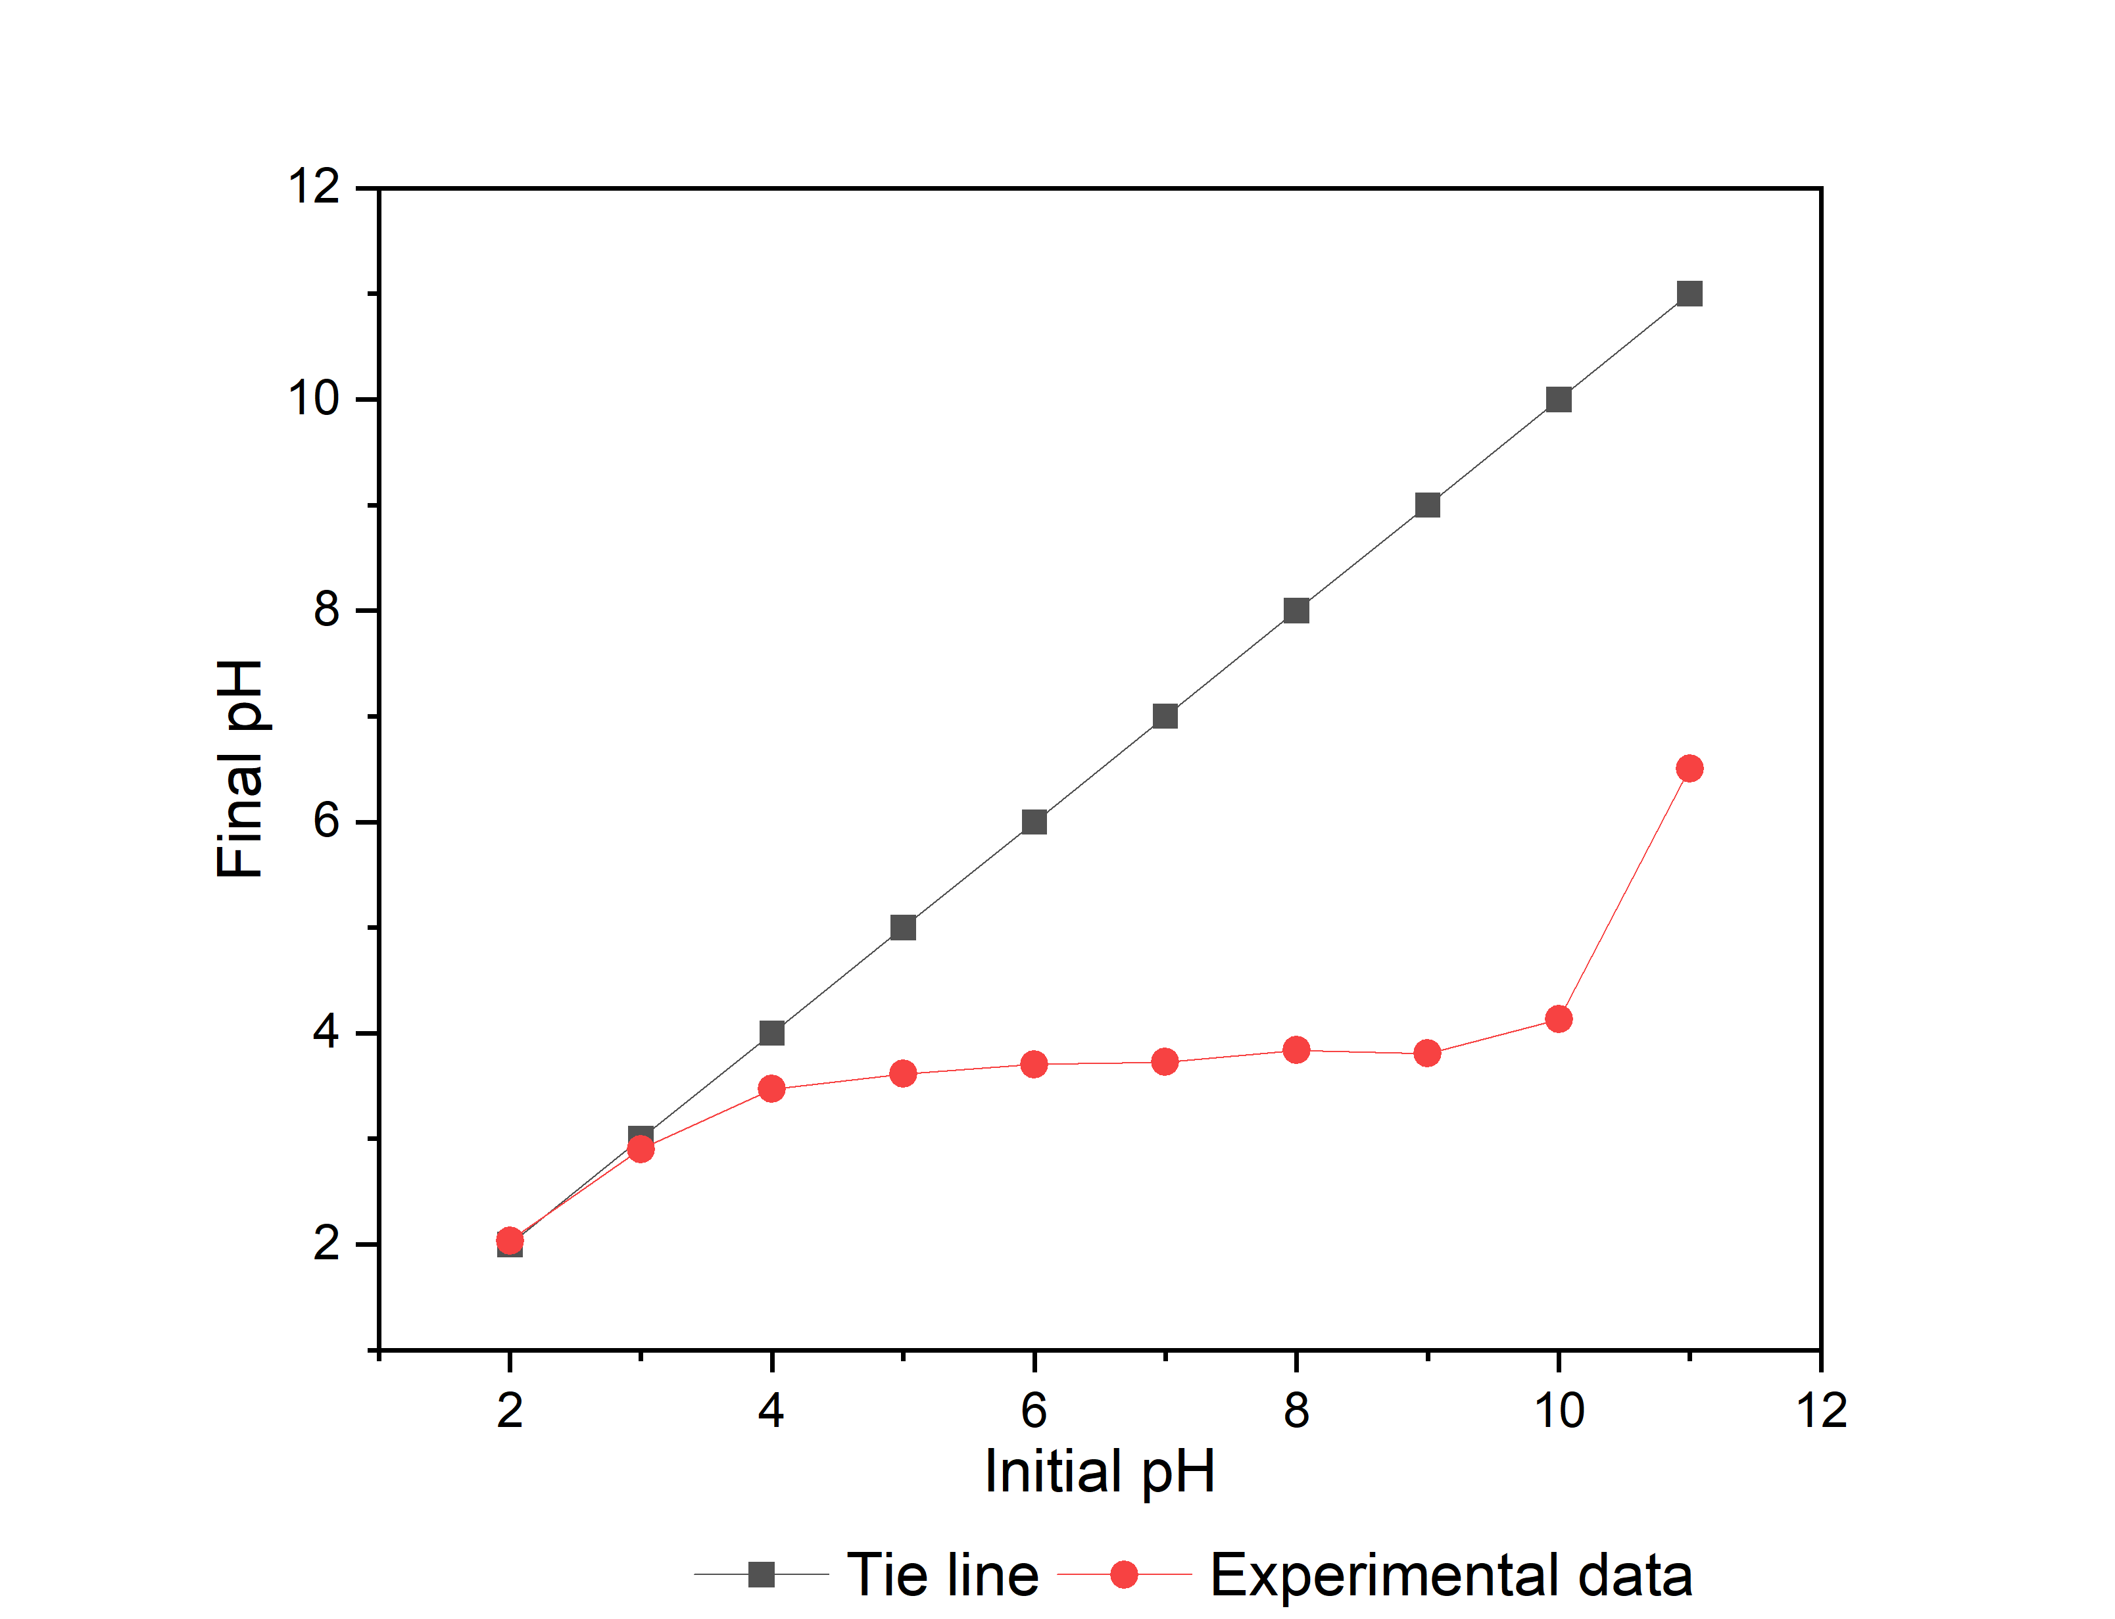

Figure S2. Determination of the point of zero charge (pHpzc) of AC_426_92_1.6.

