Supplementary material

Table S1: Amount of Oligosaccharides in the different breads.
Bread | Oligosaccharides DP≤8  [g/100g] | Oligosaccharides DP>8  [g/100g] | Total Oligosaccharides  [g/100g]
W SF Y | 3.6 | 1.6 | 5.3
W SF S | 3.3 | 1.4 | 4.6
W SF SB | 4.4 | 2.0 | 6.4
W WG Y | 4.2 | 1.6 | 5.8
Sp SF Y | 1.8 | 1.4 | 3.2
R SF Y | 5.8 | 2.2 | 8.0
Abbreviations: W, Wheat; Sp, Spelt; R, Rye; SF, Superfine flour; WG, Wholegrain flour; Y, Yeast fermented; S, Sourdough fermented; DP, Degree of Polymerization.

Table S2. Average food intake and liver/body weight ratio, body weight changes in Casp8^{ΔIEC} and Casp8^{fl} mice.
 | Genotype | GF | 5G | WSFY | WSFS | WSFSB | WWGY | SpSFY | RSFY
Food intake/ mouse [g/day] | Casp8^{ΔIEC} | 2.6 ±0.26 | 2.5 ±0.25 | 2.5  ±0.23 | 2.4  ±0.05 | 2.7  ±0.12 | 2.8  ±0.14 | 2.5  ±0.21 | 2.6  ±0.15
Food intake/ mouse [g/day] | Casp8^{fl} | 2.5 ±0.00 | 2.8 ±0.14 | 2.4  ±0.05 | 2.5  ±0.15 | 2.7  ±0.10 | 2.9  ±0.15 | 2.7  ±0.17 | 2.6  ±0.12
Liver/Body weight ratio [g] | Casp8^{ΔIEC} | 0.05 ±0.00 | 0.04 ±0.00 | 0.04  ±0.4 | 0.05 ±0.01 | 0.05  ±0.00 | 0.04 ±0.00 | 0.05 ±0.01 | 0.05  ±0.01
Liver/Body weight ratio [g] | Casp8^{fl} | 0.04 ±0.00 | 0.03 ±0.01 | 0.04 ±0.00 | 0.04 ±0.01 | 0.04  ±0.00 | 0.04 ±0.00 | 0.04 ±0.00 | 0.04  ±0.01
Body weight changes [%] | Casp8^{ΔIEC} | 20.3 ±6.45 | 8.6 ±3.65 | 2.9 ±5.80* | 2.4 ±3.99* | 7.5  ±2.50 | 2.4 ±5.49* | 2.4 ±4.18* | -3.7 ±5.23***
Body weight changes [%] | Casp8^{fl} | 13.8 ±2.99 | 12.1 ±1.68 | 10.5 ±1.75 | 12.0 ±1.84 | 16.6  ±2.48 | 14.4 ±2.93 | 11.0  ±2 .54 | 10.2  ±1.56
Mice were fed a gluten-free diet (GF), GF with 5% gluten added (5G) or a diet with 50% bread. Values are means ± SEM, statistics by two-factor ANOVA. Group differences were assessed by the Tukey’s post hoc test. Only differences compared to the GF diet were found and indicated by asterisks (*P<0.05; ***P<0.001). No genotype-specific differences were found. Abbreviations: W, Wheat; Sp, Spelt; R, Rye; SF, Superfine flour; WG, Wholegrain flour; Y, Yeast fermented; S, Sourdough fermented.
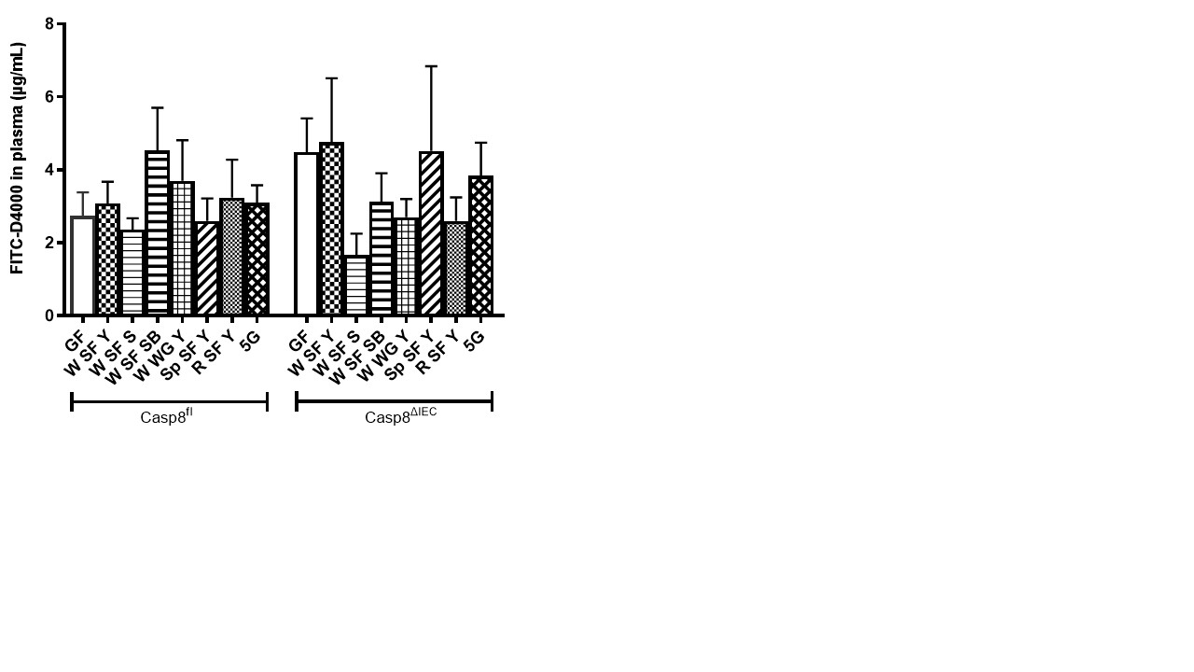
Figure S1: Small intestinal barrier analyzed by FITC-Dextran 4000 in plasma. Abbreviations see Table S1.

