FOCUS GROUP DISCUSSION AND INTERVIEW GUIDELINE
Thank you for taking the time to participate in this focus group discussion and interview about the Nigerian maize sector. This focus group/interview is part of a larger research process to obtain information and learn more about the maize sector, the related stakeholders/institutions in the innovation system, and institutional and governance challenges inhibiting government policies from improving the agricultural sector in Nigeria.
You are a group of people who deal in maize and with whom sectoral, regional, or national issues on maize are pertinent. Specifically, we would like to hear from you about the stakeholders/institutions involved in supporting the sector, the implementation process of the input subsidy programme, and associated governance challenges that limited the successful implementation of the programme in the country. Also, we would like to learn about possible recommendations on how the institutional and governance challenges and entry points can be resolved to foster maize productivity and competitiveness of private actors in the sector.
During the focus group discussion/interviews, we will ask questions and facilitate a conversation on the above issues. For the focus group discussions, we will use an instrument called the Process Net-Mapping tool. The purpose of this tool is to stimulate conversation and represent the consensus opinion of everyone on the cardboard. Please note that there are no “right” or “wrong” answers, so feel comfortable speaking honestly, sharing your ideas, and representing them on the cardboard.
Please note that this session will be recorded. The notetaker (Mr./Ms. XXX) will also take notes of important details. This will ensure that we adequately capture your ideas during the focus group discussion/interview. However, kindly note that your identity during the sessions will remain confidential, and your name will not be attached to any comments you make.

Do you have any questions before we begin?

Do you consent to participate in this focus group discussion/interview?

QUESTIONS ON THE IMPLEMENTATION PROCESS AND GOVERNANCE CHALLENGES IN THE INPUT SUBSIDY PROGRAMME
Before we start, let us do a quick round of introductions.
Can each of you tell the group your name and your years of experience in the sector?
Main questions | Supplementary questions | Illustrative questions
Can you please provide us with some detailed information about government policies that have been implemented on maize in recent years? | - What does each policy entail?  - What are the objectives of these maize policies?  - Who were the main actors during the adoption and implementation of these policies?  - From your experience, what challenges did you face during the adoption and implementation of these policies?  - How were these challenges addressed by the government?  - What are the benefits you derived from these policies?  - How will you rate each of these policies?  - What policies would you like to be scrapped and why?  - What other policies would you like to have? | - Do you feel the same?  - Can you tell us anything else apart from the one already discussed?  - What do you think about this?  - Can you clarify this further?  - Can you provide some examples of this?
Focusing on the Growth Enhancement Support Scheme (GESS) could provide us with details of what this policy entails. | - Can you tell us how this policy was implemented to support the maize sector?  - What does this program entail?  - What are the objectives of these maize policies?  - To what extent were the pre-stated objectives achieved?  - To what extent were the procedures complied with?  - What are the supporting structures/guidelines employed to attain compliance?  - From your experience, what are the strengths and challenges of this policy vis-à-vis maize production and support for economic growth in the country?  - What improvements should be made to this policy?
Implement the Process Net-Map procedures from here
How was the e-wallet GESS implemented in Nigeria?  Responses should be depicted on the cardboard provided, based on the Process Net-Map procedure described below! | - What steps are involved in the implementation of the Nigerian e-wallet programme?  - Who were the main actors during the design and implementation of this programme?  - What were their roles and location in the programme?  - What institutional strengths exist among these stakeholders/institutions that contributed to the successful implementation of the programme?  - What are the forms of tension or conflict that exist among these stakeholders/institutions?  - What are the possible complementarities that exist among these actors/stakeholders?  - Which actors/stakeholders were most influential in the successful implementation of the programme (Rank them)?  - Which actors/stakeholders were most influential in ensuring the effective design and implementation of the programme (Rank them)?  (Note: This power influence does not reflect “hierarchical relations” as some institutions with limited hierarchical power can be influential in terms of their rate of work in supporting actors along the maize value web and driving the attainment of an effective design and implementation process)!
Can you tell us about the challenges that limited the effective implementation of the e-wallet GESS in Nigeria?  Responses should be depicted on the cardboard provided, based on the Net-Map procedure described! | - From your experience, which challenges did you face during the implementation of the GESS?  - What other challenges existed during the implementation process of the programme?  - What impact do these challenges have on the successful implementation of the programme?  - Overall, which challenges limited the effective implementation of the programme the most?  - Where were these challenges located along the implementation process of the programme?  - What were the entry points of these challenges?  - Can you identify the entry points of these challenges on the Process Net-Map?  - How dynamic were these challenges compared to the previous programmes?  - In which phases were these bottlenecks found in the previous programmes?  - In which phases are these bottlenecks found in the current programme?
How did the actors/stakeholders in the programme adapt to resolve the challenges identified above? | - Which amendments were made to overcome these governance challenges in the programme?  - Why were these specific amendments made?  - What other supporting structures were employed to overcome these governance challenges?  - To what extent is this programme consistent with other programmes in the sector?  - How will you rate the effectiveness of this programme relative to previous programmes?
How can these governance challenges and their entry points be resolved? | - What can be done to overcome these governance challenges and support the effective design and implementation of future input subsidy programmes?  - What roles do the following actors need to play to bridge entry points for these challenges:  - Public actors  - Private actors  - Community actors

Detailed explanation of the governance challenges in the ISP

Governance challenges in input subsidy programmes
ISPs involve three types of governance structures (Figure 1): government (state), private (market), and third (community-based) sectors, each with its idiosyncratic governance challenges. While state and market sectors dominate, the third sector, which includes non-governmental organizations (NGOs) and farmer groups, intervenes to play complementary roles where public and private sectors fail to effectively implement ISPs. In the next subsections, we use perspectives from new institutional economics to pinpoint governance challenges in these sectors.

Market failure in the input subsidy programme
Market failures ensue when the production system is unable to efficiently allocate resources and provide goods and services at levels considered optimal by society (Birner & Anderson, 2007). In ISPs, market failure revolves around the nature of the market, goods, and exchange. It results from externalities that affect the optimal functionality of the market system. ISPs drive the adoption and application of agricultural inputs among rural farmers, leading to positive externalities such as improved soil fertility, higher farm yields, and improved food security (Holden, 2018; Wossen et al., 2017). With higher agricultural productivity and cultivated areas, and decreasing poverty levels, the private sector may become overwhelmed by higher demand for agricultural inputs, making it necessary for the government to intervene. ISP can also result in negative externalities such as pollution/acidification and loss of arable lands that, in turn, reduce demand for agricultural inputs and lessen the economic viability for the private sector to invest in ISPs (Chirwa & Dorward, 2013).
Another reason is exclusion brought on by the geographical distance between agro-dealers in urban centres and recipients in rural areas (Liverpool-Tasie & Takeshima, 2013). This has ex-ante and ex-post implications for the agricultural input markets. First, the geographical marginalization of rural farmers and the lack of accurate data make it difficult for private agro-dealers to ascertain the actual demand for agricultural inputs. Such uncertainty may widen the supply-demand gap for major agricultural inputs (Jayne et al., 2018). Second, geographically distant recipients and agro-dealers incur higher transportation and transaction costs, which make investments in SISP unprofitable for private agro-dealers and the targeting of rural recipients difficult (Birner et al., 2010; Liverpool-Tasie et al., 2017; Steiner & Atterton, 2015).
Also, governments in SSA often view ISPs as political instruments, which makes the upscaling, downscaling, and exiting problematic (Holden, 2018). In SSA, ISPs are perpetual because of rent-seeking and political manipulation (Pan & Christiaensen, 2012). However, input subsidy and political involvement undermine the functioning of input market systems by dislodging unsubsidized inputs and restricting market prices and volumes. Also, government involvement increases uncertainty about ISP design and implementation and discourages risk-averse agro-dealers from investing in ISP, procuring inputs, and accepting vouchers (Liverpool-Tasie & Takeshima, 2013). Equally, inefficient subsidy administration processes and poor targeting allow rent-seeking actors to exclude and crowd out competitive agro-suppliers (Liverpool-Tasie, 2014b).
Input distribution and adoption through ISPs come with a learning process. Hence, input demand may be lower in the early stage because expected benefits and initial returns are low (Chirwa & Dorward, 2013). However, as agricultural inputs become affordable and farmers get exposed to their utilisation and efficiency, farmers can be induced to participate in the private input market, and demand higher subsidized inputs beyond the supply capacity of the private sector (Holden, 2018).
Moreover, farmers rely on a few agro-dealers in an oligopolistic input market. This may exacerbate principal-agent problems because of the higher market power of the agro-dealers. High information asymmetry and ineffective coordination between farmers and input dealers may further worsen the situation (Adetoyinbo et al., 2022). This is because rural farmers are often unaware of ISPs and their procedures, and thus, cannot adequately evaluate the quantity and quality of inputs received.

Government failure in the input subsidy programme
To overcome inherent market failures in ISPs, the government has played an important role in the finance, procurement, and distribution of agricultural inputs in SSA (Jayne et al., 2013; Jayne & Rashid, 2013; Jayne et al., 2018; Liverpool-Tasie, 2014a). However, ISPs are political with inherent governance challenges that make the “government (or state)” fail in ISPs (Takeshima & Liverpool-Tasie, 2015).
Most ISPs in SSA are state-led; thus, institutional challenges remain a big concern (Adetoyinbo et al., 2022). ISPs are marked by financial inadequacies that revolve around the sustainability of fiscal expenses, including government spending, budget harmonisation, and funding timelines (Liverpool-Tasie & Takeshima, 2013; Takeshima & Liverpool-Tasie, 2015; Tiri et al., 2015). Although many SSA countries maintain tight budgets, ISPs, which occasionally account for about 40% of the agricultural budget, add to the financial burden of national governments (Wossen et al., 2017). This widens the input supply-demand gap as governments, rather than market forces, drive input demand and supply ultimately through rationing.
Moreover, ineffective coordination and collaboration among public agencies and between state-led agencies and NGOs may result in divergent objectives, lengthy bureaucratic processes, and inefficient distribution systems and information flow (Chirwa & Dorward, 2013; Holden, 2018; Liverpool-Tasie & Takeshima, 2013; Stenholm et al., 2013). Previous studies (Daum & Birner, 2017; Pan & Christiaensen, 2012; Takeshima & Liverpool-Tasie, 2015) have shown that suitable recipients are excluded because ineffective institutional settings and a lack of up-to-date agricultural data make state interventions too generic and unsuited to recipients’ situations.
Widespread corruption, reallocation, and smuggling of subsidized inputs are common features in government-led ISPs (Holden, 2018; Liverpool-Tasie & Takeshima, 2013). While the tendering process for input procurement is liable to bribery, farmers often make kickback payments before receiving subsidized inputs (Holden, 2018). Kickbacks at the port and checkpoints (Cadoni & Angelucci, 2013), as well as elite capture, clientelism, and political targeting, have been identified as common challenges in many state-led programmes (Daum & Birner, 2017; Mason & Ricker-Gilbert, 2013). Equally, the rationing of subsidized inputs and the selection of targeted areas in ISPs are often political. In Nigeria, political leaders chose target areas to gain political support or reward previous political victories Liverpool-Tasie & Takeshima, 2013). Likewise, the targeting and distribution roles of agro-suppliers were replaced by local political leaders.

2.2.3 Community-based failure in the input subsidy programme
Targeting in ISPs is complex because it involves both geographical (based on states, local government, and communities) and intra-community targeting (between different categories of farming households) (Chirwa & Dorward, 2013). Intra-community targeting is costly for private and public stakeholders because farming households are classified according to their socioeconomic factors. Accordingly, the roles of the community (CO), farmer-based organizations (FBO), and NGOs have been important in ISPs (Jayne et al., 2018; Liverpool-Tasie, 2014b; Pan & Christiaensen, 2012).
However, COs and FBOs face peculiar challenges such as information asymmetry, elite capture and exclusion, limited capacity and financial base, and collective action problems that may lead to “community failure” in service provision (Henderson et al., 2020; Lubungu & Birner, 2018; Pan & Christiaensen, 2012). COs and FBOs are often inadequately integrated into ISPs because, as community service providers, they, on average, lack appropriate training on the quality, application, and management of modern inputs (e.g., fertilizers and varieties) distributed by ISPs.
Elite capture and exclusion are also common because CO- and FBO-led programmes are dominated by high-performing and knowledgeable middle-class farmers and rural elites who take advantage and exclude socially-marginalized actors like small-scale farmers and women (Adetoyinbo et al., 2022). These challenges are more prominent in ISPs because subsidized inputs are private goods (e.g., fertilizer and seed varieties) characterized by high excludability and rivalry. ISPs are also subject to political (e.g., low local power structure and awareness), economic (e.g., low income), sociological (e.g., community homogeneity), and institutional factors (e.g., coordination mechanisms) that drive elite capture (Adetoyinbo et al., 2022).
Moreover, most COs, FBOs, and NGOs lack the capacity and financial base to deal with the high transaction costs of implementing ISP or acquiring modern inputs that would serve communities. Many SSA countries import agricultural inputs; thus, COs and FBOs would require an in-depth understanding of trade regulations and close links with international markets to function. Similarly, modern agricultural inputs are expensive, and COs and FBOs may find it hard to borrow from commercial banks because of their limited collateral and transaction history (Daum & Birner, 2017). The collective action problem of free-riding may ensue in COs and FBOs when members are required to collectively invest their time and finances to ensure effective procurement and targeting in ISP (Birner & Anderson, 2007).
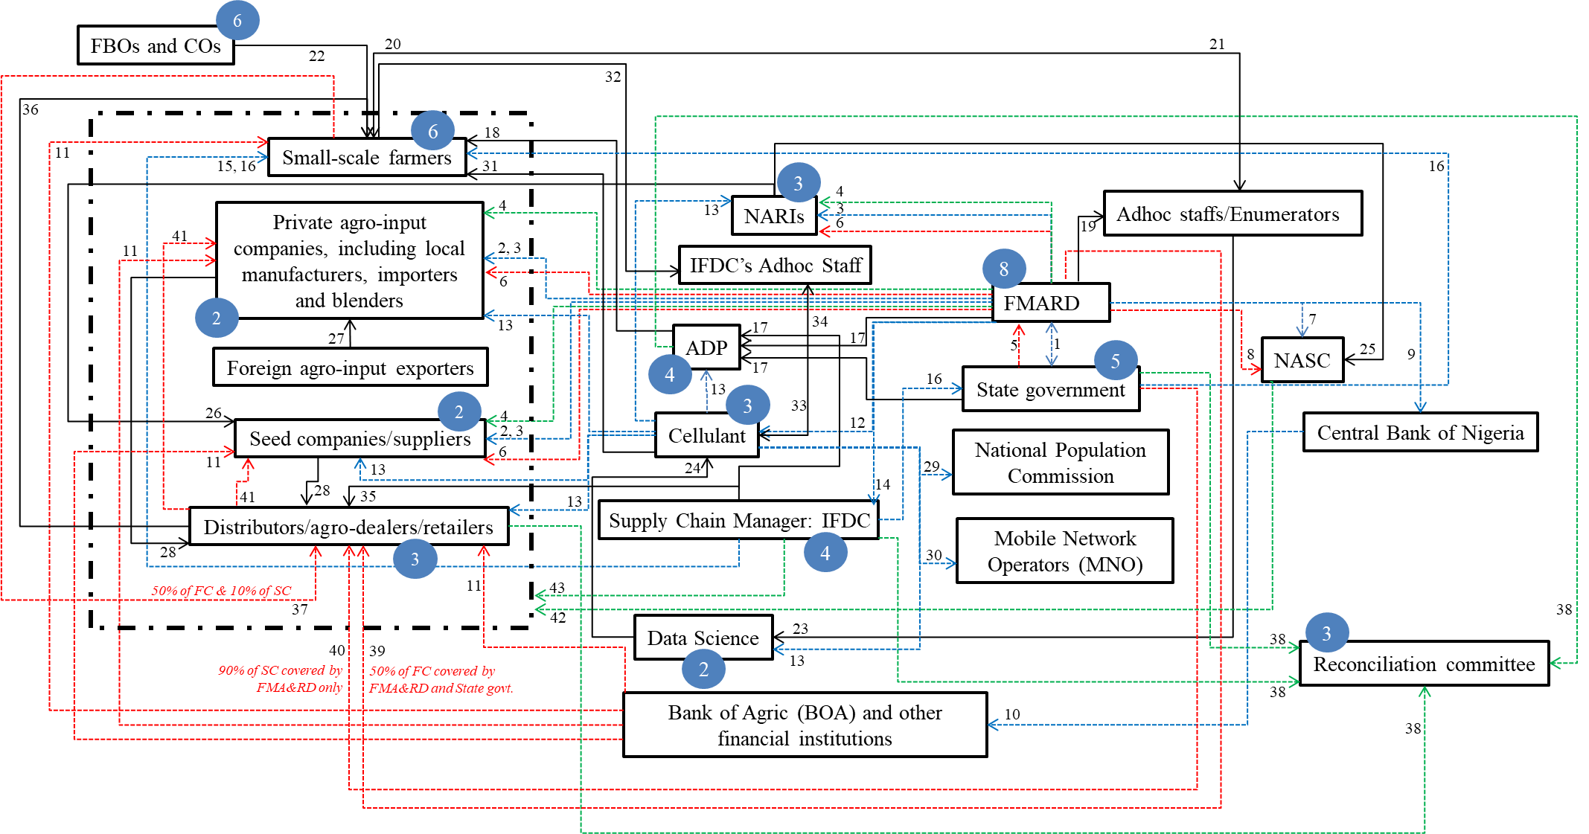
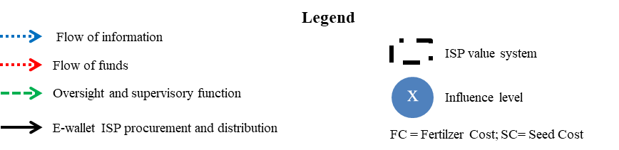
Figure A1: Process Net-Map of the Nigerian second-generation e-wallet ISP showing all the processes
Source: Authors’ illustration


Figure A2: Process Net-Map showing FMARD’s interaction and activities during the GESS


Figure A3: A copy of the farmers’ registration form during the GESS
Table S1: Comparison between different input programmes in Nigeria
Features | FISP (Before 2011) | E-wallet SISP (2012-2015) | PFI (2016 till date)
Goal | Subsidizes agricultural inputs for all farmers, encouraging modern input use by reducing costs | Ensures transparency and equality in fertilizer distribution and use, by stimulating farmers’ demand for modern inputs through subsidies and encouraging further input demand from contemporary input markets | Lowers market prices by supporting local input producers to scale up supply and blend fertilizers, capping market prices
Target recipients | Broad, often targeting middlemen and larger farmers | Registered small-scale farmers, with 5 ha or less and growing certain crops (e.g., maize or rice) | Local companies registered under the PFI framework
Focus | Broad and often undefined | Demand-driven, with a focus on small-scale farmers | Supply and private sector-driven, with a business-oriented model
Input type | Mainly fertilizers | Fertilizers and hybrid seeds | Fertilizer
Digitalization | None | E-voucher sent through mobile phone | Digital finance and payments to input companies
Input procurement and distribution method | Done by federal and state government agencies | Initiation by the government, but procurement and distribution are done by private actors through mobile notification and the use of electronic systems for verification and monitoring | Initiation by the government, but production and distribution are done by private actors in local factories, with market forces taking over demand.
Subsidy type | Broad subsidies, with limited transparency | Subsidies delivered directly to farmers through an e-wallet | Subsidizing local production to reduce fertilizer prices instead of farmers
Registration system | Often, weak beneficiary registration | Centralized, paper-to-digital biometrics-based registration | Company registration through the PFI framework
Transparency and efficiency | Low due to political control and manual processes | Higher transparency through e-wallet and electronic monitoring | Transparency on local production, but little information on small-scale farmer consumption
Organizational structures | The public sector oversees the design, procurement, distribution, and delivery of agricultural inputs to farmers. | Lower public sector role, limited to policy design and subsidy payments, while the private sector handled procurement, distribution, and delivery to farmers, sometimes partnering with community groups such as NGOs and farmer associations | Lower public sector role, focused on policy and funding, with the private sector leading other activities and minimal involvement from community groups such as NGOs and farmer associations.
Main challenges | - Widespread elite capture and corruption  - Political control and interference  - Mistargeting and poorly tailored input packages  - Low coverage  - Huge fiscal burden  - Distribution inefficiencies  - Poor and highly inconsistent institutional environment and support  - Very weak institutional arrangement and capacity  - Huge fiscal burden | - Localized elite capture and corruption  - Delayed inconsistent funding  - Round-tripping, leakage, adulteration, and diversion  - Poor institutional environment and weak support  - Limited institutional capacity and arrangement  - Heavy fiscal burden | - High market price  - Weak infrastructure and constrained input supply chains  - Low awareness and limited capacity among small-scale farmers  - Strong farmers’ preference for subsidized fertilizers  - High financing costs  - Vulnerable to market distortions from international fertilizer market price fluctuations  - Fertilizer-focused approach, with no attention to hybrid seeds
Achievements | - Limited, due to inefficiencies and late input supply | - Notable yield and welfare gains reported in some areas  - Better targeting and higher coverage across the country  - Lower corruption and political interference or control  - Higher transparency and cost control | - Higher fertilizer production and consumption  - Availability of different fertilizer types  - Further impact evaluation is needed, particularly concerning access by small-scale farmers.
Source: Authors’ compilation based on literature review and participants’ perspectives.

