Supplementary Materials

Title: To move or not to move – factors influencing small-scale herder and livestock movements in the Dzungarian Gobi, Mongolia

Lena M. Michler_{a},_{b}, Petra Kaczensky_{d,e}, Ganbaatar Oyunsaikhan_{f}, Gundula S. Bartzke_{g}, Olivier Devineau_{d}, Anna C. Treydte_{a,c}

Corresponding author: Lena M. Michler; e-mail: lena.m.michler@gmail.com
a) Faculty of Agricultural Sciences, Institute of Agricultural Sciences in the Tropics (Hans-Ruthenberg-Institute), Department of Ecology of Tropical Agricultural Systems, University of Hohenheim, 70599 Stuttgart, Germany
b) International Takhi Group, 8135 Sihlwald, Switzerland

Anna C. Treydte; e-mail: anna.treydte@natgeo.su.se;
c) Department of Physical Geography, Stockholm University, 10691 Stockholm, Sweden
and
a) Faculty of Agricultural Sciences, Institute of Agricultural Sciences in the Tropics (Hans-Ruthenberg-Institute), Department of Ecology of Tropical Agricultural Systems, University of Hohenheim, 70599 Stuttgart, Germany

Petra Kaczensky; email: petra.kaczensky@inn.no;
d) Faculty of Applied Ecology, Agricultural Sciences and Biotechnology, Department of Forestry and Wildlife, Inland Norway University of Applied Sciences, Norway
and
e) Research Institute of Wildlife Ecology, University of Veterinary Medicine, Vienna, Austria

Ganbaatar Oyunsaikhan; email: greatgobib@gmail.com
f) Great Gobi B Strictly Protected Area Administration, Bugat Soum, Gobi-Altai, Mongolia

Gundula S. Bartzke; email: Gundula.Bartzke@uni-hohenheim.de
g) Faculty of Agricultural Sciences, Institute of Crop Science, Department of Biostatistics, University of Hohenheim, 70599 Stuttgart, Germany

Olivier Devineau ; email: olivier.devineau@inn.no
d) Faculty of Applied Ecology, Agricultural Sciences and Biotechnology, Department of Forestry and Wildlife, Inland Norway University of Applied Sciences, Norway
Fig. S1: Average monthly temperature and precipitation from January 2018 until May 2020 at herder camps in the Altai highlands and the Gobi plains of Mongolia collected by Copernicus ERA5 monthly data. The dashed lines show the mean precipitation (blue) and mean temperature (red) over the entire study period.

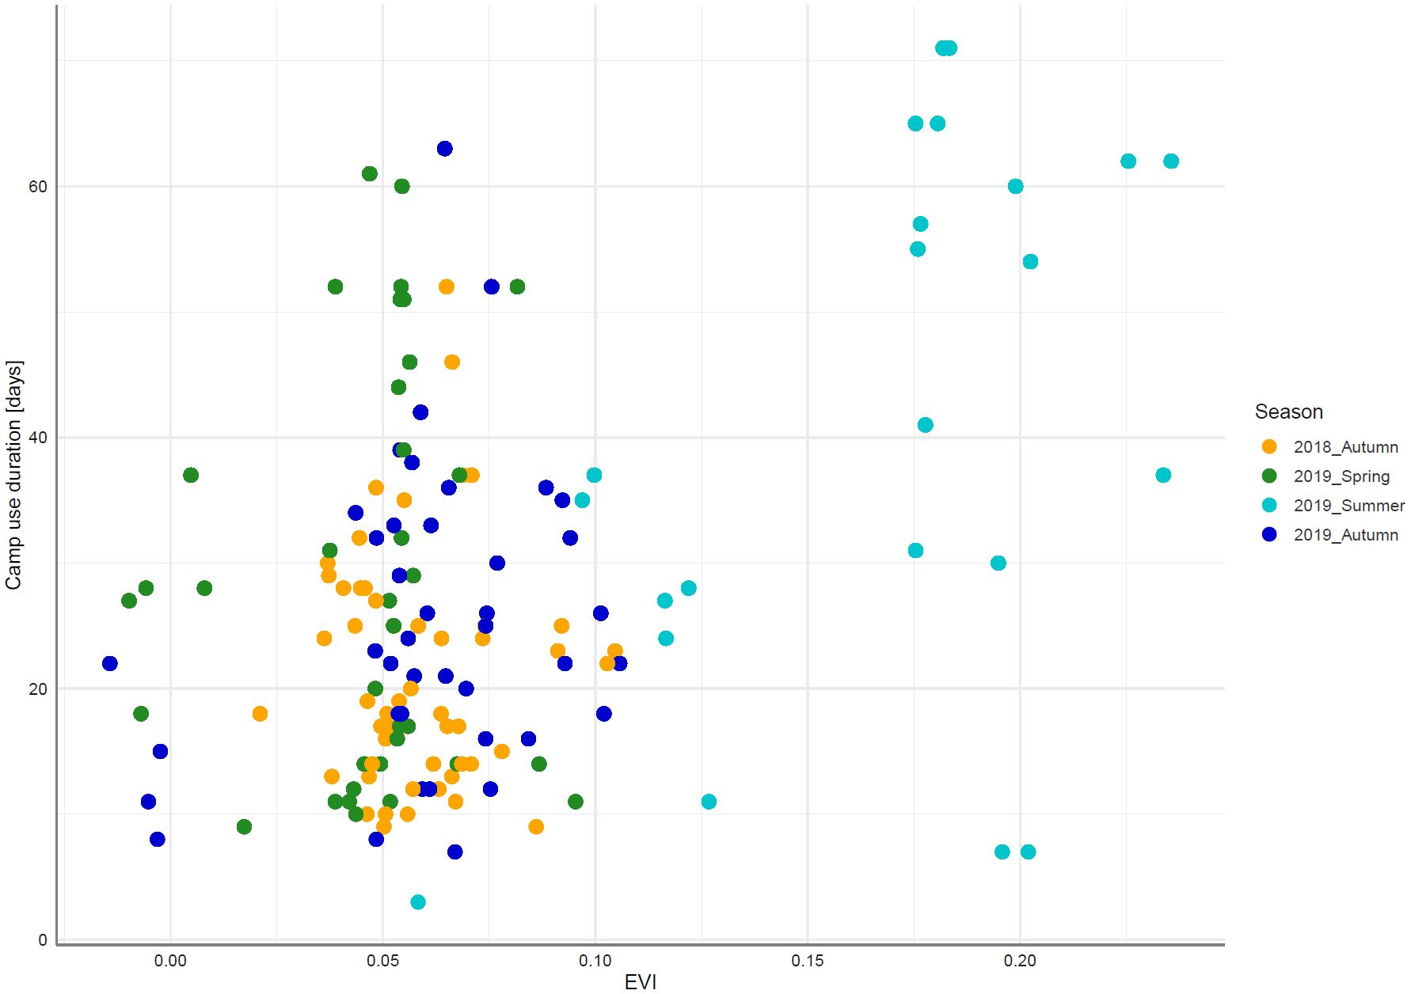
Fig. S2: Herder camp use duration (days) dependent on enhanced vegetation index (EVI) and season by year (SeasonalCamp). Herder camps were located in and around the Great Gobi B Strictly Protected Area, Mongolia.

Table S1: All candidate models that we used to estimate the camp use duration (CampUse) in the Great Gobi B Strictly Protected Area, Mongolia, based on GPS movement data collected in autumn 2018, spring 2019, summer 2019 and autumn 2019. The explanatory variables in the model were: enhanced vegetation index (EVI), season by year (SeasonalCamp), herd size (HerdSize) and herd ratio (HerdRatio; goats/sheep) in sheep forage units. Herder ID was included as random effect in all models.
Model | AIC_{c} | ΔAIC_{c} | AIC_{c} weight | Log- Likelihood
EVI + SeasonalCamp + EVI:SeasonalCamp* | 32169 | 0.00 | 1 | -16075
EVI + SeasonalCamp + (1|HerderID) | 32385 | 216 | 0 | -16186
SeasonalCamp + HerdSize + SeasonalCamp : HerdSize | 32622 | 453 | 0 | -16301
SeasonalCamp + HerdRatio + SeasonalCamp : HerdRatio | 32673 | 504 | 0 | -16326
SeasonalCamp | 32675 | 506 | 0 | -16332
SeasonalCamp + HerdSize | 32676 | 507 | 0 | -16331
SeasonalCamp + HerdRatio | 32677 | 507 | 0 | -16331
EVI + HerdSize + EVI:HerdSize | 32945 | 776 | 0 | -16467
EVI | 32955 | 785 | 0 | -16473
EVI + HerdRatio + EVI:HerdRatio | 32956 | 787 | 0 | -16472
EVI + HerdRatio | 32956 | 787 | 0 | -16473
EVI + HerdSize | 32957 | 787 | 0 | -16473
HerdRatio | 34051 | 1881 | 0 | -17021
HerdSize | 34052 | 1882 | 0 | -17022
*The division sign (:) represents an interaction between two explanatory variables

Fig. S3: Herder arrival date versus date of first permanent snow cover at winter camps in the Great Gobi B Strictly Protected Area, Mongolia, in 2018 and 2019.

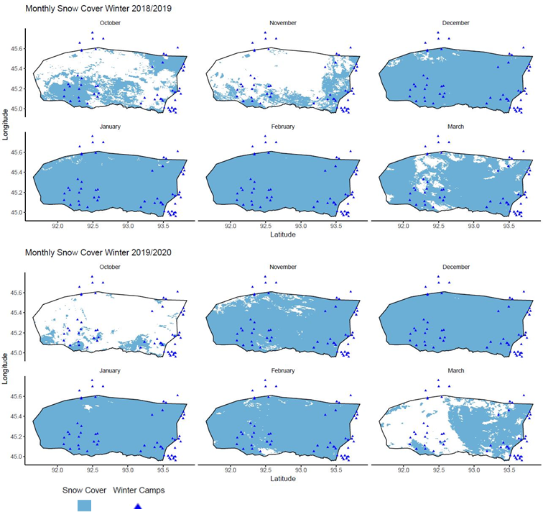
Fig. S4: Monthly snow cover in winter 2018/2019 and winter 2019/2020 in the Great Gobi B Strictly Protected Area, Mongolia. Blue represents snow cover, white shows areas without snow. Blue triangles show the general location of winter camps used by the pastoralists based on GPS data.

Table S2: All candidate models that we used to estimate daily walking distances (WalkDist) by small livestock in the Great Gobi B Strictly Protected Area, Mongolia, based on GPS movement data collected in autumn 2018, spring 2019, summer 2019 and autumn 2019. The explanatory variables in the models were: enhanced vegetation index (EVI), seasonal camp location in respective years (SeasonalCamp), herd size (HerdSize) and herd ratio (HerdRatio; goats/sheep) in sheep forage units, temperature (Temp) and days since camp use start (CampStart). Herder ID was included as a random effect in all models.
Model | AIC_{c} | Delta  AIC_{c} | AIC_{c} Weight | Log-Likelihood
SeasonalCamp + CampStart | 20007 | 0 | 1 | -9996
EVI + SeasonalCamp | 20028 | 21 | 0 | -10007
EVI + SeasonalCamp + EVI : SeasonalCamp* | 20028 | 21 | 0 | -10007
SeasonalCamp + HerdSize | 20029 | 22 | 0 | -10008
EVI + SeasonalCamp + Temp + SeasonalCamp : Temp + HerdRatio | 20029 | 22 | 0 | -10008
SeasonalCamp | 20031 | 24 | 0 | -10009
HerdSize + Temp | 20031 | 24 | 0 | -10009
SeasonalCamp + HerdRatio | 20033 | 26 | 0 | -10009
EVI + SeasonalCamp + EVI : SeasonalCamp + HerdRatio | 20033 | 26 | 0 | -10009
EVI + Temp | 20736 | 729 | 0 | -10363
Temp | 20800 | 793 | 0 | -10396
Temp + CampStart | 20800 | 793 | 0 | -10396
EVI + CampStart | 20886 | 879 | 0 | -10438
CampStart | 20901 | 894 | 0 | -10447
HerdSize + CampStart | 20901 | 894 | 0 | -10447
EVI + HerdSize | 20955 | 948 | 0 | -10472
HerdSize | 20955 | 948 | 0 | -10473
HerdRatio + Temp | 20955 | 948 | 0 | -10473
EVI | 20960 | 953 | 0 | -10476
EVI + HerdRatio | 20962 | 955 | 0 | -10476
HerdRatio | 20962 | 955 | 0 | -10477
HerdRatio + CampStart | 20962 | 955 | 0 | -10477
*The division sign (:) represents an interaction between two explanatory variables

Table S3: All candidate models that we used to estimate daily maximum walking distances by small livestock from camps (MaxDist) in the Great Gobi B Strictly Protected Area, Mongolia, based on GPS movement data collected in autumn 2018, spring 2019, summer 2019 and autumn 2019. The explanatory variables in the models were: enhanced vegetation index (EVI), seasonal camp location in respective years (SeasonalCamp), herd size (HerdSize) and herd ratio (HerdRatio; goats/sheep) in sheep forage units, temperature (Temp) and days since camp use start (CampStart). Herder ID was included as a random effect in all models.
Model | AIC_{c} | Delta  AIC_{c} | AIC_{c} Weight | Log-Likelihood
SeasonalCamp + CampStart | 14869 | 0 | 1 | -7428
SeasonalCamp + HerdSize | 14985 | 116 | 0 | -7485
SeasonalCamp | 14988 | 119 | 0 | -7488
HerdSize + Temp | 14988 | 119 | 0 | -7488
EVI + SeasonalCamp | 14989 | 120 | 0 | -7487
EVI + SeasonalCamp + EVI : SeasonalCamp | 14989 | 120 | 0 | -7487
SeasonalCamp + HerdRatio | 14991 | 121 | 0 | -7488
EVI + SeasonalCamp + EVI : SeasonalCamp + HerdRatio | 14991 | 121 | 0 | -7488
EVI + CampStart | 15216 | 347 | 0 | -7603
EVI + SeasonalCamp + EVI : SeasonalCamp + HerdSize | 15216 | 347 | 0 | -7603
CampStart | 15240 | 371 | 0 | -7616
HerdSize + CampStart | 15240 | 371 | 0 | -7616
EVI + Temp | 15358 | 489 | 0 | -7674
Temp | 15368 | 499 | 0 | -7680
Temp + CampStart | 15368 | 499 | 0 | -7680
HerdSize | 15388 | 519 | 0 | -7690
HerdRatio + Temp | 15388 | 519 | 0 | -7690
EVI + HerdSize | 15389 | 520 | 0 | -7690
EVI | 15395 | 526 | 0 | -7694
HerdRatio | 15396 | 527 | 0 | -7694
HerdRatio + CampStart | 15396 | 527 | 0 | -7694
EVI + HerdRatio | 15397 | 528 | 0 | -7694
*The division sign (:) represents an interaction between two explanatory variables

Table S4: All candidate models that we used to estimate daily pasture time (PastureTime) by small livestock in the Great Gobi B Strictly Protected Area, Mongolia, based on GPS movement data collected in autumn 2018, spring 2019, summer 2019 and autumn 2019. The explanatory variables in the models were: enhanced vegetation index (EVI), seasonal camp location in respective years (SeasonalCamp), herd size (HerdSize) and herd ratio (HerdRatio; goats/sheep) in sheep forage units, temperature (Temp) and days since camp use start (CampStart). Herder ID was included as a random effect in all models.
Model | AIC_{c} | Delta  AIC_{c} | AIC_{c} Weight | Log-Likelihood
EVI + Temp | 17058 | 0 | 1 | -8524
Temp | 17192 | 133 | 0 | -8592
Temp + CampStart | 17192 | 133 | 0 | -8592
EVI + SeasonalCamp | 17348 | 290 | 0 | -8667
EVI + SeasonalCamp + EVI : SeasonalCamp* | 17348 | 290 | 0 | -8667
SeasonalCamp + CampStart | 17469 | 410 | 0 | -8727
SeasonalCamp | 17478 | 420 | 0 | -8733
HerdSize^{d} + Temp | 17478 | 420 | 0 | -8733
SeasonalCamp + HerdRatio | 17479 | 421 | 0 | -8733
EVI + SeasonalCamp + EVI : SeasonalCamp + HerdRatio | 17479 | 421 | 0 | -8733
SeasonalCamp + HerdSize | 17480 | 422 | 0 | -8733
EVI + CampStart | 17690 | 632 | 0 | -8840
EVI + SeasonalCamp + EVI : SeasonalCamp + HerdSize | 17690 | 632 | 0 | -8840
EVI | 17691 | 633 | 0 | -8841
EVI + HerdSize | 17692 | 633 | 0 | -8841
EVI + HerdRatio | 17693 | 634 | 0 | -8841
CampStart | 18209 | 1151 | 0 | -9101
HerdSize + CampStart | 18209 | 1151 | 0 | -9101
HerdRatioHerdRatio | 18240 | 1182 | 0 | -9116
HerdRatioHerdRatio + CampStart | 18240 | 1182 | 0 | -9116
HerdSize | 18241 | 1183 | 0 | -9117
HerdRatioHerdRatio + Temp | 18241 | 1183 | 0 | -9117
*The division sign (:) represents an interaction between two explanatory variables

Table S5: Liveweight [kg] of goat and sheep breeds divided into sex occurring in the area around the Great Gobi B Strictly Protected Area, Mongolia. All selected animals were adults (>2 years old). Presented is own data and literature data from Jamsran et al. (2018).
Livestock species | Breed | Sex | Liveweight [kg]
Livestock species | Breed | Sex | Spring  (April - May) | Autumn  (October)
Goat | Mongolian native (own data) | Male | 50.0 | 63.0
Goat | Mongolian native (own data) | Female | 32.0 | 41.0
Goat | Mongolian native (literature data) | Male | 42.0 | 55.0
Goat | Mongolian native (literature data) | Female | 30.0 | 40.0
Goat | Altai red (literature data) | Male | 50.0 | 64.0
Goat | Altai red (literature data) | Female | 38.0 | 48.0
Goat | Uuliin brow (literature data) | Male | 42.0 | 58.0
Goat | Uuliin brow (literature data) | Female | 28.0 | 39.0
Sheep | Mongolian native (own data) | Male | 58.0 | 70.0
Sheep | Mongolian native (own data) | Female | 42.0 | 55.0
Sheep | Mongolian native (literature data) | Male | 45.0 | 60.0
Sheep | Mongolian native (literature data) | Female | 38.0 | 48.0
Sheep | Gobi-Altai (literature data) | Male | 53.0 | 68.0
Sheep | Gobi-Altai (literature data) | Female | 38.0 | 53.0
Sheep | Sutai strain (literature data) | Male | 52.0 | 65.0
Sheep | Sutai strain (literature data) | Female | 39.0 | 53.0
Sheep | Torguud (literature data) | Male | 55.0 | 65.0
Sheep | Torguud (literature data) | Female | 42.0 | 50.0

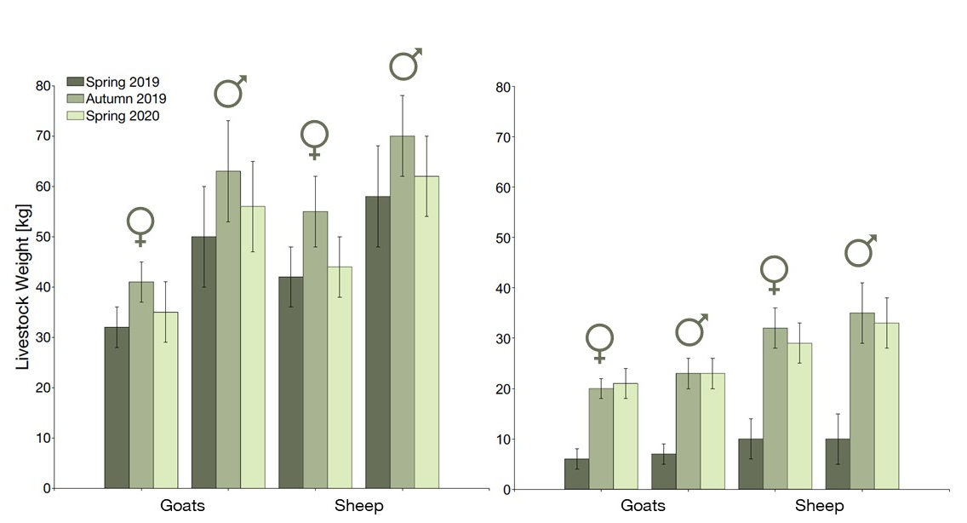
Fig. S5: Weight [kg] of individually marked adult goats and sheep (left) and their young of the year (right), divided into female (♀) and male (♂) across three seasons in the Great Gobi B Strictly Protected Area, Mongolia. Whiskers show the standard deviation. Data were collected in April 2019/2020 and October 2019, N = 228.

Table S6: Number of goats and sheep in sheep forage units (1 sheep = 0.9 goat), herd ratio (goat/sheep) and herd size of 19 livestock herders in 2018 in the Great Gobi B Strictly Protected Area, Mongolia.
Herder ID | No. of Goats | No. of Sheep | Herd_Ratio | Herd_Size
1a_East | 675 | 300 | 2.25 | 975
2a_East | 360 | 200 | 1.80 | 560
3a_East | 270 | 150 | 1.80 | 420
4a_East | 720 | 450 | 1.60 | 1170
5a_East | 675 | 550 | 1.23 | 1225
6a_East | 576 | 340 | 1.69 | 916
7a_East* | 283.5 | 20 | 14.18 | 303.5
8a_East | 270 | 150 | 1.80 | 420
9a_East | 355.5 | 285 | 1.25 | 640.5
10a_East | 702 | 800 | 0.88 | 1502
12a_East | 252 | 170 | 1.48 | 422
1b_West | 540 | 1100 | 0.49 | 1640
2b_West | 450 | 700 | 0.64 | 1150
3b_West | 540 | 200 | 2.70 | 740
4b_West | 459 | 600 | 0.77 | 1059
5b_West | 225 | 300 | 0.75 | 525
6b_West | 450 | 300 | 1.50 | 750
7b_West | 274.5 | 155 | 1.77 | 429.5
8b_West | 373.5 | 255 | 1.46 | 628.5
*This dataset was excluded from the analysis as the herd ratio was very extreme.

