Online Resources
What will the future bring? – Socio-economic challenges to herder households in the Great Gobi B strictly protected area, Mongolia
Journal: Human Ecology
Lena M. Michler_{a,b}, Petra Kaczensky_{c,d}, Daginnas Batsukh_{e,f}, Anna C. Treydte_{a,g}
Corresponding author: Lena M. Michler_{a,b}, e-mail: lena.m.michler@gmail.com; ORCID: 0000-0002-8031-7491
- Department of Ecology of Tropical Agricultural Systems (490f), Institute of Agricultural Sciences in the Tropics (Hans-Ruthenberg-Institute), University of Hohenheim, 70599 Stuttgart, Germany
and
- International Takhi Group, 8135 Sihlwald, Switzerland
Petra Kaczensky_{c,d}: email: petra.kaczensky@inn.no; ORCID: 0000-0001-5428-1176
c) Department of Forestry and Wildlife, Faculty of Applied Ecology, Agricultural Sciences and Biotechnology, Inland Norway University of Applied Sciences, Norway
and
d) Research Institute of Wildlife Ecology, University of Veterinary Medicine, Vienna, Austria
Daginnas Batsukh_{e,f}: email: daginnasb@gmail.com; ORCID: 0000-0002-8952-3945
e) Darkhan campus, Mongolian University of Life Sciences, Darkhan, Mongolia
f) Climate International Cooperation Department, Incheon National University, Republic of Korea
Anna C. Treydte_{a,g}: e-mail: anna.treydte@natgeo.su.se; ORCID: 0000-0003-0605-3069
g) Department of Physical Geography, Stockholm University, 10691 Stockholm, Sweden
and
a) Department of Ecology of Tropical Agricultural Systems (490f), Institute of Agricultural Sciences in the Tropics (Hans-Ruthenberg-Institute), University of Hohenheim, 70599 Stuttgart, Germany

Online Resource 1 Questionnaire Great Gobi B SPA

Date: Time:
I. Household information:
1) Interview number (ID): (Everything will be anonymous and the name will be left out)
2) Main interviewee partner:......................................................................... Age:
Family name:…………………………………………………………………………………………
3) For how long have you / your family been a herder household?:
4) Were you born and raised in this region (ask for aimag, soum and bag?:
5) Location of current camp (GPS):
6) Which camp is this: □ Fall/Autumn □ Winter □ Spring □ Summer
7) Number of people associated with this household: use household network sheet
8) What is the normal migration route: use camp sheet

II. Livestock situation:
1) How many animals do you graze?
 |  | Goats | Sheep | Cattle | Yaks | Horses | Camels
How many animals do you graze?
How (km) far from your ger do animals graze? | Summer
How (km) far from your ger do animals graze? | Winter

2) How many dogs do you have:
3) Has the total number of the livestock you graze within the last 3 years:
□ Increased □ Decreased □ Remained the same
4) Would you like to increase the livestock numbers in future? □ Yes □ No
If yes: Why and what species?
………………………………………………………………………………………………………………………………………………………………………………………………………………………………………………………………………………………………………………………….
5) Ownership of herd?
□ Own %: □ Other family members %: □ Animals of someone else (unrelated)%:
6) Herding regime?
 | At ger at night |  | Herder with flock |  | Only check-ups |  |  | Other
 | inside corral | next to ger | whole day | part day | ≥1 / day | ≥1 / week | ≥1 1 / month | Other
Sheep & goats
Cattle
Yaks
Horses
Camels

6) Who is herding your animals? ..........................................................................................................
7a) How far (km) from the ger does the herder walk/ride everyday?……………………………………………
7b) Do you herd with:
□ by foot □ on horse □ with motorbike □ with camel
8) When does the herder leave the ger in the morning hour and when do you come back in the afternoon?
 | Time leaving | Time coming back
Summer
Winter

9) Who in your household is mainly responsible for the animals in daily / annual routines?
Task | Responsible person(s) in household | Season of main work load
Herding
Milking
Shearing wool
Combing cashmere
Marking / castrating
Slaughtering
Selling/purchasing
Caring for young animals
Caring for sick animals

IV. Livestock household economy:
1) To which percentage does herding contribute to your total income?
□0 – 25 % □25 – 50 % □50 – 75 % □75 – 100 %
2) Do you have any other sources of income? □ Yes □ No
If, yes:
% of overall household income
Park related income (what?)
Agricultural activity (what?)
Trade, small shop, souvenirs (what?)
Support from family member who is working in village/town
Other, e.g. governmental grants (pension, child grant, disability grant)
3) What are your household expenses for different items over the year?
Item | Expenses in % | Has the importance of these expenses changed and if so in which direction?
Food
Clothing
Health care
Health insurance
Retirement
Education of children
Travelling / transportation
Recreation
Livestock health
Equipment
Other:_______________
4) Which products do you sell?
Animal | Products: Milk or milk products, Wool, Cashmere, Meat, Hide, Animals | Revenue gain (high, moderate, low)
Goat
Sheep
Cattle
Yak
Horse
Camel
5) What prices do you fetch for:
Product | In MNT | Earnings in relative importance (high, low, medium, not important)
Milk [L]
Wool [kg] / Cashmere [kg]
Meat [kg]
Animals [price per animals]
Hide [price per hides]

7) How many animals do you need for a good living? ....................................................................
Minimum, what is a good herd size…………………………………………………………………………………………….
Can the herds be to big? ……………………………………………………………………………………………………….

Online Resource 2 Interview Statistics of 125 herder household interviews in 2017/2018 in the Great Gobi B strictly protected area in Mongolia. When a couple was interviewed the age of the male partner was recorded.
ID | Main interview partner(s) | Age of main interview partner | Belongs to district
1 | female | 30 | Altai soum
2 | male | 40 | Bugat soum
3 | male & female | 54 | Bugat soum
4 | male | 58 | Bugat soum
5 | male | 53 | Bugat soum
6 | male & female | 63 | Bugat soum
7 | male | 46 | .
8 | male & female | 50 | Bugat soum
9 | male | 43 | .
10 | female | 58 | Bugat soum
11 | male | 46 | .
12 | male | 57 | Bugat soum
13 | female | 31 | Bugat soum
14 | male | 34 | Bugat soum
15 | female | 28 | Tonkhil soum
16 | male & female | 61 | Tonkhil soum
17 | female | 30 | Tonkhil soum
18 | male | 43 | Altai soum
19 | male | 40 | Altai soum
20 | male | 33 | Altai soum
21 | male & female | 33 | Altai soum
22 | female | 29 | Bugat soum
23 | male & female | 47 | Bugat soum
24 | female | 33 | Bugat soum
25 | male & female | 49 | Bugat soum
26 | male | 41 | Altai soum
27 | male | 54 | Altai soum
28 | female | 51 | Altai soum
29 | male | 55 | Altai soum
30 | male | 34 | Altai soum
31 | son | 26 | Altai soum
32 | male | 31 | Altai soum
33 | male | 22 | Altai soum
34 | male & female | 32 | Bugat soum
35 | male & female | 61 | Bugat soum
36 | male | 57
37 | male & female | 39 | Bugat soum
38 | male & female | 60 | Bugat soum
39 | male & female | 66 | Bugat soum
40 | male | 24 | Bugat soum
41 | male & female | 43 | Tonkhil soum
42 | male | 36 | Tonkhil soum
43 | female | 50 | Altai soum
44 | male | 33 | Altai soum
45 | male | 56 | Altai soum
46 | male & female | 43 | Bugat soum
47 | male | 38 | Tonkhil soum
48 | female | 43 | Bugat soum
49 | male | 17 | Bugat soum
50 | female | 41 | Tonkhil soum
51 | male | 38 | Bugat soum
52 | female | 59 | Tonkhil soum
53 | male | 67 | Bugat soum
54 | female | 48 | Bugat soum
55 | female | 60 | Bugat soum
56 | female | 53 | Bugat soum
57 | male | 27 | Mankhan soum
58 | male & female | 40 | .
59 | male & female | 42 | Bugat soum
60 | male & female | 50 | Bugat soum
61 | female | 61 | Bugat soum
62 | female | 41 | Bugat soum
63 | female | 55 | Bugat soum
64 | male | 51 | Bugat soum
65 | female | 64 | Bugat soum
66 | male | 56 | Bugat soum
67 | male | 41 | Bugat soum
68 | male | 70 | Altai soum
69 | male | 38 | Altai soum
70 | male | 34 | Bulgan soum
71 | female | 53 | Altai soum
72 | male | 39 | Altai soum
73 | male & female | 51 | Altai soum
74 | male | 57 | Altai soum
75 | female | . | Altai soum
76 | male | 60 | Mankhan soum
77 | male | 22 | Altai soum
78 | male | 22 | Altai soum
79 | male & female | 51 | Altai soum
80 | female | 45 | Altai soum
81 | female | 42 | Altai soum
82 | female | 20 | Altai soum
83 | male | 54 | Bulgan soum
84 | male | 42 | Altai soum
85 | male | 39 | Altai soum
86 | male | 48 | Altai soum
87 | male | 39 | Altai soum
88 | male | 36 | Tsetseg soum
89 | male & female | 31 | Altai soum
90 | male | 45 | Altai soum
91 | male | 33 | Altai soum
92 | male | 34 | Altai soum
93 | female | 27 | Altai soum
94 | female | 59 | Altai soum
95 | female | 28 | Altai soum
96 | male | 66 | Altai soum
97 | male | 57 | Altai soum
98 | male & female | 57 | Altai soum
99 | female | 58 | Altai soum
100 | female | 48 | Altai soum
101 | male | 67 | Altai soum
102 | female | 49 | Altai soum
103 | female | 25 | Altai soum
104 | male | 37 | Altai soum
105 | male | 30 | Altai soum
106 | female | 43 | Altai soum
107 | male | 49 | Altai soum
108 | female | 43 | Altai soum
109 | male | 38 | Altai soum
110 | male | 29 | Altai soum
111 | male | 59 | Altai soum
112 | male | 49 | Altai soum
113 | male | 20 | Altai soum
114 | male | 32 | Altai soum
115 | male & female | 48 | Altai soum
116 | male & female | 67 | Altai soum
117 | male | 31 | Altai soum
118 | male | 49 | Altai soum
119 | male | 45 | Altai soum
120 | male | 64 | Altai soum
121 | male & female | 32 | Uyench soum
122 | male | 39 | Altai soum
123 | male | 41 | Altai soum
124 | male | 66 | Altai soum
125 | female | 60 | Altai soum

Online Resource 3 State of collaboration between the protected area administration and local herders in the Great Gobi B strictly protected area in Mongolia 2019. Results of the survey on the participation of herders in the management of protected areas (N=36)
Q1: Living close to the Great Gobi B SPA is good for the livelihood of my family and me.
Q2: My family and I always follow all the regulations and recommendations given by the Great Gobi B SPA administration.
Q3: My family and I participate in consultative meetings with the Great Gobi B SPA to express our ideas about regulations and recommendations developed by the Great Gobi B SPA administration.
Q4: It is certain that my views are considered in decision-making by the National Park Administration.
Q5: The Great Gobi B SPA administration develops the management plan based on mutual understanding between stakeholders.
Q6: The Great Gobi B SPA administration regularly and openly presents their action plan for co-operation.
Q7: Locals and Great Gobi B SPA administration should collaborate on the conservation of nature and usage of natural resources.
Q8: The Great Gobi B SPA administration needs to improve its co-operation with herders and local communities in order to ensure environmental protection and sustainable use of natural resources.

Online Resource 4 Conflicts between stakeholders in the Great Gobi B strictly protected area in Mongolia 2019. Results of the survey on the participation of herders in the management of protected areas (N=36)
“I have faced the following challenges or troubles while living in the buffer zone of the protected area.”

Q9: Pasture land is limited for small livestock (sheep and goats).
Q10: Ability to move and rotate pastures with livestock is limited.
Q11: Pasture for horses is limited during the summer season due to Takhi breeding.
Q12: There are misunderstandings with the Great Gobi B SPA administration when transiting through the protected area.

Online Resource 5 Challenges of herders in regard to communication with the Great Gobi B strictly protected area in Mongolia 2019. Results of the survey on the participation of herders in the management of protected areas (N=36)
“I have the following challenges in regard to co-operating, and participating in environmental conservation and sustainable use of natural resources in the Great Gobi B SPA.”

Q13: Information about meetings and workshops is not distributed sufficiently to reach everyone, especially those in remote areas.
Q14: The Great Gobi B SPA administration does not organize meetings for listening to the views of local people.
Q15: The Great Gobi B SPA administration does not take action to resolve complaints and views of the local people.
Q16: There is lack of information and understanding of the rights of the community regarding co-operation and participation in the use of natural resources for environmental protection.

Online Resource 6 Future perspectives of 9 focus group participants (“young herders”) on their herder lifestyle in the Great Gobi B strictly protected area, Mongolia 2019.
Why did you become a herder?  Are your siblings herders too?  Did your parents envision you to become a herder? | Is there anything that will force you to change your lifestyle? Like to move to the town/city. Did you consider moving to the town/city? | What kind of school/university degree do you have? | If you would have an alternative job opportunity, would you still want to continue the herder lifestyle?
Does not know | Will continue to herd livestock | Primary school | Yes. I will herd livestock.
Parents are herders  Relatives are herders | Will continue to herd livestock | Secondary education | No
My husband is herder | Will continue to herd livestock | Secondary education | Yes. I will herd livestock.
Parents are herders | Will continue to herd livestock | Secondary education | Maybe I will choose a permanent job.
Parents are herders | I would like to move to the town | Secondary education | Yes. I will herd livestock.
Parents are herders | I would like to move to the town | Secondary education | Yes. I will herd livestock.
Parents are herders | I will continue to herd livestock | Secondary education | Maybe I will choose a permanent job.
Husband is herder | I would like to move to the town | Secondary education | No
No answer | No answer | Secondary education | No answer

Online Resource 7 Advantages and challenges of living a herder lifestyle in Mongolia reported by N=9 participants in a focus group discussion at the Great Gobi B Strictly Protected Area in Mongolia 2019.
Perspective | Advantages of living as a herder in Mongolia | Challenges of living as herder in Mongolia
Livestock Husbandry | - No time limitation  - Own production of cashmere, wool and dairy products  - Working for oneself  - Huge territory available for herding | - Climate: snow storms and hard winters  - Limited growth of grass and dry summer  - Limited communication options (phone networks & internet)  - Fluctuating market prices of cashmere, wool, and meat
Pasture Use | - Untouched rangelands  - Livestock gains enough fat for meat and dairy production  - Practice camp rotation during four seasons to protect the rangeland  - Consider rangeland use and its resources | - Staying for a long time at the same place destroys the rangeland  - Use rangeland for seasonal grazing  - A lot of snow during winter bring troubles  - Herders winter camps are close to each other, sometimes this brings minor conflicts
Social and Household | (No advantages mentioned by the focus group) | - Lack of public/governmental services:  Live far from school and kindergarten; Transfer of children to different schools influence their study quality  - Mostly girls go to schools and university; Boys are mostly responsible for herding livestock  - Safety is not provided, no police, no emergency service  - Difficult to get medical/health services  - Limited communication options (phone networks & internet)

Online Resource 8 Answers of focus group discussions with “young herders” of the Great Gobi B Strictly Protected Area, Mongolia, in November 2019. Questions were answered under the perspectives of livestock husbandry, pasture use and social and household aspects
Questions | Livestock Husbandry | Pasture Use | Social and Household
Traditional skills | - Marking animals through cutting ears  - Separating animals (carrying females and males)  - Livestock breeding | - Herding livestock (small livestock always with a herder)  - Get up early in the morning  - Separate animals (carrying females and males)  - Protecting the winter camp from wind and cold  - Prepare fodder for winter  - Preparing dairy products | - Preparing dairy products  - Preparing fodder / hay for winter  - Use the winter camps of grandparents  - Herding livestock
Traditional skills for coping in winter | - Separate weak and young animals  - Caring for weak and young animals at the warm winter camp  - Feed additional hay/fodder  - Herd livestock in a sheltered area with enough grass  - Have a good supply of pasture for the winter (be well prepared) | - Well protected winter camp (wind and snow)  - Consider pasture and winter rangeland  - Prepare “khujir” a white salty mineral for livestock and enough water | - Feed livestock additional fodder/hay  - Clean winter area from snow and ice  - Care for weak and young livestock
Incentive to change traditional herding / Already practiced changes | - No. Traditional herding is based on huge experience and it has worked for hundreds of years | - Give ownership status for rangeland | - Adapt to use motorbikes for herding. Before we only used horses, camels or walked for herding  - Get weather information from TV and radio and decide then where to herd livestock
Influence of media/internet on herding | - Get weather forecast from TV and radio  - Learning about experiences from others | - Get weather information  - Get information on new laws regarding animal husbandry | - Get information on lost animals  - Exchange experiences with each other  - Get recent information; helps to not stay behind in development
Influence of conservation activities on herder lifestyle | - Wildlife number increase influences rangeland degradation and it can affect our animal husbandry | - Conservation activities do influence rangeland use  - Sometimes wildlife home range is overlapping with livestock rangeland | - Will influence livestock rangeland  - Wildlife home range will influence rangeland of livestock
Influence of the protected area on herder lifestyle | - There is not much influence on the lifestyle yet | - Does not influence the lifestyle  - There will be an influence in the rangeland  - Beneficial due to no mining exploration | - Protecting water resources of “Gashuun”  - Internet connection

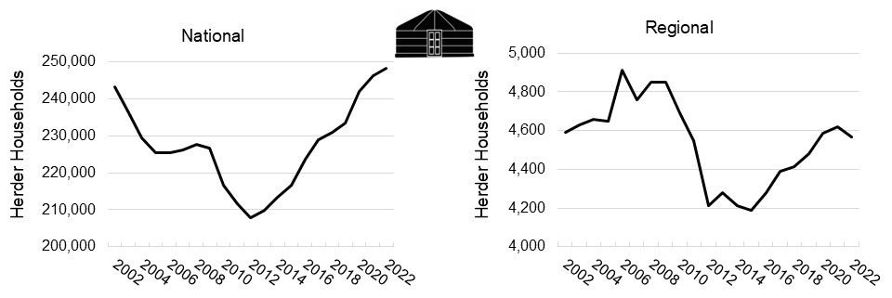
Online Resource 9 Herder household data in Mongolia (national) and within the five districts surrounding the Great Gobi B strictly protected area (regional) over 20 years (2002-2022; Mongolian Statistical Information, 2023).

Online Resource 10 Detailed household expenditures [%] of N=125 herder households in the Great Gobi B Strictly Protected Area in Mongolia 2017/2018

Online Resource 11 Daily and seasonal tasks of herder households over the course of one year inside the Great Gobi B Strictly Protected Area, Mongolia (N =70).
Annual/Seasonal Task | I | II | III | IV | V | VI | VII | VIII | IX | X | XI | XII
Herding
Slaughtering for daily consumption
Caring for offspring
Caring for sick animals
Marking/Castrating
Combing cashmere
Shearing sheep wool
Shearing camel wool
Milking
Slaughtering for winter preparation

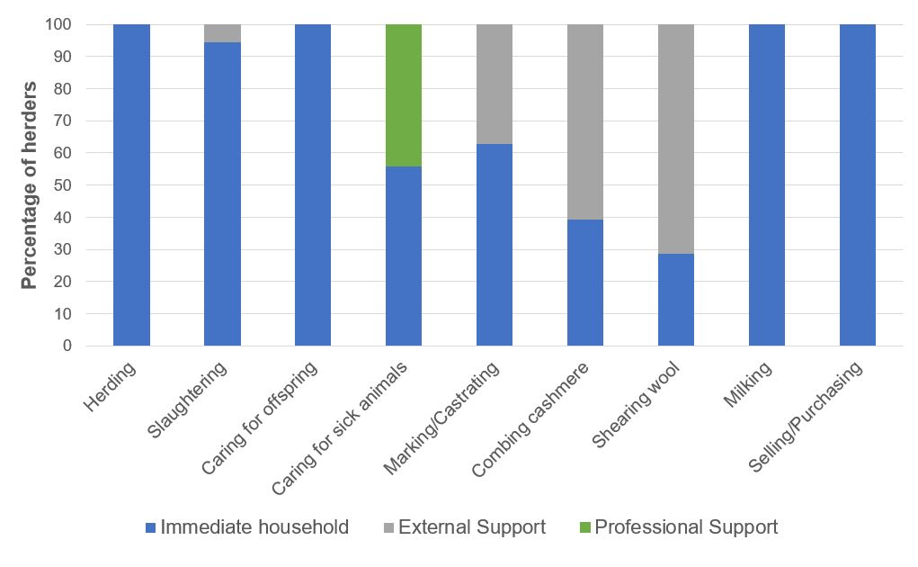
Online Resource 12 Responsible persons [%] for daily/seasonal routines of herder households inside the Great Gobi B Strictly Protected Area, Mongolia (N = 70)

