Supplementary material

Fig. S1 Rainfall and temperature conditions during the field trials, measured on site I at the University of Agriculture, Faisalabad, Pakistan: A) First season: March 13th to July 1st, 2017; B) Second season: July 11th to September 14th, 2017

Table S1 Dry matter accumulation in g plant⁻¹ and partitioning in % of total dry matter of mungbean inoculated with a multi-strain inoculum consisting of Rhizobium phaseoli, Bacillus subtilis, and Pseudomonas fluorescens (= multi) or an autoclaved broth (= control) at physiological maturity (two seasons), flowering and podfilling (one season only) in 2017 at the University of Agriculture, Faisalabad. DM = dry matter.
 | Dry matter accumulation in g plant⁻¹ and partitioning in % (of total dry matter)
 | March – July 2017 |  | July – September 2017
 | Maturity |  | Flowering |  | Podfilling |  | Maturity
 | g plant⁻¹ | % of total DM | g plant⁻¹ | % of total DM | g plant⁻¹ | % of total DM | g plant⁻¹ | % of total DM
Roots
Control | 2 | 6 | 2 | 11 | 2 | 7 | 3 | 7
Multi | 1 | 4 | 2 | 10 | 2 | 7 | 3 | 6
P | ns | ns | ns | ns | ns | ns | ns | ns
AG
Control | 11 | 34 | 17 | 88 | 25 | 72 | 24 | 59
Multi | 13 | 38 | 16 | 89 | 23 | 69 | 28 | 57
P | ns | ns | ns | ns | ns | ns | ns | ns
Pods
Control | 18 | 60 | 0 | 0 | 7 | 21 | 14 | 34
Multi | 19 | 58 | 0 | 0 | 8 | 24 | 19 | 37
P | ns | ns | - | - | ns | ns | ns | ns
**P indicates a statistically significant difference between treatments within one harvest stage at 0.05 significance level. Different letters indicate significant differences between treatments. ns means not significantly different.

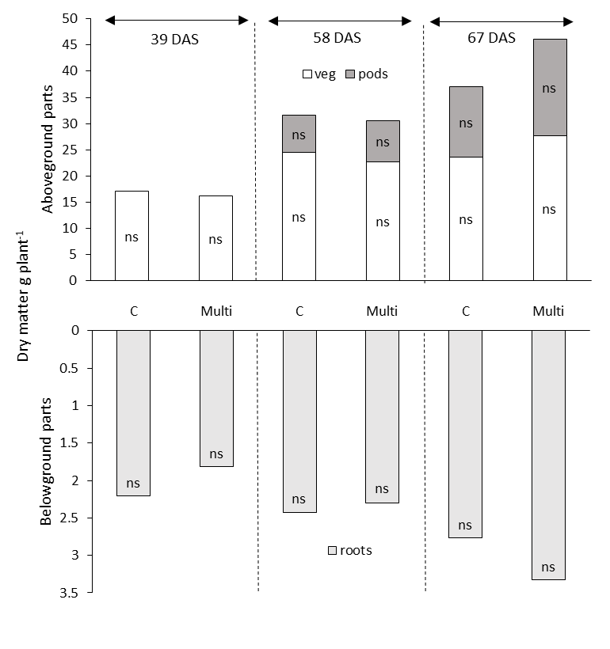
Fig. S2 Dry matter accumulation in different plant parts in g plant⁻¹ of mungbean inoculated with a multi-strain inoculum consisting of Rhizobium phaseoli, Bacillus subtilis, and Pseudomonas fluorescens (= multi) or an autoclaved broth (= control, C) at flowering (39 days after sowing [DAS]), mid-podfilling (58 DAS) and maturity (67 DAS) during one season in 2017 at the University of Agriculture, Faisalabad. Statistical significance was tested at 0.05 and 0.1 significance levels on each harvest date. ns means not significantly different.

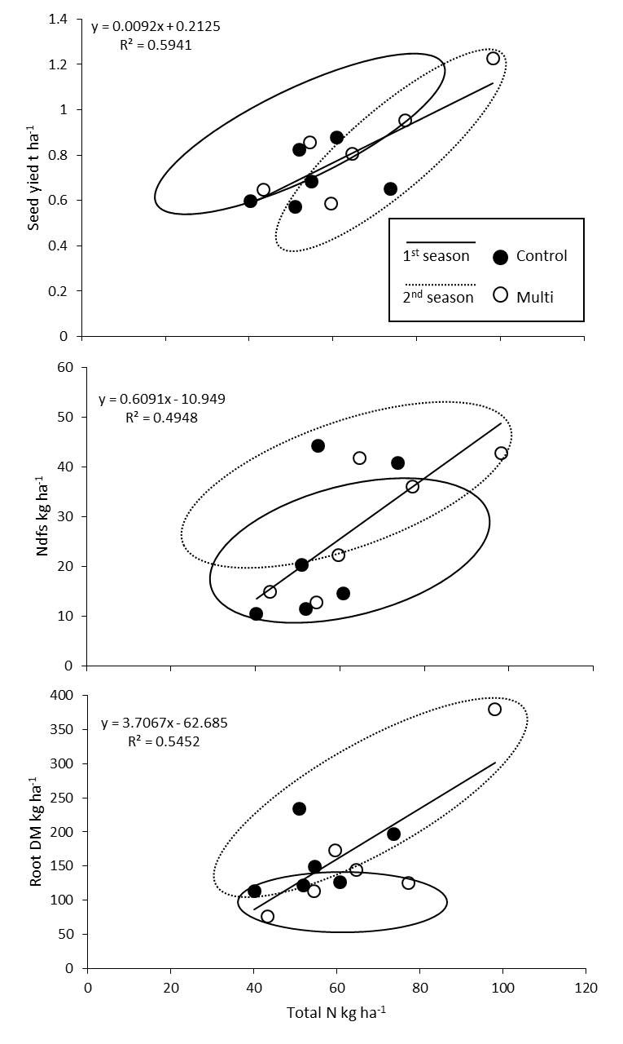
Fig. S3 Relationships between total plant-N in kg ha⁻¹ and root dry matter in kg ha⁻¹, N deriving from the soil (Ndfs) kg ha⁻¹ and seed yield in t ha⁻¹ of mungbean, inoculated with a multi-strain inoculum consisting of Rhizobium phaseoli, Bacillus subtilis, and Pseudomonas fluorescens (= multi) or with autoclaved broth (= control). Plants were cultivated in two seasons of 2017 (1st season: March–July 2017; 2nd season: July–September 2017) at the University of Agriculture, Faisalabad, Pakistan. Data refers to physiological maturity.
Table S2 Dry matter accumulation in g plant⁻¹ and partitioning in % of total dry matter of mungbean inoculated with Rhizobium phaseoli (M9), Bacillus subtilis (Y16), Pseudomonas fluorescens (Mk20), a mixture of all strains (= multi) or an autoclaved broth (= control) at flowering, podfilling and maturity in 2017 at the University of Agriculture, Faisalabad. DM = dry matter.
 | Dry matter accumulation in g plant⁻¹ and partitioning in % (of total dry matter)
 | Flowering |  | Podfilling |  | Maturity
 | g plant⁻¹ | % of total DM | g plant⁻¹ | % of total DM | g plant⁻¹ | % of total DM
Roots
Control | 1 | 10 | 3 | 9 | 3 c | 6 b
Multi  M9  Y16  Mk20 | 1  1  1  1 | 8  10  9  11 | 3  3  4  4 | 8  11  9  12 | 4 bc  4 b  6 a  3 bc | 6 b  7 ab  8 a  7 ab
P | ns | ns | ns | ns | ** | **
AG
Control | 9 ab | 90 | 27 | 78 | 31 b | 60
Multi  M9  Y16  Mk20 | 13 a  9 ab  11 ab  8 b | 92  90  91  89 | 30  26  35  26 | 75  76  76  74 | 40 a  38 ab  44 a  31 b | 65  63  59  63
P | ** | ns | ns | ns | ** | ns
Pods
Control | 0 | 0 | 5 | 14 | 17 ab | 34
Multi | 0 | 0 | 7 | 17 | 19 ab | 30
M9 | 0 | 0 | 4 | 13 | 18 ab | 30
Y16 | 0 | 0 | 7 | 15 | 25 a | 33
Mk20 | 0 | 0 | 6 | 15 | 15 b | 30
P |  |  | ns | ns | ** | ns
** Statistical significance was tested at 0.05 significance level at each harvest date. ns means not significantly different.

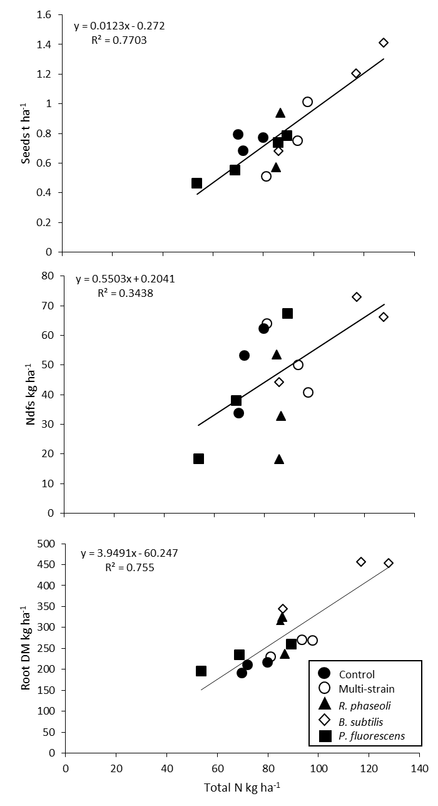
Fig. S4 Relationships between total plant-N in kg ha⁻¹ and root dry matter in kg ha⁻¹, N deriving from the soil (Ndfs) kg ha⁻¹ and seed yield in t ha⁻¹ of mungbean, inoculated with Rhizobium phaseoli, Bacillus subtilis, Pseudomonas fluorescens, a mixture of all strains (= multi) or with autoclaved broth (= control). Plants were cultivated in one season of 2017 at the University of Agriculture, Faisalabad, Pakistan. Data refers to physiological maturity, except Ndfs which was assessed at mid-podfilling.

