Combining spring wheat genotypes with contrasting root architectures modifies plant-microbe interactions under different water regimes
Adrian Lattacher¹, Samuel Le Gall², Youri Rothfuss², Moritz Harings², Wolfgang Armbruster³, Dagmar van Dusschoten⁴, Daniel Pflugfelder⁴, Samir Alahmad⁵, Lee T. Hickey⁵, Ellen Kandeler¹, Christian Poll¹
¹ Soil Biology Department, Institute of Soil Science and Land Evaluation, University of Hohenheim, 70599 Stuttgart, Germany
² Institute of Bio- and Geosciences, Agrosphere (IBG-3), Forschungszentrum Jülich, 52428 Jülich, Germany
³ Department of Food Chemistry and Analytical Chemistry, Institute of Food and Chemistry, University of Hohenheim, 70599 Stuttgart, Germany
⁴ Institute of Bio- and Geoscience, Plant Sciences (IBG-2), Forschungszentrum Jülich, 52428 Jülich, Germany
⁵ Queensland Alliance for Agriculture and Food Innovation, The University of Queensland, St Lucia, QLD 4072, Australia
Corresponding author: Adrian Lattacher (adrian.lattacher@uni-hohenheim.de)
Plant and Soil
Supplementary material
Table S1 Experimental setup of the runs 1 to 3, each containing one replicate of each treatment. The table also shows the respective column positions of the different treatments within the climate chamber during each run.
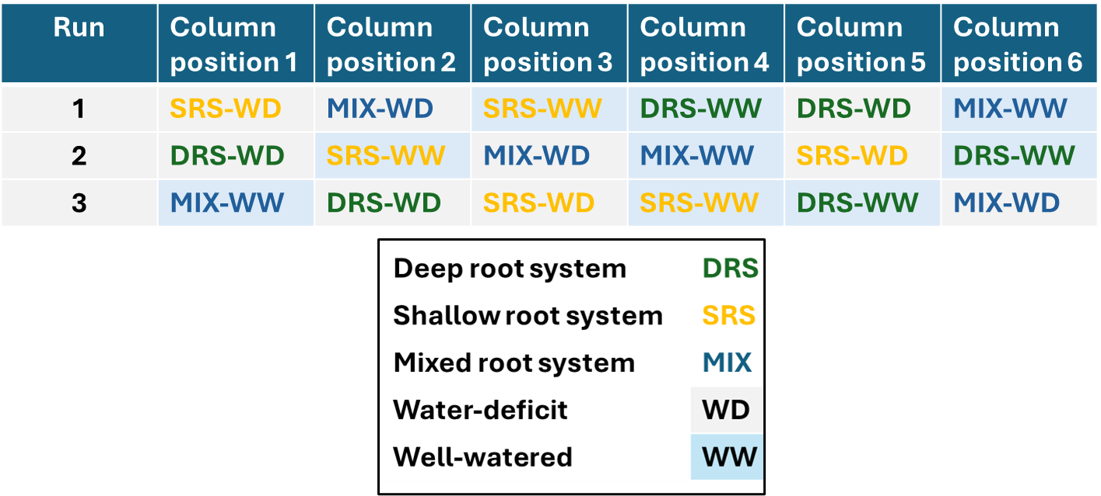
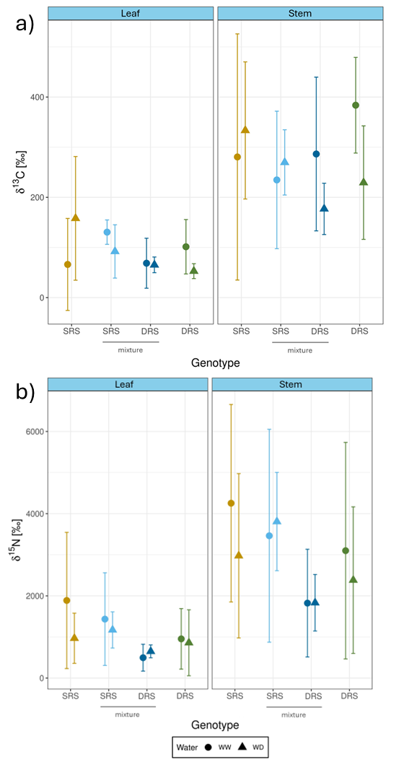

Fig. S1 δ¹³C (a) and δ¹⁵N signal (b) in leaf and stem for the phenotype with the deep root system (DRS) (green), the phenotype with the shallow root system (SRS) (yellow), the phenotype with the deep root system in the mixture (dark blue) and the phenotype with the shallow root system in the mixture (light blue). Error bars represent the standard deviation of 3 replicates. Circles represent the mean value under well-watered conditions (WW) while triangles represent the mean value under water deficit conditions (WD).
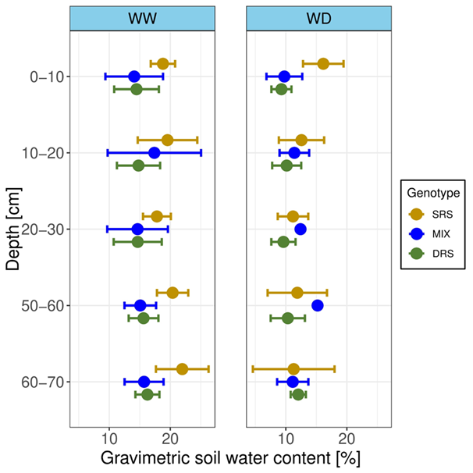
Fig. S2 Gravimetric soil water content in in various soil depths for the deep root system (DRS) (green), shallow root system (SRS) (yellow) and the mixture (MIX) (blue) under well-watered (WW) and water-deficit (WD) conditions. Data represent means of 3 replicates with standard deviation of 3 replicates
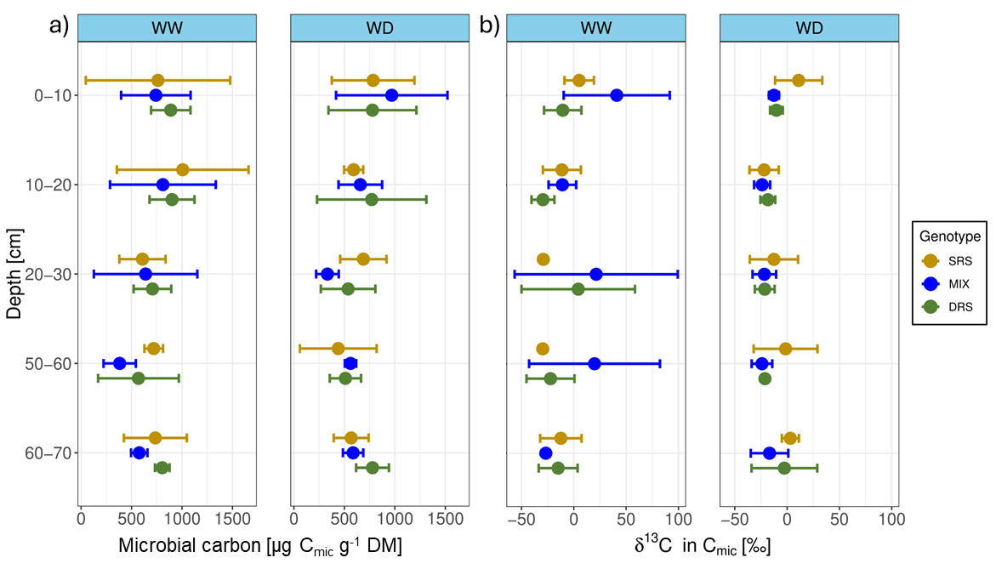
Fig. S3 Microbial carbon (a) and δ¹³C signal in microbial carbon (b) in various soil depths for the deep root system (DRS) (green), shallow root system (SRS) (yellow) and the mixture (MIX) (blue) under well-watered (WW) and water-deficit (WD) conditions. Error bars represent the standard deviation of 3 replicates.
Statistical model
mod1<- lme(Parameter~Phenotype*Depth*Water, data=data, random=~1|Run/Column, na.action = na.omit)
anova(mod1)
For the term "Parameter", the respective analytical endpoint was inserted (e.g., PLFA, enzyme activity, etc.).

