Hydrolyzable microplastics in soil – low biodegradation but formation of a specific microbial habitat?
Lion Schöpfer^{1*}, Uwe Schnepf², Sven Marhan¹, Franz Brümmer², Ellen Kandeler¹, Holger Pagel³
¹Soil Biology Department, Institute of Soil Science and Land Evaluation, University of Hohenheim, Emil-Wolff-Str. 27, 70599 Stuttgart, Germany
²Research Unit Biodiversity and Scientific Diving, Institute of Biomaterials and Biomolecular Systems, University of Stuttgart, Pfaffenwaldring 57, 70569 Stuttgart, Germany
³Biogeophysics Department, Institute of Soil Science and Land Evaluation, University of Hohenheim, Emil-Wolff-Str. 27, 70599 Stuttgart, Germany

* Corresponding author.
E-mail address: l.schoepfer@uni-hohenheim.de (L. Schöpfer).

Supplementary Information

1 Particle size and shape distributions
Particle size and shape distributions of MP were obtained by static image analysis based on international standards (International Organization for Standardization 2014). Stitches were taken with a digital 3D-microscope (VHX-7000 & VHX-S650E, KEYENCE CORPORATION, Osaka, Japan) using either ZS20 or ZS200 objective (size fraction < 0.5 mm: scale = 870 px mm⁻¹, total size: 17,243 x 18,834 – 17,304 x 18,887 px; size fraction 0.5 – 2 mm: scale = 280 px mm⁻¹, total image size: 6,540 x 6,650 px; and PHB: scale = 3,610 px mm⁻¹, total image size: 17,300 x 18,890 px).
Images were processed with a customized macro in Fiji 1.52p (Schindelin et al. 2012; Schneider et al. 2012). No pre- or post-processing was done. Automatic thresholding was performed using the Otsu algorithm (Otsu 1979). Particles were then measured with the “Particles8_v2.19” function of the Morphology plugin by Landini (2008). In total, 16,072 MP particles were measured for LDPE < 0.5 mm; 5,451 for LDPE 0.5 - 2 mm; 10,004 for PLA/PBAT < 0.5 mm; 697 for PLA/PBAT 0.5 – 2 mm; and 8,370 for PHB.
According to Shekunov et al. (2007), data entries with a Feret’s diameter ≤ 3 µm were completely removed due to the measurement range of light microscopes, and MP smaller or larger than the respective mesh size of the sieves were also not considered in the subsequent analysis (for details, refer to “Microplastics preparation and characteristics” section, Materials & Methods; LDPE < 0.5 mm: 19.94%, PLA/PBAT < 0.5 mm: 36.13%, LDPE 0.5 - 2 mm: 96.72%, PLA/PBAT 0.5 – 2 mm: 68.72%, PHB: 32.01%). The width of particle size distributions was categorized as defined by Merkus (2009).
Shape descriptors (sphericity, elongation, and solidity) were calculated as described in the literature (Crompton 2005; Riley 1941). If data entries exceeded the maximum values of the theoretical Sphericity versus Elongation model proposed by Kröner and Doménech Carbó (2013), they were also removed (LDPE < 0.5 mm: 0.23%, LDPE 0.5 - 2 mm: 0%, PLA/PBAT < 0.5 mm: 0.55%, PLA/PBAT 0.5 - 2 mm: 0%, PHB: 0%, Fig. S2).

Supplementary Tables

Table S1 Summary statistics for particle size and shape of the different plastic types and size fractions used in this study. D₅₀ is the median of the sample, IQR its interquartile range, D₉₀ its 90th percentile, D₁₀ its 10th percentile, and SD means standard deviation. The width of particle size distributions was determined according to Merkus (2009). Proportions of fibers were calculated based on the criterion proposed by Cole (2016).
 |  |  | Size |  |  |  |  |  |  |  | Spher-icity |  | Elong-ation |  | Soli-dity |  | Fibers
Plastic type | Fraction | Particle number | Average (mm) | SD (mm) | D₅₀ (mm) | IQR (mm) | D₁₀ (mm) | D₉₀ (mm) | D₉₀/D₁₀ | Distri-bution width | Average | SD | Average | SD | Average | SD | Pro-portion (%)
LDPE | 0.5 - 2 mm | 179 | 0.907 | 0.361 | 0.806 | 0.459 | 0.550 | 1.511 | 2.75 | medium | 0.15 | 0.12 | 0.43 | 0.17 | 0.59 | 0.14 | 6
 | < 0.5 mm | 12,839 | 0.074 | 0.079 | 0.051 | 0.092 | 0.005 | 0.174 | 33.80 | very broad | 0.29 | 0.18 | 0.42 | 0.18 | 0.79 | 0.15 | 9
PHB |  | 5,691 | 0.014 | 0.018 | 0.008 | 0.010 | 0.004 | 0.028 | 7.20 | broad | 0.40 | 0.16 | 0.28 | 0.14 | 0.84 | 0.08 | 0
PLA/PBAT | 0.5 - 2 mm | 214 | 0.866 | 0.252 | 0.813 | 0.325 | 0.587 | 1.200 | 2.04 | medium | 0.47 | 0.17 | 0.25 | 0.13 | 0.87 | 0.09 | 1
 | < 0.5 mm | 6,355 | 0.073 | 0.094 | 0.024 | 0.106 | 0.004 | 0.210 | 50.78 | very broad | 0.32 | 0.17 | 0.41 | 0.19 | 0.82 | 0.15 | 10

Table S2 Experimental design. The second header line shows names of the factors as used in the data evaluation. Dry and wet soil are here presented with their pF values (pF = 4 and pF = 2, respectively). The particle size fractions of < 0.5 and 0.5 – 2 mm were considered as small and large MP, respectively.
Incubation days | Soil moisture (pF) | Control / Treatment | Plastic type | Particle size (mm) | n
Timepoint | pF | ConVSTrt | PlasticType | ParticleSize
104 d | 4 | Con |  |  | 2
104 d | 4 | Trt | LDPE | < 0.5 | 3
 |  |  |  | 0.5 - 2 | 3
104 d | 4 | Trt | PLA/PBAT | < 0.5 | 3
 |  |  |  | 0.5 - 2 | 4
104 d | 2 | Con |  |  | 4
104 d | 2 | Trt | LDPE | < 0.5 | 3
 |  |  |  | 0.5 - 2 | 4
104 d | 2 | Trt | PLA/PBAT | < 0.5 | 4
 |  |  |  | 0.5 - 2 | 4
230 d | 4 | Con |  |  | 2
230 d | 4 | Trt | LDPE | < 0.5 | 3
 |  |  |  | 0.5 - 2 | 3
230 d | 4 | Trt | PLA/PBAT | < 0.5 | 3
 |  |  |  | 0.5 - 2 | 4
230 d | 2 | Con |  |  | 4
230 d | 2 | Trt | LDPE | < 0.5 | 3
 |  |  |  | 0.5 - 2 | 4
230 d | 2 | Trt | PLA/PBAT | < 0.5 | 4
 |  |  |  | 0.5 - 2 | 4

Table S3 Dunnett’s contrasts for cumulative CO₂ production over 230 days of MP-amended soil and MP-free control soil and percentage of mineralized MP-C in relation to initially applied MP-C (mineralization degree) of small and large (< 0.5 / 0.5 - 2 mm) LDPE, PLA/PBAT and PHB (< 0.5 mm, positive control) particles in dry and wet soil (pF = 4 / pF = 2), respectively.
Soil moisture level | Plastic type | Particle size (mm) | Difference in cumulative CO₂ production to the control with [lower; upper 95% CI]  (mg CO₂ g⁻¹ dry soil) | Mineralization of initially added MP-C with [lower; upper 95% CI] (%) | df | Dunnett's t | p
Dry | PHB | < 0.5 | 1.72 [1.46; 1.98] | 84.3 [71.5; 97.1] | 12 | 19.28 | < 0.001
Dry | LDPE | < 0.5 | 0.11 [-0.15; 0.37] | 3.6 [-4.7; 11.9] | 12 | 1.26 | 0.595
Dry | LDPE | 0.5 - 2 | 0.18 [-0.08; 0.44] | 5.6 [-2.7; 14.0] | 12 | 1.98 | 0.238
Dry | PLA/PBAT | < 0.5 | 0.23 [-0.03; 0.49] | 10.7 [-1.5; 22.8] | 12 | 2.55 | 0.095
Dry | PLA/PBAT | 0.5 - 2 | 0.33 [0.08; 0.58] | 15.4 [3.8; 27.0] | 12 | 3.90 | 0.009
Wet | PHB | < 0.5 | 2.66 [2.49; 2.83] | 130.7 [122.3; 139.1] | 17 | 43.76 | < 0.001
Wet | LDPE | < 0.5 | -0.21 [-0.40; -0.03] | -6.7 [-12.6; -0.9] | 17 | -3.21 | 0.022
Wet | LDPE | 0.5 - 2 | -0.16 [-0.33; 0.01] | -5.1 [-10.5; 0.4] | 17 | -2.62 | 0.071
Wet | PLA/PBAT | < 0.5 | -0.04 [-0.21; 0.13] | -1.8 [-9.8; 6.1] | 17 | -0.64 | 0.909
Wet | PLA/PBAT | 0.5 - 2 | 0.07 [-0.10; 0.24] | 3.4 [-4.6; 11.4] | 17 | 1.20 | 0.626

Table S4 ANOVAs for PLFAs, specific microbial respiration rates, and specific enzyme activities with Kenward-Roger approximation of degrees of freedom (Kenward and Roger 1997). Sum of squares (sumsq), mean sum of squares (meansq), numerator degrees of freedom (df num), denominator degrees of freedom (df den), F-statistic (F), p-value (p).
Variable | Term | sumsq | meansq | df num | df den | F | p
General bacterial PLFAs | Timepoint | 3.2e+00 | 3.2e+00 | 1 | 24 | 129.33 | < 0.001
General bacterial PLFAs | pF | 1.25e+00 | 1.25e+00 | 1 | 24 | 50.58 | < 0.001
General bacterial PLFAs | ConVSTrt | 1.56e-02 | 1.56e-02 | 1 | 24 | 0.63 | 0.435
General bacterial PLFAs | pF:ConVSTrt | 1.7e-03 | 1.7e-03 | 1 | 24 | 0.07 | 0.796
General bacterial PLFAs | Timepoint:pF | 1.32e-01 | 1.32e-01 | 1 | 24 | 5.34 | 0.03
General bacterial PLFAs | Timepoint:ConVSTrt | 4.18e-03 | 4.18e-03 | 1 | 24 | 0.17 | 0.685
General bacterial PLFAs | pF:ConVSTrt:PlasticType | 7.61e-02 | 3.81e-02 | 2 | 24 | 1.54 | 0.235
General bacterial PLFAs | pF:ConVSTrt:ParticleSize | 1.13e-01 | 5.63e-02 | 2 | 24 | 2.28 | 0.125
General bacterial PLFAs | Timepoint:pF:ConVSTrt | 2.98e-03 | 2.98e-03 | 1 | 24 | 0.12 | 0.732
General bacterial PLFAs | pF:ConVSTrt:PlasticType:ParticleSize | 6.24e-02 | 3.12e-02 | 2 | 24 | 1.26 | 0.302
General bacterial PLFAs | Timepoint:pF:ConVSTrt:PlasticType | 3.39e-03 | 1.7e-03 | 2 | 24 | 0.07 | 0.934
General bacterial PLFAs | Timepoint:pF:ConVSTrt:ParticleSize | 4.57e-02 | 2.29e-02 | 2 | 24 | 0.92 | 0.411
General bacterial PLFAs | Timepoint:pF:ConVSTrt:PlasticType:ParticleSize | 9.73e-02 | 4.87e-02 | 2 | 24 | 1.97 | 0.162
Sum of bacterial PLFAs | Timepoint | 3.94e+01 | 3.94e+01 | 1 | 24 | 36.12 | < 0.001
Sum of bacterial PLFAs | pF | 3.95e+01 | 3.95e+01 | 1 | 24 | 36.19 | < 0.001
Sum of bacterial PLFAs | ConVSTrt | 3.35e-01 | 3.35e-01 | 1 | 24 | 0.31 | 0.585
Sum of bacterial PLFAs | pF:ConVSTrt | 1.88e-01 | 1.88e-01 | 1 | 24 | 0.17 | 0.682
Sum of bacterial PLFAs | Timepoint:pF | 5.96e+00 | 5.96e+00 | 1 | 24 | 5.46 | 0.028
Sum of bacterial PLFAs | Timepoint:ConVSTrt | 4.43e-02 | 4.43e-02 | 1 | 24 | 0.04 | 0.842
Sum of bacterial PLFAs | pF:ConVSTrt:PlasticType | 1.62e+00 | 8.08e-01 | 2 | 24 | 0.74 | 0.488
Sum of bacterial PLFAs | pF:ConVSTrt:ParticleSize | 2.69e+00 | 1.34e+00 | 2 | 24 | 1.23 | 0.31
Sum of bacterial PLFAs | Timepoint:pF:ConVSTrt | 9.23e-02 | 9.23e-02 | 1 | 24 | 0.08 | 0.774
Sum of bacterial PLFAs | pF:ConVSTrt:PlasticType:ParticleSize | 2.08e+00 | 1.04e+00 | 2 | 24 | 0.95 | 0.399
Sum of bacterial PLFAs | Timepoint:pF:ConVSTrt:PlasticType | 2.21e-01 | 1.1e-01 | 2 | 24 | 0.10 | 0.904
Sum of bacterial PLFAs | Timepoint:pF:ConVSTrt:ParticleSize | 8.01e-01 | 4.01e-01 | 2 | 24 | 0.37 | 0.697
Sum of bacterial PLFAs | Timepoint:pF:ConVSTrt:PlasticType:ParticleSize | 3.13e+00 | 1.57e+00 | 2 | 24 | 1.43 | 0.258
Specific ß-glucosidase activity | Timepoint | 2.76e+02 | 2.76e+02 | 1 | 24 | 26.38 | < 0.001
Specific ß-glucosidase activity | pF | 1.36e+01 | 1.36e+01 | 1 | 24 | 1.30 | 0.266
Specific ß-glucosidase activity | ConVSTrt | 8.17e-02 | 8.17e-02 | 1 | 24 | 0.01 | 0.930
Specific ß-glucosidase activity | pF:ConVSTrt | 2.36e+00 | 2.36e+00 | 1 | 24 | 0.23 | 0.639
Specific ß-glucosidase activity | Timepoint:pF | 1.13e+02 | 1.13e+02 | 1 | 24 | 10.79 | 0.003
Specific ß-glucosidase activity | Timepoint:ConVSTrt | 6.48e+00 | 6.48e+00 | 1 | 24 | 0.62 | 0.439
Specific ß-glucosidase activity | pF:ConVSTrt:PlasticType | 3.38e+00 | 1.69e+00 | 2 | 24 | 0.16 | 0.852
Specific ß-glucosidase activity | pF:ConVSTrt:ParticleSize | 6.12e+01 | 3.06e+01 | 2 | 24 | 2.92 | 0.073
Specific ß-glucosidase activity | Timepoint:pF:ConVSTrt | 3.23e+01 | 3.23e+01 | 1 | 24 | 3.09 | 0.092
Specific ß-glucosidase activity | pF:ConVSTrt:PlasticType:ParticleSize | 1.65e+01 | 8.26e+00 | 2 | 24 | 0.79 | 0.465
Specific ß-glucosidase activity | Timepoint:pF:ConVSTrt:PlasticType | 3.12e+01 | 1.56e+01 | 2 | 24 | 1.49 | 0.245
Specific ß-glucosidase activity | Timepoint:pF:ConVSTrt:ParticleSize | 2.38e+01 | 1.19e+01 | 2 | 24 | 1.14 | 0.337
Specific ß-glucosidase activity | Timepoint:pF:ConVSTrt:PlasticType:ParticleSize | 4.74e+00 | 2.37e+00 | 2 | 24 | 0.23 | 0.799
Specific microbial respiration rate | Timepoint | 1.14e-06 | 1.14e-06 | 1 | 24 | 0.19 | 0.665
Specific microbial respiration rate | pF | 2.1e-03 | 2.1e-03 | 1 | 24 | 354.34 | < 0.001
Specific microbial respiration rate | ConVSTrt | 3.91e-06 | 3.91e-06 | 1 | 24 | 0.66 | 0.425
Specific microbial respiration rate | pF:ConVSTrt | 5.32e-06 | 5.32e-06 | 1 | 24 | 0.90 | 0.353
Specific microbial respiration rate | Timepoint:pF | 5.53e-05 | 5.53e-05 | 1 | 24 | 9.33 | 0.005
Specific microbial respiration rate | Timepoint:ConVSTrt | 2.67e-06 | 2.67e-06 | 1 | 24 | 0.45 | 0.508
Specific microbial respiration rate | pF:ConVSTrt:PlasticType | 4.17e-05 | 2.09e-05 | 2 | 24 | 3.52 | 0.046
Specific microbial respiration rate | pF:ConVSTrt:ParticleSize | 2.05e-05 | 1.03e-05 | 2 | 24 | 1.73 | 0.199
Specific microbial respiration rate | Timepoint:pF:ConVSTrt | 2.74e-06 | 2.74e-06 | 1 | 24 | 0.46 | 0.503
Specific microbial respiration rate | pF:ConVSTrt:PlasticType:ParticleSize | 4.38e-06 | 2.19e-06 | 2 | 24 | 0.37 | 0.695
Specific microbial respiration rate | Timepoint:pF:ConVSTrt:PlasticType | 7.52e-07 | 3.76e-07 | 2 | 24 | 0.06 | 0.939
Specific microbial respiration rate | Timepoint:pF:ConVSTrt:ParticleSize | 1.5e-06 | 7.5e-07 | 2 | 24 | 0.13 | 0.882
Specific microbial respiration rate | Timepoint:pF:ConVSTrt:PlasticType:ParticleSize | 5.88e-06 | 2.94e-06 | 2 | 24 | 0.50 | 0.615
Fungal PLFAs | Timepoint | 5.3e-01 | 5.3e-01 | 1 | 24 | 143.13 | < 0.001
Fungal PLFAs | pF | 3.47e-01 | 3.47e-01 | 1 | 24 | 93.63 | < 0.001
Fungal PLFAs | ConVSTrt | 2.53e-03 | 2.53e-03 | 1 | 24 | 0.68 | 0.417
Fungal PLFAs | pF:ConVSTrt | 3.1e-03 | 3.1e-03 | 1 | 24 | 0.84 | 0.369
Fungal PLFAs | Timepoint:pF | 3.29e-04 | 3.29e-04 | 1 | 24 | 0.09 | 0.768
Fungal PLFAs | Timepoint:ConVSTrt | 2.87e-03 | 2.87e-03 | 1 | 24 | 0.77 | 0.388
Fungal PLFAs | pF:ConVSTrt:PlasticType | 6.72e-03 | 3.36e-03 | 2 | 24 | 0.91 | 0.417
Fungal PLFAs | pF:ConVSTrt:ParticleSize | 9.19e-05 | 4.6e-05 | 2 | 24 | 0.01 | 0.988
Fungal PLFAs | Timepoint:pF:ConVSTrt | 2.79e-03 | 2.79e-03 | 1 | 24 | 0.75 | 0.394
Fungal PLFAs | pF:ConVSTrt:PlasticType:ParticleSize | 6.04e-03 | 3.02e-03 | 2 | 24 | 0.81 | 0.455
Fungal PLFAs | Timepoint:pF:ConVSTrt:PlasticType | 6.37e-03 | 3.18e-03 | 2 | 24 | 0.86 | 0.436
Fungal PLFAs | Timepoint:pF:ConVSTrt:ParticleSize | 2.87e-03 | 1.44e-03 | 2 | 24 | 0.39 | 0.683
Fungal PLFAs | Timepoint:pF:ConVSTrt:PlasticType:ParticleSize | 1.23e-03 | 6.14e-04 | 2 | 24 | 0.17 | 0.848
Ratio of fungal to bacterial PLFAs | Timepoint | 1.2e-03 | 1.2e-03 | 1 | 24 | 30.47 | < 0.001
Ratio of fungal to bacterial PLFAs | pF | 5.31e-04 | 5.31e-04 | 1 | 24 | 13.49 | 0.001
Ratio of fungal to bacterial PLFAs | ConVSTrt | 1.69e-06 | 1.69e-06 | 1 | 24 | 0.04 | 0.838
Ratio of fungal to bacterial PLFAs | pF:ConVSTrt | 9.54e-06 | 9.54e-06 | 1 | 24 | 0.24 | 0.627
Ratio of fungal to bacterial PLFAs | Timepoint:pF | 3.97e-05 | 3.97e-05 | 1 | 24 | 1.01 | 0.325
Ratio of fungal to bacterial PLFAs | Timepoint:ConVSTrt | 1.25e-05 | 1.25e-05 | 1 | 24 | 0.32 | 0.578
Ratio of fungal to bacterial PLFAs | pF:ConVSTrt:PlasticType | 5.95e-05 | 2.98e-05 | 2 | 24 | 0.76 | 0.48
Ratio of fungal to bacterial PLFAs | pF:ConVSTrt:ParticleSize | 3.58e-05 | 1.79e-05 | 2 | 24 | 0.45 | 0.64
Ratio of fungal to bacterial PLFAs | Timepoint:pF:ConVSTrt | 1.16e-05 | 1.16e-05 | 1 | 24 | 0.29 | 0.592
Ratio of fungal to bacterial PLFAs | pF:ConVSTrt:PlasticType:ParticleSize | 3.87e-05 | 1.93e-05 | 2 | 24 | 0.49 | 0.618
Ratio of fungal to bacterial PLFAs | Timepoint:pF:ConVSTrt:PlasticType | 5.56e-05 | 2.78e-05 | 2 | 24 | 0.71 | 0.503
Ratio of fungal to bacterial PLFAs | Timepoint:pF:ConVSTrt:ParticleSize | 1.61e-05 | 8.04e-06 | 2 | 24 | 0.20 | 0.817
Ratio of fungal to bacterial PLFAs | Timepoint:pF:ConVSTrt:PlasticType:ParticleSize | 2.48e-05 | 1.24e-05 | 2 | 24 | 0.32 | 0.733
Gram-negative PLFAs | Timepoint | 5.09e+00 | 5.09e+00 | 1 | 24 | 403.68 | < 0.001
Gram-negative PLFAs | pF | 2.44e+00 | 2.44e+00 | 1 | 24 | 193.39 | < 0.001
Gram-negative PLFAs | ConVSTrt | 9.08e-04 | 9.08e-04 | 1 | 24 | 0.07 | 0.791
Gram-negative PLFAs | pF:ConVSTrt | 6.89e-04 | 6.89e-04 | 1 | 24 | 0.05 | 0.817
Gram-negative PLFAs | Timepoint:pF | 3.09e-02 | 3.09e-02 | 1 | 24 | 2.45 | 0.131
Gram-negative PLFAs | Timepoint:ConVSTrt | 6.52e-04 | 6.52e-04 | 1 | 24 | 0.05 | 0.822
Gram-negative PLFAs | pF:ConVSTrt:PlasticType | 1.79e-02 | 8.94e-03 | 2 | 24 | 0.71 | 0.502
Gram-negative PLFAs | pF:ConVSTrt:ParticleSize | 1.59e-02 | 7.93e-03 | 2 | 24 | 0.63 | 0.542
Gram-negative PLFAs | Timepoint:pF:ConVSTrt | 2.89e-03 | 2.89e-03 | 1 | 24 | 0.23 | 0.637
Gram-negative PLFAs | pF:ConVSTrt:PlasticType:ParticleSize | 4.46e-03 | 2.23e-03 | 2 | 24 | 0.18 | 0.839
Gram-negative PLFAs | Timepoint:pF:ConVSTrt:PlasticType | 1.46e-02 | 7.28e-03 | 2 | 24 | 0.58 | 0.569
Gram-negative PLFAs | Timepoint:pF:ConVSTrt:ParticleSize | 5.37e-03 | 2.68e-03 | 2 | 24 | 0.21 | 0.81
Gram-negative PLFAs | Timepoint:pF:ConVSTrt:PlasticType:ParticleSize | 1.52e-02 | 7.59e-03 | 2 | 24 | 0.60 | 0.556
Gram-positive PLFAs | Timepoint | 5e+00 | 5e+00 | 1 | 24 | 6.61 | 0.017
Gram-positive PLFAs | pF | 1.3e+01 | 1.3e+01 | 1 | 24 | 17.21 | < 0.001
Gram-positive PLFAs | ConVSTrt | 1.79e-01 | 1.79e-01 | 1 | 24 | 0.24 | 0.631
Gram-positive PLFAs | pF:ConVSTrt | 1.34e-01 | 1.34e-01 | 1 | 24 | 0.18 | 0.678
Gram-positive PLFAs | Timepoint:pF | 3.62e+00 | 3.62e+00 | 1 | 24 | 4.79 | 0.039
Gram-positive PLFAs | Timepoint:ConVSTrt | 1.45e-02 | 1.45e-02 | 1 | 24 | 0.02 | 0.891
Gram-positive PLFAs | pF:ConVSTrt:PlasticType | 7.52e-01 | 3.76e-01 | 2 | 24 | 0.50 | 0.614
Gram-positive PLFAs | pF:ConVSTrt:ParticleSize | 1.46e+00 | 7.3e-01 | 2 | 24 | 0.97 | 0.395
Gram-positive PLFAs | Timepoint:pF:ConVSTrt | 9.17e-02 | 9.17e-02 | 1 | 24 | 0.12 | 0.731
Gram-positive PLFAs | pF:ConVSTrt:PlasticType:ParticleSize | 1.44e+00 | 7.21e-01 | 2 | 24 | 0.95 | 0.399
Gram-positive PLFAs | Timepoint:pF:ConVSTrt:PlasticType | 3.56e-01 | 1.78e-01 | 2 | 24 | 0.24 | 0.792
Gram-positive PLFAs | Timepoint:pF:ConVSTrt:ParticleSize | 3.76e-01 | 1.88e-01 | 2 | 24 | 0.25 | 0.782
Gram-positive PLFAs | Timepoint:pF:ConVSTrt:PlasticType:ParticleSize | 1.81e+00 | 9.07e-01 | 2 | 24 | 1.20 | 0.318
Ratio of Gram-positive to Gram-negative PLFAs | Timepoint | 2.06e+01 | 2.06e+01 | 1 | 24 | 105.80 | < 0.001
Ratio of Gram-positive to Gram-negative PLFAs | pF | 3.14e+00 | 3.14e+00 | 1 | 24 | 16.13 | < 0.001
Ratio of Gram-positive to Gram-negative PLFAs | ConVSTrt | 1.21e-02 | 1.21e-02 | 1 | 24 | 0.06 | 0.805
Ratio of Gram-positive to Gram-negative PLFAs | pF:ConVSTrt | 2.34e-02 | 2.34e-02 | 1 | 24 | 0.12 | 0.732
Ratio of Gram-positive to Gram-negative PLFAs | Timepoint:pF | 2.69e-02 | 2.69e-02 | 1 | 24 | 0.14 | 0.714
Ratio of Gram-positive to Gram-negative PLFAs | Timepoint:ConVSTrt | 8.74e-04 | 8.74e-04 | 1 | 24 | 0.00 | 0.947
Ratio of Gram-positive to Gram-negative PLFAs | pF:ConVSTrt:PlasticType | 1.9e-04 | 9.48e-05 | 2 | 24 | 0.00 | 1
Ratio of Gram-positive to Gram-negative PLFAs | pF:ConVSTrt:ParticleSize | 1.46e-01 | 7.31e-02 | 2 | 24 | 0.38 | 0.691
Ratio of Gram-positive to Gram-negative PLFAs | Timepoint:pF:ConVSTrt | 7.58e-02 | 7.58e-02 | 1 | 24 | 0.39 | 0.539
Ratio of Gram-positive to Gram-negative PLFAs | pF:ConVSTrt:PlasticType:ParticleSize | 3.5e-01 | 1.75e-01 | 2 | 24 | 0.90 | 0.421
Ratio of Gram-positive to Gram-negative PLFAs | Timepoint:pF:ConVSTrt:PlasticType | 5.26e-01 | 2.63e-01 | 2 | 24 | 1.35 | 0.278
Ratio of Gram-positive to Gram-negative PLFAs | Timepoint:pF:ConVSTrt:ParticleSize | 2.07e-02 | 1.04e-02 | 2 | 24 | 0.05 | 0.948
Ratio of Gram-positive to Gram-negative PLFAs | Timepoint:pF:ConVSTrt:PlasticType:ParticleSize | 1.3e-01 | 6.5e-02 | 2 | 24 | 0.33 | 0.72
Specific lipase activity (heptanoate) | Timepoint | 4.91e+03 | 4.91e+03 | 1 | 24 | 24.94 | < 0.001
Specific lipase activity (heptanoate) | pF | 3.08e+02 | 3.08e+02 | 1 | 24 | 1.57 | 0.223
Specific lipase activity (heptanoate) | ConVSTrt | 3.04e+02 | 3.04e+02 | 1 | 24 | 1.54 | 0.226
Specific lipase activity (heptanoate) | pF:ConVSTrt | 2.36e+01 | 2.36e+01 | 1 | 24 | 0.12 | 0.732
Specific lipase activity (heptanoate) | Timepoint:pF | 2.75e+01 | 2.75e+01 | 1 | 24 | 0.14 | 0.712
Specific lipase activity (heptanoate) | Timepoint:ConVSTrt | 6.12e+02 | 6.12e+02 | 1 | 24 | 3.11 | 0.091
Specific lipase activity (heptanoate) | pF:ConVSTrt:PlasticType | 4.16e+01 | 2.08e+01 | 2 | 24 | 0.11 | 0.9
Specific lipase activity (heptanoate) | pF:ConVSTrt:ParticleSize | 1.52e+03 | 7.62e+02 | 2 | 24 | 3.87 | 0.035
Specific lipase activity (heptanoate) | Timepoint:pF:ConVSTrt | 6.24e+02 | 6.24e+02 | 1 | 24 | 3.17 | 0.088
Specific lipase activity (heptanoate) | pF:ConVSTrt:PlasticType:ParticleSize | 2.04e+02 | 1.02e+02 | 2 | 24 | 0.52 | 0.603
Specific lipase activity (heptanoate) | Timepoint:pF:ConVSTrt:PlasticType | 3.63e+02 | 1.82e+02 | 2 | 24 | 0.92 | 0.411
Specific lipase activity (heptanoate) | Timepoint:pF:ConVSTrt:ParticleSize | 2.97e+01 | 1.49e+01 | 2 | 24 | 0.08 | 0.928
Specific lipase activity (heptanoate) | Timepoint:pF:ConVSTrt:PlasticType:ParticleSize | 3.05e+02 | 1.52e+02 | 2 | 24 | 0.77 | 0.472
Specific lipase activity (oleate) | Timepoint | 9.15e-01 | 9.15e-01 | 1 | 24 | 1.65 | 0.212
Specific lipase activity (oleate) | pF | 6.46e+00 | 6.46e+00 | 1 | 24 | 11.63 | 0.002
Specific lipase activity (oleate) | ConVSTrt | 3.52e-01 | 3.52e-01 | 1 | 24 | 0.63 | 0.434
Specific lipase activity (oleate) | pF:ConVSTrt | 1.47e-01 | 1.47e-01 | 1 | 24 | 0.26 | 0.612
Specific lipase activity (oleate) | Timepoint:pF | 1.56e-03 | 1.56e-03 | 1 | 24 | 0.00 | 0.958
Specific lipase activity (oleate) | Timepoint:ConVSTrt | 1.58e+00 | 1.58e+00 | 1 | 24 | 2.84 | 0.105
Specific lipase activity (oleate) | pF:ConVSTrt:PlasticType | 1.24e+00 | 6.21e-01 | 2 | 24 | 1.12 | 0.343
Specific lipase activity (oleate) | pF:ConVSTrt:ParticleSize | 7.02e-01 | 3.51e-01 | 2 | 24 | 0.63 | 0.54
Specific lipase activity (oleate) | Timepoint:pF:ConVSTrt | 1.37e-02 | 1.37e-02 | 1 | 24 | 0.02 | 0.876
Specific lipase activity (oleate) | pF:ConVSTrt:PlasticType:ParticleSize | 4.57e-01 | 2.28e-01 | 2 | 24 | 0.41 | 0.668
Specific lipase activity (oleate) | Timepoint:pF:ConVSTrt:PlasticType | 2.76e-02 | 1.38e-02 | 2 | 24 | 0.02 | 0.976
Specific lipase activity (oleate) | Timepoint:pF:ConVSTrt:ParticleSize | 1.24e-01 | 6.22e-02 | 2 | 24 | 0.11 | 0.895
Specific lipase activity (oleate) | Timepoint:pF:ConVSTrt:PlasticType:ParticleSize | 6.54e-01 | 3.27e-01 | 2 | 24 | 0.59 | 0.563
Sum of microbial PLFAs | Timepoint | 3.1e+02 | 3.1e+02 | 1 | 24 | 122.51 | < 0.001
Sum of microbial PLFAs | pF | 1.14e+02 | 1.14e+02 | 1 | 24 | 45.12 | < 0.001
Sum of microbial PLFAs | ConVSTrt | 1.94e+00 | 1.94e+00 | 1 | 24 | 0.77 | 0.39
Sum of microbial PLFAs | pF:ConVSTrt | 4.42e-01 | 4.42e-01 | 1 | 24 | 0.17 | 0.68
Sum of microbial PLFAs | Timepoint:pF | 1.05e+01 | 1.05e+01 | 1 | 24 | 4.14 | 0.053
Sum of microbial PLFAs | Timepoint:ConVSTrt | 9.04e-02 | 9.04e-02 | 1 | 24 | 0.04 | 0.852
Sum of microbial PLFAs | pF:ConVSTrt:PlasticType | 3.92e+00 | 1.96e+00 | 2 | 24 | 0.77 | 0.472
Sum of microbial PLFAs | pF:ConVSTrt:ParticleSize | 6.38e+00 | 3.19e+00 | 2 | 24 | 1.26 | 0.301
Sum of microbial PLFAs | Timepoint:pF:ConVSTrt | 3.84e-01 | 3.84e-01 | 1 | 24 | 0.15 | 0.7
Sum of microbial PLFAs | pF:ConVSTrt:PlasticType:ParticleSize | 4.27e+00 | 2.14e+00 | 2 | 24 | 0.84 | 0.442
Sum of microbial PLFAs | Timepoint:pF:ConVSTrt:PlasticType | 4.64e-02 | 2.32e-02 | 2 | 24 | 0.01 | 0.991
Sum of microbial PLFAs | Timepoint:pF:ConVSTrt:ParticleSize | 1.81e+00 | 9.07e-01 | 2 | 24 | 0.36 | 0.702
Sum of microbial PLFAs | Timepoint:pF:ConVSTrt:PlasticType:ParticleSize | 7.72e+00 | 3.86e+00 | 2 | 24 | 1.53 | 0.238
Specific phenoloxidase activity | Timepoint | 3.27e+04 | 3.27e+04 | 1 | 24 | 4.56 | 0.043
Specific phenoloxidase activity | pF | 3.13e+04 | 3.13e+04 | 1 | 24 | 4.35 | 0.048
Specific phenoloxidase activity | ConVSTrt | 3.23e+03 | 3.23e+03 | 1 | 24 | 0.45 | 0.509
Specific phenoloxidase activity | pF:ConVSTrt | 7.18e+03 | 7.18e+03 | 1 | 24 | 1.00 | 0.327
Specific phenoloxidase activity | Timepoint:pF | 7.28e+01 | 7.28e+01 | 1 | 24 | 0.01 | 0.921
Specific phenoloxidase activity | Timepoint:ConVSTrt | 1.56e+04 | 1.56e+04 | 1 | 24 | 2.17 | 0.154
Specific phenoloxidase activity | pF:ConVSTrt:PlasticType | 7.29e+03 | 3.64e+03 | 2 | 24 | 0.51 | 0.608
Specific phenoloxidase activity | pF:ConVSTrt:ParticleSize | 6.53e+03 | 3.26e+03 | 2 | 24 | 0.45 | 0.64
Specific phenoloxidase activity | Timepoint:pF:ConVSTrt | 3.19e+02 | 3.19e+02 | 1 | 24 | 0.04 | 0.835
Specific phenoloxidase activity | pF:ConVSTrt:PlasticType:ParticleSize | 2.7e+02 | 1.35e+02 | 2 | 24 | 0.02 | 0.981
Specific phenoloxidase activity | Timepoint:pF:ConVSTrt:PlasticType | 1.77e+04 | 8.84e+03 | 2 | 24 | 1.23 | 0.31
Specific phenoloxidase activity | Timepoint:pF:ConVSTrt:ParticleSize | 2.73e+04 | 1.36e+04 | 2 | 24 | 1.90 | 0.171
Specific phenoloxidase activity | Timepoint:pF:ConVSTrt:PlasticType:ParticleSize | 6.48e+03 | 3.24e+03 | 2 | 24 | 0.45 | 0.642
Specific ß-xylosidase activity | Timepoint | 1.95e-01 | 1.95e-01 | 1 | 24 | 1.16 | 0.292
Specific ß-xylosidase activity | pF | 1.51e-01 | 1.51e-01 | 1 | 24 | 0.90 | 0.353
Specific ß-xylosidase activity | ConVSTrt | 5.92e-01 | 5.92e-01 | 1 | 24 | 3.51 | 0.073
Specific ß-xylosidase activity | pF:ConVSTrt | 2.19e-02 | 2.19e-02 | 1 | 24 | 0.13 | 0.722
Specific ß-xylosidase activity | Timepoint:pF | 2.6e-01 | 2.6e-01 | 1 | 24 | 1.54 | 0.226
Specific ß-xylosidase activity | Timepoint:ConVSTrt | 1.11e-01 | 1.11e-01 | 1 | 24 | 0.66 | 0.425
Specific ß-xylosidase activity | pF:ConVSTrt:PlasticType | 3.28e-01 | 1.64e-01 | 2 | 24 | 0.97 | 0.393
Specific ß-xylosidase activity | pF:ConVSTrt:ParticleSize | 1.79e+00 | 8.94e-01 | 2 | 24 | 5.31 | 0.012
Specific ß-xylosidase activity | Timepoint:pF:ConVSTrt | 5.22e-03 | 5.22e-03 | 1 | 24 | 0.03 | 0.862
Specific ß-xylosidase activity | pF:ConVSTrt:PlasticType:ParticleSize | 1.71e-01 | 8.53e-02 | 2 | 24 | 0.51 | 0.609
Specific ß-xylosidase activity | Timepoint:pF:ConVSTrt:PlasticType | 1.86e-01 | 9.31e-02 | 2 | 24 | 0.55 | 0.583
Specific ß-xylosidase activity | Timepoint:pF:ConVSTrt:ParticleSize | 9.05e-02 | 4.52e-02 | 2 | 24 | 0.27 | 0.767
Specific ß-xylosidase activity | Timepoint:pF:ConVSTrt:PlasticType:ParticleSize | 2.35e-02 | 1.18e-02 | 2 | 24 | 0.07 | 0.933

Table S5 Comparisons of marginal means of control and PHB using the Tukey method (main effects according to significant F statistics). The difference between the marginal means of the control and PHB is expressed as absolute and relative deviation (%) from the estimated marginal mean of the control.
Variable | Contrast | Difference | Difference (%) | df | t | p
General bacterial PLFAs | PHB vs. Control | 0.24 nmol g⁻¹ dry soil | 10.4 | 9.00 | 3.19 | 0.011
Gram-negative PLFAs | PHB vs. Control | 0.35 nmol g⁻¹ dry soil | 18.6 | 9.00 | 6.44 | < 0.001

Table S6 Comparisons of marginal means of control and PHB by soil moisture and timepoint levels using the Tukey method (interaction effects according to significant F statistics). The difference between the marginal means of the control and PHB is expressed as absolute and relative deviation (%) from the estimated marginal mean of the control.
Variable | Contrast | Factor level | Difference | Difference (%) | df | t | p
Gram-positive PLFAs | PHB vs. Control | Dry | 2.35 nmol g⁻¹ dry soil | 25.9 | 9.00 | 3.21 | 0.011
Gram-positive PLFAs | PHB vs. Control | Wet | -0.09 nmol g⁻¹ dry soil | -1.2 | 9.00 | -0.17 | 0.872
Sum of microbial PLFAs | PHB vs. Control | Dry | 4.37 nmol g⁻¹ dry soil | 17.0 | 9.00 | 3.65 | 0.005
Sum of microbial PLFAs | PHB vs. Control | Wet | 0.73 nmol g⁻¹ dry soil | 3.2 | 9.00 | 0.79 | 0.449
Specific microbial respiration rate | PHB vs. Control | 104 days | 0.01 µg CO₂ nmol⁻¹ PLFAs h⁻¹ | 30.5 | 18.00 | 3.57 | 0.002
Specific microbial respiration rate | PHB vs. Control | 230 days | -0.00 µg CO₂ nmol⁻¹ PLFAs h⁻¹ | -1.0 | 18.00 | -0.12 | 0.909

Table S7 Comparisons of marginal means of timepoint and soil moisture using the Tukey method (main effects according to significant F statistics). The difference between the marginal means in wet and dry soil (pF = 2 / pF = 4) and at 104 and 230 days, respectively, is expressed as absolute and relative deviation (%) from the estimated marginal mean of dry soil and of 104 days, respectively.
Variable | Contrast | Difference | Difference (%) | df | t | p
Fungal PLFAs | 230 vs. 104 days | -0.18 nmol g⁻¹ dry soil | -23.8 | 24 | -9.00 | < 0.001
Fungal PLFAs | Wet vs. dry | -0.17 nmol g⁻¹ dry soil | -21.7 | 24 | -7.71 | < 0.001
Ratio of fungal to bacterial PLFAs | 230 vs. 104 days | -0.01 | -15.5 | 24 | -4.30 | < 0.001
Ratio of fungal to bacterial PLFAs | Wet vs. dry | -0.01 | -11.5 | 24 | -3.05 | 0.005
Ratio of Gram-positive to Gram-negative PLFAs | 230 vs. 104 days | 1.11 | 27.3 | 24 | 7.50 | < 0.001
Ratio of Gram-positive to Gram-negative PLFAs | Wet vs. dry | 0.46 | 10.4 | 24 | 2.73 | 0.012
Gram-negative PLFAs | 230 vs. 104 days | -0.55 nmol g⁻¹ dry soil | -25.6 | 24 | -14.66 | < 0.001
Gram-negative PLFAs | Wet vs. dry | -0.39 nmol g⁻¹ dry soil | -18.8 | 24 | -10.32 | < 0.001
Specific lipase activity (oleate) | Wet vs. dry | 0.55 nmol nmol⁻¹ PLFAs h⁻¹ | 16.9 | 24 | 2.21 | 0.037
Specific lipase activity (heptanoate) | 230 vs. 104 days | -9.15 nmol nmol⁻¹ PLFAs h⁻¹ | -11.4 | 24 | -1.95 | 0.063
Specific phenoloxidase activity | 230 vs. 104 days | 71.4 nmol nmol⁻¹ PLFAs h⁻¹ | 23.6 | 24 | 2.52 | 0.019
Specific phenoloxidase activity | Wet vs. dry | 67.99 nmol nmol⁻¹ PLFAs h⁻¹ | 22.3 | 24 | 2.25 | 0.034
Sum of microbial PLFAs | 230 vs. 104 days | -4.19 nmol g⁻¹ dry soil | -16.1 | 24 | -7.87 | < 0.001
Sum of microbial PLFAs | Wet vs. dry | -2.76 nmol g⁻¹ dry soil | -10.9 | 24 | -5.19 | < 0.001

Table S8 Comparisons of marginal means of microbial variables in wet compared to dry soil by Timepoint (104 and 230 days) using the Tukey method. The difference between the marginal means of wet and dry soil (pF = 2 / pF = 4) is expressed as absolute and relative deviation (%) from the marginal mean of dry soil.
Variable | Contrast | Timepoint | Difference | Difference (%) | df | t | p
General bacterial PLFAs | Wet vs. dry | 104 days | -0.18 nmol g⁻¹ dry soil | -6.7 | 48.00 | -2.36 | 0.022
General bacterial PLFAs | Wet vs. dry | 230 days | -0.38 nmol g⁻¹ dry soil | -16.9 | 48.00 | -5.17 | < 0.001
Sum of bacterial PLFAs | Wet vs. dry | 104 days | -0.94 nmol g⁻¹ dry soil | -6.8 | 48.00 | -1.89 | 0.065
Sum of bacterial PLFAs | Wet vs. dry | 230 days | -2.31 nmol g⁻¹ dry soil | -17.7 | 48.00 | -4.67 | < 0.001
Specific ß-glucosidase activity | Wet vs. dry | 104 days | 2.11 nmol nmol⁻¹ PLFAs h⁻¹ | 19.4 | 45.42 | 1.20 | 0.235
Specific ß-glucosidase activity | Wet vs. dry | 230 days | -5.47 nmol nmol⁻¹ PLFAs h⁻¹ | -28.8 | 45.42 | -3.12 | 0.003
Specific microbial respiration rate | Wet vs. dry | 104 days | 0.01 µg CO₂ nmol⁻¹ PLFAs h⁻¹ | 55.0 | 48.00 | 8.88 | < 0.001
Specific microbial respiration rate | Wet vs. dry | 230 days | 0.01 µg CO₂ nmol⁻¹ PLFAs h⁻¹ | 78.1 | 48.00 | 11.49 | < 0.001
Gram-positive PLFAs | Wet vs. dry | 104 days | -0.40 nmol g⁻¹dry soil | -4.5 | 48.00 | -0.98 | 0.332
Gram-positive PLFAs | Wet vs. dry | 230 days | -1.50 nmol g⁻¹dry soil | -16.9 | 48.00 | -3.66 | < 0.001

Table S9 Comparisons of marginal means of microbial variables at 230 days compared to 104 days by soil moisture level (dry / wet soil: pF = 4 / pF = 2) using the Tukey method. The difference between the marginal means at 104 and 230 days is expressed as absolute and relative deviation (%) from the marginal mean of 104 days.
Variable | Contrast | Soil moisture level | Difference | Difference (%) | df | t | p
General bacterial PLFAs | 230 vs. 104 days | Dry | -0.33 nmol g⁻¹ dry soil | -12.5 | 24.00 | -3.87 | < 0.001
General bacterial PLFAs | 230 vs. 104 days | Wet | -0.54 nmol g⁻¹ dry soil | -22.0 | 24.00 | -8.56 | < 0.001
Sum of bacterial PLFAs | 230 vs. 104 days | Dry | -0.79 nmol g⁻¹ dry soil | -5.7 | 24.00 | -1.40 | 0.173
Sum of bacterial PLFAs | 230 vs. 104 days | Wet | -2.16 nmol g⁻¹ dry soil | -16.8 | 24.00 | -5.19 | < 0.001
Specific ß-glucosidase activity | 230 vs. 104 days | Dry | 8.10 nmol nmol⁻¹ PLFAs h⁻¹ | 74.2 | 24.00 | 4.66 | < 0.001
Specific ß-glucosidase activity | 230 vs. 104 days | Wet | 0.52 nmol nmol⁻¹ PLFAs h⁻¹ | 4.0 | 24.00 | 0.40 | 0.693
Specific microbial respiration rate | 230 vs. 104 days | Dry | -0.00 µg CO₂ nmol⁻¹ PLFAs h⁻¹ | -8.9 | 24.00 | -1.27 | 0.217
Specific microbial respiration rate | 230 vs. 104 days | Wet | 0.00 µg CO₂ nmol⁻¹ PLFAs h⁻¹ | 4.7 | 24.00 | 1.38 | 0.180
Gram-positive PLFAs | 230 vs. 104 days | Dry | 0.06 nmol g⁻¹ dry soil | 0.7 | 24.00 | 0.12 | 0.902
Gram-positive PLFAs | 230 vs. 104 days | Wet | -1.04 nmol g⁻¹ dry soil | -12.3 | 24.00 | -3.01 | 0.006

Table S10 Comparisons of marginal means of lipase activities on the surface of MP particles by plastic type and soil moisture (dry / wet soil: pF = 4 / pF = 2), respectively. Statistical tests are performed on log-transformed data. The ratios of the contrasts are back-transformed to the original scale of the data.
Contrast | Factor level | Ratio | df | t ratio | p
pF 4 / pF 2 | PLA/PBAT | 3.69 | 11 | 5.02 | < 0.001
pF 4 / pF 2 | LDPE | 1.96 | 11 | 2.81 | 0.017
(PLA/PBAT) / LDPE | pF 4 | 7.45 | 11 | 7.60 | < 0.001
(PLA/PBAT) / LDPE | pF 2 | 3.91 | 11 | 5.90 | < 0.001

Supplementary Figures

Fig. S1 Particle size distributions and representative micrographs of MP used in this study. a - b LDPE < 0.5 mm. c - d LDPE 0.5 – 2 mm. e - f PLA/PBAT < 0.5 mm. g - h PLA/PBAT 0.5 - 2 mm. i - j PHB. Note that particles < 3 µm were excluded from the particle size distributions due to the lower detection limit of a light microscope (Shekunov et al. 2007). Particles outside the mesh size range of the sieves were also not considered in the particle size distribution. Normalized frequencies were calculated according to Filella (2015). Scale bars: 1 mm.

Fig. S2 Sphericity versus Elongation diagram for MP used in this study (Kröner and Doménech Carbó 2013). a LDPE < 0.5 mm. b PLA/PBAT < 0.5 mm. c LDPE 0.5 - 2 mm. d PLA/PBAT 0.5 - 2 mm. e PHB. The blue line indicates the theoretical maximum of elongation for a given sphericity. Most MP particles had a valid combination of sphericity and elongation (points). Only very few particles are pictured as invalid on the right of the theoretical curve due to digitization errors (crosses). This indicates that the digital resolution of the images was sufficient for shape characterization.

Fig. S3 Shape distributions for sphericity, elongation, and solidity of MP used in this study.
a – c LDPE < 0.5 mm. d – f LDPE 0.5 - 2 mm. g – i PLA/PBAT 0.5 mm. j – l PLA/PBAT 0.5 - 2 mm. m – o PHB. Sphericity is the parameter that indicates how much a MP particle deviates from a perfect circle. Thus, values closer to unity indicate a spherical shape. The aspect ratio of MP was measured in terms of elongation. Values closer to unity indicate a very small breadth-to-length ratio, while values closer to zero are typical for particles with a circular shape. Note that particles with either a rough or a smooth surface might have equal elongations. To determine surface ruggedness of particles, solidity was assessed. Values close to unity are typical for smooth surfaces, while values closer to zero tend to be found in case of irregularly shaped particles. All shape descriptors were calculated by formulae mentioned in the literature (Crompton 2005; Riley 1941). Note that values for shape descriptors were removed when they fell outside the theoretical range of the Sphericity versus Elongation model (Kröner and Doménech Carbó 2013; Fig. S2). Normalized frequencies were calculated according to Filella (2015).

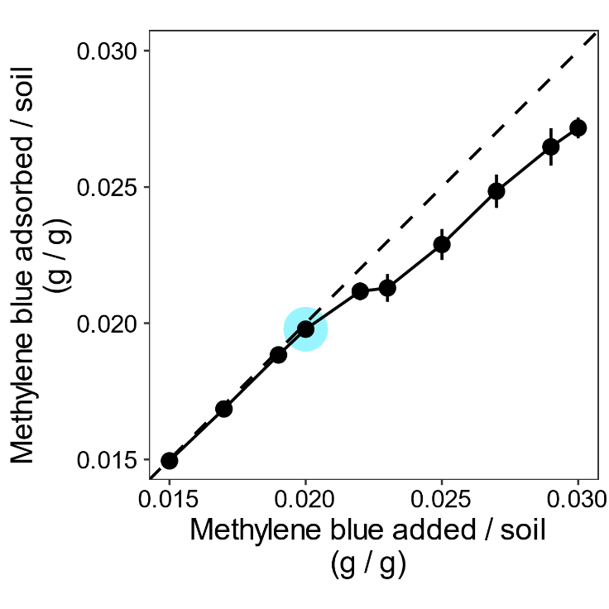
Fig. S4 Determination of the specific soil surface area via the methylene blue method according to Yukselen and Kaya (2006). Methylene blue absorbed by soil against methylene blue added to the soil. Points represent the mean value of three replicates (except at 0.015 g Methylene blue added to soil, with n = 2, where one replicate was below the limit of quantification). The bright blue stroke indicates the point of full cation replacement. Error bars show standard errors.

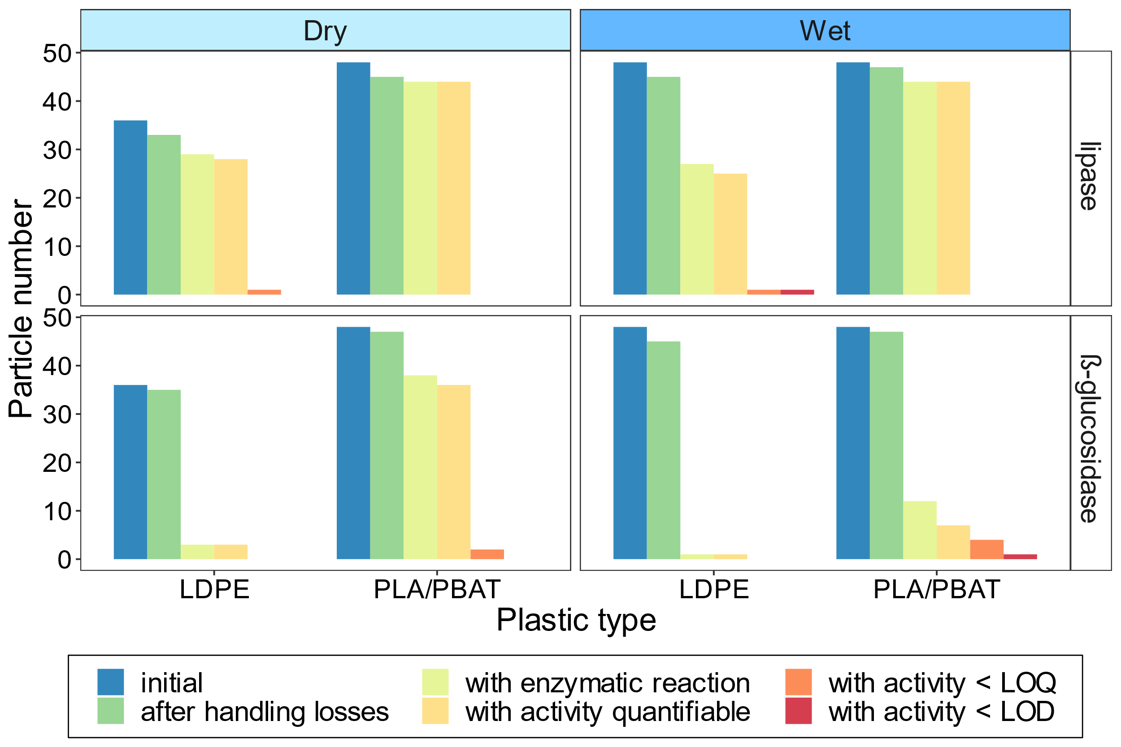
Fig. S5 Number of MP particles used in the lipase and ß-glucosidase analyses on the surface of MP particles. Number of MP particles: initially used in the enzyme assay, after handling losses, showing an enzymatic reaction, with quantifiable enzyme activity, with enzyme activity below the limit of quantification (LOQ), and below the limit of detection (LOD), respectively, in dry (pF = 4) and wet soil (pF = 2).

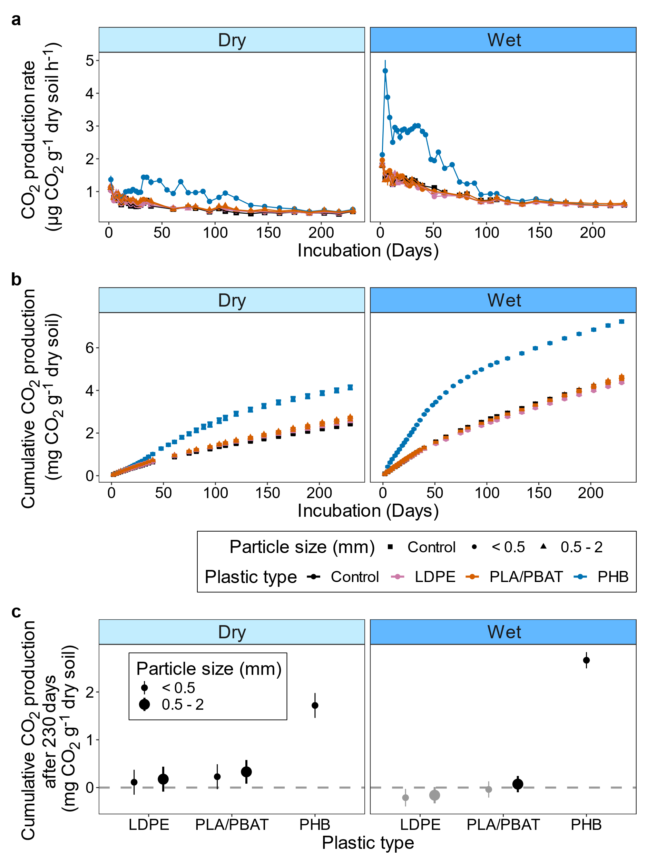
Fig. S6 a CO₂ production rates and b cumulative CO₂ production over 230 days in response to small and large (< 0.5 / 0.5 - 2 mm) LDPE, PLA/PBAT, and PHB (< 0.5 mm, positive control) particles in dry and wet soil (pF = 4/ pF = 2). Error bars show standard errors. c Differences in cumulative CO₂ production after 230 days between MP-amended soil compared to MP-free control soil. Error bars show 95% CIs obtained from two-tailed Dunnett’s tests. Gray-colored figures indicate that cumulative CO₂ production was lower than that of the corresponding MP-free control soil.
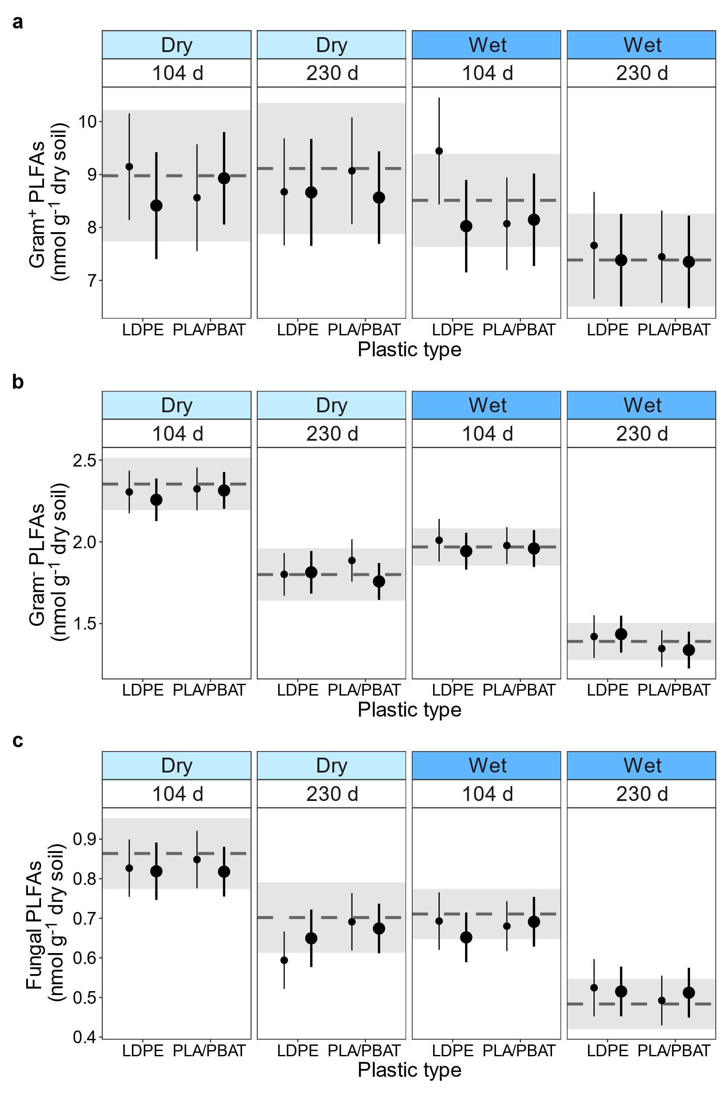
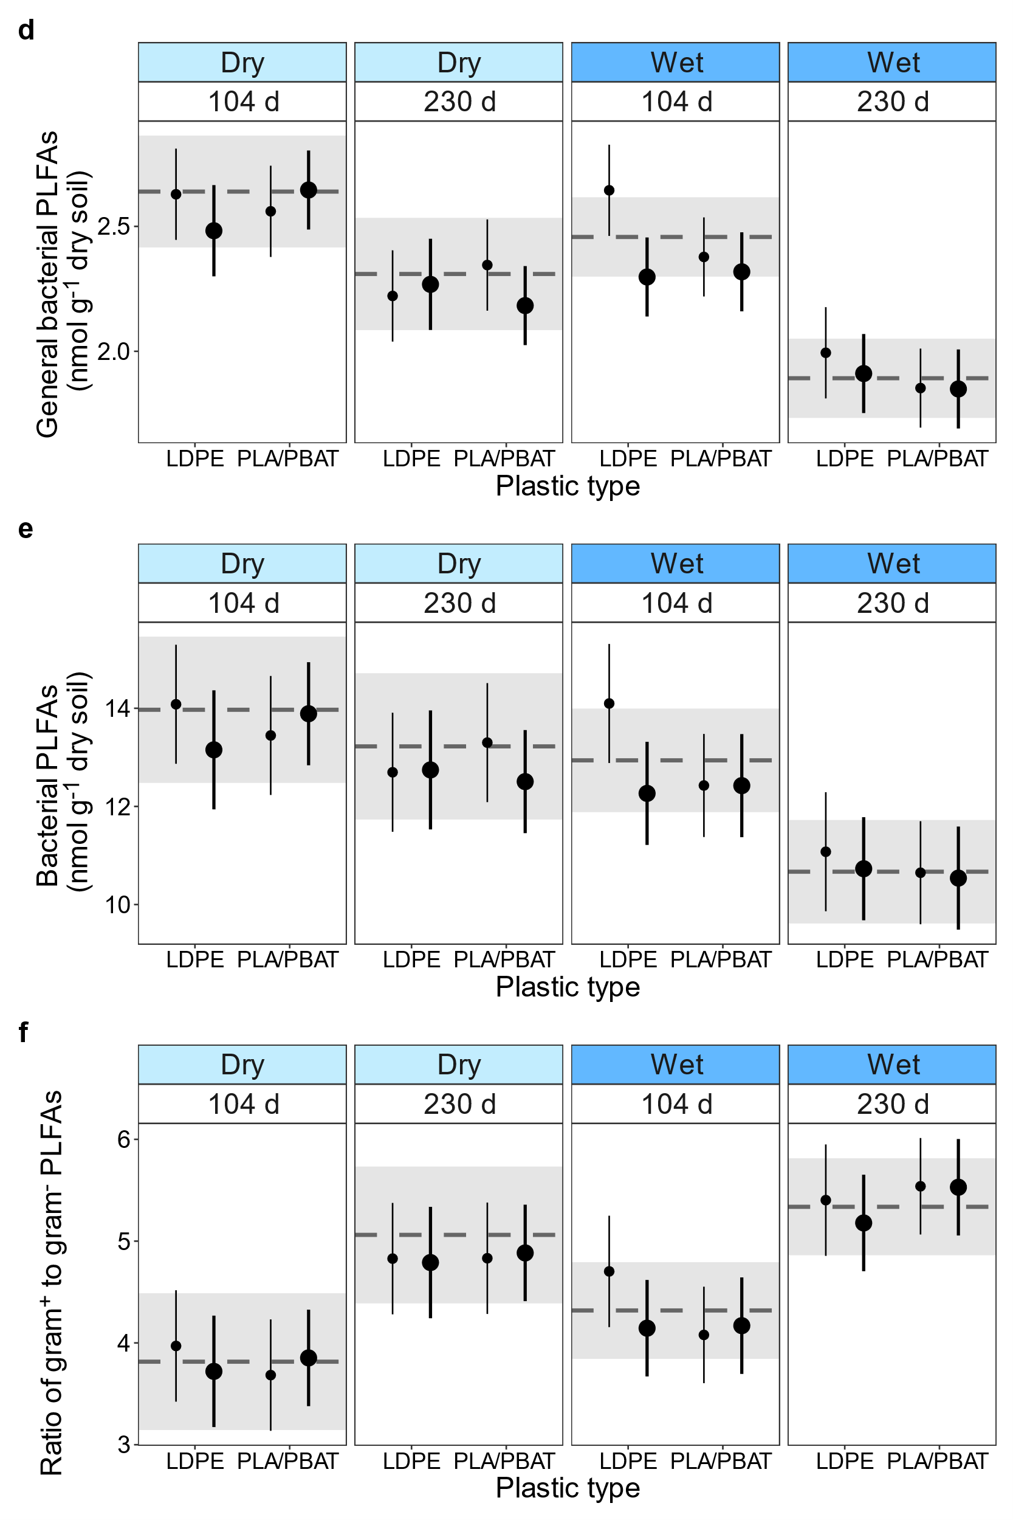
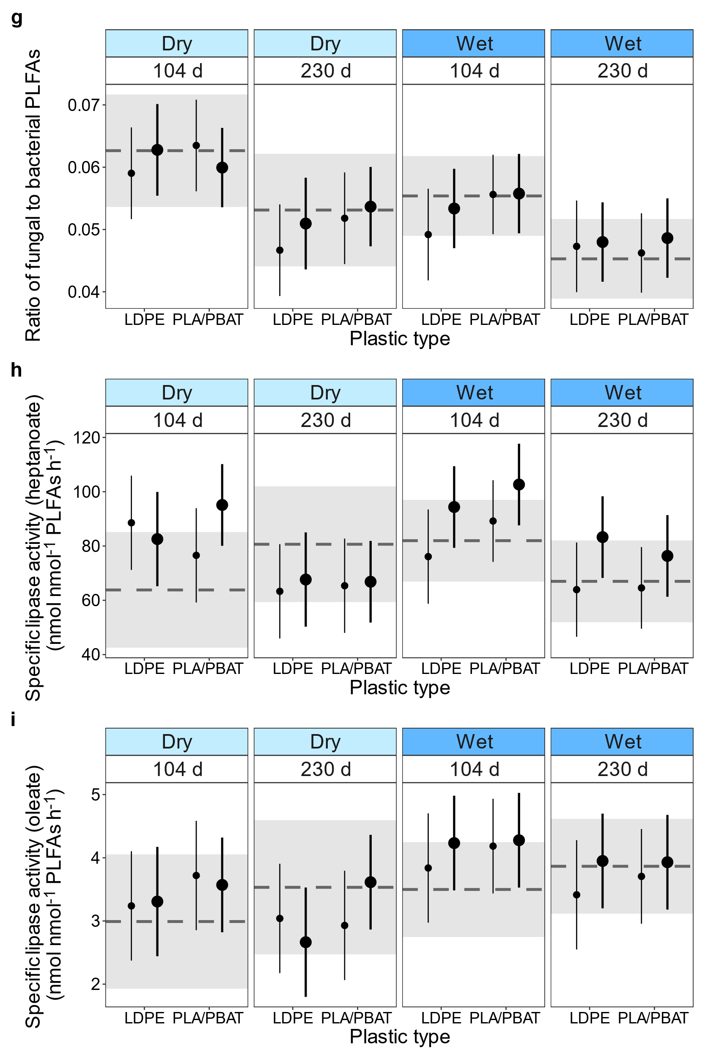
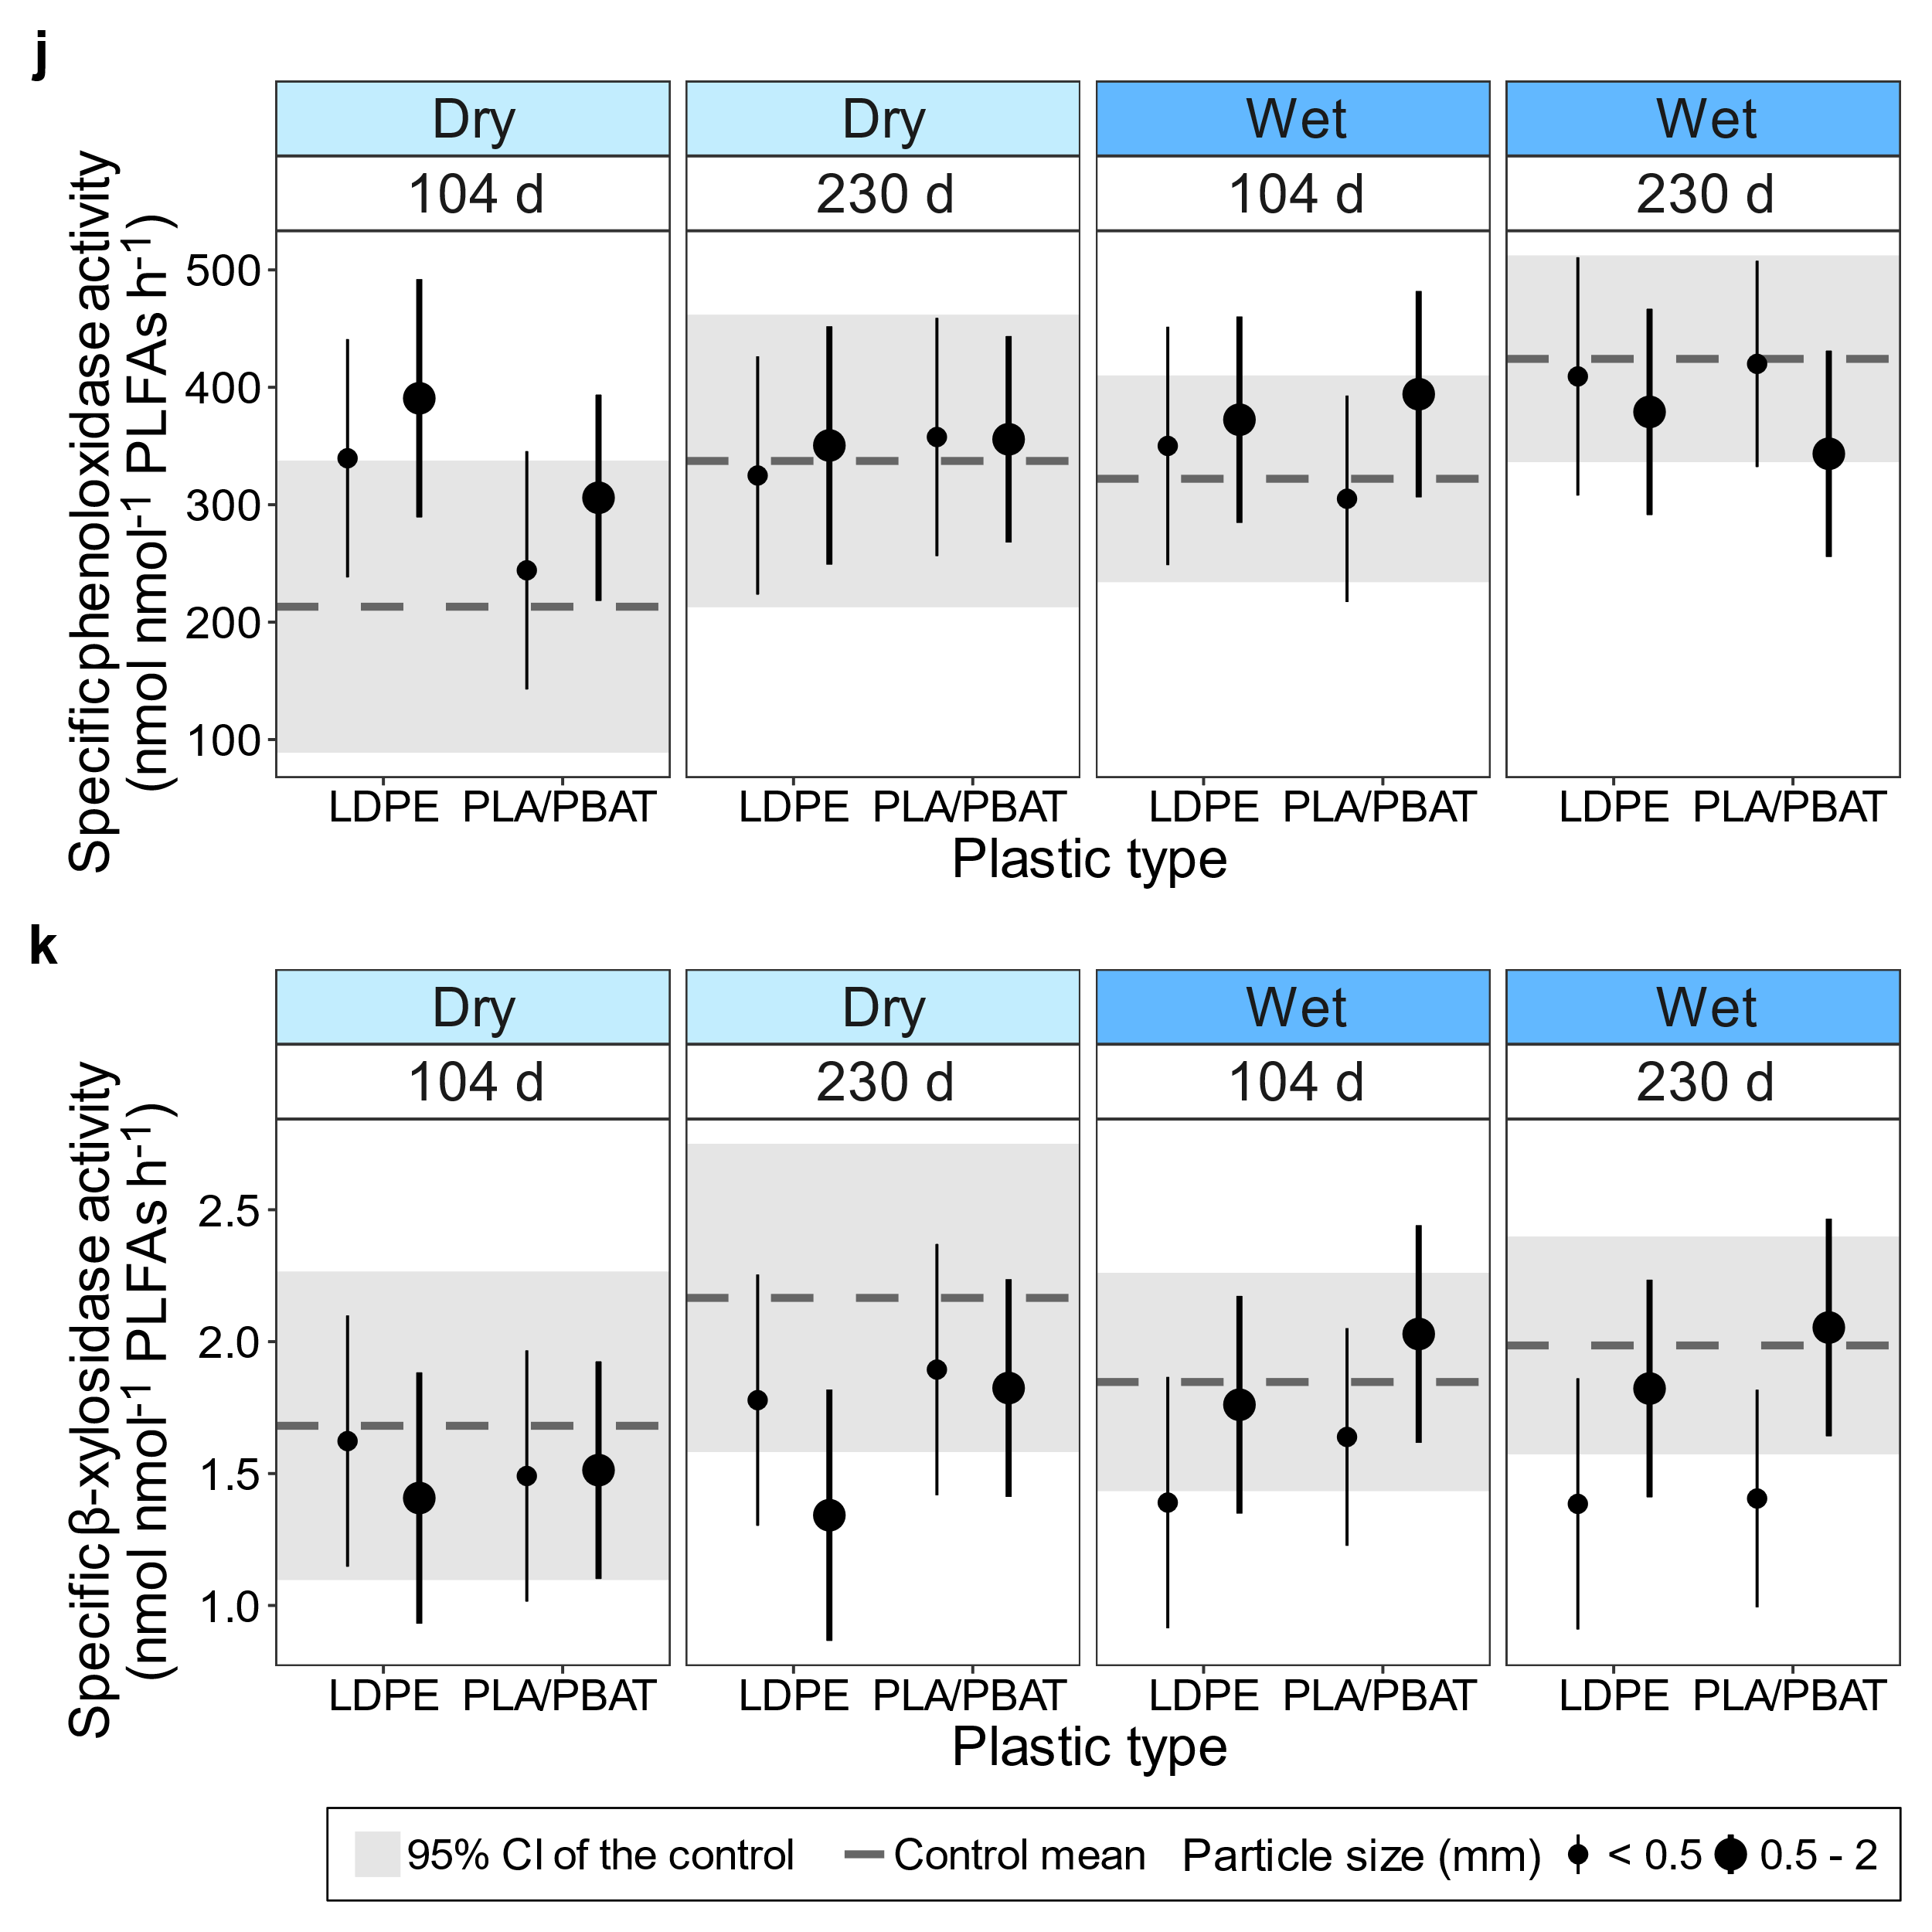
Fig. S7 Composition and abundance of main microbial groups and specific enzyme activity in response to small and large (< 0.5 / 0.5-2 mm) LDPE and PLA/PBAT particles in dry and wet soil (pF = 4/ pF = 2) after 104 and 230 days in comparison to MP-free soil (control). a Gram-positive, b Gram-negative, c fungal, d general bacterial, e sum of bacterial PLFAs. f Ratio of Gram-positive to Gram-negative bacteria and g ratio of fungi to bacteria. h Specific lipase activity with heptanoate and i oleate as the substrate, respectively. j Specific phenoloxidase and k specific ß-xylosidase activity. Specific enzyme activities are related to the sum of microbial PLFAs (nmol) as indicator for microbial biomass. Data are presented as estimated marginal means and 95% confidence intervals (error bars) obtained from linear mixed effect models. The dashed line and the gray-colored area display the mean and the 95% confidence intervals, respectively, of the MP-free control soil.

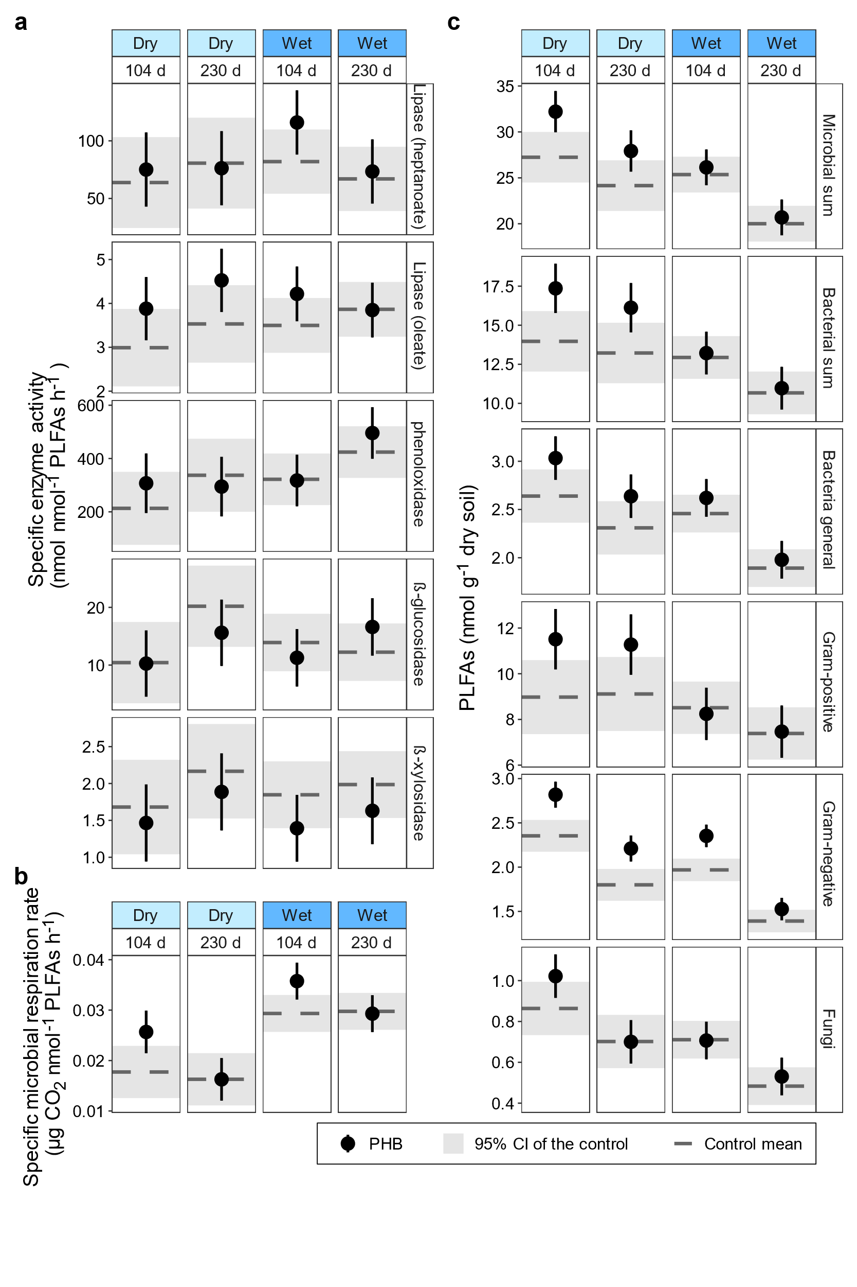
Fig. S8 a Specific enzyme activities, b specific microbial respiration rate, and c composition and abundance of main microbial groups in response to PHB addition to soil in relation to MP-free control soil. Specific microbial respiration rate and specific ß-glucosidase activity are both related to the sum of microbial PLFAs (nmol) as indicator for microbial biomass. Data are presented as estimated marginal means and 95% confidence intervals obtained from linear mixed effect models. The dashed line and the gray-colored area display the mean and the 95% confidence intervals, respectively, of the MP-free control soil.

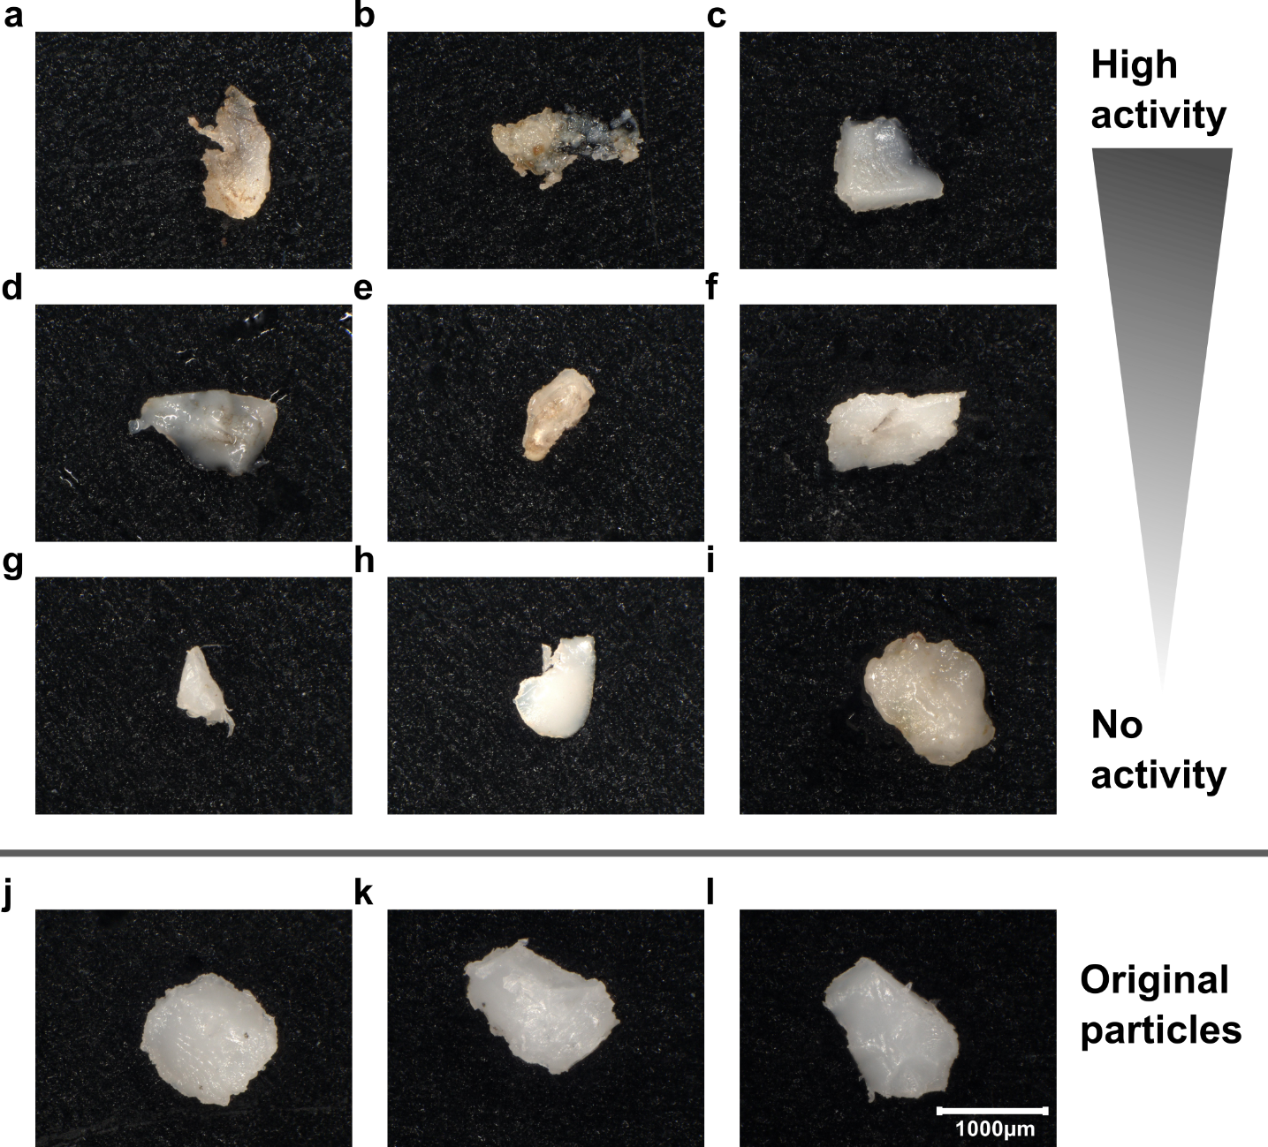

Fig. S9 PLA/PBAT particles after incubation for 230 days in dry soil (pF = 4). MP particles a - c with high lipase activity, d - f with lipase activity between 25th and 75th percentiles, and g - i with no quantifiable activity. j - l are non-incubated PLA/PBAT control particles.

References

Cole M (2016) A novel method for preparing microplastic fibers. Sci Rep 6:34519. https://doi.org/10.1038/srep34519
Crompton C (2005) Particle shape: an important parameter in pharmaceutical manufacturing. Pharmaceutical Manufacturing and Packing Sourcer
Filella M (2015) Questions of size and numbers in environmental research on microplastics: methodological and conceptual aspects. Environ Chem 12:527. https://doi.org/10.1071/EN15012
International Organization for Standardization (2014) ISO 13322-1:2014: Particle size analysis - Image analysis methods - Part 1: Static image analysis methods
Kenward MG, Roger JH (1997) Small sample inference for fixed effects from restricted Maximum Likelihood. Biometrics 53:983. https://doi.org/10.2307/2533558
Kröner S, Doménech Carbó MT (2013) Determination of minimum pixel resolution for shape analysis: Proposal of a new data validation method for computerized images. Powder Technology 245:297–313. https://doi.org/10.1016/j.powtec.2013.04.048
Landini G (2008) Advanced shape analysis with ImageJ. In: Proceedings of the Second ImageJ User and Developer Conference, Luxembourg, pp 116–121
Merkus HG (2009) Particle Size Measurements: Fundamentals, practice, quality, 1st edn. Particle technology series, vol 17. Springer Netherlands, Dordrecht
Otsu N (1979) A threshold selection method from gray-level histograms. IEEE Trans. Syst., Man, Cybern. 9:62–66. https://doi.org/10.1109/TSMC.1979.4310076
Riley NA (1941) Projection sphericity. SEPM JSR Vol. 11. https://doi.org/10.1306/D426910C-2B26-11D7-8648000102C1865D
Schindelin J, Arganda-Carreras I, Frise E, Kaynig V, Longair M, Pietzsch T, Preibisch S, Rueden C, Saalfeld S, Schmid B, Tinevez J-Y, White DJ, Hartenstein V, Eliceiri K, Tomancak P, Cardona A (2012) Fiji: an open-source platform for biological-image analysis. Nat Methods 9:676–682. https://doi.org/10.1038/nmeth.2019
Schneider CA, Rasband WS, Eliceiri KW (2012) NIH Image to ImageJ: 25 years of image analysis. Nat Methods 9:671–675. https://doi.org/10.1038/nmeth.2089
Shekunov BY, Chattopadhyay P, Tong HHY, Chow AHL (2007) Particle size analysis in pharmaceutics: principles, methods and applications. Pharm Res 24:203–227. https://doi.org/10.1007/s11095-006-9146-7
Yukselen Y, Kaya A (2006) Comparison of methods for determining specific surface area of soils. J Geotech Geoenviron Eng 132:931–936. https://doi.org/10.1061/(ASCE)1090-0241(2006)132:7(931)

