Temporal increase of Varroa mites in trap frames used for drone brood removal during the honey bee season

Richard Odemer^{1*}, Franziska Odemer², Gerhard Liebig³, Doris de Craigher³

¹Julius Kühn-Institut (JKI) – Federal Research Centre for Cultivated Plants, Institute for Bee Protection, Braunschweig, Germany
²Institute for Apiculture, Lower Saxony State Office for Consumer Protection and Food Safety, Celle, Germany
³Apicultural State Institute, University of Hohenheim, Stuttgart, Germany

*Corresponding author: richard.odemer@julius-kuehn.de, Tel.: 0531-299-4218

SUPPLEMETARY INFORMATION

MATERIAL AND METHODS
Supplementary Method M1: R packages used for statisticl analyses
All analyses were performed in R v.4.1.1 (R Core Team, 2021) with the packages glmmTMB v.1.1.2.3 (Brooks et al. 2017), emmeans v.1.7.0 (Lenth, 2022) , multcomp v.1.4-17 (Hothorn et al. 2008), MuMIn v.1.43.17 (Barton, 2020), tidyverse v.1.3.1 (Wickham et al. 2021), and ggpubr v.0.4.0 (Kassambara 2020). A significance level of α = 0.05 was used for all tests, respectively.

References
Mollie E. Brooks, Kasper Kristensen, Koen J. van Benthem, Arni Magnusson, Casper W. Berg,
Anders Nielsen, Hans J. Skaug, Martin Maechler and Benjamin M. Bolker (2017). glmmTMB
Balances Speed and Flexibility Among Packages for Zero-inflated Generalized Linear Mixed
Modeling. The R Journal, 9(2), 378-400.

Russell V. Lenth (2022). emmeans: Estimated Marginal Means, aka Least-Squares Means. R package version 1.7.2. https://CRAN.R-project.org/package=emmeans

Torsten Hothorn, Frank Bretz and Peter Westfall (2008). Simultaneous Inference in General Parametric Models. Biometrical Journal 50(3), 346--363.

Kamil Barton (2020). MuMIn: Multi-Model Inference. R package version 1.43.17.
https://CRAN.R-project.org/package=MuMIn

Wickham et al., (2021). Welcome to the tidyverse. Journal of Open Source Software, 4(43),
1686, https://doi.org/10.21105/joss.01686

Alboukadel Kassambara (2020). ggpubr: 'ggplot2' Based Publication Ready Plots. R package
version 0.4.0. https://CRAN.R-project.org/package=ggpubr

SUPPLEMENTARY TABLES

Table S1: Model output [formula: mites ~ month + location + (1 | capped_perc)]
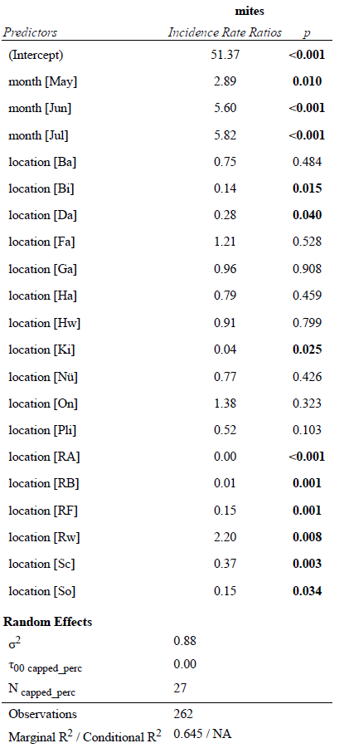

SUPPLEMENTARY FIGURES
Figure S1: The total number of samples per apiary and the percentage this represents of all samples
Fig. S1: All apiaries (n = 18) that were sampled for drone frames. The total number of samples per apiary were as follows: Aa (n = 38, 14.50%), Ba (n = 11, 4.20%), Bi (n = 3, 1.15%), Da (n = 4, 1.53%), Fa (n = 27, 10.31%), Ga (n = 14, 5.34%), Ha (n = 28, 10.69%), Hw (n = 17, 6.49%), Ki (n = 1, 0.38%), Nü (n = 20, 7.63%), On (n = 21, 8.02%), Pli (n = 12, 4.58%), RA (n = 8, 3.05%), RB (n = 1, 0.38%), RF (n = 5, 1.91%), Rw (n = 30, 11.45%), Sc (n = 20, 7.63%) and So (n = 2, 0.76%). Mite counts denoted by a different letter indicate significant differences between locations (Tukey-HSD, P < 0.05).

Figure S2: Distribution of mites in all collected drone trap frames (n = 262)
Fig. S2: Histogram of Varroa mites in n = 262 samples; Mean = 208.49, SD = 344.21, Median = 71.50 (dotted blue line), MAD = 95.63, range: [0, 2650], Skewness = 3.31, Kurtosis = 14.63. There were only six samples that contained 0 mites (2.3%) and 40 samples that contained less than 10 mites (15.3%).

Figure S3: Distribution of samples according to the proportions of the frames with capped brood
Fig. S3: Histogram of the proportion of capped cells in n = 250 samples; Mean = 62.98 (dotted red line), SD = 23.93, Median = 60.00, MAD = 29.65, range: [5, 100], Skewness = -0.27, Kurtosis = -0.81. There were 40 drone frames that were less than 50% capped (16% of all samples).

