Online Supplementary Material
Comparative analysis of minerals, carotenoids, and tocochromanols in ripe seeds, immature seeds and tepals of bitter and non-bitter quinoa genotypes
Luise Amelie Lauer,ª Marius Kollmar,^{b} Sandra M. Schmöckel,^{b} Jan Frank ª
ª University of Hohenheim, Institute of Nutritional Sciences, Department of Food Biofunctionality (140b), Garbenstraße 28, 70599 Stuttgart, Germany
^{b} University of Hohenheim, Institute of Crop Science, Department of Physiology of Yield Stability (340k), Otto-Sander-Straße 5, 70599 Stuttgart, Germany

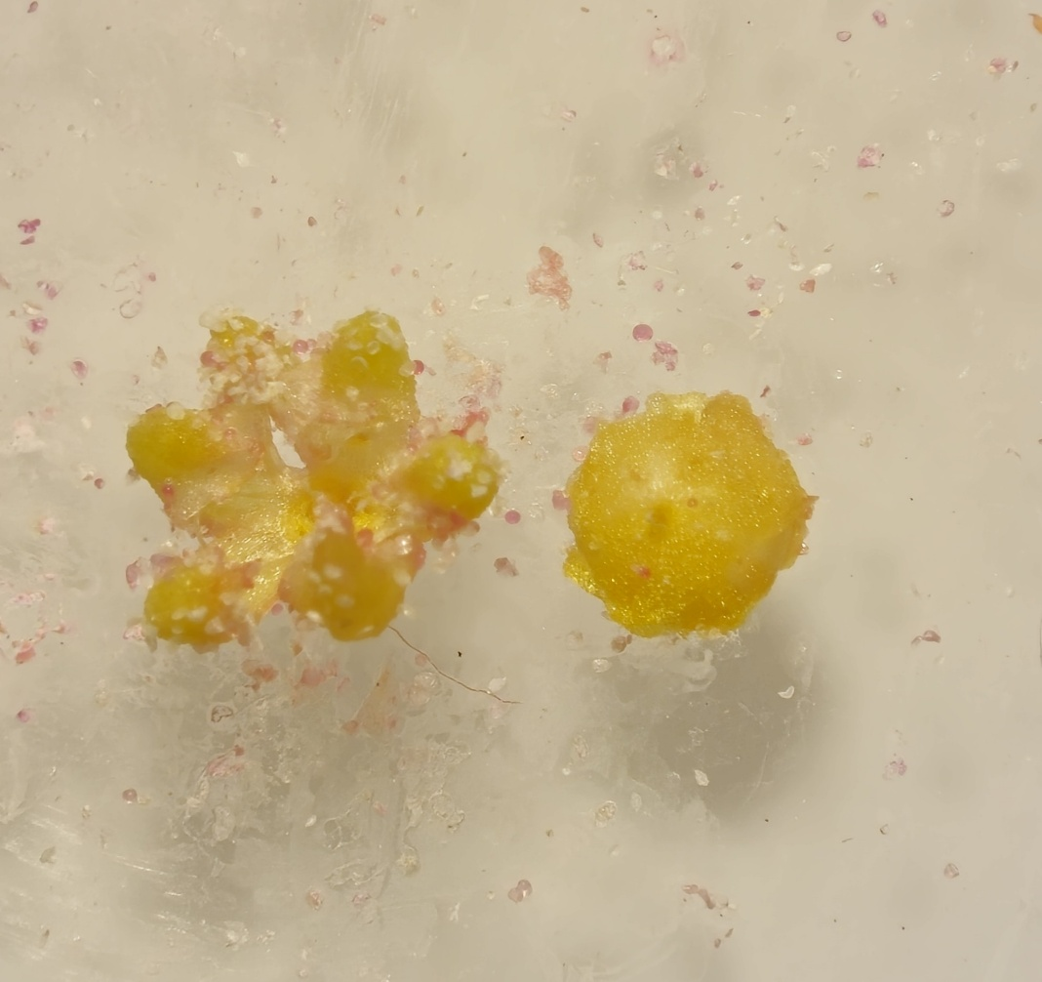
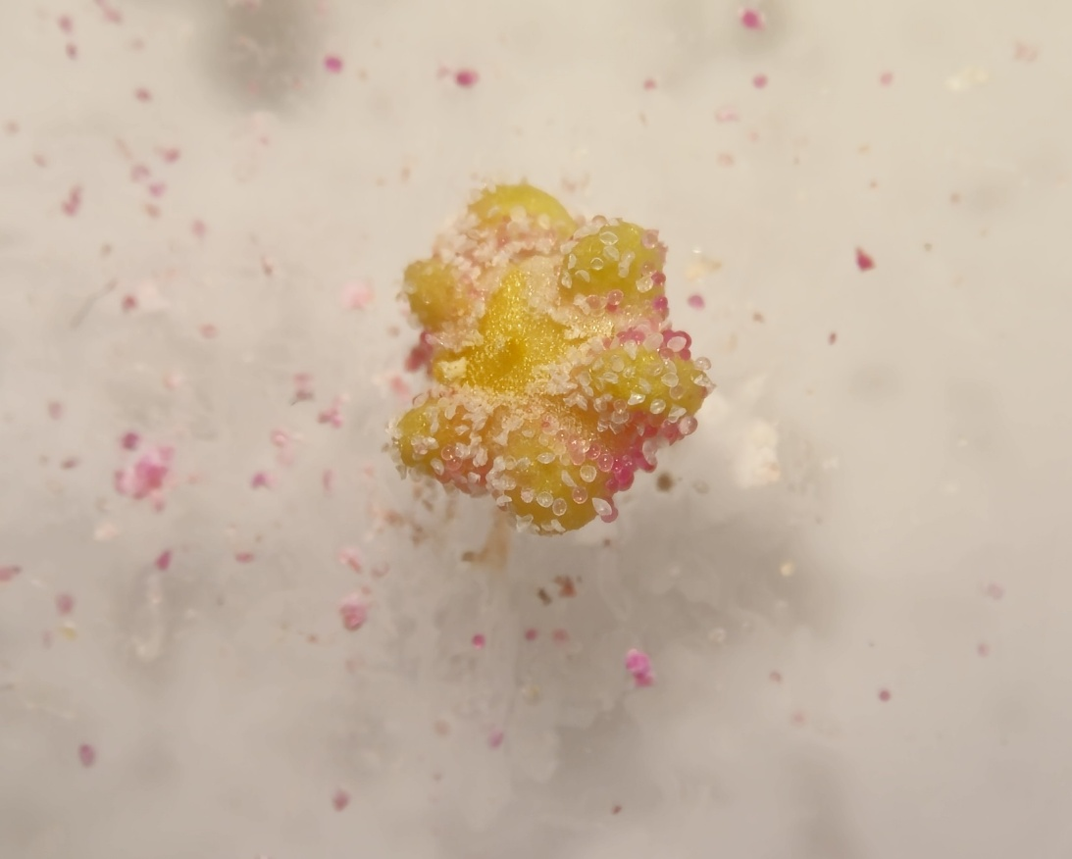
Figure S1. Harvest of early maturation seeds and tepals. Seed during early seed set (BBCH 72) surrounded by its tepal (A) and tepal separated from the immature seed (B).
2 mm
A
B

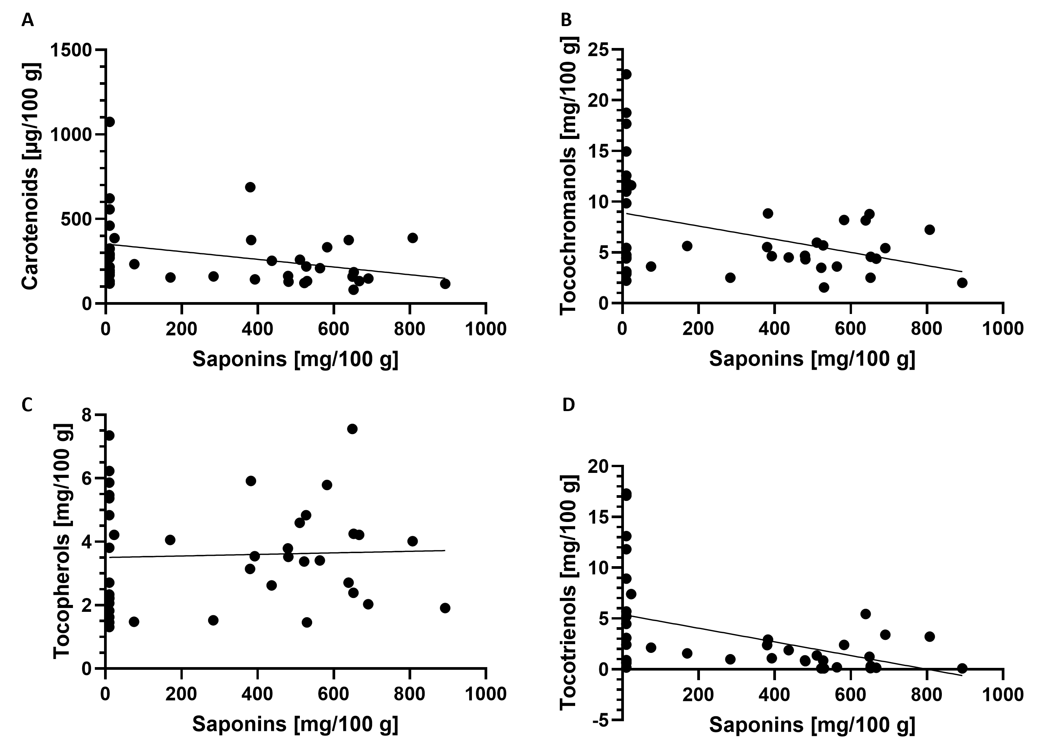
Figure S2. Spearman correlations between saponin content in ripe quinoa seeds and carotenoid content (A), total tocochromanol content (B), total tocopherol content (C) and total tocotrienol content (D).
Table S1. Fifty quinoa genotypes with their Hohenheim-ID, phenotype, site, country of origin and tissues used in the analyses
Genotype | ID | Phenotype | Saponin content [mg/100 g]ª | Site | Country of origin | Tissues analyzed
Ames-13722 | 48 | Bitter | 479.75 | Lowland | USA | Seeds, tepals
Ames-13735 | 49 | Bitter | 392.66 | Lowland | USA | Seeds
Ames-13737 | 194 | Bitter | 170.36 | Lowland | USA | Seeds
CHEN-91 | 437 | Bitter | 527.67 | Highland | Peru | Seeds
CHEN-141 | H00222 | Bitter | 380.19 | Highland | Bolivia | Seeds
CHEN-160 | H00202 | Bitter | 639.11 | Highland | Bolivia | Seeds, tepals
CHEN-389 | H00203 | Bitter | 807.57 | Highland | Peru | Seeds
D-11889 | 182 | Bitter | 563.54 | Lowland | Argentina | Seeds
D-11980 | H00196 | Bitter | 582.59 | Highland | Peru | Seeds, tepals
D-12014 | H00225 | Bitter | 510.70 | NA | Peru | Seeds
D-12036 | 19 | Bitter | 652.41 | Highland | Peru | Seeds
D-12119 | 444 | Bitter | NA | NA | Peru | Seeds
PI-510546 | H00230 | Bitter | 382.33 | Highland | Peru | Seeds, tepals
PI-584524 | H00206 | Bitter | 283.67 | Lowland | Chile | Seeds
PI-614885 | H00205 | Bitter | 691.11 | Lowland | Chile | Seeds
PI-614886 | H00232 | Bitter | 436.90 | NA | NA | Seeds
PI-614887 | 34 | Bitter | 893.21 | Lowland | Chile | Seeds, tepals
PI-614888 | H00311 | Bitter | 480.73 | Lowland | Chile | Seeds
PI-634917 | 532 | Bitter | 522.32 | Lowland | Chile | Seeds, tepals
PI-634918 | 242 | Bitter | 651.90 | Lowland | Chile | Seeds
PI-634924 | 67 | Bitter | 648.96 | Lowland | Chile | Seeds
PI-665276 | 667 | Bitter | NA | Highland | Bolivia | Seeds
Titicaca | H00234 | Bitter | 529.74 | Lowland | NA | Seeds
Ames-13751 | 147 | Non-bitter | <10 | Lowland | USA | Seeds
Ames-13760 | 76 | Non-bitter | NA | Lowland | USA | Seeds, tepals
CHEN-112 | H00229 | Non-bitter | <10 | Highland | Peru | Seeds, tepals
CHEN-126 | H00204 | Non-bitter | <10 | Highland | Bolivia | Seeds
CHEN-147 | 548 | Non-bitter | 75.37 | NA | Bolivia | Seeds
CHEN-159 | H00211 | Non-bitter | <10 | Highland | Bolivia | Seeds, tepals
CHEN-222 | 118 | Non-bitter | NA | Highland | Bolivia | Seeds
CHEN-226 | 624 | Non-bitter | NA | Highland | Bolivia | Seeds
CHEN-349 | 534 | Non-bitter | NA | Highland | Peru | Seeds
CHEN-427 | H00221 | Non-bitter | <10 | Highland | Peru | Seeds
CHEN-465 | H00199 | Non-bitter | <10 | Highland | Peru | Seeds
CHEN-69 | H00231 | Non-bitter | <10 | Highland | Peru | Seeds
D-11924 | 156 | Non-bitter | <10 | Highland | Peru | Seeds
D-12120 | H00216 | Non-bitter | <10 | Highland | Peru | Seeds
D-12166 | 432 | Non-bitter | NA | Highland | Bolivia | Seeds
D-12184 | H00209 | Non-bitter | <10 | Highland | Peru | Seeds, tepals
D-12225 | H00195 | Non-bitter | <10 | Highland | Peru | Seeds
D-12243 | H00200 | Non-bitter | 23.30 | Highland | Peru | Seeds
D-12256 | H00224 | Non-bitter | <10 | Highland | Peru | Seeds, tepals
D-12289 | H00212 | Non-bitter | <10 | Highland | Peru | Seeds, tepals
D-12320 | 92 | Non-bitter | <10 | Highland | Peru | Seeds
D-12341 | 212 | Non-bitter | NA | NA | Peru | Seeds
D-12420 | 543 | Non-bitter | NA | Highland | Bolivia | Seeds
PI-510545 | H00217 | Non-bitter | <10 | NA | Peru | Seeds
PI-510549 | H00213 | Non-bitter | <10 | Highland | Peru | Seeds
PI-510551 | 346 | Non-bitter | NA | NA | Peru | Seeds
PI-614929 | 148 | Non-bitter | NA | Highland | Bolivia | Seeds
NA: no information available
ªKollmar et al. (2025)

Table S2. Analytical parameters for the quantification of carotenoids by HPLC
Standard | Linear range (µg/100 g) | Linear response (r²) | Equation  (y=m · x + b) | Limit of Detection (µg/100 g) | Limit of Quantification (µg/100 g)
Lutein | 2.958 – 58.990 | 0.9970 | y=0.5232x+0.0032 | 1.144 | 3.813
Zeaxanthin | 3.129 – 62.577 | 0.9971 | y=0.4356x+0.0039 | 1.700 | 5.667
β-Carotene | 11.221 – 224.681 | 0.9945 | y=0.1798x-0.0022 | 2.282 | 7.607
β-Crypto-xanthin | 5.916 – 118.425 | 0.9958 | y=0.4918x+0.0083 | 1.011 | 3.373
Limits of detection, limits of quantification, linear responses and equations are represented by means of three independent experiments. b: Y-intercept; m: slope of the regression line; x: ratio peak area/peak area internal standard; y: concentration.

Table S3. Analytical parameters for the quantification of tocochromanols by HPLC
Standard | Linear range (mg/100 g) | Linear response (r²) | Equation  (y=m · x + b) | Limit of Detection (mg/100 g) | Limit of Quantification (mg/100 g)
αT | 0.026 – 1.292 | 0.9705 | y=542x+118827 | 0.067 | 0.222
βT | 0.004 – 0.208 | 0.9992 | y=3304x+37472 | 0.004 | 0.012
γT | 0.004 – 0.208 | 0.9966 | y=3565X+110934 | 0.004 | 0.019
δT | 0.004 – 0.201 | 0.9996 | y=4251X+77309 | 0.002 | 0.006
αT3 | 0.025 – 1.274 | 0.9784 | y=669x+82447 | 0.054 | 0.180
βT3 | 0.004 – 0.205 | 0.9991 | y=2308x+27790 | 0.003 | 0.009
γT3 | 0.004 – 0.205 | 0.9981 | y=2452x+6164 | 0.004 | 0.013
δT3 | 0.004 – 0.196 | 0.9996 | y=3575x+47913 | 0.001 | 0.005
Limits of detection, limits of quantification, linear responses and equations are represented by means of three independent experiments. b: Y-intercept; m: slope of the regression line; T: tocopherol; T3: tocotrienol; x: peak area; y: concentration.
Table S4. Content of minerals [mg/kg] in ripe seeds of bitter and non-bitter quinoa genotypes
Genotype | Pheno-type | P | Mg | Ca | Fe | Zn | Mn | Cu
Ames-13722 | Bitter | 4447.44 | 1782.40 | 505.45 | 57.29 | 31.30 | 22.56 | 7.88
Ames-13735 | Bitter | 4353.25 | 1740.58 | 778.01 | 45.15 | 25.48 | 19.93 | 6.80
Ames-13737 | Bitter | 4790.05 | 1849.54 | 791.43 | 60.55 | 34.26 | 22.50 | 6.81
CHEN-91 | Bitter | 5322.41 | 2249.41 | 484.55 | 39.16 | 39.71 | 29.76 | 6.37
CHEN-141 | Bitter | 4771.63 | 2184.12 | 706.08 | 60.75 | 48.60 | 23.04 | 7.30
CHEN-160 | Bitter | 4806.35 | 2160.94 | 1338.25 | 50.94 | 24.17 | 19.73 | 5.26
CHEN-389 | Bitter | 4875.47 | 2724.12 | 1655.61 | 529.25 | 31.63 | 36.70 | 6.67
D-11889 | Bitter | 4503.19 | 1868.98 | 627.05 | 55.56 | 30.72 | 21.07 | 7.17
D-11980 | Bitter | 4504.18 | 2145.67 | 990.26 | 50.25 | 22.75 | 22.36 | 4.59
D-12014 | Bitter | 4705.81 | 2255.90 | 1022.59 | 46.20 | 24.75 | 18.36 | 5.36
D-12036 | Bitter | 4861.91 | 1946.64 | 556.24 | 65.00 | 42.80 | 23.51 | 5.86
D-12119 | Bitter | 4744.57 | 1851.27 | 673.65 | 63.32 | 26.64 | 27.48 | 5.21
PI-510546 | Bitter | 4360.34 | 2185.59 | 929.33 | 57.60 | 30.58 | 29.52 | 6.15
PI-584524 | Bitter | 5139.75 | 2302.79 | 834.86 | 56.31 | 20.46 | 30.64 | 5.43
PI-614885 | Bitter | 7018.45 | 3592.11 | 2511.81 | 250.93 | 36.06 | 82.06 | 7.77
PI-614886 | Bitter | 4607.35 | 1964.10 | 1160.89 | 45.28 | 19.67 | 22.28 | 4.78
PI-614887 | Bitter | 4013.45 | 1933.51 | 695.3 | 57.89 | 32.10 | 31.06 | 5.67
PI-614888 | Bitter | 4349.58 | 1827.97 | 513.99 | 51.32 | 31.70 | 18.69 | 7.46
PI-634917 | Bitter | 4659.01 | 2137.22 | 752.01 | 55.91 | 28.79 | 24.10 | 7.37
PI-634918 | Bitter | 4824.55 | 2395.90 | 1079.33 | 60.61 | 26.29 | 23.57 | 6.32
PI-634924 | Bitter | 5605.29 | 3020.76 | 701.98 | 38.79 | 53.71 | 37.97 | 6.65
PI-665276 | Bitter | 4809.93 | 2852.46 | 2298.44 | 67.96 | 47.98 | 40.52 | 8.02
Titicaca | Bitter | 5304.24 | 2268.00 | 1058.9 | 51.16 | 28.27 | 21.38 | 4.70
Ames-13751 | Non-bitter | 4485.81 | 2005.24 | 747.60 | 57.38 | 39.12 | 20.74 | 8.37
Ames-13760 | Non-bitter | 4452.74 | 2678.99 | 708.60 | 56.66 | 50.35 | 41.62 | 9.11
CHEN-112 | Non-bitter | 4504.20 | 2359.60 | 1040.77 | 49.17 | 24.67 | 20.41 | 5.16
CHEN-126 | Non-bitter | 5039.98 | 2512.25 | 1155.53 | 43.86 | 33.82 | 21.53 | 6.26
CHEN-147 | Non-bitter | 4907.71 | 2753.97 | 1433.42 | 52.23 | 44.25 | 35.91 | 7.61
CHEN-159 | Non-bitter | 4277.33 | 1887.10 | 1082.33 | 84.71 | 46.92 | 32.41 | 8.00
CHEN-222 | Non-bitter | 4911.58 | 2548.47 | 636.64 | 50.37 | 43.13 | 35.41 | 7.21
CHEN-226 | Non-bitter | 5779.60 | 2317.70 | 541.81 | 56.56 | 58.13 | 24.86 | 7.47
CHEN-349 | Non-bitter | 5311.45 | 2837.37 | 1014.85 | 55.89 | 42.86 | 37.33 | 7.91
CHEN-427 | Non-bitter | 4341.03 | 2283.35 | 1283.98 | 65.82 | 30.76 | 28.26 | 5.45
CHEN-465 | Non-bitter | 5118.94 | 2234.55 | 1185.09 | 56.88 | 29.14 | 24.28 | 5.28
CHEN-69 | Non-bitter | 4737.93 | 2196.33 | 1132.24 | 67.42 | 34.59 | 20.43 | 6.60
D-11924 | Non-bitter | 5015.95 | 2247.38 | 533.23 | 76.31 | 52.86 | 23.32 | 8.55
D-12120 | Non-bitter | 5694.95 | 2958.66 | 902.88 | 70.79 | 50.45 | 50.80 | 9.47
D-12166 | Non-bitter | 5826.06 | 2765.18 | 781.69 | 66.78 | 51.78 | 32.70 | 8.21
D-12184 | Non-bitter | 4701.43 | 2386.61 | 1541.93 | 56.72 | 26.75 | 27.07 | 5.97
D-12225 | Non-bitter | 5000.13 | 2738.60 | 788.93 | 36.17 | 39.44 | 17.70 | 8.27
D-12243 | Non-bitter | 4875.85 | 2176.89 | 983.31 | 63.55 | 30.77 | 26.12 | 6.02
D-12256 | Non-bitter | 5313.96 | 2658.46 | 900.79 | 53.57 | 32.48 | 31.60 | 6.23
D-12289 | Non-bitter | 5149.57 | 2187.09 | 763.41 | 303.58 | 35.79 | 30.33 | 6.81
D-12320 | Non-bitter | 4716.43 | 2743.31 | 704.40 | 31.85 | 41.68 | 19.34 | 8.19
D-12341 | Non-bitter | 5218.96 | 2866.81 | 1068.86 | 71.42 | 50.53 | 42.59 | 9.04
D-12420 | Non-bitter | 5294.71 | 2436.82 | 659.92 | 63.34 | 53.85 | 31.00 | 8.14
PI-510545 | Non-bitter | 4680.54 | 2040.14 | 848.61 | 47.86 | 27.39 | 24.65 | 4.80
PI-510549 | Non-bitter | 5569.71 | 2980.70 | 2178.09 | 70.93 | 37.78 | 23.14 | 7.53
PI-510551 | Non-bitter | 5527.40 | 2589.82 | 711.33 | 62.18 | 56.11 | 43.81 | 7.90
PI-614929 | Non-bitter | 5628.71 | 2762.61 | 695.35 | 278.39 | 52.29 | 43.39 | 7.17
Values in bold indicate the highest phosphorus, iron and manganese contents significantly differing from the other genotypes at p < 0.05, one-way ANOVA. P: phosphorus; Mg: magnesium, Ca: calcium; Fe: iron; Zn: zinc; Mn: manganese; Cu: copper.
Genotype | ID | Phenotype | Lutein | Zeaxanthin | β-Carotene | β-Crypto-xanthin | Total carotenoids
Ames-13722 | 48 | Bitter | 109.69  ± 3.62 | 41.13 ± 1.93 | 10.44 ± 0.60 | 1.43 ± 0.15 | 162.69 ± 6.30
Ames-13735 | 49 | Bitter | 81.80 ± 3.37 | 32.98 ± 1.68 | 25.91 ± 0.66 | 2.54 ± 0.09 | 143.23 ± 5.81
Ames-13737 | 194 | Bitter | 84.64 ± 8.05 | 58.21 ± 6.35 | 10.38 ± 0.24 | 1.07 ± 0.20 | 154.31 ± 14.85
CHEN-91 | 437 | Bitter | 169.30  ± 1.29 | 37.60 ± 5.41 | 9.52 ± 0.39 | 2.35 ± 0.26 | 218.77 ± 7.35
CHEN-141 | H00222 | Bitter | 496.95  ± 20.30 | 94.40 ± 7.32 | 88.87 ± 4.17 | 8.22 ± 1.21 | 688.44 ± 33.00
CHEN-160 | H00202 | Bitter | 174.28  ± 3.70 | 70.01 ± 3.31 | 115.87 ± 4.86 | 15.44 ± 0.64 | 375.60 ± 12.51
CHEN-389 | H00203 | Bitter | 262.90  ± 16.03 | 66.89 ± 3.18 | 53.79 ± 4.43 | 4.29 ± 0.01 | 387.88 ± 23.66
D-11889 | 182 | Bitter | 75.65  ± 58.53 | 107.20  ± 45.71 | 24.49 ± 0.65 | 2.29 ± 0.54 | 209.63 ± 105.43
D-11980 | H00196 | Bitter | 235.79  ± 31.29 | 56.84 ± 8.10 | 35.02 ± 4.57 | 5.71 ± 0.05 | 333.36 ± 44.00
D-12014 | H00225 | Bitter | 185.43  ± 17.13 | 50.37 ± 0.85 | 20.39 ± 2.76 | 2.73 ± 0.07 | 258.92 ± 20.81
D-12036 | 19 | Bitter | 144.96  ± 3.02 | 32.25 ± 1.98 | 6.72 ± 0.12 | 2.00 ± 0.09 | 185.93 ± 5.21
D-12119 | 444 | Bitter | 72.48 ± 8.06 | 53.07 ± 4.74 | 7.85 ± 1.18 | ND | 133.40 ± 13.98
PI-510546 | H00230 | Bitter | 299.27  ± 4.05 | 52.62 ± 6.15 | 22.11 ± 2.33 | 2.12 ± 0.17 | 376.12 ± 12.71
PI-584524 | H00206 | Bitter | 106.96  ± 5.80 | 41.40 ± 1.71 | 10.11 ± 0.67 | 1.72 ± 0.11 | 160.18 ± 8.30
PI-614885 | H00205 | Bitter | 46.38 ± 2.00 | 13.50 ± 0.72 | 84.85 ± 5.33 | 3.35 ± 0.29 | 148.07 ± 8.33
PI-614886 | H00232 | Bitter | 164.50  ± 9.63 | 45.55 ± 6.97 | 40.95 ± 0.97 | 1.68 ± 0.14 | 252.67 ± 17.71
PI-614887 | 34 | Bitter | 75.63 ± 4.29 | 26.62 ± 2.50 | 14.81 ± 0.92 | ND | 117.06 ± 7.71
PI-614888 | H00311 | Bitter | 71.45 ± 8.17 | 54.54 ± 9.32 | 3.51 ± 0.36 | ND | 129.50 ± 17.85
PI-634917 | 532 | Bitter | 67.78 ± 2.66 | 45.11 ± 1.48 | 9.01 ± 0.49 | ND | 121.89 ± 4.63
PI-634918 | 242 | Bitter | 41.43 ± 1.21 | 20.87 ± 0.71 | 19.99 ± 1.53 | ND | 82.28 ± 3.45
PI-634924 | 67 | Bitter | 98.44 ± 0.86 | 50.96 ± 5.38 | 10.30 ± 0.31 | ND | 159.71 ± 6.55
PI-665276 | 667 | Bitter | 509.26  ± 20.79 | 66.60 ± 3.19 | 47.53 ± 4.00 | 8.91 ± 0.72 | 632.29 ± 28.70
Titicaca | H00234 | Bitter | 58.42 ± 1.56 | 16.83 ± 1.03 | 54.67 ± 3.00 | 2.98 ± 0.26 | 132.90 ± 5.85
Table S5. Content of carotenoids [µg/100 g] in ripe seeds of different quinoa genotypes
Ames-13751 | 147 | Non-bitter | 77.84 ± 0.63 | 28.73 ± 0.74 | 10.68 ± 0.34 | 1.08 ± 0.01 | 118.34 ± 1.71
Ames-13760 | 76 | Non-bitter | 90.44 ± 3.60 | 27.03 ± 2.31 | 6.62 ± 0.53 | ND | 124.10 ± 6.45
CHEN-112 | H00229 | Non-bitter | 384.07  ± 23.93 | 87.08 ± 4.85 | 77.45 ± 0.53 | 8.57 ± 0.06 | 557.18 ± 29.38
CHEN-126 | H00204 | Non-bitter | 673.64  ± 23.12 | 112.62  ± 1.16 | 275.93  ± 4.05 | 12.17 ± 0.57 | 1074.36 ± 28.89
CHEN-147 | 548 | Non-bitter | 187.52  ± 7.67 | 35.68 ± 1.67 | 8.44 ± 0.92 | 1.31 ± 0.21 | 232.95 ± 10.46
CHEN-159 | H00211 | Non-bitter | 335.77  ± 6.23 | 76.20 ± 0.63 | 107.89  ± 16.68 | 8.93 ± 0.07 | 528.78 ± 23.60
CHEN-222 | 118 | Non-bitter | 142.83  ± 8.46 | 32.35 ± 0.94 | 7.41 ± 0.24 | 0.71 ± 0.11 | 183.30 ± 9.75
CHEN-226 | 624 | Non-bitter | 169.75  ± 4.01 | 28.01 ± 2.13 | 3.46 ± 0.23 | 1.22 ± 0.00 | 202.44 ± 6.38
CHEN-349 | 534 | Non-bitter | 176.06  ± 3.36 | 35.28 ± 0.73 | 8.26 ± 0.44 | 1.62 ± 0.17 | 221.22 ± 4.71
CHEN-427 | H00221 | Non-bitter | 124.08  ± 15.76 | 35.33 ± 4.54 | 54.83 ± 1.69 | 2.27 ± 0.72 | 216.50 ± 22.72
CHEN-465 | H00199 | Non-bitter | 119.82  ± 3.20 | 30.59 ± 1.28 | 17.12 ± 1.90 | 1.37 ± 0.11 | 168.90 ± 6.49
CHEN-69 | H00231 | Non-bitter | 363.43  ± 33.31 | 93.73  ± 12.87 | 91.32  ± 13.56 | 9.80 ± 1.12 | 558.27 ± 60.86
D-11924 | 156 | Non-bitter | 120.42  ± 10.64 | 30.39 ± 0.60 | 3.40 ± 0.06 | 0.62 ± 0.00 | 154.83 ± 11.30
D-12120 | H00216 | Non-bitter | 186.87  ± 5.92 | 67.12 ± 2.52 | 12.85 ± 1.31 | 3.97 ± 0.33 | 270.80 ± 10.08
D-12166 | 432 | Non-bitter | 202.95  ± 12.05 | 34.01 ± 2.60 | 11.39 ± 0.16 | 2.52 ± 0.36 | 250.87 ± 15.18
D-12184 | H00209 | Non-bitter | 228.04  ± 17.30 | 36.97 ± 2.82 | 20.12 ± 1.76 | 0.37 ± 0.00 | 285.50 ± 21.89
D-12225 | H00195 | Non-bitter | 374.17  ± 6.34 | 161.01  ± 2.20 | 78.39 ± 2.89 | 8.29 ± 0.34 | 621.86 ± 11.77
D-12243 | H00200 | Non-bitter | 251.97  ± 30.24 | 41.94 ± 1.35 | 91.04  ± 56.97 | 2.35 ± 0.65 | 387.30 ± 89.21
D-12256 | H00224 | Non-bitter | 305.27  ± 15.33 | 73.10 ± 7.79 | 73.52 ± 6.75 | 8.76 ± 0.66 | 460.65 ± 30.53
D-12289 | H00212 | Non-bitter | 212.20  ± 4.86 | 57.44 ± 0.55 | 18.96 ± 1.83 | 4.14 ± 0.38 | 292.74 ± 7.61
D-12320 | 92 | Non-bitter | 146.47  ± 1.20 | 34.48 ± 1.18 | 13.52 ± 0.88 | 1.69 ± 0.13 | 196.17 ± 3.39
D-12341 | 212 | Non-bitter | 142.42  ± 4.06 | 26.00 ± 2.10 | 14.80 ± 1.35 | 1.71 ± 0.26 | 184.94 ± 7.77
D-12420 | 543 | Non-bitter | 142.85  ± 4.80 | 37.62 ± 0.19 | 5.86 ± 0.54 | 1.46 ± 0.16 | 187.81 ± 5.70
PI-510545 | H00217 | Non-bitter | 92.39 ± 2.96 | 26.33 ± 0.92 | 13.53 ± 0.32 | ND | 132.24 ± 4.20
PI-510549 | H00213 | Non-bitter | 252.40  ± 15.90 | 45.21 ± 3.46 | 22.25 ± 2.87 | 3.76 ± 0.39 | 323.62 ± 22.62
PI-510551 | 346 | Non-bitter | 245.19  ± 6.05 | 59.46 ± 1.22 | 17.97 ± 1.70 | 2.65 ± 0.23 | 325.27 ± 9.19
PI-614929 | 148 | Non-bitter | 157.53  ± 3.42 | 39.19 ± 0.43 | 8.21 ± 0.19 | 2.28 ± 0.34 | 207.21 ± 4.38
ND: not detected.
Table S6. Carotenoid content [µg/100 g] of n=6 bitter and n=6 non-bitter ripe and immature quinoa seeds and tepals
Genotype | Phenotype | Tissue | Lutein | Zeaxanthin | β-Carotene | β-Cryptoxanthin | Total content
Ames-13722 | Bitter | Seeds ripe | 109.69 ± 3.62 | 41.13 ± 1.93 | 10.44 ± 0.60 | 1.43 ± 0.15 | 162.69 ± 6.30
Ames-13722 | Bitter | Seeds immature | 220.37 ± 4.91 | 67.37 ± 2.90 | 142.28 ± 5.22 | 2.36 ± 0.07 | 432.38 ± 13.10
Ames-13722 | Bitter | Tepals | 5168.90 ± 502.55 | 671.54 ± 100.09 | 6246.00 ± 365.87 | ND | 12086.44 ± 968.51
CHEN-160 | Bitter | Seeds ripe | 174.28 ± 3.70 | 70.01 ± 3.31 | 115.87 ± 4.86 | 15.44 ± 0.64 | 375.60 ± 12.51
CHEN-160 | Bitter | Seeds immature | 72.19 ± 2.20 | 24.83 ± 1.14 | 25.10 ± 2.34 | 0.42 ± 0.09 | 122.54 ± 5.77
CHEN-160 | Bitter | Tepals | 3441.87 ± 298.86 | 782.55 ± 78.33 | 2609.88 ± 345.00 | ND | 6834.29 ± 722.20
D-11980 | Bitter | Seeds ripe | 235.79 ± 31.29 | 56.84 ± 8.10 | 35.02 ± 4.57 | 5.71 ± 0.05 | 333.36 ± 44.00
D-11980 | Bitter | Seeds immature | 31.88 ± 0.99 | 11.76 ± 0.70 | 8.98 ± 0.22 | 0.35 ± 0.01 | 52.97 ± 1.92
D-11980 | Bitter | Tepals | 2128.38 ± 180.44 | 365.18 ± 25.03 | 1079.77 ± 37.46 | ND | 3573.33 ± 242.93
PI-510546 | Bitter | Seeds ripe | 299.27 ± 4.05 | 52.62 ± 6.15 | 22.11 ± 2.33 | 2.12 ± 0.17 | 376.12 ± 12.71
PI-510546 | Bitter | Seeds immature | 59.60 ± 0.80 | 18.71 ± 1.63 | 15.91 ± 0.51 | 0.38 ± 0.06 | 94.60 ± 3.00
PI-510546 | Bitter | Tepals | 2822.09 ± 61.21 | 753.19 ± 52.53 | 1852.25 ± 41.57 | ND | 5427.54 ± 155.32
PI-614887 | Bitter | Seeds ripe | 75.63 ± 4.29 | 26.62 ± 2.50 | 14.81 ± 0.92 | ND | 117.06 ± 7.71
PI-614887 | Bitter | Seeds immature | 245.54 ± 7.04 | 93.58 ± 12.59 | 200.43 ± 5.99 | 3.39 ± 0.21 | 542.93 ± 25.82
PI-614887 | Bitter | Tepals | 4094.54 ± 9.31 | 497.71 ± 25.53 | 3469.08 ± 54.94 | ND | 8061.33 ± 89.78
PI-634917 | Bitter | Seeds ripe | 67.78 ± 2.66 | 45.11 ± 1.48 | 9.01 ± 0.49 | ND | 121.89 ± 4.63
PI-634917 | Bitter | Seeds immature | 298.63 ± 24.41 | 172.92 ± 10.56 | 303.08 ± 26.13 | 5.08 ± 1.22 | 779.71 ± 62.32
PI-634917 | Bitter | Tepals | 2407.29 ± 50.36 | 564.53 ± 39.70 | 2323.27 ± 42.03 | ND | 5295.10 ± 132.09
Ames-13760 | Non-bitter | Seeds ripe | 90.44 ± 3.60 | 27.03 ± 2.31 | 6.62 ± 0.53 | ND | 124.10 ± 6.45
Ames-13760 | Non-bitter | Seeds immature | 161.68 ± 11.30 | 87.06 ± 4.72 | 72.23 ± 5.27 | 1.71 ± 0.35 | 322.67 ± 21.64
Ames-13760 | Non-bitter | Tepals | 1616.27 ± 62.21 | 375.07 ± 24.70 | 1126.88 ± 45.97 | ND | 3118.23 ± 132.88
CHEN-112 | Non-bitter | Seeds ripe | 384.07 ± 23.93 | 87.08 ± 4.85 | 77.45 ± 0.53 | 8.57 ± 0.06 | 557.18 ± 29.38
CHEN-112 | Non-bitter | Seeds immature | 69.17 ± 2.62 | 42.89 ± 2.57 | 26.20 ± 2.33 | 0.68 ± 0.06 | 138.95 ± 7.58
CHEN-112 | Non-bitter | Tepals | 4377.44 ± 400.67 | 658.24 ± 65.09 | 3585.48 ± 338.97 | ND | 8621.16 ± 804.73
CHEN-159 | Non-bitter | Seeds ripe | 335.77 ± 6.23 | 76.20 ± 0.63 | 107.89 ± 16.68 | 8.93 ± 0.07 | 528.78 ± 23.60
CHEN-159 | Non-bitter | Seeds immature | 75.44 ± 4.22 | 30.21 ± 1.12 | 21.81 ± 0.68 | 0.83 ± 0.15 | 128.30 ± 6.17
CHEN-159 | Non-bitter | Tepals | 3832.21 ± 214.85 | 691.62 ± 49.43 | 2934.80 ± 197.46 | ND | 7458.63 ± 461.73
D-12184 | Non-bitter | Seeds ripe | 228.04 ± 17.30 | 36.97 ± 2.82 | 20.12 ± 1.76 | 0.37 ± 0.00 | 285.50 ± 21.89
D-12184 | Non-bitter | Seeds immature | 167.09 ± 7.37 | 57.49 ± 1.43 | 101.20 ± 10.34 | 0.80 ± 0.09 | 326.57 ± 19.23
D-12184 | Non-bitter | Tepals | 2919.18 ± 209.46 | 690.48 ± 46.60 | 2108.39 ± 167.48 | ND | 5718.04 ± 423.54
D-12256 | Non-bitter | Seeds ripe | 305.27 ± 15.33 | 73.10 ± 7.79 | 73.52 ± 6.75 | 8.76 ± 0.66 | 460.65 ± 30.53
D-12256 | Non-bitter | Seeds immature | 191.30 ± 11.21 | 65.51 ± 3.73 | 96.47 ± 7.81 | 2.16 ± 0.88 | 355.44 ± 23.62
D-12256 | Non-bitter | Tepals | 4614.27 ± 101.79 | 461.48 ± 19.81 | 4214.86 ± 90.31 | ND | 9290.61 ± 211.91
D-12289 | Non-bitter | Seeds ripe | 212.20 ± 4.86 | 57.44 ± 0.55 | 18.96 ± 1.83 | 4.14 ± 0.38 | 292.74 ± 7.61
D-12289 | Non-bitter | Seeds immature | 101.19 ± 2.19 | 43.45 ± 1.01 | 24.69 ± 1.49 | 1.04 ± 0.44 | 170.37 ± 5.14
D-12289 | Non-bitter | Tepals | 2919.04 ± 161.81 | 884.87 ± 34.63 | 2237.10 ± 211.61 | ND | 6041.01 ± 408.05
ND: not detected.

Table S7. Content of tocopherols and tocotrienols [mg/100 g] in ripe seeds of different quinoa genotypes
Genotype | ID | Phenotype | αT | βT | γT | δT | αT3 | βT3 | γT3 | δT3 | Total toco-chromanols
Ames-13722 | 48 | Bitter | 0.067  ± 0.008 | 0.165  ± 0.006 | 2.674  ± 0.058 | 0.881  ± 0.008 | 0.838  ± 0.115 | 0.032  ± 0.002 | ND | 0.007  ± 0.001 | 4.665  ± 0.198
Ames-13735 | 49 | Bitter | 1.522  ± 0.086 | 0.442  ± 0.054 | 1.531  ± 0.170 | 0.046  ± 0.004 | 1.025  ± 0.064 | 0.066  ± 0.003 | ND | 0.005  ± 0.0001 | 4.638  ± 0.382
Ames-13737 | 194 | Bitter | 0.951  ± 0.074 | 0.447  ± 0.048 | 2.541  ± 0.132 | 0.121  ± 0.005 | 1.522  ± 0.113 | 0.040  ± 0.003 | ND | 0.006  ± 0.0001 | 5.628  ± 0.375
CHEN-91 | 437 | Bitter | 0.718  ± 0.029 | 0.070  ± 0.005 | 3.643  ± 0.186 | 0.405  ± 0.026 | 0.744  ± 0.0005 | 0.048  ± 0.003 | 0.063  ± 0.004 | 0.011  ± 0.0001 | 5.702  ± 0.253
CHEN-141 | H00222 | Bitter | 0.505  ± 0.098 | 0.844  ± 0.086 | 1.610  ± 0.094 | 0.178  ± 0.012 | 2.288  ± 0.255 | 0.085  ± 0.004 | ND | 0.017  ± 0.00004 | 5.527  ± 0.548
CHEN-160 | H00202 | Bitter | 0.648  ± 0.028 | 0.004  ± 0.0005 | 1.844  ± 0.073 | 0.211  ± 0.021 | 5.376  ± 0.016 | 0.033  ± 0.004 | 0.014  ± 0.001 | 0.016  ± 0.002 | 8.147  ± 0.146
CHEN-389 | H00203 | Bitter | 2.188  ± 0.017 | 0.034  ± 0.003 | 1.649  ± 0.063 | 0.150  ± 0.006 | 3.094  ± 0.001 | 0.056  ± 0.007 | 0.041  ± 0.005 | 0.031  ± 0.0004 | 7.242  ± 0.102
D-11889 | 182 | Bitter | 1.850  ± 0.110 | 0.124  ± 0.012 | 1.386  ± 0.078 | 0.053  ± 0.005 | 0.146  ± 0.009 | 0.044  ± 0.003 | ND | 0.005  ± 0.001 | 3.609  ± 0.218
D-11980 | H00196 | Bitter | 3.003  ± 0.397 | 0.573  ± 0.050 | 2.152  ± 0.065 | 0.065  ± 0.007 | 2.299  ± 0.088 | 0.084  ± 0.004 | ND | 0.012  ± 0.001 | 8.190  ± 0.612
D-12014 | H00225 | Bitter | 1.793  ± 0.082 | 0.340  ± 0.038 | 2.403  ± 0.121 | 0.068  ± 0.009 | 1.264  ± 0.206 | 0.083  ± 0.009 | ND | 0.011  ± 0.001 | 5.961  ± 0.467
D-12036 | 19 | Bitter | 0.828  ± 0.071 | 0.113  ± 0.003 | 3.216  ± 0.155 | 0.094  ± 0.008 | 0.258  ± 0.011 | 0.061  ± 0.009 | ND | 0.013  ± 0.001 | 4.583  ± 0.258
D-12119 | 444 | Bitter | 2.722  ± 0.177 | 0.067  ± 0.003 | 1.404  ± 0.093 | 0.032  ± 0.003 | 0.116  ± 0.020 | 0.033  ± 0.003 | ND | 0.006  ± 0.001 | 4.379  ± 0.300
PI-510546 | H00230 | Bitter | 3.315  ± 0.085 | 0.605  ± 0.071 | 1.898  ± 0.026 | 0.099  ± 0.0003 | 2.825  ± 0.305 | 0.086  ± 0.001 | ND | 0.012  ± 0.002 | 8.839  ± 0.490
PI-584524 | H00206 | Bitter | 0.098  ± 0.004 | 0.171  ± 0.012 | 1.025  ± 0.052 | 0.221  ± 0.004 | 0.934  ± 0.077 | 0.050  ± 0.003 | ND | 0.011  ± 0.001 | 2.511  ± 0.153
PI-614885 | H00205 | Bitter | 0.924  ± 0.021 | 0.009  ± 0.001 | 0.835  ± 0.057 | 0.261  ± 0.014 | 3.182  ± 0.778 | 0.067  ± 0.005 | 0.085  ± 0.008 | 0.070  ± 0.001 | 5.433  ± 0.885
PI-614886 | H00232 | Bitter | 1.860  ± 0.126 | ND | 0.701  ± 0.023 | 0.060  ± 0.001 | 1.806  ± 0.155 | 0.071  ± 0.009 | ND | 0.008  ± 0.0001 | 4.506  ± 0.314
PI-614887 | 34 | Bitter | 0.090  ± 0.005 | 0.033  ± 0.003 | 1.485  ± 0.091 | 0.306  ± 0.008 | 0.054  ± 0.006 | 0.034  ± 0.003 | ND | 0.005  ± 0.0005 | 2.007  ± 0.117
PI-614888 | H00311 | Bitter | 2.069  ± 0.133 | 0.059  ± 0.008 | 1.055  ± 0.039 | 0.334  ± 0.014 | 0.689  ± 0.075 | 0.102  ± 0.009 | ND | 0.011  ± 0.001 | 4.319  ± 0.279
PI-634917 | 532 | Bitter | 2.471  ± 0.508 | 0.084  ± 0.007 | 0.773  ± 0.055 | 0.052  ± 0.002 | 0.056  ± 0.024 | 0.040  ± 0.005 | ND | 0.003  ± 0.0001 | 3.479  ± 0.602
PI-634918 | 242 | Bitter | 1.721  ± 0.075 | 0.048  ± 0.001 | 0.599  ± 0.028 | 0.027  ± 0.001 | 0.073  ± 0.008 | 0.026  ± 0.002 | ND | 0.007  ± 0.001 | 2.501  ± 0.115
PI-634924 | 67 | Bitter | 5.173  ± 0.170 | 0.085  ± 0.001 | 1.986  ± 0.048 | 0.317  ± 0.007 | 1.056  ± 0.070 | 0.155  ± 0.011 | ND | 0.020  ± 0.0005 | 8.792  ± 0.307
PI-665276 | 667 | Bitter | 2.035  ± 0.070 | 0.249  ± 0.026 | 3.305  ± 0.200 | 0.660  ± 0.026 | 2.165  ± 0.052 | 0.173  ± 0.006 | ND | 0.026  ± 0.0008 | 8.613  ± 0.381
Titicaca | H00234 | Bitter | 0.618  ± 0.065 | 0.080  ± 0.009 | 0.729  ± 0.002 | 0.034  ± 0.005 | 0.028  ± 0.003 | 0.052  ± 0.004 | ND | 0.015  ± 0.002 | 1.557  ± 0.089
Ames-13751 | 147 | Non-bitter | 3.461  ± 0.149 | 0.056  ± 0.005 | 1.096  ± 0.045 | 0.223  ± 0.018 | 0.519  ± 0.037 | 0.083  ± 0.007 | ND | 0.012  ± 0.0007 | 5.450  ± 0.262
Ames-13760 | 76 | Non-bitter | 0.681  ± 0.021 | 0.067  ± 0.004 | 0.877  ± 0.045 | 0.155  ± 0.009 | 0.833  ± 0.030 | 0.059  ± 0.005 | 0.093  ± 0.008 | 0.009  ± 0.001 | 2.774  ± 0.122
CHEN-112 | H00229 | Non-bitter | 0.711  ± 0.010 | 0.934  ± 0.012 | 5.447  ± 0.256 | 0.261  ± 0.038 | 5.132  ± 0.255 | 0.077  ± 0.003 | ND | 0.014  ± 0.002 | 12.576  ± 0.575
CHEN-126 | H00204 | Non-bitter | 1.825  ± 0.032 | 0.021  ± 0.001 | 4.026  ± 0.065 | 0.357  ± 0.001 | 5.529  ± 0.181 | 0.069  ± 0.004 | 0.034  ± 0.0008 | 0.062  ± 0.0007 | 11.923  ± 0.286
CHEN-147 | 548 | Non-bitter | 0.668  ± 0.085 | ND | 0.558  ± 0.024 | 0.249  ± 0.004 | 2.067  ± 0.269 | 0.051  ± 0.004 | 0.002  ± 0.0002 | 0.015  ± 0.001 | 3.611  ± 0.388
CHEN-159 | H00211 | Non-bitter | 2.246  ± 0.125 | 0.017  ± 0.032 | 2.852  ± 0.060 | 0.284  ± 0.010 | 3.092  ± 0.246 | 0.142  ± 0.003 | ND | 0.032  ± 0.002 | 8.665  ± 0.478
CHEN-222 | 118 | Non-bitter | 0.766  ± 0.074 | 0.098  ± 0.007 | 2.417  ± 0.060 | 0.518  ± 0.037 | 1.129  ± 0.090 | 0.076  ± 0.008 | 0.175  ± 0.011 | 0.037  ± 0.005 | 5.218  ± 0.291
CHEN-226 | 624 | Non-bitter | 1.745  ± 0.143 | 0.578  ± 0.045 | 4.181  ± 0.359 | 0.452  ± 0.011 | 1.597  ± 0.155 | 0.067  ± 0.008 | 0.087  ± 0.002 | 0.013  ± 0.0004 | 8.720  ± 0.723
CHEN-349 | 534 | Non-bitter | 0.482  ± 0.006 | ND | 0.615  ± 0.024 | 0.277  ± 0.005 | 9.353  ± 1.152 | 0.062  ± 0.005 | ND | 0.018  ± 0.001 | 10.806  ± 1.194
CHEN-427 | H00221 | Non-bitter | 0.955  ± 0.098 | ND | 0.188  ± 0.017 | 0.318  ± 0.032 | 17.147  ± 2.694 | 0.119  ± 0.009 | 0.013  ± 0.002 | 0.032  ± 0.0001 | 18.774  ± 2.852
CHEN-465 | H00199 | Non-bitter | 2.119  ± 0.061 | 0.021  ± 0.001 | 3.495  ± 0.436 | 0.225  ± 0.008 | 11.568  ± 1.343 | 0.116  ± 0.002 | 0.059  ± 0.001 | 0.079  ± 0.0009 | 17.682  ± 1.853
CHEN-69 | H00231 | Non-bitter | 0.884  ± 0.041 | 0.562  ± 0.106 | 0.779  ± 0.142 | 0.113  ± 0.004 | 2.341  ± 0.482 | 0.071  ± 0.005 | 0.002  ± 0.0002 | 0.014  ± 0.001 | 4.766  ± 0.783
D-11924 | 156 | Non-bitter | 1.402  ± 0.181 | 0.231  ± 0.018 | 3.419  ± 0.169 | 0.395  ± 0.042 | 0.815  ± 0.061 | 0.061  ± 0.006 | 0.126  ± 0.008 | 0.019  ± 0.002 | 6.468  ± 0.487
D-12120 | H00216 | Non-bitter | 0.620  ± 0.007 | 0.278  ± 0.032 | 1.129  ± 0.032 | 0.198  ± 0.012 | 0.837  ± 0.097 | 0.064  ± 0.007 | ND | 0.003  ± 0.0003 | 3.130  ± 0.186
D-12166 | 432 | Non-bitter | 1.132  ± 0.068 | 0.093  ± 0.005 | 3.228  ± 0.234 | 0.724  ± 0.023 | 0.873  ± 0.054 | 0.069  ± 0.004 | 0.123  ± 0.005 | 0.025  ± 0.001 | 6.266  ± 0.395
D-12184 | H00209 | Non-bitter | 1.946  ± 0.071 | 0.037  ± 0.003 | 3.063  ± 0.109 | 0.322  ± 0.011 | 4.330  ± 0.473 | 0.119  ± 0.008 | ND | 0.020  ± 0.0002 | 12.735  ± 0.675
D-12225 | H00195 | Non-bitter | 0.713  ± 0.091 | 0.181  ± 0.015 | 2.566  ± 0.167 | 0.350  ± 0.025 | 0.615  ± 0.073 | 0.072  ± 0.010 | ND | 0.017  ± 0.002 | 4.513  ± 0.384
D-12243 | H00200 | Non-bitter | 0.673  ± 0.075 | 1.038  ± 0.132 | 2.316  ± 0.109 | 0.192  ± 0.021 | 7.284  ± 0.746 | 0.101  ± 0.004 | 0.001  ± 0.0004 | 0.013  ± 0.002 | 11.618  ± 1.090
D-12256 | H00224 | Non-bitter | 0.168  ± 0.008 | ND | 1.432  ± 0.098 | 0.463  ± 0.007 | 8.808  ± 0.653 | 0.101  ± 0.006 | ND | 0.016  ± 0.001 | 10.988  ± 0.773
D-12289 | H00212 | Non-bitter | 0.353  ± 0.025 | ND | 0.805  ± 0.083 | 0.156  ± 0.020 | 2.988  ± 0.106 | 0.097  ± 0.003 | ND | 0.011  ± 0.001 | 4.410  ± 0.238
D-12320 | 92 | Non-bitter | 0.260  ± 0.032 | ND | 1.225  ± 0.064 | 0.136  ± 0.012 | 0.500  ± 0.006 | 0.079  ± 0.002 | ND | 0.011  ± 0.00005 | 2.210  ± 0.116
D-12341 | 212 | Non-bitter | 0.242  ± 0.026 | ND | 1.306  ± 0.076 | 0.272  ± 0.027 | 13.044  ± 1.761 | 0.064  ± 0.002 | ND | 0.011  ± 0.0007 | 14.939  ± 1.892
D-12420 | 543 | Non-bitter | 0.960  ± 0.034 | 0.086  ± 0.008 | 2.815  ± 0.012 | 0.610  ± 0.031 | 1.068  ± 0.066 | 0.084  ± 0.002 | 0.138  ± 0.006 | 0.022  ± 0.001 | 5.783  ± 0.160
PI-510545 | H00217 | Non-bitter | 1.182  ± 0.167 | 0.054  ± 0.002 | 1.426  ± 0.129 | 0.048  ± 0.004 | 0.046  ± 0.0002 | 0.110  ± 0.010 | ND | 0.021  ± 0.001 | 2.886  ± 0.314
PI-510549 | H00213 | Non-bitter | 1.874  ± 0.053 | 0.030  ± 0.002 | 3.131  ± 0.109 | 0.437  ± 0.009 | 16.743  ± 0.928 | 0.199  ± 0.005 | 0.050  ± 0.004 | 0.095  ± 0.002 | 22.559  ± 1.112
PI-510551 | 346 | Non-bitter | 0.252  ± 0.022 | 0.003  ± 0.0003 | 1.585  ± 0.108 | 0.366  ± 0.026 | 0.780  ± 0.093 | 0.055  ± 0.003 | ND | 0.013  ± 0.001 | 3.054  ± 0.253
PI-614929 | 148 | Non-bitter | 1.041  ± 0.069 | 0.082  ± 0.006 | 2.368  ± 0.127 | 0.316  ± 0.008 | 0.799  ± 0.059 | 0.047  ± 0.004 | 0.092  ± 0.005 | 0.022  ± 0.0008 | 4.766  ± 0.278
T: tocopherol; T3: tocotrienol; ND: not detected.

Table S8. Tocochromanol content [mg/100 g] of n=6 bitter and n=6 non-bitter ripe and immature quinoa seeds and tepals
Genotype | Phenotype | Part of the Plant | αT | βT | γT | δT | αT3 | βT3 | γT3 | δT3 | Total tocochromanols
Ames-13722 | Bitter | Seeds ripe | 0.067  ± 0.008 | 0.165  ± 0.006 | 2.674  ± 0.058 | 0.881  ± 0.008 | 0.838 ± 0.115 | 0.032  ± 0.002 | ND | 0.007  ± 0.001 | 4.665  ± 0.198
Ames-13722 | Bitter | Seeds immature | 0.681 ± 0.099 | ND | 2.070  ± 0.358 | 0.182  ± 0.020 | 0.326  ± 0.013 | ND | 0.061  ± 0.009 | 0.018  ± 0.0025 | 3.338  ± 0.501
Ames-13722 | Bitter | Tepals | 4.932  ± 0.129 | ND | 0.457  ± 0.020 | 0.860  ± 0.057 | ND | ND | ND | ND | 6.250  ± 0.206
CHEN-160 | Bitter | Seeds ripe | 0.648  ± 0.028 | 0.004  ± 0.0005 | 1.844  ± 0.073 | 0.211  ± 0.021 | 5.376  ± 0.016 | 0.033  ± 0.004 | 0.014  ± 0.001 | 0.016  ± 0.002 | 8.147  ± 0.146
CHEN-160 | Bitter | Seeds immature | 0.296  ± 0.028 | 0.082  ± 0.006 | 1.554  ± 0.065 | 0.204  ± 0.024 | 0.857  ± 0.113 | ND | 0.098  ± 0.011 | 0.010  ± 0.0012 | 3.100  ± 0.248
CHEN-160 | Bitter | Tepals | 11.155  ± 0.673 | ND | 1.079  ± 0.030 | 2.345  ± 0.108 | ND | ND | ND | ND | 14.580  ± 0.811
D-11980 | Bitter | Seeds ripe | 3.003  ± 0.397 | 0.573  ± 0.050 | 2.152  ± 0.065 | 0.065  ± 0.007 | 2.299  ± 0.088 | 0.084  ± 0.004 | ND | 0.012  ± 0.001 | 8.190  ± 0.612
D-11980 | Bitter | Seeds immature | 0.521  ± 0.060 | ND | 1.255  ± 0.062 | 0.121  ± 0.011 | 0.607  ± 0.083 | ND | 0.072  ± 0.004 | 0.020  ± 0.0014 | 2.596  ± 0.221
D-11980 | Bitter | Tepals | 22.425  ± 2.097 | ND | 2.129  ± 0.181 | 5.092  ± 0.437 | ND | ND | ND | ND | 29.646  ± 2.716
PI-510546 | Bitter | Seeds ripe | 3.315  ± 0.085 | 0.605  ± 0.071 | 1.898  ± 0.026 | 0.099  ± 0.0003 | 2.825  ± 0.305 | 0.086  ± 0.001 | ND | 0.012  ± 0.002 | 8.839  ± 0.490
PI-510546 | Bitter | Seeds immature | 0.336  ± 0.012 | ND | 1.156  ± 0.023 | 0.183  ± 0.009 | 0.857  ± 0.084 | ND | 0.140  ± 0.012 | 0.024  ± 0.001 | 2.696  ± 0.140
PI-510546 | Bitter | Tepals | 18.471  ± 2.668 | ND | 1.387  ± 0.052 | 3.428  ± 0.201 | ND | ND | ND | ND | 23.286  ± 2.922
PI-614887 | Bitter | Seeds ripe | 0.090  ± 0.005 | 0.033  ± 0.003 | 1.485  ± 0.091 | 0.306  ± 0.008 | 0.054  ± 0.006 | 0.034  ± 0.003 | ND | 0.005  ± 0.0005 | 2.007  ± 0.117
PI-614887 | Bitter | Seeds immature | 0.265  ± 0.011 | ND | 1.100  ± 0.155 | 0.050  ± 0.007 | 0.181  ± 0.015 | ND | 0.026  ± 0.003 | 0.022  ± 0.003 | 1.644  ± 0.194
PI-614887 | Bitter | Tepals | 9.334  ± 0.214 | ND | 1.886  ± 0.139 | 0.457  ± 0.023 | ND | ND | ND | 0.037  ± 0.004 | 11.714  ± 0.379
PI-634917 | Bitter | Seeds ripe | 2.471 ±  ± 0.508 | 0.084  ± 0.007 | 0.773  ± 0.055 | 0.052  ± 0.002 | 0.056  ± 0.024 | 0.040  ± 0.005 | ND | 0.003  ± 0.0001 | 3.479  ± 0.602
PI-634917 | Bitter | Seeds immature | 0.179  ± 0.001 | ND | 0.275  ± 0.034 | 0.016  ± 0.0002 | 0.152  ± 0.017 | ND | ND | 0.017  ± 0.0004 | 0.639  ± 0.052
PI-634917 | Bitter | Tepals | 3.243  ± 0.232 | ND | 6.718  ± 0.143 | 0.483  ± 0.007 | ND | ND | ND | 0.030  ± 0.002 | 10.474  ± 0.383
Ames-  13760 | Non-bitter | Seeds ripe | 0.681  ± 0.021 | 0.067  ± 0.004 | 0.877  ± 0.045 | 0.155  ± 0.009 | 0.833  ± 0.030 | 0.059  ± 0.005 | 0.093  ± 0.008 | 0.009  ± 0.001 | 2.774  ± 0.122
Ames-  13760 | Non-bitter | Seeds immature | 0.474  ± 0.066 | ND | 1.555  ± 0.03 | 0.112  ± 0.006 | 0.616  ± 0.079 | ND | 0.070  ± 0.009 | 0.010  ± 0.001 | 2.836  ± 0.187
Ames-  13760 | Non-bitter | Tepals | 7.277  ± 0.074 | ND | 14.047  ± 0.858 | 1.324  ± 0.012 | ND | ND | ND | 0.061  ± 0.005 | 22.709  ± 0.949
CHEN-112 | Non-bitter | Seeds ripe | 0.711  ± 0.010 | 0.934  ± 0.012 | 5.447  ± 0.256 | 0.261  ± 0.038 | 5.132  ± 0.255 | 0.077  ± 0.003 | ND | 0.014  ± 0.002 | 12.576  ± 0.575
CHEN-112 | Non-bitter | Seeds immature | 0.513  ± 0.017 | ND | 1.348  ± 0.113 | 0.279  ± 0.036 | 1.475  ± 0.055 | ND | 0.225  ± 0.030 | 0.016  ± 0.001 | 3.857  ± 0.252
CHEN-112 | Non-bitter | Tepals | 17.493  ± 0.398 | ND | 1.356  ± 0.058 | 3.137  ± 0.095 | ND | ND | ND | ND | 21.987  ± 0.551
CHEN-159 | Non-bitter | Seeds ripe | 2.246  ± 0.125 | 0.017  ± 0.032 | 2.852  ± 0.060 | 0.284  ± 0.010 | 3.092  ± 0.246 | 0.142  ± 0.003 | ND | 0.032  ± 0.002 | 8.665  ± 0.478
CHEN-159 | Non-bitter | Seeds immature | 0.323  ± 0.030 | ND | 1.215  ± 0.048 | 0.195  ± 0.022 | 0.942  ± 0.027 | ND | 0.165  ± 0.012 | 0.013  ± 0.001 | 2.853  ± 0.138
CHEN-159 | Non-bitter | Tepals | 12.548  ± 1.378 | ND | 0.761  ± 0.018 | 2.088  ± 0.170 | ND | ND | ND | ND | 15.397  ± 1.566
D-12184 | Non-bitter | Seeds ripe | 1.946  ± 0.071 | 0.037  ± 0.003 | 3.063  ± 0.109 | 0.322  ± 0.011 | 4.330  ± 0.473 | 0.119  ± 0.008 | ND | 0.020  ± 0.0002 | 12.735  ± 0.675
D-12184 | Non-bitter | Seeds immature | 0.282  ± 0.037 | ND | 1.827  ± 0.048 | 0.203  ± 0.005 | 0.694  ± 0.048 | ND | 0.074  ± 0.003 | 0.009  ± 0.001 | 3.088  ± 0.142
D-12184 | Non-bitter | Tepals | 19.923  ± 1.351 | ND | 1.401  ± 0.102 | 2.326  ± 0.220 | ND | ND | ND | ND | 23.650  ± 1.674
D-12256 | Non-bitter | Seeds ripe | 0.168  ± 0.008 | ND | 1.432  ± 0.098 | 0.463  ± 0.007 | 8.808  ± 0.653 | 0.101  ± 0.006 | ND | 0.016  ± 0.001 | 10.988  ± 0.773
D-12256 | Non-bitter | Seeds immature | 0.112  ± 0.007 | ND | 1.544  ± 0.056 | 0.199  ± 0.064 | 0.636  ± 0.076 | ND | 0.089  ± 0.012 | 0.014  ± 0.001 | 2.594  ± 0.215
D-12256 | Non-bitter | Tepals | 5.547  ± 0.388 | ND | 0.616  ± 0.054 | 0.961  ± 0.042 | ND | ND | ND | 0.074  ± 0.003 | 7.199  ± 0.484
D-12289 | Non-bitter | Seeds ripe | 0.353  ± 0.025 | ND | 0.805  ± 0.083 | 0.156  ± 0.020 | 2.988  ± 0.106 | 0.097  ± 0.003 | ND | 0.011  ± 0.001 | 4.410  ± 0.238
D-12289 | Non-bitter | Seeds immature | 0.378  ± 0.058 | ND | 1.372  ± 0.201 | 0.271  ± 0.014 | 1.260  ± 0.060 | ND | 0.183  ± 0.016 | 0.015  ± 0.0004 | 3.478  ± 0.349
D-12289 | Non-bitter | Tepals | 10.146  ± 0.259 | ND | 0.924  ± 0.046 | 0.107  ± 0.004 | ND | ND | ND | ND | 11.177  ± 0.309
T: tocopherol; T3: tocotrienol; ND: not detected.

