Supplementary Material
- Methods
- Pesticide residues
Glyphosate, AMPA and MCPA residues for days 0, 2, 7, 14, 21, 28 and 56 were extracted following Wimmer et al. (2022). Briefly, 200 mg freeze dried samples were mixed with 500 µl Na₃PO₄. After sonication for 30 minutes and centrifugation, 20 µl 2 M HCl were added. Following centrifugation 20 µl of the supernatant was measured on CE-MS (Agilent Technologies, Waldbronn, Germany; Agilent Technologies, Palo Alto, CA, USA).
The extraction of DFC was performed following an adaption of the QuEChERS method as described by Silva et al. (2019). For this, 1 g of soil was mixed with 10 ml of acetonitrile, 5 ml of H₂O_{deion.} and an internal standard. Samples were shaken for 15 min. and QuEChERS salts (Agilent, Santa Clara, CA, USA). were added. After shaking by hand, samples were placed in an ice bath and, after cooling down, centrifuged. Supernatants were diluted with Millipore water (0.1%FA) and measured using an Agilent 1200 chromatographic system (Agilent, Santa Clara, CA, USA) connected to an ESI/QqQ mass spectrometer Agilent Triple Quad 6410 (Agilent, Santa Clara, CA, USA).
- Microbial respiration
Soil microbial respiration was measured via titration (DIN EN ISO 16072:2011-09). The microcosms enclosing the soil for the last sampling at day 56 were fitted with carbon dioxide traps containing 2 ml of 1 M NaOH. After 2, 5, 9, 14, 21, 28, 35, 42, 49 and 56 days, 0.5 ml of the NaOH were mixed with 0.5 ml 1 M BaCl₂ and titrated with 0.1 M HCl solution to neutral using phenolphthalein as indicator.
To determine the 𝛿¹³C content of the CO₂, the remaining 1.5 ml NaOH in the trap were mixed with 1.5 ml 1M BaCl₂ and 40 ml of H₂O_{deion.}. Samples were vortexed, centrifuged and the supernatant was poured off. Washing with H₂O_{deion.} was repeated two more times followed by drying at 60°C. Precipitated BaCO₃ was then weighted into tin capsules and measured on an elemental analyzer (EA, Euro EA 3000, Euro Vector, Milan, Italy) coupled with a Delta Plus XP mass spectrometer (Thermo Finnigan MAT, Bremen, Germany).
Calculations for the cumulative mineralization of GLP were as follows:
$$x_{rel }[\%]= \frac{δsample-δcontrol}{δsolution-δbackground}×100$$

$$x_{abs }[µg CO_{2}\text{-}C h^{-1}g^{-1}DW]=\frac{\frac{x_{rel} ×CO_{2}rate}{44}×12}{100}$$
$$x_{cum} \left[\%\right]=\frac{x_{abs} × t_{inc}}{GLP_{initial}}×100$$
, where x_{rel} was the relative amount of GLP-derived ¹³C in CO₂, $δ$sample was the $δ$¹³C value of the GLP-treated sample, $δ$control the $δ$¹³C value of the control sample, $δ$solution the $δ$¹³C value of the initially applied GLP-solution, $δ$background the $δ$¹³C of the control soil, x_{abs} the absolute amount of GLP-derived ¹³C of CO₂-C, CO₂rate the rate of CO₂ production [µg g⁻¹ DW h⁻¹], GLP_{initial} the initially applied GLP-C [µg], x_{cum} the cumulative amount of x_{min} and t_{inc} the incubation time [h].
- Microbial biomass
The microbial biomass carbon for days 0, 2, 7, 14, 21, 28 and 56 was analysed via chloroform fumigation extraction (CFE) (Joergensen, 1996). Briefly, 10 g of field fresh soil were exposed to a chloroform atmosphere (fumigation) in vacuum for 24 hours and subsequently extracted with 40 ml 0.025M K₂SO₄ solution. As background 10 g of field fresh soil was directly extracted with the same solution. Samples were measured on the TOC-TNb Analyzer Multi-N/C 2100S (Analytik Jena, Jena, Germany). Values were corrected with 0.45 giving the extractable fraction of total microbial biomass C (Joergensen, 1996).
Extracts were concentrated in a rotary evaporator (RVC 2-25, Christ, Osterode am Harz, Germany) and the formed salt was weighted into tin capsules. The 𝛿¹³C content was determined using an elemental analyzer (EA, Euro EA 3000, Euro Vector, Milan, Italy) coupled with a Delta Plus XP mass spectrometer (Thermo Finnigan MAT, Bremen, Germany).
- Phospholipid fatty acids (PLFAs)
The abundance of major microbial groups was determined for days 0, 2, 7, 14, 21, 28 and 56 by PLFA analysis according to Frostegård et al. (1991). Briefly, 4 g thawed field moist soil was extracted with chloroform, methanol and citrate buffer (pH 4) (1:2:0.8 v/v/v) (Bligh and Dyer, 1959). Using silica acid SPE cartridges (Bond Elut SI, 500 mg, 3 ml, Agilent Technologies Inc, Santa Clara, CA, USA) the extract was fractionated and only phospholipid fatty acids were collected. Using an alkaline methanolysis (Kramer et al., 2012), PLFAs were transformed into fatty acid methyl esters (FAMEs) and measured on a gas chromatograph (GC) (AutoSystem XL, Perkin Elmer Inc., USA) equipped with an HP-5 capillary column and flame ionisation detector with helium as carrier gas. In line with Ruess and Chamberlain (2010) we classified FAMEs i15:0, a15:0, i16:0, and i17:0 as gram positive bacteria, cy17:0 and cy19:0 as gram negative bacteria, and the sum of gram-positive and gram-negative markers together with 16:1ω7 as the total bacterial FAMEs. Abundance of fungal markers was represented by the FAME 18:2ω6,9.
An additional four-step fractionation was carried out to determine the 𝛿¹³C content in the PLFA using n-hexane and acetone mixtures with increasing concentrations of acetone (99:1; 96:4; 90:10; 0:100, v/v) in Ag+-SPE cartridges (6 ml, Supelco, Palo Alto, USA) according to Kramer et al. (2012). This was performed to remove monoenoic trans- and cis-FAMEs (2nd and 3rd fractions) and retain the saturated (1st fraction) and dienoic FAMEs (4th fraction). Samples were measured on a gas chromatograph (6890 series, Agilent Technologies, Santa Clara, CA, USA) coupled to a gas chromatography incinerator III Interphase (Thermo Finnigan, Waltham, MA, USA) connected to a Delta Plus XP mass spectrometer (Thermo Finnigan MAT, Bremen, Germany). Calculation of the % ¹³C in the microbial FAMEs was done with the following calculation steps:
$$\%^{13}C per FA= \frac{δsample-δcontrol}{δsolution-δbackground}×100$$
, where $δ$sample was the $δ$¹³C value of a specific fatty acid (FA) corrected for the substituted methyl group, $δ$control the $δ$¹³C value of the same FA in the control sample, $δ$solution the $δ$¹³C value of the initially applied GLP-solution and $δ$background the $δ$¹³C of the control soil. The mean value of the FAs belonging to the microbial groups as defined above were calculated.
- DNA extraction and determination of copy numbers of functional genes
DNA for days 0, 2, 7, 14, 21, 28 and 56 was extracted from 0.4 g frozen soil using the E.Z.N.A Soil DNA Kit (Omega Bio-tek Inc., Georgia, USA) and following the manufacturer’s protocol. After quantification of DNA on a Nanodrop 2000 (Thermo scientific, Massachusetts, USA), samples were diluted to a final concentration of 5 ng µl⁻¹ in 50 µl.
Real time quantitative PCR (qPCR) was performed to determine the abundance of functional genes involved in glyphosate degradation (goxA (Wirsching et al., 2022) and sarc (González-Valenzuela and Dussán, 2018)) and MCPA degradation (tfdA (Bælum et al., 2008)) using an ABI Prism 7500 Fast (Applied Biosystems, Germany) with SYBR® Green detection. Primers and qPCR conditions are described in Supp. Table 1. The efficiencies ranged from 90 to 110 %.
- Supplementary figures and tables

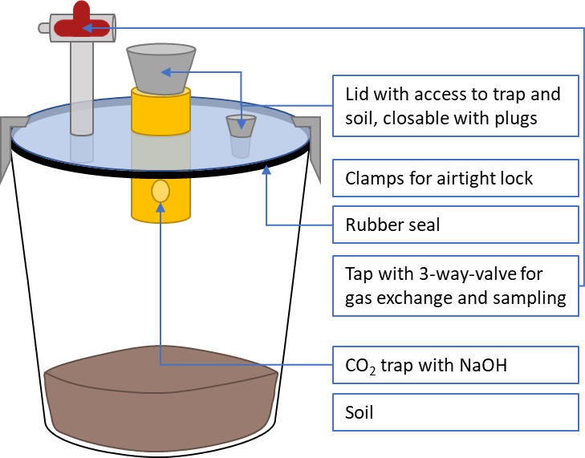
Supp. Fig. 1: Schematic of the used microcosm
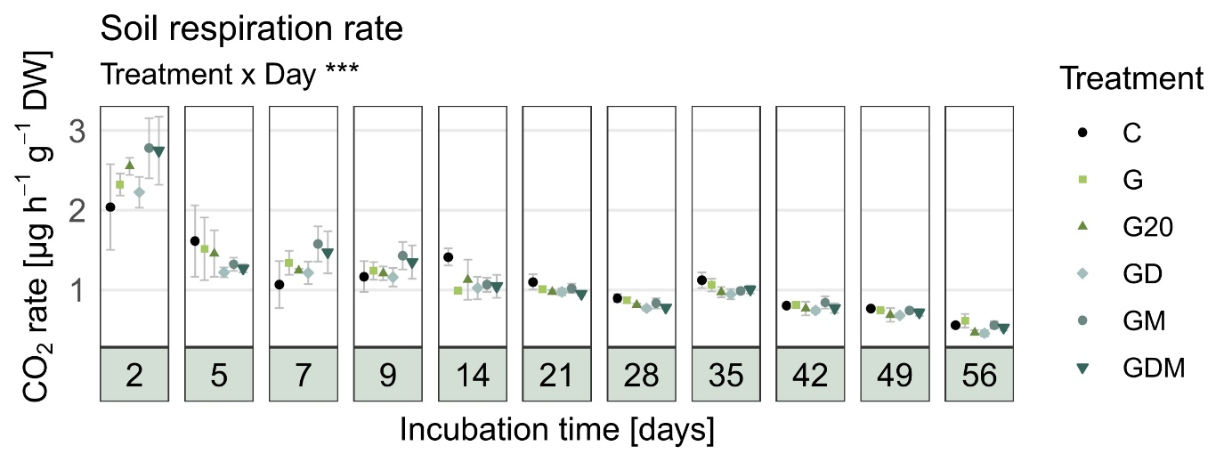
Supp. Fig. 2: CO₂ rate [µg h⁻¹ g⁻¹ DW] over the 56 days incubation (n = 4). C = control, G = glyphosate [10 mg kg⁻¹], G20 = glyphosate [20 mg kg⁻¹], GD = G + difenoconazole [10 mg kg⁻¹], GM = G + MCPA [10 mg kg⁻¹], GDM = G + MCPA [5 mg kg⁻¹] + difenoconazole [5 mg kg⁻¹]. Error bars indicate standard deviation. Significance codes: p < 0.05*, p < 0.01**, p < 0.001***.
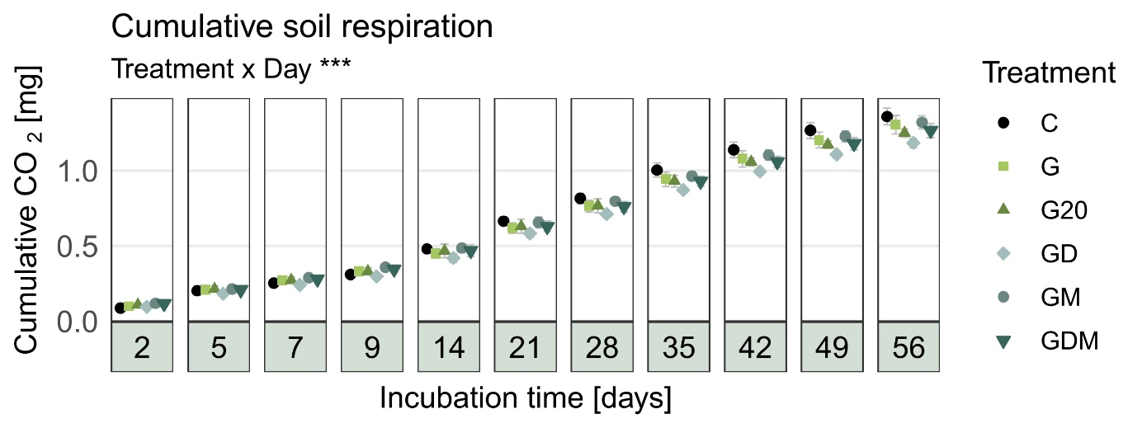
Supp. Fig. 3: Cumulative CO₂ production [mg] over the 56 days incubation (n = 4). C = control, G = glyphosate [10 mg kg⁻¹], G20 = glyphosate [20 mg kg⁻¹], GD = G + difenoconazole [10 mg kg⁻¹], GM = G + MCPA [10 mg kg⁻¹], GDM = G + MCPA [5 mg kg⁻¹] + difenoconazole [5 mg kg⁻¹]. Error bars indicate standard deviation. Significance codes: p < 0.05*, p < 0.01**, p < 0.001***.

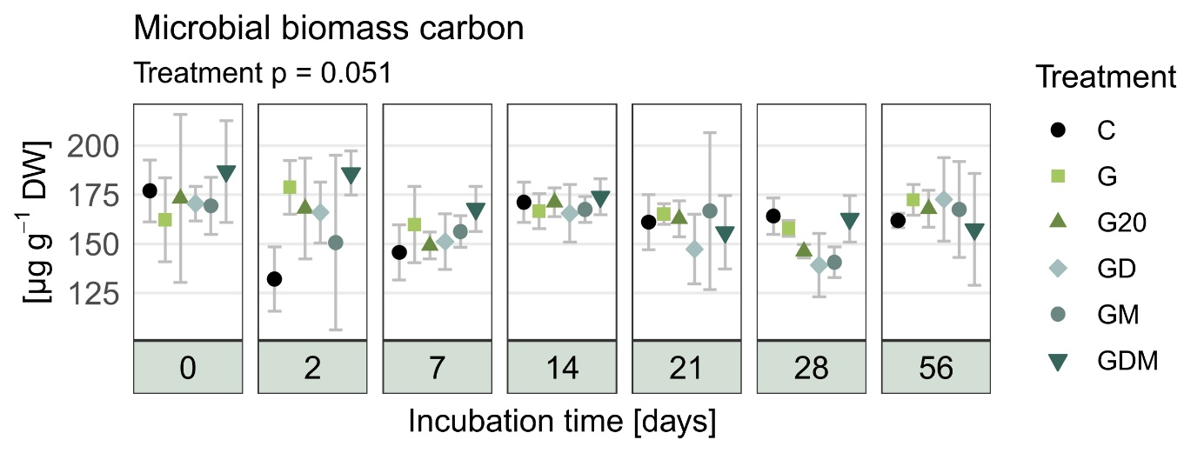
Supp. Fig. 4: Microbial biomass carbon (n=4). C = control, G = glyphosate [10 mg kg⁻¹], G20 = glyphosate [20 mg kg⁻¹], GD = G + difenoconazole [10 mg kg⁻¹], GM = G + MCPA [10 mg kg⁻¹], GDM = G + MCPA [5 mg kg⁻¹] + difenoconazole [5 mg kg⁻¹]. Error bars indicate standard deviation. Significance codes: p < 0.05*, p < 0.01**, p < 0.001***.
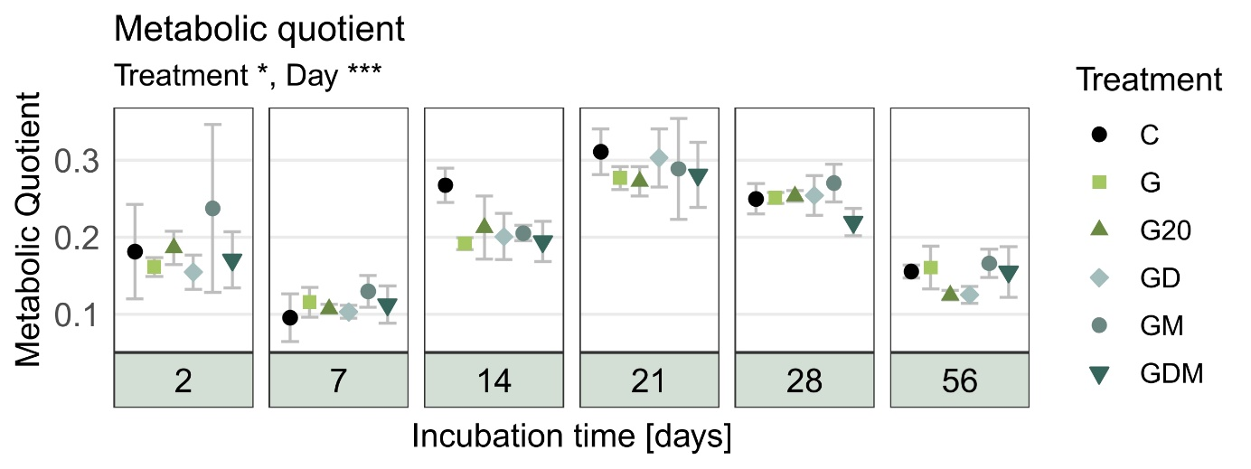
Supp. Fig. 5: Metabolic quotient qCO₂ (n=4). C = control, G = glyphosate [10 mg kg⁻¹], G20 = glyphosate [20 mg kg⁻¹], GD = G + difenoconazole [10 mg kg⁻¹], GM = G + MCPA [10 mg kg⁻¹], GDM = G + MCPA [5 mg kg⁻¹] + difenoconazole [5 mg kg⁻¹]. Error bars indicate standard deviation. Significance codes: p < 0.05*, p < 0.01**, p < 0.001***.
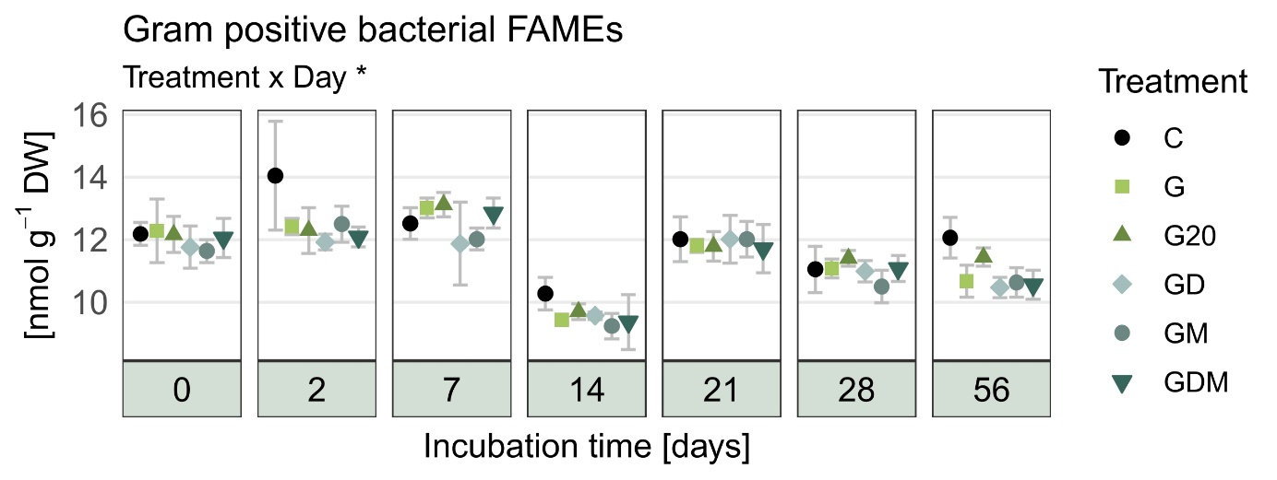
Supp. Fig. 6: Gram positive bacterial FAMEs (n=4). C = control, G = glyphosate [10 mg kg⁻¹], G20 = glyphosate [20 mg kg⁻¹], GD = G + difenoconazole [10 mg kg⁻¹], GM = G + MCPA [10 mg kg⁻¹], GDM = G + MCPA [5 mg kg⁻¹] + difenoconazole [5 mg kg⁻¹]. Error bars indicate standard deviation. Significance codes: p < 0.05*, p < 0.01**, p < 0.001***.
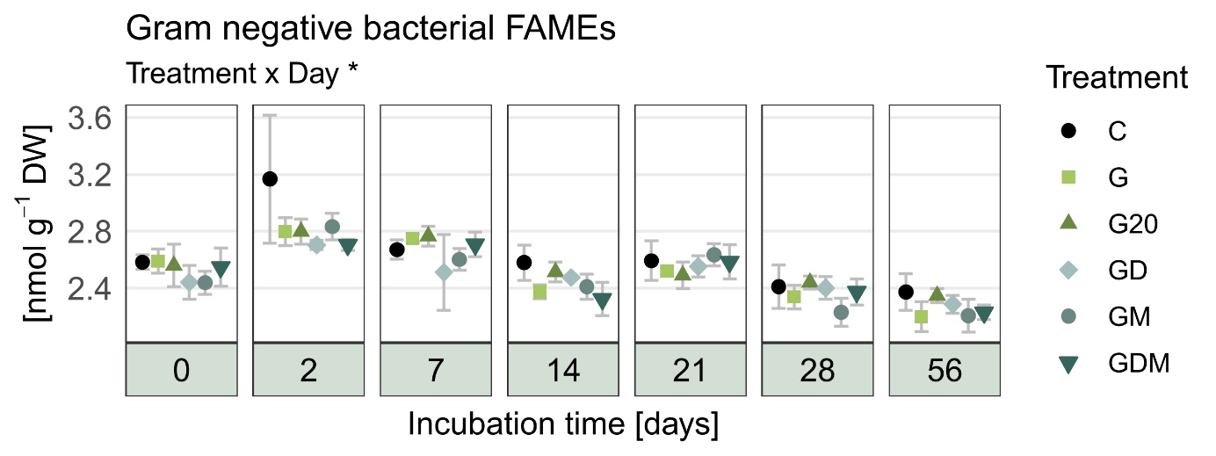
Supp. Fig. 7: Gram negative bacterial FAMEs (n=4). C = control, G = glyphosate [10 mg kg⁻¹], G20 = glyphosate [20 mg kg⁻¹], GD = G + difenoconazole [10 mg kg⁻¹], GM = G + MCPA [10 mg kg⁻¹], GDM = G + MCPA [5 mg kg⁻¹] + difenoconazole [5 mg kg⁻¹]. Error bars indicate standard deviation. Significance codes: p < 0.05*, p < 0.01**, p < 0.001***.
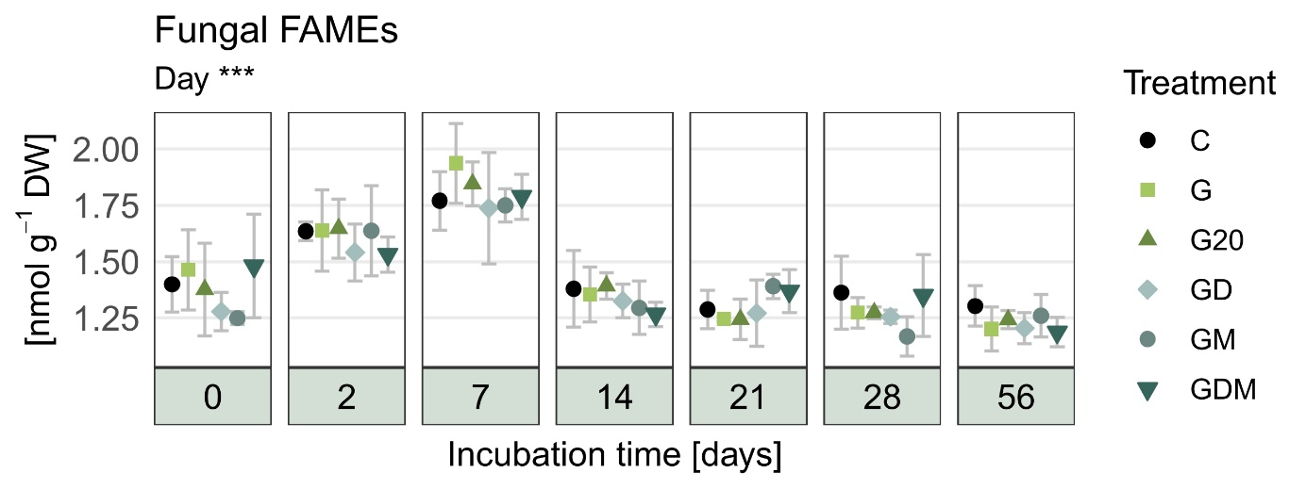
Supp. Fig. 8: Fungal FAMEs (n=4). C = control, G = glyphosate [10 mg kg⁻¹], G20 = glyphosate [20 mg kg⁻¹], GD = G + difenoconazole [10 mg kg⁻¹], GM = G + MCPA [10 mg kg⁻¹], GDM = G + MCPA [5 mg kg⁻¹] + difenoconazole [5 mg kg⁻¹]. Error bars indicate standard deviation. Significance codes: p < 0.05*, p < 0.01**, p < 0.001***.

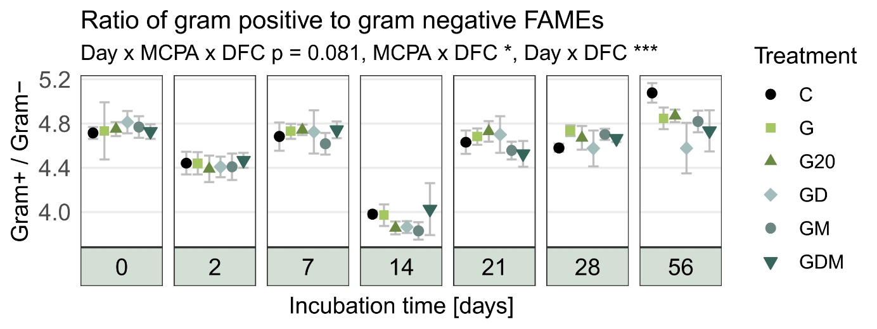
Supp. Fig. 9: Ratio of Gram positive to Gram negative FAMEs (n=4). C = control, G = glyphosate [10 mg kg⁻¹], G20 = glyphosate [20 mg kg⁻¹], GD = G + difenoconazole [10 mg kg⁻¹], GM = G + MCPA [10 mg kg⁻¹], GDM = G + MCPA [5 mg kg⁻¹] + difenoconazole [5 mg kg⁻¹]. Error bars indicate standard deviation. Significance codes: p < 0.05*, p < 0.01**, p < 0.001***.
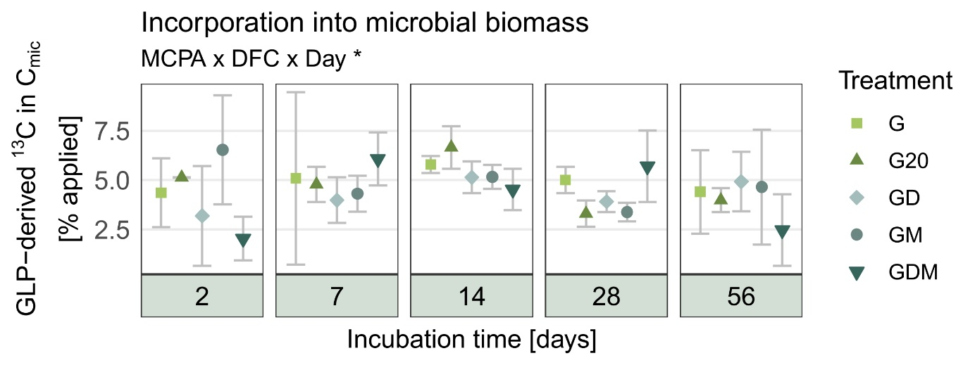
Supp. Fig. 10: Glyphosate derived ¹³C in the microbial biomass [% initial applied] over the 56 days incubation (n = 4). G = glyphosate [10 mg kg⁻¹], G20 = glyphosate [20 mg kg⁻¹], GD = G + difenoconazole [10 mg kg⁻¹], GM = G + MCPA [10 mg kg⁻¹], GDM = G + MCPA [5 mg kg⁻¹] + difenoconazole [5 mg kg⁻¹]. Error bars indicate standard deviation. Significance codes: p < 0.05*, p < 0.01**, p < 0.001***.
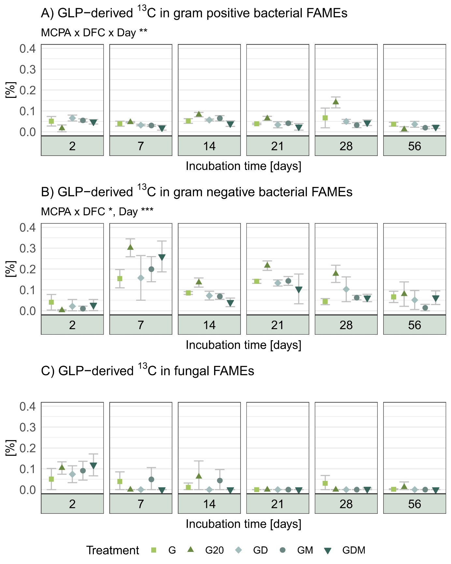
Supp. Fig. 11: Glyphosate-derived ¹³C in FAMEs of A) gram positive bacteria, B) gram negative bacteria and C) fungi [%] over the 56 days incubation (n = 4). G = glyphosate [10 mg kg⁻¹], G20 = glyphosate [20 mg kg⁻¹], GD = G + difenoconazole [10 mg kg⁻¹], GM = G + MCPA [10 mg kg⁻¹], GDM = G + MCPA [5 mg kg⁻¹] + difenoconazole [5 mg kg⁻¹]. Error bars indicate standard deviation. Significance codes: p < 0.05*, p < 0.01**, p < 0.001***.
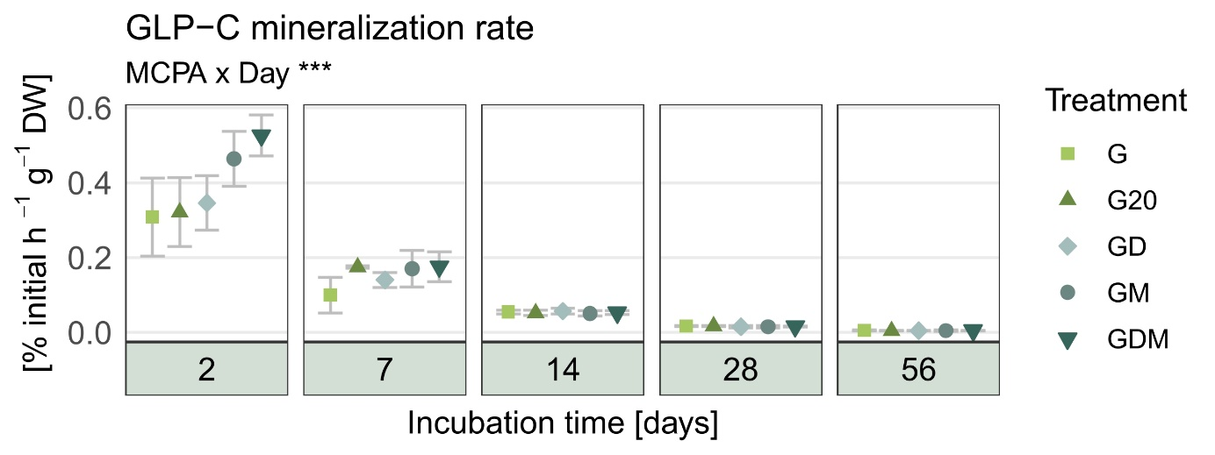
Supp. Fig. 12: Glyphosate derived ¹³C mineralization [% applied h⁻¹] over the 56 days incubation (n = 4). G = glyphosate [10 mg kg⁻¹], G20 = glyphosate [20 mg kg⁻¹], GD = G + difenoconazole [10 mg kg⁻¹], GM = G + MCPA [10 mg kg⁻¹], GDM = G + MCPA [5 mg kg⁻¹] + difenoconazole [5 mg kg⁻¹]. Error bars indicate standard deviation. Significance codes: p < 0.05*, p < 0.01**, p < 0.001***.
Supp. Table 1: Primer sequences and conditions for qPCR
Supp. Table 2: Dissipation time for 50% and 90% of glyphosate

References
Bælum, J., Nicolaisen, M.H., Holben, W.E., Strobel, B.W., Sørensen, J., Jacobsen, C.S., 2008. Direct analysis of tfdA gene expression by indigenous bacteria in phenoxy acid amended agricultural soil. The ISME Journal 2, 677–687. https://doi.org/10.1038/ismej.2008.21
Bligh, E.G., Dyer, W.J., 1959. A rapid method of total lipid extraction and purification. Canadian journal of biochemistry and physiology 37, 911–917. https://doi.org/10.1139/o59-099
Frostegård, Å., Tunlid, A., Bååth, E., 1991. Microbial biomass measured as total lipid phosphate in soils of different organic content. Journal of Microbiological Methods 14, 151–163. https://doi.org/10.1016/0167-7012(91)90018-L
González-Valenzuela, L.E., Dussán, J., 2018. Molecular assessment of glyphosate-degradation pathway via sarcosine intermediate in Lysinibacillus sphaericus. Environmental Science and Pollution Research 25, 22790–22796. https://doi.org/10.1007/s11356-018-2364-9
Joergensen, R.G., 1996. The fumigation-extraction method to estimate soil microbial biomass: Calibration of the kEC value. Soil Biology and Biochemistry 28, 25–31. https://doi.org/10.1016/0038-0717(95)00102-6
Kramer, S., Marhan, S., Ruess, L., Armbruster, W., Butenschoen, O., Haslwimmer, H., Kuzyakov, Y., Pausch, J., Scheunemann, N., Schoene, J., Schmalwasser, A., Totsche, K.U., Walker, F., Scheu, S., Kandeler, E., 2012. Carbon flow into microbial and fungal biomass as a basis for the belowground food web of agroecosystems. Pedobiologia 55, 111–119. https://doi.org/10.1016/j.pedobi.2011.12.001
Ruess, L., Chamberlain, P.M., 2010. The fat that matters: Soil food web analysis using fatty acids and their carbon stable isotope signature. Soil Biology and Biochemistry 42, 1898–1910. https://doi.org/10.1016/j.soilbio.2010.07.020
Silva, V., Mol, H.G.J., Zomer, P., Tienstra, M., Ritsema, C.J., Geissen, V., 2019. Pesticide residues in European agricultural soils - A hidden reality unfolded. Science of The Total Environment 653, 1532–1545. https://doi.org/10.1016/j.scitotenv.2018.10.441
Wimmer, B., Neidhardt, H., Schwientek, M., Haderlein, S.B., Huhn, C., 2022. Phosphate addition enhances alkaline extraction of glyphosate from highly sorptive soils and aquatic sediments. Pest Management Science 78, 2550–2559. https://doi.org/10.1002/ps.6883
Wirsching, J., Wimmer, B., Ditterich, F., Schlögl, J., Martin-Laurent, F., Huhn, C., Haderlein, S., Kandeler, E., Poll, C., 2022. 13C assimilation as well as functional gene abundance and expression elucidate the biodegradation of glyphosate in a field experiment. Environmental Pollution 306, 119382. https://doi.org/10.1016/j.envpol.2022.119382

