SUPPLEMENTARY FILE
Supplementary file 1. Agronomic, Genetic, and Administrative Characteristics of Winter Wheat Cultivars Used in the Study
Cultivar/Trait | Ludwig | Mulan | Winnetou
quality groups | Class A | Class B | Class C
Approval Dates | 26.03.1998 | 22.03.2006 | 19.03.2002
Breeder | Pflanzenzucht Oberlimpurg  Oberlimpurg 2  74523 Schwäbisch Hall,  Germany | NORDSAAT Saatzuchtgesellschaft mbH  Böhnshauser Str. 1  38895 Halberstadt OT Langenstein,  Germany | Saatzucht Firlbeck GmbH + Co. KG  Johann-Firlbeck-Straße 20  94348 Atting, Germany
Photoperiod Sensitivity | Sensitive (Ppd-D1b allele) | Sensitive (Ppd-D1b allele) | Insensitive
Dwarfing Gene | Rht8b | Rht8b | None
Winter Hardiness | 4 | 3 | 6
Heading Date | 4 | 4 | 5
Maturity | 5 | 5 | 5
Plant Height (Score) | 7 | 5 | 5
Stand Density (Score) | 8 | 6 | 6
Thousand Kernel Mass (TKM) | 8 | 6 | 5
Grain Yield (Stage 1) | 7 | 8 | 8
Grain Yield (Stage 2) | 5 | 7 | 5
Falling Number | 7 | 6 | 8
Protein Content | High | Moderate | Low
Wet Gluten Content | High | Moderate | Low
Baking Quality | Excellent | Good | Poor
Predominant Property | Baking quality | Milling quality | High feed yield
Dough Surface Texture | Normal | Smooth | Sticky
Disease Resistance (Score)
- Pseudocercosporella | 4 | 5 | 6
- Powdery Mildew | 4 | 5 | 4
- Leaf Septoria | 3 | 4 | 5
- Drechslera tritici-repentis | 5 | 5 | 2
- Yellow Rust | 5 | 5 | 5
- Brown Rust | 5 | 5 | 5
- Fusarium Head Blight | 4 | 3 | 4
Scores range from 1 to 9, where 1 indicates poor performance or early development (e.g., heading, maturity), and 9 represents excellent performance or late development, with intermediate values indicating moderate levels

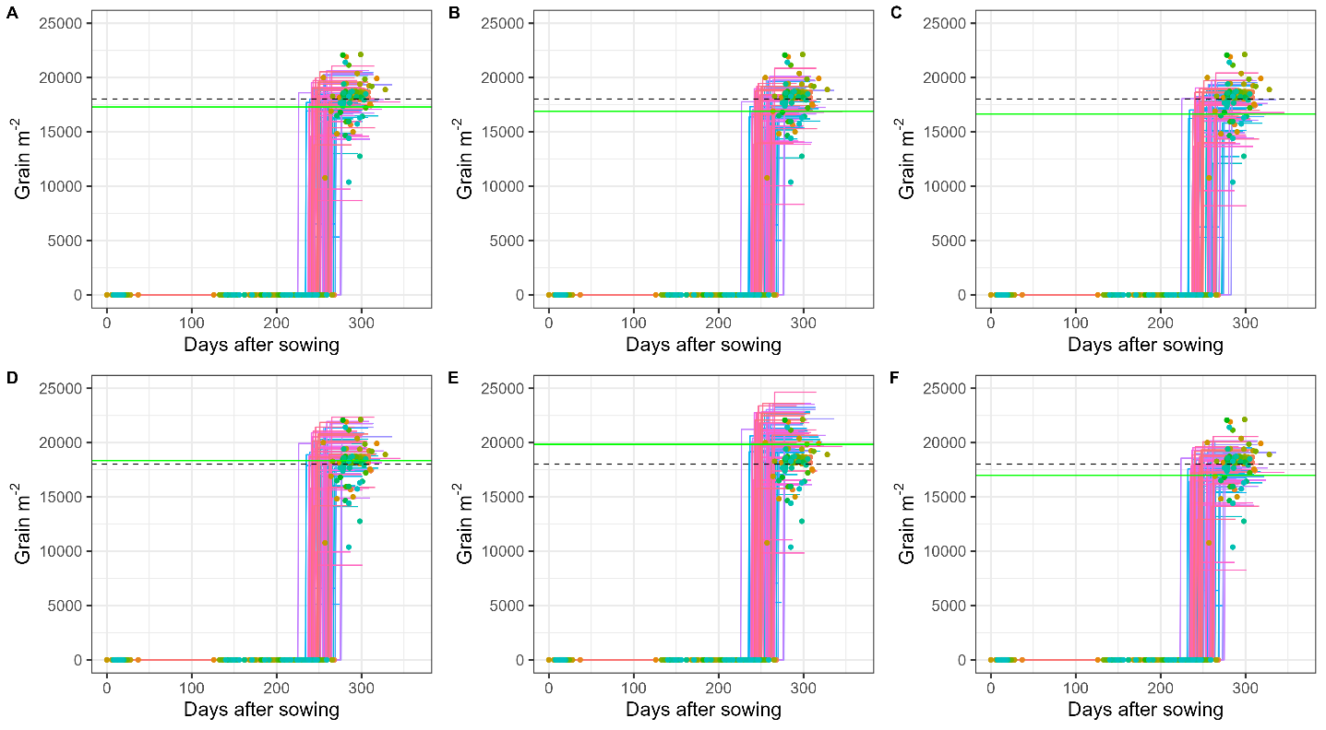
Supplementary file 2. Observed vs simulated Grain m⁻² at harvest for Ludwig cultivar, dashed line represents observed mean and green line presents simulated mean.
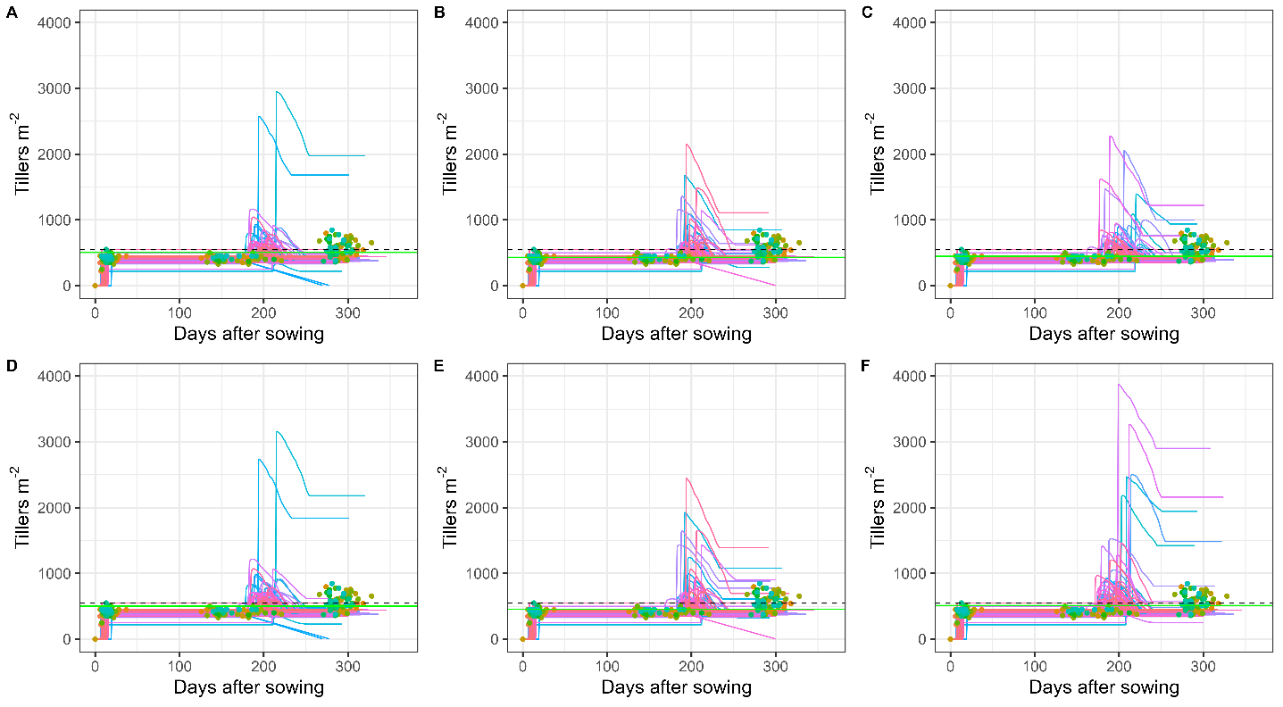
Supplementary file 3. Observed vs simulated tiller m⁻² at harvest for Ludwig cultivar, dashed line represents observed mean and green line presents simulated mean.

Supplementary file 4. Overview of the three comparative strategies used to calibrate the DSSAT-NWheat model, including the number of simulation runs for the winter wheat variety Winnetou
Strategies | Target traits | First exhaustive gridding |  | Second exhaustive gridding |  | Third exhaustive gridding |  | Total no. of runs
 |  | No. of simulation runs |  | No. of simulation runs |  | No. of simulation runs
Strategy one | Phenology | 4^{b} × 3ª= 81 | 50 × 81= 4050 | 4^{b} × 3ª= 81 | 50 × 81= 4050 | 4^{b} × 3ª= 81 | 50 × 81= 4050 | 12150 | 15300
Strategy one | Leaf area index | 2^{b} × 3ª= 9 | 50 × 9= 450 | 2^{b} × 3ª= 9 | 50 × 9= 450 | 2^{b}× 3ª= 9 | 50 × 9= 450 | 1350 | 15300
Strategy one | Biomass | 1^{b} × 3ª= 3 | 50 × 3= 150 | 1^{b} × 3ª= 3 | 50 × 3= 150 | 1^{b} × 3ª= 3 | 50 × 3= 150 | 450 | 15300
Strategy one | Grain yield | 2^{b} × 3ª= 9 | 50 × 9= 450 | 2^{b} × 3ª= 9 | 50 × 9= 450 | 2^{b} × 3ª= 9 | 50 × 9= 450 | 1350 | 15300
Strategy two | Phenology | 4^{b}× 3ª= 81 | 50 × 81= 4050 | 4^{b} × 3ª= 81 | 50 × 81= 4050 | 4^{b} × 3ª= 81 | 50 × 81= 4050 | 12150 | 15300
Strategy two | Leaf area index | 2^{b} × 3ª= 9 | 50 × 9= 450 | 2^{b} × 3ª= 9 | 50 × 9= 450 | 2^{b} × 3 ª= 9 | 50 × 9= 450 | 1350 | 15300
Strategy two | Biomass | 1^{b} × 3ª= 3 | 50 × 3= 150 | 1^{b} × 3ª= 3 | 50 × 3= 150 | 1^{b} × 3ª= 3 | 50 × 3= 150 | 450 | 15300
Strategy two | Grain yield | 2^{b} × 3ª= 9 | 50 × 9= 450 | 2^{b} × 3ª= 9 | 50 × 9= 450 | 2^{b} × 3ª= 9 | 50 × 9= 450 | 1350 | 15300
Strategy three | Max Param | 7^{b} × 3ª= 2187 | 50 × 2187= 109350 | 7^{b} × 3ª= 2187 | 50 × 2187= 109350 | 7^{b} × 3ª= 2187 | 50 × 2187= 109350 | 328050 | 329400
Strategy three | PPSEN-VSEN | 2^{b} × 3ª= 9 | 50 × 9= 450 | 2^{b} × 3ª= 9 | 50 × 9= 450 | 2^{b} × 3ª= 9 | 50 × 9= 450 | 1350 | 329400
^{b}= Parameter; ª= Quantile

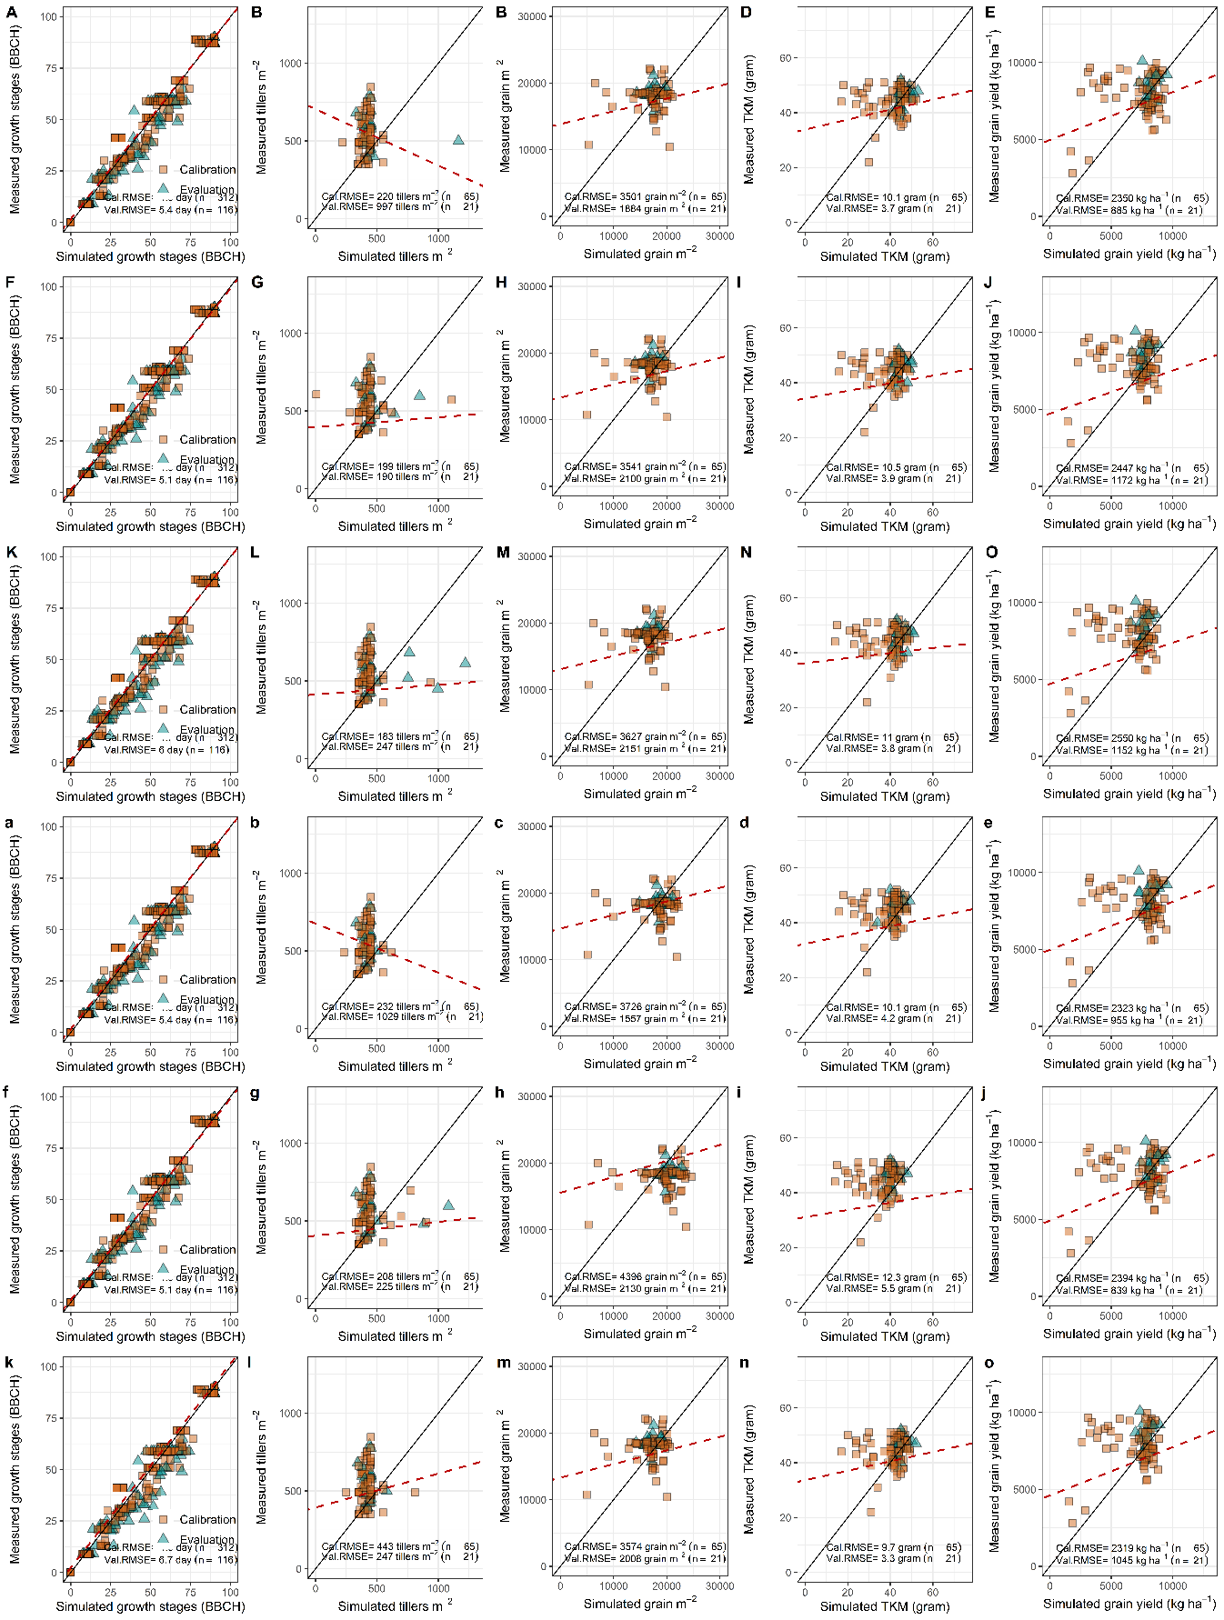
Supplementary file 5. Comparison of simulated and observed data for cultivar Ludwig’s growth stages (BBCH), tillers m⁻², grain m⁻², thousand kernel mass (TKM), and grain yield at harvest under different strategies and datasets. Panels A-E, F-J, and K-O show results from strategies one, two, and three using the full dataset, respectively. Panels’ a-e, f-j, and k-o display results for the same strategies using the restricted dataset.

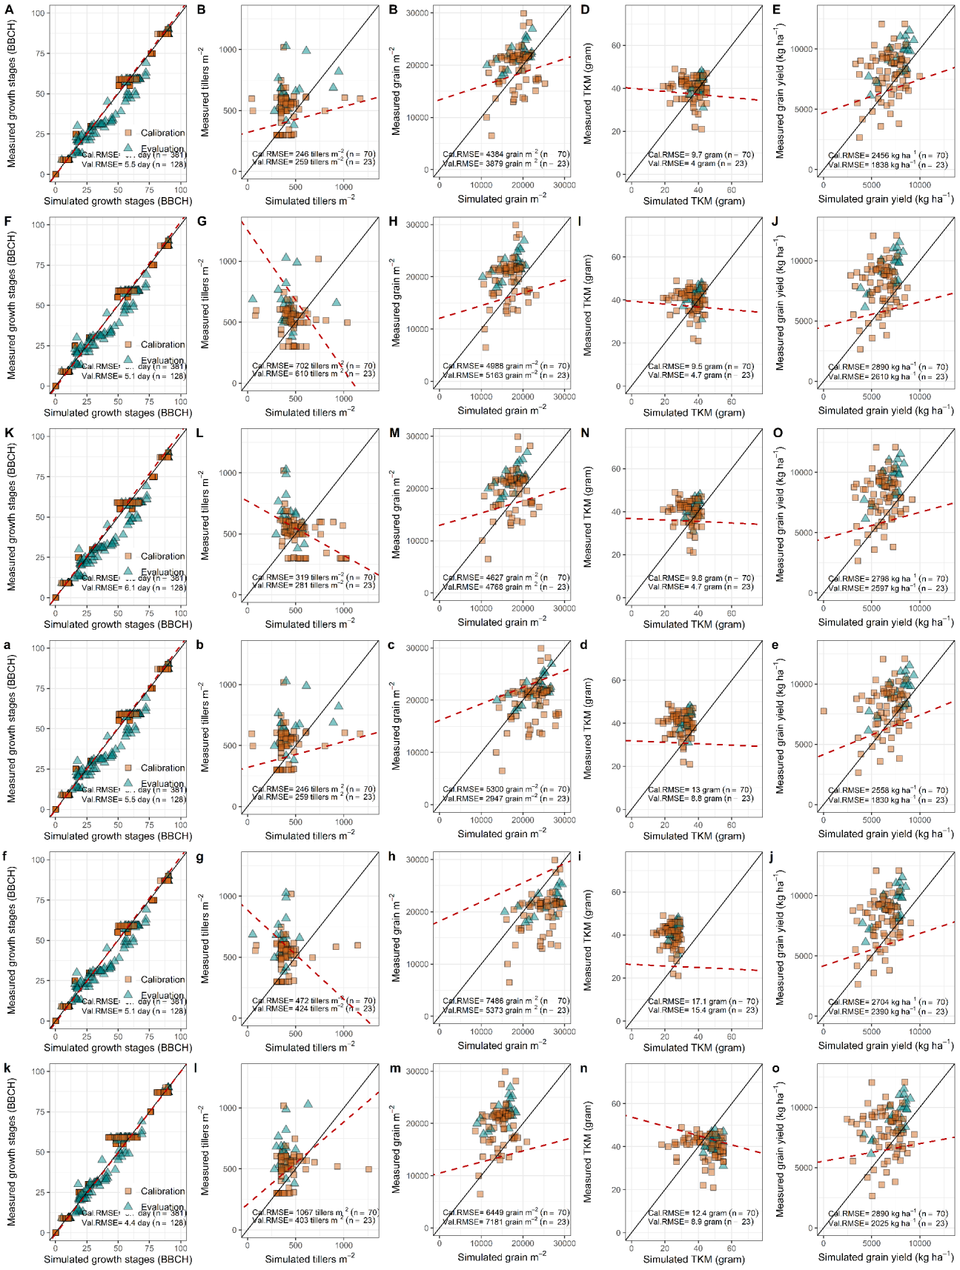
Supplementary file 6. Comparison of simulated and observed data for cultivar Mulan’s growth stages (BBCH), tillers m⁻², grain m⁻², thousand kernel mass (TKM), and grain yield at harvest under different strategies and datasets. Panels A-E, F-J, and K-O show results from strategies one, two, and three using the full dataset, respectively. Panel’s a-e, f-j, and k-o display results for the same strategies using the restricted dataset.

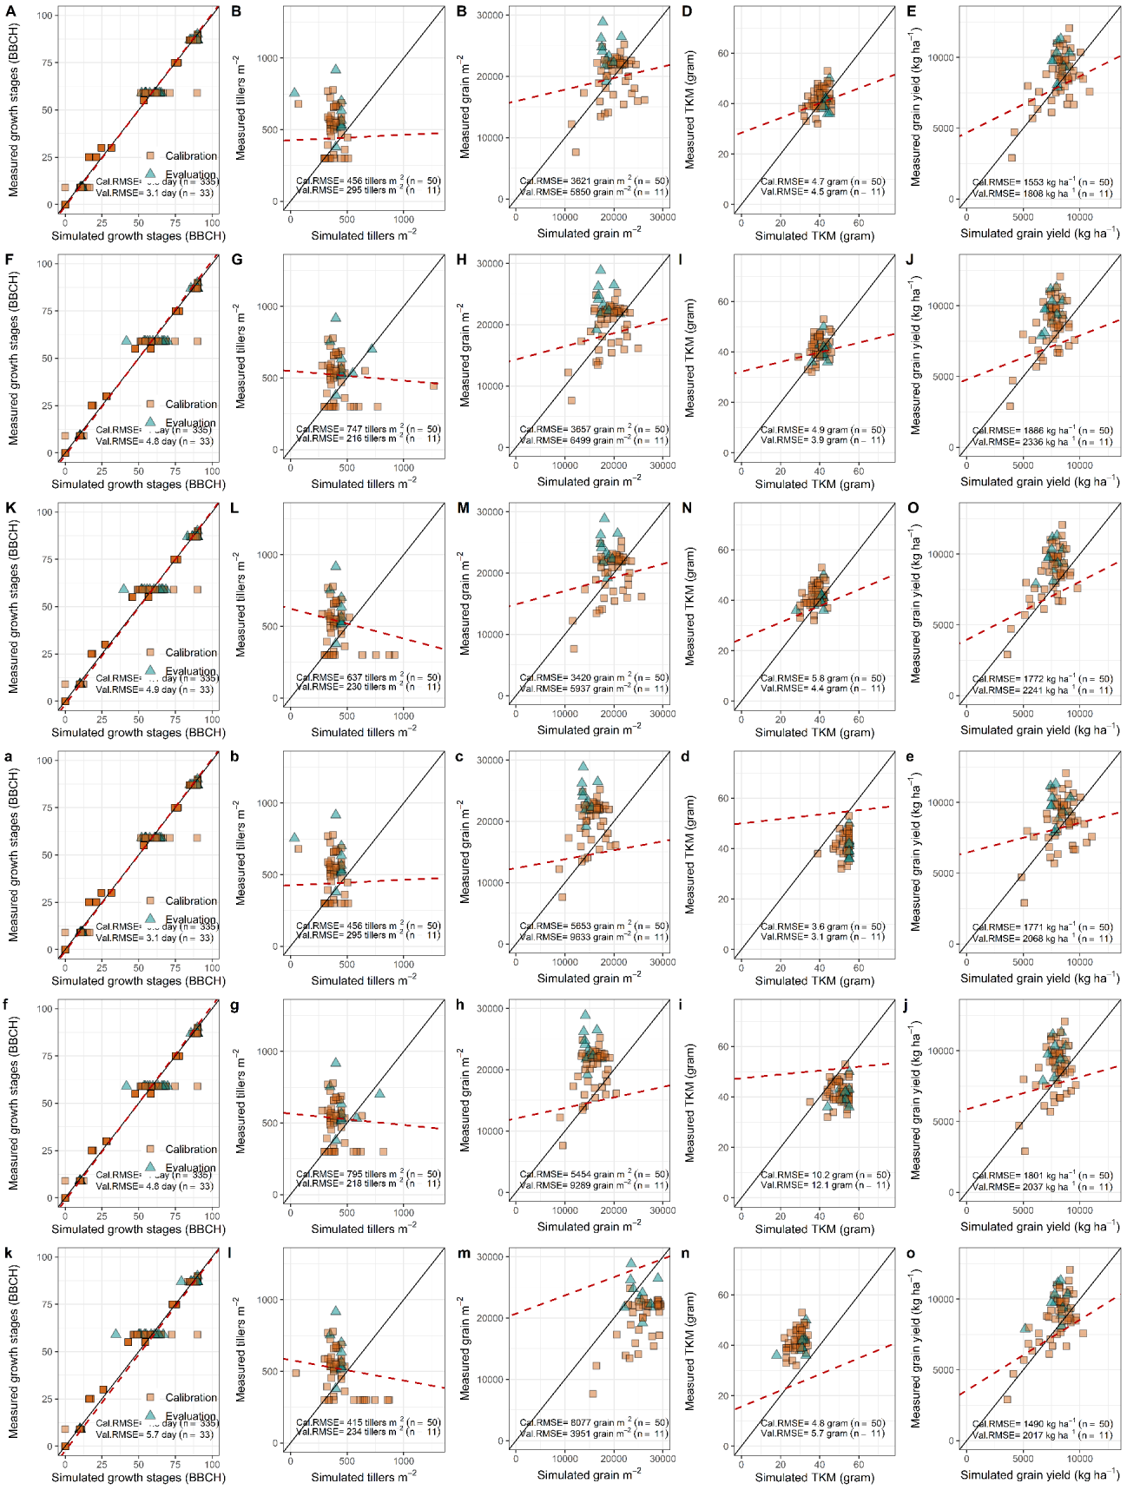
Supplementary file 7. Comparison of simulated and observed data for cultivar Winnetou’s growth stages (BBCH), tillers m⁻², grain m⁻², thousand kernel mass (TKM), and grain yield at harvest under different strategies and datasets. Panels A-E, F-J, and K-O show results from strategies one, two, and three using the full dataset, respectively. Panels’ a-e, f-j, and k-o display results for the same strategies using the restricted dataset.

