Supplementary Material
Role of homovanillic acid esters in the regulation of skin inflammatory pathways and their effect on tight junction protein expression
Maria Fernanda Cervantes Recalde^{1,2}, Elena Zoe Bogensperger¹, Joachim Hans³, Dominik Stuhlmann³, Veronika Somoza^{1,4}, Barbara Lieder^{1,5*}
¹Institute of Physiological Chemistry, Faculty of Chemistry, University of Vienna, Vienna, Austria
²Vienna Doctoral School in Chemistry (DoSChem), University of Vienna, Vienna, Austria
³Symrise AG, Muehlenfeldstrasse 1, Holzminden, Germany
⁴Leibniz Institute of Food Systems Biology, Technical University of Munich, Freising, Germany
⁵University of Hohenheim, Institute of Clinical Nutrition, Stuttgart, Germany
* Correspondence:
Corresponding Author
Barbara.Lieder@uni-hohenheim.de
Keywords: skin, inflammation, TRPV1₃, claudin 1, homovanillic acid ester

1 Supplementary Figures

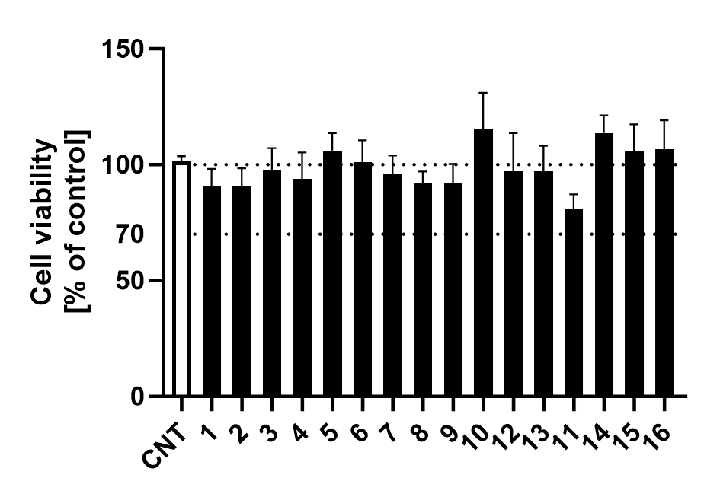

FIGURE S1. Cell viability assessment of HaCaT cells pre-treated with 10 µM of the different homovanillic acid esters for 24 h. No significant decrease in cell viability was observed after 24 h application of compounds 1-16 (black). Data presented as percentage of the non-treated control (white). Dotted lines represent 100 % cell viability and the 70 % cut-off for assessing adverse effects on cell viability measured using an MTT assay. (Statistics: mean + SEM; technical replicates: 4, biological replicates: 5, ordinary one-way ANOVA)

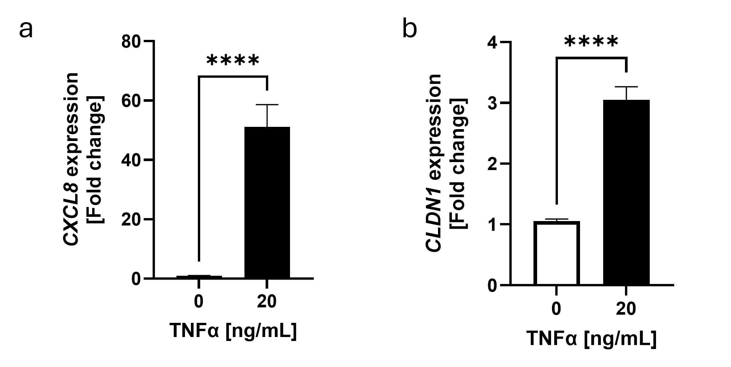

FIGURE S2. Characterization of CXCL8 and CLDN1 gene expression in skin samples after TNFα treatment for 6 h. HaCaT keratinocytes cultured under low calcium conditions (0.06 mM Ca²⁺) for 4 days were treated with 20 ng/mL TNFα for 6 h. (a) CXCL8 and (b) CLDN1 gene expression (black) was measured after TNFα treatment and presented as fold change of the non-treated control (white). Relative gene expression was measured with RT-qPCR and normalized to the geomean of the reference genes (Statistics: mean + SEM; technical replicates: 3, biological replicates: 5).

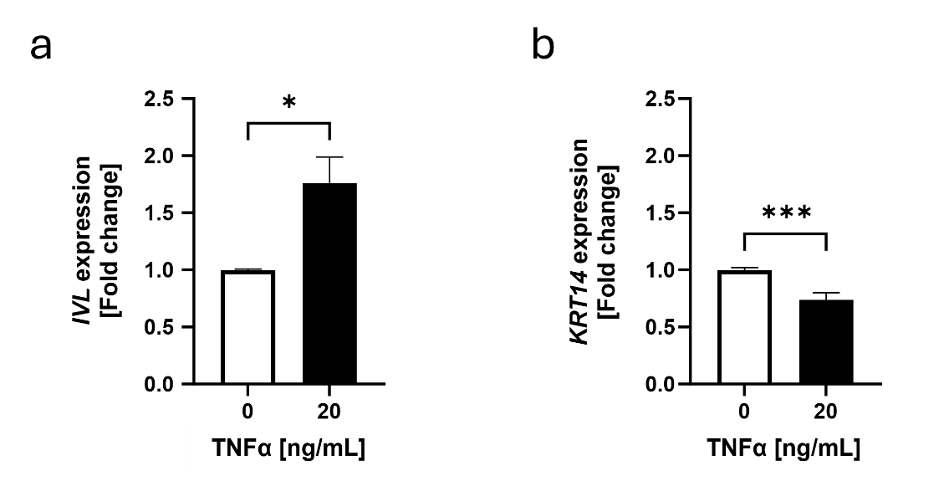
FIGURE S3. TNFα-induced changes in IVL and KRT14 expression in HaCaT keratinocytes. TNFα increased (a) IVL gene expression and (b) reduced KRT14 after 6 h treatment with 20 ng/mL TNFα compared to the non-treated control. IVL and KRT14 expression were measured using real-time PCR. Data is presented as fold change to non-treated control. White bars represent the non-treated control and black bars represent TNFα treatment. (Statistics: mean + SEM; technical replicates: 3, biological replicates: 10-11; Welch’s t- test, *p<0.05, ***p<0.001).
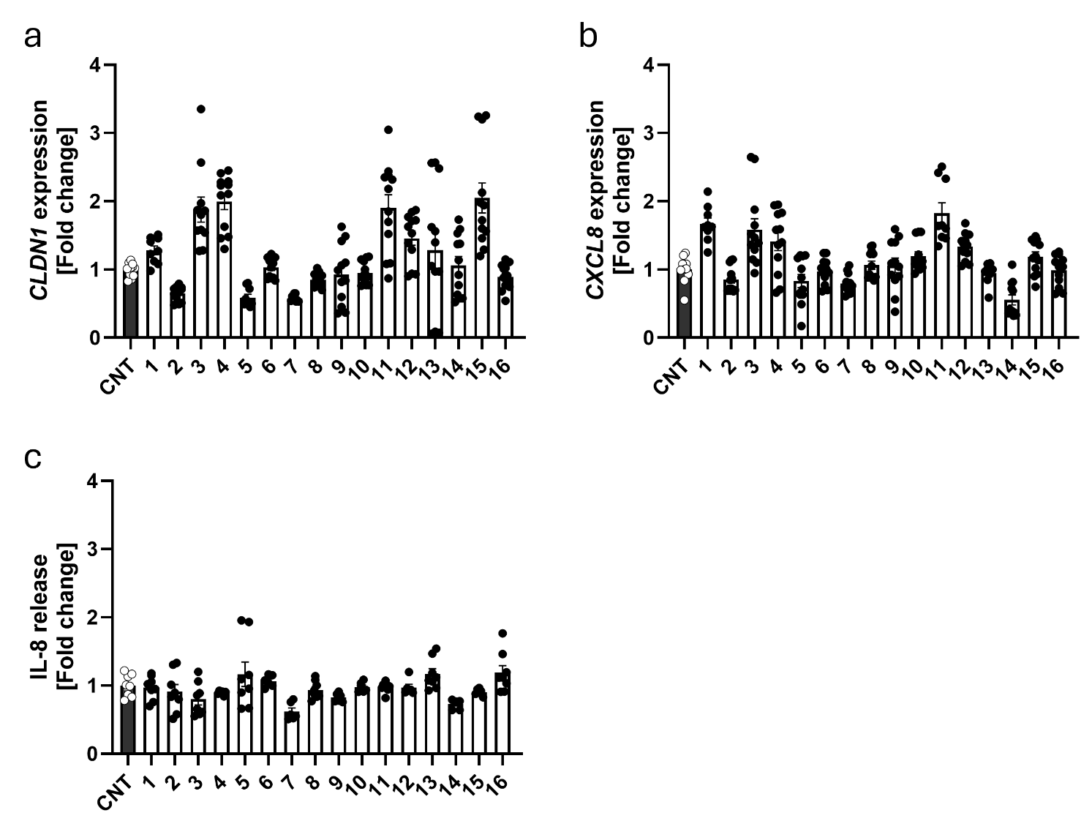
FIGURE S4. TNFα-induced variation of CLDN1 and CXCL8 expression in HaCaT keratinocytes. (a) CLDN1 expression, (b) CXCL8 expression and (c) IL-8 release corresponding to the data presented in figures 2a and 2b. Mean value + SEM (bars) and single datapoints (dots) are presented for the TNFα control and the homovanillic acid esters (1-16). Data is presented as fold change to TNFα control. (Statistics: mean + SEM; technical replicates: 3, biological replicates: 4).
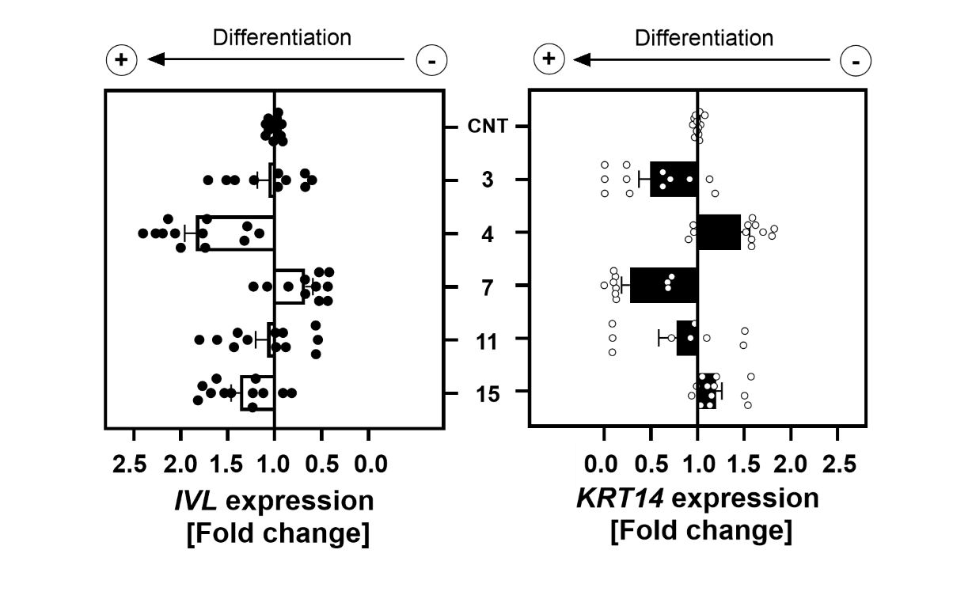
FIGURE S5. TNFα-induced variation in IVL and KRT14 expression in HaCaT keratinocytes corresponding to the data presented in figures 4a. Mean value + SEM (bars) and single datapoints (dots) are presented for the TNFα control and compounds 3, 4, 7, 11, and 15. Data is presented as fold change to TNFα control. (Statistics: mean + SEM; technical replicates: 3, biological replicates: 4).

