Table S1 Extraction efficacy for STL extraction from cotyledons and hypocotyl/root tissues, respectively. Values are given as mean and SE of n = 3 experiments

 | Extraction efficacy in %
Extracted tissue | 8-epixanthatin | tomentosin | costunolide | dehydrocostuslactone
cotyledons | 62 ± 4 % | 75 ± 8 % | 29 ±7 % | 52 ± 6 %
hypocotyl or root | 64 ± 5 % | 76 ± 1 % | 20 ± 4 % | 20 ± 3 %

Table S2 Primers used for qPCR.
Gene  (Accession-Nr.) | Primer  (5´–3´) | Size  (bp) | Ta (ª)  (°C) | E  (%) | R² | Refe-  rence
HaGAO/  CYP71AV6  (GU256646) | CCGCCCCAAACGGAAGATACTC  GATCCCGAATACTGGAAAGACGC | 85 | 60 | 89.0 | 0.999 | Frey et al. 2018
HaG8H/ CYP71BL1  (HQ439590) | TACGTTAGGCGATGTTAGCGAAGACCACGTGGTCTACTTCTGTGTTCCCTCAA | 214 | 64 | 91.2 | 0.997 | Frey et al. 2018
Actin  (AF282624) | GCCGTGCTTTCTCTTTATGCCAGCGACCAGCGAGATCAAGACGAAG | 137 | 60 | 89.8 | 0.999 | Frey et al. 2018
EF 1α  (AY094064) | ACCAAATCAATGAGCCCAAGAGACCCATACCGGGCTTGATCACACCAG | 131 | 60 | 93.8 | 0.998 | Frey et al. 2018
α-tubulin  (AF401481) | TGCCGTTTCAGAGGTTTTCAGTCGCGCCTTCTTCCATCCCTTCACC | 104 | 60 | 84.8 | 0.985 | Frey et al. 2018
HaCOS/  CYP71BL9  (^{b}) | GATACTTATAAATGCGTGGGCTTGTGC GGCCCCAAACGGAAGGAACTC | 136 | 64 | 95.9 | 0.998 | this paper
(ª) Ta: annealing temperature, E: amplification efficiency, EF 1α elongation factor, HaGAO Helianthus annuus germacrene A oxidase, HaG8H Helianthus annuus germacrene A acid 8β-hydroxylase, HaCOS Helianthus annuus costunolide synthase.
(^{b}) GeneBank number not assigned, yet (publication of enzyme in separate manuscript currently under review).

Table S3 LSD Test for 8-Epixanthatin and Tomentosin values of 2h light versus 2h dark

Signifikanztest 8-EPI: 2h Lichtwert ist nicht signifikant höher als 2h Dunkelwert; p=0,1
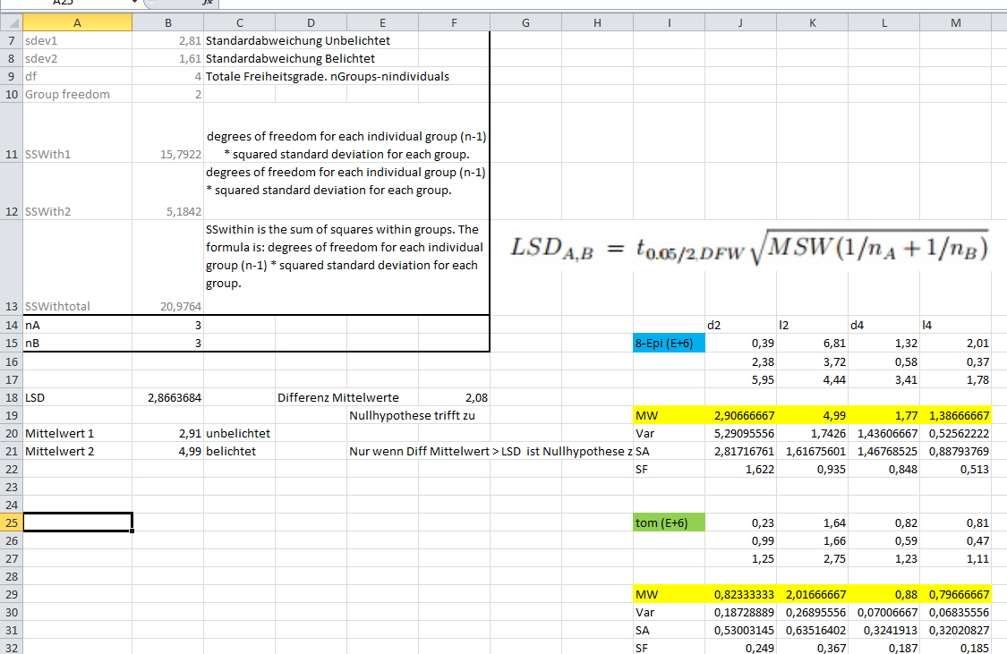
Signifikanztest TOM: 2h Lichtwert ist signifikant höher als 2h Dunkelwert; p=0,05
