Supplement

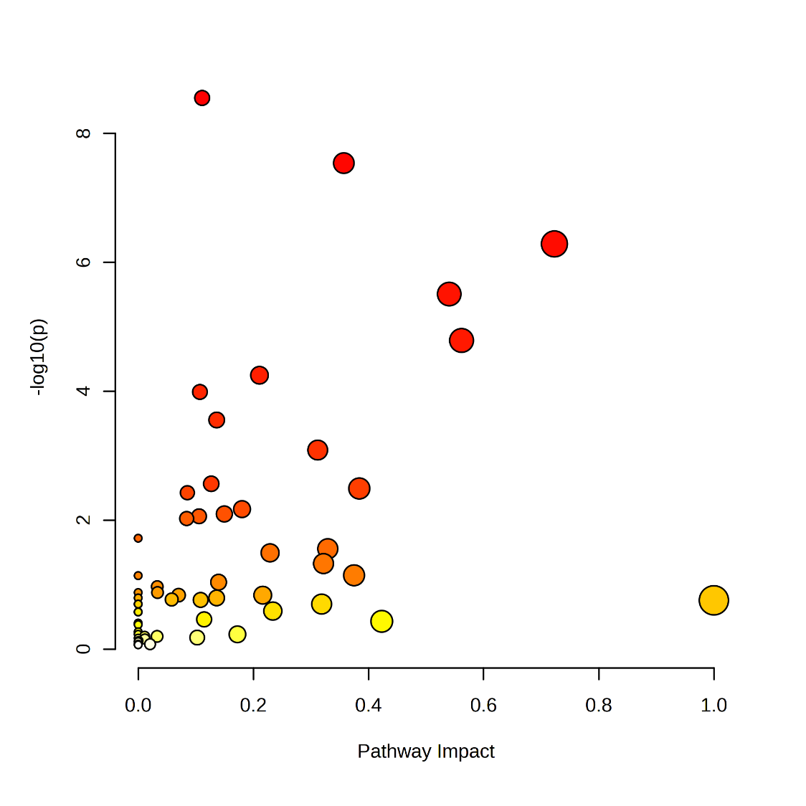
Pathway enrichment significance
low high
Pathway impact
low high
Glyoxylate and dicarboxylate metabolism (10 metabolites)
Galactose metabolism (8 metabolites)
Alanine, aspartate and glutamate metabolism (8 metabolites)
Citrate cycle (6 metabolites)
Aminoacyl-tRNA biosynthesis (13 metabolites)
Carbon fixation (5 metabolites)
Glycine, serine and threonine metabolism (8 metabolites)
Arginine and proline metabolism (5 metabolites)

Supplemental figure 1: Joint-pathway analysis of drought-affected pathways conducted through MetaboAnalyst with metabolites significantly influenced by treatments (Mack-Skillings-Test, p≤0.05) in leaf samples of Zea mays. The impact of identified metabolites on each pathway is represented on the x-axis and the circle colour. Pathway enrichment significance (y-axis and circle size) indicates (according to Zhu and Assmann (2017)) the extent to which the indicated pathway is enriched in the identified metabolites.

