Adapting Wheat Production to Global Warming in West Asia: Facultative Wheat Outperforms Winter and Spring Wheat at Conventional Nitrogen Levels

Afsaneh Yousefi^{1,2}, Alireza Koocheki², Mehdi Nassiri Mahallati², Soroor Khorramdel², Jonas Trenz³, Ali Malakshahi Kurdestani⁴, Uwe Ludewig¹, Niels Julian Maywald^{1*}
¹ Department of Nutritional Crop Physiology, University of Hohenheim, 70593 Stuttgart, Germany
² Department of Agrotechnology, Ferdowsi University of Mashhad, Mashhad, Iran
³ Department of Agronomy, University of Hohenheim, 70593 Stuttgart, Germany
⁴ Department of Fertilization and Soil Matter Dynamics, University of Hohenheim, 70593 Stuttgart, Germany

*Corresponding Author

Supplementary Material

Supplementary Table 1: Soil texture at different soil depth (0-30 cm, 30-60 cm, 60-90 cm) for the two growing seasons.
Depth (cm) | Soil Texture | Clay (%) | Silt (%) | Sand (%)
2020-2021
0-30 | Loam | 23 | 48 | 29
30-60 | Silt-loam | 20 | 51 | 29
60-90 | Silt-loam | 18 | 52 | 30
2021-2022
0-30 | Loam | 26 | 49 | 25
30-60 | Silt-loam | 22 | 59 | 19
60-90 | Silt-loam | 20 | 59 | 21

Supplementary Table 2: Fertilization dates for the split N applications. Total nitrogen application levels were 0, 100, 200, 300 kg ha⁻¹. Total nitrogen application was split in three N applications. First N application before planting (40% of total N), second N application during tillering (30% of total N); third N application at the jointing stage (30% of total N).
 | First N application | Second N application | Third N application
2020-2021
WW/FWW | 11.11.20 | 28.01.21 | 15.03.21
SW/FSW | 14.02.21 | 29.03.21 | 24.04.21
2021-2022
WW/FWW | 08.11.21 | 25.01.22 | 12.03.22
SW/FSW | 19.02.22 | 01.04.22 | 27.04.22

Supplementary Table 3: Irrigation dates and quantities (m³ ha⁻¹) after determination of plant water requirement for the two growing seasons.
2020-2021 | 11.11.  2020 | 28.01.  2021 | 14.02.  2021 | 30.02.  2021 | 15.03.  2021 | 29.03.  2021 | 12.04.  2021 | 24.04.  2021 | 10.05.  2021 | 24.05.  2021 | Total
WW, FWW | 340.0 | 150.0 | 390.0 | 334.2 | 369.6 | 376.2 | 405.7 | 450.5 | 372.5 | 329.3 | 3518.0
SW, FSW | -- | -- | 390.0 | 334.2 | 369.6 | 376.2 | 405.7 | 450.5 | 372.5 | 329.3 | 3028.0
2021-2022 | 08.11.  2021 | 25.01.  2022 | 19.02.  2022 | 01.03.  2022 | 12.03.  2022 | 01.04.  2022 | 15.04.  2022 | 27.04.  2022 | 12.05.  2022 | 28.05.  2022 | Total
WW, FWW | 450.0 | 255.0 | 410.0 | 390.0 | 420.0 | 440.0 | 464.6 | 510.0 | 382.0 | 363.0 | 4084.6
SW, FSW | -- | -- | 410.0 | 390.0 | 420.0 | 440.0 | 464.6 | 510.0 | 382.0 | 363.0 | 3379.6

Supplementary Table 4: Vernalization degree days (VDD) until early reproductive stage for the authum-sown WW and FWW in season 2020-21 and 2021-22 for the different nitrogen levels 0, 100, 200 and 300 kg N ha-1.
 | N-level (kg N ha⁻¹) | VDD  2020-21 | VDD  2021-22
WW | 0 | 188 | 175
WW | 100 | 192 | 184
WW | 200 | 204 | 200
WW | 300 | 209 | 214
FWW | 0 | 181 | 168
FWW | 100 | 186 | 174
FWW | 200 | 195 | 189
FWW | 300 | 204 | 205

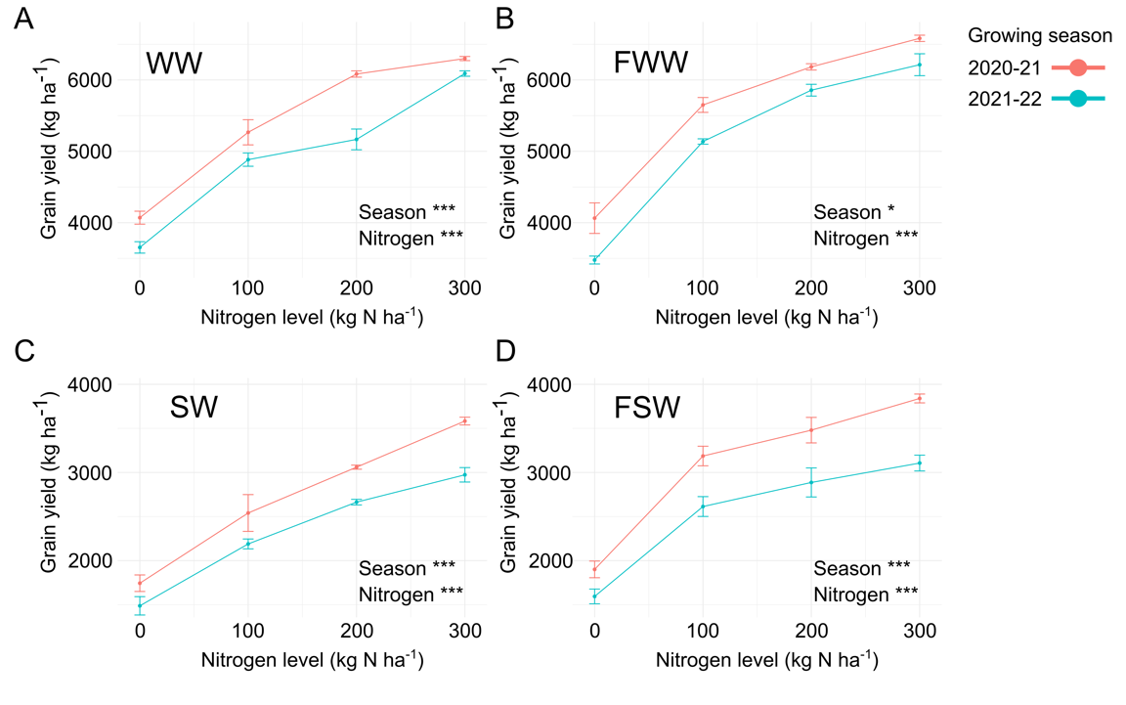
Supplementary Figure 1: Grain yield (kg ha⁻¹) seperated for the two growing seasons 2020-21 (red), 2021-22 (blue) for WW (A), FWW (B), SW (C) and FSW (D) for the nitrogen levels 0, 100, 200 and 300 kg N ha⁻¹. For each variety a ANOVA was perfomed to assess the statistical significance of differences in grain yield (kg/ha) across different levels of nitrogen and years. Significant differences are indicated with asterisks (*** P < 0.001, ** P < 0.01, * P < 0.05). F-values and corresponding P-values (Pr(>F)) for the factors Season, Nitrogen, and their interaction (Season:Nitrogen) are given in Supplementary Table 1.

Supplementary Table 5: Results of the ANOVA for the cultivars WW, FWW, SW, and FSW, showing the F-values and corresponding P-values (Pr(>F)) for the factors Season, Nitrogen, and their interaction (Season:Nitrogen). Significant differences are indicated with asterisks (*** P < 0.001, ** P < 0.01, * P < 0.05). The ANOVA was used to assess the statistical significance of differences in grain yield (kg/ha) across different levels of nitrogen and years.
WW | F-Value | Pr(>F)
Season | 16.83 | < 0.001 ***
Nitrogen | 206.80 | < 0.001 ***
Season:Nitrogen | 0.01 | 0.94
FWW
Season | 7.85 | 0.011 *
Nitrogen | 141.08 | < 0.001 ***
Season:Nitrogen | 0.34 | 0.57
SW
Season | 30.38 | < 0.001 ***
Nitrogen | 280.76 | < 0.001 ***
Season:Nitrogen | 2.85 | 0.11
FSW
Season | 18.61 | < 0.001 ***
Nitrogen | 91.29 | < 0.001 ***
Season:Nitrogen | 1.29 | 0.27

Supplementary Table 6: Results of the ANOVA showing the F-values and corresponding P-values (Pr(>F)) to assess statistical differences of grain yield (kg ha⁻¹) vs VDD_{ERS} (vernalization degree days to early reproductive stage), vs GDD_{ERS} (growing degree days to early reproductive stage) and vs GDD_{M} (growing degree days to maturity). Significant differences are indicated with asterisks (*** P < 0.001, ** P < 0.01, * P < 0.05).
 | F value | Pr(>F)
Grain yield vs VDD_{ERS}
VDD_{ERS} | 307.02 | < 0.001 ***
Nitrogen | 40.58 | < 0.001 ***
Year | 27.08 | < 0.001 ***
Variety | 3.02 | 0.12
Grain yield vs GDD_{ERS}
GDD_{ERS} | 1.11 | < 0.001 ***
Nitrogen | 272.22 | < 0.001 ***
Year | 58.43 | < 0.001 ***
Variety | 2.20 | 0.17
Grain yield vs GDD_{M}
GDD_{M} | 323.89 | < 0.001 ***
Nitrogen | 39.28 | < 0.001 ***
Year | 24.80 | < 0.001 ***
Variety | 1.93 | 0.20

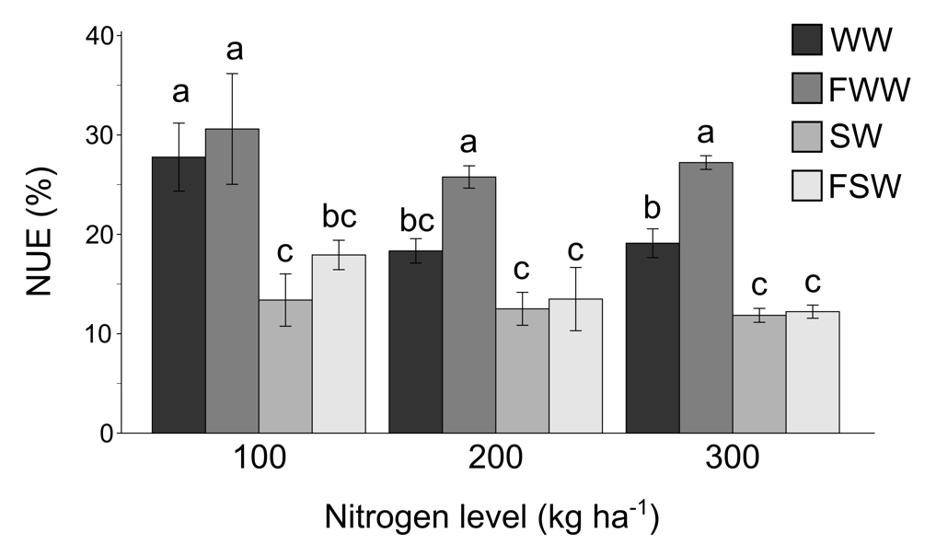

Supplementary Figure 2: Nitrogen use efficiency (NUE) in percent at different nitrogen levels (0-300 kg N ha⁻¹). WW = winter wheat; FWW = facultative winter wheat; SW = spring wheat; FSW = facultative spring wheat.

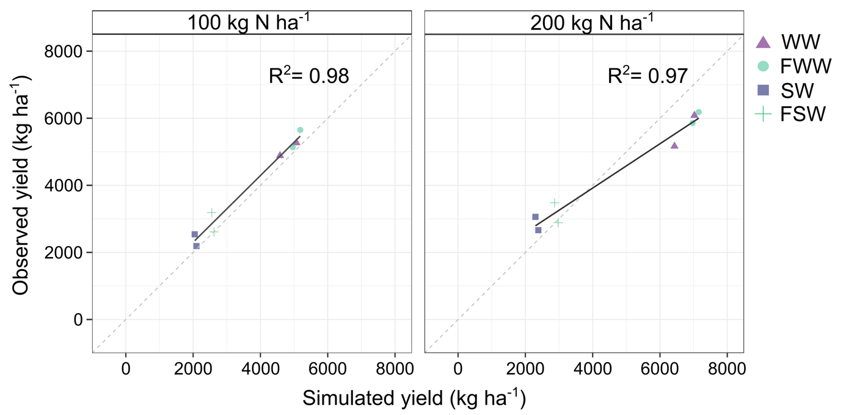
Supplementary Figure 3: Simulated vs. observed grain yield (kg ha⁻¹) illustrated for two fertilizer levels 100 N kg ha⁻¹ (R² = 0.98) and 200 N kg ha⁻¹ (R² = 0.97) for WW, FWW, SW and FSW (2021-2022).

