Supplementary Information
Table SI1 LUFA 2.3 soil properties
Sand | Silt | Clay | pH | Org. carbon | Nitrogen
[%] | [%] | [%] | 0.01 M CaCl₂ | [% C] | [% N]
59.7 ± 0.8 | 33.3 ± 1.3 | 7.0 ± 1.0 | 6.0 ± 0.4 | 0.66 ± 0.05 | 0.08 ± 0.01

Table SI2 Quantitative PCR primer sequences and run conditions
Target sequence | Primer | Run conditions | References
16S rRNA gene | 341F: CCT ACG GGA GGC AGC AG  515R: ATT ACC GCG GCT GCT GGC A | 600s at 95°C, Cycles (35): 15s at 95°C, 30s at 60, 30s at72°C, 30s at 75°C | López-Gutiérrez et al. (2004)
16S Archaea | 109F: ACK GCT CAG TAA CAC GT  912R: CTC CCC CGC CAA TTC CTT TA | 600s at 95°C, Cycles (35): 15s at 95°C, 60s at 52°C, 60s at 72°C, 30s at 75°C | Lueders and Friedrich (2000)
Fungal ITS region  (amplified region: 5.8S and ITS2) | 3F: GCA TCG ATG AAG AAC GCA GC  4R: TCC TCC GCT TAT TGA TAT GC | 600s at 95°C, Cycles (35): 15s at 95°C, 30s at 55°C, 30s at 72°C, 30s at 76°C | Manerkar et al. (2008) and White et al. (1990)
nifH | F: AAA GGY GGW ATC GGY AAR TCC ACC AC  R: TTG TTS GCS GCR TAC ATS GCC ATC AT | 600s at 95°C, Cycles (40): 45s at 95°C, 45s at 55°C, 45s at 72°C | Rösch et al. (2002)
amoa AOA | 19F: ATG GTC TGG CTW AGA CG  616R: GCC ATC CAB CKR TAN GTC CA | 600s at 95°C, Cycles (40): 45s at 95°C, 45s at 55°C, 45s at 72°C | Leininger et al. (2006)
amoa AOB | 1F: GGG GTT TCT ACT GGT GGT  2R: CCC CTC KGS AAA GCC TTC TTC | 600s at 95°C, Cycles (40): 45s at 95°C, 45s at 60°C, 45s at 72°C | Rotthauwe et al. (1997)
nirK | 876F: ATY GGC GGV CAY GGC GA  1040R: GCC TCG ATC AGR TTR TGG TT | 600s at 95°C, Cycles (35): 15s at 95°C, 30s at 63°C, 30s at 72°C, 30s at 80°C | Henry et al. (2004)
nirS | Cd3aF: GTS AAC GTS AAG GAR ACS GG  3cdR: GAS TTC GGR TGS GTC TTS AYG AA | 600s at 95°C, Touchdown Cycles (6): 15s at 95°C, 30s start at 63°C, -1°C for each cycle, 30s at 72°C, Cycles (35): 15s at 95°C, 30s at 58°C, 30s at 72°C, 30s at 80°C | Throbäck et al. (2004)
phoN | FW: GGA AGA ACG GCT CCT ACC CIW SNG GNC A  RW: CAC GTC GGA CTG CCA GTG IDM IYY RCA | 600s at 95°C, Touchdown Cycles (5): 15s at 95°C, 30s start at 65°C, -1°C for each cycle, 45s at 72°C, Cycles (40): 15s at 95°C, 30s at 60°C, 45s at 72°C | Bergkemper et al. (2016)
M = A/C, S = G/C, R = A/G, Y = C/T, K = G/T, W = C/G/T, V = A/C/G, N = A/C/G/T

Table SI3 Boscalid (B) concatenations on all sampling days. Displayed as mean concentrations and standard deviations for all boscalid-treated soils (1B, 2B, 5B and 10B)
Soil  [days] | 1B |  | 2B |  | 5B |  | 10B
Soil  [days] | Mean concentration  [mg kg⁻¹] | Standard deviation  [mg kg⁻¹] | Mean concentration  [mg kg⁻¹] | Standard deviation  [mg kg⁻¹] | Mean concentration  [mg kg⁻¹] | Standard deviation  [mg kg⁻¹] | Mean concentration  [mg kg⁻¹] | Standard deviation  [mg kg⁻¹]
0 | 0.85 | ±0.22 | 1.84 | ±0.23 | 4.74 | ±1.90 | 9.84 | ±5.47
3 | 0.77 | ±0.11 | 2.16 | ±0.79 | 5.28 | ±2.46 | 9.08 | ±3.73
7 | 1.11 | ±0.21 | 2.12 | ±0.45 | 4.76 | ±0.32 | 11.18 | ±5.00
14 | 0.65 | ±0.09 | 2.05 | ±0.47 | 4.45 | ±0.40 | 10.07 | ±3.65
21 | 0.77 | ±0.11 | 1.99 | ±0.43 | 5.52 | ±2.37 | 9.11 | ±1.74
28 | 0.84 | ±0.06 | 2.24 | ±0.57 | 2.91 | ±0.16 | 10.23 | ±1.16
56 | 0.85 | ±0.11 | 1.66 | ±0.10 | 5.76 | ±0.97 | 10.25 | ±3.09

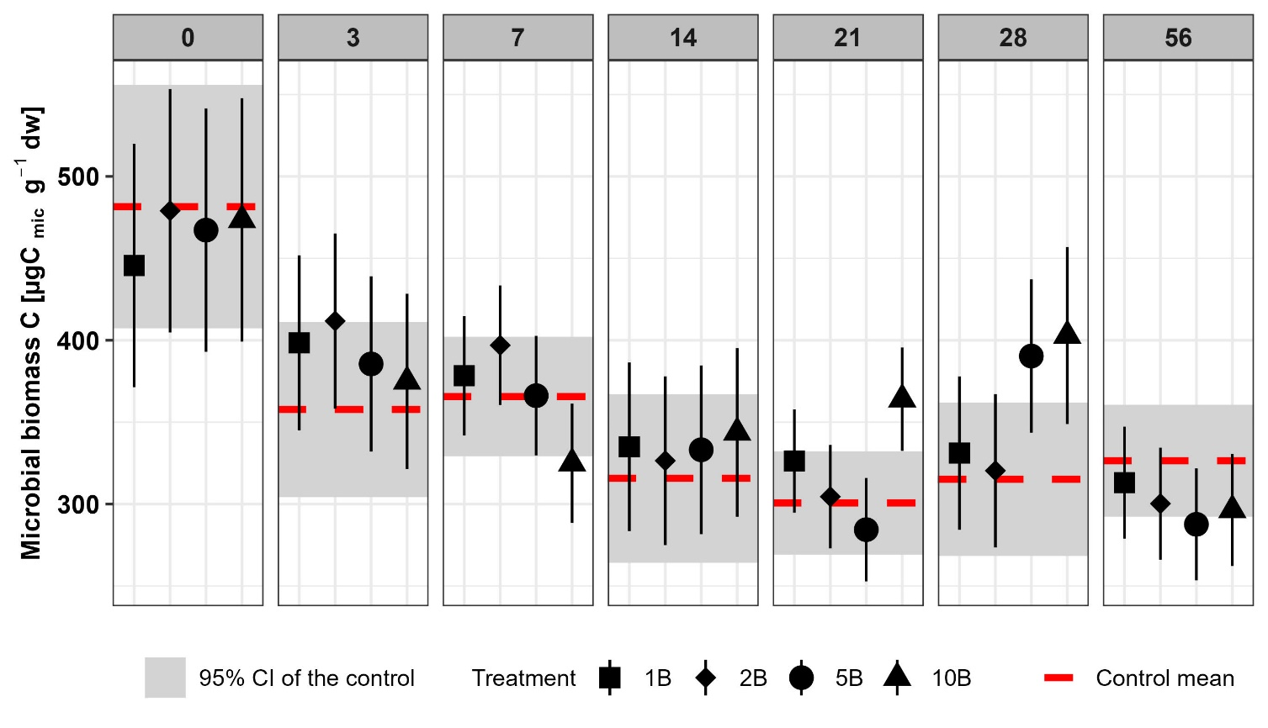
Fig. SI1 Effect of boscalid on microbial biomass C (C_{mic}) on all sampling days. Symbols indicate estimated marginal means with 95% confidence interval as error bars of boscalid (B) treated soils (1xPEC: 1B, 2xPEC: 2B, 5xPEC: 5B and 10xPEC: 10B). Red dotted lines indicate the estimated marginal mean and the grey rectangles the 95% confidence intervals of the control soil
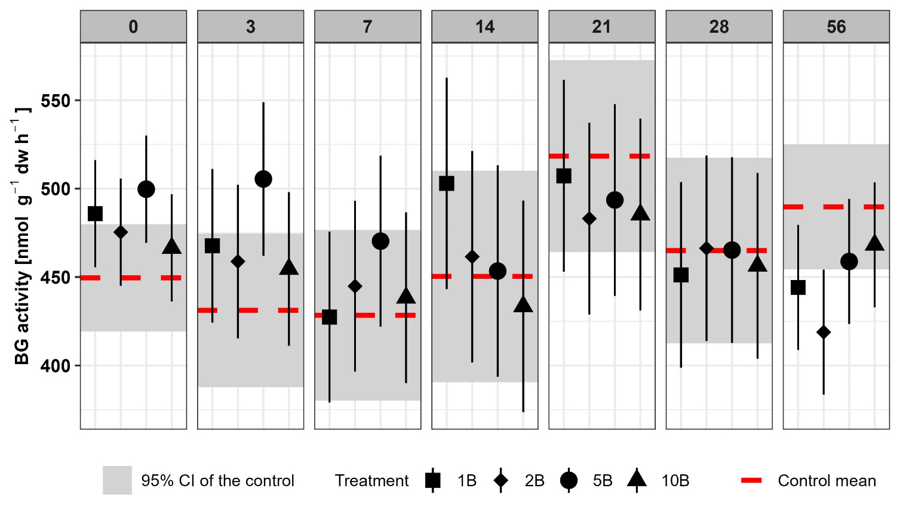
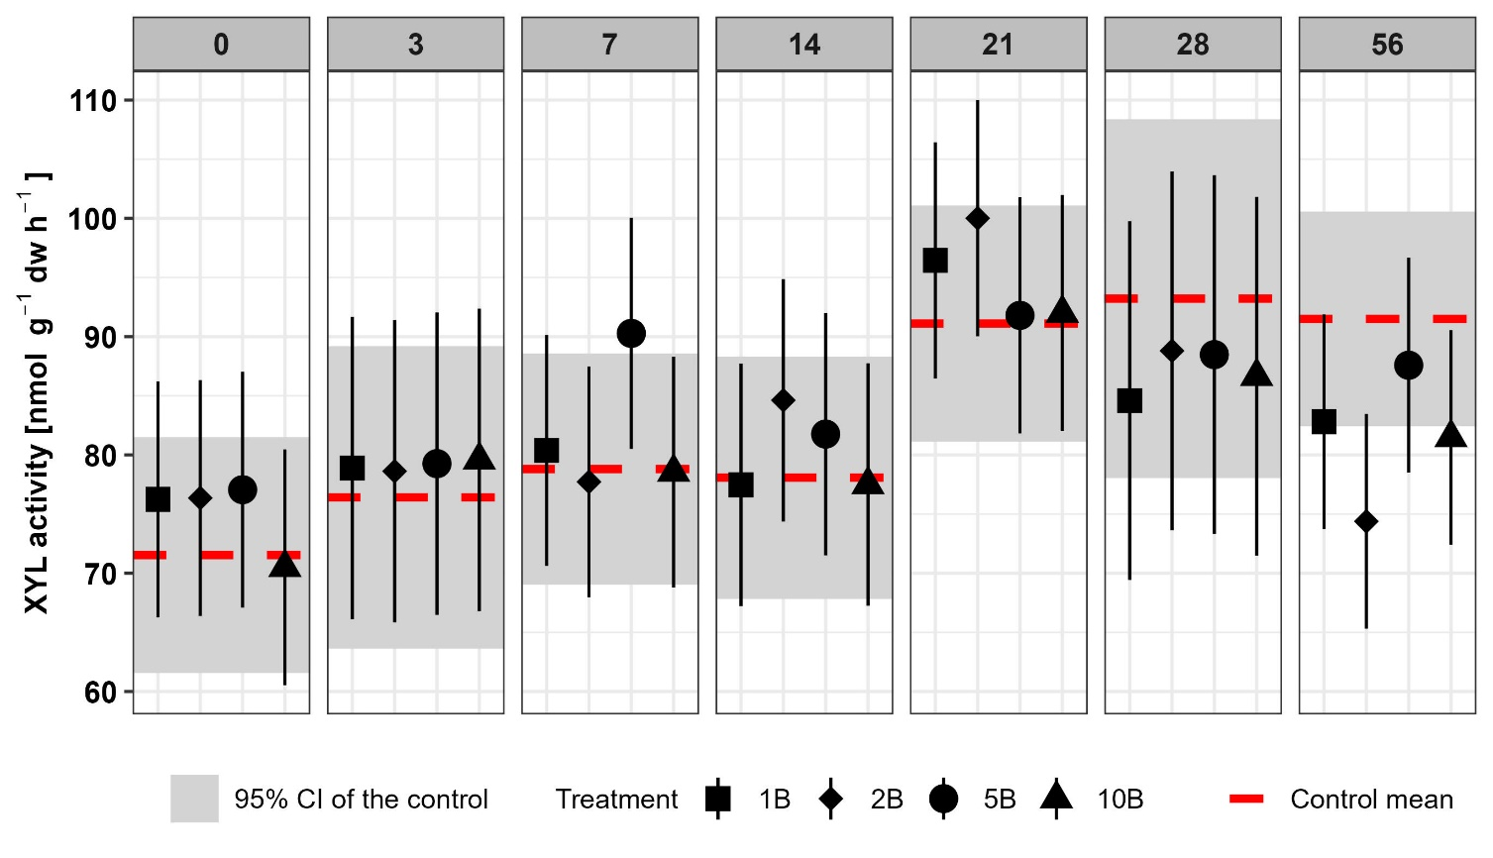
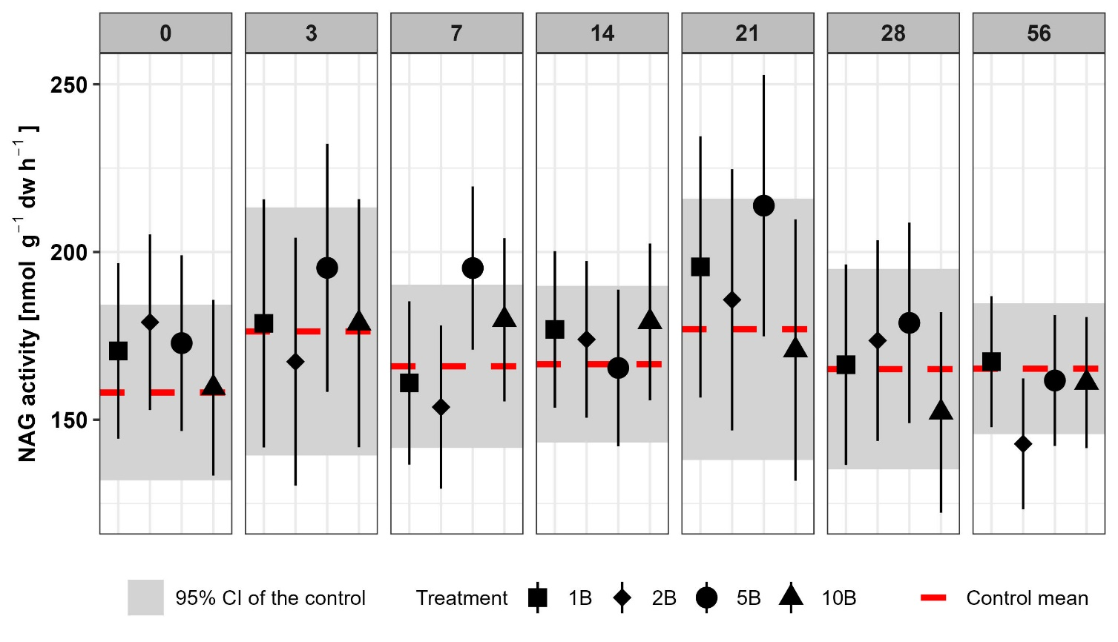
c)
b)
a)
Fig SI2 Effect of boscalid (B) on enzyme activities of β-glucosidase (a), β-xylosidase (b) and N-acetyl-β-glucosaminidase (c) on all sampling days. Symbols indicate estimated marginal means with 95% confidence interval as error bars of boscalid treated soils (1xPEC: 1B, 2xPEC: 2B, 5xPEC: 5B and 10xPEC: 10B). Red dotted lines indicate the estimated marginal mean and the grey rectangle the 95% confidence interval of the control soil
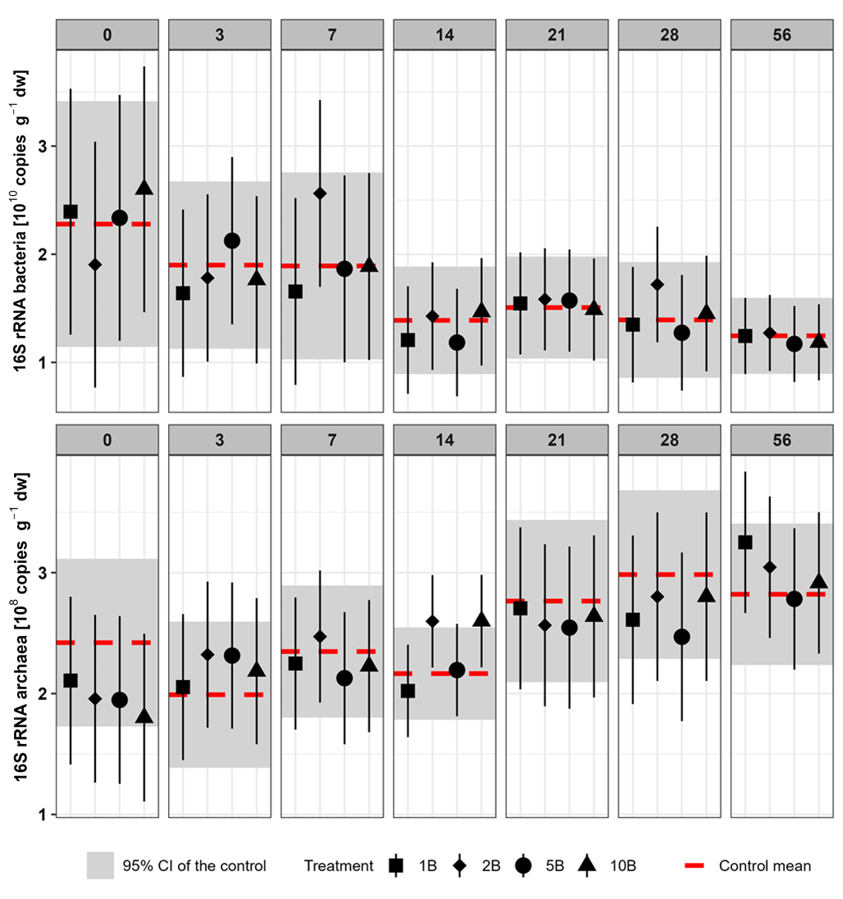
b)
a)
Fig. SI3 Effect of boscalid (B) on abundances of 16S rRNA bacteria (a) and archaea (b) on all sampling days. Symbols represent estimated marginal means with 95% confidence interval as error bars of boscalid treated soils (1xPEC: 1B, 2xPEC: 2B, 5xPEC: 5B and 10xPEC: 10B). Red dotted lines indicate the estimated marginal mean and the grey rectangle the 95% confidence interval of the control soil

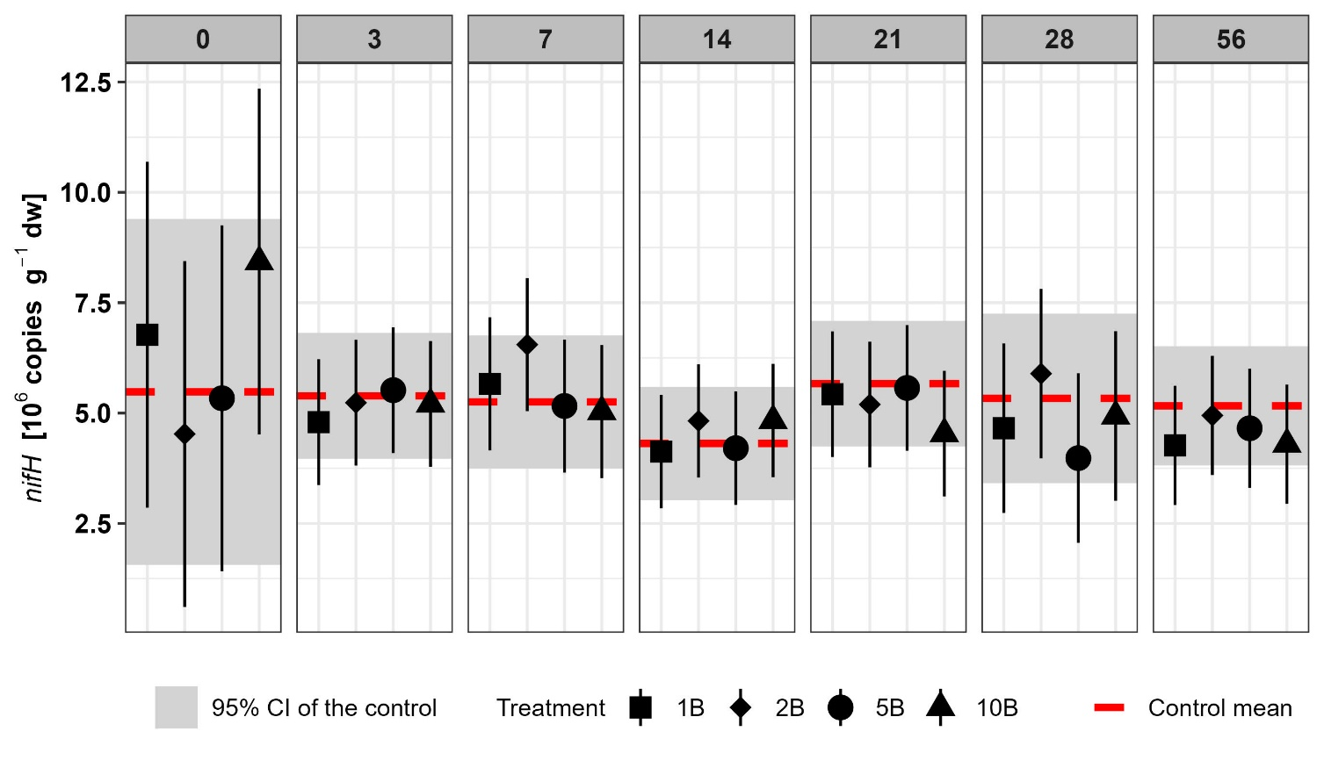
Fig. SI4 Effect of boscalid (B) on the abundance of nifH on all sampling days. Symbols represent estimated marginal means with 95% confidence interval as error bars of boscalid treated soils (1xPEC: 1B, 2xPEC: 2B, 5xPEC: 5B and 10xPEC: 10B). Red dotted lines indicate the estimated marginal mean and the grey rectangle the 95% confidence interval of the control soil
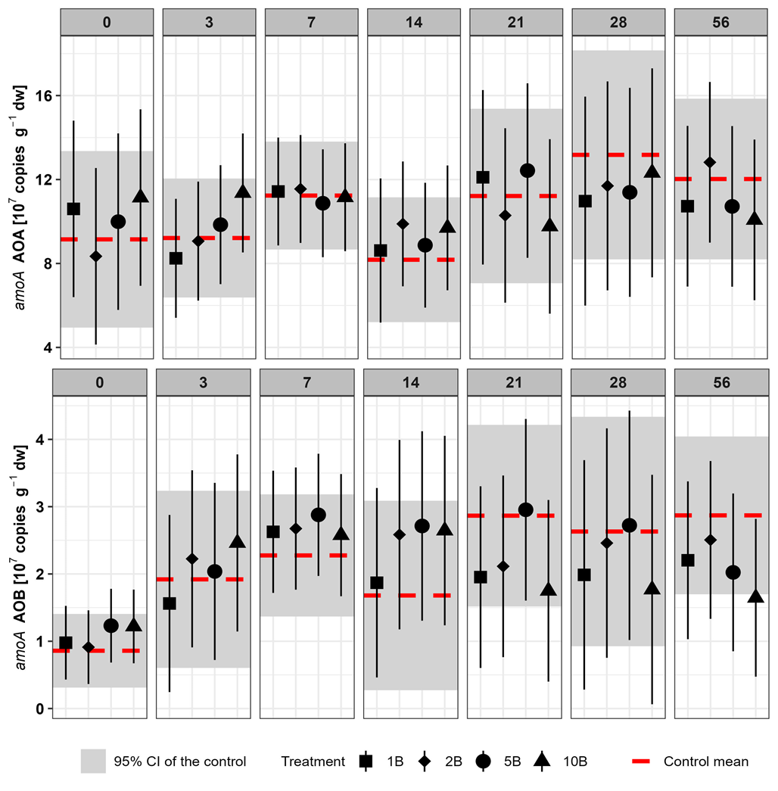
b)
a)
Fig. SI5 Effect of boscalid (B) on abundances of amoA AOA (a) and amoA AOB (b) on all sampling days. Symbols represent estimated marginal means with 95% confidence interval as error bars of boscalid treated soils (1xPEC: 1B, 2xPEC: 2B, 5xPEC: 5B and 10xPEC: 10B). Red dotted lines indicate the estimated marginal mean and the grey rectangle the 95% confidence interval of the control soil
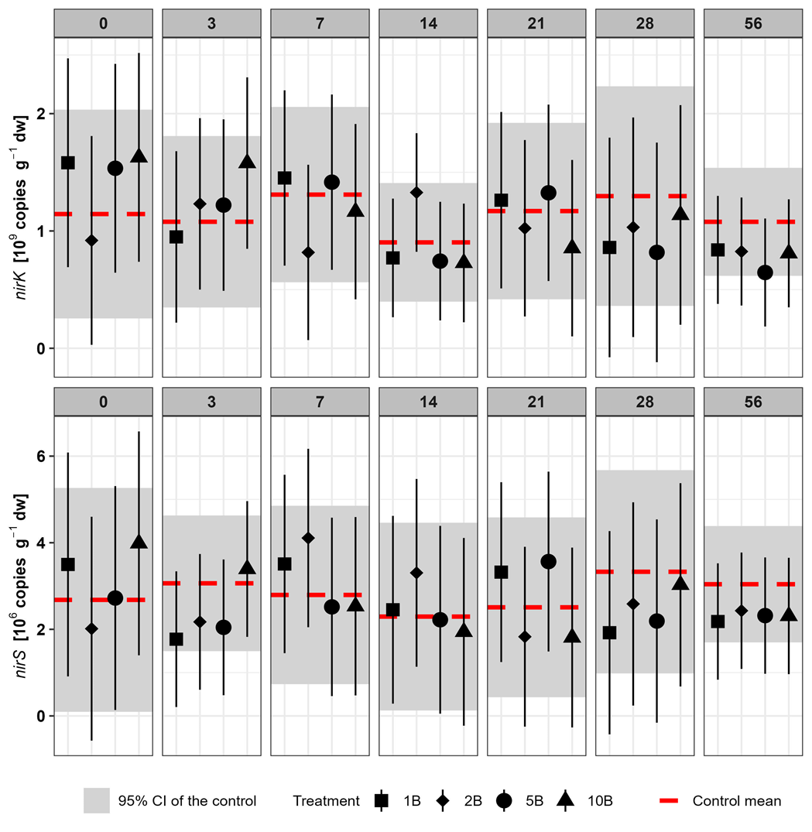
b)
a)
Fig SI6 Effect of boscalid (B) on abundances of nirK (a) and nirS (b) on all sampling days. Symbols represent estimated marginal means with 95% confidence interval as error bars of boscalid treated soils (1xPEC: 1B, 2xPEC: 2B, 5xPEC: 5B and 10xPEC: 10B). Red dotted lines indicate the estimated marginal mean and the grey rectangle the 95% confidence interval of the control soil

References
Bergkemper F, Kublik S, Lang F, Krüger J, Vestergaard G, Schloter M, Schulz S (2016) Novel oligonucleotide primers reveal a high diversity of microbes which drive phosphorous turnover in soil. J Microbiol Methods 125:91–97. https://doi.org/10.1016/j.mimet.2016.04.011
Henry S, Baudoin E, López-Gutiérrez JC, Martin-Laurent F, Brauman A, Philippot L (2004) Quantification of denitrifying bacteria in soils by nirK gene targeted real-time PCR. J Microbiol. Methods 59:327–335. https://doi.org/10.1016/j.mimet.2004.07.002

Leininger S, Urich T, Schloter M, Schwark L, Qi J, Nicol GW, Prosser JI, Schuster SC, Schleper C (2006) Archaea predominate among ammonia-oxidizing prokaryotes in soils. Nature 442:806–809. https://doi.org/10.1038/nature04983
López-Gutiérrez JC, Henry S, Hallet S, Martin-Laurent F, Catroux G, Philippot L (2004) Quantification of a novel group of nitrate-reducing bacteria in the environment by real-time PCR. J Microbiol Methods 57:399–407. https://doi.org/10.1016/j.mimet.2004.02.009
Lueders T, Friedrich M (2000) Archaeal population dynamics during sequential reduction processes in rice field soil. Appl Environ Microbiol 66:2732–2742. https://doi.org/10.1128/AEM.66.7.2732-2742.2000
Manerkar MA, Seena S, Bärlocher F (2008) Q-RT-PCR for assessing archaea, bacteria, and fungi during leaf decomposition in a stream. Microb Ecol 56:467–473. https://doi.org/10.1007/s00248-008-9365-z
Rotthauwe JH, Witzel KP, Liesack W (1997) The ammonia monooxygenase structural gene amoA as a functional marker: molecular fine-scale analysis of natural ammonia-oxidizing populations. Appl Environ Microbiol 63:4704–4712. https://doi.org/10.1128/aem.63.12.4704-4712.1997
Rösch C, Mergel A, Bothe H (2002) Biodiversity of denitrifying and dinitrogen-fixing bacteria in an acid forest soil. Appl Environ Microbiol 68:3818–3829. https://doi.org/10.1128/AEM.68.8.3818-3829.2002
Throbäck IN, Enwall K, Jarvis A, Hallin S (2004) Reassessing PCR primers targeting nirS, nirK and nosZ genes for community surveys of denitrifying bacteria with DGGE. FEMS Microbiol Ecol 49:401–417. https://doi.org/10.1016/j.femsec.2004.04.011
White TJ, Bruns T, Lee S, Taylor J (1990) Amplification and direct sequencing of fungal ribosomal RNA genes for phylogenetics. PCR Protocols. Elsevier, pp315–322. https://doi.org/10.1016/b978-0-12-372180-8.50042-1

