Results

SNP genotyping
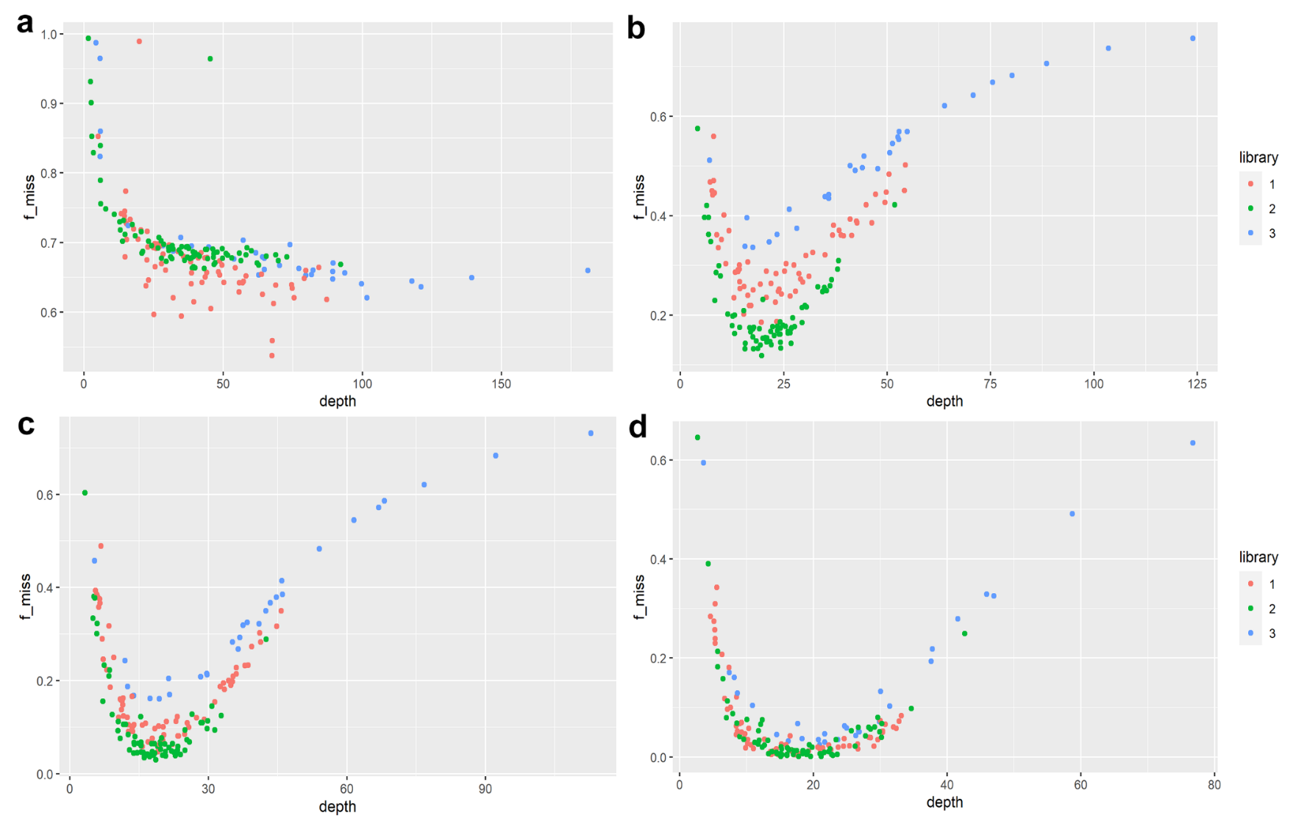
Figure S1. Mean depth per individual (depth) plotted against the individual missingness (f_miss) coloured by library from the raw ALB SNP dataset with 185 individuals (a) and the different filtered data subsets b) 170Indvf8g50m50 c) 170Indvf8g75m25 and d) 170Indvf8g90m10.
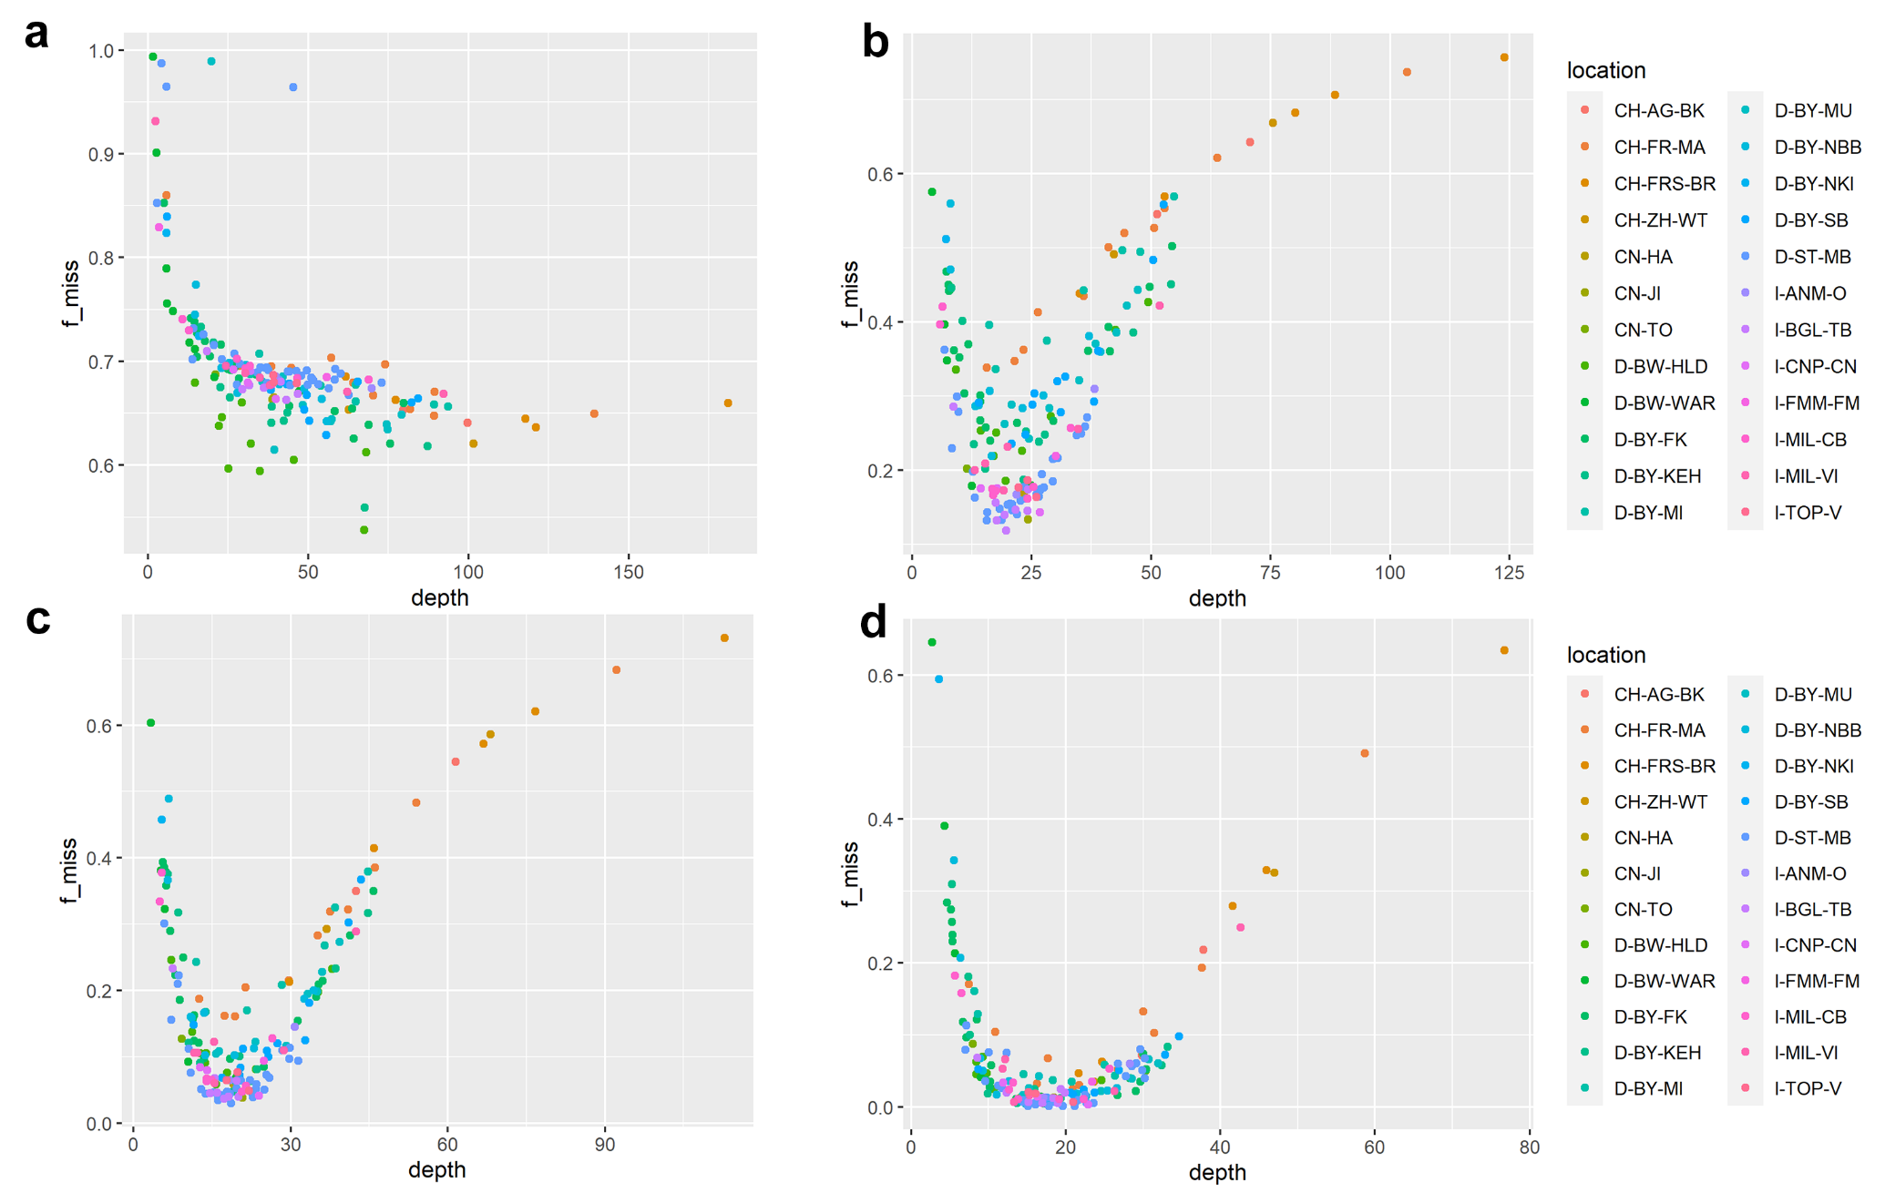
Figure S2. Mean depth per individual (depth) plotted against the individual missingness (f_miss) coloured by location (Pop-ID) from the ALB SNP datasets: raw 185 individuals (a) and the different filtered data subsets b) 170Indvf8g50m50 c) 170Indvf8g75m25 and d) 170Indvf8g90m10.
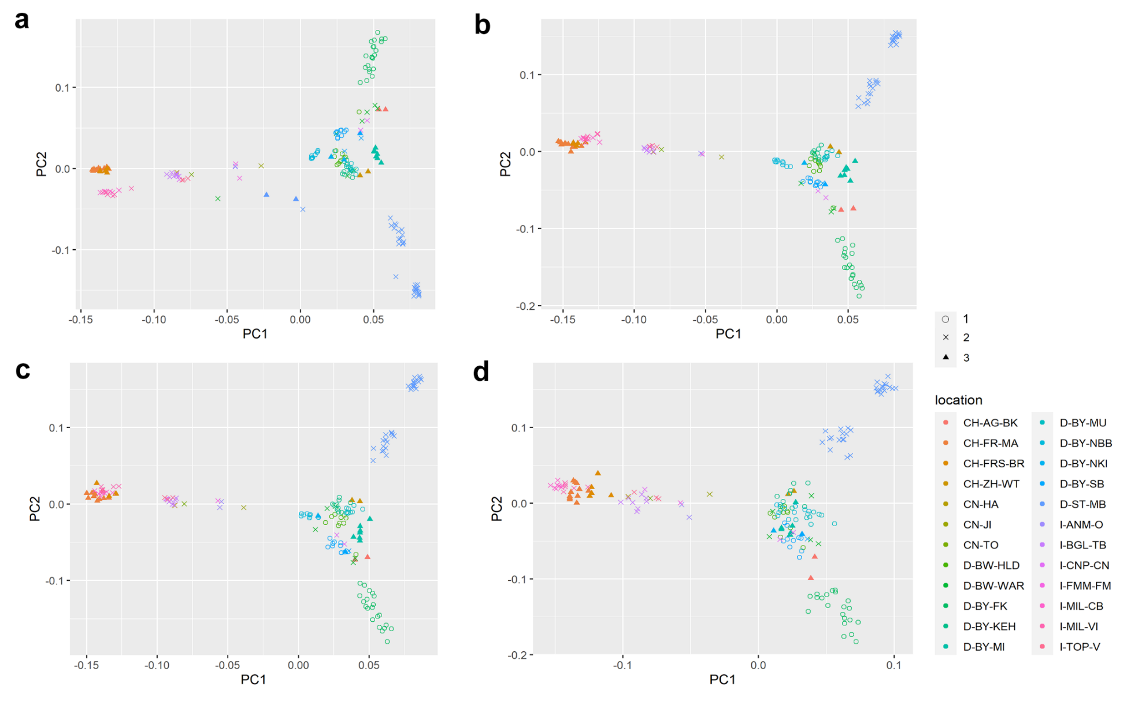
Figure S3. Scatter plot of principal components 1 and 2 coloured by location and shaped by library from the raw ALB SNP dataset with 185 individuals (a) and the different filtered data subsets b) 170Indvf8g50m50 c) 170Indvf8g75m25 and d) 170Indvf8g90m10.

Table S1. SNP and individual count at all filter settings.
VCF-file (.vcf) | SNPs | individuals | setting
GBS-Run1_Variants_raw_All.vcf | 239604 out of 239604 sites | 72 out of 72 | raw data Run1
GBS-Run2_Variants_raw_All.vcf | 128391 out of 128391 sites | 80 out of 80 | raw data Run2
GBS-Run3_Variants_raw_All.vcf | 180962 out of 180962 sites | 33 out of 33 | raw data Run3
Variants_raw_185Indv.vcf | 331191 out of 331191 sites | 185 out of 185 | raw data merged
178Indvf7.recode.vcf | 73364 out of 331191 sites | 178 out of 185 | filter7
170Indvf8.recode.vcf | 64830 out of 64830 sites | 170 out of 178 | filter8, Fmiss cut-off 0.7
170Indvf8g50m50.recode.vcf | 32432 out of 64830 sites | 170 out of 170 | max-missing 0.5
170Indvf8g75m25.recode.vcf | 10226 out of 64830 sites | 170 out of 170 | max-missing 0.75
170Indvf8g90m10.recode.vcf | 922 out of 64830 sites | 170 out of 170 | max-missing 0.9
170Indvf8g99m1.recode.vcf | 0 out of 64830 sites | 170 out of 170 | max-missing 0.99
filter7 (f7) = --minQ 30 --remove-filtered-all --maf 0.01 --mac 3 --max-alleles 2 --min-alleles 2 --min-meanDP 3 --minDP 3 --max-meanDP 55 --min-alleles 2, cut-off 0.9 on F_miss for individuals (--remove <file>); filter8 (f8) = --thin10 on f7-filtered subset; 185Indv = specimen count on the unfiltered merged VCF-file; 178Indv = specimen count after cut-off 0.9 on individual F_miss; 170Indv = specimen count after cut-off 0.7 individual F_miss on f8-filtered subset; g50m50 = genotype call rate 50% and tolerated missingness 50% (analogous for higher genotype rates); All individual counts include D-BY-SB-15-047 as internal control, for GBS-Run2 and GBS-Run3 only once, but in all following VCF-files three times respectively.

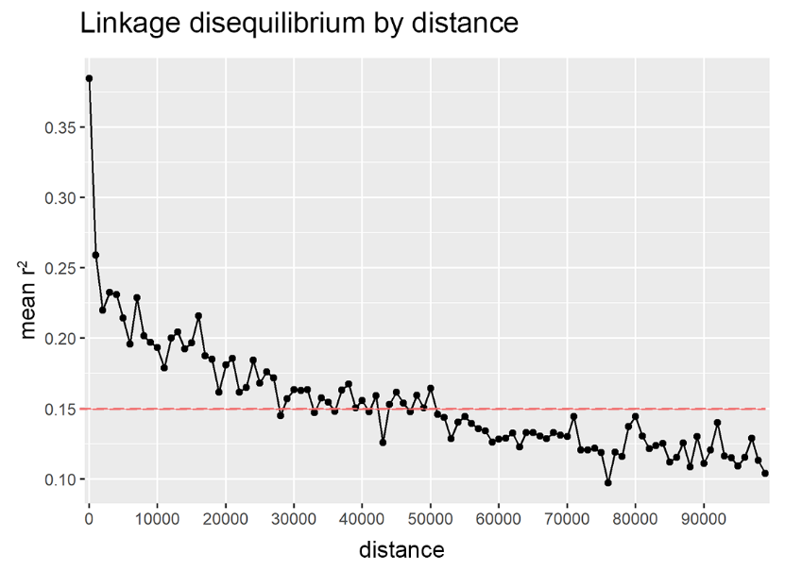
Figure S4. Decay of linkage disequilibrium (LD) with physical distance (0-9.9 kb) on genomic ALB SNP subset 170Indvf8g50m50 (32432 SNPs).
The value of 0.15 of mean-r² (red line) was set as a threshold for linkage equilibrium (LE) and were used to prune the 170Indvf8g50m50 dataset, remaining with 7810 independent SNPs.

Population structure of invasive ALB populations in Europe
Table S2. F_{ST}-matrix – Population differentiation on LD-pruned subset of genomic ALB SNP data with 7810 SNPs conducted in Arlequin v. 3.5.
 | Pop-ID | 1 | 2 | 3 | 4 | 5 | 6 | 7 | 8 | 9 | 10 | 11 | 12 | 13 | 14 | 15
1 | CH-FR-MA | 0.000 | - | + | + | + | + | + | + | + | + | + | + | + | + | +
2 | CH-FRS-BR | 0.015 | 0.000 | + | + | + | + | + | + | + | + | + | + | + | + | +
3 | D-BW-HLD | 0.362 | 0.372 | 0.000 | + | + | + | + | + | + | + | + | + | + | + | +
4 | D-BW-WAR | 0.304 | 0.337 | 0.216 | 0.000 | + | + | + | + | + | + | + | + | + | + | -
5 | D-BY-FK | 0.255 | 0.293 | 0.240 | 0.208 | 0.000 | + | + | + | + | + | + | + | + | + | +
6 | D-BY-KEH | 0.227 | 0.236 | 0.134 | 0.047 | 0.148 | 0.000 | + | + | + | + | + | + | + | + | +
7 | D-BY-MI | 0.377 | 0.411 | 0.255 | 0.295 | 0.311 | 0.203 | 0.000 | + | + | + | + | + | + | + | +
8 | D-BY-MU | 0.271 | 0.293 | 0.274 | 0.217 | 0.229 | 0.184 | 0.268 | 0.000 | + | + | + | + | + | + | +
9 | D-BY-NBB | 0.356 | 0.444 | 0.279 | 0.255 | 0.234 | 0.198 | 0.457 | 0.268 | 0.000 | + | + | + | + | + | +
10 | D-BY-SB | 0.398 | 0.416 | 0.286 | 0.221 | 0.368 | 0.204 | 0.350 | 0.277 | 0.380 | 0.000 | + | + | + | + | +
11 | D-ST-MB | 0.500 | 0.496 | 0.356 | 0.348 | 0.321 | 0.307 | 0.246 | 0.332 | 0.395 | 0.423 | 0.000 | + | + | + | +
12 | I-BGL-TB | 0.100 | 0.093 | 0.269 | 0.165 | 0.127 | 0.090 | 0.259 | 0.198 | 0.281 | 0.287 | 0.385 | 0.000 | + | + | +
13 | I-MIL-CB | 0.495 | 0.561 | 0.537 | 0.472 | 0.439 | 0.372 | 0.610 | 0.462 | 0.578 | 0.571 | 0.487 | 0.351 | 0.000 | + | +
14 | I-MIL-VI | 0.487 | 0.563 | 0.497 | 0.429 | 0.369 | 0.320 | 0.575 | 0.469 | 0.544 | 0.567 | 0.422 | 0.278 | 0.149 | 0.000 | +
15 | out | 0.134 | 0.141 | 0.157 | 0.056 | 0.168 | 0.036 | 0.169 | 0.126 | 0.192 | 0.119 | 0.289 | 0.073 | 0.330 | 0.313 | 0.000
Distance method: pairwise differences. In the lower matrix, the exact F_{ST}-values are shown, while the upper matrix shows if they were significant (+) or not significant (– and red) (110 permutations); significance level = 0.05. Population labels were used as set in Table S5. Black boxes mark F_{ST}-values >0.5, red boxes not significant F_{ST}-values and bold black letters F_{ST}-values >0.25, while bold green letters mark <0.1.

Table S3. p-values to F_{ST}-values – Population differentiation on LD-pruned subset of genomic ALB SNP data with 7810 SNPs conducted in Arlequin v. 3.5.
 | 1 | 2 | 3 | 4 | 5 | 6 | 7 | 8 | 9 | 10 | 11 | 12 | 13 | 14 | 15
1 | * | - | + | + | + | + | + | + | + | + | + | + | + | + | +
2 | 0.12613+-0.0309 | * | + | + | + | + | + | + | + | + | + | + | + | + | +
3 | 0.00000+-0.0000 | 0.00000+-0.0000 | * | + | + | + | + | + | + | + | + | + | + | + | +
4 | 0.00000+-0.0000 | 0.00901+-0.0091 | 0.00901+-0.0091 | * | + | + | + | + | + | + | + | + | + | + | -
5 | 0.00000+-0.0000 | 0.00000+-0.0000 | 0.00000+-0.0000 | 0.00000+-0.0000 | * | + | + | + | + | + | + | + | + | + | +
6 | 0.00000+-0.0000 | 0.00000+-0.0000 | 0.00000+-0.0000 | 0.02703+-0.0194 | 0.00000+-0.0000 | * | + | + | + | + | + | + | + | + | +
7 | 0.00000+-0.0000 | 0.00000+-0.0000 | 0.00000+-0.0000 | 0.00000+-0.0000 | 0.00000+-0.0000 | 0.00000+-0.0000 | * | + | + | + | + | + | + | + | +
8 | 0.00000+-0.0000 | 0.00000+-0.0000 | 0.00000+-0.0000 | 0.00000+-0.0000 | 0.00000+-0.0000 | 0.00000+-0.0000 | 0.00000+-0.0000 | * | + | + | + | + | + | + | +
9 | 0.00000+-0.0000 | 0.00000+-0.0000 | 0.00000+-0.0000 | 0.00000+-0.0000 | 0.00000+-0.0000 | 0.00000+-0.0000 | 0.00000+-0.0000 | 0.00000+-0.0000 | * | + | + | + | + | + | +
10 | 0.00000+-0.0000 | 0.00000+-0.0000 | 0.00000+-0.0000 | 0.00000+-0.0000 | 0.00000+-0.0000 | 0.00000+-0.0000 | 0.00000+-0.0000 | 0.00000+-0.0000 | 0.00000+-0.0000 | * | + | + | + | + | +
11 | 0.00000+-0.0000 | 0.00000+-0.0000 | 0.00000+-0.0000 | 0.00000+-0.0000 | 0.00000+-0.0000 | 0.00000+-0.0000 | 0.00000+-0.0000 | 0.00000+-0.0000 | 0.00000+-0.0000 | 0.00000+-0.0000 | * | + | + | + | +
12 | 0.00000+-0.0000 | 0.01802+-0.0121 | 0.00000+-0.0000 | 0.00000+-0.0000 | 0.00000+-0.0000 | 0.00000+-0.0000 | 0.00000+-0.0000 | 0.00000+-0.0000 | 0.00000+-0.0000 | 0.00000+-0.0000 | 0.00000+-0.0000 | * | + | + | +
13 | 0.00000+-0.0000 | 0.00000+-0.0000 | 0.00000+-0.0000 | 0.00000+-0.0000 | 0.00000+-0.0000 | 0.00000+-0.0000 | 0.00000+-0.0000 | 0.00000+-0.0000 | 0.00000+-0.0000 | 0.00000+-0.0000 | 0.00000+-0.0000 | 0.00000+-0.0000 | * | + | +
14 | 0.00000+-0.0000 | 0.00901+-0.0091 | 0.00000+-0.0000 | 0.00000+-0.0000 | 0.00000+-0.0000 | 0.00000+-0.0000 | 0.00000+-0.0000 | 0.00000+-0.0000 | 0.00000+-0.0000 | 0.00000+-0.0000 | 0.00000+-0.0000 | 0.00000+-0.0000 | 0.00901+-0.0091 | * | +
15 | 0.00000+-0.0000 | 0.01802+-0.0121 | 0.00000+-0.0000 | 0.10811+-0.0264 | 0.00000+-0.0000 | 0.01802+-0.0121 | 0.00000+-0.0000 | 0.00000+-0.0000 | 0.00000+-0.0000 | 0.00000+-0.0000 | 0.00000+-0.0000 | 0.01802+-0.0121 | 0.00000+-0.0000 | 0.00000+-0.0000 | *
110 permutations, 1-15 represent the Pop-IDs shown in 2 in the same order. Population labels were used as set in Table S5. Values not falling below the significance level of 0.05 are marked in red.

Table S4. Eigenvalues from PCA analysis performed in PLINK v. 1.9 on LD-pruned 170Indvf8g50m50 subset of genomic ALB SNP-Data.
PC | Eigenvalues | % variance explained
1 | 25.785 | 17.513
2 | 16.198 | 11.002
3 | 13.670 | 9.284
4 | 10.155 | 6.897
5 | 9.597 | 6.518
6 | 8.883 | 6.033
7 | 7.812 | 5.306
8 | 7.601 | 5.163
9 | 6.958 | 4.726
10 | 5.711 | 3.879
11 | 4.750 | 3.226
12 | 4.109 | 2.791
13 | 3.878 | 2.634
14 | 3.363 | 2.284
15 | 3.135 | 2.130
16 | 3.042 | 2.066
17 | 2.315 | 1.572
18 | 2.277 | 1.547
19 | 2.166 | 1.471
20 | 2.033 | 1.380
21 | 1.944 | 1.321
22 | 1.856 | 1.261

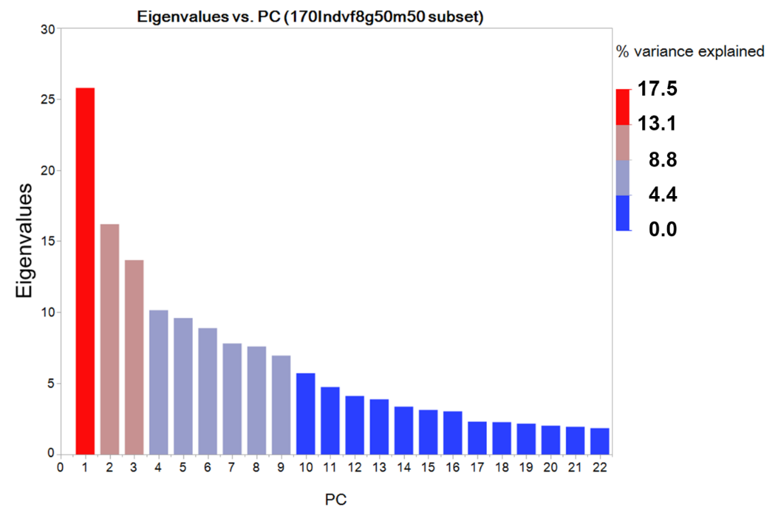
Figure S4. Eigenvalues from PCA analysis performed in PLINK v. 1.9 plotted to the first 22 principal components of the LD-pruned 170Indvf8g50m50 subsets of genomic ALB SNPs.

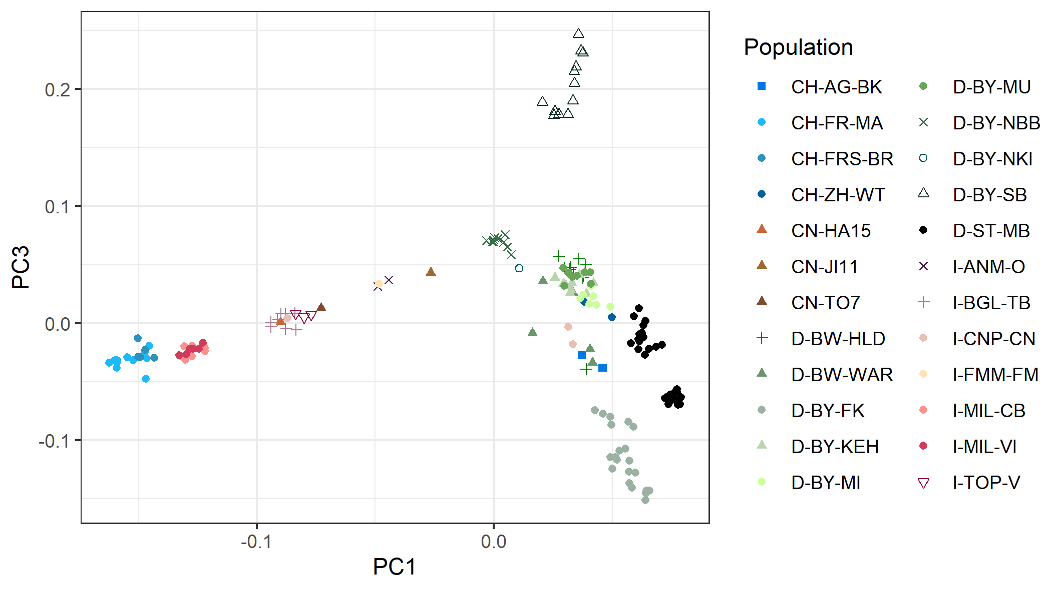
Figure S5. Scatter plot of principal components PC1 (17.513%) and PC3 (9.284%) on the LD-pruned subset 170Indvf8g50m50 of genomic ALB SNP data.

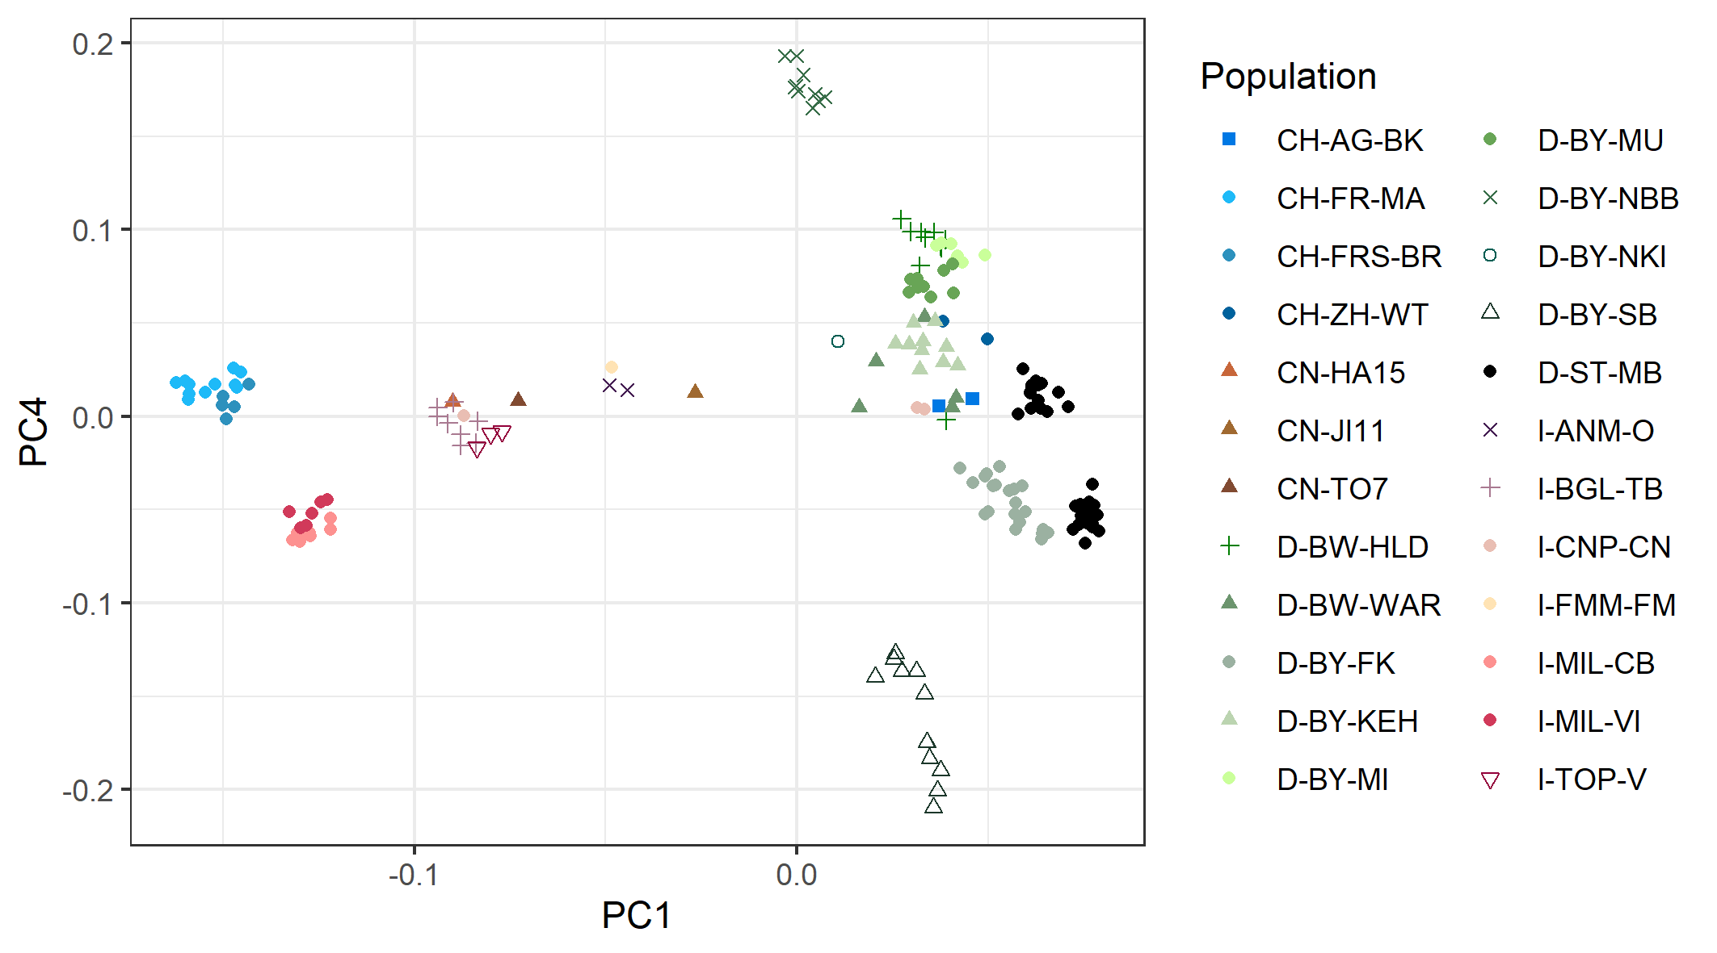
Figure S6. Scatter plot of principal components PC1 (17.513%) and PC4 (6.897%) on the LD-pruned subset 170Indvf8g50m50 of genomic ALB SNP data.

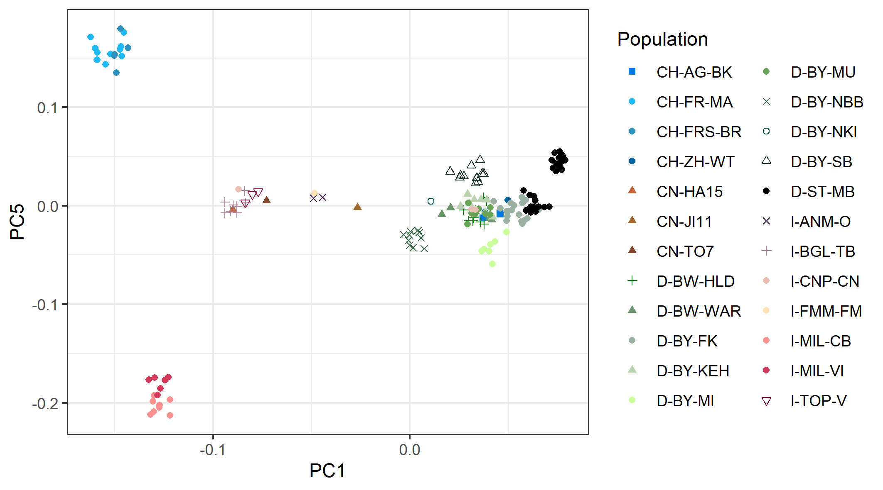
Figure S7. Scatter plot of principal components PC1 (17.513%) and PC5 (6.518%) on the LD-pruned subset 170Indvf8g50m50 of genomic ALB SNP data.

Ancestry of European invasive ALB populations
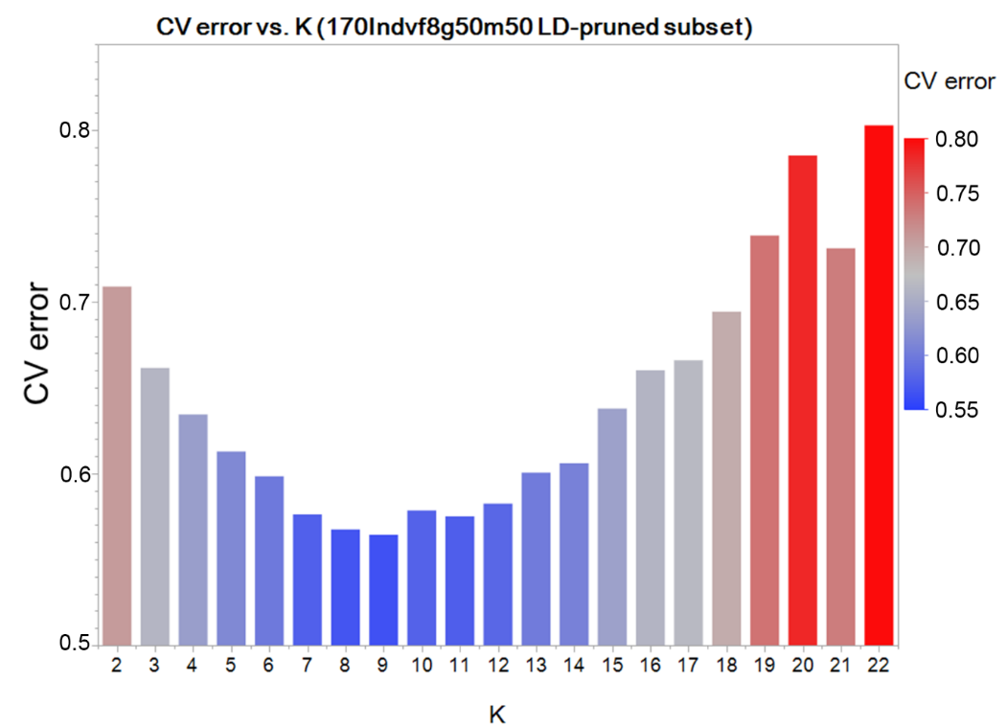
Figure S8. Cross-validation errors to choose the right K-value on the ancestry in the LD-pruned 170Indvf8g50m50 ALB SNP data subset conducted in ADMIXTURE v. 1.3.0.

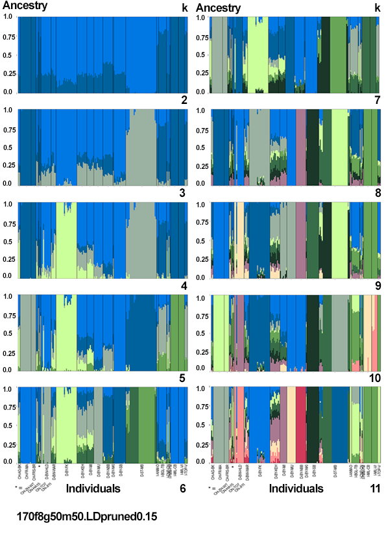
Figure S9. Analysis of Ancestry of 170 ALB samples from Switzerland, China, Germany and Italy conducted in ADMIXTURE v. 1.3.0; sequential K = 2 to K = 9; 7810 SNPs.
The LD-pruned ALB SNP subset 170Indvf8g50m50 was analysed here.

Methods

Sampling of Asian long-horned beetle (ALB)
Table S5. ALB collection sites (alphabetically) used in this study. – (1/2)
Country | State / province |  | Location |  | Lat Long | Year(s) | Pop-ID |  | n
Switzerland (CH) | Aargau (AG) |  | Berikon (BK) |  | 47.349900, 8.373270 | 2015 | CH-AG-BK |  | 2
Switzerland (CH) | Freiburg (FR) |  | Marly (MA) |  | 46.776089, 7.164610 | 2014 | CH-FR-MA |  | 12
Switzerland (CH) | Freiburg Sense (FRS) |  | Brünsried (BR) |  | 46.759570, 7.278770 | 2013 | CH-FRS-BR |  | 5
Switzerland (CH) | Zürich (ZH) |  | Winterthur (WT) |  | 47.499880, 8.726160 | 2012 | CH-ZH-WT |  | 2
China (CN) | Heilongjiang |  | Harbin (HA) |  | 45.803776, 126.534966 | 2016 | CN-HA |  | 1
China (CN) | Shangdong |  | Jinan (JI) |  | 36.651199, 117.120094 | 2016 | CN-JI |  | 1
China (CN) | Inner Mongolia |  | Tongliao (TO) |  | 43.621910, 122.268051 | 2016 | CN-TO |  | 1
Germany (D) | Baden-Württemberg (BW) |  | Hildrizhausen (HLD) |  | 48.625221, 8.966090 | 2016 | D-BW-HLD |  | 10
Germany (D) | Baden-Württemberg (BW) |  | Weil am Rhein (WAR) |  | 47.592419, 7.613150 | 2015 | D-BW-WAR |  | 9
Germany (D) | Bavaria (BY) |  | Feldkirchen (FK) |  | 48.147380, 11.730140 | 2013, 2014 | D-BY-FK |  | 18
Germany (D) | Bavaria (BY) |  | Feldkirchen Riem (FKR) |  | 48.140630, 11.683950 | 2016 | D-BY-FK |  | 4
Germany (D) | Bavaria (BY) |  | Kelheim (KEH) |  | 48.918610, 11.872230 | 2016 | D-BY-KEH |  | 10
Germany (D) | Bavaria (BY) |  | Miesbach (MI) |  | 47.789420, 11.833550 | 2019 | D-BY-MI |  | 7
Germany (D) | Bavaria (BY) |  | Murnau (MU) |  | 47.677410, 11.200950 | 2017 | D-BY-MU |  | 10
Germany (D) | Bavaria (BY) |  | Neubiberg (NBB) |  | 48.076910, 11.657100 | 2014 | D-BY-NBB |  | 10
Germany (D) | Bavaria (BY) |  | Neukirchen am Inn (NKI) |  | 48.519482, 13.372620 | 2012 | D-BY-NKI |  | 2
Germany (D) | Bavaria (BY) |  | Schönebach (SB) |  | 48.308160, 10.578670 | 2015, 2018 | D-BY-SB |  | 11
Table S5. ALB collection sites (alphabetically) used in this study. – (2/2)
Country | State / province |  | Location |  | Lat Long | Year(s) | Pop-ID |  | n
Germany (D) | Saxsony-Anhalt (ST) |  | Magdeburg (MB) |  | 52.131672, 11.640320 | 2015, 2018, 2019 | D-ST-MB |  | 35
Italy (I) | Ancona-Marche (ANM) | Ostra (O) |  | 43.614850, 13.159240 |  | 2017 |  | I-ANM-O |  | 2
Italy (I) | Bergamo-Lombardia (BGL) | Trescore-Balneario (TB) |  | 45.694910, 9.846540 |  | 2017, 2018 |  | I-BGL-TB |  | 8
Italy (I) | Cuneo-Piemonte (CNP) | Cuneo (CN) |  | 44.384476, 7.542671 |  | 2018 |  | I-CNP-CN |  | 3
Italy (I) | Fermo-Marche (FMM) | Fermo (FM) |  | 43.158875, 13.720088 |  | 2015 |  | I-FMM-FM |  | 2
Italy (I) | Milano-Lombardia (MIL) | Corbetta (CB) |  | 45.469566, 8.918932 |  | 2016, 2017 |  | I-MIL-CB |  | 8
Italy (I) | Milano-Lombardia (MIL) | Vittuone (VI) |  | 45.485081, 8.958650 |  | 2014, 2016 |  | I-MIL-VI |  | 7
Italy (I) | Torino-Piemonte (TOP) | Vaie (V) |  | 45.101662, 7.289800 |  | 2018 |  | I-TOP-V |  | 3
n is the number of specimens per collection site (Pop-ID).

