Impact of added phytase and different dietary InsP6 levels on the structure and core microbiota of the digestive tract in broiler chickens

- Ismael Rubio-Cervantes¹ Stephanie Wolfrum¹, Markus Rodehutscord^{1,2}, Amélia Camarinha-Silva^{1,2}
¹Institute of Animal Science, University of Hohenheim, Stuttgart, Germany
²HoLMiR-Hohenheim Center for Livestock Microbiome Research

Corresponding author: Prof. Dr. Amélia Camarinha Silva, Hohenheim University, Department of Livestock Microbial Ecology (460m), Emil-Wolff-Str. 8, Room 105, +49 711 459 23064 amelia.silva@uni-hohenheim.de

Supplementary information

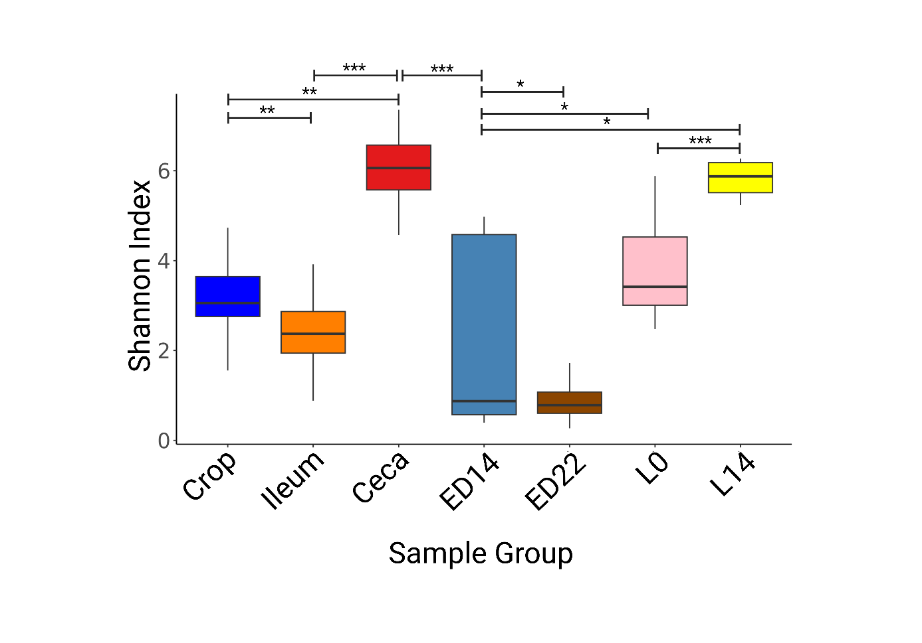
Figure S1: Boxplots based on Shannon index crop, ileum, ceca, ED14, ED22, L0, L14. * p<0.05, ** p<0.01, *** p<0.001.

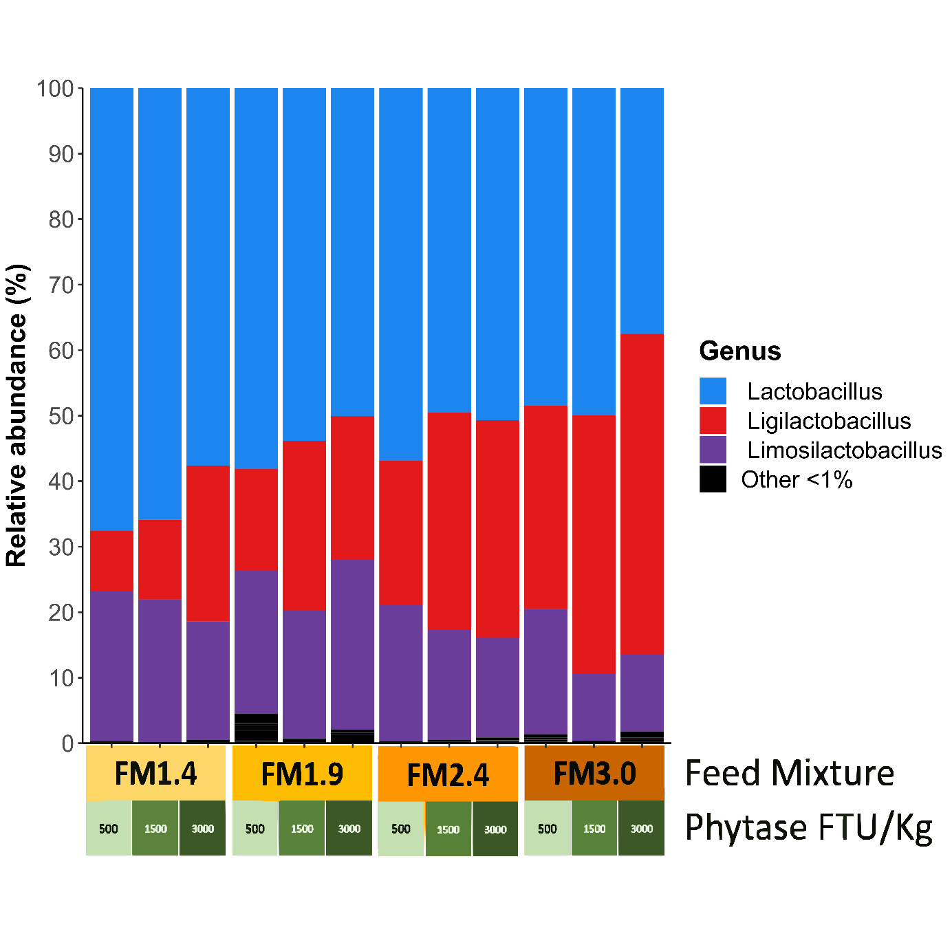

Figure S2: Barplots of the microbiota composition at the genus level across the combinations of FM and phytase, in the crop.

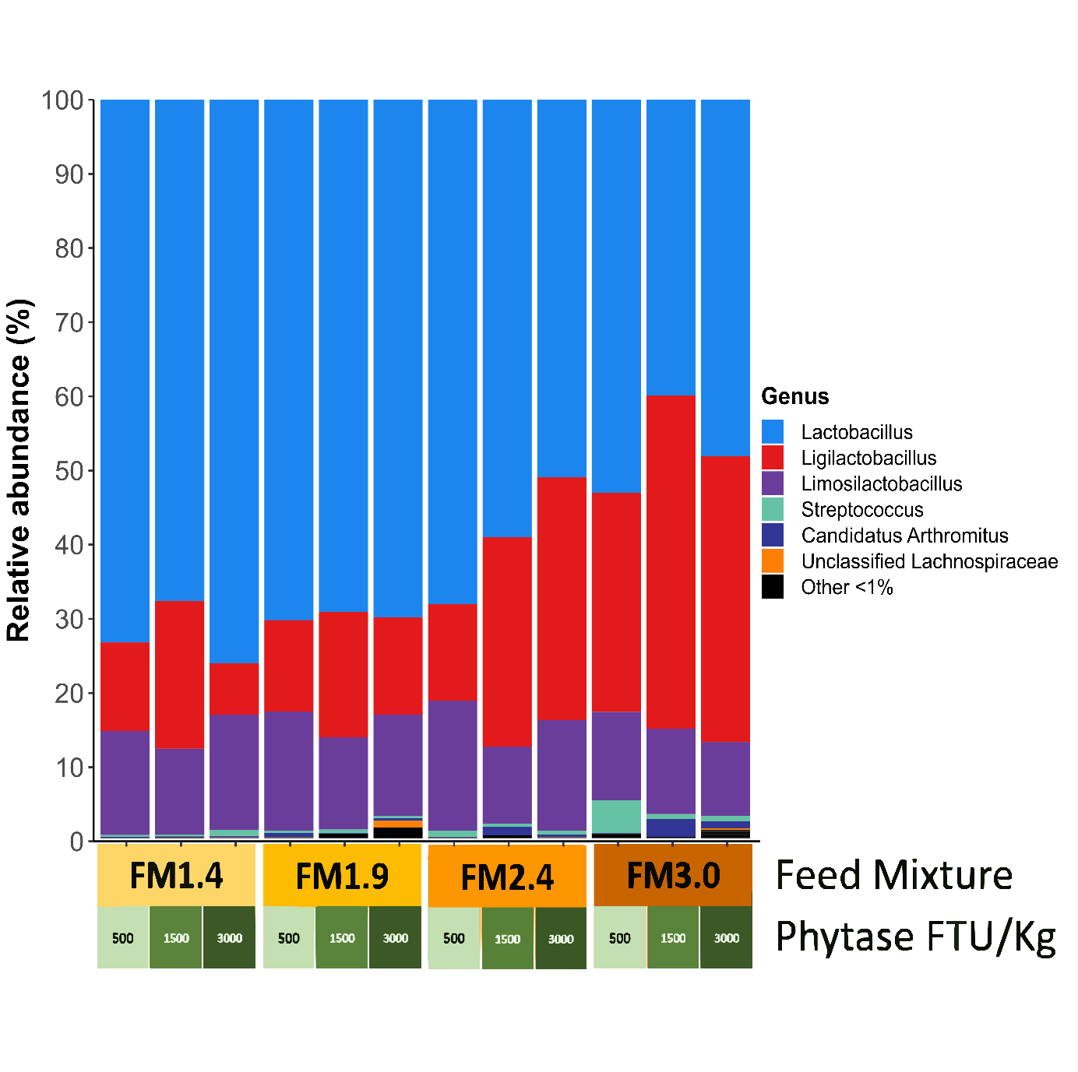Figure S3: Barplots of the microbiota composition at the genus level across the combinations of FM and phytase, in the ileum.

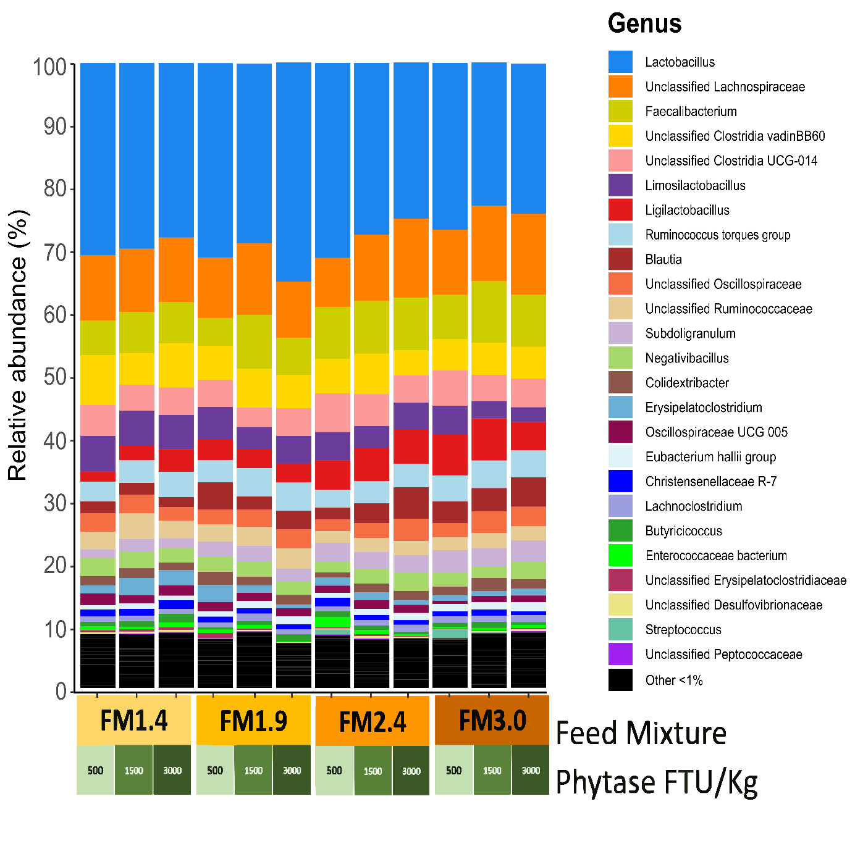
Figure S4: Barplots of the microbiota composition at the genus level across the combinations of FM and phytase, in the ceca.

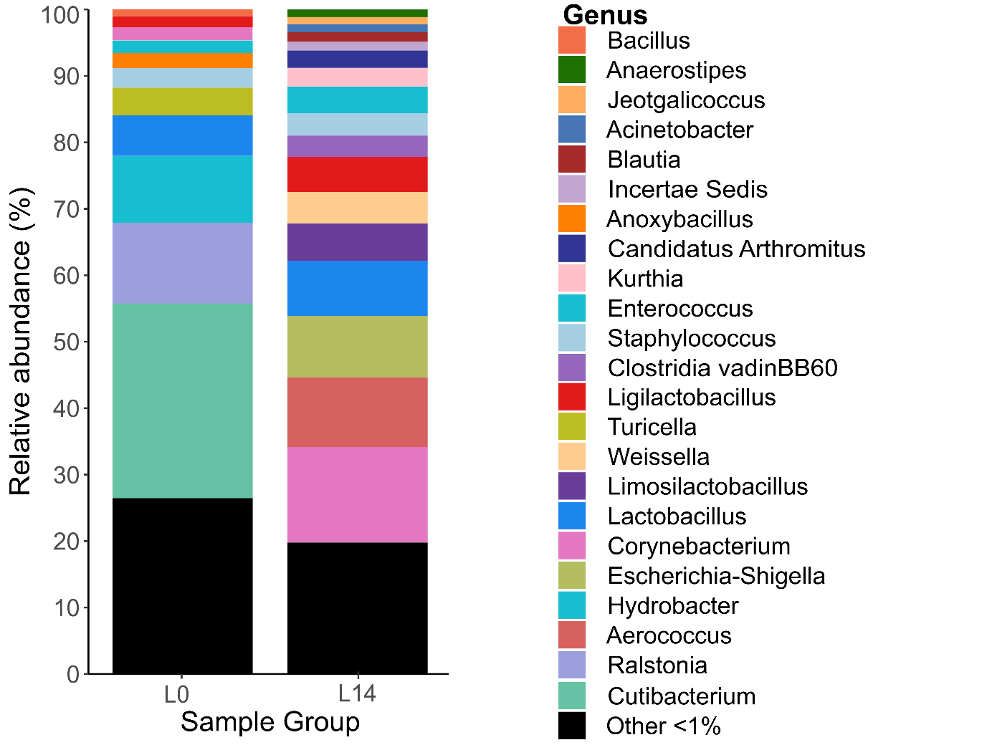
Figure S5: Barplots of the microbiota composition of the L0 and L14 at the genus level.

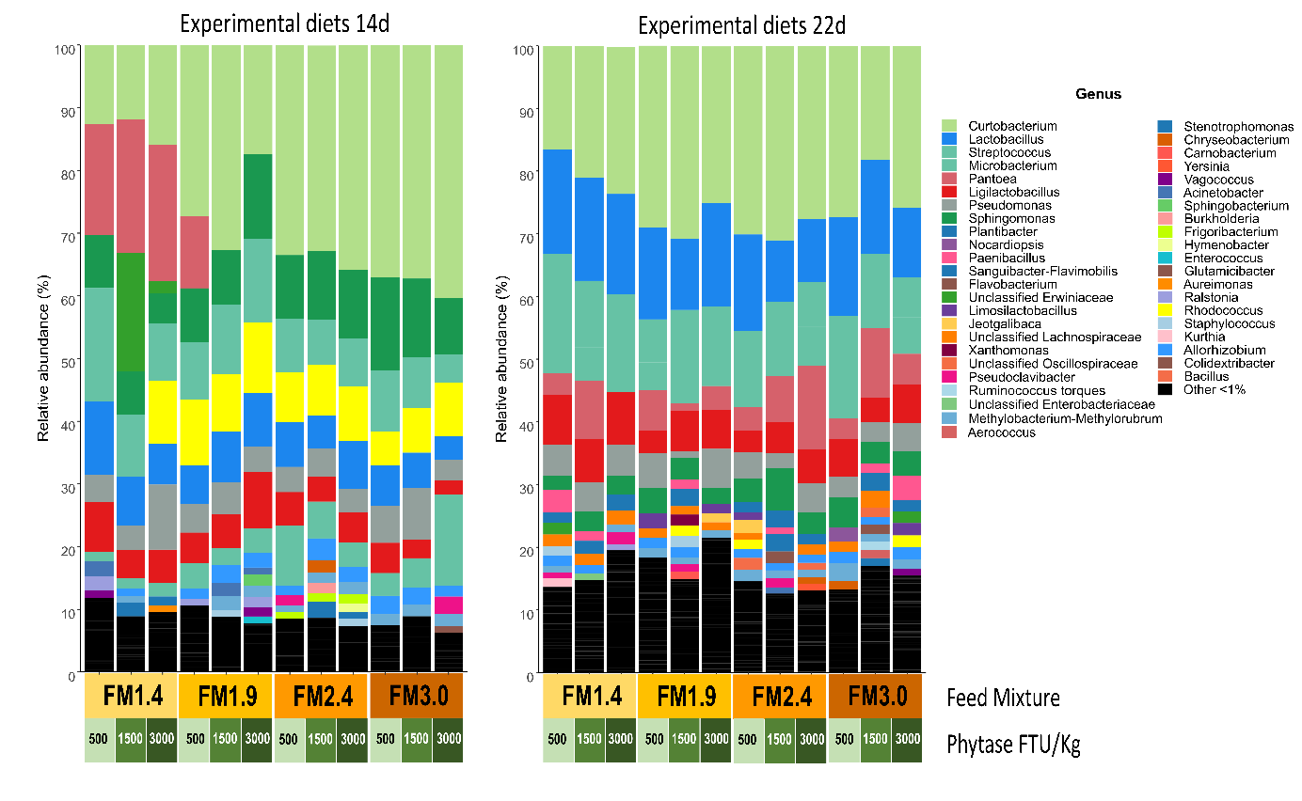
Figure S6: Barplots of the microbiota composition at the genus level across the combinations of FM and phytase, sample groups ED14 and ED22.

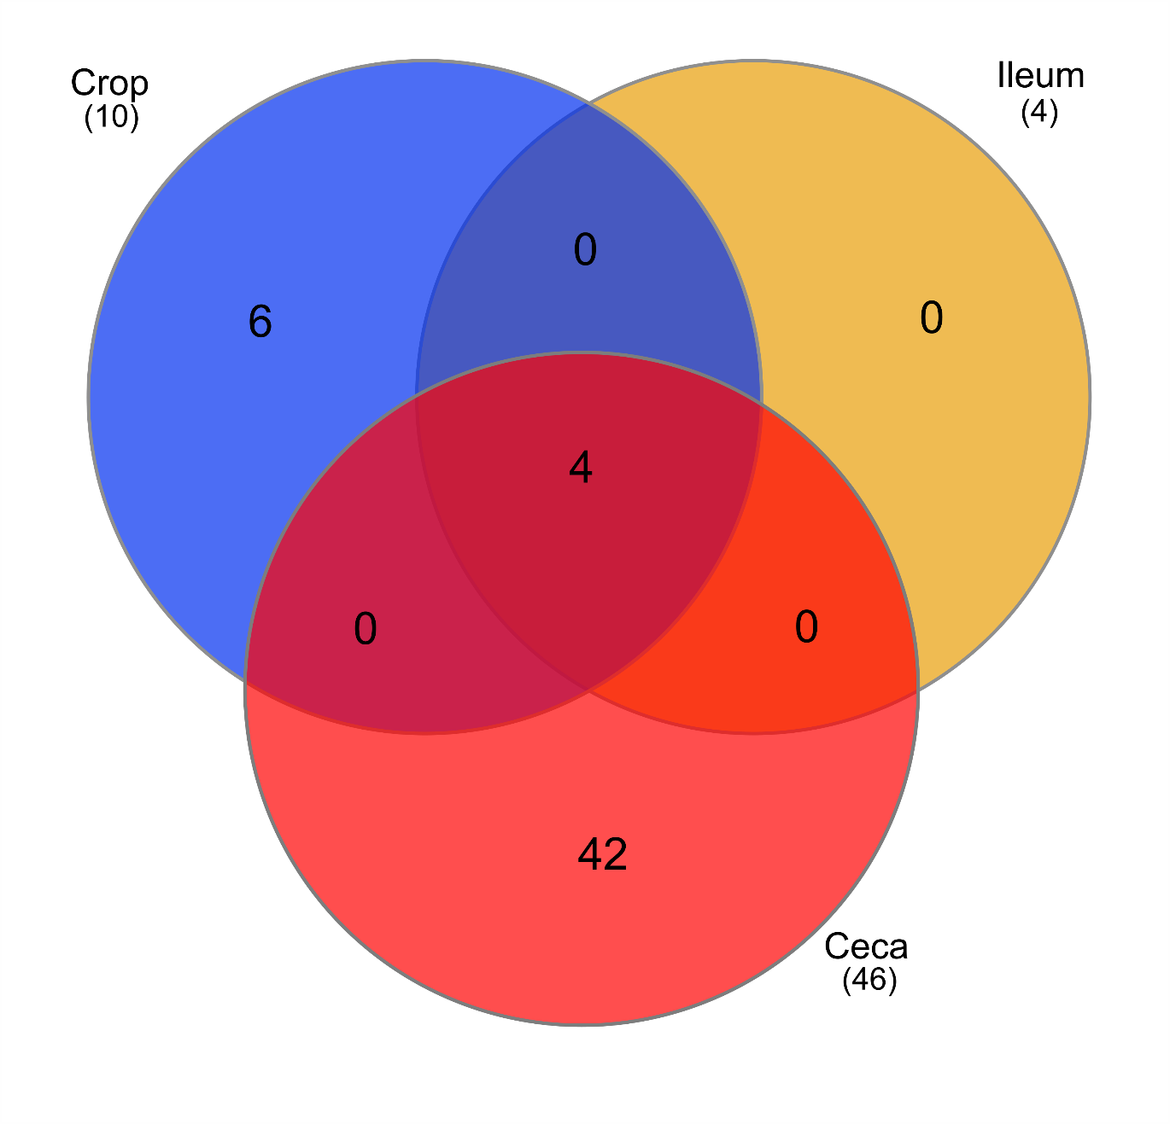Figure S7: Venn diagram showing distribution of the total number of ASVs among GIT sections. The number in parenthesis is the observed number of ASVs in each group. The detection threshold for the core members was set to 0.01% abundance and a prevalence of 80% across all samples.

