Web Appendix
Contents
Web Appendix Table 1: Stakeholder Profiles, including Jobs, Gains, and Pains, derived from Literature on Corporate Ideation Systems 2
Web Appendix Table 2: Summary of Stakeholder Pains and AI Agents 8
Web Appendix Figure 1: The Inspirer in Action 13
Web Appendix Figure 2: The Stylist in Action (Idea Generation) 13
Web Appendix Figure 3: The Stylist in Action (Feedback Formulation) 14
Web Appendix Figure 4: The Matchmaker in Action 14
Web Appendix Figure 5: The Analyst in Action 15
Web Appendix Table 3: Summary of Identified Risks in regard to AI Agents 16

Web Appendix Table 1: Stakeholder Profiles, including Jobs, Gains, and Pains, derived from Literature on Corporate Ideation Systems
Stakeholder | Jobs | Gains | Challenges | Systematization of challenges into pains
 |  |  |  | Creativity  Pain | Content  formulation pain | Search pain | Analytical Pain | Administration Pain
Idea manager/ moderator | Platform management and maintenance (Vanharanta, 2018); formulate ideation strategy (Beretta, Björk and Magnusson, 2018; Beretta et al., 2021); formulate feedback policy (Boënne, Leten and Van Dyck, 2023); formulate evaluation policy (Beretta et al., 2019; 2021); set rewarding policy (Gerlach and Brem, 2017); initiate innovation topics/campaigns (Kruft et al., 2019); describe the campaign including problem statement/formulation (Campos-Blázquez et al., 2020); guide discussions (Zhu et al., 2019); provide idea feedback (Zhu et al., 2019); match ideas with synergistic content (Zhu et al., 2019); manage idea evaluation process (Beretta, Björk and Magnusson, 2018); promote the program, assess it against appropriate KPIs, and report it to the management (Gerlach and Brem, 2017); train employees (Vanharanta, 2018) | Job success in form of high quantity and quality of ideas (Vanharanta, 2018 ) | Campaigns/topics for ideation are too narrowly defined rather focusing on incremental topics (Malhotra et al., 2017; Beretta et al., 2021) or they are too openly formulated (Benbya and Leidner, 2018) |  | x |  | x
Idea manager/ moderator |  |  | Lack of transformational leadership language (Becker et al., 2022) |  | (x)  challenge likely stems from idea manager’s /moderator’s content formulation pain
Idea manager/ moderator |  |  | Potential lack of constructive, integrative and/or diverse feedback (Zhu et al., 2019) |  | (x)  challenge likely stems from idea manager’s /moderator’s content formulation pain |  | (x)  challenge likely stems from idea manager’s /moderator’s analytical pain
Idea manager/ moderator |  |  | Idea selection bias towards incremental solution (Beretta, Björk and Magnusson, 2018) |  |  |  | x

Stakeholder | Jobs | Gains | Challenges | Systematization of challenges into pains
 |  |  |  | Creativity  Pain | Content  formulation pain | Search pain | Analytical Pain | Administration Pain
Idea generator | Find idea topic (Beretta, Björk and Magnusson, 2018); find ideation team (Deichmann and Jensen, 2018); generate and properly formulate ideas (Gamber, Kruft and Kock, 2022; Vanharanta, 2018); test and validate solutions (Deichmann, Gillier and Tonellato, 2021; Vanharanta, 2018); refine and revise ideas (e.g., Chen, Magnusson and Björk, 2023; Gamber, Kruft and Kock, 2022; Boënne, Leten and Van Dyck, 2023); respond to comments from peers ( Chen, Magnusson and Björk, 2022; Gamber, Kruft and Kock, 2022; Zhu et al., 2019); propagate one’s idea (Gamber, Kruft and Kock, 2022) | Compensation (e.g., idea reward or part of salary) (e.g., Campos-Blázquez et al., 2020; Gernreich, 2018; Kruft and Kock, 2021; Ruiz and Beretta, 2021; Schweisfurth and Dharmawan, 2019; Vanharanta, 2018); experience (Boënne, Leten and Van Dyck, 2023; Deichmann and van den Ende, 2014) recognition and reputation (Boënne, Leten and Van Dyck, 2023; Campos-Blázquez et al., 2020; Deichmann and van den Ende, 2014; Gallus, Jung and Lakhani, 2020); workplace improvement (Gernreich, 2018; Vanharanta, 2018); resources for idea implementation (Boënne, Leten and Van Dyck, 2023) | Increased convergent thinking and less radical ideas due to focused ideation and rewards (Beretta, Björk and Magnusson, 2018) or expert knowledge (Zuchowski, 2016) | x
Idea generator |  |  | Lack of literacy skills (Gernreich, 2018) |  | (x)  challenge likely causes idea generator’s content formulation pain
Idea generator |  |  | Lack of knowledge or network connections (Beretta, Björk and Magnusson, 2018; Gernreich, 2018) |  |  | (x)  challenge likely causes idea generator’s search pain
Idea generator |  |  | Lack of skills to properly use the system (Gernreich, 2018) |  |  |  |  | x
Idea generator |  |  | Negative or unproper idea feedback (Gernreich, 2018); unconstructive idea feedback (Gernreich, 2018); delayed up to missing feedback ( Beretta, Björk and Magnusson, 2018; Malhotra et al., 2017; Malhotra et al., 2020) |  | (x)  challenge likely stems from idea evaluator’s or  contributor’s content formulation pain |  | (x)  challenge likely stems from idea evaluator’s or contributor’s analytical pain

Stakeholder | Jobs | Gains | Challenges | Systematization of challenges into pains
 |  |  |  | Creativity  Pain | Content  formulation pain | Search pain | Analytical Pain | Administration Pain
Idea evaluator | Screen, categorize and filter ideas (Campos-Blázquez et al., 2020; Kruft et al., 2019); collect or calculate further details on idea (Deichmann, Gillier and Tonellato, 2021; Vanharanta, 2018); test idea (prototyping) (Deichmann, Gillier and Tonellato, 2021); review ideas and decide to move idea forward or implement it (e.g., Boënne, Leten and Van Dyck, 2023; Deichmann and Jensen, 2018; Deichmann, Gillier and Tonellato, 2021; Kruft and Kock, 2021; Schweisfurth and Dharmawan, 2019) | Compensation by salary (part of daily job) (Vanharanta, 2018); employee engagement, empowerment and satisfaction (Malhotra et al., 2017); collaboration across departments (Deichmann, Gillier and Tonellato, 2021) | unproper formulated idea or low quality in idea formulation (Vanharanta, 2018) |  | (x)  challenge likely stems from idea generator’s content formulation pain
Idea evaluator |  |  | Information scarcity in idea description  (Beretta, 2019; Vanharanta, 2018; Kruft et al., 2019) |  |  | (x)  challenge likely stems from idea generator’s search  pain | (x)  challenge likely stems from idea generator’s analytical  pain
Idea evaluator |  |  | Idea selection bias (Asplund, Björk and Magnusson, 2022; Beretta, Björk and Magnusson, 2018; Chen, Magnusson and Björk, 2023; Kruft et al., 2019) |  |  |  | x
Idea evaluator |  |  | Issues in assessing idea novelty and value (Benbya and Leidner, 2018) |  |  |  | x
Idea evaluator |  |  | Idea selection decision involving many constraints which delays the process (e.g., budget, functional topics) (Malhotra et al., 2020) |  |  | (x)  challenge likely causes idea evaluator’s search pain | (x)  challenge likely causes idea evaluator’s analytical pain

Stakeholder | Jobs | Gains | Challenges | Systematization of challenges into pains
 |  |  |  | Creativity  Pain | Content  formulation pain | Search pain | Analytical Pain | Administration Pain
Contributor | Provide idea feedback (i.e., comment on others’ ideas) (Beretta, 2019; Beretta and Søndergaard, 2021; Chen, Magnusson and Björk, 2022; Deichmann, Gillier and Tonellato, 2021; Zhu et al., 2019); vote for ideas (Beretta and Søndergaard, 2021; Campos-Blázquez et al., 2020; Deichmann, Gillier and Tonellato, 2021; Malhotra et al., 2017) | Socializing (Beretta and Søndergaard, 2021); learning (Chen, Magnusson and Björk, 2022) | Potential lack of constructive feedback (Boënne, Leten and Van Dyck, 2023; Zhu et al., 2019); or diverse feedback (Beretta, 2019; Zhu et al., 2019) |  | (x)  challenge likely stems from contributor’s content formulation pain |  | (x)  challenge likely stems from contributor’s analytical pain
Note: The literature summary focuses on recent studies on firm-internal ideation systems (or equivalent) to investigate current pains of corporate ideation system stakeholders. The profile of the idea manager and moderator is merged due to similar tasks. The above stakeholder profiles include only primary stakeholders; secondary stakeholders (e.g., campaign sponsors, Asplund, Björk and Magnusson, 2022; Campos-Blázquez et al., 2020; Kruft et al., 2019; managers, Beretta et al., 2023) are intentionally omitted due to lower importance in the ideation process. Contributor: committing on others’ ideas = signal to join the idea as a team member. Moderator: formulate ideation strategy = analyzing the internal environment to identify opportunities as idea scouts. x = pain explicitly mentioned in the paper; (x) = pain implicitly mentioned, e.g., in form of a cause or consequence of a pain.
References

Asplund, Fredrik, Jennie Björk, and Mats Magnusson. “Knowing too much? On bias due to domain‐specific knowledge in internal crowdsourcing for explorative ideas.” R&D Management 52, no. 4 (2022): 720–734.
Becker, Laura, Kristof Coussement, Marion Büttgen, and Ellen Weber. “Leadership in innovation communities: The impact of transformational leadership language on member participation.” Journal of Product Innovation Management 39, no. 3 (2022): 371–393.
Benbya, Hind, and Dorothy Leidner. “How Allianz UK Used an Idea Management Platform to Harness Employee Innovation.” MIS Quarterly Executive 17, no. 2 (2018): 139–155.
Beretta, Michela, and Helle A. Søndergaard. “Employee behaviours beyond innovators in internal crowdsourcing: What do employees do in internal crowdsourcing, if not innovating, and why?.” Creativity and Innovation Management 30, no. 3 (2021): 542–562.
Beretta, Michela, Jennie Björk, and Mats Magnusson. “Moderating ideation in web‐enabled ideation systems.” Journal of Product Innovation Management 35, no. 3 (2018): 389–409.
Beretta, Michela, Lars Frederiksen, Martin Wallin, and Viktorija Kulikovskaja. “Why and How Firms Implement Internal Crowdsourcing Platforms.” IEEE Transactions on Engineering Management 70, no. 9 (2021): 3036–3049.
Beretta, Michela. “Idea Selection in Web-Enabled Ideation Systems.” Journal of Product Innovation Management 36, no. 1 (2019): 5–23.
Boënne, Mathias, Bart Leten, and Walter Van Dyck. “Does constructive feedback improve idea quality in idea contests? Exploring the role of hierarchy and feedback overlap.” R&D Management 53 (2023): 245–363.
Campos-Blázquez, Juan Ramón, Patricio Morcillo, and Luis Rubio-Andrada. “Employee innovation using ideation contests: Seven-step process to align strategic challenges with the innovation process.” Research-Technology Management 63, no. 5 (2020): 20–28.
Chen, Qian, Mats Magnusson, and Jennie Björk. “Exploring the effects of problem- and solution-related knowledge sharing in internal crowdsourcing.” Journal of Knowledge Management 26, no. 11 (2022): 324–347.
Chen, Qian, Mats Magnusson, and Jennie Björk. “Selection bias of ideas for sustainability-oriented innovation in internal crowdsourcing.” Technovation 124 (2023): 102761.
Deichmann, Dirk, and Jan van den Ende. “Rising from failure and learning from success: The role of past experience in radical initiative taking.” Organization Science 25, no. 3 (2014): 670–690.
Deichmann, Dirk, and Michael Jensen. “I can do that alone… or not? H ow idea generators juggle between the pros and cons of teamwork.” Strategic Management Journal 39, no. 2 (2018): 458–475.
Deichmann, Dirk, Thomas Gillier, and Marco Tonellato. “Getting on board with new ideas: An analysis of idea commitments on a crowdsourcing platform.” Research Policy 50, no. 9 (2021): 104320.
Gallus, Jana, Olivia S. Jung, and Karim R. Lakhani. “Recognition incentives for internal crowdsourcing: A field experiment at NASA. ” Harvard Business School Technology & Operations Mgt. Unit Working Paper 20-059 (2020).
Gamber, Michael, Tobias Kruft, and Alexander Kock. “Which effort pays off? Analyzing ideators’ behavioral patterns on corporate ideation platforms.” Journal of Product Innovation Management 39, no. 3 (2022): 419–444.
Gerlach, Sophia, and Alexander Brem. “Idea management revisited: A review of the literature and guide for implementation.” International Journal of Innovation Studies 1, no. 2 (2017): 144–161.
Gernreich, Chris C. “What employees really want: demands for individual idea development.” International Journal of Innovation Management 22, no. 8 (2018): 1840010.
Kruft, Tobias, and Alexander Kock. “Unlocking novel opportunities: How online ideation platforms implicitly guide employees toward better ideas by spurring their desire to innovate.” Creativity and Innovation Management 30, no. 4 (2021): 816–835.
Kruft, Tobias, Christoph Tilsner, Andreas Schindler, and Alexander Kock. ‘”in Corporate Idea Contests: The Moderating Role of Content Scarcity on Decision-Making.” Journal of Product Innovation Management 36, no. 5 (2019): 560–585.
Malhotra, Arvind, Ann Majchrzak, William Bonfield, and Steve Myers. “Engaging customer care employees in internal collaborative crowdsourcing: Managing the inherent tensions and associated challenges.” Human Resource Management 59, no. 2 (2020): 121–134.
Malhotra, Arvind, Ann Majchrzak, Lâle Kesebi, and Sean Looram. “Developing innovative solutions through internal crowdsourcing.” MIT Sloan Management Review 58, no. 4 (2017): 73–79.
Ruiz, Émilie, and Michela Beretta. “Managing internal and external crowdsourcing: An investigation of emerging challenges in the context of a less experienced firm.” Technovation 106 (2021): 102290.
Schweisfurth, Tim G., and Magha P. Dharmawan. “Does lead userness foster idea implementation and diffusion? A study of internal shopfloor users.” Research Policy 48, no. 1 (2019): 289–297.
Vanharanta, Outi. “Whose responsibility is it anyway? Competing narratives of suggestion system change.” Creativity and Innovation Management 27, no. 3 (2018): 244–254.
Zhu, Hangzi, Alexander Kock, Marc Wentker, and Jens Leker. “How Does Online Interaction Affect Idea Quality? The Effect of Feedback in Firm-Internal Idea Competitions.” Journal of Product Innovation Management 36, no. 1 (2019): 24–40.
Zuchowski, Oliver, Oliver Posegga, Daniel Schlagwein, and Kai Fischbach. “Internal crowdsourcing: conceptual framework, structured review, and research agenda.” Journal of Information Technology 31, no. 2 (2016): 166–184.

Web Appendix Table 2: Summary of Stakeholder Pains and AI Agents
Stakeholder Pain | Description | Examples  (Affected stakeholder) | Representative Quotes | AI Agent | Description | Example  (AI technology) | Representative Quotes
Creativity Pain | The problem of lack of creativity-related, problem-finding or divergent thinking skills necessary to find creative solutions. | - Missing idea solution for an existing problem  (Idea generator)  - Biased, less novel idea concepts, e.g., due to fixation on prior successful ideas  (Idea generator)  - Lack of time to think of creative communication measures  (Idea manager, moderator) | “Sometimes employees could be out of inspiration, there is a contest, but they don't have any kind of idea.”  (Researcher, Source #2)  “There is a situation, not too bad, but maybe it could be better and he is looking for an idea. What to do in this case?”  (Consultant, Source #2)  “I think that once [an idea manager] has several other responsibilities, then of course it's getting hard to keep track with the idea management (…), keep the people entertained, keep the people engaged. Find creative marketing campaigns. Communication is everything.”  (Idea manager, Source #2) | Inspirer | AI inspires content creation by providing food for thought, inspirational input and/or first ideas. | a-b) AI makes suggestions  for possible solutions or  provides creative  thinking methods to  come up with a  solution, and thus helps  to break through  cognitive fixation  (Generative AI)  AI could help find a  solution by looking at  different industries with  similar processes in the  area of the problem (Recommender systems, analogy mining)  - AI helps to generate creative content for communication purposes (Generative AI) | “[Using ChatGPT] may be inspiring and that's the big point for me. I take this as inspiring, as something which gives me a first draft (…). It will be wrong. Doesn't matter. I just have to make some corrections because I know the facts, but it can give me some inspiration. I would have to make many walks in the forest to get a fresh idea.”  (Consultant, Source #2)  “This artificial intelligence kind of solution could provide [employees] with some kind of creative thinking methods that gives the stimulation for how to generate idea.”  (Researcher, Source #2)  “One application is you address a topic and you just get inspiration. Most probably wrong, but still inspiring and maybe some right direction.”  (Consultant, Source #2)  “But the moderator or facilitator has also a task to inspire (…). He could present ideas created by the machines to their employees and tell them ‘look, this is a nonsense created by the machine. What are your ideas or what do you have as an idea to improve this?’ This is an inspiring act.”  (Consultant, Source #2)

Stakeholder Pain | Description | Examples  (Affected stakeholder) | Representative Quotes | AI Agent | Description | Example  (AI technology) | Representative Quotes
Content formulation  pain | The problem of correctly formulating text content to ensure that the information is properly understood by the reader and/or appealing. | Lack of writing expertise, time, or language skills to appropriately:  - Describe the idea  (Idea generator)  - Formulate feedback (Evaluator, peer, moderator)  - Formulate communication material, such as mailings, or campaigns and contest briefs, including proper problem formulation  (Idea manager, moderator) | “Maybe there's also a language issue, because we asked our employees to put every idea in English.” (Idea manager, Source #2)  „He has an idea, but has no competence in articulating his idea. (…) He has an idea of what kind of feedback he would like to give, what would be the facts to be presented, but he doesn't know how to say it nice”  (Consultant, Source #2)  “We used to work a lot with meetings. Then we made appointments with the managers and worked through the ideas (…). That's when I noticed that the manager had a hard time giving constructive feedback.”  (Consultant, Source #2) | Stylist | AI reformulates existing content in a way that makes it understandable and/or appealing for others, thereby changing the presentation of a message but not its meaning. | - AI automatically translates content from one language to another  (Automatic speech recognition)  AI puts an idea in a nutshell  (Generative AI)  - AI reformulates feedback to sound, e.g., more positive and/or constructive  (Generative AI, sentiment analysis)  - AI reformulates communication materials (e.g., campaigns, contest briefs, mailings) to make them more appealing, motivating and/or target-group specific  (Generative AI) | “If there will be such kind of universal systems with languages and interpretations, that could be brilliant because it's very important that everyone in the system understands the idea, otherwise the evaluation process with these crowdsourcing approaches are not valuable at the end.”  (Researcher, Source #2)  “He has written and written and written. He's really overflowing and he gets five pages to describe his idea (…). If I present these five pages, nobody would like to read it. He could ask AI for a summary. Or he could ask it for a very short and triggering headline.“  (Consultant, Source #2)  “He does not want to say, ‘that is nonsense’, because that's not a good feedback. So he gives the facts to the AI. The machine suggests how to say this nice. Because that's the most power the generative machines have. They are really good in making words.”  (Consultant, Source #2)  “Standard communication you could occasionally translate into some funny language and this can be done by AI. And this transformation can be helpful because it makes it more interesting for a specific target group or just by making it funny. By engaging people, getting attention for that.”  (Consultant, Source #2)  “[T]o make mailings more motivating. I can go to ChatGPT and write [a speech] there and then I get a nicer one.”  (Idea manager, Source #2)

Stakeholder Pain Type | Description | Examples  (Affected stakeholder) | Representative Quotes | AI Agent | Description | Example  (AI technology) | Representative Quotes
Search Pain | The problem of lacking  specific knowledge, expertise, information, or an overall view accompanied by great search efforts. | - Finding the right ideator team  (Idea generator)  - Seeking peers to comment on or improve ideas, or evaluators to review ideas  (Idea manager, moderator)  - Finding ideas with similar content  (Idea generator, idea manager, moderator)  - Search for information needed to develop ideas (idea generator), or to make a decision  (Evaluator)  - Find further company locations to implement an idea at multi-sided companies  (Idea generator, evaluator) | “The problem here at our company is that for a lot of ideas there is not really known which is the right decider about the idea.”  (Idea manager, Source #2)  “And I need, as an idea manager or as a campaign manager from an idea campaign, to be able to find the responsible people within the company to help me evaluate the ideas.“ (Consultant, Source#2)  “The second [pain] was finding duplicate ideas. Ideas that have been submitted before and that was 10 years ago or so.“  (Consultant, Source #2)  “The idea should be of some quality. Before submission, the ideator has to consult people, collect insights etc.”  (Idea manager, Source #1)  “The new, proposed process would perhaps be better, but I now need IT knowhow, for example, to be able to evaluate it. So you need additional interfaces or have to clarify legal issues. (…) And that's the biggest pain [evaluators] have.”  (Idea manager, Source #2)  “What do you do with proposals that would apply to multiple plants?”  (Idea generator, Source #1) | Matchmaker | AI matches stakeholders with information, knowledge and/or people. | g-h) AI suggests team members, peers or evaluators considering individual’s skills and knowledge  (Matching, classification, and clustering algorithms)  i) AI finds ideas with similar content  (Text mining)  j) AI provides the information required to develop ideas or make decisions  (Matching, classification, and clustering algorithms)  k) AI proposes further  company locations for  implementing  the idea  (Recommender systems) | “For example, you can use AI to solve the problem that certain people shall get invited to a mission (a campaign) because their point of interest is connected to the campaign.”  (System provider, Source #2)  “So a good function here on AI based supporting could be that by key in the ideas we get a proposal about the decider, who could be the one who decides about the idea.”  (Idea manager, Source #2)  “AI will be great to find the idea which already exists, because in all the policies or the rules of the idea management we have written, it's not allowed to write down ideas which already exist.“  (Idea manager, Source #2)  “In our platform, we have some mechanism that can identify similar ideas, but it doesn't work that well, could be better. I think in this case, artificial intelligence can offer a significant improvement (…) use the semantic search or semantic comparison.”  (Idea manager, Source #2)

Stakeholder Pain | Description | Examples  (Affected stakeholder) | Representative Quotes | AI Agent | Description | Example  (AI technology) | Representative Quotes
Analytical pain | The problem of analyzing, evaluating and interpreting information correctly. | - Identify areas for improvement to set up campaigns or contests, or to train ideators  (Idea manager, moderator)  - Critical review and assessment of the idea before submission  (Idea generator)  - Biased decision making and/or unfair rewarding, e.g., due to operational blindness, hierarchical status of the ideator, and/or idea novelty  (Evaluator)  - Intense workload in the evaluation of ideas  (Evaluator) | “I’ve noticed that many evaluators are a bit operationally blind.”  (Idea generator, Source #1)  “Ideas that were more novel, are typically those that get discarded. A panel of experts or experts make decisions that tend to focus on low risk and more feasible ideas in a way.”  (Researcher, Source #2)  “Another issue is the fairness in evaluation. One ideator gets a higher reward than the other for a similar idea.”  (Idea manager, Source #3)  “In the past we've had campaigns with over 2,000 ideas and imagine, we've been working two years now on these 2,000 ideas, right? Only selecting the best ones and then coming up with new stuff; connecting ideas, clustering them.”  (Consultant, Source #2) | Analyst | AI interprets and assesses complex information (objectively), and recommends actionable steps. | - AI conducts trend analysis inside and/or outside the company to suggest topics for, e.g., campaigns, contests, or training  (Text mining, predictive analytics)  m-n) AI provides arguments for and against ideas, thus helping to improve ideas and/or break evaluators’ biases  (Generative AI, Chatbots)  - AI helps to filter out good or bad ideas, clusters and categorizes them, and/or assigns a score  (Text mining, classification, clustering algorithms) | “So based on ideas that are entered to the system, you can collect trends. So, for example, when you're doing regularly campaigns, you probably will see the trends that people are more and more talking about ChatGPT or AI. So, it could be helpful to know what kind of trends are coming from the employees itself. (…) ‘What are they talking about? What are the main problems in my organization?’”  (System provider, Source #2)  “[The evaluator] could ask ‘what may be obstacles to my idea? Are there any aspects I didn't think about who could prevent somebody to like this idea?’ A machine will tell some arguments (…) and he could think about his idea twice. And take time to improve his suggestion.”  (Consultant, Source #2)  “If an idea has to be rejected, it means the submitter didn't know something. (…) If you analyze all rejected ideas, you may find some topics where it's worth to make some qualifying measures for the employees.”  (Consultant, Source #2)  “AI could make the rewarding of ideas more objective and fair.”  (Idea manager, Source #3)  “ AI could be used (…) to filter out poor ideas, going back to what we are trying to see in our recent study.”  (Researcher, Source #2)  “AI could be helpful in categorizing, making keywords and also in maybe scoring of ideas (…) to find out what is the ideas that are most promising to follow up on.”  (System provider, Source #2)

Stakeholder Pain | Description | Examples  (Affected stakeholder) | Representative Quotes | AI Agent | Description | Example  (AI technology) | Representative Quotes
Administration pain | The problem of managing and maintaining the ideation system. | - Manual set up of statistics and reports  (Idea manager, moderator)  - Onboarding of new members, and regularly answering questions (e.g., idea status, system operation of the system)  (Idea manager, moderator)  - Sending out personal reminders because evaluators’ missed their deadlines, or arrangement of personal meetings for this matter  (Idea manager, moderator) | “Right now we spend about 3 hours each month for preparing the statistics.”  (Idea manager, Source #2)  “[Moderators] onboard community members so this is basically also the biggest challenge they're facing.”  (Consultant, Source #2)  “The information that [the companies] are demanding (…) in the moment that [employees] are going to deposit their idea, the level of complexity of the formula. Sometimes they want very specific details and when they come with very long type of forms, [employees] get demotivated very quickly.”  (System provider, Source #2) | Organizer | AI supports in scheduling, monitoring, administration, and controlling tasks. | - AI provides information for dashboards  (Regression and classification algorithms, semi-automated by generative AI)  - AI onboards users and assists in answering questions  (Chatbots)  - AI addresses evaluators with delayed decisions using personalized messages  (Generative AI)  AI schedules the meetings based on the availability shown in the participants’ calendars  (Planning algorithms) | “Create the reports or the dashboards, could maybe also helpful by using the AI. Power BI is no AI, but both combined.”  (Idea manager, Source #2)  “[It] would be useful during the submission process if a chatbot provides you guidelines in how to structure your idea or how to submit it.”  (Idea manager, Source #2)  “So you have this automated way to keep the conversation going (…) Even maybe send reminders or kind of emails (…) you cannot gather the attention further by sending more kind of customized automated messages .”  (Idea manager, Source #2)  “I then worked through the ideas via personal appointments with the contacts. Convenient would be if AI would do the appointment setting.”  (Consultant, Source #2)  “[I]t would be very interesting to see how AI could improve the whole management process so that we as idea managers or as campaign managers don't always have to put these ideas forward in the process manually (…) Here the efficiency gain through this would be immense and we could put more effort on other stuff like promoting good ideas.”  (Consultant, Source #2)

Web Appendix Figure 1: The Inspirer in Action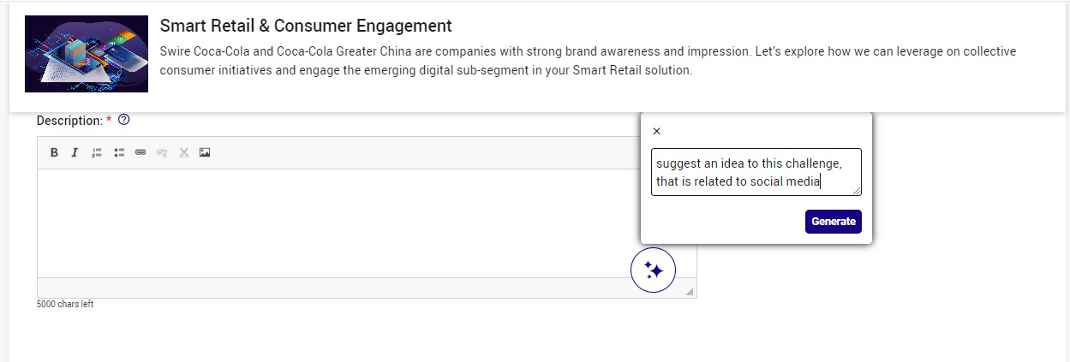

Web Appendix Figure 2: The Stylist in Action (Idea Generation)
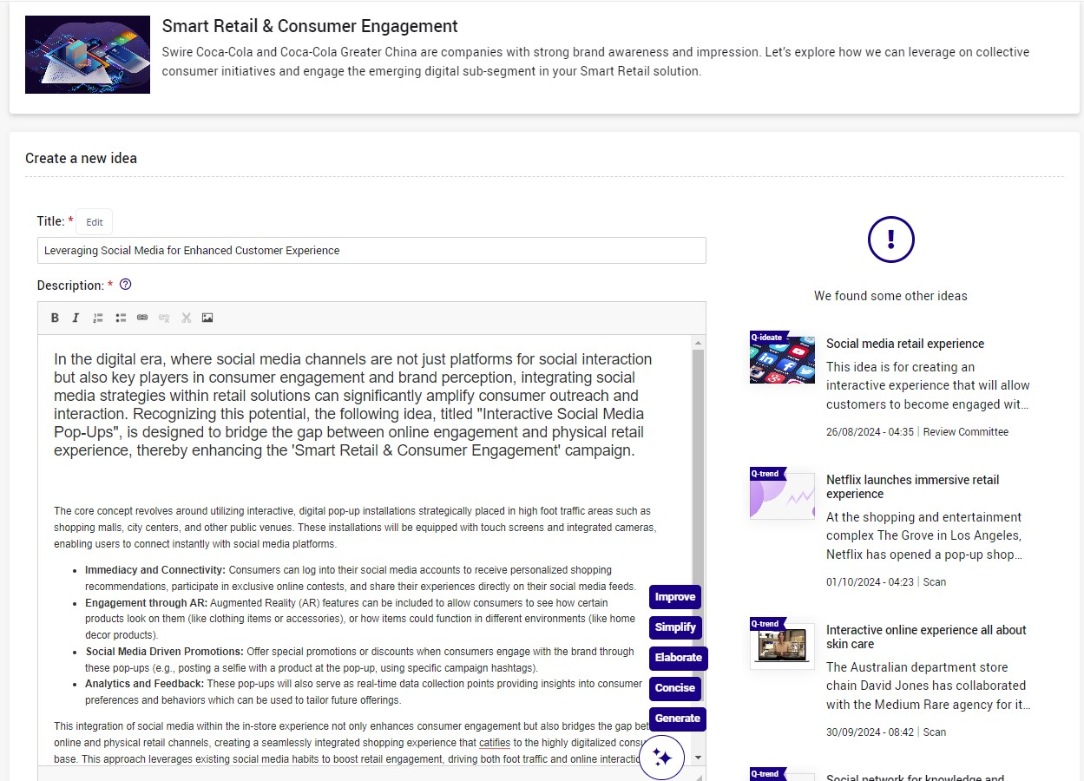

Web Appendix Figure 3: The Stylist in Action (Feedback Formulation)
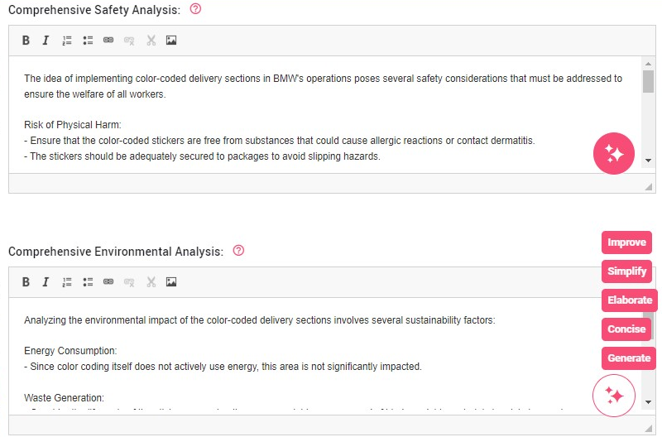

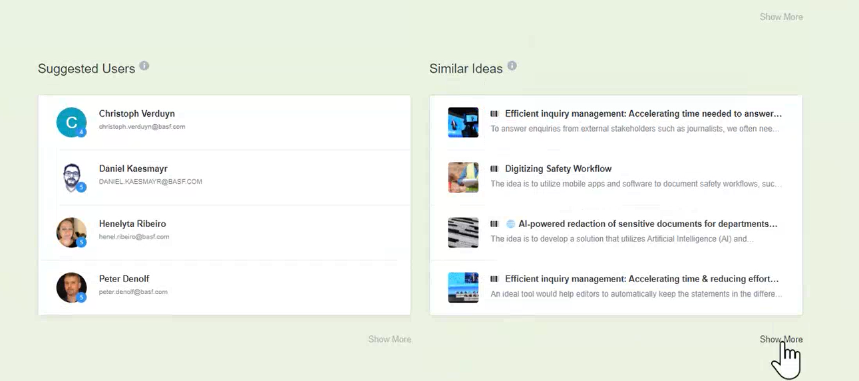

Web Appendix Figure 4: The Matchmaker in Action

Web Appendix Figure 5: The Analyst in Action
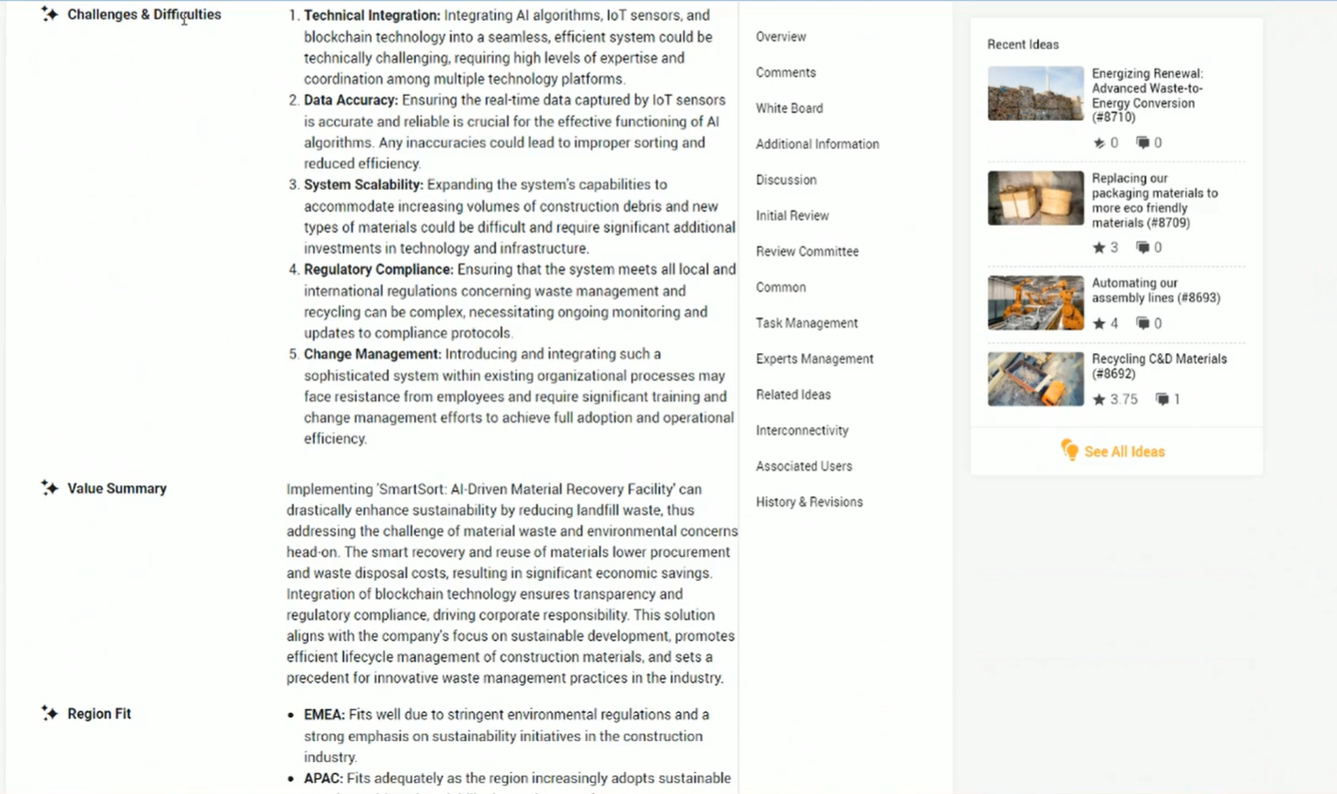

Web Appendix Table 3: Summary of Identified Risks in regard to AI Agents
AI Agent | Potential risks and limitations | Representative Quotes
Inspirer | - Lack of breakthrough, novel ideas  - Less suitable for highly complex and specific topics  - Copyright issues | “There's a concept that is really important for us and it's called the sweet spot of innovation. So when we talk about the sweet spot of an idea, you have them in certain ideas that might sound crazy, might even be bad ideas, but they have something in the core of the idea, or an aspect of the idea is really good and interesting. And you have to have knowledge about the industry you're working in, or you have to have knowledge about trends at the moment to find these sweet spots, and I am not sure if an AI will be able to find these sweet spots.” (Consultant, Source #2)  “Maybe you can use it for inspiration purposes. But it's difficult, AI needs a lot of information to get insightful results. And when it's too specific to a context of a company, in combination with a department, in combination with an end user, it's becoming too complex for that.” (System provider, Source #2)  “When you submit an idea that AI basically created for you. For example, we do a marketing campaign and we want to change the logo of the idea management. And now someone comes in and he submits an idea, but he didn't make the logo. It was done by AI. So who's the creative director of this? To whom belongs this idea?” (Idea manager, Source #2)
Stylist | - Misinterpretation of radical ideas  - Similarity in description leading | “So maybe AI will understand it in a different way. Because in all innovation processes it depends on the degree of the innovation. But if it's not an incremental, if it's more a radical innovation, maybe AI doesn't know it so deeply, so maybe it will translate it a little bit different. And then there is misinterpretation or miscommunication.” (Consultant, Source #2)  “ It's all becoming the same.” (Idea manager, Source #3)  “Variety is being lost.” (Idea manager, Source #3)
Matchmaker | - Blind faith in the technology  - Prone to knowledge silos | “I would be afraid that this would eventually lead to a blind faith in AI. That one day you don't question it anymore.” (Idea manger, Source #3)  “It could lead to this clustering of people, and these silos of knowledge that gets reinforced through the algorithm, because algorithms usually identify patterns.” (Researcher, Source #2)
Analyst | - Less reliable predictions for radical ideas  - Lack of learning | “When we are entering the area of novelty, talking about the radical kind of ideas, they are also very difficult to assess. By definition, they have a high levels of risk and uncertainty, so it's very difficult to predict the likely outcome and requires the company a lot of experimentation before bring in this to market. So maybe [AI] could support a bit the argumentation, but it is still tricky because of the nature of these ideas.” (Researcher, Source #2)  “So sometimes it's better not to suggest that the idea already exists to be able to merge it in a correct way instead of letting machine help you by optimizing this, because you are canceling the opportunity to learn something new.“ (System provider, Source #2)
Organizer | - Impersonal communication and decreasing engagement | “I just see the risk of the communication becoming very asocial or really losing the personal touch. So if you've ever interacted with the chatbot with your local mobile provider or bank account, then it depends I guess on the chatbot and how well it's designed, but it doesn't really incentivize to engage very much or very deeply.” (Researcher, Source #2)
Across agents | - Model misbehavior due to biased training or insufficient data availability  - Interaction issues (including inability to use technology properly)  - Loss of intellectual property  - Data privacy concerns  - Frustration | “I see it as a support tool, but as any other tool, it is also subject to biases. Building these models, the human is feeding all the inputs.” (Researcher, Source #2)  “AI could be helpful in categorizing, making keywords and also in maybe scoring of ideas. But that's is a difficult one because AI can learn, but learning from a big number of data, that is how AI is learning most of the times. And when the data is not that big, it's probably not that trustworthy yet.” (System provider, Source #2)  “You need to get the employees, but in the first step maybe the idea managers or whoever in the company to be able to operate an AI properly.” (Idea manager, Source #3)  “You should never give to the Google translator content of something you want to protect as intellectual property. It's gone. Google knows it. So this is the same with public accessible artificial intelligence.” (Consultant, Source #2)  “Talking about open AI, it means that all the questions that you're asking, everything that you're putting there is going to be added in a database, it can be tricky. So yes, I think that the privacy, data protection, this is something that often pops up as a concern.” (System provider, Source#2)  “I could see that people become frustrated if just the algorithm kind of discriminates against them and their ideas. And then not receiving any recognition, especially if it's very depersonalized, I think it can create a lot of frustration as well, against the technology and this whole process.” (Researcher, Source #2)

