Supplementary material

Li et al. (2021)

Tables S1-S7
Figures S1-S4

Table S1 Detailed information about each genotype used in the experiment.
Genotype | Group | Year | Background
SF1 | DH_LR | 1959ª | from the German population  Strenzfelder
SF2 | DH_LR | 1959ª | from the German population  Strenzfelder
SM1 | DH_LR | 1960^{b} | from the Romanian population  Satu Mare
SM2 | DH_LR | 1960^{b} | from the Romanian population  Satu Mare
SM3 | DH_LR | 1960^{b} | from the Romanian population  Satu Mare
CG1 | DH_LR | 1960ª | from the French population  Campan Galade
WA1 | DH_LR | 1960^{b} | from the Swiss population Wallis
EP1 | FL Flint | 1949^{c} | originated from landrace from  Lizargarate (Spain)
F2 | FL Flint | 1953^{d} | originated from landrace Gelber  Badischer Landmais (Germany)
F7 | FL Flint | 1954e | originated from landrace from  Lacaune (France)
1105 | FL Flint | 1974 | originated from landrace from  Lacaune (France)
1102 | EL Flint1 | 1978 | developed by the maize breeding program of the University of Hohenheim (UHOH); covered a period from the 1970s to 2016; were among the most successful lines of the UHOH maize breeding program in their respective time period
1107 | EL Flint1 | 1978
1278 | EL Flint1 | 1984
5113 | EL Flint1 | 1989
5250 | EL Flint2 | 1994
5267 | EL Flint2 | 1994
5271 | EL Flint2 | 1994
F012 | EL Flint2 | 1999
F030 | EL Flint3 | 2001
F047 | EL Flint3 | 2004
F160 | EL Flint3 | 2015
F142 | EL Flint3 | 2016
Mo17 | Old Dent | 1965 | Old dent from the BSSS × Lancaster heterotic
B73 | Old Dent | 1975 | Old dent from the BSSS × Lancaster heterotic
P024 | EL Dent | 1997 | developed by the maize breeding program of the University of Hohenheim from 1997 to 2014
P040 | EL Dent | 2000
P330 | EL Dent | 2011
P415 | EL Dent | 2014
S072 | EL Dent | 2003
VD03 | EL Dent | 2010
P330×F047 | Hybrid | 2016
P330×F142 | Hybrid | 2016
P415×F142 | Hybrid | 2016
Genotype | Group | Year | Background
SF1 | DH_LR | 1959ª | from the German population  Strenzfelder
SF2 | DH_LR | 1959ª | from the German population  Strenzfelder
SM1 | DH_LR | 1960^{b} | from the Romanian population  Satu Mare
SM2 | DH_LR | 1960^{b} | from the Romanian population  Satu Mare
SM3 | DH_LR | 1960^{b} | from the Romanian population  Satu Mare
CG1 | DH_LR | 1960ª | from the French population  Campan Galade
WA1 | DH_LR | 1960^{b} | from the Swiss population Wallis
EP1 | FL Flint | 1949^{c} | originated from landrace from  Lizargarate (Spain)
F2 | FL Flint | 1953^{d} | originated from landrace Gelber  Badischer Landmais (Germany)
F7 | FL Flint | 1954e | originated from landrace from  Lacaune (France)
1105 | FL Flint | 1974 | originated from landrace from  Lacaune (France)
1102 | EL Flint1 | 1978 | developed by the maize breeding program of the University of Hohenheim (UHOH); covered a period from the 1970s to 2016; were among the most successful lines of the UHOH maize breeding program in their respective time period
1107 | EL Flint1 | 1978
1278 | EL Flint1 | 1984
5113 | EL Flint1 | 1989
5250 | EL Flint2 | 1994
5267 | EL Flint2 | 1994
5271 | EL Flint2 | 1994
F012 | EL Flint2 | 1999
F030 | EL Flint3 | 2001
F047 | EL Flint3 | 2004
F160 | EL Flint3 | 2015
F142 | EL Flint3 | 2016
Mo17 | Old Dent | 1965 | Old dent from the BSSS × Lancaster heterotic
B73 | Old Dent | 1975 | Old dent from the BSSS × Lancaster heterotic
P024 | EL Dent | 1997 | developed by the maize breeding program of the University of Hohenheim from 1997 to 2014
P040 | EL Dent | 2000
P330 | EL Dent | 2011
P415 | EL Dent | 2014
S072 | EL Dent | 2003
VD03 | EL Dent | 2010
P330×F047 | Hybrid | 2016
P330×F142 | Hybrid | 2016
P415×F142 | Hybrid | 2016
ª Year of the collection according to the European maize landrace database (2000)
^{b} Year of the collection is unknown and set to 1960
^{c} Release in the late 1940s (Cartea et al. 1999), set to 1949
^{d} Year of release according to Cauderon (1984)
^{e} Year of release according to Cauderon (2002)

Table S2. Chemical properties of the soils used in the experiments.
Soil | pH (CaCl₂) | Total N % | C_{org} % | CAL-P (mg·kg⁻¹) | CAL-K (mg·kg⁻¹) | CaCl₂-Mg (mg·kg⁻¹) | CAT-Fe (mg·kg⁻¹) | CAT-Mn (mg·kg⁻¹) | CAT-Cu (mg·kg⁻¹) | CAT-Zn (mg·kg⁻¹)
C-loess | 7.60 | 0.02 | <0.3 | 7.8 | 58 | 180 | 9.82 | 12.7 | 0.52 | 0.28

Table S3 Two-way ANOVA result for biomass and P-status traits with log-transformed data for 34 genotypes and two soil phosphorus (P) treatments.
 | Genotypes |  |  | P Treatment |  |  | Genotypes × P Treatment
Traits | df | F | P-value | df | F | P-value | df | F | P-value
Shoot dry weight (SDW) | 33 | 35.3 | <0.0001 | 1 | 316.2 | <0.0001 | 33 | 4.0 | <0.0001
Root dry weight (RDW) | 33 | 44.2 | <0.0001 | 1 | 7.3 | 0.0073 | 33 | 5.2 | <0.0001
Total dry weight (TDW) | 33 | 40.5 | <0.0001 | 1 | 220.0 | <0.0001 | 33 | 4.4 | <0.0001
Shoot P concentration (Shoot [P]) | 33 | 6.9 | <0.0001 | 1 | 3016.3 | <0.0001 | 33 | 5.3 | <0.0001
Root P concentration (Root [P]) | 33 | 10.3 | <0.0001 | 1 | 951.2 | <0.0001 | 33 | 7.3 | <0.0001
Shoot P content (Shoot P) | 33 | 32.2 | <0.0001 | 1 | 2225.6 | <0.0001 | 33 | 4.4 | <0.0001
Root P content (Root P) | 33 | 28.7 | <0.0001 | 1 | 437.5 | <0.0001 | 33 | 6.5 | <0.0001
Total P content (Total P) | 33 | 40.0 | <0.0001 | 1 | 2885.3 | <0.0001 | 33 | 7.2 | <0.0001

Table S4 Abbreviations, descriptions, and units of each root functional trait measured in the experiment.

Traits | Abbreviation | Description | Units
Root morphological traits
Total root length | TRL | The total length of the whole root system | m
Specific root length | SRL | Length per unit dry mass of the whole root system | m·g⁻¹ root dry weight (DW)
Root diameter | RootDiam | The average diameter of the whole root system | mm
Root hair length | RootHairLen | Average root hair length observed from the observation window | mm
Root exudation (P-mobilizing traits)
the amounts of organic acids released from root tips | Carboxylates | The total amount of organic acids collected by filter papers on the surface of root tips | nmol·h⁻¹·cm⁻¹ root length
Rhizosphere soil pH | Rhizos-pH | the pH of the rhizosphere soil solution or pH in the rhizosheath
Acid phosphatase activity released from the root surface | APase | Rate of substrate p-nitrophenyl phosphate (p-NP)  hydrolyzed per minute at 25°C  in sodium acetate buffer (pH 5.2) | ug p-NP·h⁻¹·g⁻¹ root fresh weight

Table S5 Two-way ANOVA result for eight root functional traits with log-transformed data for 34 maize genotypes and two soil phosphorus (P) treatments.
 | Genotypes |  |  | P Treatment |  |  | Genotypes × P Treatment
Traits | df | F | P-value | df | F | P-value | df | F | P-value
TRL | 33 | 16.8 | <0.0001 | 1 | 0.3 | 0.567 | 33 | 8.7 | <0.0001
SRL | 33 | 45.0 | <0.0001 | 1 | 2.8 | 0.105 | 33 | 10.3 | <0.0001
Root/Shoot | 33 | 15.2 | <0.0001 | 1 | 475.2 | <0.0001 | 33 | 3.6 | <0.0001
APase | 32 | 3.4 | <0.0001 | 1 | 48.1 | <0.0001 | 32 | 3.0 | <0.0001
RootDiam | 33 | 42.2 | <0.0001 | 1 | 139.4 | <0.0001 | 33 | 14.6 | <0.0001
Rhizos-pH | 31 | 20.6 | <0.0001 | 1 | 344.1 | <0.0001 | 31 | 14.2 | <0.0001
Carboxylates | 31 | 7.8 | <0.0001 | 1 | 25.4 | <0.0001 | 31 | 3.3 | <0.0001
RootHairLen | 21 | 5.3 | <0.0001 | 1 | 299.3 | <0.0001 | 21 | 9.0 | <0.0001
The data for APase are without SM3 (n=33); Rhizos-pH without P024 & P330 (n=32); RootHairLen without SM3, dents& hybrids (n=22); Carboxylates without P330 × F142 & P415 × F142 (n=32). Root trait abbreviations: TRL, total root length; SRL, specific root length; Root/Shoot, root to shoot ratio; APase, acid phosphatase activity on the root surface; RootDiam, average root diameter; Rhizos-pH, rhizosphere soil solution pH; RootHairLen, average root hair length; Carboxylates, the amounts of carboxylates in the rhizosheath.

Table S6 Shoot mass, root biomass, shoot phosphorus (P) concentration, shoot P content, root P concentration, root P content, and total P content at harvest of the 34 genotypes in response to the two P treatment. Each value is the mean (±SE) of five replicates.

Genotype | Shoot dry weight  (g·plant⁻¹) |  | Root dry weight  (g·plant⁻¹) |  | Total dry weight  (g·plant⁻¹) |  | Shoot P concentration (mg·g ⁻¹) |  | Shoot P content  (mg·plant ⁻¹) |  | Root P concentration  (mg·g ⁻¹) |  | Root P content  (mg·plant ⁻¹) |  | Total P content  (mg·plant ⁻¹)
 | LP | HP | LP | HP | LP | HP | LP | HP | LP | HP | LP | HP | LP | HP | LP | HP
Double haploid lines produced from flint landraces (DH_LR)
SF1 | 0.34±0.03 | 0.5±0.04 | 0.13±0.01 | 0.11±0.02 | 0.47±0.04 | 0.61±0.06 | 1.51±0.06 | 3.37±0.20 | 0.51±0.03 | 1.70±0.23 | 1.31±0.08 | 1.59±0.12 | 0.17±0.02 | 0.20±0.04 | 0.71±0.03 | 1.89±0.26
SF2 | 0.26±0.04 | 0.49±0.11 | 0.07±0.01 | 0.05±0.01 | 0.33±0.03 | 0.54±0.12 | 1.59±0.11 | 3.44±0.12 | 0.41±0.06 | 1.43±0.29 | 1.62±0.35 | 1.58±0.23 | 0.11±0.01 | 0.10±0.02 | 0.52±0.06 | 1.53±0.31
SM1 | 0.3±0.04 | 0.57±0.05 | 0.12±0.01 | 0.11±0.01 | 0.46±0.04 | 0.68±0.06 | 1.72±0.12 | 2.87±0.19 | 0.61±0.09 | 1.65±0.25 | 1.27±0.09 | 1.84±0.11 | 0.15±0.02 | 0.20±0.03 | 0.75±0.10 | 1.85±0.28
SM2 | 0.32±0.01 | 0.78±0.05 | 0.11±0.01 | 0.20±0.02 | 0.43±0.01 | 0.99±0.06 | 1.82±0.03 | 3.22±0.16 | 0.58±0.01 | 2.58±0.18 | 1.21±0.08 | 2.06±0.06 | 0.13±0.01 | 0.42±0.04 | 0.71±0.01 | 3.00±0.18
SM3 | 0.36±0.01 | 0.77±0.17 | 0.14±0.01 | 0.21±0.05 | 0.51±0.02 | 0.98±0.22 | 1.55±0.19 | 3.19±0.24 | 0.56±0.06 | 2.35±0.40 | 1.21±0.07 | 1.77±0.14 | 0.17±0.02 | 0.37±0.08 | 0.73±0.06 | 2.72±0.47
CG1 | 0.52±0.03 | 1.97±0.09 | 0.16±0.01 | 0.52±0.05 | 0.68±0.03 | 2.49±0.16 | 1.29±0.16 | 3.64±0.06 | 0.58±0.09 | 7.19±0.47 | 1.18±0.05 | 1.99±0.07 | 0.19±0.01 | 1.04±0.10 | 0.76±0.10 | 8.23±0.53
WA1 | 0.23±0.02 | 0.47±0.07 | 0.12±0.01 | 0.13±0.02 | 0.35±0.03 | 0.59±0.08 | 1.45±0.16 | 2.80±0.14 | 0.33±0.04 | 1.63±0.06 | 1.47±0.13 | 1.56±0.14 | 0.18±0.02 | 0.19±0.03 | 0.51±0.04 | 1.82±0.06
Founder flint lines (FL Flint)
F2 | 0.95±0.03 | 1.39±0.24 | 0.32±0.00 | 0.30±0.05 | 1.28±0.03 | 1.68±0.27 | 0.99±0.03 | 2.20±0.20 | 0.93±0.03 | 2.88±0.29 | 1.00±0.09 | 1.76±0.17 | 0.31±0.01 | 0.50±0.06 | 1.24±0.04 | 3.37±0.34
EP1 | 1.52±0.10 | 2.14±0.10 | 0.83±0.13 | 0.36±0.03 | 2.35±0.21 | 2.50±0.10 | 1.19±0.06 | 2.73±0.23 | 1.81±0.12 | 5.35±0.20 | 1.10±0.18 | 1.89±0.05 | 0.84±0.07 | 0.68±0.05 | 2.65±0.15 | 6.02±0.23
F7 | 0.50±0.01 | 1.77±0.28 | 0.16±0.00 | 0.40±0.05 | 0.66±0.02 | 2.17±0.33 | 1.17±0.02 | 2.71±0.07 | 0.59±0.01 | 4.78±0.75 | 0.95±0.13 | 2.08±0.14 | 0.15±0.02 | 0.82±0.11 | 0.74±0.02 | 5.60±0.86
1105 | 0.68±0.07 | 1.79±0.21 | 0.24±0.03 | 0.40±0.05 | 0.92±0.11 | 2.19±0.24 | 0.97±0.04 | 3.09±0.17 | 0.66±0.08 | 5.43±0.38 | 1.11±0.09 | 2.13±0.05 | 0.25±0.02 | 0.85±0.09 | 0.92±0.10 | 6.28±0.46
Elite lines time periods 1 (EL Flint1)
1102 | 0.58±0.12 | 1.69±0.14 | 0.15±0.02 | 0.38±0.02 | 0.73±0.14 | 2.07±0.16 | 1.19±0.06 | 2.87±0.05 | 0.77±0.14 | 4.84±0.38 | 1.63±0.19 | 1.94±0.07 | 0.19±0.03 | 0.75±0.07 | 0.95±0.14 | 5.59±0.43
1107 | 0.68±0.04 | 0.81±0.02 | 0.17±0.03 | 0.17±0.04 | 0.85±0.07 | 0.98±0.05 | 1.27±0.04 | 3.95±0.20 | 0.87±0.06 | 3.18±0.13 | 1.20±0.11 | 2.53±0.31 | 0.19±0.03 | 0.40±0.04 | 1.06±0.08 | 3.58±0.15
1278 | 0.52±0.04 | 1.11±0.10 | 0.16±0.01 | 0.18±0.02 | 0.68±0.04 | 1.29±0.12 | 1.26±0.04 | 3.83±0.20 | 0.65±0.05 | 3.80±0.29 | 1.22±0.11 | 2.39±0.27 | 0.19±0.01 | 0.68±0.09 | 0.85±0.05 | 4.55±0.33
5113 | 0.51±0.03 | 0.47±0.03 | 0.17±0.01 | 0.13±0.02 | 0.68±0.04 | 0.60±0.04 | 1.28±0.04 | 5.12±0.42 | 0.64±0.04 | 2.36±0.14 | 1.07±0.05 | 2.43±0.16 | 0.19±0.02 | 0.31±0.04 | 0.83±0.05 | 2.67±0.18
Elite lines time periods 2 (EL Flint2)
5250 | 0.45±0.06 | 0.62±0.09 | 0.18±0.02 | 0.13±0.02 | 0.63±0.07 | 0.75±0.11 | 1.22±0.08 | 4.28±0.29 | 0.54±0.05 | 2.64±0.41 | 1.08±0.05 | 2.29±0.11 | 0.19±0.02 | 0.29±0.05 | 0.73±0.07 | 2.92±0.46
5267 | 0.37±0.02 | 0.55±0.05 | 0.15±0.01 | 0.16±0.02 | 0.52±0.03 | 0.70±0.06 | 1.18±0.05 | 3.09±0.20 | 0.44±0.03 | 1.69±0.18 | 1.30±0.07 | 2.17±0.23 | 0.19±0.01 | 0.34±0.06 | 0.63±0.04 | 2.03±0.22
5271 | 0.33±0.02 | 0.70±0.07 | 0.14±0.01 | 0.14±0.02 | 0.47±0.02 | 0.85±0.09 | 1.34±0.05 | 4.14±0.08 | 0.45±0.04 | 3.12±0.20 | 1.23±0.16 | 2.34±0.31 | 0.17±0.02 | 0.35±0.06 | 0.62±0.05 | 3.53±0.21
F012 | 0.31±0.01 | 1.06±0.26 | 0.14±0.00 | 0.21±0.05 | 0.46±0.01 | 1.27±0.31 | 1.21±0.05 | 3.35±0.26 | 0.38±0.02 | 3.08±1.08 | 1.21±0.07 | 1.70±0.08 | 0.17±0.01 | 0.35±0.06 | 0.55±0.03 | 3.43±1.13
Genotype | Shoot dry weight  (g·plant⁻¹) |  | Root dry weight  (g·plant⁻¹) |  | Total dry weight  (g·plant⁻¹) |  | Shoot P concentration (mg·g ⁻¹) |  | Shoot P content  (mg·plant ⁻¹) |  | Root P concentration  (mg·g ⁻¹) |  | Root P content  (mg·plant ⁻¹) |  | Total P content  (mg·plant ⁻¹)
 | LP | HP | LP | HP | LP | HP | LP | HP | LP | HP | LP | HP | LP | HP | LP | HP
Elite lines time periods 3 (EL Flint3)
F030 | 0.57±0.06 | 0.70±0.09 | 0.16±0.01 | 0.12±0.02 | 0.72±0.06 | 0.72±0.15 | 1.33±0.15 | 3.27±0.44 | 0.75±0.13 | 1.77±0.33 | 1.04±0.07 | 2.23±0.37 | 0.16±0.01 | 0.25±0.02 | 0.91±0.13 | 2.02±0.35
F047 | 0.45±0.04 | 0.67±0.10 | 0.14±0.01 | 0.12±0.01 | 0.59±0.05 | 0.79±0.11 | 1.25±0.05 | 4.44±0.33 | 0.56±0.04 | 2.85±0.31 | 1.26±0.04 | 1.54±0.06 | 0.18±0.01 | 0.18±0.02 | 0.74±0.04 | 3.03±0.33
F142 | 0.49±0.09 | 0.72±0.10 | 0.15±0.03 | 0.17±0.01 | 0.64±0.10 | 0.89±0.12 | 1.36±0.04 | 2.73±0.10 | 0.66±0.05 | 1.93±0.23 | 1.11±0.09 | 1.70±0.19 | 0.17±0.05 | 0.28±0.03 | 0.83±0.07 | 2.21±0.24
F160 | 0.35±0.03 | 0.64±0.08 | 0.14±0.01 | 0.16±0.05 | 0.49±0.04 | 0.80±0.12 | 1.33±0.02 | 4.29±0.22 | 0.47±0.04 | 2.82±0.26 | 1.41±0.07 | 1.54±0.12 | 0.20±0.01 | 0.16±0.02 | 0.67±0.05 | 3.12±0.24
Old dent lines (Old Dent)
Mo17 | 0.66±0.07 | 1.25±0.15 | 0.34±0.02 | 0.46±0.05 | 1.00±0.08 | 1.71±0.20 | 1.35±0.11 | 3.72±0.41 | 0.92±0.14 | 4.56±0.64 | 0.92±0.04 | 1.50±0.07 | 0.31±0.02 | 0.68±0.07 | 1.23±0.14 | 5.25±0.69
B73 | 0.63±0.04 | 1.14±0.09 | 0.22±0.01 | 0.45±0.03 | 0.86±0.05 | 1.58±0.12 | 1.37±0.08 | 3.43±0.18 | 0.86±0.06 | 3.86±0.25 | 1.15±0.07 | 1.73±0.08 | 0.26±0.02 | 0.76±0.04 | 1.12±0.06 | 4.62±0.26
Elite dent lines (EL Dent)
P024 | 1.10±0.10 | 3.36±0.44 | 0.52±0.04 | 0.96±0.25 | 1.62±0.13 | 4.32±0.65 | 0.93±0.10 | 3.33±0.32 | 1.00±0.10 | 11.45±2.40 | 0.68±0.01 | 1.58±0.15 | 0.35±0.02 | 1.51±0.38 | 1.27±0.08 | 12.96±2.72
P040 | 0.90±0.08 | 1.83±0.05 | 0.82±0.09 | 0.77±0.05 | 1.72±0.16 | 2.60±0.04 | 1.46±0.10 | 3.91±0.32 | 1.30±0.14 | 7.21±0.73 | 0.71±0.10 | 1.72±0.05 | 0.58±0.10 | 1.33±0.10 | 2.04±0.13 | 8.54±0.63
P330 | 0.97±0.08 | 2.02±0.14 | 0.50±0.03 | 0.60±0.05 | 1.47±0.10 | 2.62±0.18 | 1.25±0.09 | 3.93±0.17 | 1.24±0.16 | 7.97±0.75 | 0.68±0.03 | 1.68±0.06 | 0.34±0.04 | 1.01±0.10 | 1.60±0.11 | 8.98±0.82
P415 | 1.67±0.17 | 3.50±0.35 | 1.01±0.08 | 1.14±0.15 | 2.69±0.24 | 4.63±0.50 | 1.17±0.05 | 4.12±0.35 | 1.96±0.22 | 14.04±0.96 | 0.58±0.03 | 1.75±0.04 | 0.59±0.04 | 1.99±0.28 | 1.75±0.07 | 16.02±1.18
S072 | 1.10±0.29 | 1.34±0.28 | 0.52±0.11 | 0.49±0.08 | 1.62±0.40 | 1.83±0.36 | 1.60±0.13 | 5.20±0.44 | 1.68±0.33 | 6.56±1.05 | 0.62±0.03 | 1.34±0.02 | 0.31±0.05 | 0.65±0.11 | 1.92±0.12 | 7.21±1.15
VD03 | 1.07±0.09 | 1.27±0.23 | 0.50±0.03 | 0.33±0.07 | 1.57±0.11 | 1.64±0.30 | 1.45±0.04 | 5.51±0.42 | 1.54±0.11 | 6.71±0.74 | 0.63±0.03 | 1.86±0.08 | 0.31±0.02 | 0.69±0.13 | 1.76±0.04 | 7.40±0.87
Hybrids crossed by elite flint and elite dent (Hybrid)
P330×F047 | 1.48±0.10 | 2.79±0.10 | 0.46±0.03 | 0.59±0.03 | 1.94±0.12 | 3.38±0.12 | 1.11±0.08 | 3.90±0.12 | 1.63±0.12 | 10.92±0.61 | 0.68±0.03 | 2.05±0.10 | 0.31±0.02 | 1.22±0.12 | 1.43±0.08 | 12.14±0.67
P330×F142 | 1.90±0.06 | 2.53±0.28 | 0.47±0.04 | 0.38±0.07 | 2.37±0.09 | 2.92±0.34 | 1.05±0.05 | 4.70±0.63 | 2.00±0.09 | 11.30±0.62 | 0.65±0.02 | 1.76±0.19 | 0.31±0.03 | 0.63±0.08 | 1.36±0.05 | 11.93±0.66
P415×F142 | 1.48±0.07 | 2.41±0.27 | 0.59±0.02 | 0.43±0.09 | 2.07±0.07 | 2.48±0.50 | 1.12±0.08 | 4.14±0.49 | 1.63±0.09 | 7.80±1.39 | 0.64±0.03 | 1.70±0.15 | 0.38±0.01 | 0.72±0.15 | 1.49±0.07 | 8.52±1.51

Table S7 Correlations between P status and TDW with P uptake and seed P content. Significant correlations are marked with *, 0.01 ≤ P < 0.05; **, 0.001 ≤ P < 0.01; ***, P <0.001.

Treatment | P/Biomass | P uptake | Seed P content
HP | Total dry weight (TDW) | 0.94*** | 0.36***
 | Shoot P concentration (Shoot [P]) | 0.25** | 0.00
 | Root P concentration (Root [P]) | -0.14 | 0.16
 | Total P content | 1.00*** | 0.30***
LP | Total dry weight (TDW) | 0.73*** | 0.29***
 | Shoot P concentration (Shoot [P]) | 0.12 | -0.43***
 | Root P concentration (Root [P]) | -0.48*** | -0.20*
 | Total P content | 0.96*** | 0.19*

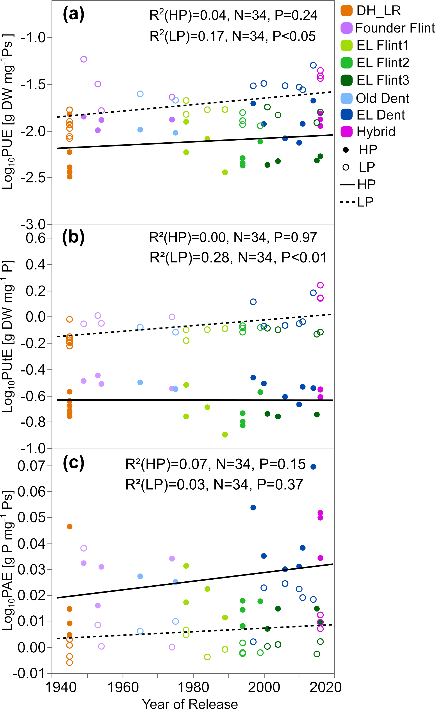
Figure S1 PUE measures of all analyzed genotypes with respect to release date of individual genotypes. Mean performance for (a) total phosphorus use efficiency (PUE), (b) phosphorus utilization efficiency (PUtE), and (c) phosphorus acquisition efficiency (PAE) of 34 maize genotypes plotted versus the year of release of the lines. Regressions are based on the genotypes in the LP and HP treatment separately. DH lines are plotted at the left margin, as they represent old material, but DH lines were produced only recently. Different colors represent different groups. The open circle represents the mean of each genotype under LP condition; the closed circle represents the means of each genotype under HP condition. The dashed line is the linear regression under LP for flints; the solid line the linear regression in HP for flints.

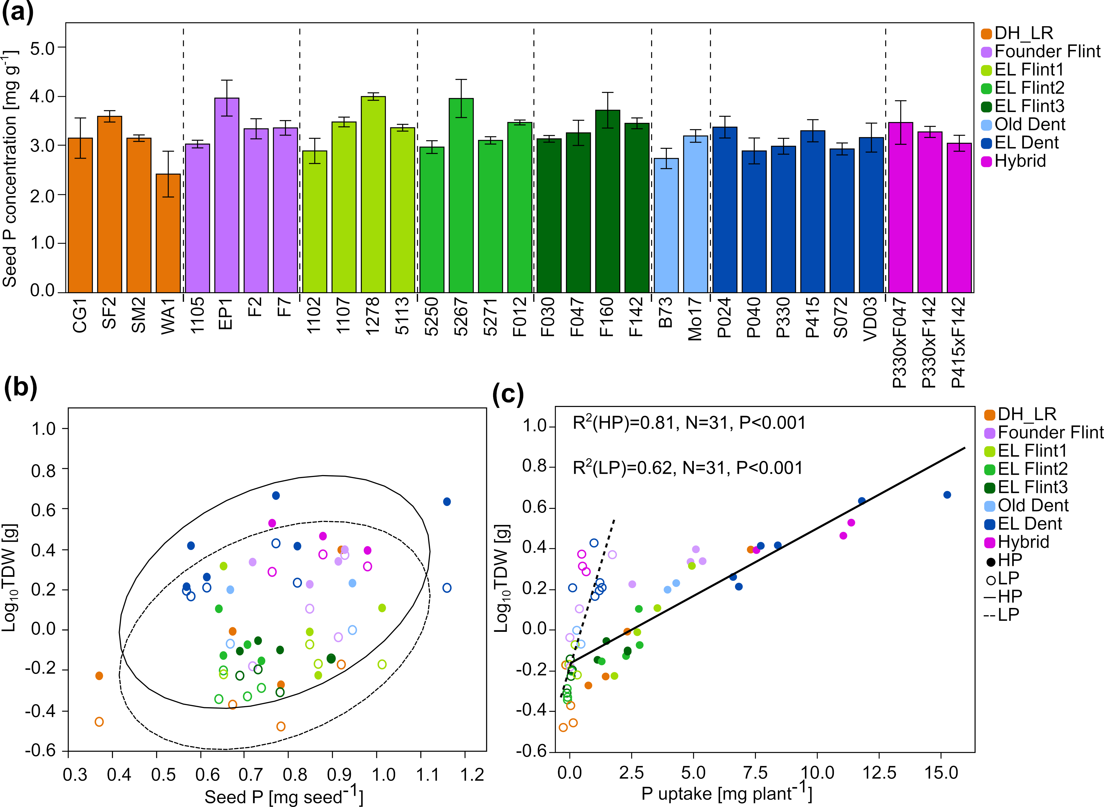
Figure S2 Seed P concentrations and the relation of total dry weight to seed P and P uptake. Seed P concentration (a) of different lines and the correlation between total dry weight (TDW) and seed P content (b) and P uptake (c) in the LP and HP treatments for all genotypes. P uptake = Total P content – seed P content. Different colors represent different groups. The open circle represents the mean of each genotype under LP condition; the closed circle represents the means of each genotype under HP condition. The dashed line is the linear regression under LP; the solid line the linear regression in HP.

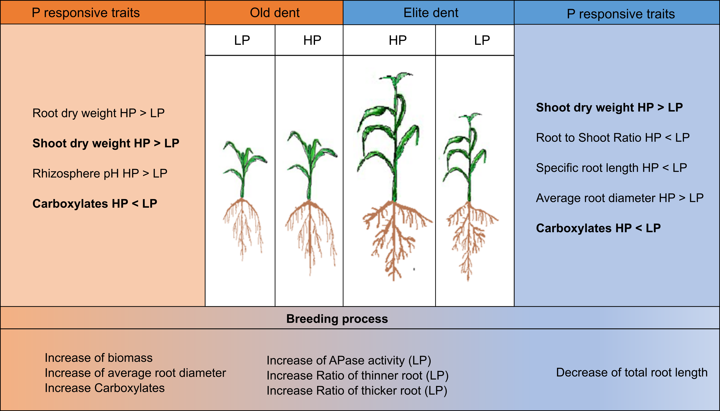
Figure S3 Schematic model summarizing the major observations of traits contributing to PUE, PAE and PUtE of Old dent and Elite dent. Schematic plant appearance for LP and HP is shown.

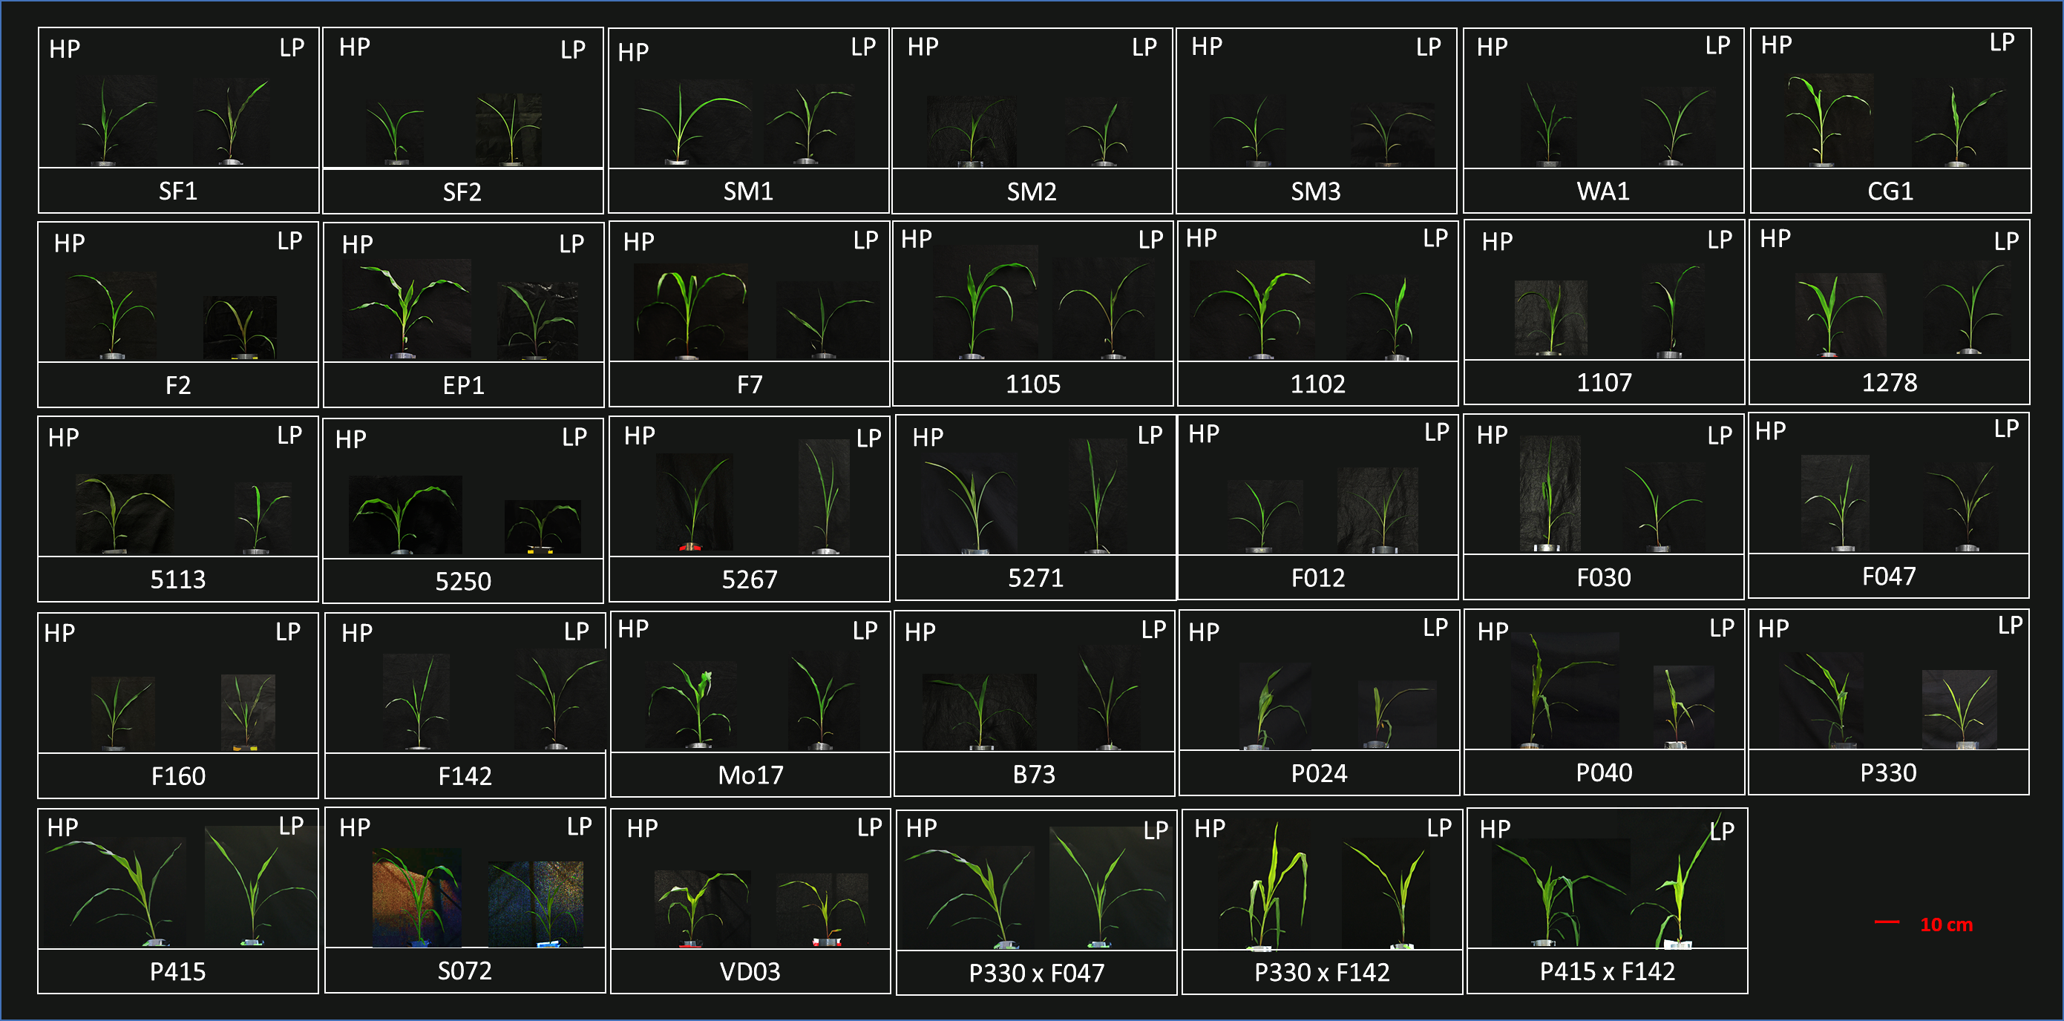
Figure S4 Picture showing shoots of 34 genotypes under low- and high soil phosphorus (P) availability at harvest.

