Supplementary materials
Table 1 Mann-Kendall trend test results for seasonal and annual T_{max} and T_{min} over the study period (1981–2018).
Months/ seasons | Tmax |  |  |  |  | Tmin
Months/ seasons | Mean | Mann Kendals trend test (Z-value) | p-value | Sen’s slope | Mean | Mann Kendals trend test (Z-value) | p-value | Sen’s slope
January | 25.4 | 1.56 | 0.12 | 0.013 | 10.3 | -0.28 | 0.78 | -0.006
February | 26.1 | 3.44 | 0.0006** | 0.032 | 10.9 | -0.91 | 0.36 | -0.014
March | 26.2 | 1.84 | 0.07 | 0.026 | 11.7 | -0.68 | 0.5 | -0.008
April | 25.6 | 1.68 | 0.09 | 0.028 | 11.8 | -0.51 | 0.61 | -0.006
May | 25.3 | 0 | 1 | 0 | 11.9 | -0.34 | 0.73 | -0.004
June | 24.4 | -0.35 | 0.72 | -0.005 | 11.5 | 0.71 | 0.48 | 0.008
July | 23.1 | 0.13 | 0.9 | 0.001 | 11.6 | 1.92 | 0.05* | 0.023
August | 23.2 | 0.01 | 0.99 | 0.001 | 11.5 | 0.2 | 0.84 | 0.004
September | 24 | 1.03 | 0.3 | 0.015 | 11.3 | -0.23 | 0.82 | -0.003
October | 24.6 | 2 | 0.045* | 0.019 | 10.8 | 0.2 | 0.84 | 0.002
November | 25.6 | 0.51 | 0.61 | 0.005 | 10.6 | -2.07 | 0.038* | -0.031
December | 25.6 | 0 | 1 | 0 | 10.3 | -0.65 | 0.51 | -0.019
Annual | 24.9 | 0.67 | 0.5 | 0.004 | 11.2 | -0.4 | 0.69 | -0.001
Kiremt | 23.7 | -0.51 | 0.61 | 0.019 | 10.3 | 1.02 | 0.31 | 0.013
Belg | 25.8 | 2.64 | 0.008** | -0.003 | 10.9 | -1.14 | 0.26 | -0.008
Bega | 25.3 | 1.32 | 0.19 | 0.008 | 11.7 | -0.31 | 0.75 | -0.015
* Statistically significant at the 5% significance level
**Statistically significant at the 1% significance level

Table 2 Results of monthly, seasonal and annual rainfall trend and variability assessment over the study period 1981-2018
p-value at (α = 0.05) (two tailed) |  |  |  |  |  |  | Mann-Kendall trend test |  |  | Sens slope
p-value at (α = 0.05) (two tailed) | Min | Max | Mean | % | SD | CV (%) | Mann-Kendall trend test | p-value | Trend | Sens slope
January | 0.16 | 56 | 18.67 | 0.02 | 17.79 | 95.3 | -0.35 | 0.72 | - ve | -0.04
February | 0 | 162 | 31.36 | 0.03 | 32.21 | 102.7 | -0.93 | 0.35 | - ve | -0.42
March | 7.2 | 178 | 71.58 | 0.07 | 44.81 | 62.6 | -1.03 | 0.3 | - ve | -0.81
April | 11.6 | 212 | 97.1 | 0.09 | 43.94 | 45.3 | -0.75 | 0.45 | - ve | -0.62
May | 28 | 221 | 108.34 | 0.1 | 45.37 | 41.9 | 0.04 | 0.97 | + ve | 0.42
June | 40 | 201 | 114.44 | 0.11 | 33.13 | 29 | 1.91 | 0.05* | + ve | 1.04
July | 89 | 254 | 175.55 | 0.17 | 36.38 | 20.7 | 1.01 | 0.31 | + ve | 0.62
August | 118 | 237 | 174.64 | 0.17 | 28.61 | 16.4 | 0.18 | 0.86 | + ve | 0.05
September | 65 | 174 | 122.91 | 0.12 | 26.16 | 21.3 | 0.77 | 0.44 | + ve | 0.41
October | 3 | 194 | 54.67 | 0.05 | 44.8 | 81.9 | -0.09 | 0.93 | - ve | -0.08
November | 0.4 | 95 | 16.39 | 0.02 | 20.67 | 126.1 | 2.36 | 0.02* | + ve | 0.32
December | 0 | 73 | 12.68 | 0.01 | 17.09 | 134.8 | -1.33 | 0.18 | - ve | -0.09
Kiremt | 441 | 829 | 634.01 | 0.6 | 84.25 | 13.3 | 1.08 | 0.28 | + ve | 1.55
Belg | 151 | 526 | 305.13 | 0.29 | 88.71 | 29.1 | -1.23 | 0.22 | - ve | -1.78
Bega | 15 | 325 | 111.67 | 0.11 | 61.92 | 55.5 | 0.5 | 0.62 | + ve | 0.51
Annual | 764 | 1298 | 1050.8 | 1 | 120.1 | 11.4 | 0.03 | 0.98 | + ve | 0.07
* Statistically significant trends at the 5% significance level

Figures
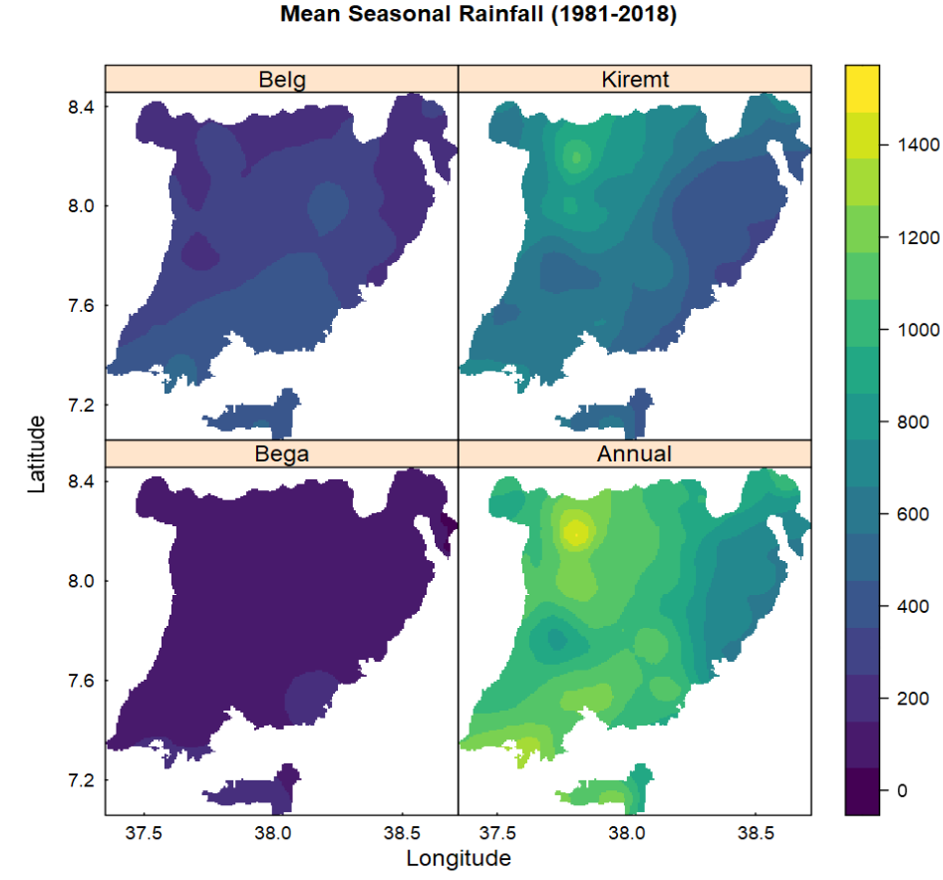
Fig. 1 Areal distribution of Belg, Kiremt, Bega and annual rainfall (in mm) in the Central Ethiopian Region from 1981-2018.
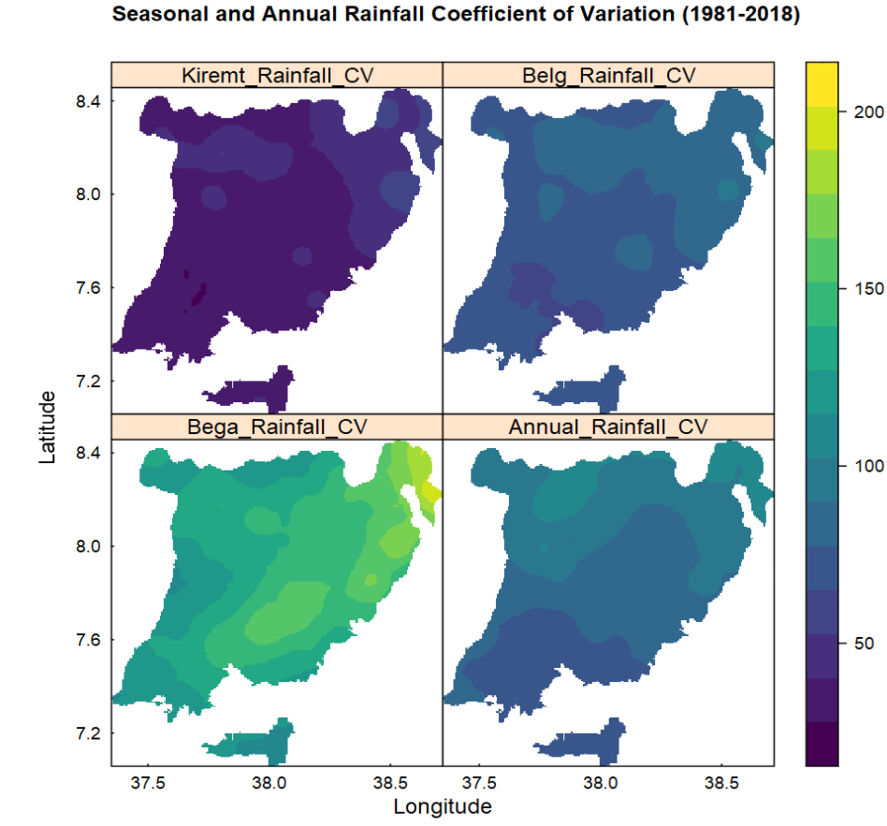
Fig. 2 Coefficient of Variation (CV) of areal distribution of Belg, Kiremt, Bega and Annual rainfall in the Central Ethiopia Region from 1981-2018.
Fig. 3 Standardized Rainfall Anomaly index trend in the Central Ethiopia Region: Kiremt, Belg, Bega, and annual
Fig. 4. Box and whisker plots of monthly, seasonal, and annual maximum and minimum temperatures (ºC) in the Central Ethiopia Region (1981-2018). The median is indicated by the centre line in box plots and the box spans the interquartile range between the 25th to the 75th percentiles.
Fig. 5 Trends of Kiremt, Belg, Bega and annual rainfall from 1981-2018 in the Central Ethiopia Region (1981-2018).

