Appendix

Appendix 1
Table A.1.1. A list of multiple-choice questions in a common questionnaire for collecting students’ feedback on the game (used in all participating universities)
No. | Question | Possible choices | No. of responses
1 | How likely are you to adopt precision farming on a farm? | Very likely, somehow likely, neutral, somewhat unlikely, not likely, don’t know | 145
2 | How did you find the process of accessing the PF DLC? | Very easy, quite easy, easy, neither easy nor difficult, difficult, very difficult | 137
3 | What was it like playing with the PF DLC? | Quite good fun, good fun, neither fun nor boring, a bit boring, very boring | 134

Table A.1.2. A list of open-ended questions in a common questionnaire for collecting students’ feedback on the game (used in all participating universities)
No. | Question | No. of responses | No. of codes | No. of categories
1 | What was best about the precision farming (PF) DLC? | 107 | 116 | 10
2 | What was worst about the precision farming (PF) DLC? | 105 | 32 | 3
3 | Any comments on what made it easy? | 57 | 52 | 4
4 | Any comments on what made it difficult? | 55 | 14 | 3
5 | How could accessing the PF DLC be improved? | 83 | 24 | 2
6 | How could the PF DLC be made more fun? | 84 | 39 | 6
7 | What did you learn about PF as a result of playing with the PF DLC? | 68 | 50 | 7
8 | How do you think the PF DLC can be improved to make you and others more likely to adopt PF? | 72 | 42 | 6
9 | Any other comments about the software and the PF DLC | 46 | 28 | 4

Table A.1.3. A questionnaire on PF ranking

PF feature | 1 | 2 | 3 | 4 | 5
Modifications of soil sampling
Soil sampling performed in an automatic mode (compared to the manual mode in the current version of the DLC)
Soil scanner to pre-scan the field before soil sampling and then taking one sample per zone
Purchase of soil/nutrient maps from a service provider
Adding a layer for soil moisture - link to wheel slip and track depth (trafficability)
Adding a layer for soil density
Automatic steering
Combination of automatic steering and manual turns
Controlled traffic farming
Variable rate seeding/drilling
Seed density based on soil type/yield potential
Variable rate weed control
Display weed patches in the field
Section control/Individual nozzle control
Weed detection via camera/sensor for see & spray actions
Weed maps from service provider (UAV imagery)
Sensing biomass differences in the field
Real-time biomass sensor (e.g. Fritzmeier Isaria, Yara N-Sensor, etc.)
Purchase of biomass images from service provider (UAVs)
Purchase of biomass images from satellite imagery
Variable rate organic fertilization
Use of the John Deere HarvestLabTM sensor to measure ingredients in liquid manure
Slurry manure tank wagon with bypass for sensor
Variable rate mineral fertiliser application
Online sensor readings
Consideration of the residual nitrogen from previous crop or catch crop
Variable rate crop protection
Utilisation of growth regulators
Use of insecticides
Use of fungicides
Harvesting
Combination of moisture and protein map
Self propelled forage harvester for yield and moisture map
Criteria for environmental score
Use of herbicides
Use of nitrogen fertiliser beyond crop demands

Table A.1.4. A list of multiple-choice questions used in New Zealand to collect students’ feedback on Farm Simulation Labs
No. | Question | Possible choices | No. of responses
1 | Was this your first time playing FS19? | Yes, no | 114
2 | Did you enjoy playing the farm simulation game? | Yes, no | 113
3 | Do you believe that the farm simulation game enhanced your learning? | Yes, no | 113
4 | Did the farm simulation game improve your understanding of modern farm? | Yes, no | 112
5 | Do you think this software would be useful for other courses? | Yes, no | 110
6 | Has playing the farm simulation game changed your views of farm games? | Yes, no | 113
7 | Did you find the Farm Simulation Labs beneficial? | Yes, no | 108
8 | Do you feel like playing the farm simulation game will help you to achieve your long-term goals? | Yes, no | 111
9 | Do you have a farming background? | Yes, no | 112

Table A.1.5. A list of open-ended questions used in New Zealand to collect students’ feedback on Farm Simulation Labs
No. | Question | No. of codes | No. of categories
1 | What parts of the farm simulation did you particularly like? | 180 | 11
2 | What parts of the farm simulation did you particularly dislike? | 46 | 5
3 | If so, how did the farm simulation game enhance your learning?? | 98 | 8
4 | For which courses this software would be useful? | 81 | 4
5 | Why the software would be useful for other courses? | 63 | 3
6 | If yes, how did playing the farm simulation game change your views of farm games? | 61 | 5
7 | Why did you find the Farm Simulation Labs beneficial? | 69 | 3
8 | Why did not you find the Farm Simulation Labs beneficial? | 26 | 2
9 | If so, how the farm simulation game will help you to achieve your long-term goals? | 35 | 4

Appendix 2

RTK base stations
The DLC introduced two new buildings in the game set. These are available in the Game Shop: a small house and a garage (Fig. A.2.1). Both have a base station on top, providing RTK correction to the GNSS receivers that were already in the game before the development of the PF DLC. This was a necessary addition to the DLC in order to offer improved navigation for farming operations. After placing the RTK base station on the farm, the operation can be performed more efficiently in terms of overlapping the parallel infield passes. Compared to the basic mode of the FS game, where the automatic steering has a 15.0 % overlap, the automatic steering in the DLC has no overlap, thus saving both fuel and time.

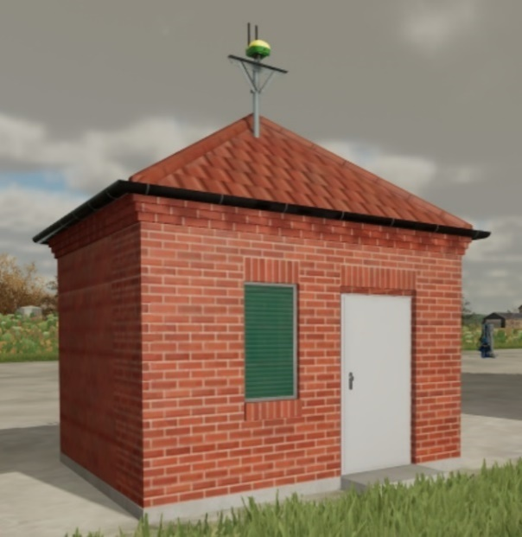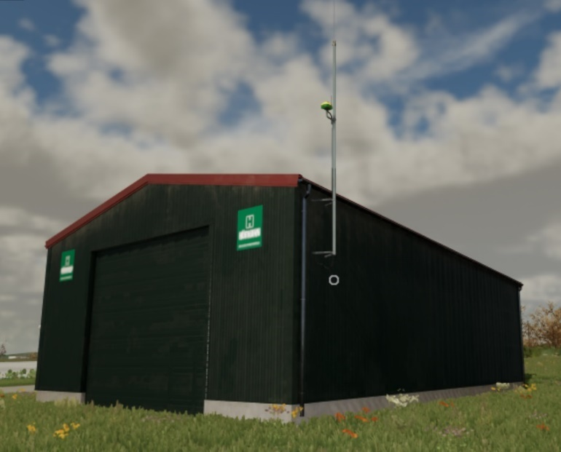
Fig. A.2.1. (left) A small house and (right) a garage with the RTK base stations.

Soil texture classes
The DLC introduced four soil texture classes: (i) loamy sand; (ii) sandy loam; (iii) loam; and (iv) silty clay, with each class characteristics affecting crop growth and therefore yield potential (Table A.2.1). To get the maximum yield from a particular field, each soil texture class requires a specific treatment to be applied. Soil sampling should be carried out to determine which soil texture classes are present and where they are located. The soil texture classes are visualised on a map after the soil samples have been taken and analysed.

Table A.2.1. Connection between the pH of the four soil texture classes and yield potential.
Soil texture class | Loamy sand | Sandy loam | Loam | Silty clay
pH | 5.0 - 6.5 | 5.5 - 7.0 | 6.0 - 7.5 | 6.0 - 8.0
Yield potential (%) | 80 | 100 | 125 | 90

pH value
In addition to the soil texture class, a pH value is also determined and can be found on the pH map. The DLC instructs players that depending on the soil texture class, the pH should always be within the range defined for each soil texture class. The characteristics of the management decisions are given in Table A.2.1. Considering the game environment limitations there was a relative approach adopted connecting soil texture classes and yield as it was not possible to have an absolute reference in terms of yield. Thus, based on the experience of the scientists involved, sandy loam was considered 100 %.

Soil sampling
For soil sampling (Fig. A.2.2), the ISARIA SCOUT (Fritzmeier Umwelttechnik GmbH & Co. KG, Großhelfendorf, Germany) is utilised. The sampler allows the player to determine the soil texture class in which the crops are growing. Samples are collected in the containers at the bottom of the unit. Each sample represents a 32.5 m radius. After each sample is taken, the corresponding part of the field is coloured dark red on the soil map. The best result is achieved when the maximum number of soil samples per field is taken so that the field is covered in dark red colour. The soil samples are then sent to a laboratory for analysis.

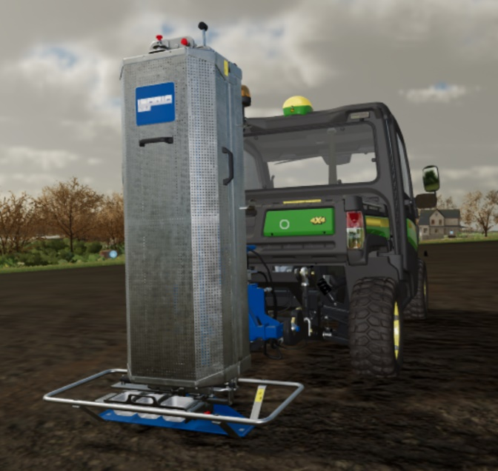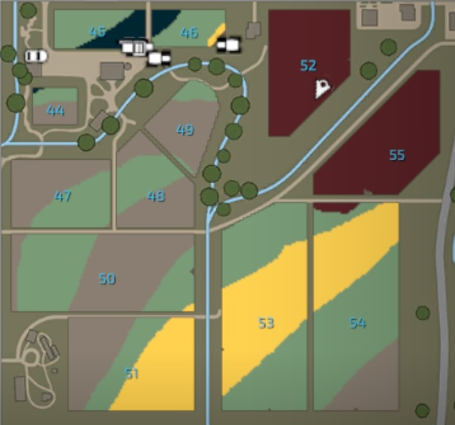
Fig. A.2.2. (left) Soil sampling and (right) soil texture classes.

Site-specific variable rate lime application
The player can increase the pH by applying lime to the field (Fig. A.2.3). The DLC provides the lime application bar: the red markers show the current pH level (to three decimal places to make the game more informative), while the flag shows the target pH. As the player travels around the field, the application rate will vary according to the needs of the site. In the game, it is recommended to apply lime to every third crop. If the pH is not optimal, the yield will decrease. The pH will decrease after each crop, depending on the soil texture class. By default, the lime spreader automatically adjusts the application rate to the optimum pH level based on the amount required. Each soil texture class has a different optimum value. There is also an option to control the rate manually if desired. The automatic mode selects the amount of lime to be applied based on the data in Table A.2.2. An application of 0.7 t ha⁻¹ of lime is required to increase the pH by 0.1. The reduction in pH per year in Table A.2.2 is based on information from the Landwirtschaftskammer Nordrhein-Westfalen [1].
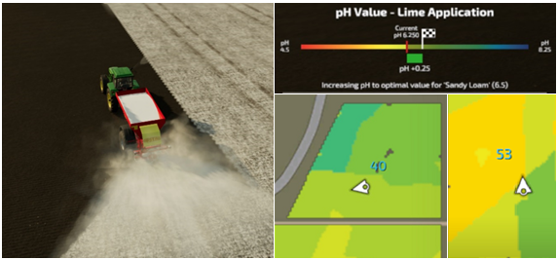
Fig. A.2.3. (left) Lime application and (right) current and targeted pH values.

Table A.2.2. Connection between the soil texture classes and required lime spreading.
Soil texture class | Loamy sand | Sandy loam | Loam | Silty clay
pH target value | 6.0 | 6.4 | 6.8 | 7.0
Amount of lime required to keep target level (t ha⁻¹) | 1.6 | 2.0 | 2.4 | 2.8
Reduction of pH per year | 0.075 | 0.095 | 0.115 | 0.135

Site-specific variable rate N application
An N map was implemented in the game (Fig. A.2.4). The player can see the current and target N levels of a specific location on the field by driving to that field and looking at the "Field Info Display". The game offers the possibility to increase the N level with mineral or organic fertiliser. Depending on the crop to be sown, the player first applies slurry or manure to the soil. This helps to reduce the rate and cost of later mineral N application. Depending on the soil texture class, the application of slurry or manure increases its level by a fixed value (Table A.2.3). Only one type of slurry is considered and in DLC 1 it is assumed that the manure N content is homogeneous with a value of 4 kg N m⁻³. After the crop has been sown, the N content can be adjusted to the crop’s target value by applying mineral fertiliser. The player can choose between a disc spreader or a sprayer. During liming or fertilising, the rising values can be seen live on the mini-map.

Table A.2.3. Application of organic N fertilisation.
Soil texture class | Loamy sand | Sandy loam | Loam | Silty clay
Suggested amount (m³ ha⁻¹) | 10 | 15 | 20 | 15
Amount of N (kg ha⁻¹) | 40 | 60 | 80 | 60

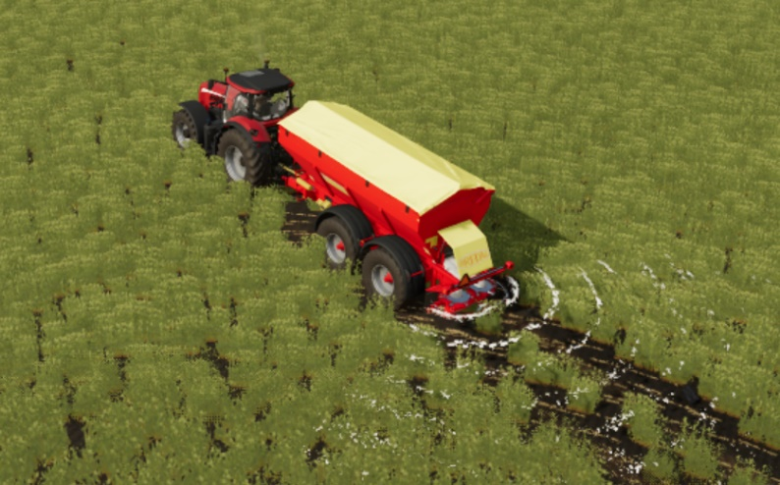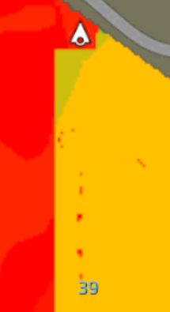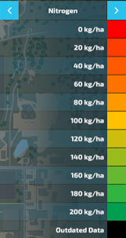
Fig. A.2.4. (left) N application, (middle) N application map of the field with red color showing the area of not applied N, and (right) the different N levels.

Yield mapping and financial analysis
Yield mapping provides the ability to see the yield at specific points in each field (Fig. A.2.5). Different yield potentials are specified for different crops. Each yield potential is assigned with a specific colour, from red for low yields to green for high yields. Yield maps are also used to analyse the field afterward as each field has its financial analysis that is shown in the box (Fig. A.2.5). The box presents the cost, income, and balance of the field. The player can see the total or the reset values of the field in a window. The reset values are the statistics since the last reset button click. The player can use the "Economic analysis" panel to compare different harvests. Fig. A.2.5 shows the values for a particular field in the game. It presents the cost of soil sampling, liming, fertiliser, seed, fuel, vehicle maintenance, and labour. It also shows the Gross Margin from the crop. The player can see the total income with the extracted costs.

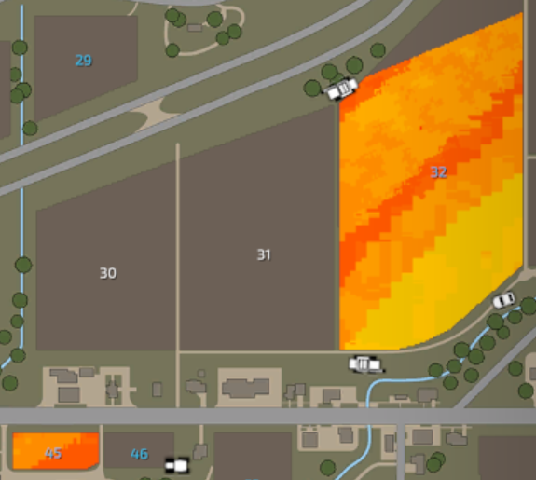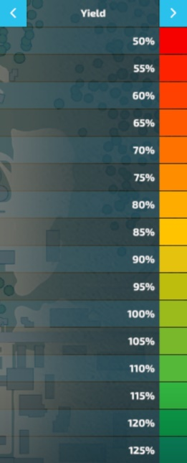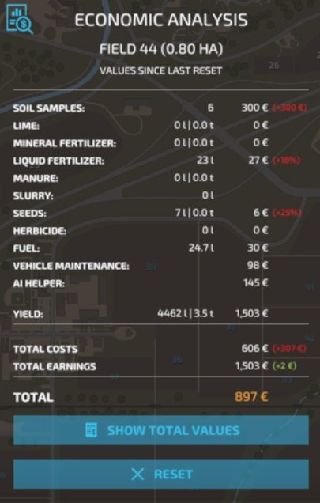
Fig. A.2.5. (left) Yield mapping and (right) financial analysis.

Purchase of soil/nutrient maps from a service provider​
This feature allows the player to save time by not having to perform soil sampling in manual mode. The decision to add this feature was because after the release of the first manual soil sampling DLC, there were many complaints from students and players of the game that soil sampling was a time-consuming experience and, at one point, became annoying. The price varies depending on the size of the field, the number of soil samples, and the time that was spent by an Artificial Intelligence (AI) worker.

Variable rate seeding/drilling
Variable rate seeding/drilling has been added for several crops (Fig. A.2.6). Three seed rate options are available: low, standard, and high. The seed rate adjustment is available in different zones of each field. The best seeding rate has the highest yield potential and increases the crop’s competitiveness against weeds.

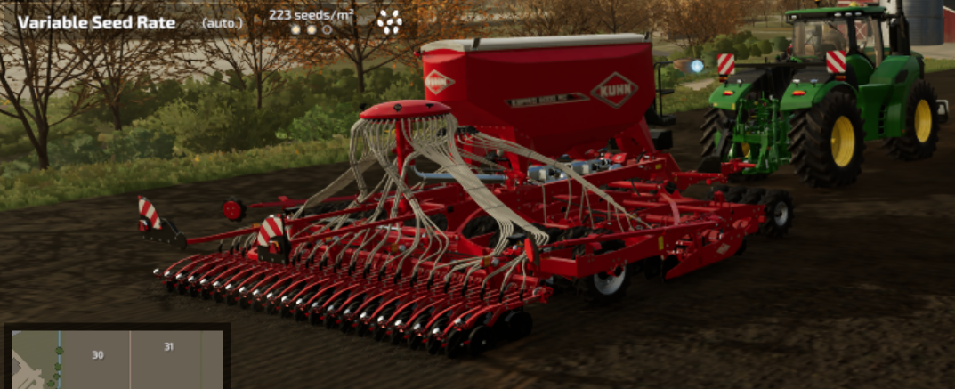
Fig. A.2.6. Variable rate seeding/drilling.

Variable rate weed control and individual nozzle control
In the basic version of the game and also in the DLC 1, weeds appear uniformly across the field. In this situation, the implementation of spot spraying is not possible. To present this feature of PF, the changes were done in the DCL 2. Thus, weeds may appear in larger or smaller patches in different spots of a field. Because weeds do not grow all over the field, there is an opportunity to save money on herbicide by using a sprayer with a "spot spray" option (Fig. A.2.7). This ensures that each nozzle on the sprayer is only activated when there are actual weeds under the nozzle. The DLC added the John Deere R732i PowrSpray sprayer, which included the See & Spray™ configuration.
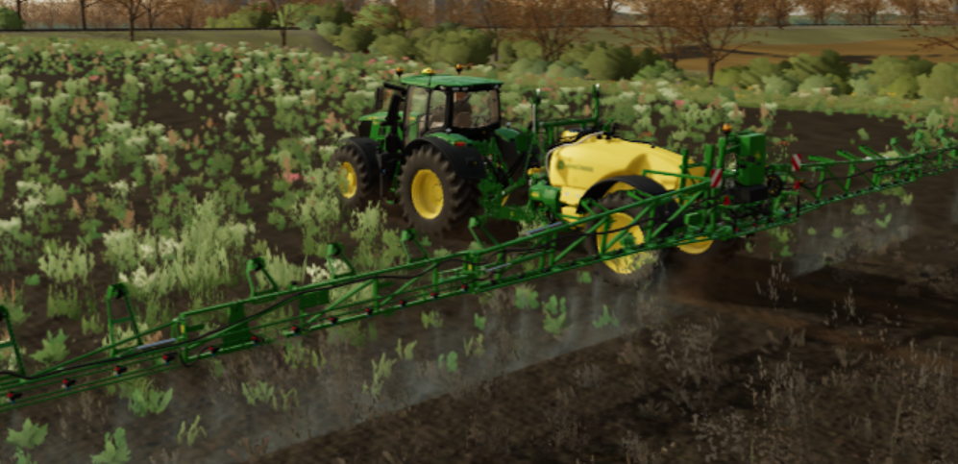
Fig. A.2.7. Variable rate weed control with a camera and individual nozzle control.

Variable rate organic fertilization with HarvestLabTM Manure Sensing
The DLC 2 has added new functionality to the game so that the N concentration in the slurry is no longer homogeneous but varies constantly. The N applied can vary by up to 40.0 % from the expected application rate. To compensate for this, each slurry tanker in the game now has the option to install John Deere’s Manure Sensing System, which uses a near-infrared sensor to measure the current N content. As the machine travels across the field, the fertiliser application can be adjusted based on the information from the sensor.

Definition of crop N demand/variable rate fertilisation
Two sensors are available in the game: (i) "active" - the ISARIA PRO Active - which can be used day and night: and (ii) "passive" - the ISARIA PRO Compact - which requires daylight to function. Using the information provided by these sensors, variable rate N fertilisation can be applied in real time.

References
[1] LNW, “Kalkung Landwirtschaftskammer Nordrhein-Westfalen,” 2015.

