Supporting Information
Reduced body mass in a highly insectivorous mammal, the garden dormouse - Ecological consequences of insect decline?
Stefanie Erhardt^{1,2}, Marc I. Förschler³, Joanna Fietz^{1,2}

¹ University of Hohenheim, Institute of Biology, Department of Zoology, Stuttgart, Germany
² KomBioTa – Center of Biodiversity and Integrative Taxonomy, University of Hohenheim, Stuttgart, Germany
³ Black Forest National Park, Department for Ecological Monitoring, Research and Species Protection, Seebach, Germany

Corresponding author: Stefanie.erhardt@uni-hohenheim.de

Table S1: Results of the linear mixed effect model explaining the variance of the proportion of arthropod residues in the fecal samples of adult garden dormice (n = 31, N = 15). Reference level is the month_{May/June}, sex_{female}, year₂₀₁₈. Random factor: ID, variance of random effect is 0.08, residual variance is 0.01, R²m = 0.39, R²c = 0.91.
 | estimate | SE | df | t | p
(Intercept) | 0.21 | 0.15 | 25 | 1.45 | 0.16 | n.s.
month_{July} | 0.08 | 0.1 | 13.02 | 0.74 | 0.47 | n.s.
month_{August} | 0.11 | 0.1 | 14.08 | 1.05 | 0.31 | n.s.
month_{Sep.} | 0.47 | 0.12 | 15.38 | 3.91 | < 0.01 | **
year₂₀₁₉ | -0.2 | 0.11 | 23.31 | -1.73 | 0.09 | (.)
sex_{male} | 0.21 | 0.18 | 13.12 | 1.17 | 0.26 | n.s.

Table S2: Tukey post-hoc test for the factor month of the linear mixed effect model explaining the variance in arthropod residuals in fecal samples of adult garden dormice (n = 31, N = 15).
 | estimate | SE | z | p
month_{July} – month_{May/June} | 0.08 | 0.1 | 0.74 | 0.88 | n.s.
month_{August} – month_{May/June} | 0.11 | 0.1 | 1.05 | 0.71 | n.s.
month_{Sep.} – month_{May/June} | 0.47 | 0.12 | 3.91 | <0.001 | ***
month_{August} – month_{July} | 0.03 | 0.07 | 0.44 | 0.97 | n.s.
month_{Sept.} – month_{July} | 0.4 | 0.09 | 4.43 | <0.001 | ***
month_{Sep.} – month_{August} | 0.37 | 0.08 | 4.52 | <0.001 | ***

Table S3: Results of the linear mixed effect model explaining the square root transformed variance of the proportion of seed residues in the fecal samples of adult garden dormice (n = 31, N = 15). Reference level is the month May/June. Random factor = ID, variance of random effect is 0.02, residual variance is 0.03, R²m = 0.26, R²c = 0.53.
 | estimate | SE | df | t | p
(Intercept) | 0.28 | 0.14 | 22.45 | 1.98 | 0.06 | (.)
month_{July} | -0.02 | 0.14 | 13.05 | -0.17 | 0.87 | n.s.
month_{August} | 0.14 | 0.13 | 20.63 | 1.1 | 0.28 | n.s.
month_{Sep.} | 0.11 | 0.15 | 23.43 | 0.76 | 0.45 | n.s.
year₂₀₁₉ | -0.2 | 0.11 | 13.35 | -1.9 | 0.08 | (.)
sex_{male} | -0.12 | 0.13 | 7.44 | -0.95 | 0.37 | n.s.

Table S4: Tukey post-hoc test for the factor month of the linear mixed effect model explaining the variance in seed residuals in fecal samples of adult garden dormice (n = 31, N = 15).
 | estimate | SE | z | p
month_{July} – month_{May/June} | -0.02 | 0.14 | -0.17 | 0.998 | n.s.
month_{August} – month_{May/June} | 0.14 | 0.13 | 1.1 | 0.68 | n.s.
month_{Sep.} – month_{May/June} | 0.11 | 0.15 | 0.76 | 0.89 | n.s.
month_{August} – month_{July} | 0.17 | 0.1 | 1.70 | 0.32 | n.s.
month_{Sept.} – month_{July} | 0.14 | 0.12 | 1.12 | 0.64 | n.s.
month_{Sep.} – month_{August} | -0.03 | 0.1 | -0.29 | 0.99 | n.s.

Table S5: Tukey post-hoc test for the factor month of the linear mixed effect model explaining the variance in the proportion of arthropod residuals in fecal samples of juvenile garden dormice (n = 47, N = 33).
 | estimate |  | SE | z | p
month_{August} – month_{July} | 0.15 | 0.1 |  | 1.46 | 0.31 | n.s.
month_{Sept.} – month_{July} | 0.06 | 0.1 |  | 0.63 | 0.81 | n.s.
month_{Sep.} – month_{August} | -0.08 | 0.09 |  | -0.94 | 0.62 | n.s.

Table S6: Results of the linear mixed effect model explaining the variance of the proportion of arthropod residuals in fecal samples in juvenile garden dormice (n=47, N=35). Reference level of the factor: month_{July}, year₂₀₁₈. Random factor = ID, R²m = 0.10.
 | estimate | SE | df | t | p
(Intercept) | 0.5 | 0.08 | 43 | 6.07 | < 0.001 | ***
month_{August} | 0.15 | 0.01 | 43 | 1.46 | 0.15 | n.s.
month_{Sep.} | 0.06 | 0.1 | 43 | 0.63 | 0.54 | n.s.
year₂₀₁₉ | -0.16 | 0.08 | 43 | -2.06 | < 0.05 | *

Table S7: Results of the negative binomial generalized linear model explaining the variance of the proportion of fruit residuals in fecal samples in juvenile garden dormice (n = 47, N = 33). Reference level of the factor: month_{July}, year₂₀₁₈. Random factor = ID, R²m = 0.09.
 | estimate | SE | z | p
(Intercept) | -2.0 | 0.84 | -2.37 | < 0.05 | *
month_{August} | -0.58 | 1.11 | -0.52 | 0.61 | n.s.
month_{Sep.} | -1.31 | 1.37 | -0.95 | 0.34 | n.s.
year₂₀₁₉ | 0.1 | 1.04 | 0.1 | 0.92 | n.s.

Table S8: Tukey post-hoc test for the factor month of the linear mixed effect model explaining the variance in the proportion of fruit residuals in fecal samples of juvenile garden dormice.
 | estimate | SE | z | p
month_{August} – month_{July} | -0.58 | 1.11 | -0.52 | 0.86 | n.s.
month_{Sept.} – month_{July} | -1.31 | 1.37 | -0.95 | 0.61 | n.s.
month_{Sep.} – month_{August} | -0.73 | 1.45 | -0.5 | 0.87 | n.s

Table S9: Results of the negative binomial generalized linear model explaining the variance of the proportion of seed residuals in fecal samples in juvenile garden dormice (n = 47, N = 33). Reference level of the factor: month_{July}, year₂₀₁₈. Random factor = ID, R²m = 0.11.
 | estimate | SE | z | p
(Intercept) | -2.27 | 0.98 | -2.34 | 0.02 | *
month_{August} | 0.31 | 1.27 | 0.24 | 0.81 | n.s.
month_{Sep.} | 0.81 | 1.1 | 0.74 | 0.45 | n.s.
year₂₀₁₉ | -0.85 | 0.96 | -0.9 | 0.37 | n.s.

Table S10: Tukey post-hoc test for the factor month of the linear mixed effect model explaining the variance in the proportion of seed residuals in fecal samples of juvenile garden dormice.
 | estimate | SE | z | p
month_{August} – month_{July} | 0.31 | 1.27 | 0.24 | 0.97 | n.s.
month_{Sept.} – month_{July} | 0.81 | 1.1 | 0.74 | 0.74 | n.s.
month_{Sep.} – month_{August} | 0.5 | 1 | 0.5 | 0.87 | n.s.

Table S11: Estimated marginal means for the interaction month x period of the linear mixed effect model explaining the variance in BM of female garden dormice.
month | period | emmean | SE | df | lower CI | upperCI
May | period 1 | 64 | 4.1 | 73.6 | 55.7 | 72.3
June | period 1 | 68.5 | 3.5 | 49.6 | 61.5 | 75.6
July | period 1 | 67.9 | 3.4 | 46.7 | 61.1 | 74.7
August | period 1 | 71 | 3.2 | 38.1 | 64.5 | 77.5
Sep. | period 1 | 85.5 | 3.6 | 55 | 78.3 | 92.8
May | period 2 | 63.5 | 3.7 | 63.1 | 56.2 | 70.8
June | period 2 | 66.5 | 4.9 | 93 | 56.9 | 76.2
July | period 2 | 60.4 | 3.2 | 41 | 54 | 66.9
August | period 2 | 64.2 | 3 | 36.5 | 58.1 | 70.3
Sep. | period 2 | 75.5 | 3 | 34.6 | 69.4 | 81.5

Table S12: Post-hoc test for the interaction month x period of the linear mixed effect model explaining the variance in BM of female garden dormice.
 | contrast | estimate | SE | df | lowerCI | upperCI | t | p
period 1 | June-May | 4.5 | 3.8 | 93.2 | -3.0 | 12.1 | 1.12 | 0.23 | n.s.
period 1 | July-May | 3.9 | 3.9 | 96.7 | -3.8 | 11.6 | 1.0 | 0.32 | n.s.
period 1 | July-June | -0.7 | 3.0 | 94.3 | -6.6 | 5.3 | -0.2 | 0.82 | n.s.
period 1 | August-May | 7.0 | 4.0 | 97.9 | -0.9 | 15.0 | 1.8 | 0.08 | n.s.
period 1 | August-June | 2.5 | 3.0 | 100.1 | -3.5 | 8.5 | 0.8 | 0.42 | n.s.
period 1 | August-July | 3.1 | 2.4 | 89.4 | -1.7 | 8.0 | 1.3 | 0.2 | n.s.
period 1 | Sep.-May | 21.5 | 4.4 | 97.8 | 12.8 | 30.3 | 4.9 | < 0.001 | ***
period 1 | Sep.-June | 17.0 | 3.6 | 100.4 | 9.9 | 24.1 | 4.8 | < 0.001 | ***
period 1 | Sep.-July | 17.7 | 3.0 | 92.9 | 11.7 | 23.6 | 5.9 | < 0.001 | ***
period 1 | Sep.-August | 14.5 | 2.6 | 89 | 9.4 | 19.7 | 5.6 | < 0.001 | ***
period 2 | June-May | 3.0 | 4.8 | 93.3 | -6.5 | 12.6 | 0.6 | 0.53 | n.s.
period 2 | July-May | -3.1 | 3.2 | 94.3 | -9.4 | 3.2 | -1.0 | 0.33 | n.s.
period 2 | July-June | -6.1 | 4.8 | 99.4 | -15.6 | 3.4 | -1.3 | 0.2 | n.s.
period 2 | August-May | 0.7 | 2.9 | 86 | -5.0 | 6.5 | 0.3 | 0.8 | n.s.
period 2 | August-June | -2.3 | 4.4 | 96.8 | -11.0 | 6.4 | -0.5 | 0.6 | n.s.
period 2 | August-July | 3.8 | 2.4 | 92.6 | -0.9 | 8.6 | 1.6 | 0.11 | n.s.
period 2 | Sep.-May | 12.0 | 2.9 | 88.9 | 6.2 | 17.8 | 4.1 | < 0.001 | ***
period 2 | Sep.-June | 8.9 | 4.6 | 97.7 | -0.1 | 18.0 | 2.0 | 0.053 | (.)
period 2 | Sep.-July | 15.1 | 2.3 | 96 | 10.5 | 19.6 | 6.5 | < 0.001 | ***
period 2 | Sep.-August | 11.2 | 2.0 | 84.6 | 7.2 | 15.3 | 5.6 | < 0.001 | ***
month_{May} | period 2-period 1 | -0.5 | 5.5 | 79 | -11.5 | 10.5 | -0.1 | 0.93 | n.s.
month_{June} | period 2-period 1 | -2.0 | 5.8 | 90.9 | -13.6 | 9.5 | -0.3 | 0.73 | n.s.
month_{July} | period 2-period 1 | -7.5 | 4.4 | 50.4 | -16.2 | 1.3 | -1.7 | 0.09 | (.)
month_{August} | period 2-period 1 | -6.8 | 4.2 | 44.1 | -15.2 | 1.7 | -1.6 | 0.11 | n.s.
month_{Sep.} | period 2-period 1 | -10.1 | 4.4 | 51.1 | -18.9 | -1.3 | -2.3 | < 0.05 | *

Table S13: Results of the linear mixed effect model, explaining the variance in BM of female garden dormice (n = 118, N = 29) reference level of factors: month_{May}, time period₂₀₀₃₋₂₀₀₅, site_{ME,}, random factor = ID. Variance of random effect: 43.8, residual variance: 34.5, R²m = 0.48, R²c = 0.72. Significant differences are bold.
 | estimate | SE | df | t | p
(Intercept) | -27.4 | 23.5 | 94.9 | -1.2 | 0.25 | n.s.
month_{June} | 4.5 | 3.8 | 90.0 | 1.2 | 0.23 | n.s.
month_{July} | 3.9 | 3.8 | 94.4 | 1.0 | 0.32 | n.s.
month_{August} | 7.0 | 4.0 | 95.9 | 1.8 | 0.08 | (.)
month_{Sep.} | 21.5 | 4.4 | 95.8 | 4.9 | < 0.001 | ***
TL | 2.6 | 0.7 | 99.5 | 3.7 | < 0.001 | ***
period₂ | -0.5 | 5.5 | 73.0 | -0.1 | 0.93 | n.s.
site_{RL} | 5.6 | 5.4 | 20.9 | 1.0 | 0.31 | n.s.
site_{WK} | 3.56 | 7.1 | 19.3 | 0.5 | 0.62 | n.s.
T_{aminhib} | 0.2 | 3.5 | 74.3 | 0.05 | 0.96 | n.s.
month_{June}: period 2 | -1.5 | 6.1 | 91.7 | -0.2 | 0.80 | n.s.
month_{July}: period 2 | -7.0 | 4.8 | 92.0 | -1.5 | 0.15 | n.s.
month_{August}: period 2 | -6.3 | 4.6 | 90.7 | -1.4 | 0.18 | n.s.
month_{Sep.}: period 2 | -9.6 | 4.9 | 92.5 | -2.0 | 0.054 | (.)

Table S14: Tukey post-hoc test for the factor study site of the linear mixed effect model explaining the variance in BM of female garden dormice.
 | estimate | SE | z | p
site_{RL} – site_{ME} | 5.6 | 5.4 | 1.0 | 0.54 | n.s.
site_{WK} – site_{ME} | 3.6 | 7.1 | 0.5 | 0.86 | n.s.
site_{WK} – site_{RL} | -2.1 | 4.5 | -0.5 | 0.88 | n.s.

Table S15: Estimated marginal means for the interaction month x period of the linear mixed effect model explaining the variance in BM of male garden dormice.
month | period | emmean | SE | df | lower CI | upperCI
May | period 1 | 66.1 | 2.9 | 58.9 | 60.4 | 71.8
June | period 1 | 67.1 | 2.9 | 46.4 | 61.4 | 72.9
July | period 1 | 68.8 | 3.2 | 49.7 | 62.5 | 75.1
August | period 1 | 81 | 4 | 58.2 | 73 | 89.1
Sep. | period 1 | 105.1 | 4.2 | 62.6 | 96.7 | 113.5
May | period 2 | 61.7 | 2.9 | 45.2 | 55.9 | 67.5
June | period 2 | 62.2 | 5.7 | 65.2 | 50.8 | 73.5
July | period 2 | 66.4 | 3.6 | 39.9 | 59.3 | 73.6
August | period 2 | 77.1 | 3.6 | 58 | 69.9 | 84.2
Sep. | period 2 | 91.8 | 4 | 57.4 | 83.7 | 100

Table S16: Post-hoc test for the interaction month x period of the linear mixed effect model explaining the variance in BM of male garden dormice.
 |  | estimate | SE | df | lower CI | upper CI | t | p
period 1 | June-May | 1.0 | 2.2 | 69 | -3.4 | 5.4 | 0.5 | 0.64 | n.s.
period 1 | July-May | 2.7 | 2.5 | 68.9 | -2.3 | 7.7 | 1.1 | 0.29 | n.s.
period 1 | July-June | 1.7 | 2.6 | 67.5 | -3.5 | 6.8 | 0.6 | 0.52 | n.s.
period 1 | August-May | 14.9 | 3.2 | 68.8 | 8.6 | 21.3 | 4.7 | < 0.001 | ***
period 1 | August-June | 13.9 | 3.3 | 68.8 | 7.3 | 20.5 | 4.2 | < 0.001 | ***
period 1 | August-July | 12.2 | 3.3 | 60.7 | 5.6 | 18.9 | 3.7 | < 0.001 | ***
period 1 | Sep.-May | 39.0 | 3.6 | 68.9 | 31.9 | 46.0 | 11.9 | < 0.001 | ***
period 1 | Sep.-June | 37.9 | 3.7 | 69 | 30.6 | 45.3 | 10.3 | < 0.001 | ***
period 1 | Sep.-July | 36.3 | 3.8 | 66.1 | 28.7 | 43.8 | 9.6 | < 0.001 | ***
period 1 | Sep.-August | 24.0 | 4.2 | 62.1 | 15.7 | 32.4 | 5.8 | < 0.001 | ***
period 2 | June-May | 0.5 | 5.4 | 67.4 | -10.3 | 11.3 | 0.1 | 0.93 | n.s.
period 2 | July-May | 4.8 | 3.6 | 48.8 | -2.4 | 11.9 | 1.3 | 0.19 | n.s.
period 2 | July-June | 4.3 | 6.0 | 63.4 | -7.8 | 16.3 | 0.7 | 0.48 | n.s.
period 2 | August-May | 15.4 | 3.8 | 58.5 | 7.8 | 23.0 | 4.1 | < 0.001 | ***
period 2 | August-June | 14.9 | 5.3 | 62.2 | 4.4 | 25.4 | 2.8 | < 0.01 | **
period 2 | August-July | 10.6 | 4.4 | 48.9 | 1.8 | 19.5 | 2.4 | < 0.05 | *
period 2 | Sep.-May | 30.1 | 4.4 | 58.3 | 21.3 | 38.9 | 6.8 | < 0.001 | ***
period 2 | Sep.-June | 29.6 | 5.9 | 64 | 17.8 | 41.4 | 5.0 | < 0.001 | ***
period 2 | Sep.-July | 25.4 | 5.2 | 54.6 | 15.0 | 35.7 | 4.9 | < 0.001 | ***
period 2 | Sep.-August | 14.7 | 4.3 | 67.4 | 6.2 | 23.3 | 3.4 | < 0.01 | **
month_{May} | period 2-period 1 | -4.4 | 3.1 | 56.8 | -10.6 | 1.8 | -1.4 | 0.16 | n.s.
month_{June} | period 2-period 1 | -5.0 | 6.4 | 64.8 | -17.7 | 7.8 | -0.8 | 0.44 | n.s.
month_{July} | period 2-period 1 | -2.4 | 3.9 | 40.7 | -10.2 | 5.5 | -0.6 | 0.55 | n.s.
month_{August} | period 2-period 1 | -3.9 | 5.2 | 54.6 | -14.3 | 6.5 | -0.8 | 0.45 | n.s.
month_{Sep,} | period 2-period 1 | -13.2 | 6.2 | 61.6 | -25.6 | -0.9 | -2.2 | < 0.05 | *

Table S17: Results of the linear mixed effect model, explaining the variance in BM of male garden dormice (n = 83, N = 32) reference level of factors: month_{May}, time period₂₀₀₃₋₂₀₀₅, site_{ME,} random factor = ID. Variance of random effect: 1.47, residual variance: 36.7, R²m = 0.77, R²c = 0.78. Significant differences are bold.

 | estimate | SE | df | t | p
(Intercept) | 20.9 | 26.1 | 68.1 | 0.8 | 0.43 | n.s.
month_{June} | 1.0 | 2.2 | 69.0 | 0.5 | 0.63 | n.s.
month_{July} | 2.7 | 2.5 | 68.9 | 1.1 | 0.28 | n.s.
month_{August} | 14.9 | 3.1 | 68.9 | 4.9 | < 0.001 | ***
month_{Sep.} | 39.0 | 3.4 | 68.9 | 11.4 | < 0.001 | ***
TL | 1.2 | 0.7 | 68.0 | 1.8 | 0.08 | (.)
period 2 | -4.4 | 3.7 | 62.3 | -1.4 | 0.16 | n.s.
site_{RL} | 0.2 | 4.7 | 50.0 | 0.05 | 0.96 | n.s.
site_{WK} | 4.6 | 6.5 | 51.7 | 0.7 | 0.48 | n.s.
T_{aminhib} | 2.7 | 4.3 | 68.9 | 0.6 | 0.53 | n.s.
month_{June}: period 2 | -0.5 | 5.8 | 68.1 | -0.1 | 0.92 | n.s.
month_{July}: period 2 | 2.1 | 4.2 | 64.6 | 0.5 | 0.62 | n.s.
month_{August}: period 2 | 0.5 | 4.6 | 65.6 | 0.1 | 0.91 | n.s.
month_{Sep.}: period 2 | -8.8 | 5.6 | 66.8 | -1.6 | 0.12 | n.s.

Table S18: Tukey post-hoc test for the factor study site of the linear mixed effect model explaining the variance in BM of male garden dormice.
 | estimate | SE | z | p
site_{RL} – site_{ME} | 0.2 | 4.7 | 0.05 | 1.0 | n.s.
site_{WK} – site_{ME} | 4.6 | 6.5 | 0.7 | 0.75 | n.s.
site_{WK} – site_{RL} | 4.4 | 4.5 | 1.0 | 0.58 | n.s.

Table S19: Tukey post-hoc test for the linear mixed effect model explaining the variance in TL of adult garden dormice.
 | estimate | SE | z | p
month_{June}-month_{May} | -0.09 | 0.26 | -0.33 | 1.0 | n.s.
month_{July}-month_{May} | 0.77 | 0.25 | 3.12 | < 0.05 | *
month_{August}-month_{May} | 1.25 | 0.26 | 4.76 | < 0.001 | ***
month_{Sep}-month_{May} | 0.62 | 0.36 | 1.72 | 0.41 | n.s.
month_{July}-month_{June} | 0.86 | 0.26 | 3.3 | < 0.01 | **
month_{August}-month_{June} | 1.34 | 0.27 | 5.0 | < 0.001 | ***
month_{Sep}-month_{June} | 0.71 | 0.36 | 2.0 | 0.27 | n.s.
month_{August}-month_{July} | 0.48 | 0.23 | 2.09 | 0.21 | n.s.
month_{Sep}-month_{July} | -0.15 | 0.32 | -0.49 | 0.99 | n.s.
month_{Sep}-month_{August} | -0.63 | 0.26 | -2.45 | < 0.1 | (.)

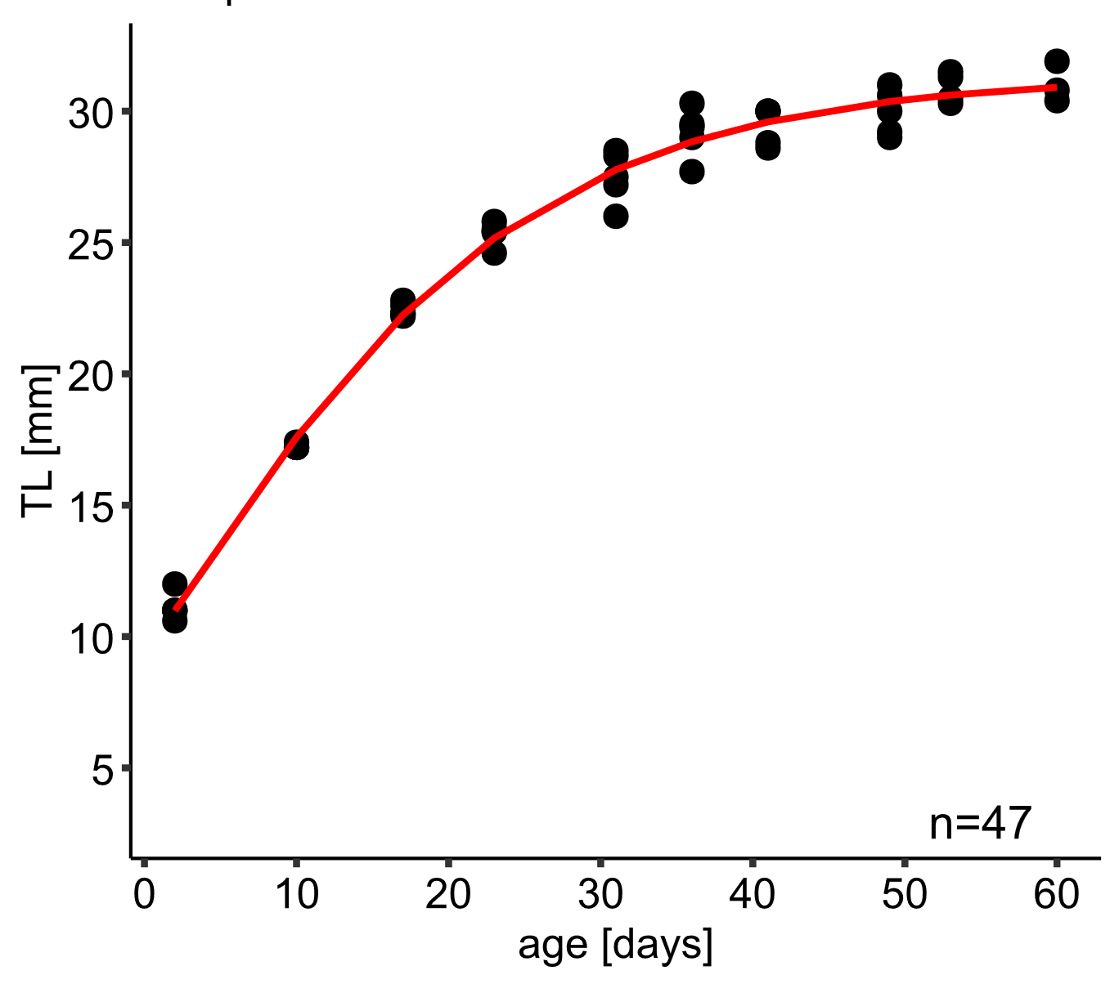
Figure S1: Fit of the Gompertz model (line) to the growth data for TL in the reference litter of juvenile garden dormice at the age between 2 and 60 days.

