EvaMol: A Python Tool for Evaluating Molecules in Hit-to-Lead Optimization

Anna-Maria Herzog, Julia Steuber, Günter Fritz
Department of Cellular Microbiology, University of Hohenheim, 70599 Stuttgart, Germany

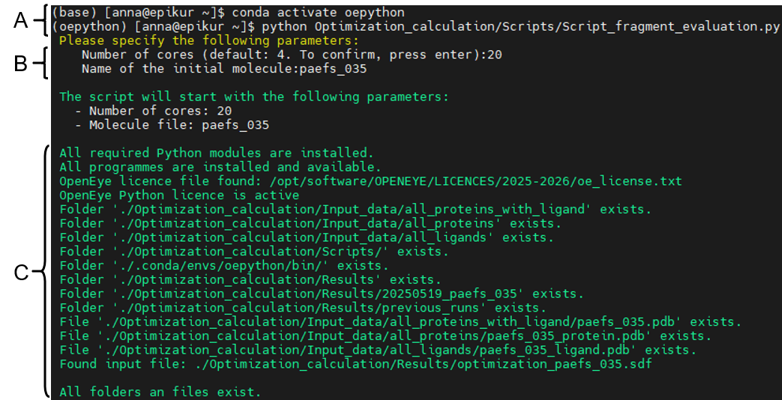
Supplementary Files
Supplementary Figure S1: Starting the software ‘Evaluating Molecules: A Python Tool for Fragment-to-Lead Optimization’ via command line.
Here a screenshot of a typical start of EvaMol is shown. (A) The software is started after the activation of the conda environment ‘oepython’. (B) The user is then prompted to specify the number of computational cores used for the analysis (in this example 20 cores) and the name of the initial molecule (in this example ‘paefs_035’). (C) Subsequently, the software automatically verifies the availability of the required folder structure, files and programs input data files. After verification the analysis starts.

