Regression approaches for modelling genotype-environment interaction and making predictions into unseen environments
Maksym Hrachov¹, Hans-Peter Piepho¹, Niaz Md. Farhat Rahman², Waqas Ahmed Malik¹
1 Biostatistics Unit, Institute of Crop Science, University of Hohenheim, Stuttgart, Germany
2 Bangladesh Rice Research Institute (BRRI), Gazipur, Bangladesh

Theoretical and Applied Genetics (TAG)

Correspondence
Hans-Peter Piepho, Biostatistics Unit, Institute of Crop Science, University of Hohenheim, 70593 Stuttgart, Germany.
Email: piepho@uni-hohenheim.de

SUPPLEMENTARY INFORMATION
Table S1. Model fit (winter rice) featuring the total number of parameters in the model, including those involved in synthetic covariates, full log-likelihood, and Akaike Information Criterion (AIC). Displayed values are rounded. Baseline – model without genotype-covariate interactions, Kernel – model with an environmental kernel matrix, RRR1 and RRR2 – reduced rank regression of rank one and two with observed covariates, FW1-US and FW2-US – random factorial regression with one and two synthetic covariates respectively, RFR – random factorial regression with observed covariates.
With the main EC effect |  |  |  | Without the main EC effect
Model | Parameters | LogLik | AIC | Model | Parameters | LogLik | AIC
Baseline | 16 | -542 | 1117 | Baseline | 8 | -553 | 1122
Kernel | 17 | -542 | 1119 | Kernel | 9 | -553 | 1124
RRR1 | 24 | -525 | 1098 | RRR1 | 16 | -536 | 1104
RRR2 | 32 | -505 | 1074 | RRR2 | 24 | -516 | 1079
RFR | 60 | -496 | 1113 | RFR | 52 | -507 | 1118
FW1-US | 19 | -519 | 1077 | FW1-US | 18 | -524 | 1084
FW2-US | 30 | -507 | 1074 | FW2-US | 28 | -513 | 1082

Table S2. Variance components of models (summer rice). Baseline – model without genotype-covariate interactions, Kernel – model with an environmental kernel matrix, RRR1 and RRR2 – reduced rank regression of rank one and two with observed covariates, FW1-US and FW2-US – random factorial regression with one and two synthetic covariates respectively, RFR – random factorial regression with observed covariates, L – location, Y – year, α – genotype.
Models with the main EC effect
Component | Baseline | Kernel | RRR1 | RRR2 | RFR | FW1-US | FW2-US
L | 0.0568 | 0.0554 | 0.0557 | 0.0536 | 0.0537 | 0.1016 | 0.0535
Y | 0.0262 | 0.0270 | 0.0257 | 0.0287 | 0.0287 | 0.0237 | 0.0370
α | 0.2422 | 0.2438 | 0.2309 | 0.2321 | 0.2291 | 0.2339 | 0.2345
LY | 0.4434 | 0.4442 | 0.4446 | 0.4466 | 0.4462 | 0.4476 | 0.4429
αL | 0.0307 | 0.0225 | 0.0268 | 0.0223 | 0.0186 | 0.0249 | 0.0218
αY | 0.0142 | 0.0108 | 0.0120 | 0.0071 | 0.0060 | 0.0097 | 0.0096
αLY | 0.2695 | 0.2693 | 0.2706 | 0.2678 | 0.2668 | 0.2667 | 0.2666
Models without the main EC effect
Component | Baseline | Kernel | RRR1 | RRR2 | RFR | FW1-US | FW2-US
L | 0.1269 | 0.1275 | 0.1295 | 0.1301 | 0.1308 | 0.1280 | 0.1299
Y | 0.0250 | 0.0263 | 0.0274 | 0.0321 | 0.0320 | 0.0300 | 0.0297
α | 0.2430 | 0.2450 | 0.2328 | 0.2344 | 0.2316 | 0.2352 | 0.2359
LY | 0.4441 | 0.4448 | 0.4459 | 0.4475 | 0.4473 | 0.4459 | 0.4472
αL | 0.0307 | 0.0226 | 0.0269 | 0.0221 | 0.0186 | 0.0248 | 0.0218
αY | 0.0142 | 0.0108 | 0.0119 | 0.0071 | 0.0060 | 0.0097 | 0.0095
αLY | 0.2695 | 0.2693 | 0.2706 | 0.2678 | 0.2669 | 0.2668 | 0.2667

Table S3. Variance components of models (winter rice). Baseline – model without genotype-covariate interactions, Kernel – model with an environmental kernel matrix, RRR1 and RRR2 – reduced rank regression of rank one and two with observed covariates, FW1-US and FW2-US – random factorial regression with one and two synthetic covariates respectively, RFR – random factorial regression with observed covariates, L – location, Y – year, α – genotype.

Models with the main EC effect
Component | Baseline | Kernel | RRR1 | RRR2 | FW1-US | FW2-US | RFR
L | 0.1530 | 0.1530 | 0.1531 | 0.1537 | 0.1529 | 0.1987 | 0.1776
Y | 0.0381 | 0.0381 | 0.0383 | 0.0391 | 0.0388 | 0.0361 | 0.0301
α | 0.1331 | 0.1331 | 0.1034 | 0.1119 | 0.1152 | 0.1115 | 0.1104
LY | 0.4932 | 0.4932 | 0.4928 | 0.4930 | 0.4934 | 0.5030 | 0.5077
αL | 0.0310 | 0.0310 | 0.0304 | 0.0308 | 0.0274 | 0.0321 | 0.0304
αY | 0.0148 | 0.0148 | 0.0134 | 0.0058 | 0.0041 | 0.0066 | 0.0051
αLY | 0.2593 | 0.2593 | 0.2583 | 0.2584 | 0.2569 | 0.2591 | 0.2573
Models without the main EC effect
L | 0.2126 | 0.2126 | 0.2160 | 0.2156 | 0.2135 | 0.2129 | 0.2155
Y | 0.0435 | 0.0435 | 0.0468 | 0.0433 | 0.0425 | 0.0443 | 0.0445
α | 0.1338 | 0.1338 | 0.1051 | 0.1154 | 0.1185 | 0.1146 | 0.1135
LY | 0.5198 | 0.5198 | 0.5210 | 0.5184 | 0.5187 | 0.5202 | 0.5208
αL | 0.0310 | 0.0309 | 0.0303 | 0.0309 | 0.0274 | 0.0322 | 0.0305
αY | 0.0148 | 0.0147 | 0.0134 | 0.0057 | 0.0040 | 0.0064 | 0.0050
αLY | 0.2593 | 0.2593 | 0.2583 | 0.2584 | 0.2569 | 0.2591 | 0.2573

Table S4. Variance components present change relative to the baseline (winter rice). Baseline – model without genotype-covariate interactions, Kernel – model with an environmental kernel matrix, RRR1 and RRR2 – reduced rank regression of rank one and two with observed covariates, FW1-US and FW2-US – random factorial regression with one and two synthetic covariates respectively, RFR – random factorial regression with observed covariates, L – location, Y – year, α – genotype.
Models with the main EC effect
Component | Baselineª | Kernel | RRR1 | RRR2 | RFR | FW1-US | FW2-US
L | 0.1530 | 0.0 | 0.1 | 0.5 | -0.1 | 29.9 | 16.1
Y | 0.0381 | 0.0 | 0.5 | 2.7 | 1.9 | -5.2 | -20.9
α | 0.1331 | 0.0 | -22.3 | -15.9 | -13.4 | -16.3 | -17.0
LY | 0.4932 | 0.0 | -0.1 | 0.0 | 0.0 | 2.0 | 2.9
αL | 0.0310 | -0.1 | -1.9 | -0.6 | -11.7 | 3.5 | -1.9
αY | 0.0148 | -0.1 | -9.3 | -60.5 | -72.0 | -55.5 | -65.5
αLY | 0.2593 | 0.0 | -0.4 | -0.3 | -0.9 | -0.1 | -0.8
Models without the main EC effect
Component | Baselineª | Kernel | RRR1 | RRR2 | RFR | FW1-US | FW2-US
L | 0.2126 | 0.0 | 1.6 | 1.4 | 0.4 | 0.1 | 1.4
Y | 0.0435 | 0.0 | 7.7 | -0.4 | -2.2 | 1.9 | 2.3
α | 0.1338 | 0.0 | -21.5 | -13.8 | -11.5 | -14.4 | -15.2
LY | 0.5198 | 0.0 | 0.2 | -0.3 | -0.2 | 0.1 | 0.2
αL | 0.0310 | -0.1 | -2.1 | -0.2 | -11.4 | 3.9 | -1.5
αY | 0.0148 | -0.1 | -9.3 | -61.6 | -72.8 | -56.3 | -66.4
αLY | 0.2593 | 0.0 | -0.4 | -0.5 | -1.2 | -0.2 | -0.8
ª Baseline represents the actual values from the Baseline model, the rest are in percent relative to it.
Table S5. Leave-one-environment-out (LOEO) and leave-one-year-and-location-out (LYLO) cross-validation means (winter rice). PCC – Pearson's correlation coefficient, MSEPD – mean squared error of prediction difference, MSPE – mean squared prediction error, Baseline – model without genotype-covariate interactions, Kernel – model with an environmental kernel matrix, RRR1 and RRR2 – reduced rank regression of rank one and two with observed covariates, FW1-US and FW2-US – random factorial regression with one and two synthetic covariates, RFR – random factorial regression with observed covariates.
Type | Model | Mean PCC |  | Mean MSEPD |  | Mean MSPE
Type | Model | LOEO | LYLO | LOEO | LYLO | LOEO | LYLO
With the main EC effect | Baseline | 0.466 | 0.400 | 0.780 | 0.838 | 0.960 | 1.22
With the main EC effect | Kernel | 0.466 | 0.400 | 0.780 | 0.838 | 0.960 | 1.21
With the main EC effect | RRR1 | 0.468 | 0.393 | 0.780 | 0.846 | 0.960 | 1.22
With the main EC effect | RRR2 | 0.465 | 0.389 | 0.779 | 0.850 | 0.962 | 1.22
With the main EC effect | RFR | 0.462 | 0.389 | 0.782 | 0.849 | 0.964 | 1.22
With the main EC effect | FW1-US | 0.468 | 0.391 | 0.777 | 0.847 | 0.957 | 1.22
With the main EC effect | FW2-US | 0.465 | 0.389 | 0.780 | 0.85 | 0.962 | 1.23
Without the main EC effect | Baseline | 0.466 | 0.400 | 0.780 | 0.838 | 0.969 | 1.22
Without the main EC effect | Kernel | 0.466 | 0.400 | 0.780 | 0.838 | 0.969 | 1.22
Without the main EC effect | RRR1 | 0.468 | 0.393 | 0.780 | 0.846 | 0.971 | 1.22
Without the main EC effect | RRR2 | 0.465 | 0.389 | 0.779 | 0.850 | 0.968 | 1.22
Without the main EC effect | RFR | 0.462 | 0.389 | 0.782 | 0.849 | 0.970 | 1.22
Without the main EC effect | FW1-US | 0.467 | 0.391 | 0.777 | 0.847 | 0.966 | 1.22
Without the main EC effect | FW2-US | 0.465 | 0.388 | 0.780 | 0.850 | 0.970 | 1.22

Table S6. Leave-one-environment-out (LOEO) and leave-one-year-and-location-out (LYLO) cross-validation medians (winter rice). PCC – Pearson's correlation coefficient, MSEPD – mean squared error of prediction difference, MSPE – mean squared prediction error, Baseline – model without genotype-covariate interactions, Kernel – model with an environmental kernel matrix, RRR1 and RRR2 – reduced rank regression of rank one and two with observed covariates, FW1-US and FW2-US – random factorial regression with one and two synthetic covariates, RFR – random factorial regression with observed covariates.
Type | Model | Median PCC |  | Median MSEPD |  | Median MSPE
Type | Model | LOEO | LYLO | LOEO | LYLO | LOEO | LYLO
With the main EC effect | Baseline | 0.545 | 0.438 | 0.661 | 0.711 | 0.620 | 0.744
With the main EC effect | Kernel | 0.545 | 0.435 | 0.661 | 0.712 | 0.620 | 0.797
With the main EC effect | RRR1 | 0.544 | 0.430 | 0.658 | 0.701 | 0.622 | 0.816
With the main EC effect | RRR2 | 0.547 | 0.433 | 0.664 | 0.723 | 0.653 | 0.810
With the main EC effect | RFR | 0.553 | 0.427 | 0.678 | 0.722 | 0.634 | 0.804
With the main EC effect | FW1-US | 0.546 | 0.442 | 0.646 | 0.722 | 0.631 | 0.863
With the main EC effect | FW2-US | 0.540 | 0.430 | 0.692 | 0.731 | 0.643 | 0.851
Without the main EC effect | Baseline | 0.546 | 0.437 | 0.661 | 0.711 | 0.658 | 0.824
Without the main EC effect | Kernel | 0.546 | 0.435 | 0.661 | 0.712 | 0.658 | 0.824
Without the main EC effect | RRR1 | 0.544 | 0.431 | 0.657 | 0.702 | 0.664 | 0.851
Without the main EC effect | RRR2 | 0.547 | 0.432 | 0.665 | 0.725 | 0.633 | 0.851
Without the main EC effect | RFR | 0.553 | 0.427 | 0.677 | 0.723 | 0.630 | 0.839
Without the main EC effect | FW1-US | 0.544 | 0.443 | 0.647 | 0.723 | 0.642 | 0.846
Without the main EC effect | FW2-US | 0.539 | 0.431 | 0.693 | 0.734 | 0.634 | 0.846

Table S7. Leave-one-environment-out (LOEO) and leave-one-year-and-location-out (LYLO) cross-validation medians (summer rice). PCC – Pearson's correlation coefficient, MSEPD – mean squared error of prediction difference, MSPE – mean squared prediction error, Baseline – model without genotype-covariate interactions, Kernel – model with an environmental kernel matrix, RRR1 and RRR2 – reduced rank regression of rank one and two with observed covariates, FW1-US and FW2-US – random factorial regression with one and two synthetic covariates, RFR – random factorial regression with observed covariates.
Type | Model | Median PCC |  | Median MSEPD |  | Median MSPE
Type | Model | LOEO | LYLO | LOEO | LYLO | LOEO | LYLO
With the main EC effect | Baseline | 0.697 | 0.665 | 0.645 | 0.699 | 0.576 | 0.656
With the main EC effect | Kernel | 0.695 | 0.671 | 0.617 | 0.697 | 0.570 | 0.645
With the main EC effect | RRR1 | 0.695 | 0.668 | 0.665 | 0.709 | 0.569 | 0.660
With the main EC effect | RRR2 | 0.691 | 0.671 | 0.654 | 0.720 | 0.581 | 0.665
With the main EC effect | RFR | 0.693 | 0.661 | 0.652 | 0.720 | 0.575 | 0.665
With the main EC effect | FW1-US | 0.694 | 0.669 | 0.648 | 0.717 | 0.556 | 0.642
With the main EC effect | FW2-US | 0.694 | 0.669 | 0.665 | 0.716 | 0.605 | 0.625
Without the main EC effect | Baseline | 0.697 | 0.665 | 0.645 | 0.699 | 0.584 | 0.644
Without the main EC effect | Kernel | 0.695 | 0.670 | 0.618 | 0.697 | 0.582 | 0.652
Without the main EC effect | RRR1 | 0.695 | 0.668 | 0.665 | 0.711 | 0.582 | 0.650
Without the main EC effect | RRR2 | 0.691 | 0.670 | 0.654 | 0.720 | 0.567 | 0.672
Without the main EC effect | RFR | 0.693 | 0.662 | 0.653 | 0.720 | 0.561 | 0.678
Without the main EC effect | FW1-US | 0.694 | 0.668 | 0.648 | 0.716 | 0.571 | 0.671
Without the main EC effect | FW2-US | 0.694 | 0.668 | 0.665 | 0.716 | 0.572 | 0.672

Table S8. Mean variance of prediction (MVP) and mean squared prediction error (MSPE) from leave-one-year-and-location-out cross-validation (winter rice). Baseline – model without genotype-covariate interactions, Kernel – model with an environmental kernel matrix, RRR1 and RRR2 – reduced rank regression of rank one and two with observed covariates, FW1-US and FW2-US – random factorial regression with one and two synthetic covariates, RFR – random factorial regression with observed covariates. MVP for the baseline model was taken from the standard ASReml-R output.
Type | Model | MSPE |  | MVP
Type | Model | Mean | Median | Mean | Median
With the main EC effect | Baseline | 1.22 | 0.744 | 1.10 | 1.10
With the main EC effect | RRR1 | 1.22 | 0.816 | 1.17 | 1.17
With the main EC effect | RRR2 | 1.22 | 0.810 | 1.17 | 1.17
With the main EC effect | RFR | 1.22 | 0.804 | 1.16 | 1.16
With the main EC effect | FW1-US | 1.22 | 0.863 | 1.11 | 1.12
With the main EC effect | FW2-US | 1.23 | 0.851 | 1.08 | 1.08
Without the main EC effect | Baseline | 1.22 | 0.824 | 1.12 | 1.12
Without the main EC effect | RRR1 | 1.22 | 0.851 | 1.13 | 1.13
Without the main EC effect | RRR2 | 1.22 | 0.851 | 1.12 | 1.13
Without the main EC effect | RFR | 1.22 | 0.839 | 1.12 | 1.12
Without the main EC effect | FW1-US | 1.22 | 0.846 | 1.12 | 1.12
Without the main EC effect | FW2-US | 1.22 | 0.846 | 1.12 | 1.13

Table S9. Variance of the predicted difference (VPD) and mean squared error of prediction difference (MSEPD) from the leave-one-year-and-location-out cross-validation (winter rice). Baseline – model without genotype-covariate interactions, Kernel – model with an environmental kernel matrix, RRR1 and RRR2 – reduced rank regression of rank one and two with observed covariates, FW1-US and FW2-US – random factorial regression with one and two synthetic covariates, RFR – random factorial regression with observed covariates.
Type | Model | MSEPD |  | VPD
Type | Model | Mean | Median | Mean | Median
With the main EC effect | Baseline | 0.838 | 0.711 | 0.631 | 0.631
With the main EC effect | RRR1 | 0.846 | 0.701 | 0.626 | 0.634
With the main EC effect | RRR2 | 0.850 | 0.723 | 0.612 | 0.628
With the main EC effect | RFR | 0.849 | 0.722 | 0.624 | 0.614
With the main EC effect | FW1-US | 0.847 | 0.722 | 0.614 | 0.624
With the main EC effect | FW2-US | 0.85 | 0.731 | 0.635 | 0.616
Without the main EC effect | Baseline | 0.838 | 0.711 | 0.631 | 0.631
Without the main EC effect | RRR1 | 0.846 | 0.702 | 0.635 | 0.634
Without the main EC effect | RRR2 | 0.850 | 0.725 | 0.626 | 0.628
Without the main EC effect | RFR | 0.849 | 0.723 | 0.612 | 0.614
Without the main EC effect | FW1-US | 0.847 | 0.723 | 0.624 | 0.624
Without the main EC effect | FW2-US | 0.85 | 0.734 | 0.614 | 0.615

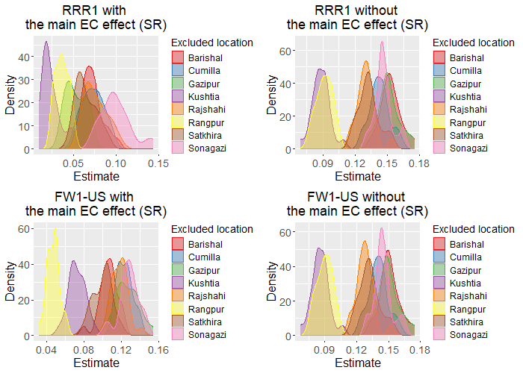
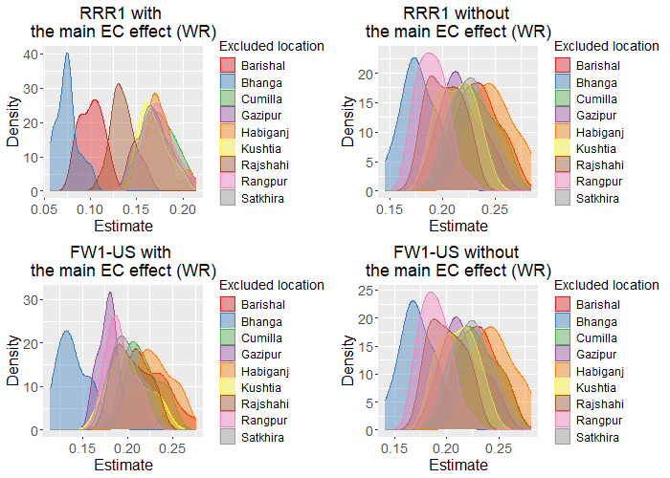
Figure S1. The distribution of the location (L) variance component estimate in leave-one-year-and-location-out (LYLO) cross-validation (CV) for the summer rice (SR) and the winter rice (WR) datasets. RRR1 and RRR2 – reduced rank regression of rank one and two with observed covariates, FW1-US and FW2-US – random factorial regression with one and two synthetic covariates.
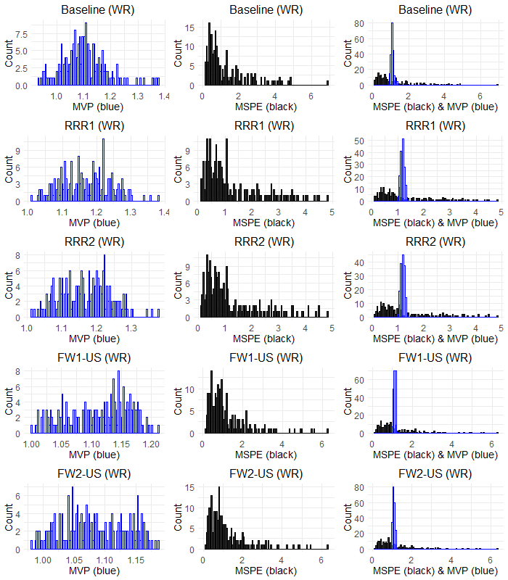
Figure S2. Distributions of model-based mean variance of prediction and cross-validation-based mean squared prediction error for all models with the main EC effect fitted to the winter rice (WR) data. Baseline – model without genotype-covariate interactions, RRR1 and RRR2 – reduced rank regression of rank one and two with observed covariates, FW1-US and FW2-US – random factorial regression with one and two synthetic covariates.
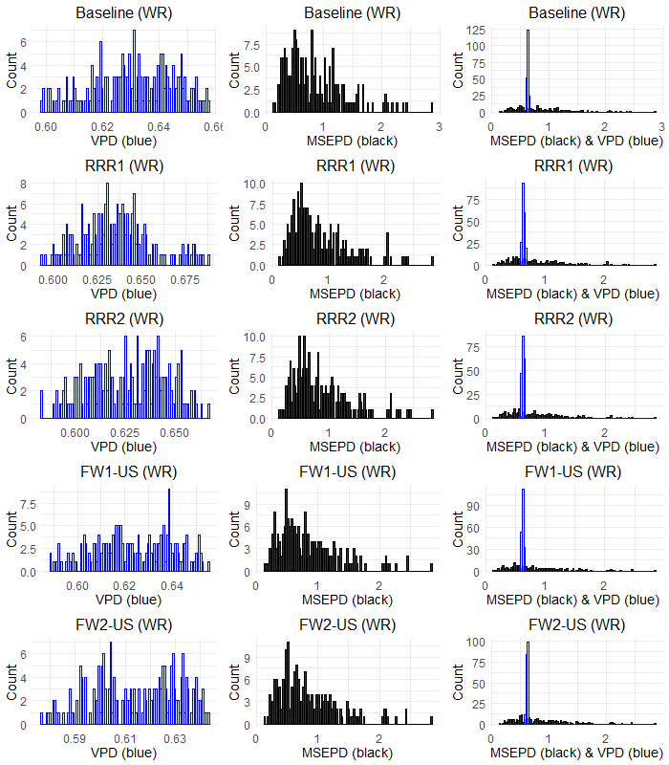
Figure S3. Distributions of model-based variance of predicted difference and cross-validation-based mean squared error of prediction difference for all models with the main EC effect fitted to the winter rice (WR) data. Baseline – model without genotype-covariate interactions, RRR1 and RRR2 – reduced rank regression of rank one and two with observed covariates, FW1-US and FW2-US – random factorial regression with one and two synthetic covariates.

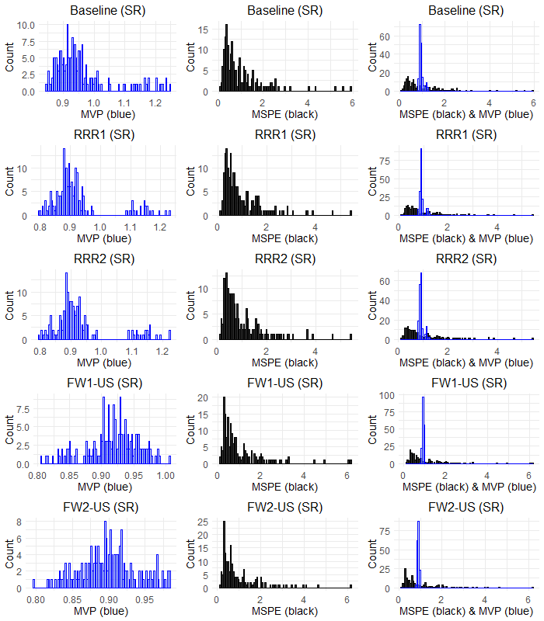
Figure S4. Distributions of model-based mean variance of prediction and cross-validation-based mean squared prediction error for all models with the main EC effect fitted to the summer rice (SR) data. Baseline – model without genotype-covariate interactions, RRR1 and RRR2 – reduced rank regression of rank one and two with observed covariates, FW1-US and FW2-US – random factorial regression with one and two synthetic covariates.

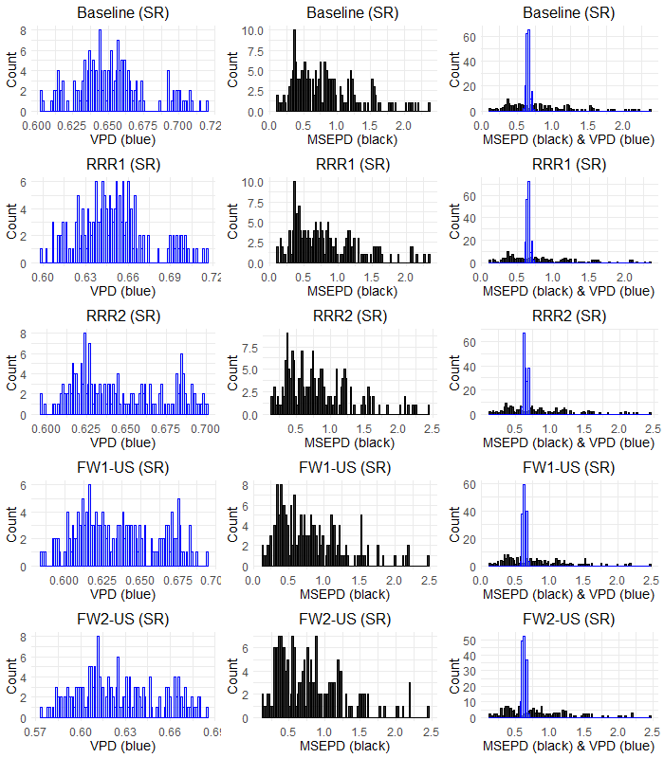
Figure S5. Distributions of model-based variance of predicted difference and cross-validation-based mean squared error of prediction difference for all models with the main EC effect fitted to the summer rice (SR) data. Baseline – model without genotype-covariate interactions, RRR1 and RRR2 – reduced rank regression of rank one and two with observed covariates, FW1-US and FW2-US – random factorial regression with one and two synthetic covariates.

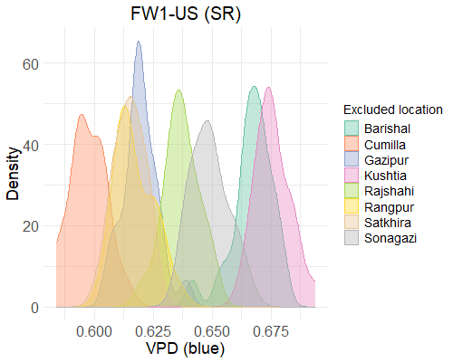
Figure S6. The bimodal distribution observed in Fig. S5 is due to exclusion of locations in the leave-one-year-and-location-out (LYLO) cross-validation approach. Different colors represent which location was excluded. VPD – variance of the predicted difference, FW1-US – random factorial regression with one synthetic covariate (with the main EC effect).

