Supplementary Material

Exploration of surfactin production by newly isolated Bacillus and Lysinibacillus strains from food related sources
Stephen Olusanmi Akintayo^{1,2}, Chantal Treinen¹, Maliheh Vahidinasab¹, Jens Pfannstiel³, Ute Bertsche³, Ilesanmi Fadahunsi², Claudia Oellig⁴, Michael Granvogl⁴, Marius Henkel¹, Lars Lilge^{1*}, Rudolf Hausmann¹
¹Department of Bioprocess Engineering, Institute of Food Science and Biotechnology, University of Hohenheim, Stuttgart, Germany
²Department of Microbiology, University of Ibadan, Ibadan, Nigeria
³ Core Facility Hohenheim, Mass Spectrometry Core Facility, University of Hohenheim, Ottilie-Zeller-Weg 2, 70599 Stuttgart, Germany
⁴Department of Food Chemistry and Analytical Chemistry, Institute of Food Chemistry, University of Hohenheim, Stuttgart, Germany

(A)
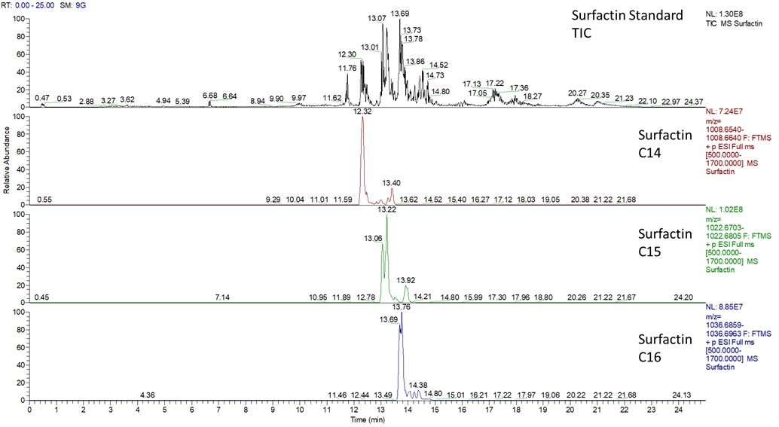
(B)
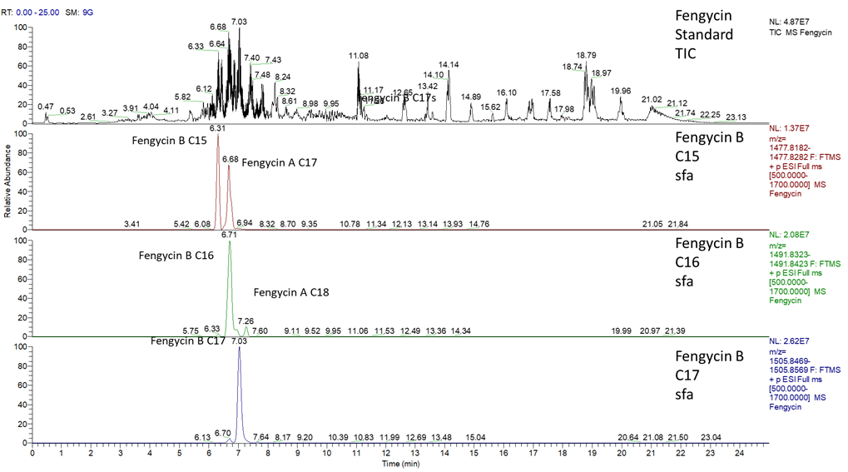

(C)
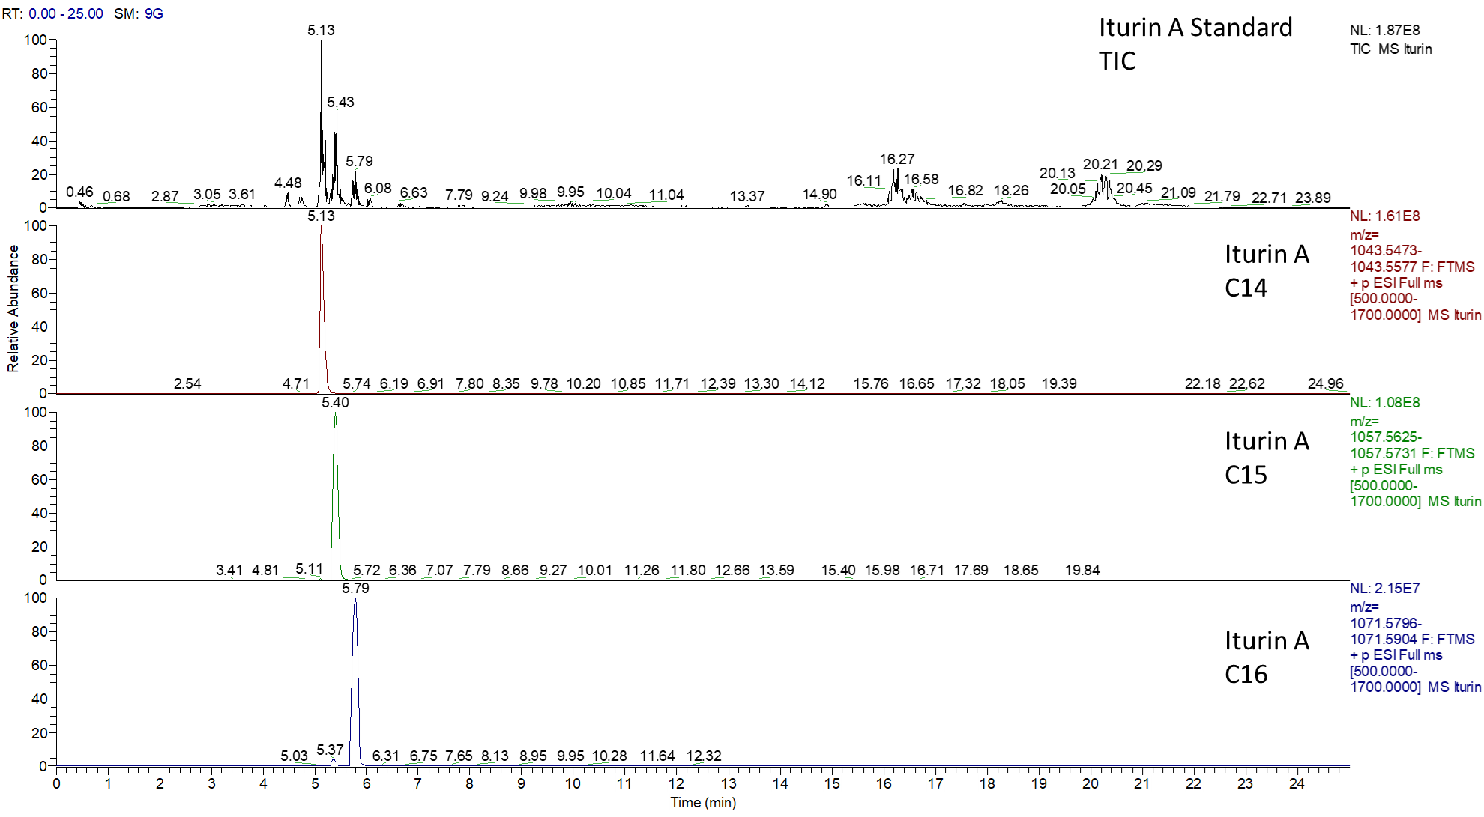

Fig. S1. Mass spectra of selected lipopeptide standards analyzed by LC–MS. The total ion chromatograms (TIC) of the surfactin (A), fengycin (B) and iturin A (C) standards are shown in the top chromatogram. The most abundant signals of each sample are additionally shown below as extracted ion chromatograms. The description "sfa" indicates the measurement of saturated fatty acids.
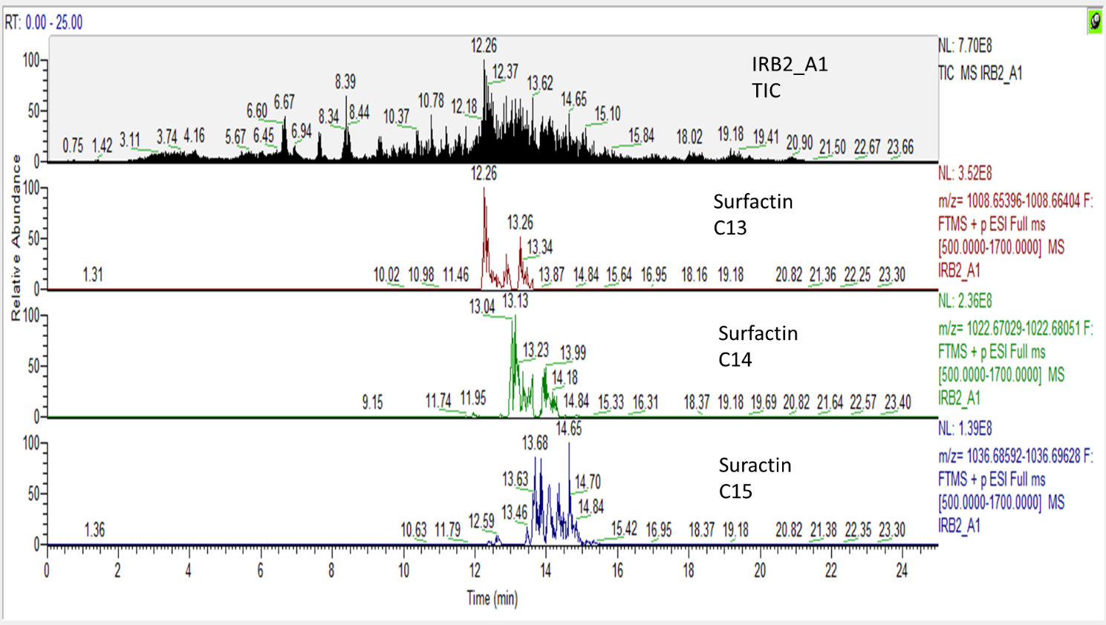
Fig. S2. LC–MS spectra of the surfactin produced by B. subtilis IRB2-A1. The sample was taken after 24 h cultivation in LB medium at 37 °C and 0.4 g (120 rpm). The upper chromatogram shows the total ion chromatogram (TIC). The most abundant signals of the surfactin congeners are additionally shown below as extracted ion chromatograms.

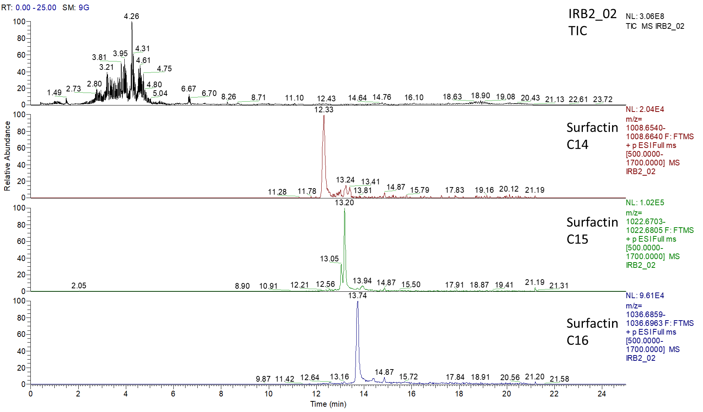
Fig. S3. LC–MS spectra of the surfactin produced by B. subtilis IRB2-02. The sample was taken after 24 h cultivation in LB medium at 37 °C and 0.4 g (120 rpm). The upper chromatogram shows the total ion chromatogram (TIC). The most abundant signals of the congeners are additionally shown below as extracted ion chromatograms.

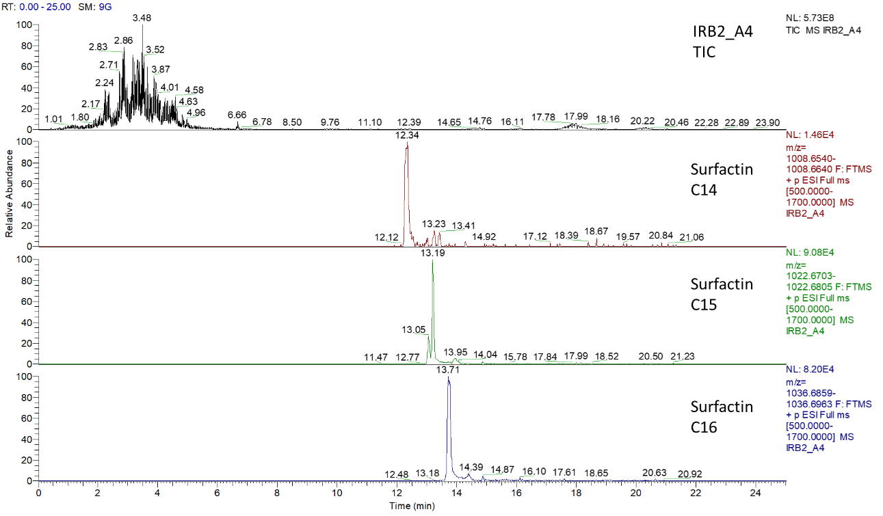
Fig. S4. LC–MS spectra of the surfactin produced by B. aryabhattai IRB2-A4. The sample was taken after 24 h cultivation in LB medium at 37 °C and 0.4 g (120 rpm). The upper chromatograms show the total ion chromatogram (TIC). The most abundant signals of the congeners are additionally shown below as extracted ion chromatograms.

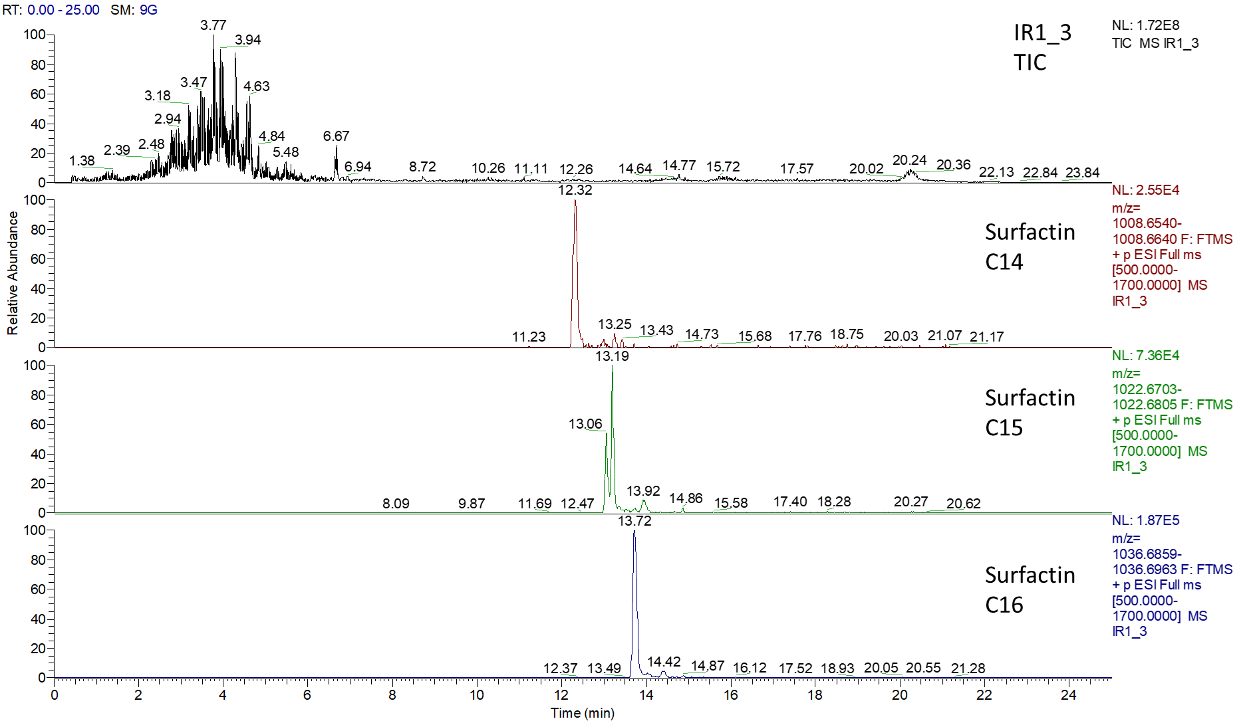

Fig. S5. LC–MS spectra of the surfactin produced by B. aryabhattai IR1-3. The sample was taken after 24 h cultivation in LB medium at 37 °C and 0.4 g (120 rpm). The upper chromatograms show the total ion chromatogram (TIC). The most abundant signals of the congeners are additionally shown below as extracted ion chromatograms.

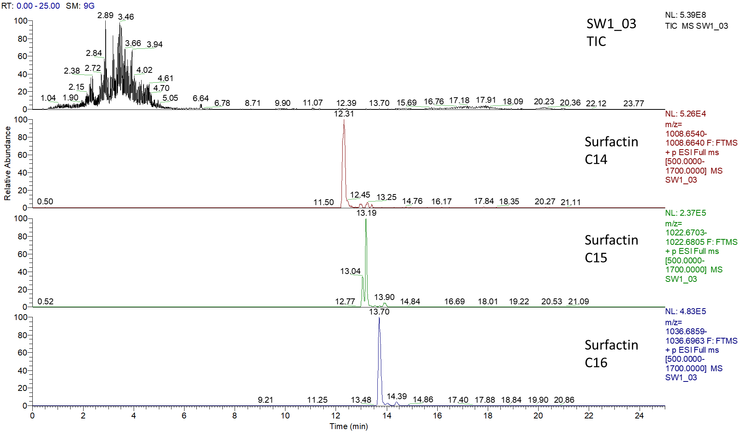

Fig. S6. LC–MS spectra of the surfactin produced by B. aryabhattai SW1-03. The sample was taken after 24 h cultivation in LB medium at 37 °C and 0.4 g (120 rpm). The upper chromatograms show the total ion chromatogram (TIC). The most abundant signals of the congeners are additionally shown below as extracted ion chromatograms.

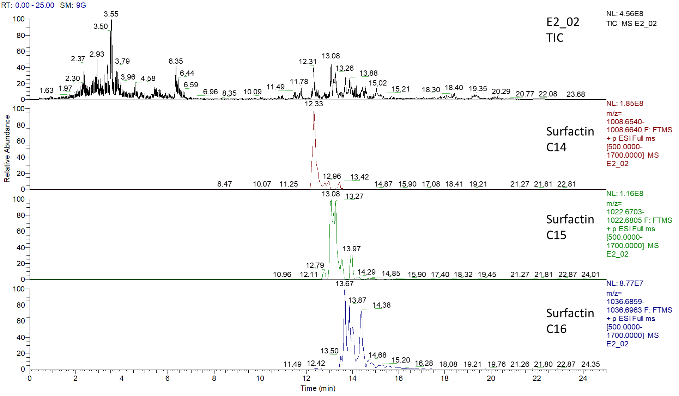
(A)

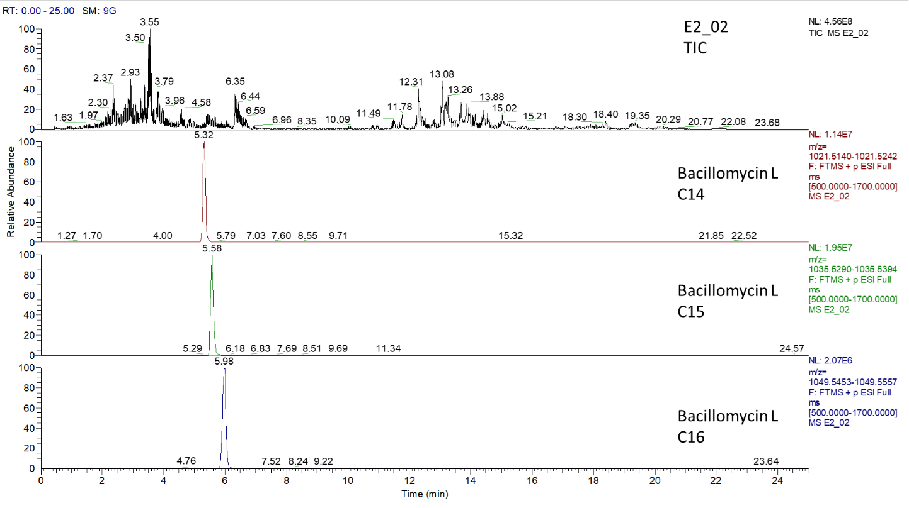
(B)

Fig. S7. LC–MS spectra of the surfactin (A), bacillomycin iturin (B) produced by B. aryabhattai E2-02. The sample was taken after 24 h cultivation in LB medium at 37 °C and 0.4 g (120 rpm). The upper chromatograms show the total ion chromatogram (TIC). The most abundant signals of the surfactin (A) and bacillomycin/iturin (B) congeners are additionally shown below as extracted ion chromatograms.

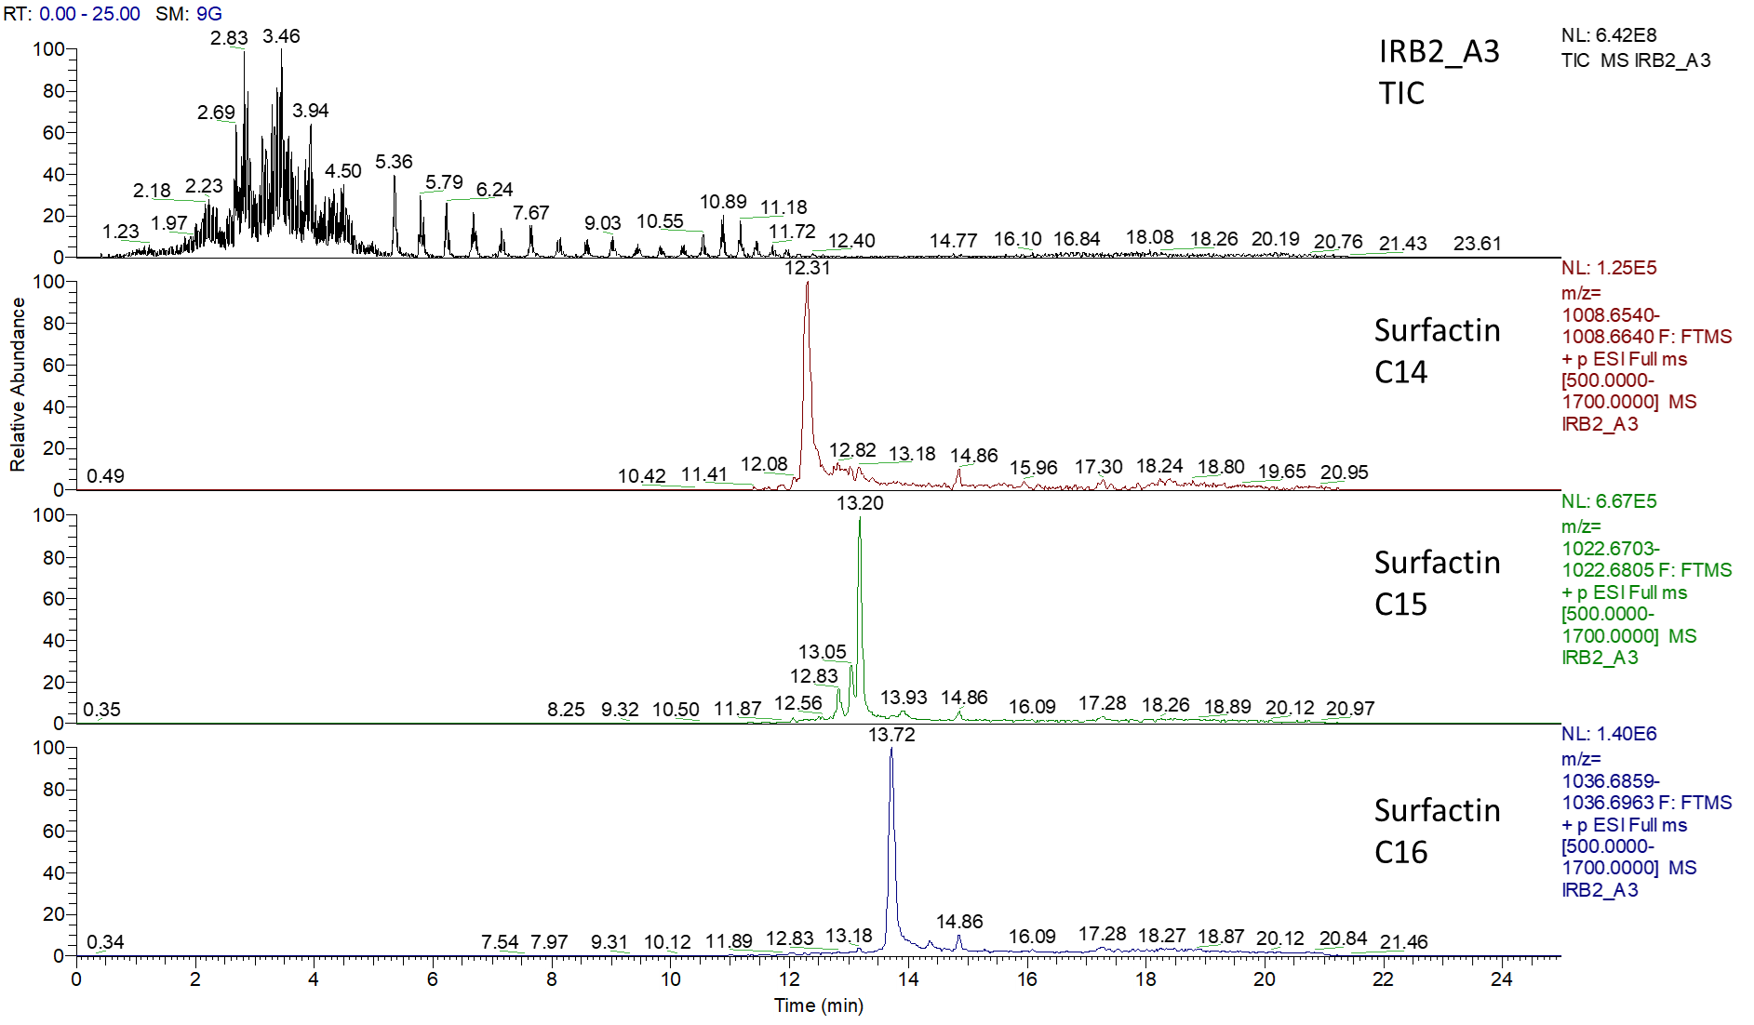

Fig. S8. LC–MS spectra of the surfactin produced by B. flexus IRB2-A3. The sample was taken after 24 h cultivation in LB medium at 37 °C and 0.4 g (120 rpm). The upper chromatograms show the total ion chromatogram (TIC). The most abundant signals of the surfactin congeners are additionally shown below as extracted ion chromatograms
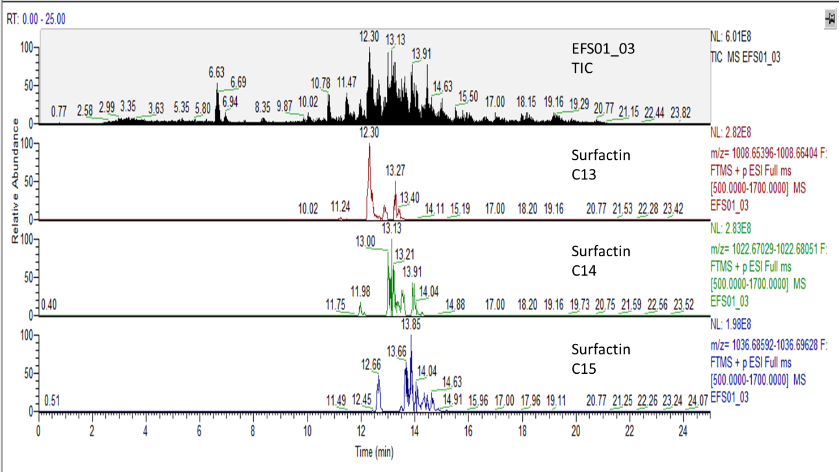
Fig. S9. LC–MS spectra of the surfactin produced by B. flexus EFSO1-03. The sample was taken after 24 h cultivation in LB medium at 37 °C and 0.4 g (120 rpm). The upper chromatogram shows the total ion chromatogram (TIC). The most abundant signals of the surfactin congeners are additionally shown below as extracted ion chromatograms.

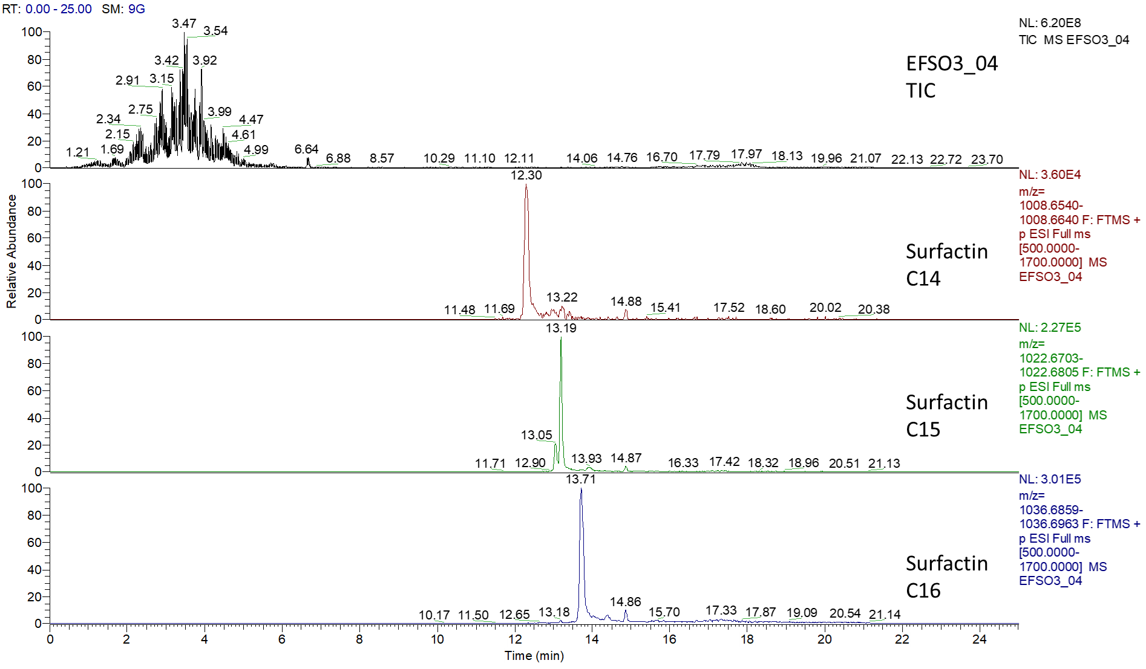

Fig. S10. LC–MS spectra of the surfactin produced by B. flexus EFSO3-04. The sample was taken after 24 h cultivation in LB medium at 37 °C and 0.4 g (120 rpm). The upper chromatograms show the total ion chromatogram (TIC). The most abundant signals of the congeners are additionally shown below as extracted ion chromatograms.

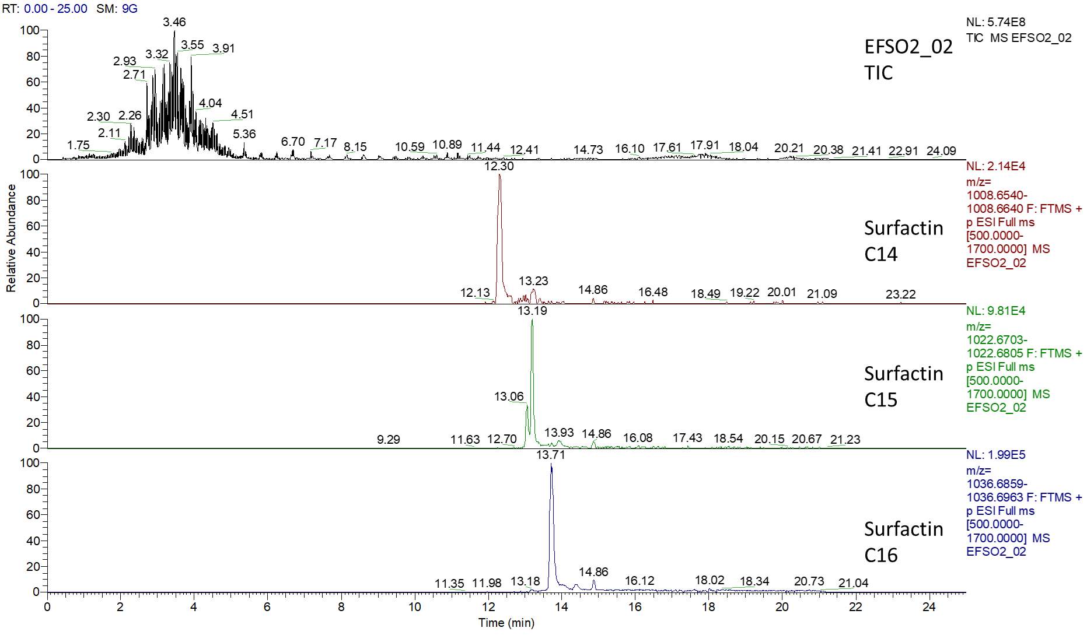

Fig. S11. LC–MS spectra of the surfactin produced by B. flexus EFSO2-02. The sample was taken after 24 h cultivation in LB medium at 37 °C and 0.4 g (120 rpm). The upper chromatograms show the total ion chromatogram (TIC). The most abundant signals of the congeners are additionally shown below as extracted ion chromatograms.

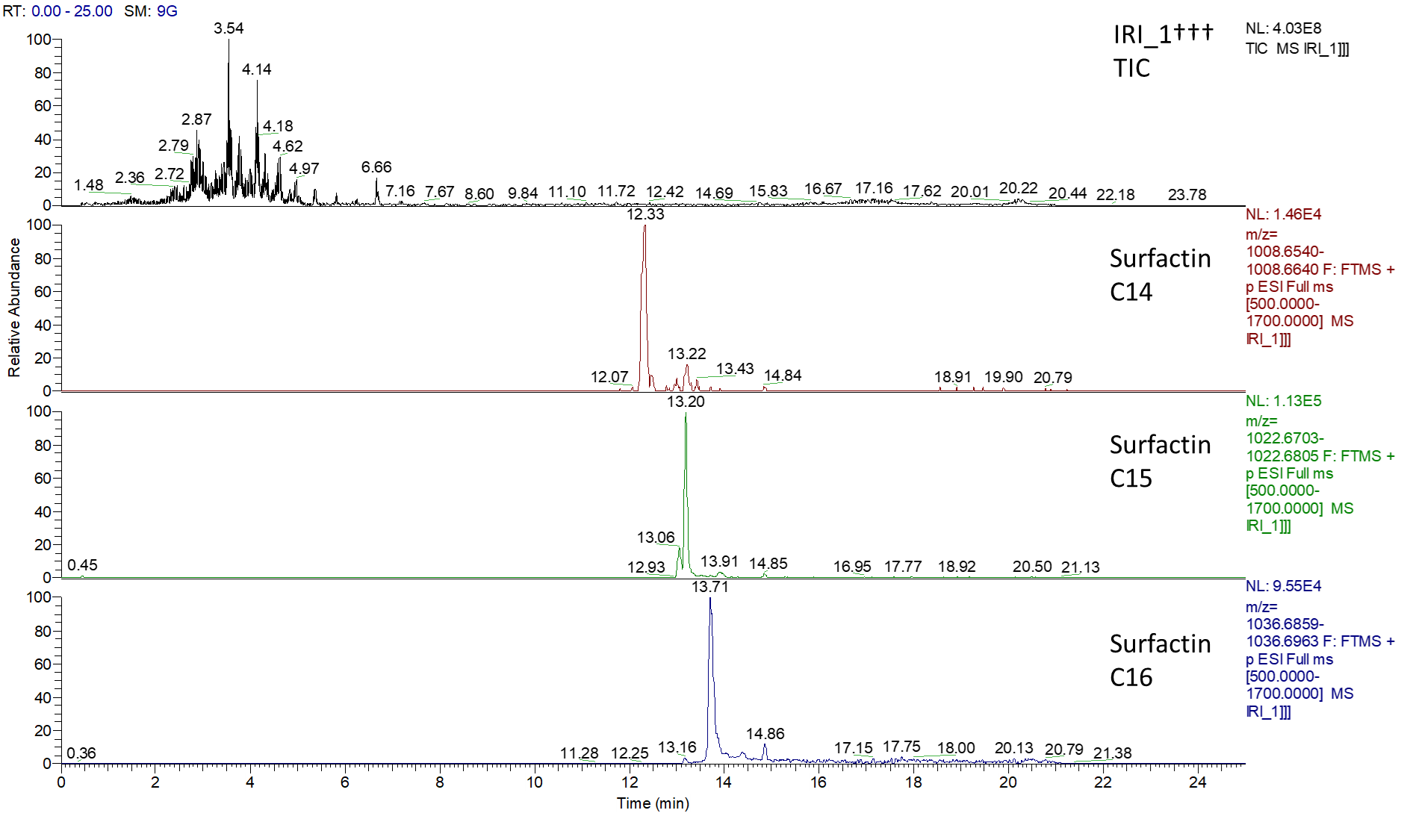
Fig. S12. LC–MS spectra of the surfactin and produced by B. velezensis IRI-1. The sample was taken after 24 h cultivation in LB medium at 37 °C and 0.4 g (120 rpm). The upper chromatograms show the total ion chromatogram (TIC). The most abundant signals of the congeners are additionally shown below as extracted ion chromatograms.

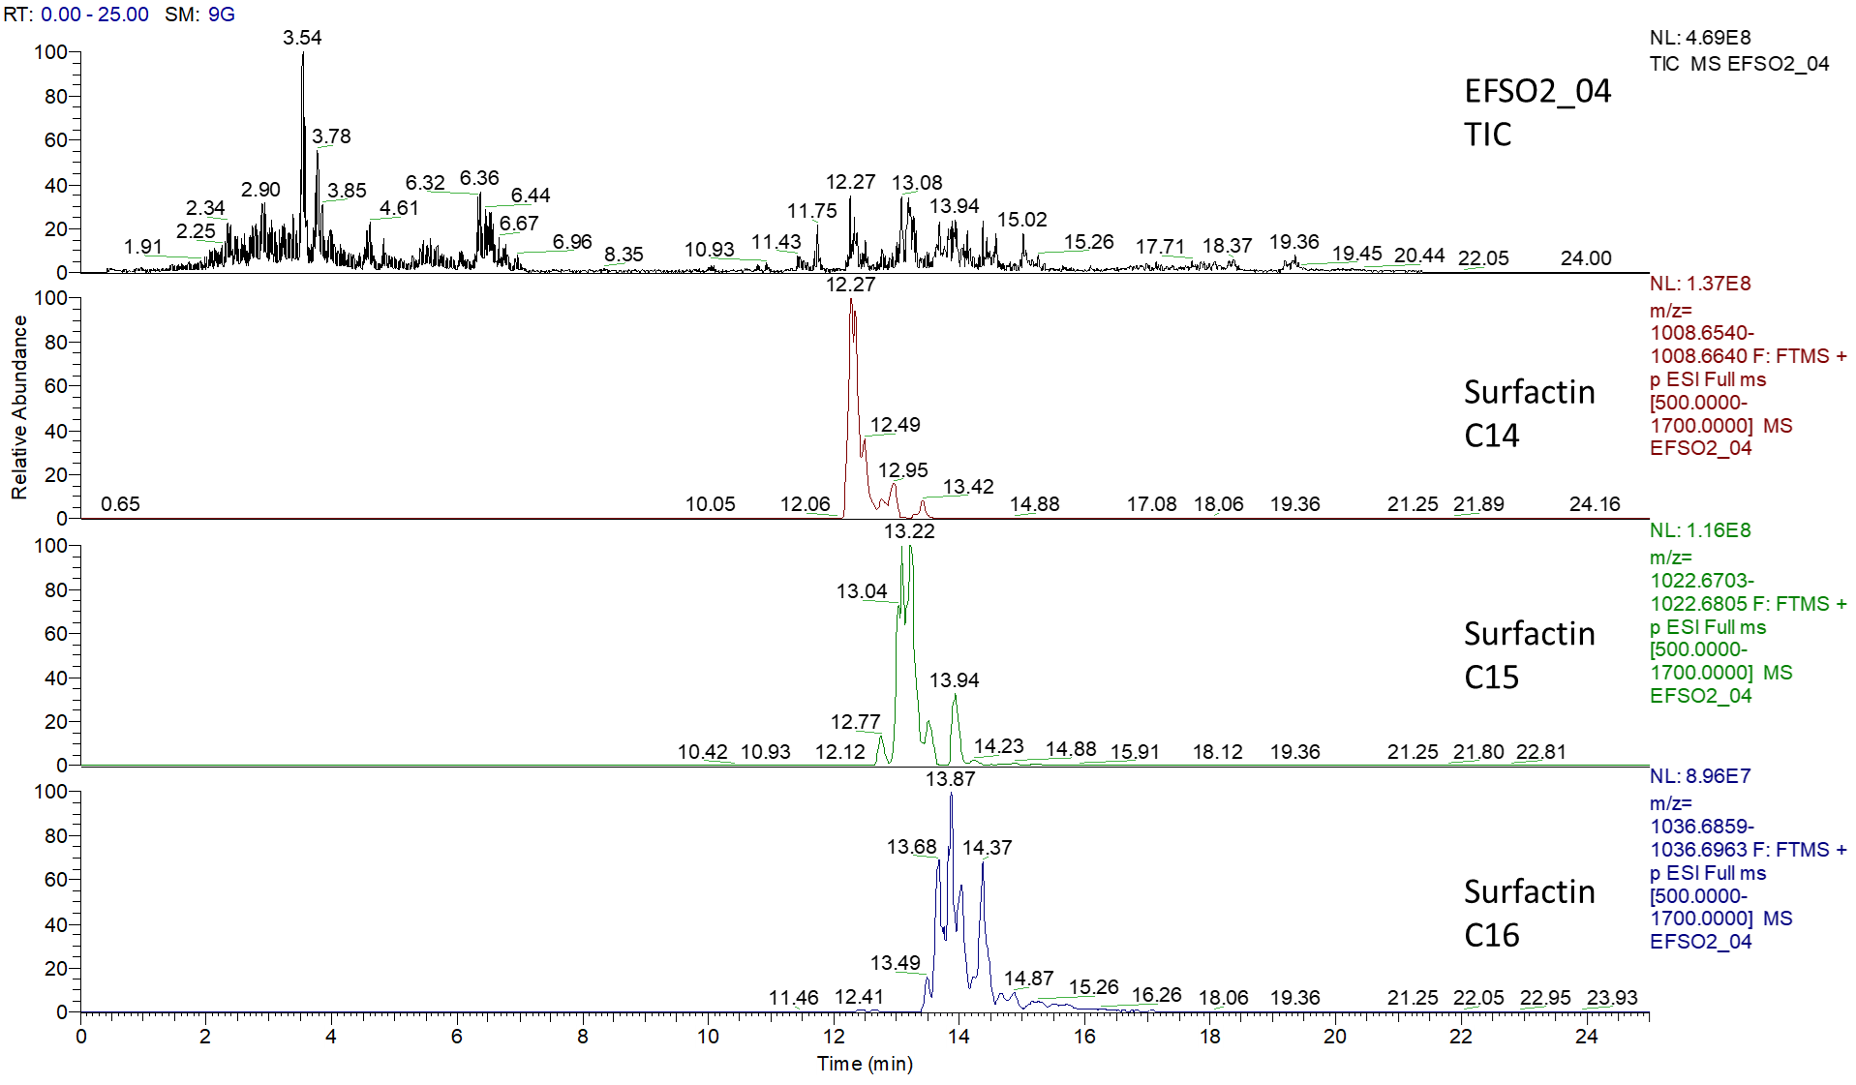
(A)

(B)
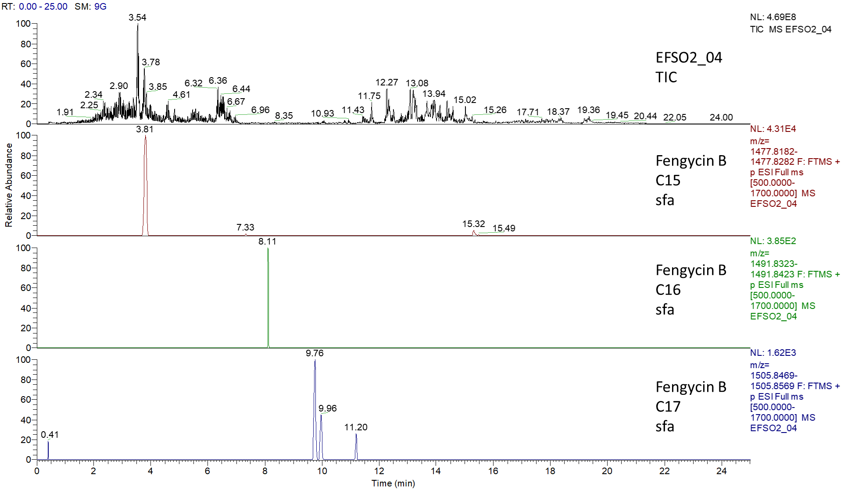

(C)
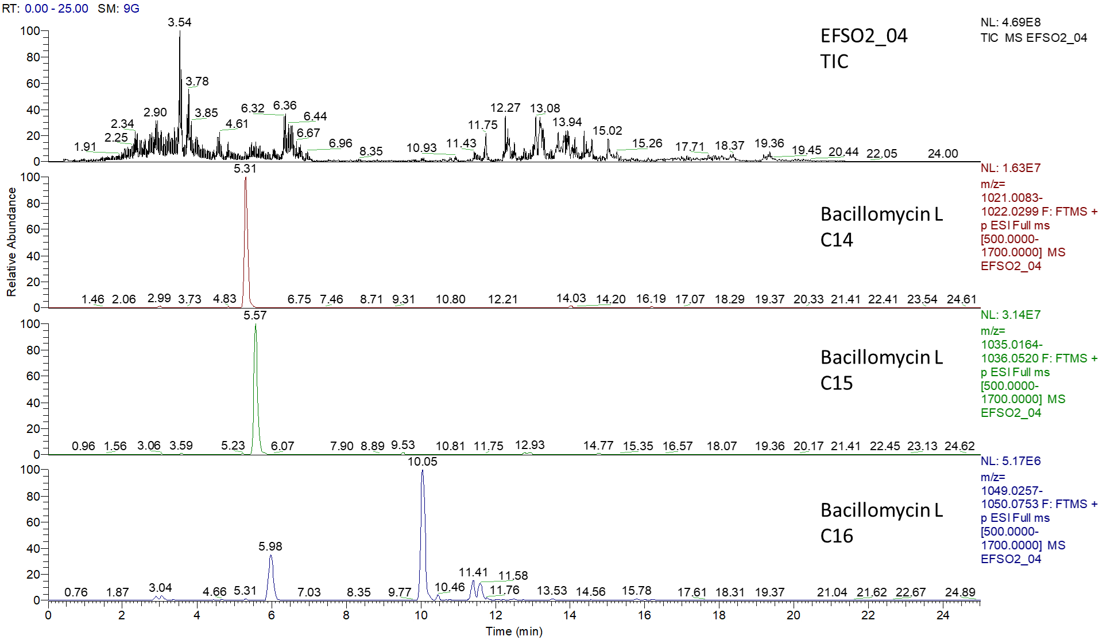
Fig. S13. LC–MS spectra of surfactin (A), fengycin (B) and bacillomycin iturin (C) produced by B. velezensis EFSO2-04. The sample was taken after 24 h cultivation in LB medium at 37 °C and 0.4 g (120 rpm). The upper chromatograms show the total ion chromatogram (TIC). The most abundant signals of the congeners are additionally shown below as extracted ion chromatograms.

(A)
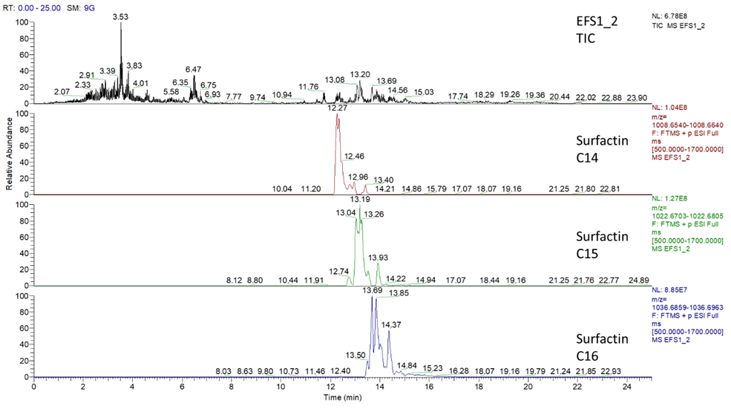
(B)
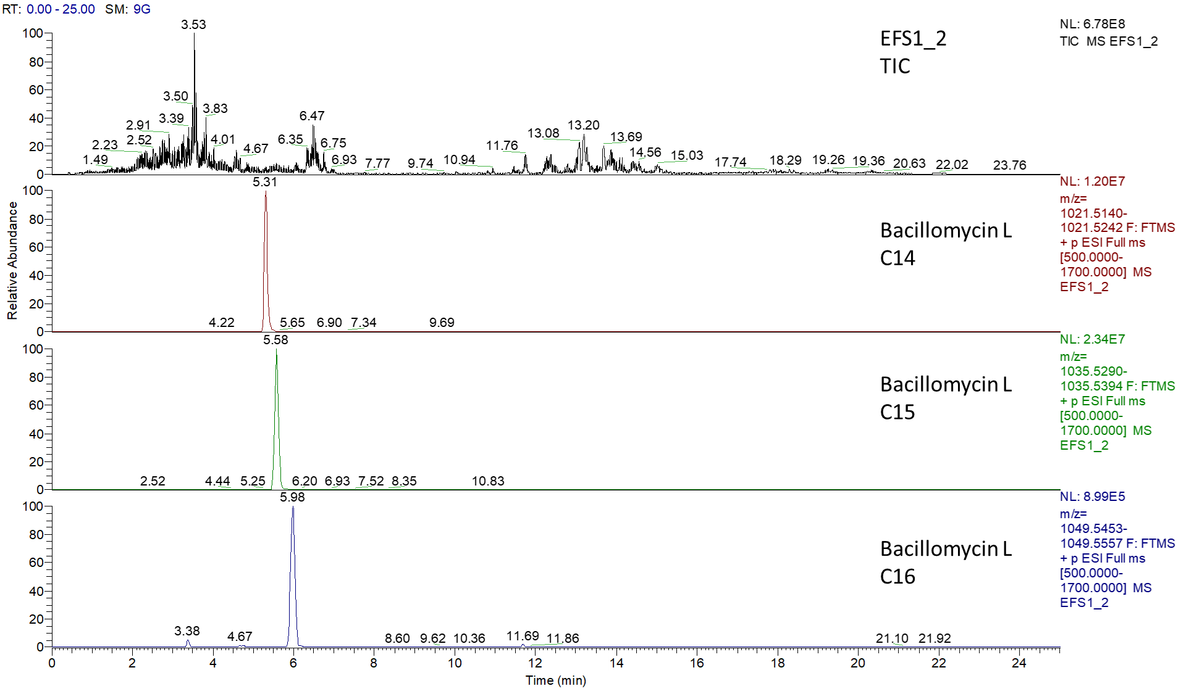

Fig. S14. LC–MS spectra of surfactin (A) and bacillomycin iturin (B) produced by B. velezensis EFS1-2. The sample was taken after 24 h cultivation in LB medium at 37 °C and 0.4 g (120 rpm). The upper chromatograms show the total ion chromatogram (TIC). The most abundant signals of the congeners are additionally shown below as extracted ion chromatograms.

(A)
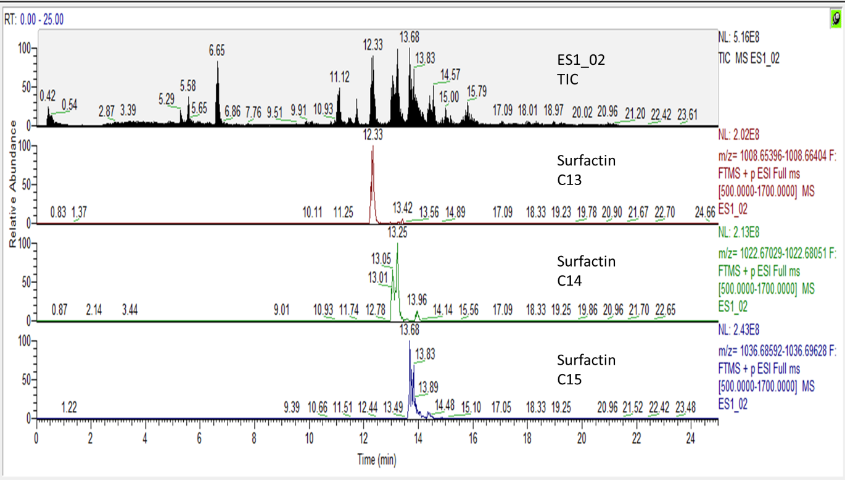

(B)
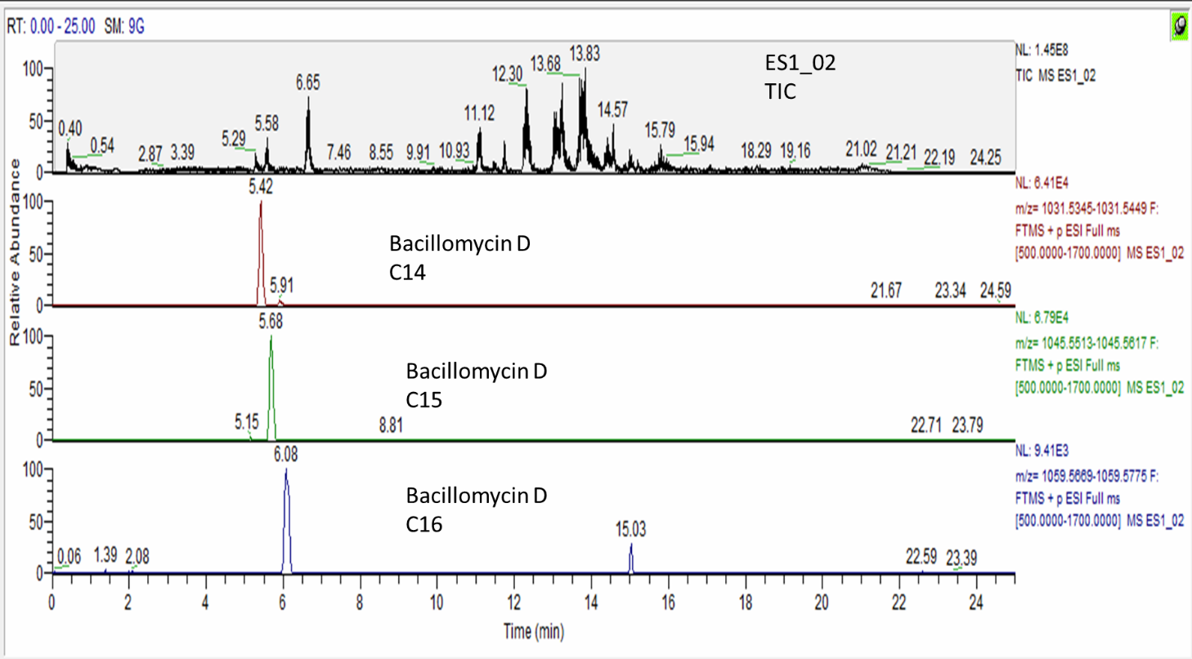
(C)
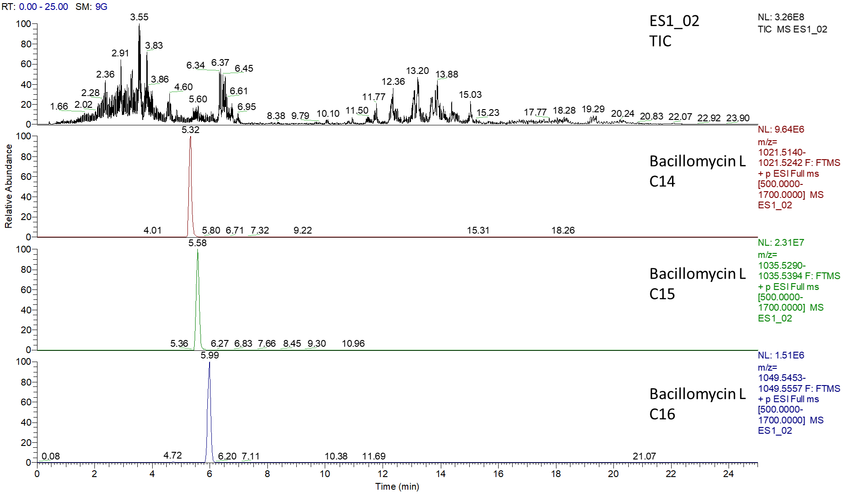
Fig. S15. LC–MS spectra of surfactin (A), and bacillomycin iturin (B, C) produced by B. velezensis ES1-02. The sample was taken after 24 h cultivation in LB medium at 37 °C and 0.4 g (120 rpm). The upper chromatograms show the total ion chromatogram (TIC). The most abundant signals of the congeners are additionally shown below as extracted ion chromatograms.

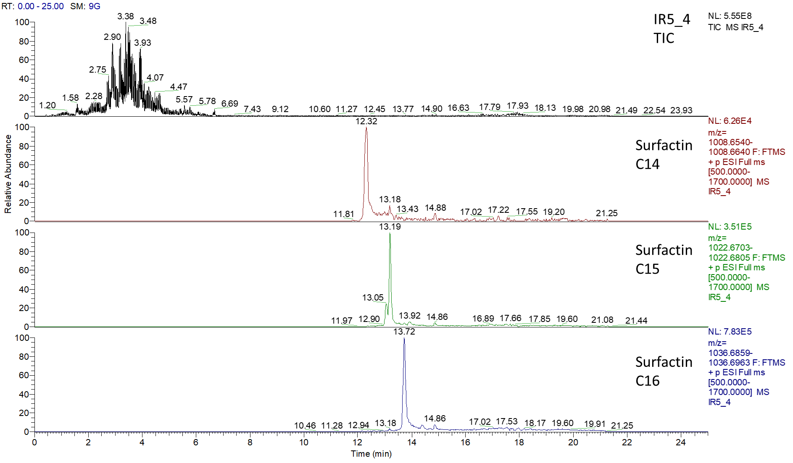

Fig. S16. LC–MS spectra of surfactin produced by B. tequelensis IR5-4. The sample was taken after 24 h cultivation in LB medium at 37 °C and 0.4 g (120 rpm). The upper chromatograms show the total ion chromatogram (TIC). The most abundant signals of the congeners are additionally shown below as extracted ion chromatograms.

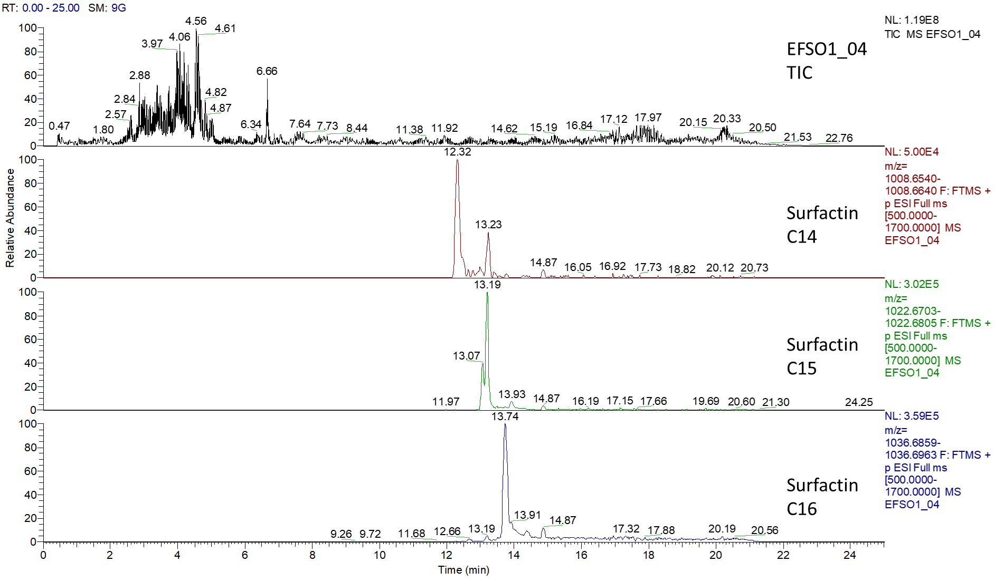
Fig. S17. LC–MS spectra of surfactin produced by B. tequelensis EFSO1-04. The sample was taken after 24 h cultivation in LB medium at 37 °C and 0.4 g (120 rpm). The upper chromatograms show the total ion chromatogram (TIC). The most abundant signals of the congeners are additionally shown below as extracted ion chromatograms.

(A)
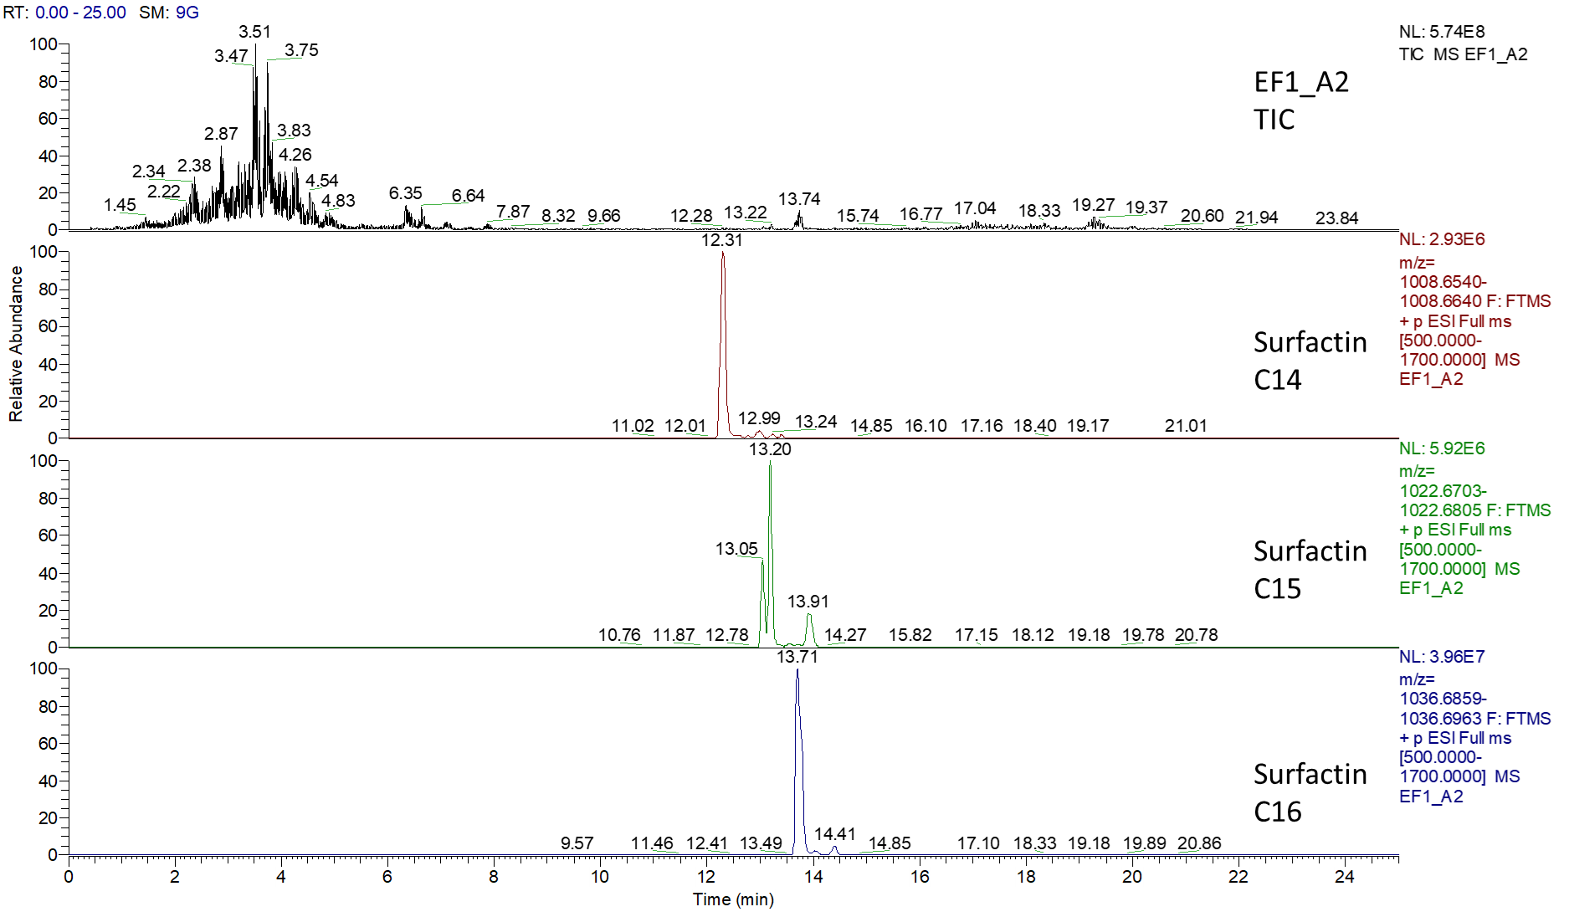
(B)
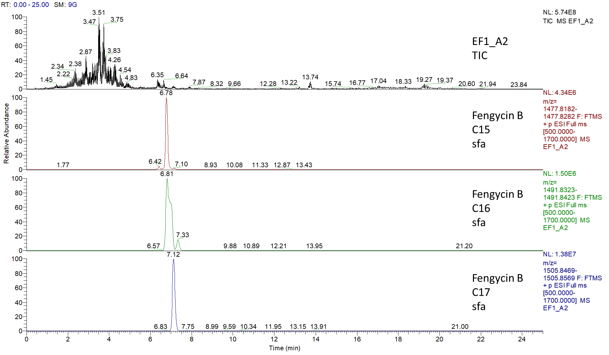
Fig. S18. LC–MS spectra of the surfactin (A) and fengycin (B) produced by B. tequilensis EF1-A2. The sample was taken after 24 h cultivation in LB medium at 37 °C and 0.4 g (120 rpm). The upper chromatograms show the total ion chromatogram (TIC). The most abundant signals of the congeners are additionally shown below as extracted ion chromatograms.

(A)
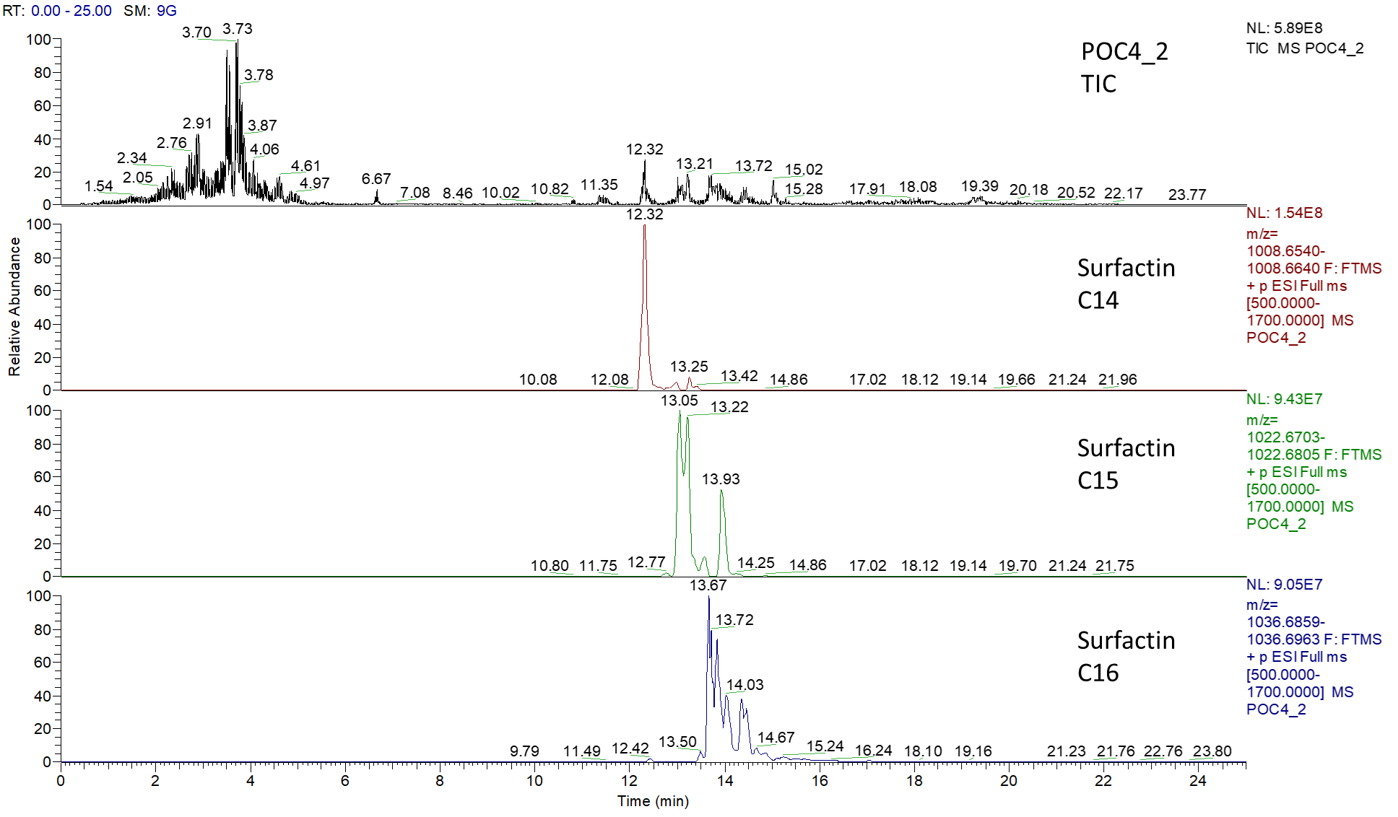

(B)
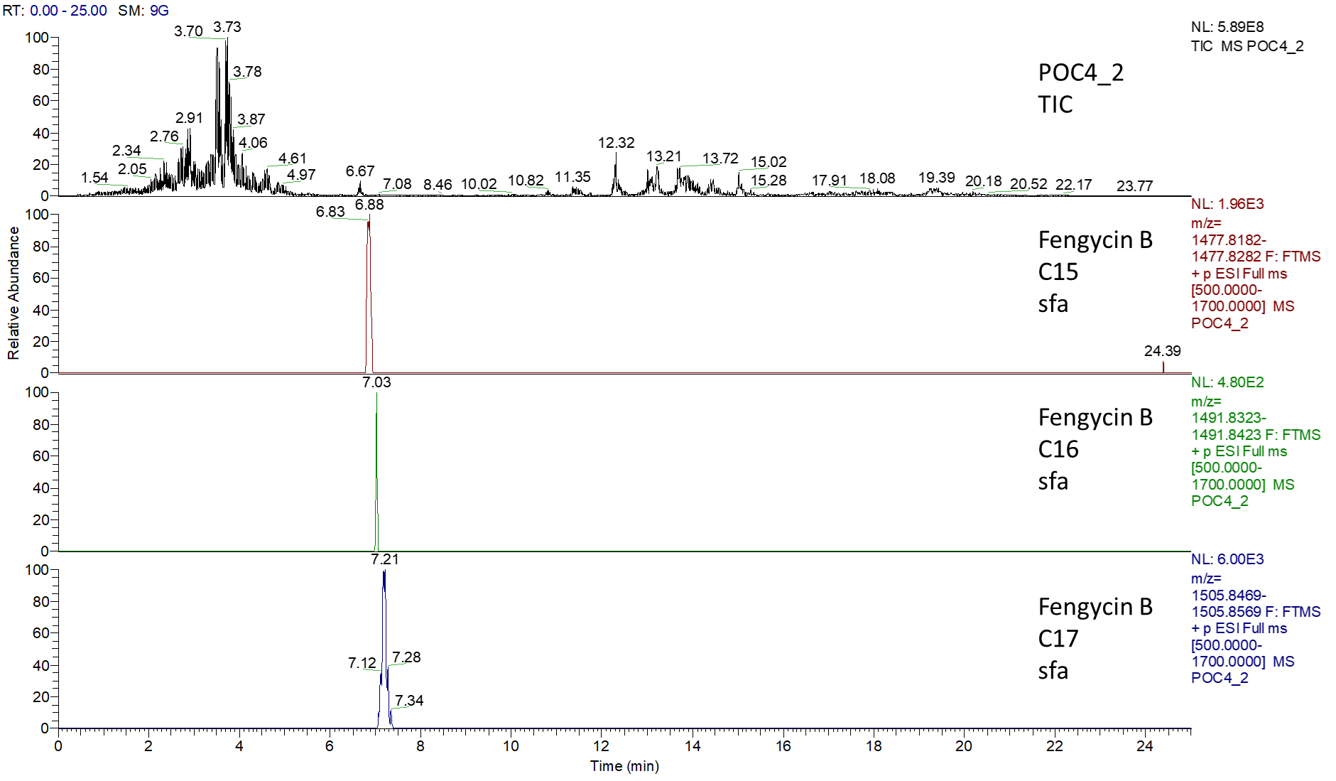
Fig. S19. LC–MS spectra of the surfactin (A) and fengycin (B) produced by B. tequilensis POC4-2. The sample was taken after 24 h cultivation in LB medium at 37 °C and 0.4 g (120 rpm). The upper chromatograms show the total ion chromatogram (TIC). The most abundant signals of the congeners are additionally shown below as extracted ion chromatograms.

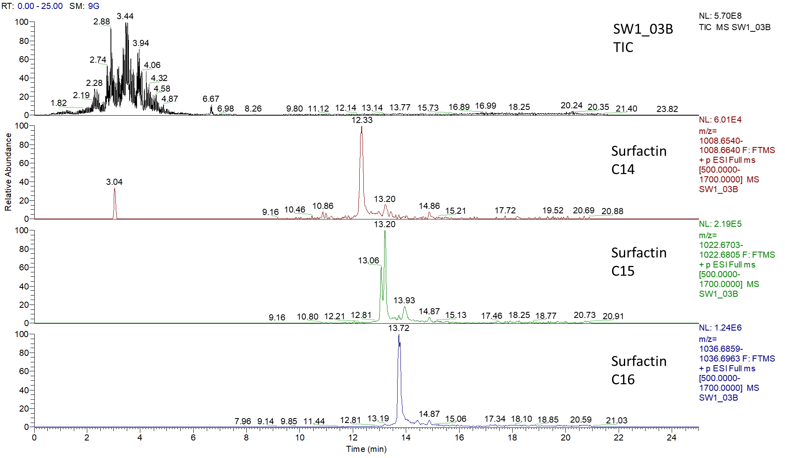
Fig. S20. LC–MS spectra of the surfactin produced by B. tequilensis SW1-03B. The sample was taken after 24 h cultivation in LB medium at 37 °C and 0.4 g (120 rpm). The upper chromatograms show the total ion chromatogram (TIC). The most abundant signals of the congeners are additionally shown below as extracted ion chromatograms.

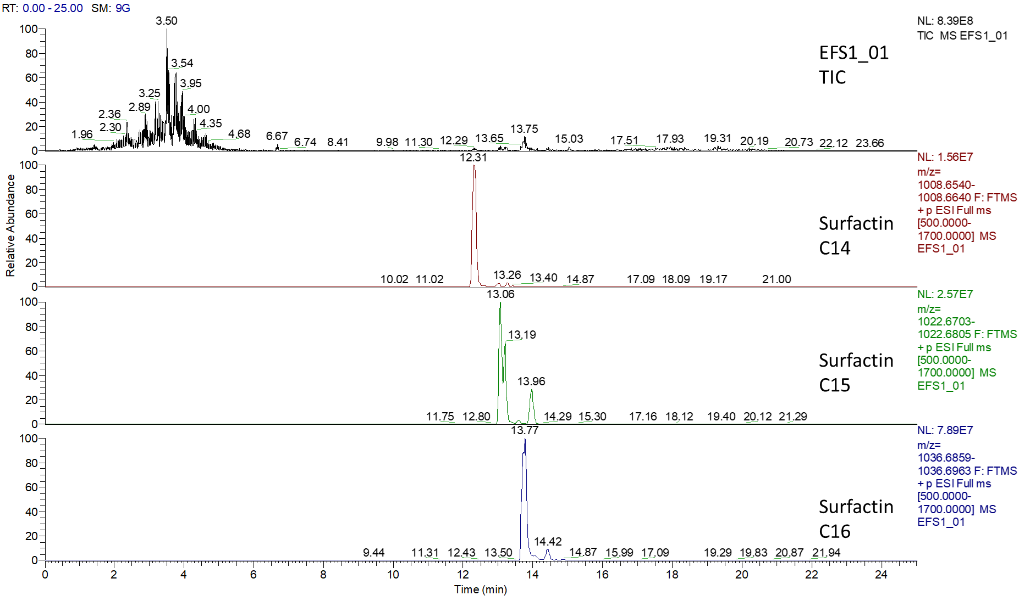

Fig. S21. LC–MS spectra of the surfactin produced by B. tequilensis EFS1-01. The sample was taken after 24 h cultivation in LB medium at 37 °C and 0.4 g (120 rpm). The upper chromatograms show the total ion chromatogram (TIC). The most abundant signals of the congeners are additionally shown below as extracted ion chromatograms.

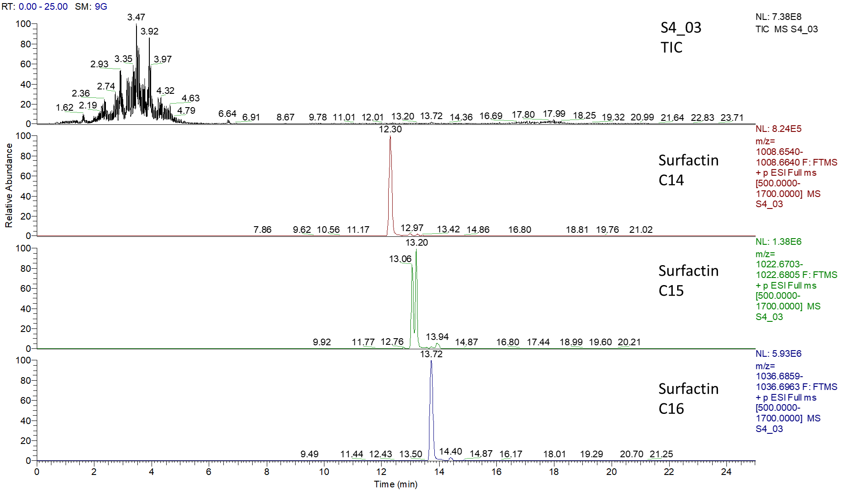
Fig. S22. LC–MS spectra of the surfactin produced by B. tequilensis S4-03. The sample was taken after 24 h cultivation in LB medium at 37 °C and 0.4 g (120 rpm). The upper chromatograms show the total ion chromatogram (TIC). The most abundant signals of the congeners are additionally shown below as extracted ion chromatograms.

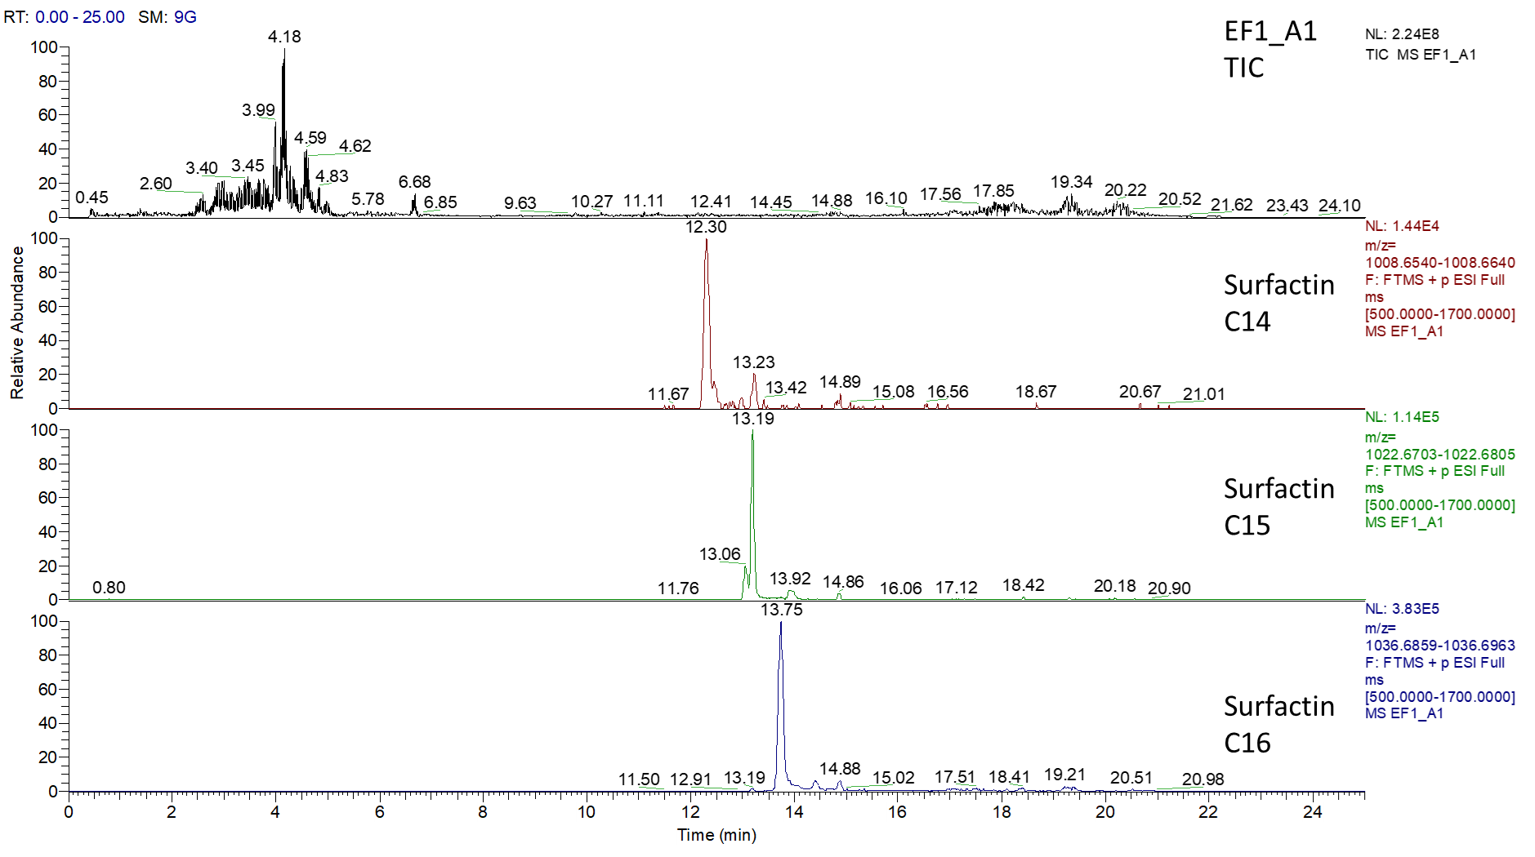
Fig. S23. LC–MS spectra of the surfactin produced by B. tequilensis EF1-A1. The sample was taken after 24 h cultivation in LB medium at 37 °C and 0.4 g (120 rpm). The upper chromatograms show the total ion chromatogram (TIC). The most abundant signals of the congeners are additionally shown below as extracted ion chromatograms.

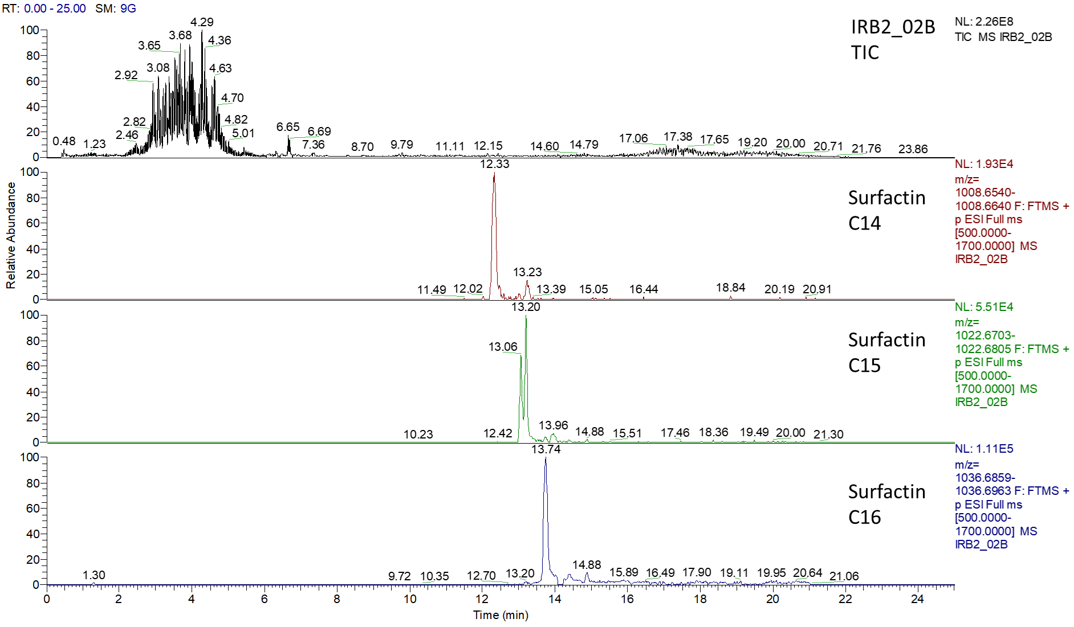
Fig. S24. LC–MS spectra of the surfactin produced by B. licheniformis IRB2-02B. The sample was taken after 24 h cultivation in LB medium at 37 °C and 0.4 g (120 rpm). The upper chromatograms show the total ion chromatogram (TIC). The most abundant signals of the congeners are additionally shown below as extracted ion chromatograms.
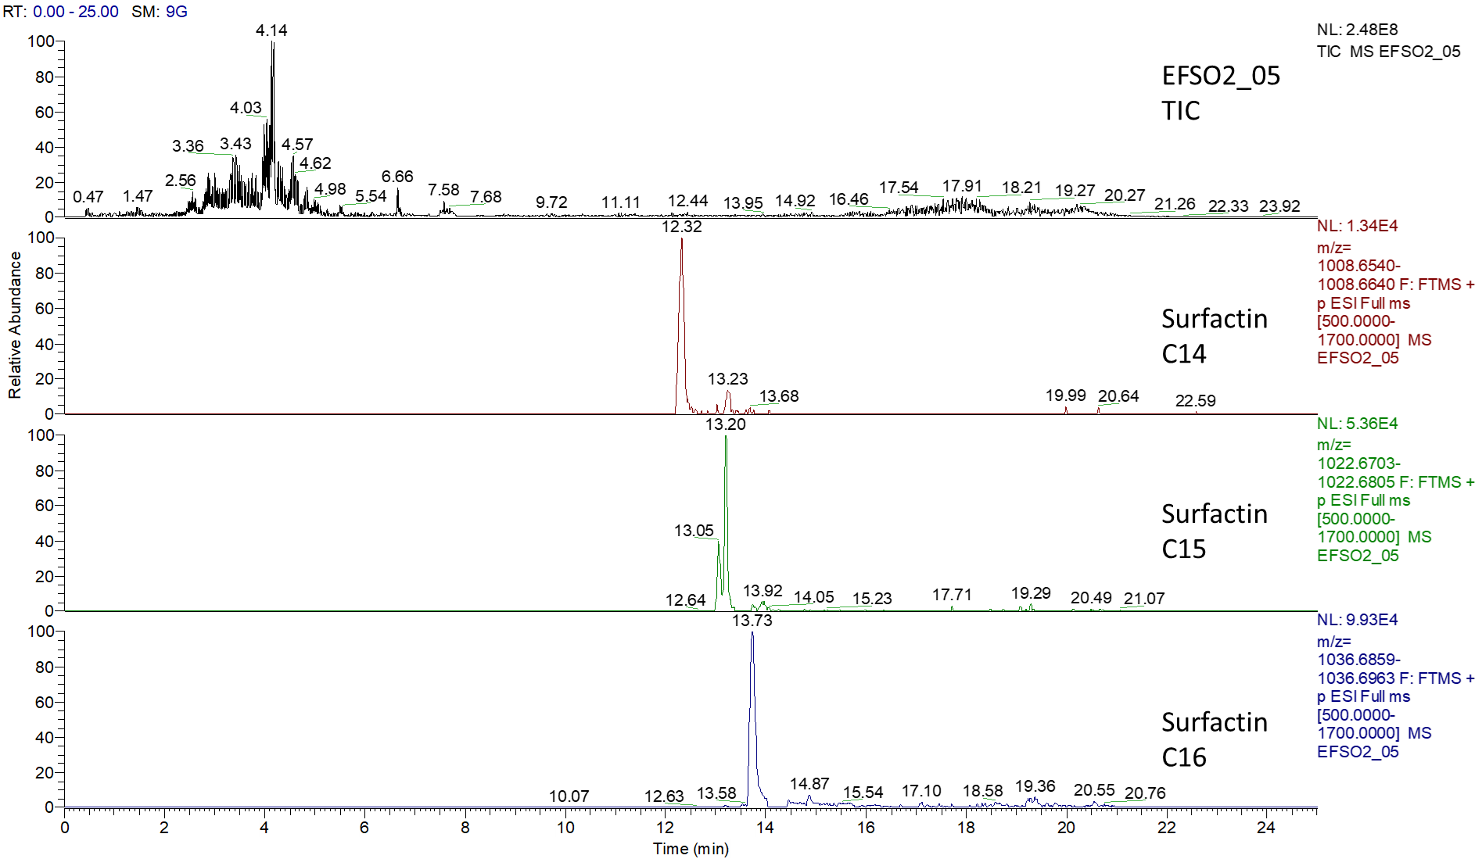

Fig. S25. LC–MS spectra of the surfactin and produced by B. licheniformis EFSO2-05. The sample was taken after 24 h cultivation in LB medium at 37 °C and 0.4 g (120 rpm). The upper chromatograms show the total ion chromatogram (TIC). The most abundant signals of the congeners are additionally shown below as extracted ion chromatograms.

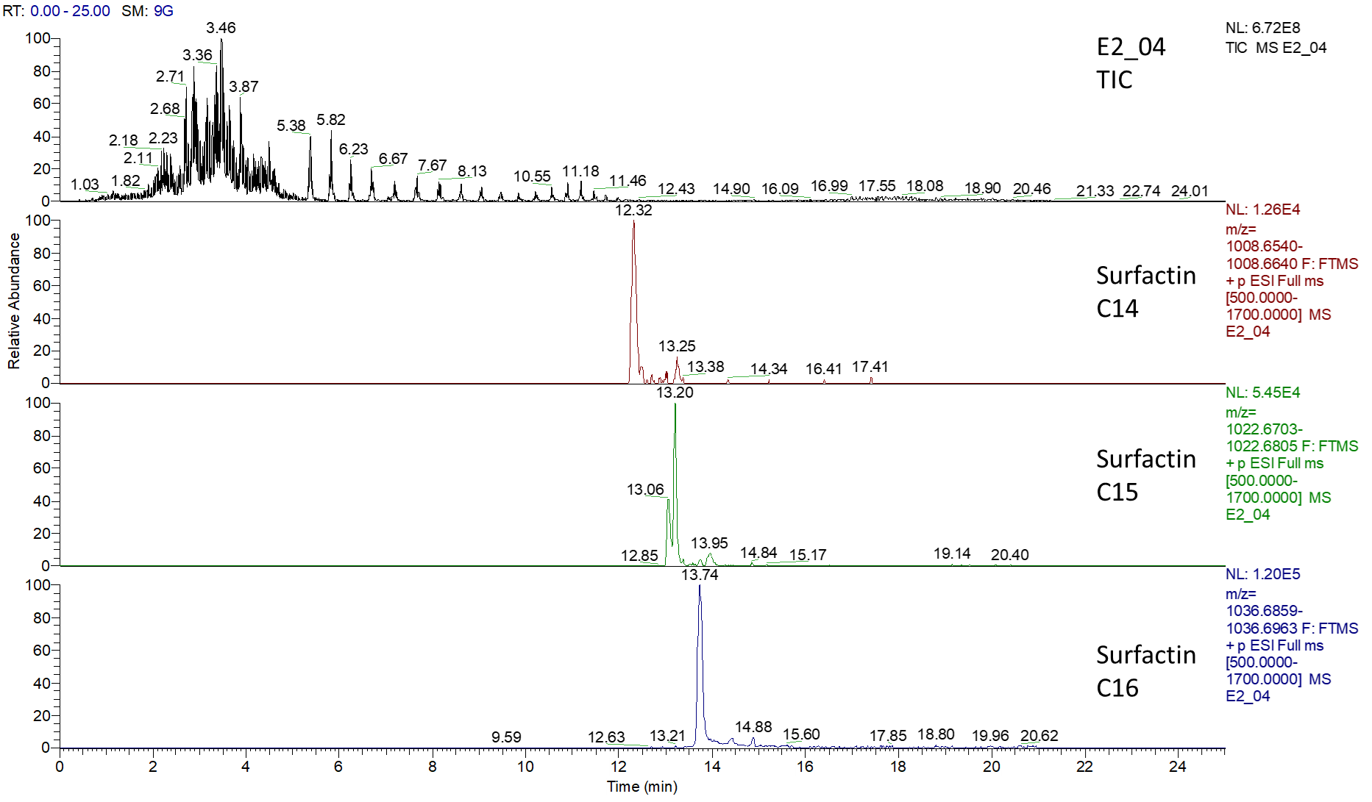
Fig. S26. LC–MS spectra of the surfactin produced by B. megaterium E2-04. The sample was taken after 24 h cultivation in LB medium at 37 °C and 0.4 g (120 rpm). The upper chromatograms show the total ion chromatogram (TIC). The most abundant signals of the congeners are additionally shown below as extracted ion chromatograms.

(A)
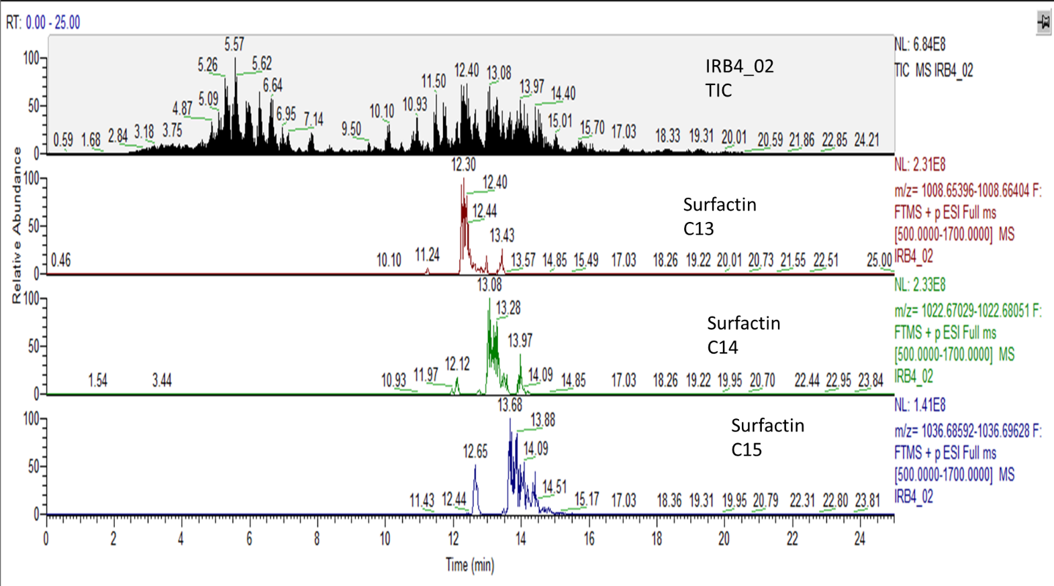

(B)
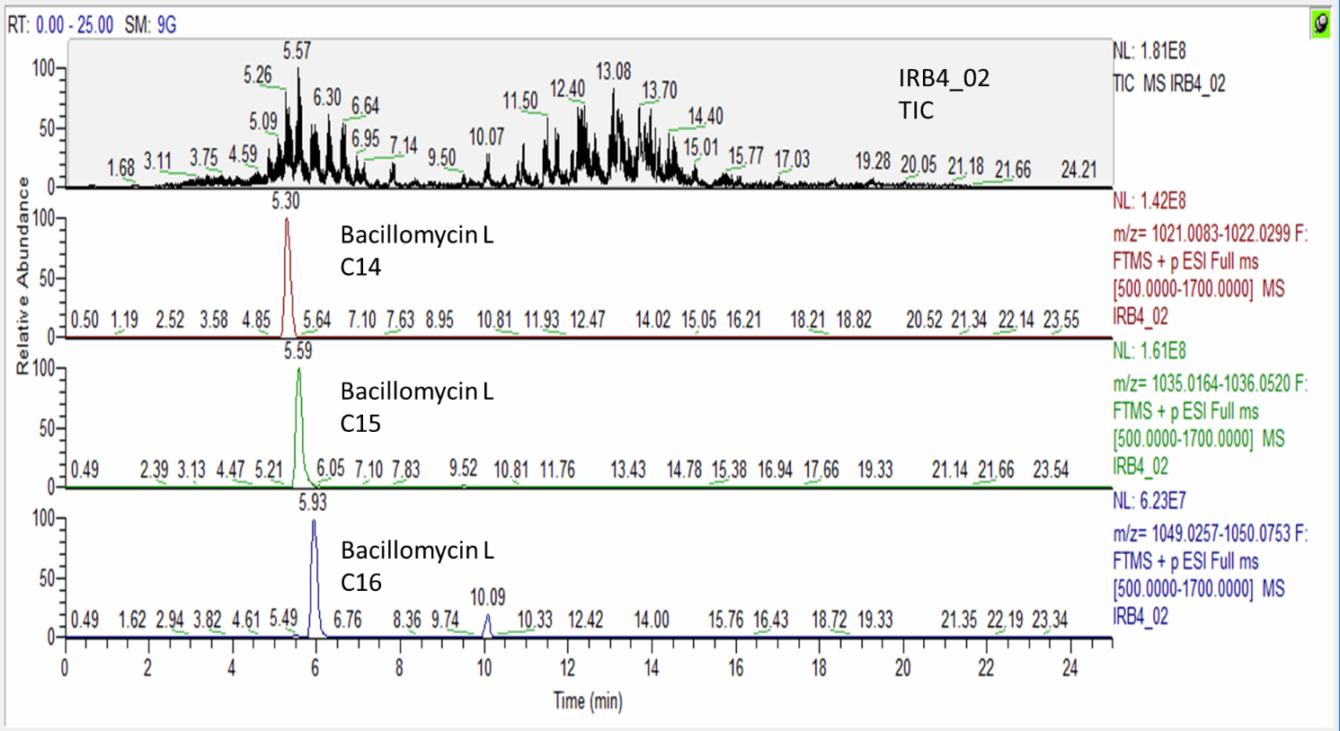
Fig. S27. LC–MS spectra of the surfactin (A) and bacillomycin iturin (B) produced by L. boronitolerans IRB4-02. The sample was taken after 24 h cultivation in LB medium at 37 °C and 0.4 g (120 rpm). The upper chromatograms show the total ion chromatogram (TIC) of the produced surfactin and bacillomycin/iturin. The most abundant signals of the congeners are additionally shown below as extracted ion chromatograms.

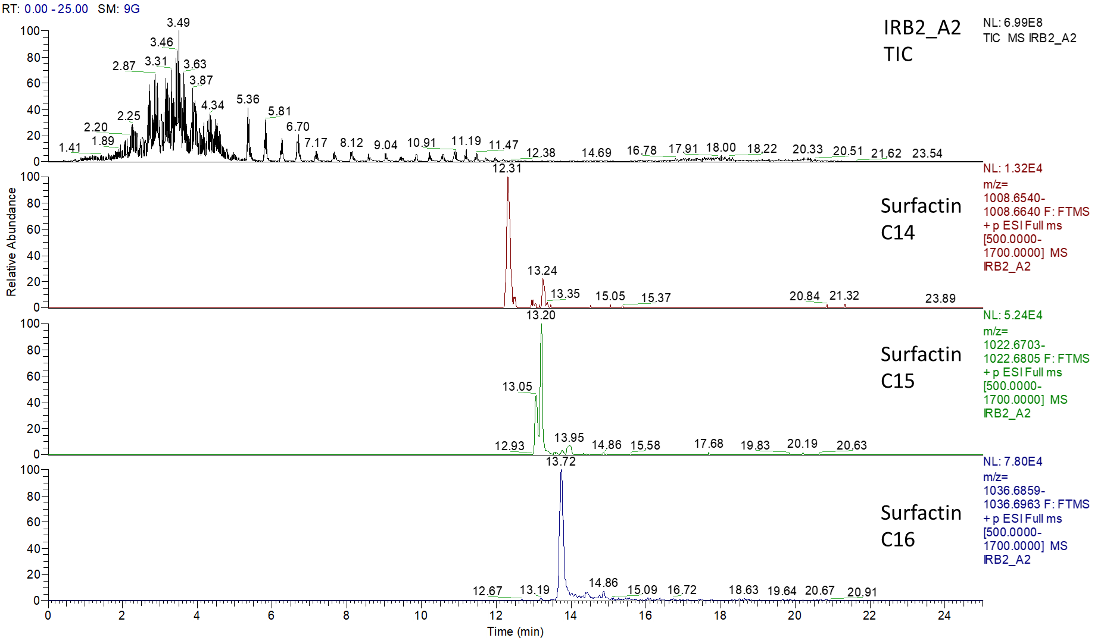
Fig. S28. LC–MS spectra of the surfactin produced by L. boronitolerans IRB2-A2. The sample was taken after 24 h cultivation in LB medium at 37 °C and 0.4 g (120 rpm). The upper chromatograms show the total ion chromatogram (TIC). The most abundant signals of the congeners are additionally shown below as extracted ion chromatograms.

(A)
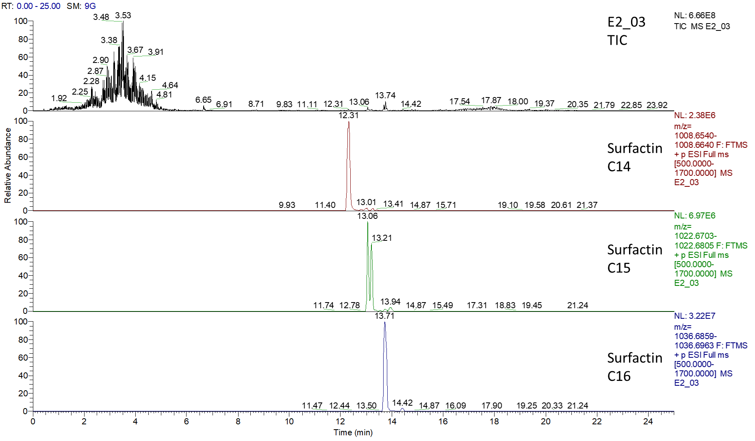

(B)
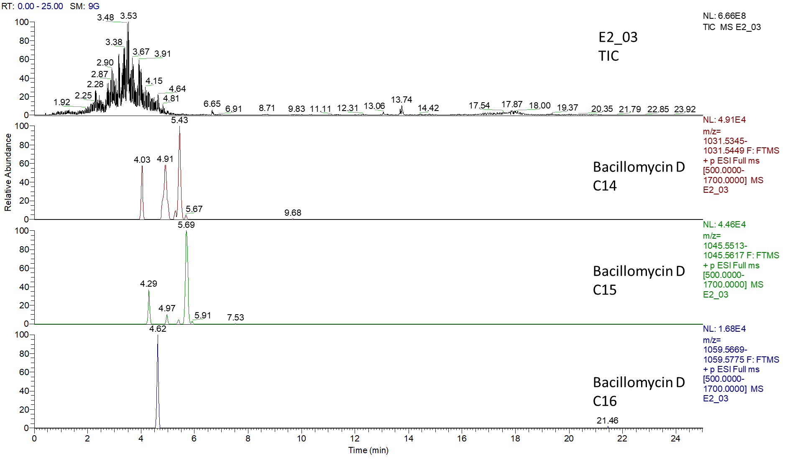
Fig. S29. LC–MS spectra of the surfactin (A) and bacillomycin iturin (B) produced by L. boronitolerans E2-03. The sample was taken after 24 h cultivation in LB medium at 37 °C and 0.4 g (120 rpm). The upper chromatograms show the total ion chromatogram (TIC) of the produced surfactin and bacillomycin/iturin. The most abundant signals of the congeners are additionally shown below as extracted ion chromatograms.
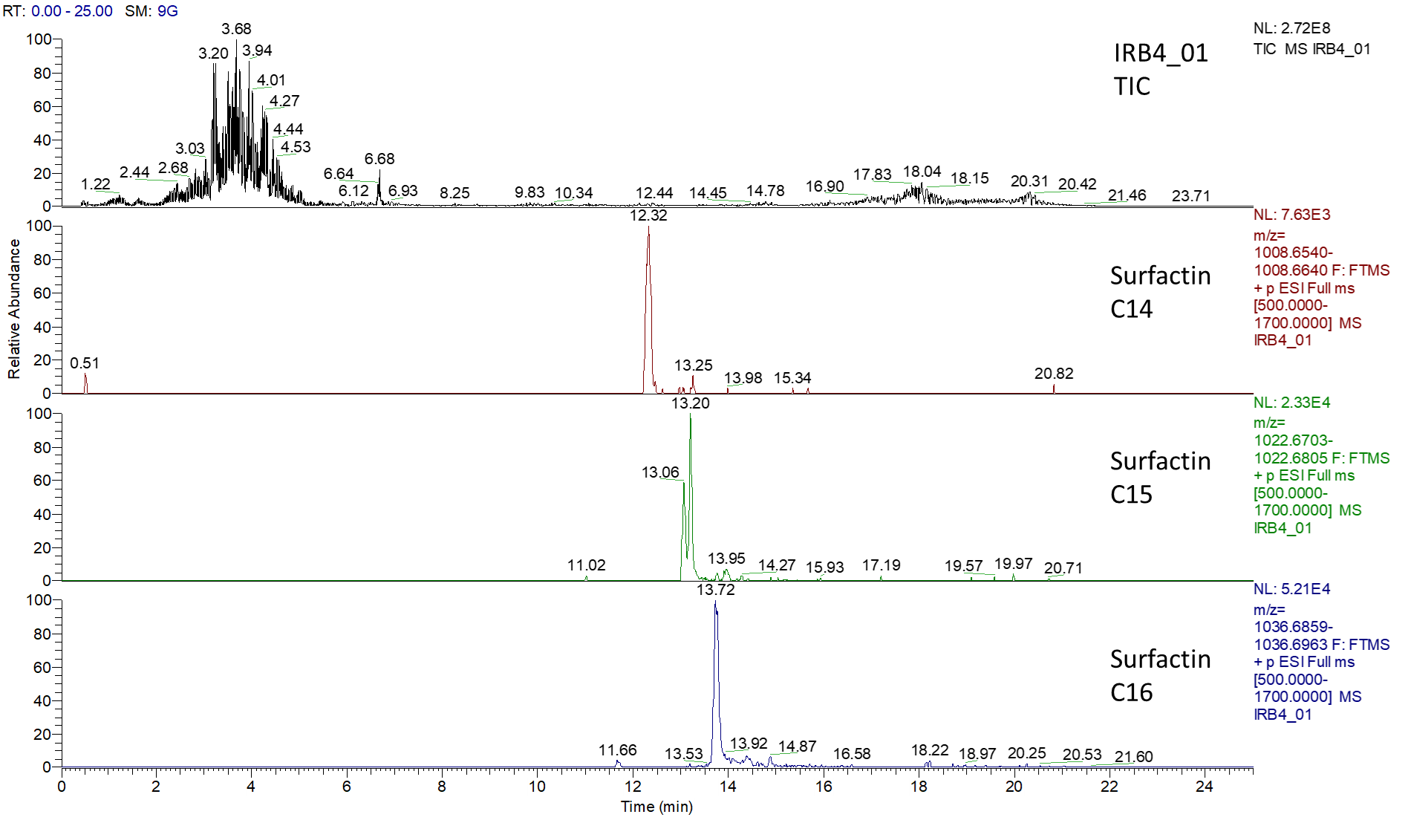

Fig. S30. LC–MS spectra of the surfactin produced by L. fusiformis IRB4-01. The sample was taken after 24 h cultivation in LB medium at 37 °C and 0.4 g (120 rpm). The upper chromatograms show the total ion chromatogram (TIC). The most abundant signals of the congeners are additionally shown below as extracted ion chromatograms.
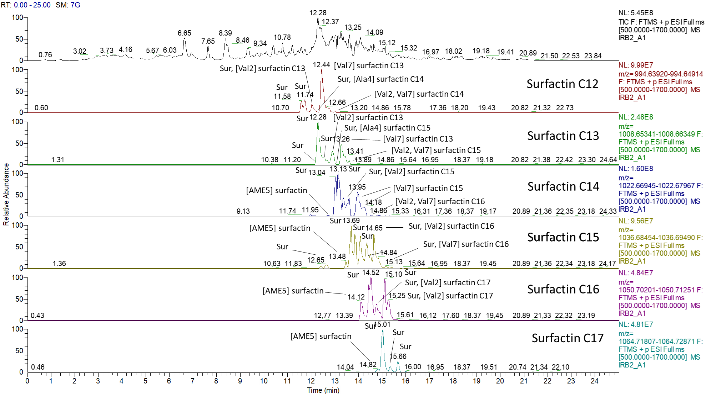
Fig. S31. Surfactin variants produced by B. subtilits IRB2-A1. The sample was taken after 24 h cultivation in LB medium at 37 °C and 0.4 g (120 rpm). The upper chromatogram shows the Total Ion Chromatogram (TIC) with a retention time (RT) of 25 min. Detailed annotations of the chromatographic spectra for surfactin C12-C17 show the identification of the surfactin parent sequence (Sur), E-L-L-V-N-L-L, and the substitutions: [Val2] – leucine at position 2 exchanged for valine; [Val7] – leucine at position 7 exchanged for valine; [Val2, Val7] – multiple substitution of leucine at positions 2 and 7; [Ala4] – valine at position 4 exchanged for alanine; [AME5] – aspartic acid at position 5 exchanged for aspartic acid 4-methylester.

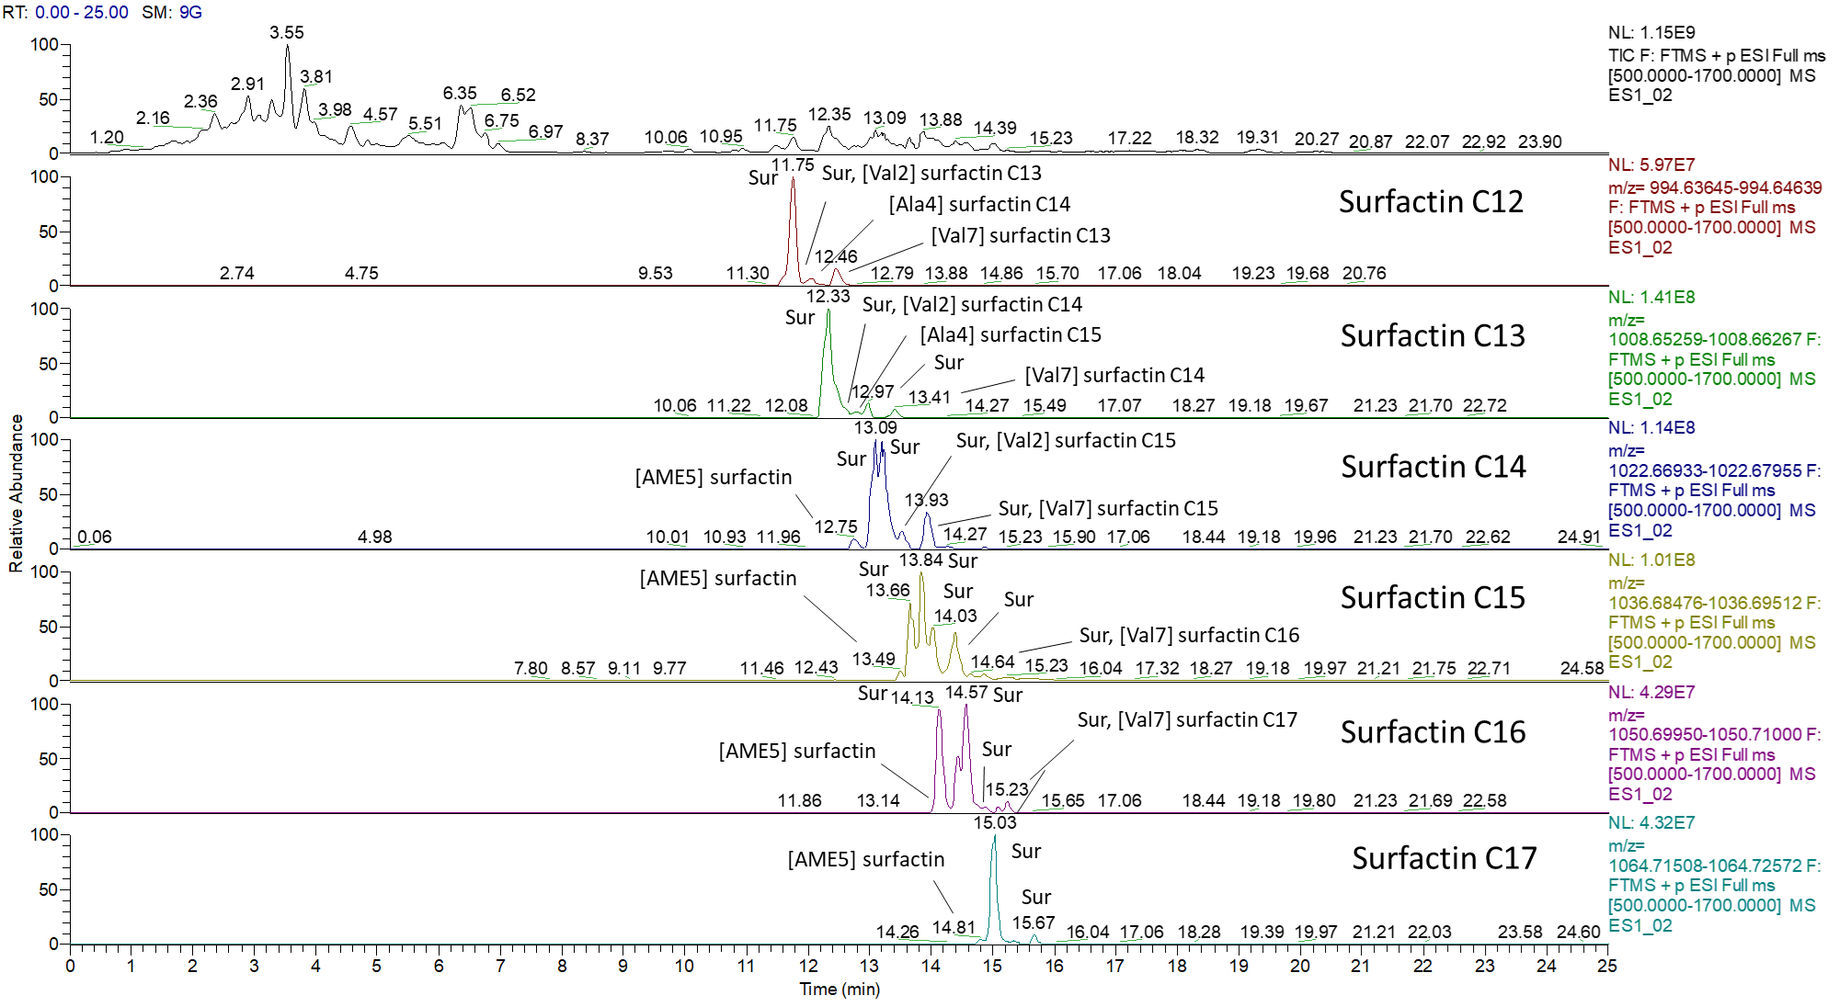
Fig. S32. Surfactin variants produced by B. velezensis ES11-02. The sample was taken after 24 h cultivation in LB medium at 37 °C and 0.4 g (120 rpm). The upper chromatogram shows the Total Ion Chromatogram (TIC) with a retention time (RT) of 25 min. Detailed annotations of the chromatographic spectra for surfactin C12-C17 show the identification of the surfactin parent sequence (Sur), E-L-L-V-N-L-L, and the substitutions: [Val2] – leucine at position 2 exchanged for valine; [Val7] – leucine at position 7 exchanged for valine; [Ala4] – valine at position 4 exchanged for alanine; [AME5] – aspartic acid at position 5 exchanged for aspartic acid 4-methylester.
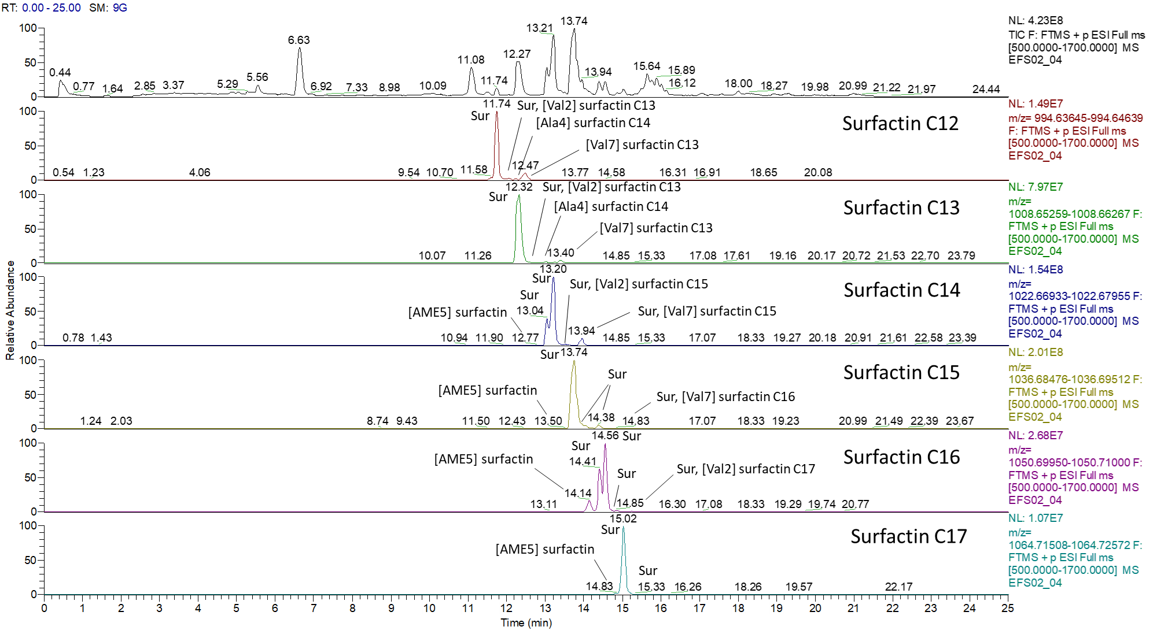
Fig. S33. Surfactin variants produced by B. velezensis EFSO2-04. The sample was taken after 24 h cultivation in LB medium at 37 °C and 0.4 g (120 rpm). The upper chromatogram shows the Total Ion Chromatogram (TIC) with a retention time (RT) of 25 min. Detailed annotations of the chromatographic spectra for surfactin C12-C17 show the identification of the surfactin parent sequence (Sur), E-L-L-V-N-L-L, and the substitutions: [Val2] – leucine at position 2 exchanged for valine; [Val7] – leucine at position 7 exchanged for valine; [Ala4] – valine at position 4 exchanged for alanine; [AME5] – aspartic acid at position 5 exchanged for aspartic acid 4-methylester.

Supporting information S34. Additional methods used for the screening procedure.
Gram staining
The Gram status was determined by microscopic examination of Gram-stained isolates (Gephart et al. 1981; Thairu et al. 2014). Therefore, a pure culture of each isolate was collected aseptically using a sterile wire loop and thin smear of the bacterial isolates were made on clean grease-free glass slides. Smears were air-dried and then heat-fixed. To Gram-stain, the bacterial smears were flooded with crystal violet for 60 s. The smear was then flooded with water to drain the excess stain. Gram’s iodine was then used to flood the smear for 60 s. The iodine serves as mordant and was washed off with water. Subsequently, a 95% (v/v) ethanol solution was used to flood the smear for 15 s until violet coloration was not visible anymore; then, it was rinsed with water. The slides were counter stained with safranin for 30 s and were then rinsed under running water and allowed to dry. Gram-positive bacteria were characterized by purple coloration while Gram-negative cells were pink to red in coloration when viewed under microscope. The microscopic examination of the stained smears also showed the shapes and arrangement of the bacterial cells.
Potassium hydroxide (KOH) string test
The Gram status of each isolate was further confirmed with KOH string test (Powers 1995; Arthi et al. 2003). This test relies on the tolerance to 3% (w/v) KOH between Gram-positive and Gram-negative cells when a portion of a colony is mixed with a small volume of 3% (w/v) KOH. If the cells lyse, the liberated cellular DNA makes the mixture viscous or “stringy”. The positive string test indicates a Gram-negative organism, while no string was observed in Gram-positive isolates.
Catalase test
This test was performed to differentiate bacteria in their ability to produce a catalase. Therefore, drops of freshly prepared 3% (v/v) hydrogen peroxide were added to clean, grease-free, and pure colonies. Evolution of frothy white gas observed by the formation of bubbles indicated a catalase positive reaction.
Spore staining
Spore staining procedure was used to determine the presence of endospores. After growth on NA plates at 37 ºC for 48 h, a pure colony was picked with a wire loop and suspended in a drop of water on a glass slide. After air drying, the bacteria were heat-fixed to the slide. The smears were stained with 5% (w/v) malachite green by flooding the slide with the stain and placing it over a steaming water. The malachite green solution was left on the cells for 5 min with continuous steaming of the slide. The slide was rinsed with water and the cells were counterstained for 30 s with 0.25% (w/v) safranin O and then rinsed with water. After completing the staining procedure, the slides were air-dried and viewed under oil immersion lens of a microscope; thereby, endospores appear green under the microscope (Reynolds et al. 2009).

Lecithinase production test
Bacterial lecithinases break down lecithin to an insoluble diglyceride resulting in an opaque halo, surrounding the colony when grown on the egg yolk agar medium. Overnight cultures of isolates were streaked on mannitol-egg yolk-polymyxin (MYP) agar. The plates were incubated at 37 ºC for 24 h. Isolates that appear pink-red without mannitol fermentation and exhibit clear zones of opacity around the colony confirm lecithinase activity and are positive for lecithinase test (Sharaf et al. 2014). While colonies that appear yellow with the absence of opacity zones are negative for lecithinase activity, un-inoculated MYP agar which remains red in color serves as control.
References
- Arthi K., Appalaraju B. and Parvathi S. (2003) Vancomycin sensitivity and KOH string test as an alternative to gram staining of bacteria. Indian J Med Microbiol 21, 121-123.
- Gephart, P., Murray, R.G.E., Costilow, R.N., Nester, E.W., Wood, W.A., Krieg, N.R. and Phillips, G.B. (1981) Manual of Methods for General Bacteriology, ASM Press, Washington D.C.
- Powers, E.M. (1995) Efficacy of the Ryu nonstaining KOH technique for rapidly determining gram reactions of food-borne and waterborne bacteria and yeasts. Appl Environ Microbiol 61, 3756-3758.
- Reynolds J., Moyes R. and Breakwell D.P. (2009) Differential staining of bacteria: endospore stain. Curr Protoc Microbiol, Nov;Appendix 3:Appendix 3J.
- Sharaf, E.F., El-Sayed, W.S. and Abosaif, R.M. (2014) Lecithinase-producing bacteria in commercial and home-made foods: Evaluation of toxic properties and identification of potent producers. J Taibah Uni Sci 8, 207-215.
- Thairu Y., Nasir I.A. and Usman Y. (2014) Laboratory perspective of gram staining and its significance in investigations of infectious diseases. Sub-Saharan Afr J Med 1, 168-74.

