Supplements
An extremely sensitive amylase activity assay and its application for the determination of the residual amylase activity in bread
Katrin Reichenberger, Sabine Lutz-Wahl, Lucas Kettner and Lutz Fischer*

University of Hohenheim, Institute of Food Science and Biotechnology,
Department of Biotechnology and Enzyme Science, Garbenstr. 25, 70599 Stuttgart, Germany

*Corresponding author: Lutz Fischer
E-mail address: Lutz.Fischer@uni-hohenheim.de
Tel.: +49 711 459-22311

Keywords: amylase assay, α-amylase, thermal stability, residual activity, bread baking, enzyme declaration, food enzyme

Table S1: Determination of different endo-amylase activities using different blanks (B1 and B2)
Submitted endo-amylase activity  [pkat mL⁻¹] | Activity calculated with Blank 1^{*1}  [pkat mL⁻¹] | Activity calculated with Blank 2^{*2}  [pkat mL⁻¹] | Percentage activity with Blank 1 [%] | Percentage activity with Blank 2 [%] | Assay run time [h]
60 | 60.91 ± 1.54 | 58.11 | 101.5 | 96.5 | 1.25
15 | 26.52 ± 0.98 | 15.35 | 176.8 | 102.3 | 2
10 | 18.20 ± 0.886 | 9.20 | 182.0 | 92.0 | 3
2 | 3.36 ± 0.074 | 1.94 | 168.0 | 97.0 | 17
1 | 3.73 ± 0.0303 | 0.93 | 373.0 | 93.0 | 24
0.5 | <LOD | <LOD |  |  | 48
^{*1} incubation of the Ceralpha reagent for the respective assay run time, addition of the stopping reagent followed by the addition of amylase solution
^{*2} incubation of the Ceralpha reagent together with heat inactivated amylase solution or buffer for the respective assay run time, addition of the stopping reagent
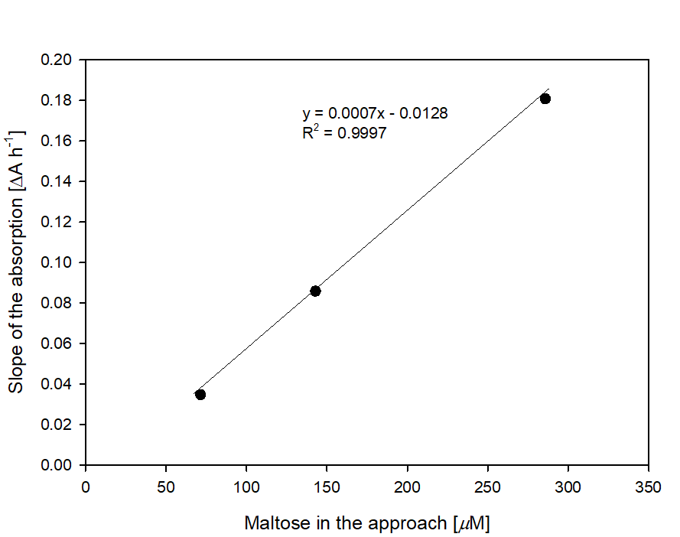

Figure S1: First calibration curve of the new Da67 assay using maltose (concentrations of assay components not yet optimized: 50 μM Da67, 681 nkat mL⁻¹ peroxidase, 150 nkat mL⁻¹ glucose oxidase and 1 % (w/v) starch)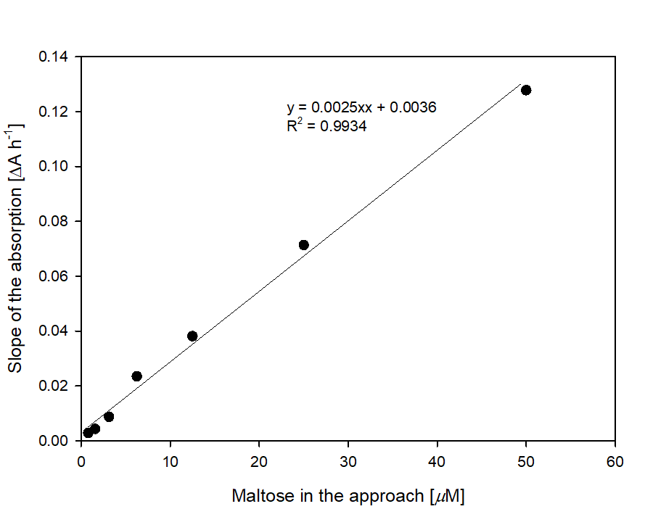
Figure S2: Calibration curve of the new Da67 assay using maltose with optimized concentration of assay components (50 μM Da67, 681 U mL⁻¹ peroxidase, 93 U mL⁻¹ glucose oxidase and 0.01 % (w/v) starch)
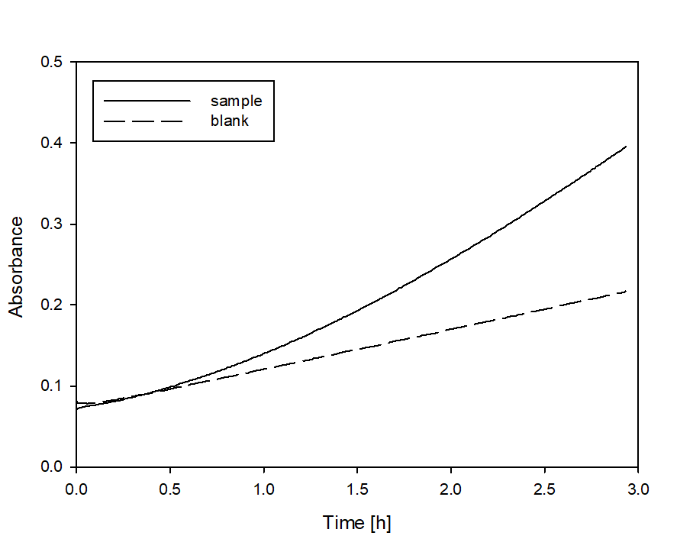
Figure S3: Absorbance values of one exemplary sample (50 ng mL⁻¹ of the α-amylase from B. subtilis) and one assay blank using a long assay run time with all assay components together (Da67, peroxidase, glucose oxidase, starch and amylase)

