Supplementary Information
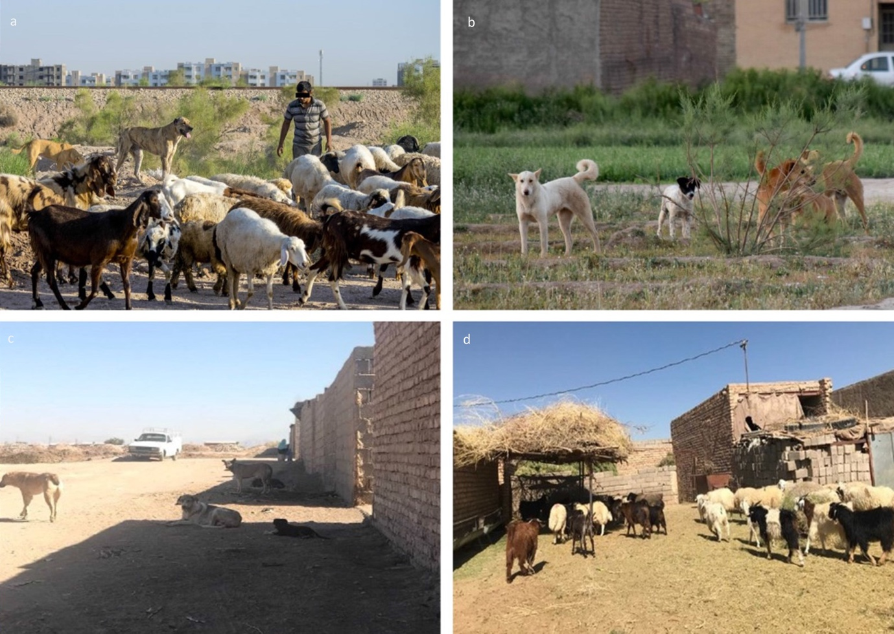

Additional file 1: Figure S1. Images demonstrating the situation facilitating the urban transmission of cystic echinococcosis in Kerman, Iran. a. Livestock husbandry on the outskirts of the city. b. Free-roaming dogs within the city. c and d. An unregistered abattoir near the city with free-roaming dogs waiting outside for food.

