Supporting information for
Density dependence of seed dispersal and fecundity profoundly alters the spread dynamics of plant populations

Jinlei Zhu*, Nataša Lukić, Jörn Pagel, Frank M. Schurr
Institute of Landscape and Plant Ecology, University of Hohenheim, 70599 Stuttgart, Germany

Correspondence
Jinlei Zhu
Institute of Landscape and Plant Ecology, University of Hohenheim, Ottilie-Zeller-Weg 2, 70599 Stuttgart, Germany
E-mail: jinlei.zhu@uni-hohenheim.de

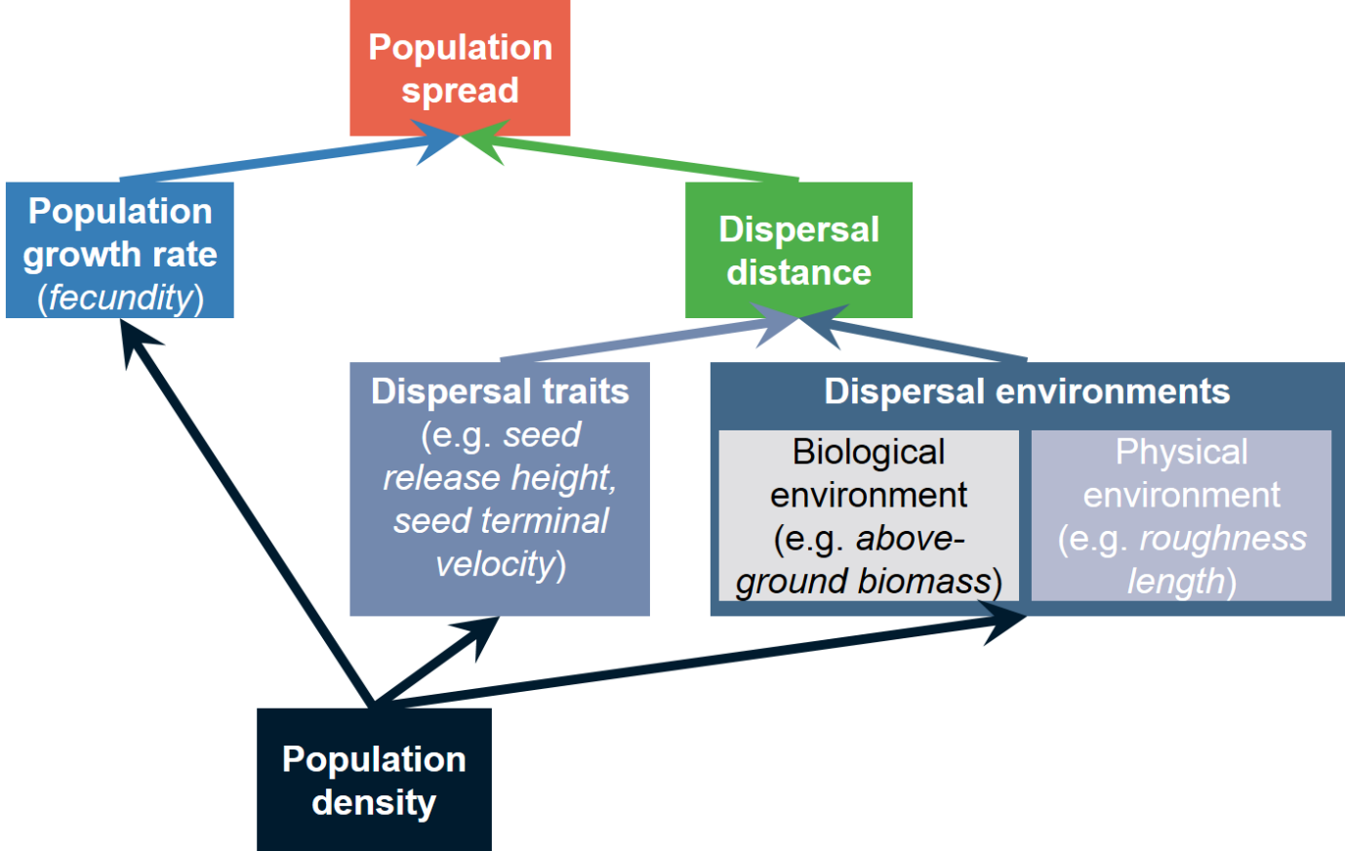
Fig. S1. Framework for simulating population spread. Population spread depends on the population growth rate and dispersal distance which depends on dispersal traits and dispersal environments that consist of both biological and physical environments. Population growth rate, dispersal traits and dispersal environments further depend on population density. In this study, we apply this framework in the context of wind dispersal which is determined by seed release height, terminal velocity, as well as dispersal environments such as above-ground biomass and roughness length.
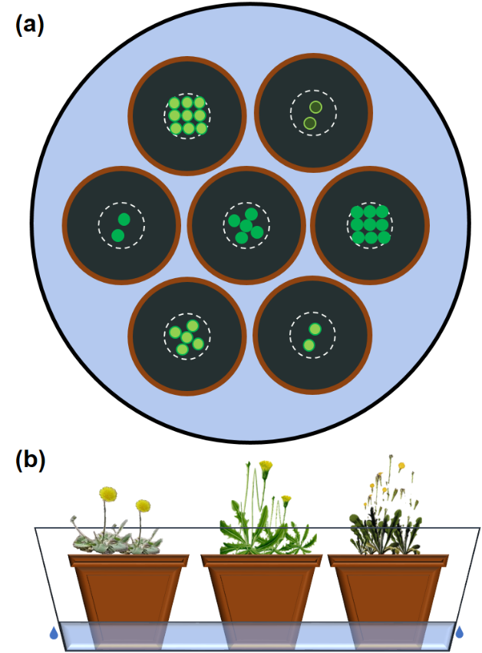
Fig. S2. Illustration of experimental design. (a) Top view: Groups of seven pots, in which two, five or nine seedlings of a study species (indicated by green circles filled with different colours; different colours represent different species) were transplanted into the central area, were randomly placed into a pool in which water table depth was controlled by creating over-flows at the 7-cm height (b, side view).

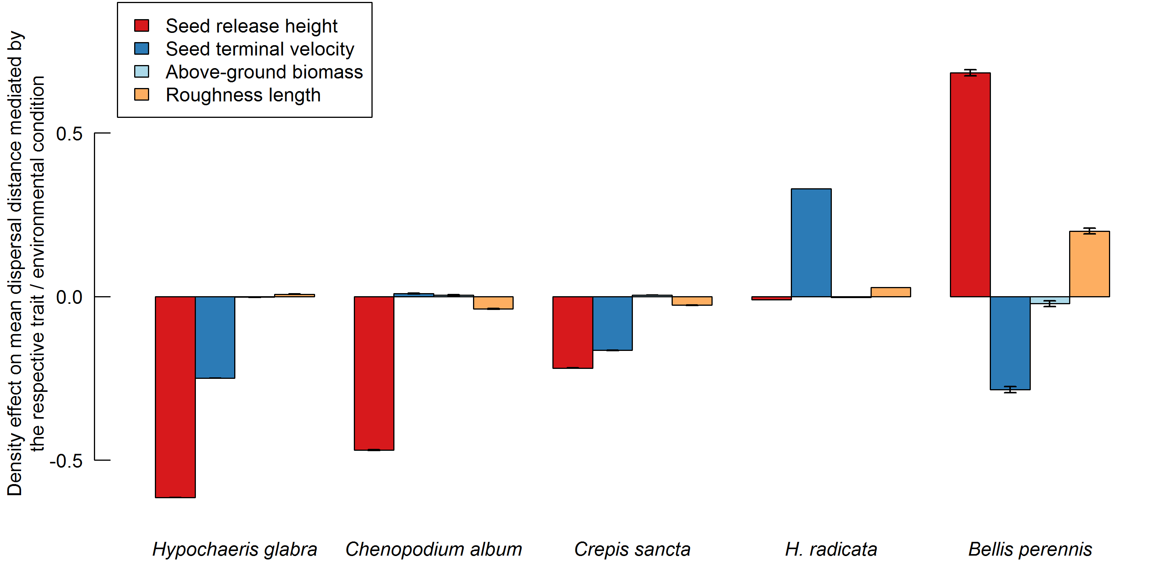
Fig. S3. Density effect on mean dispersal distance mediated by dispersal traits (seed release height and terminal velocity), the biological environmental variable (above-ground biomass), and the physical environmental variable (roughness length). Bars show standardized regression coefficients with (±) standard errors.
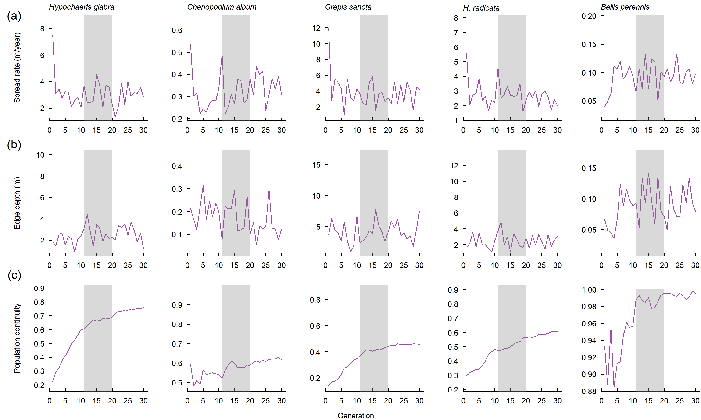
Fig. S4. Results of a simulation for 30 generations for (a) spread rate, (b) edge depth, and (c) population continuity. The shaded rectangles represent the simulation period (generation 11-20) considered in this study.
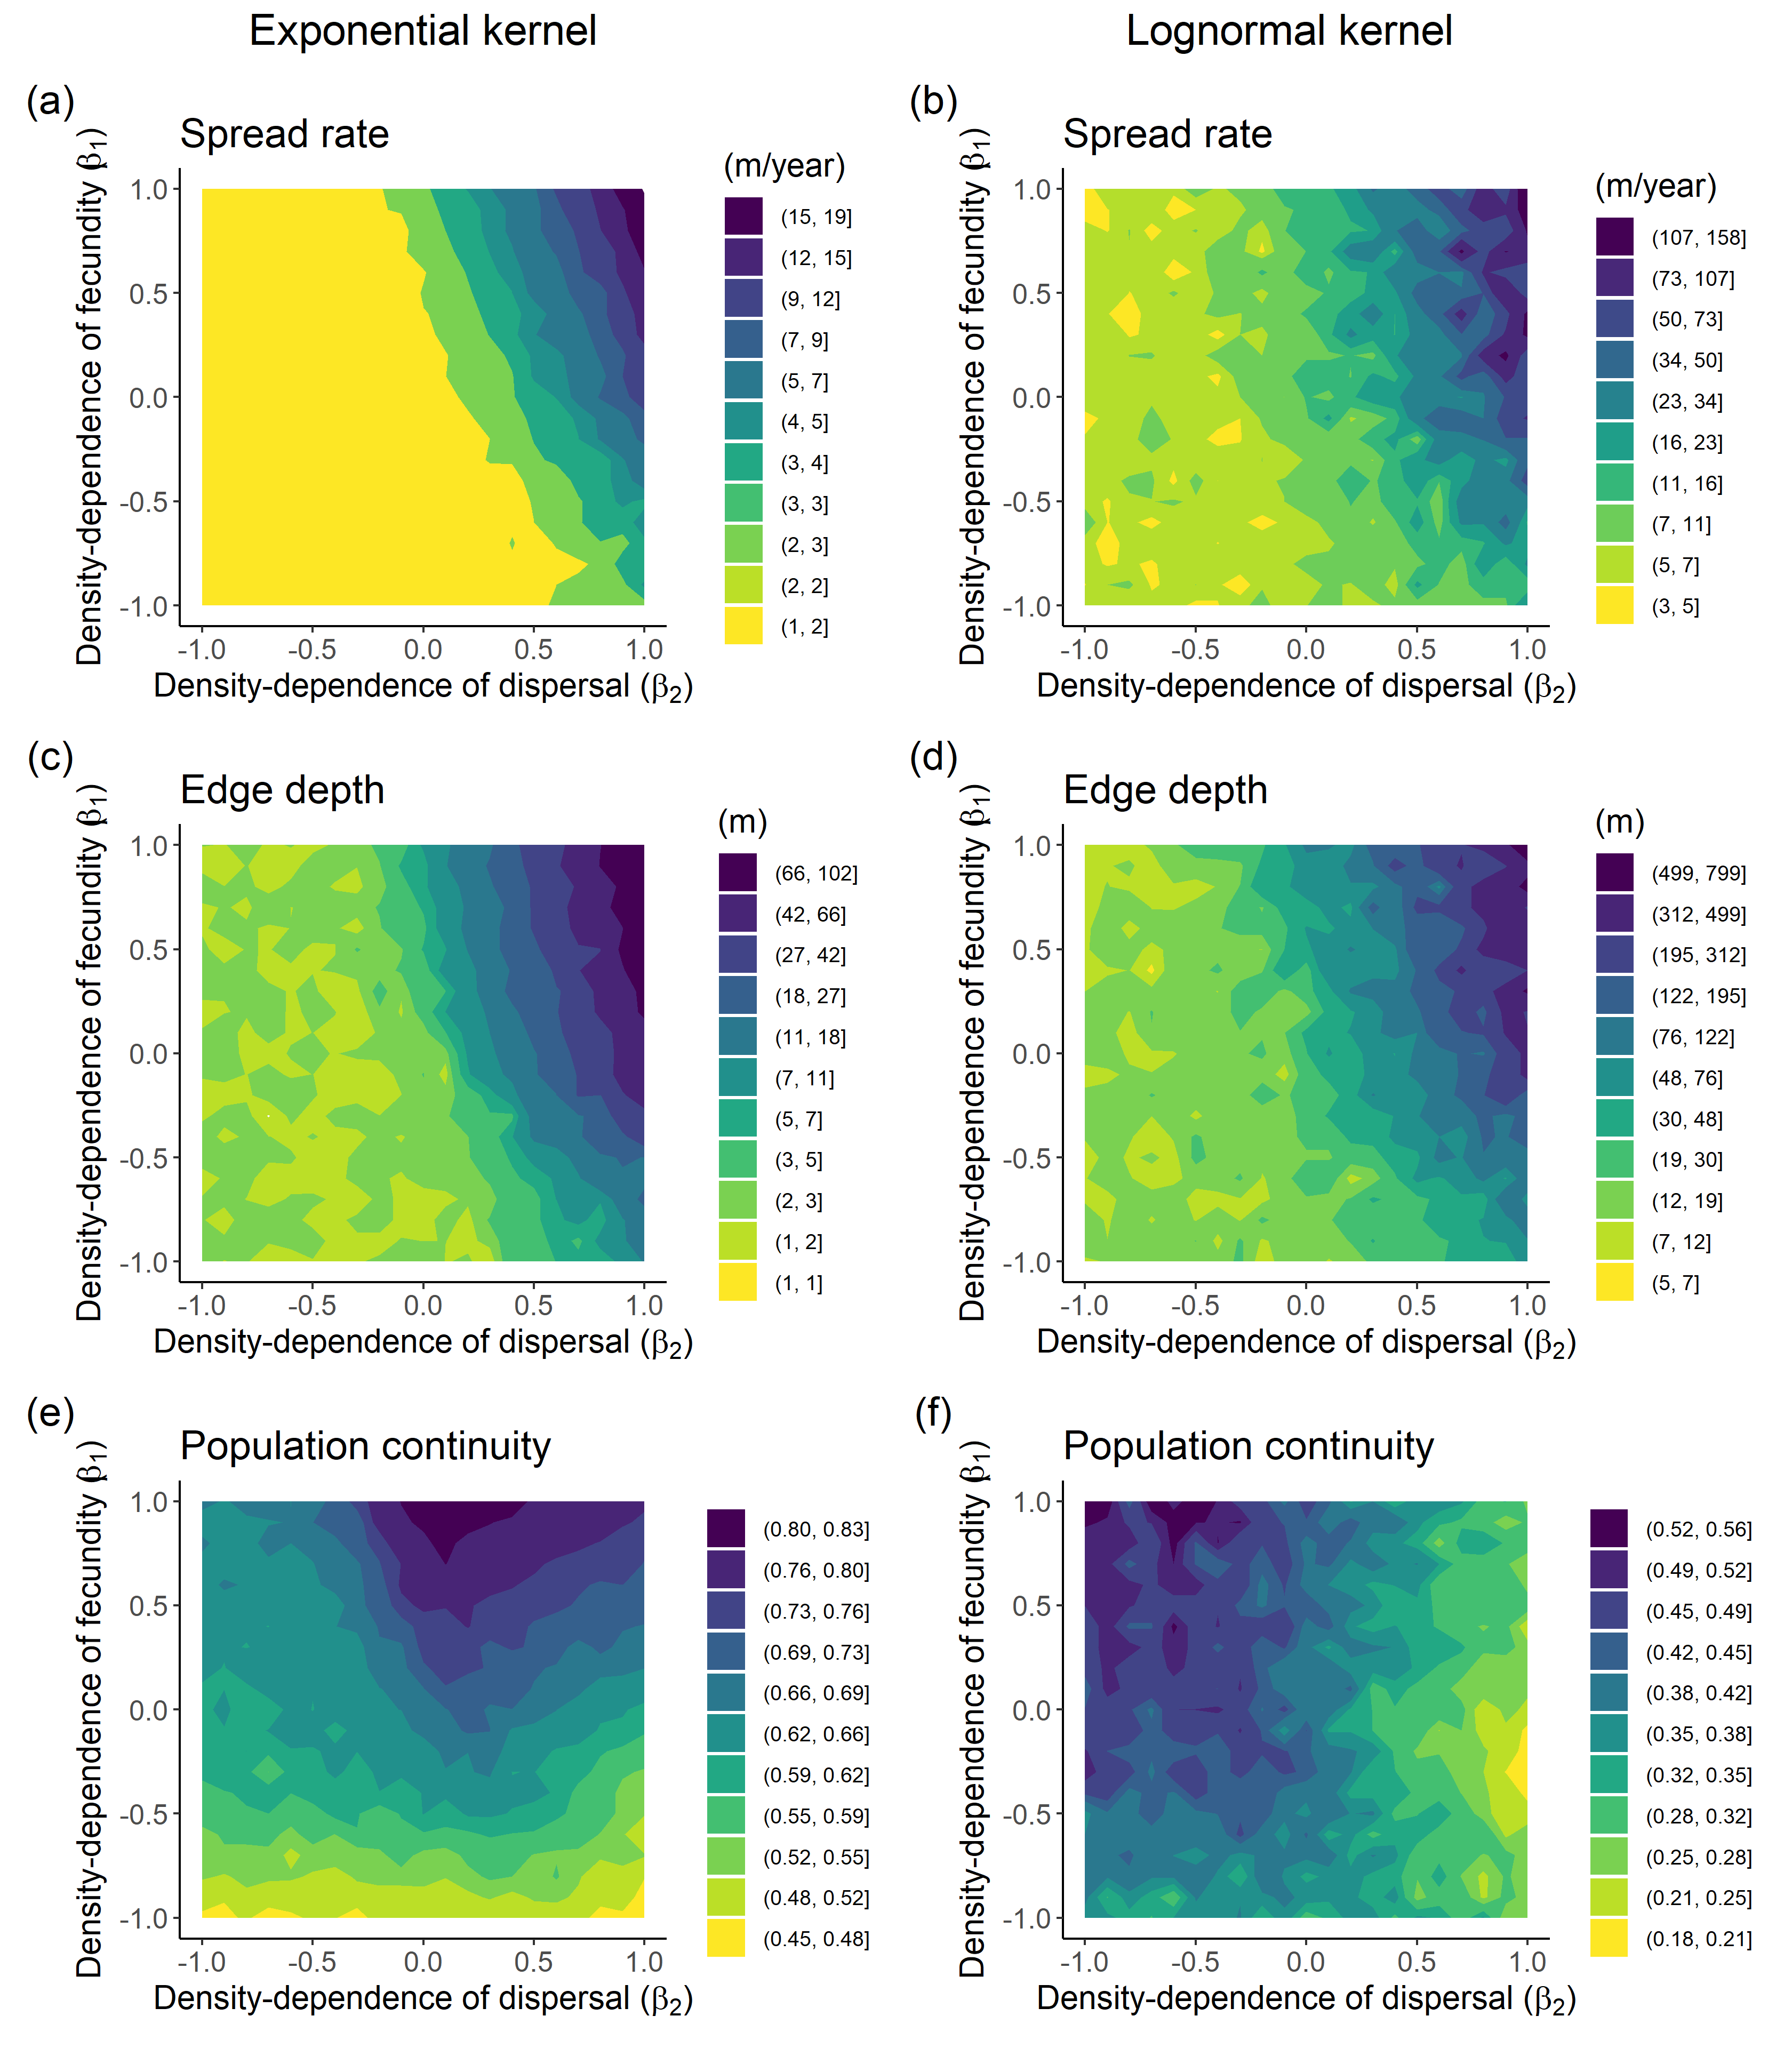
Fig. S5. Results of the global sensitivity analysis for the two-dimensional model version. The panels show how (a, b) population spread rate, (c, d) edge depth, and (e, f) population continuity respond to density-dependence of fecundity and dispersal described by negative exponential (left) and lognormal (right) dispersal kernels, respectively. The two-dimensional simulation arena was spatially unlimited in the x-direction in which we measured spread characteristics. In the perpendicular y-direction, it had an extent of 100 cells with periodic boundary conditions. Simulations were initialized with the first 10⁴ grid cells (100 rows × 100 columns) filled with one individual per cell and ran over 20 time steps (generations). Spread rate was calculated as the distance between the furthest forward individual at time t and time t + 1 in the x-direction, edge depth as the distance between the population edge at time t and the mother plant of the furthest forward individual at time t + 1 in the x-direction. Population continuity was calculated as the proportion of occupied cells in the rectangle delimited by the initial population edge at t = 0 and the furthest forward individual. For each simulation replicate, the three spread characteristics were averaged over the second half of the simulation period (t = 11 - 20). Since the two-dimensional simulations were more computationally intensive than the one-dimensional simulations, we set the low-density dispersal distance (D₀) to 2 m (rather than 10 m) and did 5 (rather than 20) simulation replicates. The remaining simulation parameters were identical to the one-dimensional simulations. Note that contours in panels a-d have logarithmic spacing.
Table S1. Correlation between the three spread characteristics in the general sensitivity analysis
dispersal kernel |  | log(spread.rate) | log(edge.depth)
exponential | log(edge.depth) | 0.9430
exponential | qlogis(continuity) | 0.5088 | 0.3529
lognormal | log(edge.depth) | 0.9561
lognormal | qlogis(continuity) | 0.2251 | 0.0703
pooled | log(edge.depth) | 0.9479
pooled | qlogis(continuity) | 0.2138 | 0.0615

Table S2. R² of the linear regression models for relationships between characteristics of population spread and density dependence of fecundity (b1) and mean dispersal distance (b2) for sensitivity analysis
 |  | Response variable
Dispersal kernel | Explanatory variables | log(spread.rate) | log(edge.depth) | qlogis(continuity)
exponential | b1+b2 | 0.46 | 0.62 | 0.37
exponential | b1*b2 | 0.58 | 0.72 | 0.38
lognormal | b1+b2 | 0.58 | 0.72 | 0.28
lognormal | b1*b2 | 0.69 | 0.84 | 0.29
pooled | b1+b2 | 0.48 | 0.58 | 0.25
pooled | b1*b2 | 0.58 | 0.67 | 0.25
Table S3. Correlation between population spread characteristics predicted by the one-dimensional and two-dimensional models. All correlation coefficients are highly significantly different from 0 (t₄₃₉ > 42, P < 0.001 for all combinations of spread characteristics and dispersal kernels
Spread characteristics | Exponential | Lognormal
Spread rate | 0.996 | 0.898
Edge depth | 0.993 | 0.933
Population continuity | 0.997 | 0.936

Simulation of dynamics of plant population spread
We present a process-based grid model for simulating spatiotemporal dynamics of plant population spread. Our model employs a one-dimensional grid of cells to represent the spatial structure of the plant population. To initiate the population, we set the density of plants at one individual per grid cell for the first 100 grid cells from the origin. We introduce a function that computes the number of seeds produced by each plant based on the density of plants in each grid cell. To achieve this, we randomly draw seed production from the Poisson distribution whose parameter depends on the current density of plants in the cell (equation 1 in the main text). Moreover, we use a dispersal kernel to randomly draw the dispersal distance of each seed. The dispersal kernel calculates the probability of a seed dispersing a certain distance based on the current density of plants and distance (equation 2 in the main text). Subsequently, we simulate plant population growth over time through iterative generations using a loop. During each time step, our model calculates the number of seeds produced by each plant, disperses the seeds to neighboring cells, and updates the plant density in each cell. The carrying capacity in each cell is set at nine.
For sensitivity analysis, we choose the thin-tailed negative exponential and fat-tailed lognormal dispersal kernels, respectively. For the population spread of wind-dispersed species, we instead use the Wald analytical long-distance dispersal (WALD) model to simulate seed dispersal distances. WALD is an analytical mechanistic model derived from a simplified 3-D stochastic dispersion model that retains the essential physics contained within the more computationally intensive coupled Eulerian-Lagrangian closure (CELC) model (Nathan et al. 2002). The analytical model reduces to the following Wald (or inverse Gaussian) distribution (eqn 5b in Katul et al. 2005). The advantage of WALD model compared to other phenomenological models is that WALD’s parameters can be estimated from the key factors affecting wind dispersal—wind statistics, seed release height, and seed terminal velocity—determined independently of dispersal data (Katul et al. 2005). The probability density of dispersal distances x is
$p\left(x\right)={\left(\frac{λ}{2πx^{3}}\right)}^{1/2}exp\left[-\frac{λ{\left(x-μ\right)}^{2}}{2μ^{2}x}\right]$ (1)
where $μ$ and $λ$ are dispersal kernel parameters, and $μ={H_{r}U}/{V_{t}}$, $λ={\left({H_{r}}/σ\right)}^{2}$, H_{r} is seed release height, U is the horizontal wind speed, V_{t} is seed terminal velocity, and σ is a turbulent flow parameter reflecting wind speed variation (Katul et al. 2005).
$σ^{2}= \frac{4{σ_{w}}^{4}}{C_{0}εU}$ (2)
where $σ_{w}$ is the vertical turbulence, $C_{0}$ is Kolmogorov constant (3.125), and $ε$ is the dissipation rate. Estimating $ε$ is challenging within the canopy (Katul et al. 2005), but we can assume 1) $ε= {{u_{*}}^{3}}/{K\left(z-d\right)}$ and 2) $A_{w}≡{σ_{w}}/{u_{*}}$ if we are mainly concerned with turbulent flow above the canopy, where $u_{*}$ is friction velocity, z is height above ground, and d is zero-plane displacement distance (Skarpaas and Shea 2007). From these assumptions and equation (2), we obtain
$σ=2{A_{w}}^{2}\sqrt{\frac{K\left(z-d\right)u_{*}}{C_{0}U}}$ (3)
Zero-plane displacement distance (d) is calculated by
$1-\frac{d}{h}=\frac{1-exp\left(-\sqrt{c_{d1}Λ}\right)}{\sqrt{c_{d1}Λ}}$ (4)
Where $c_{d1}$ is a free parameter and $Λ$ is canopy area index that can be conveniently calculated from leaf area index $λ$ by $Λ=2λ$ (Raupach 1994). Leaf area index was calculated from an empirical relationship between leaf area index and above-ground biomass (Zeeman et al. 2019).
Roughness length ($z_{0}$) is calculated by
${z_{0}}/h=\left(1-d/h\right)exp\left(-κ{U_{h}}/{u_{*}-Ψ_{h}}\right)$ (5)
Where h is vegetation height, $κ$ is von Karman constant ($≈0.4$) and $Ψ_{h}$ is the roughness-sublayer influence function and can be simplified as
$Ψ_{h}=\ln\left(c_{w}\right)-1+{c_{w}}^{-1}$ (6)
Where $c_{w}$ is a constant (=2).
Drag coefficient is approximated by
${u_{*}}/U=min\left[{\left(C_{s}+C_{R}Λ/2\right)}^{1/2},{\left({u_{*}}/U\right)}_{max}\right]$ (7)
Where ${\left({u_{*}}/U\right)}_{max}$ is the constant value of ${u_{*}}/U$ when $Λ>Λ_{max}=2λ_{max}$ (Raupach 1994).
Each seed released in the simulation was dispersed by drawing a distance from the probability distribution function, which was generated by the WALD model, utilizing wind speed, H_{r}, and V_{t} parameters. The mean horizontal wind speed and friction velocity were obtained from an eddy covariance station at the Heidfeldhof research station (Wulfmeyer et al. 2018), University of Hohenheim, Germany. The H_{r} and V_{t} parameters were determined via linear mixed-effects models that quantified the relationship between H_{r} and V_{t} and population density (with a maximum of 9 individuals per cell, corresponding to the population density in our experiment) and species identity, as explained in further detail in the Quantifying density-dependence of fecundity and dispersal traits in the main text.

References
Katul, G. G., et al. 2005. Mechanistic analytical models for long-distance seed dispersal by wind. – Am. Nat. 166: 368-81.
Nathan, R., et al. 2002. Mechanisms of long-distance dispersal of seeds by wind. - Nature 418: 409-13.
Raupach, M. R. 1994. Simplified expressions for vegetation roughness length and zero-plane displacement as functions of canopy height and area index. - Boundary-Layer Meteorology 71: 211-216.
Skarpaas, O. and Shea, K. 2007. Dispersal patterns, dispersal mechanisms, and invasion wave speeds for invasive thistles. – Am. Nat. 170: 421-30.
Wulfmeyer, V. et al. 2018. A new research approach for observing and characterizing land-atmosphere feedback. - B. Am. Meteorol. Soc. 99: 1639-1667.
Zeeman, M. J. et al. 2019. Productivity and vegetation structure of three differently managed temperate grasslands. - Agriculture, Ecosystems & Environment, 270-271: 129-148.
R code for the general model of density-dependent population spread
dd.exp.lnorm <- function(b0, b1, b2,R0,K,pot.area,start.cells,Tmax,Nsim,kern) {
# Simulate population spread in one-dimensional space accounting for density-dependent fecundity and density-dependent dispersal described with negative exponential and log-normal dispersal kernels
# Args:
# b0: intercept of density-dependent lambda for exponential distribution
# b1: slope of density-dependent fecundity
# b2: slope of density-dependent mean dispersal distance
# R0: #of offspring that a mother plant produces
# K: carrying capacity, #individuals/m2 (=1000)
# pot.area: the central area of a pot, in m2 (= pi*(0.1/2)^2)
# start.cells: the number of cells that are filled at the start of simulation (=100)
# Tmax: maximal time step (generation) (=20)
# Nsim: number of simulation replicates (=20)
# kern: dispersal kernel, currently "exp" (negative exponential) or "lnorm" (lognormal)
d <- sqrt(pot.area) #length of a grid cell
Kcell <- round(K*d^2) #carrying capacity per grid cell
plants.start <- data.frame(x=rep(-start.cells:-1*d + d/2, each=1))
range.front <- matrix(NA, nrow = Tmax, ncol = Nsim)
edge.depth <- matrix(NA, nrow = Tmax, ncol = Nsim)
population.continuity <- matrix(NA, nrow = Tmax, ncol = Nsim)
for (s in 1:Nsim) {
plants.data <- plants.start
for (g in 1:Tmax) {
plants.data$cell.id <- plants.data$x %/% d
celldens.tab <- table(plants.data$cell.id)
cell.data <- data.frame(cell.id = as.numeric(names(celldens.tab)), n = as.numeric(celldens.tab))
cell.data$n[cell.data$n>Kcell] <- Kcell
# density-dependent fecundity:
R <- exp( log(R0) + b1 * log(cell.data$n) )
cell.data$n.off <- rpois(n=nrow(cell.data),lambda=cell.data$n*R)

# density-dependent dispersal:
cell.data$lambda.simu <- exp(b0 + b2*log(cell.data$n))
x.old <- rep(cell.data$cell.id*d+d/2,times=cell.data$n.off)
Nseeds <- length(x.old)
lambda.simu <- rep(cell.data$lambda.simu,time=cell.data$n.off)
left.edge <- 0
population.continuity[g,s] <-ifelse(nrow(cell.data[cell.data$cell.id>=left.edge,])>0,
nrow(cell.data[cell.data$cell.id>=left.edge,]) / (max(cell.data[cell.data$cell.id>=left.edge,]$cell.id)-left.edge+1),NA)
if(Nseeds==0){
dx <- 0
} else {
if (kern == "exp") dx <- rexp(n=Nseeds,rate = 1/lambda.simu)
else if(kern == "lnorm") dx <- rlnorm(n=Nseeds,meanlog = log(lambda.simu))
}
direction <- sample(x = c(-1,1),size = length(dx),replace = T)
plants.data <- data.frame(x = x.old + dx*direction)
x.mother.of.furthest <- x.old[which.max(plants.data$x)]
if(nrow(plants.data)==0){
range.front[g,s] <- NA
break
} else {
range.front[g,s] <- max(plants.data$x,na.rm = TRUE)
if (g==1) {
edge.depth[g,s]<- -d/2 - x.mother.of.furthest #range front at the start of the simulation is at -d/2
} else {
edge.depth[g,s]<- range.front[g-1,s] - x.mother.of.furthest
}
}
}
}
range.front <- rbind(rep(-d/2,Nsim),range.front) #at the start (g=0), edge front is at -d/2
spread.rate<-apply(range.front,2,diff)
return(list(range.front=range.front,
spread.rate=spread.rate,
edge.depth=edge.depth,
population.continuity=population.continuity,
b0=b0,b1=b1,b2=b2,R0=R0,K=K,pot.area=pot.area,
start.cells=start.cells,Tmax=Tmax,
Nsim=Nsim,kern=kern))
}

